Challenges in Estimating Effectiveness of 2 Doses of COVID-19 Vaccines Beyond 6 Months in England

Elsie MF Horne, William J Hulme, Ruth H Keogh, Tom M Palmer, Elizabeth J Williamson, Edward PK Parker, Venexia M Walker, Rochelle Knight, Yinghui Wie, Kurt Taylor, Louis Fisher, Jessica Morley, Amir Mehrkar, Iain Dillingham, Sebastian Bacon, Ben Goldacre, Jonathan AC Sterne, The OpenSAFELY Collaborative

Web Appendix 1 2
Web Appendix 2 4
Web Appendix 3 4
Web Figures 1-6 6
Web Tables 1-21 12
References 21

Web Appendix 1
This appendix describes the methods for estimating vaccine effectiveness. The following subsections (Data source, Study design, and Statistical analysis) are abridged versions of the published text describing our previous study, with added information on classification of dominant variant over time. See Horne et al. (2022) for full details.¹

Data source
OpenSAFELY-TPP includes detailed pseudonymised primary care data linked (via National Health Service (NHS) number) with accident and emergency attendance, inpatient hospital spell records (NHS Digital’s Hospital Episode Statistics dataset), national SARS-CoV-2 testing records (Second Generation Surveillance System; SGSS), and national death registry records. Vaccination status (National Immunisation Management System; NIMS) is available in the primary care record. Healthcare worker status (recorded for vaccine recipients at the time of vaccination) is provided by NHS Digital’s covid-19 data store.

Study design
This study was approved by NHS England. People were eligible for inclusion if they were aged ≥18 years on 1 July 2021 and had been registered with a primary care doctor for at least one year before eligibility for their first vaccine dose (the “eligibility date”). People were excluded if they were aged >120 years on the date at which they became eligible for vaccination; their sex, geographical region, ethnicity, or English Index of Multiple Deprivation were unknown; or they were resident in a care home or medically housebound at six weeks after their eligibility date.
We defined three groups who received two doses of BNT162b2, received two doses of ChAdOx1, or were unvaccinated. Eligibility for the vaccinated groups was restricted to people who received their second vaccine dose during a four week “second vaccination period” within analysis strata defined by UK Joint Committee on Vaccination and Immunisation (JCVI) priority groups, eligibility date (for priority groups within which eligibility was based on age), and English NHS region (defined using individuals’ primary care practice address).
We defined the second vaccination period as the four week period during which the greatest number of people in the stratum received their second dose. We excluded people from the vaccine groups if they received their first dose before their eligibility date, had an interval between first and second dose of less than six or more than 14 weeks, or were flagged as a healthcare worker on their vaccination record. We assigned people to the unvaccinated group if they had received no covid-19 vaccine at the start of the second vaccination period for their analysis stratum. We excluded people from any group if they had evidence of previous SARS-CoV-2 infection by the start of their second vaccination period (either a positive SARS-CoV-2 test in SGSS or probable covid-19 coded in primary care records), had ever been recorded as being resident in a care home, or had evidence of having started an end-of-life care pathway.
The analysis timescale was calendar time, which ensured that vaccinated and unvaccinated people were compared on the calendar day on which each outcome event occurred. We split follow-up time for fully vaccinated people into six consecutive four week “comparison periods,” starting two weeks after receipt of the second dose. Because each second vaccination period was four weeks long and each vaccinated person was followed up for four weeks per comparison period, vaccinated people were followed during eight calendar weeks in each comparison period. Vaccinated people entered and finished follow-up on the calendar dates corresponding to the start and end of their comparison period.
We followed up unvaccinated people for the full eight calendar weeks that spanned the comparison periods for vaccinated people. To avoid overlap in follow-up of unvaccinated people between comparison periods, follow-up time for unvaccinated people was assigned at random to start either two or six weeks after the start of the second vaccination period and was split into the three consecutive eight week calendar periods during which vaccinated people were followed in each comparison period. Unvaccinated people assigned to start at two weeks were followed during odd numbered comparison periods 1, 3, 5, etc., and those assigned to start at six weeks were followed during even numbered comparison periods 2, 4, 6 etc.
We categorised follow-up time according to the dominant variant at that time, “dominant” defined as the percentage of cases with/without S-gene target failure exceeding 50%. Follow-up time before 31 May 2021 was categorised as “alpha”, follow-up time from 1 June 2021 to 14 December 2021 was categorised as “delta”, and follow-up time from 15 December 2021 onwards was categorised as “omicron”. ² Within subgroups, we categorised the comparison periods as alpha, delta or omicron based on the calendar period over which the majority of the follow-up time occurred (Web Figure 1).

Statistical analysis
For each comparison period, we estimated hazard ratios comparing BNT162b2 or ChAdOx1 recipients versus unvaccinated people. We did not estimate hazard ratios for comparison periods with fewer than three events in either group. For each person, follow-up ended at the earliest of the outcome of interest, deregistration from the primary care practice, death, or 31 March 2021. Fully vaccinated people who received a booster dose, and unvaccinated people who received a first dose were excluded from subsequent comparison periods, but follow-up within comparison periods was not censored after these events.
To estimate hazard ratios, we fitted Cox regression models with baseline hazards stratified by JCVI group, eligibility date, and region, and with the covariates described previously.¹ To avoid problems with model convergence, we excluded binary covariates from the model if any cell of the table defined by cross tabulating the covariate with vaccine group and comparison period contained fewer than three events. For categorical covariates with more than two levels, levels were merged until either all levels had more than three events or only one level existed, in which case the variable was excluded. We carried out this process independently for each outcome. We modelled age within strata as linear, with quadratic terms additionally included for strata with age range >5 years.
We did all analyses independently in four vaccine priority subgroups: aged ≥65 years and in JCVI groups 2-5, aged 18-64 years and clinically vulnerable (JCVI groups 4 or 6), aged 40-64 years (JCVI groups 7-10; restricted to those who received ChAdOx1), and aged 18-39 years (JCVI groups 11-12; restricted to those who received BNT162b2). The ≥65 subgroup included participants who were clinically vulnerable, whereas the 40-64 and 18-39 subgroups did not.

Web Appendix 2
This study was approved by the Health Research Authority (REC reference 22/PR/0095) and by the University of Bristol's Faculty of Health Sciences Ethics Committee (reference 117269).
NHS England is the data controller for OpenSAFELY-TPP; TPP is the data processor; all study authors using OpenSAFELY have the approval of NHS England. This implementation of OpenSAFELY is hosted within the TPP environment which is accredited to the ISO 27001 information security standard and is NHS IG Toolkit compliant;³
Patient data has been pseudonymised for analysis and linkage using industry standard cryptographic hashing techniques; all pseudonymised datasets transmitted for linkage onto OpenSAFELY are encrypted; access to the platform is via a virtual private network (VPN) connection, restricted to a small group of researchers; the researchers hold contracts with NHS England and only access the platform to initiate database queries and statistical models; all database activity is logged; only aggregate statistical outputs leave the platform environment following best practice for anonymisation of results such as statistical disclosure control for low cell counts.⁴
The OpenSAFELY research platform adheres to the obligations of the UK General Data Protection Regulation (GDPR) and the Data Protection Act 2018. In March 2020, the Secretary of State for Health and Social Care used powers under the UK Health Service (Control of Patient Information) Regulations 2002 (COPI) to require organisations to process confidential patient information for the purposes of protecting public health, providing healthcare services to the public and monitoring and managing the COVID-19 outbreak and incidents of exposure; this sets aside the requirement for patient consent.⁵ This was extended in July 2022 for the NHS England OpenSAFELY COVID-19 research platform.⁶ In some cases of data sharing, the common law duty of confidence is met using, for example, patient consent or support from the Health Research Authority Confidentiality Advisory Group.⁷
Taken together, these provide the legal bases to link patient datasets on the OpenSAFELY platform. GP practices, from which the primary care data are obtained, are required to share relevant health information to support the public health response to the pandemic, and have been informed of the OpenSAFELY analytics platform.

Web Appendix 3
This appendix describes the methods for investigating factors associated with uptake of third dose.

Study population
All individuals eligible for the vaccinated group in the vaccine effectiveness analysis.¹

Statistical analysis
We fitted Cox models stratified by JCVI group and eligibility date for first vaccination dose. The time scale was time since second dose, and the outcome event was third dose (any brand). Follow-up time was split according to the time-updated covariates. We adjusted for the following covariates:
- Continuous covariates defined at baseline:
  - Age (second degree polynomial), date of second dose (natural cubic spline with three knots)
- Categorical covariates defined at baseline:
  - Sex (male, female), Index of Multiple Deprivation Quintile, Ethnicity (White, Black, South Asian, Mixed, Other), Body Mass Index (Not obese, 30.0-34.9, 35-39.9, 40+), brand of second dose (BNT162b2, ChAdOx1), number of SARS CoV-2 tests taken prior to first vaccination (0, 1, 2, 3+)
- Binary covariates defined at baseline:
  - Learning disability, severe mental illness, chronic respiratory disease, chronic heart disease, chronic liver disease, chronic kidney disease, chronic neurological disease, diabetes, immunosuppression, cancer (in the three years before baseline), flu vaccine (in the five years before baseline)
- Time-updated binary covariates:
  - End of life care initiated, positive SARS-CoV-2 test in the past 30 days, in hospital on a planned admission, in hospital on an unplanned admission, in hospital on an unplanned admission with a COVID-19 code

Web Figures 1-6
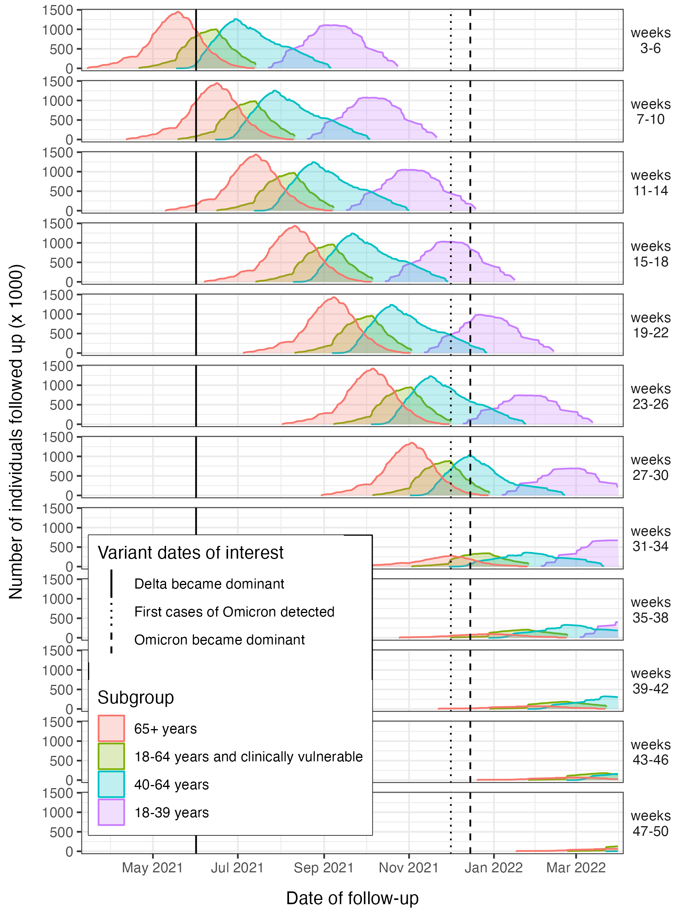
Web Figure 1. Distribution of follow-up time across comparison periods (defined by weeks since second dose)

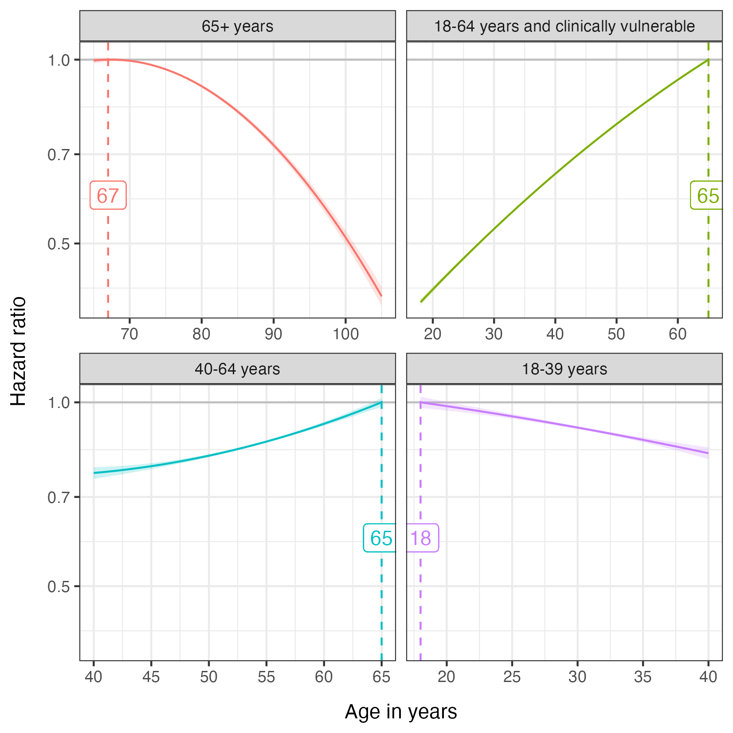
Web Figure 2. Hazard ratios for age, relative to the age with the highest predicted rate of third dose (shown by the dashed vertical line). Note that the subgroups were defined at the time of eligibility for first dose, so individuals may be up to one year older than the age range stated in the subgroup label.

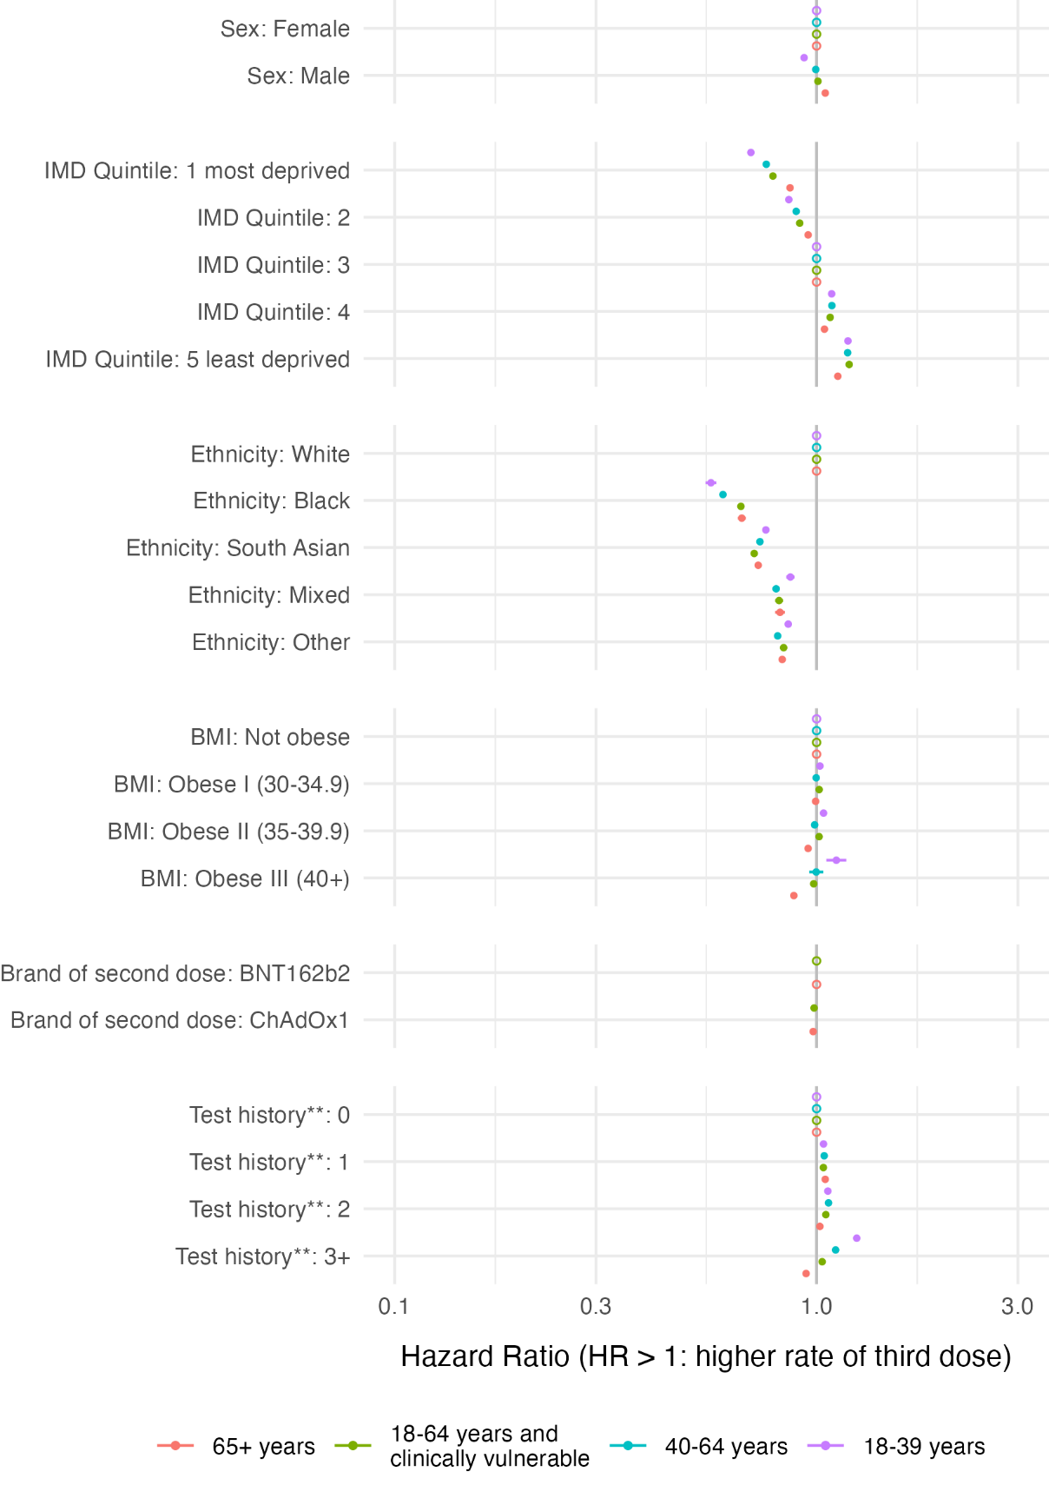
Web Figure 3. Hazard ratios for uptake of third dose. All variables defined at baseline. Hollow points correspond to reference categories.
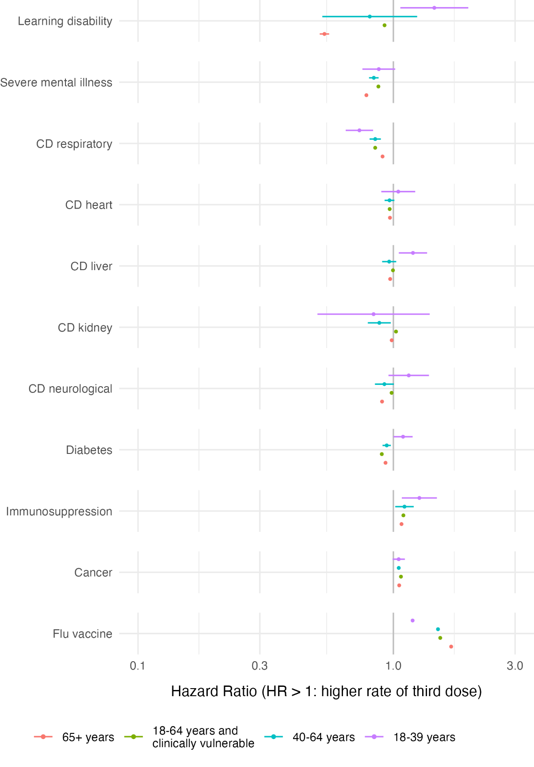
Web Figure 4. Hazard ratios for uptake of third dose. All variables defined as ever occurring before baseline, except for cancer (must have code in three years prior to baseline), and flu vaccine (received in 5 years before baseline). CD = chronic disease.
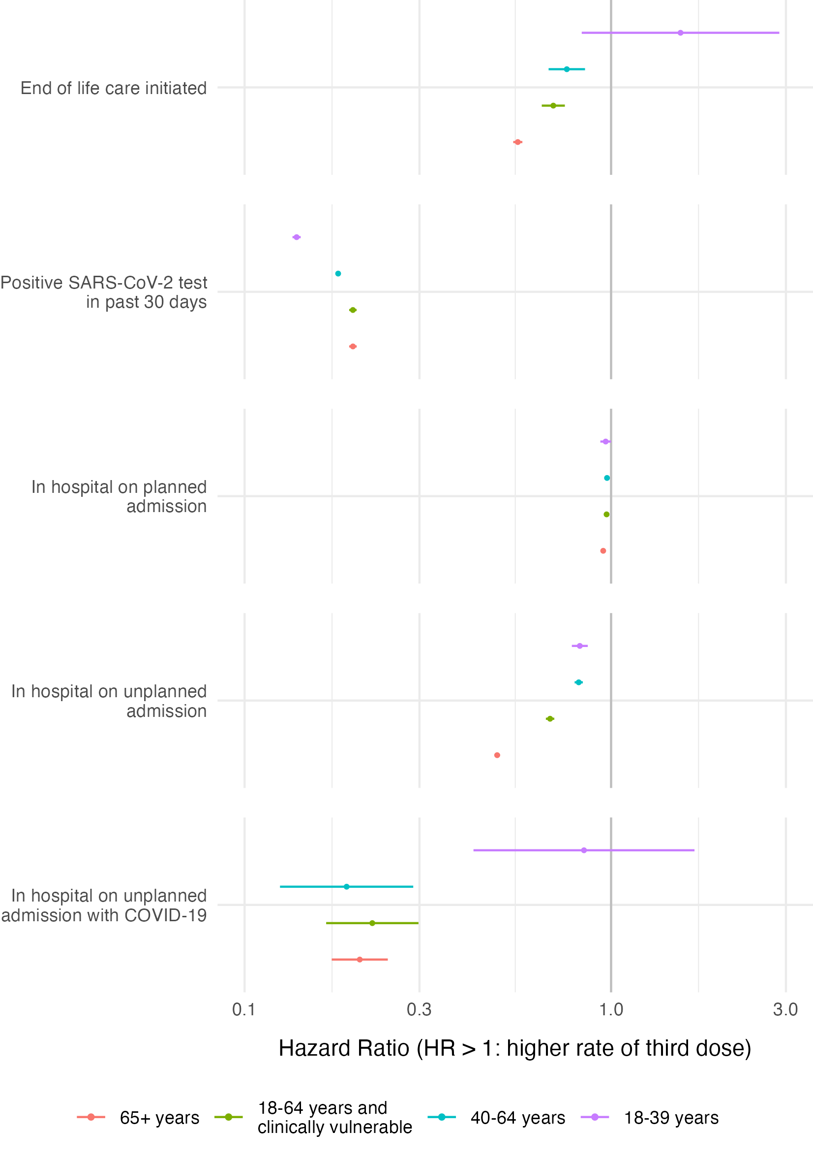
Web Figure 5. Hazard ratios for uptake of third dose. All variables are time-updating.
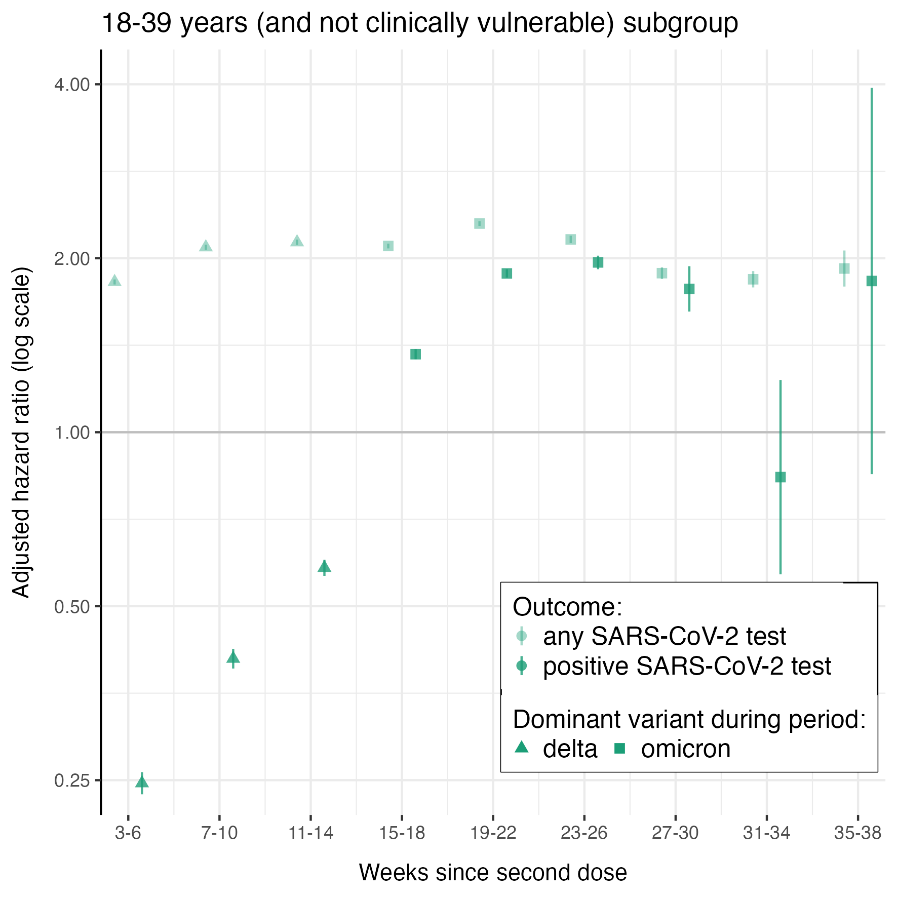
Web Figure 6. Hazard ratios for SARS-CoV-2 test and positive SARS-CoV-2 test in the 18-39 years subgroup. Follow-up was censored for both outcomes at the date of the first positive SARS-CoV-2 test. Only the first SARS-CoV-2 test in each comparison period (defined by weeks since second dose) was counted. The calendar time corresponding to each comparison period can be inferred from Web Figure 1.

Web Tables 1-21
Web Table 1. Variable definitions
Use | Name | Description
Stratification variable in all Cox models for estimating vaccine effectiveness | JCVI group | Vaccine priority group defined by the UK Joint Committee on Vaccination and Immunisation (JCVI)
 | Eligibility date | Date of eligibility for primary vaccine course
 | Region | NHS Region of England
Demographic covariate in adjusted Cox model | Age | Age on 31 March 2021
 | Sex | Male, Female
 | Index of Multiple Deprivation | English Index of Multiple Deprivation (IMD) quintile
 | Ethnicity | Census categories: White, Black, South Asian, Mixed, Other
Clinical covariate in adjusted Cox model | BMI | Body Mass Index (BMI): Not Obese, Obese I (30-34.9 kg/m2), Obese II (35-39.9 kg/m2), Obese III (340 kg/m2),
 | Learning disability | Yes, no
 | Serious mental illness | Yes, no
 | Morbidity count | Number of morbidities in the following categories: chronic respiratory disease, chronic heart disease, chronic liver disease, chronic kidney disease, chronic neurological disease, diabetes, immunosuppression.
 | Flu vaccine in previous 5 years | Yes, no
 | Number of previous SARS-CoV-2 tests | Number of tests taken between 2022-05-18 and “Eligibility date”:  0, 1, 2, ≥3
 | Pregnancy | Yes, no

Web Table 2. Counts and hazard ratios (HR) for Any SARS-CoV-2 test the 18-39 years subgroup
 | Unvaccinated |  | BNT162b2
weeks since second dose | n | events | n | events | unadjusted HR | adjusted HR
3-6 | 678,657 | 101,213 | 701,554 | 119,784 | 2.35 (2.32,2.37) | 1.82 (1.80,1.84)
7-10 | 637,630 | 86,037 | 694,400 | 120,169 | 2.71 (2.69,2.74) | 2.09 (2.07,2.11)
11-14 | 609,763 | 81,767 | 687,043 | 117,593 | 2.81 (2.78,2.84) | 2.13 (2.11,2.15)
15-18 | 586,173 | 100,380 | 676,578 | 152,446 | 2.76 (2.73,2.78) | 2.10 (2.08,2.12)
19-22 | 561,239 | 100,191 | 543,718 | 145,754 | 3.02 (2.99,3.04) | 2.30 (2.27,2.32)
23-26 | 523,810 | 63,567 | 245,630 | 41,895 | 2.83 (2.79,2.87) | 2.16 (2.12,2.19)
27-30 | 494,970 | 34,517 | 164,507 | 12,439 | 2.43 (2.38,2.48) | 1.88 (1.84,1.93)
31-34 | 484,484 | 18,284 | 134,981 | 6,174 | 2.39 (2.32,2.47) | 1.84 (1.78,1.90)
35-38 | 310,051 | 5,299 | 38,731 | 1,141 | 2.68 (2.51,2.87) | 1.92 (1.79,2.06)

Web Table 3. Counts and hazard ratios (HR) for non-COVID-19 death the 18-39 years subgroup
 | Unvaccinated |  | BNT162b2
weeks since second dose | n | events | n | events | unadjusted HR | adjusted HR
3-6 | 685,895 | 28 | 706,468 | 7 | 0.66 (0.27,1.59) | 0.64 (0.23,1.76)
7-10 | 654,024 | 28 | 702,009 | 7 | 0.18 (0.05,0.64) | 0.16 (0.04,0.59)
11-14 | 631,344 | 21 | 698,761 | 7 | 0.57 (0.21,1.53) | 0.67 (0.27,1.68)
15-18 | 614,145 | 21 | 695,639 | 14 | 0.65 (0.29,1.45) | 0.64 (0.27,1.53)
19-22 | 596,470 | 21 | 584,493 | 7 | 0.36 (0.09,1.48) | 0.34 (0.08,1.47)
23-26 | 576,205 | 21 | 305,452 | 7 | 0.41 (0.10,1.71) | 0.34 (0.07,1.60)
27-30 | 559,132 | 14 | 219,408 | 7
31-34 | 550,060 | 7 | 179,095 | 7
35-38 | 351,512 | 7 | 52,325 | 0

Web Table 4. Counts and hazard ratios (HR) for positive SARS-CoV-2 test the 18-39 years subgroup
 | Unvaccinated |  | BNT162b2
weeks since second dose | n | events | n | events | unadjusted HR | adjusted HR
3-6 | 678,657 | 16,450 | 701,554 | 2,744 | 0.31 (0.30,0.32) | 0.25 (0.24,0.26)
7-10 | 637,630 | 14,203 | 694,400 | 4,151 | 0.52 (0.50,0.54) | 0.41 (0.39,0.42)
11-14 | 609,763 | 16,688 | 687,043 | 7,420 | 0.75 (0.73,0.78) | 0.58 (0.56,0.60)
15-18 | 586,173 | 29,519 | 676,578 | 27,195 | 1.71 (1.68,1.74) | 1.36 (1.34,1.39)
19-22 | 561,239 | 35,399 | 543,718 | 42,980 | 2.32 (2.29,2.36) | 1.88 (1.85,1.91)
23-26 | 523,810 | 18,200 | 245,630 | 12,880 | 2.52 (2.46,2.58) | 1.97 (1.91,2.02)
27-30 | 494,970 | 3,325 | 164,507 | 707 | 2.38 (2.18,2.59) | 1.77 (1.62,1.94)
31-34 | 484,484 | 196 | 134,981 | 42 | 1.11 (0.77,1.60) | 0.84 (0.57,1.23)
35-38 | 310,051 | 56 | 38,731 | 14 | 2.54 (1.23,5.23) | 1.83 (0.85,3.94)

Web Table 5. Counts and hazard ratios (HR) for COVID-19 death the 18-39 years subgroup
 | Unvaccinated |  | BNT162b2
weeks since second dose | n | events | n | events | unadjusted HR | adjusted HR
3-6 | 685,895 | 14 | 706,468 | 0
7-10 | 654,024 | 14 | 702,009 | 0
11-14 | 631,344 | 14 | 698,761 | 0
15-18 | 614,145 | 14 | 695,639 | 0
19-22 | 596,470 | 7 | 584,493 | 0
23-26 | 576,205 | 7 | 305,452 | 7
27-30 | 559,132 | 7 | 219,408 | 0
31-34 | 550,060 | 7 | 179,095 | 0
35-38 | 351,512 | 0 | 52,325 | 0

Web Table 6. Counts and hazard ratios (HR) for COVID-19 hospitalisation the 18-39 years subgroup
 | Unvaccinated |  | BNT162b2
weeks since second dose | n | events | n | events | unadjusted HR | adjusted HR
3-6 | 685,622 | 763 | 706,454 | 21 | 0.04 (0.02,0.06) | 0.04 (0.03,0.07)
7-10 | 653,359 | 560 | 701,974 | 28 | 0.09 (0.06,0.14) | 0.10 (0.07,0.15)
11-14 | 630,420 | 574 | 698,698 | 42 | 0.11 (0.08,0.15) | 0.10 (0.07,0.15)
15-18 | 613,081 | 665 | 695,541 | 70 | 0.18 (0.14,0.23) | 0.17 (0.13,0.23)
19-22 | 595,175 | 791 | 584,339 | 126 | 0.28 (0.23,0.34) | 0.30 (0.24,0.37)
23-26 | 574,707 | 630 | 305,249 | 84 | 0.50 (0.40,0.64) | 0.49 (0.38,0.63)
27-30 | 557,340 | 392 | 219,170 | 56 | 0.63 (0.46,0.85) | 0.56 (0.41,0.77)
31-34 | 548,149 | 224 | 178,864 | 42 | 0.89 (0.63,1.26) | 0.69 (0.48,0.99)
35-38 | 350,091 | 56 | 52,241 | 14 | 1.97 (0.96,4.05) | 1.48 (0.69,3.17)

Web Table 7. Counts and hazard ratios (HR) for Any SARS-CoV-2 test the 40-64 years subgroup
 | Unvaccinated |  | ChAdOx1
weeks since second dose | n | events | n | events | unadjusted HR | adjusted HR
3-6 | 314,615 | 34,706 | 1,500,366 | 246,358 | 3.81 (3.76,3.86) | 2.83 (2.79,2.87)
7-10 | 296,149 | 34,566 | 1,489,642 | 254,555 | 3.53 (3.48,3.57) | 2.67 (2.64,2.71)
11-14 | 282,863 | 32,788 | 1,474,256 | 255,353 | 3.75 (3.70,3.80) | 2.86 (2.82,2.90)
15-18 | 273,161 | 30,786 | 1,454,971 | 279,734 | 4.15 (4.10,4.21) | 3.15 (3.11,3.19)
19-22 | 265,405 | 31,465 | 1,432,242 | 289,226 | 4.28 (4.23,4.34) | 3.26 (3.21,3.30)
23-26 | 258,083 | 33,460 | 1,377,586 | 296,072 | 4.42 (4.37,4.48) | 3.40 (3.35,3.44)
27-30 | 249,795 | 30,898 | 934,052 | 211,099 | 3.73 (3.68,3.79) | 2.89 (2.84,2.93)
31-34 | 238,924 | 21,350 | 160,083 | 19,117 | 2.68 (2.62,2.74) | 2.21 (2.16,2.26)
35-38 | 231,945 | 13,125 | 114,191 | 7,343 | 2.31 (2.24,2.39) | 1.90 (1.83,1.96)
39-42 | 228,557 | 7,266 | 89,033 | 4,340 | 2.49 (2.39,2.61) | 2.05 (1.95,2.14)
43-46 | 92,120 | 2,541 | 48,832 | 1,407 | 2.84 (2.65,3.06) | 2.28 (2.11,2.46)
47-50 | 3,255 | 28 | 63 | 7

Web Table 8. Counts and hazard ratios (HR) for non-COVID-19 death the 40-64 years subgroup
 | Unvaccinated |  | ChAdOx1
weeks since second dose | n | events | n | events | unadjusted HR | adjusted HR
3-6 | 315,329 | 98 | 1,504,090 | 91 | 0.25 (0.18,0.35) | 0.27 (0.18,0.41)
7-10 | 299,250 | 77 | 1,502,452 | 119 | 0.39 (0.28,0.54) | 0.41 (0.28,0.60)
11-14 | 288,862 | 84 | 1,500,744 | 126 | 0.41 (0.30,0.56) | 0.45 (0.32,0.63)
15-18 | 281,512 | 63 | 1,499,148 | 161 | 0.75 (0.53,1.06) | 0.82 (0.56,1.20)
19-22 | 276,241 | 77 | 1,497,076 | 168 | 0.57 (0.41,0.79) | 0.60 (0.42,0.87)
23-26 | 271,425 | 70 | 1,469,447 | 168 | 0.56 (0.40,0.78) | 0.66 (0.45,0.95)
27-30 | 266,399 | 70 | 1,027,222 | 140 | 0.58 (0.40,0.83) | 0.65 (0.44,0.97)
31-34 | 260,659 | 70 | 207,333 | 63 | 1.33 (0.91,1.95) | 1.23 (0.84,1.80)
35-38 | 256,767 | 63 | 149,324 | 42 | 1.41 (0.94,2.12) | 1.22 (0.80,1.87)
39-42 | 253,722 | 42 | 113,442 | 35 | 1.60 (0.99,2.60) | 1.52 (0.93,2.48)
43-46 | 100,436 | 21 | 59,577 | 14 | 2.13 (0.93,4.91) | 2.05 (0.88,4.74)
47-50 | 3,465 | 0 | 70 | 0

Web Table 9. Counts and hazard ratios (HR) for positive SARS-CoV-2 test the 40-64 years subgroup
 | Unvaccinated |  | ChAdOx1
weeks since second dose | n | events | n | events | unadjusted HR | adjusted HR
3-6 | 314,615 | 5,866 | 1,500,366 | 9,100 | 0.91 (0.88,0.95) | 0.78 (0.75,0.81)
7-10 | 296,149 | 5,985 | 1,489,642 | 13,692 | 1.06 (1.02,1.09) | 0.92 (0.89,0.96)
11-14 | 282,863 | 5,670 | 1,474,256 | 17,731 | 1.48 (1.43,1.54) | 1.27 (1.22,1.32)
15-18 | 273,161 | 5,887 | 1,454,971 | 20,734 | 1.83 (1.77,1.89) | 1.52 (1.46,1.57)
19-22 | 265,405 | 6,860 | 1,432,242 | 29,239 | 2.17 (2.10,2.23) | 1.77 (1.71,1.83)
23-26 | 258,083 | 9,884 | 1,377,586 | 43,428 | 2.60 (2.54,2.67) | 2.18 (2.13,2.24)
27-30 | 249,795 | 9,632 | 934,052 | 33,656 | 2.37 (2.30,2.44) | 2.07 (2.01,2.14)
31-34 | 238,924 | 4,417 | 160,083 | 5,320 | 2.35 (2.24,2.46) | 2.03 (1.93,2.13)
35-38 | 231,945 | 861 | 114,191 | 322 | 1.95 (1.69,2.25) | 1.60 (1.38,1.86)
39-42 | 228,557 | 70 | 89,033 | 42 | 1.71 (1.09,2.69) | 1.29 (0.80,2.10)
43-46 | 92,120 | 28 | 48,832 | 7 | 0.80 (0.36,1.79) | 0.59 (0.23,1.47)
47-50 | 3,255 | 0 | 63 | 0

Web Table 10. Counts and hazard ratios (HR) for COVID-19 death the 40-64 years subgroup
 | Unvaccinated |  | ChAdOx1
weeks since second dose | n | events | n | events | unadjusted HR | adjusted HR
3-6 | 315,329 | 14 | 1,504,090 | 7
7-10 | 299,250 | 21 | 1,502,452 | 7
11-14 | 288,862 | 49 | 1,500,744 | 7 | 0.02 (0.01,0.05) | 0.01 (0.00,0.04)
15-18 | 281,512 | 35 | 1,499,148 | 7 | 0.04 (0.02,0.09) | 0.04 (0.01,0.09)
19-22 | 276,241 | 35 | 1,497,076 | 14 | 0.06 (0.03,0.13) | 0.05 (0.02,0.10)
23-26 | 271,425 | 42 | 1,469,447 | 21 | 0.07 (0.04,0.14) | 0.06 (0.03,0.14)
27-30 | 266,399 | 42 | 1,027,222 | 21 | 0.14 (0.07,0.28) | 0.10 (0.05,0.24)
31-34 | 260,659 | 35 | 207,333 | 7 | 0.29 (0.12,0.66) | 0.26 (0.11,0.64)
35-38 | 256,767 | 14 | 149,324 | 7
39-42 | 253,722 | 7 | 113,442 | 7
43-46 | 100,436 | 7 | 59,577 | 0
47-50 | 3,465 | 0 | 70 | 0

Web Table 11. Counts and hazard ratios (HR) for COVID-19 hospitalisation the 40-64 years subgroup
 | Unvaccinated |  | ChAdOx1
weeks since second dose | n | events | n | events | unadjusted HR | adjusted HR
3-6 | 315,294 | 511 | 1,504,055 | 63 | 0.06 (0.04,0.08) | 0.05 (0.04,0.07)
7-10 | 299,026 | 588 | 1,502,354 | 112 | 0.06 (0.05,0.07) | 0.05 (0.04,0.07)
11-14 | 288,365 | 602 | 1,500,534 | 126 | 0.05 (0.04,0.07) | 0.04 (0.03,0.06)
15-18 | 280,805 | 525 | 1,498,819 | 175 | 0.10 (0.09,0.13) | 0.09 (0.07,0.11)
19-22 | 275,310 | 504 | 1,496,586 | 210 | 0.14 (0.12,0.17) | 0.12 (0.10,0.15)
23-26 | 270,340 | 553 | 1,468,761 | 322 | 0.18 (0.15,0.21) | 0.14 (0.12,0.17)
27-30 | 265,125 | 497 | 1,026,424 | 273 | 0.19 (0.16,0.23) | 0.18 (0.15,0.23)
31-34 | 259,210 | 273 | 206,864 | 119 | 0.74 (0.58,0.95) | 0.62 (0.47,0.81)
35-38 | 255,199 | 154 | 148,925 | 63 | 1.02 (0.76,1.39) | 0.83 (0.61,1.15)
39-42 | 252,147 | 70 | 113,092 | 42 | 1.48 (0.96,2.28) | 1.12 (0.70,1.80)
43-46 | 99,624 | 28 | 59,332 | 7 | 0.76 (0.34,1.69) | 0.56 (0.22,1.41)
47-50 | 3,423 | 0 | 70 | 0

Web Table 12. Counts and hazard ratios (HR) for Any SARS-CoV-2 test the 18-64 years and clinically vulnerable subgroup
 | Unvaccinated |  | BNT162b2 |  |  |  | ChAdOx1
weeks since second dose | n | events | n | events | unadjusted HR | adjusted HR | n | events | unadjusted HR | adjusted HR
3-6 | 152,572 | 20,384 | 373,863 | 48,503 | 2.23 (2.19,2.27) | 2.04 (2.00,2.09) | 658,742 | 92,666 | 2.49 (2.45,2.53) | 2.23 (2.19,2.27)
7-10 | 135,653 | 20,580 | 373,254 | 60,256 | 2.11 (2.07,2.14) | 1.95 (1.91,1.99) | 656,404 | 109,935 | 2.36 (2.32,2.40) | 2.11 (2.07,2.15)
11-14 | 122,136 | 19,873 | 371,308 | 57,442 | 2.00 (1.96,2.03) | 1.83 (1.79,1.87) | 649,866 | 103,271 | 2.20 (2.17,2.24) | 1.98 (1.95,2.02)
15-18 | 113,092 | 17,983 | 368,396 | 58,737 | 1.97 (1.93,2.01) | 1.78 (1.74,1.82) | 641,039 | 109,018 | 2.26 (2.22,2.30) | 2.01 (1.97,2.04)
19-22 | 107,212 | 16,842 | 364,595 | 64,687 | 2.26 (2.22,2.30) | 2.00 (1.96,2.04) | 631,421 | 116,522 | 2.54 (2.50,2.59) | 2.20 (2.16,2.24)
23-26 | 102,802 | 15,365 | 359,415 | 65,919 | 2.47 (2.42,2.52) | 2.12 (2.07,2.17) | 618,121 | 115,262 | 2.75 (2.71,2.80) | 2.35 (2.30,2.39)
27-30 | 98,840 | 16,751 | 332,892 | 61,334 | 2.41 (2.37,2.46) | 2.11 (2.07,2.16) | 552,272 | 109,956 | 2.58 (2.53,2.62) | 2.24 (2.20,2.28)
31-34 | 94,864 | 17,528 | 98,028 | 18,431 | 1.88 (1.84,1.92) | 1.76 (1.71,1.80) | 161,931 | 30,779 | 2.02 (1.98,2.06) | 1.90 (1.85,1.94)
35-38 | 89,509 | 13,839 | 34,265 | 5,341 | 1.81 (1.75,1.88) | 1.65 (1.59,1.71) | 72,324 | 10,073 | 1.92 (1.86,1.97) | 1.74 (1.69,1.79)
39-42 | 83,545 | 8,449 | 24,773 | 2,142 | 1.73 (1.65,1.82) | 1.53 (1.46,1.62) | 56,742 | 4,697 | 1.95 (1.88,2.03) | 1.75 (1.67,1.82)
43-46 | 81,578 | 5,236 | 23,184 | 1,603 | 1.69 (1.59,1.79) | 1.49 (1.40,1.58) | 53,480 | 3,185 | 1.89 (1.80,1.99) | 1.69 (1.60,1.78)
47-50 | 80,619 | 2,135 | 14,091 | 434 | 1.91 (1.71,2.13) | 1.74 (1.55,1.95) | 14,070 | 693 | 2.04 (1.84,2.26) | 1.81 (1.63,2.02)

Web Table 13. Counts and hazard ratios (HR) for non-COVID-19 death the 18-64 years and clinically vulnerable subgroup
 | Unvaccinated |  | BNT162b2 |  |  |  | ChAdOx1
weeks since second dose | n | events | n | events | unadjusted HR | adjusted HR | n | events | unadjusted HR | adjusted HR
3-6 | 152,677 | 147 | 373,961 | 133 | 0.69 (0.53,0.91) | 0.45 (0.33,0.61) | 659,050 | 196 | 0.51 (0.40,0.64) | 0.34 (0.26,0.44)
7-10 | 136,024 | 154 | 373,492 | 133 | 0.56 (0.42,0.75) | 0.35 (0.25,0.49) | 658,112 | 245 | 0.52 (0.42,0.64) | 0.33 (0.25,0.43)
11-14 | 123,508 | 133 | 372,974 | 147 | 0.60 (0.46,0.79) | 0.33 (0.24,0.45) | 657,132 | 287 | 0.60 (0.48,0.75) | 0.36 (0.28,0.47)
15-18 | 116,291 | 126 | 372,449 | 154 | 0.71 (0.55,0.92) | 0.41 (0.30,0.56) | 656,054 | 308 | 0.78 (0.62,0.98) | 0.57 (0.44,0.75)
19-22 | 112,000 | 119 | 371,770 | 147 | 0.65 (0.49,0.86) | 0.42 (0.30,0.57) | 654,787 | 301 | 0.73 (0.57,0.93) | 0.49 (0.38,0.64)
23-26 | 108,374 | 112 | 369,894 | 182 | 0.84 (0.63,1.11) | 0.47 (0.35,0.65) | 651,259 | 315 | 0.86 (0.66,1.11) | 0.58 (0.44,0.77)
27-30 | 105,672 | 105 | 347,928 | 175 | 0.89 (0.68,1.17) | 0.62 (0.44,0.87) | 595,651 | 322 | 0.90 (0.71,1.14) | 0.64 (0.49,0.85)
31-34 | 102,725 | 105 | 107,639 | 112 | 1.84 (1.35,2.52) | 1.20 (0.87,1.65) | 187,355 | 175 | 1.56 (1.18,2.07) | 1.18 (0.88,1.59)
35-38 | 99,547 | 77 | 40,432 | 63 | 2.95 (2.06,4.24) | 2.24 (1.55,3.24) | 90,699 | 98 | 2.13 (1.56,2.93) | 1.63 (1.19,2.23)
39-42 | 96,278 | 77 | 30,891 | 42 | 2.40 (1.57,3.67) | 1.75 (1.14,2.67) | 73,885 | 63 | 2.06 (1.41,2.99) | 1.82 (1.23,2.68)
43-46 | 94,864 | 63 | 28,903 | 28 | 1.73 (1.05,2.83) | 1.28 (0.76,2.14) | 69,664 | 49 | 1.79 (1.23,2.62) | 1.42 (0.95,2.13)
47-50 | 93,590 | 21 | 17,507 | 7 | 2.41 (0.98,5.93) | 2.02 (0.85,4.79) | 18,487 | 14 | 1.86 (0.76,4.59) | 1.51 (0.61,3.77)

Web Table 14. Counts and hazard ratios (HR) for positive SARS-CoV-2 test the 18-64 years and clinically vulnerable subgroup
 | Unvaccinated |  | BNT162b2 |  |  |  | ChAdOx1
weeks since second dose | n | events | n | events | unadjusted HR | adjusted HR | n | events | unadjusted HR | adjusted HR
3-6 | 152,572 | 1,624 | 373,863 | 147 | 0.17 (0.14,0.21) | 0.22 (0.18,0.27) | 658,742 | 1,407 | 0.60 (0.55,0.65) | 0.74 (0.67,0.80)
7-10 | 135,653 | 3,374 | 373,254 | 1,435 | 0.31 (0.29,0.34) | 0.39 (0.36,0.42) | 656,404 | 5,572 | 0.64 (0.61,0.67) | 0.77 (0.73,0.81)
11-14 | 122,136 | 3,983 | 371,308 | 2,394 | 0.39 (0.36,0.41) | 0.45 (0.42,0.48) | 649,866 | 7,784 | 0.73 (0.70,0.76) | 0.85 (0.81,0.89)
15-18 | 113,092 | 2,989 | 368,396 | 3,150 | 0.56 (0.53,0.59) | 0.59 (0.55,0.63) | 641,039 | 8,414 | 0.98 (0.93,1.02) | 1.03 (0.98,1.09)
19-22 | 107,212 | 2,695 | 364,595 | 3,374 | 0.80 (0.75,0.85) | 0.80 (0.75,0.86) | 631,421 | 9,926 | 1.24 (1.19,1.30) | 1.21 (1.15,1.27)
23-26 | 102,802 | 2,940 | 359,415 | 5,180 | 0.94 (0.89,0.99) | 0.92 (0.86,0.97) | 618,121 | 12,901 | 1.43 (1.37,1.50) | 1.38 (1.31,1.44)
27-30 | 98,840 | 4,095 | 332,892 | 4,928 | 0.84 (0.80,0.89) | 0.86 (0.81,0.91) | 552,272 | 12,957 | 1.29 (1.24,1.35) | 1.32 (1.26,1.38)
31-34 | 94,864 | 6,048 | 98,028 | 4,130 | 1.33 (1.27,1.39) | 1.37 (1.31,1.44) | 161,931 | 9,163 | 1.64 (1.58,1.70) | 1.67 (1.61,1.73)
35-38 | 89,509 | 4,130 | 34,265 | 1,848 | 1.69 (1.60,1.79) | 1.59 (1.50,1.70) | 72,324 | 2,898 | 1.69 (1.60,1.78) | 1.60 (1.51,1.70)
39-42 | 83,545 | 707 | 24,773 | 140 | 1.55 (1.27,1.90) | 1.39 (1.13,1.71) | 56,742 | 322 | 1.65 (1.42,1.92) | 1.53 (1.31,1.79)
43-46 | 81,578 | 203 | 23,184 | 35 | 0.84 (0.57,1.25) | 0.64 (0.43,0.97) | 53,480 | 77 | 0.96 (0.73,1.27) | 0.76 (0.57,1.01)
47-50 | 80,619 | 84 | 14,091 | 14 | 0.92 (0.49,1.75) | 0.72 (0.37,1.41) | 14,070 | 28 | 1.07 (0.67,1.71) | 0.86 (0.52,1.42)

Web Table 15. Counts and hazard ratios (HR) for COVID-19 death the 18-64 years and clinically vulnerable subgroup
 | Unvaccinated |  | BNT162b2 |  |  |  | ChAdOx1
weeks since second dose | n | events | n | events | unadjusted HR | adjusted HR | n | events | unadjusted HR | adjusted HR
3-6 | 152,677 | 14 | 373,961 | 0 |  |  | 659,050 | 7
7-10 | 136,024 | 28 | 373,492 | 0 |  |  | 658,112 | 7 | 0.07 (0.02,0.23) | 0.04 (0.01,0.13)
11-14 | 123,508 | 63 | 372,974 | 7 |  |  | 657,132 | 21 | 0.12 (0.07,0.20) | 0.09 (0.05,0.16)
15-18 | 116,291 | 63 | 372,449 | 14 | 0.07 (0.03,0.14) | 0.04 (0.02,0.08) | 656,054 | 28 | 0.14 (0.09,0.23) | 0.08 (0.05,0.13)
19-22 | 112,000 | 70 | 371,770 | 14 | 0.12 (0.07,0.23) | 0.07 (0.04,0.14) | 654,787 | 35 | 0.15 (0.10,0.24) | 0.09 (0.06,0.15)
23-26 | 108,374 | 49 | 369,894 | 14 | 0.14 (0.07,0.28) | 0.07 (0.03,0.14) | 651,259 | 42 | 0.22 (0.14,0.34) | 0.11 (0.07,0.17)
27-30 | 105,672 | 63 | 347,928 | 21 | 0.16 (0.09,0.28) | 0.08 (0.04,0.15) | 595,651 | 56 | 0.24 (0.16,0.36) | 0.12 (0.08,0.19)
31-34 | 102,725 | 56 | 107,639 | 14 | 0.33 (0.16,0.65) | 0.19 (0.10,0.37) | 187,355 | 28 | 0.43 (0.26,0.69) | 0.29 (0.17,0.50)
35-38 | 99,547 | 42 | 40,432 | 14 | 0.81 (0.38,1.73) | 0.63 (0.30,1.36) | 90,699 | 14 | 0.78 (0.41,1.48) | 0.57 (0.30,1.10)
39-42 | 96,278 | 21 | 30,891 | 7 |  |  | 73,885 | 7 | 0.40 (0.14,1.18) | 0.37 (0.13,1.07)
43-46 | 94,864 | 14 | 28,903 | 7 |  |  | 69,664 | 7 | 0.66 (0.18,2.45) | 0.50 (0.11,2.25)
47-50 | 93,590 | 7 | 17,507 | 7 |  |  | 18,487 | 7
Web Table 16. Counts and hazard ratios (HR) for COVID-19 hospitalisation the 18-64 years and clinically vulnerable subgroup
 | Unvaccinated |  | BNT162b2 |  |  |  | ChAdOx1
weeks since second dose | n | events | n | events | unadjusted HR | adjusted HR | n | events | unadjusted HR | adjusted HR
3-6 | 152,670 | 189 | 373,947 | 7 | 0.04 (0.02,0.10) | 0.03 (0.01,0.08) | 659,036 | 28 | 0.09 (0.06,0.14) | 0.07 (0.04,0.11)
7-10 | 135,975 | 448 | 373,471 | 28 | 0.06 (0.04,0.08) | 0.04 (0.03,0.06) | 658,077 | 161 | 0.14 (0.12,0.17) | 0.11 (0.09,0.14)
11-14 | 123,340 | 630 | 372,932 | 63 | 0.06 (0.05,0.08) | 0.05 (0.04,0.06) | 656,943 | 308 | 0.17 (0.14,0.19) | 0.13 (0.11,0.15)
15-18 | 115,857 | 490 | 372,344 | 105 | 0.12 (0.10,0.15) | 0.09 (0.07,0.11) | 655,571 | 406 | 0.26 (0.23,0.30) | 0.20 (0.17,0.24)
19-22 | 111,314 | 448 | 371,574 | 105 | 0.14 (0.11,0.17) | 0.09 (0.07,0.11) | 653,933 | 392 | 0.28 (0.24,0.33) | 0.20 (0.17,0.23)
23-26 | 107,583 | 441 | 369,607 | 133 | 0.17 (0.14,0.21) | 0.10 (0.08,0.13) | 650,055 | 518 | 0.35 (0.30,0.40) | 0.25 (0.21,0.29)
27-30 | 104,713 | 455 | 347,543 | 154 | 0.19 (0.16,0.23) | 0.12 (0.10,0.15) | 594,104 | 497 | 0.33 (0.29,0.38) | 0.24 (0.21,0.29)
31-34 | 101,661 | 511 | 107,373 | 119 | 0.38 (0.31,0.47) | 0.28 (0.22,0.35) | 186,298 | 294 | 0.54 (0.46,0.63) | 0.42 (0.36,0.50)
35-38 | 98,322 | 406 | 40,229 | 105 | 1.01 (0.80,1.26) | 0.80 (0.64,1.01) | 89,964 | 196 | 0.95 (0.79,1.15) | 0.83 (0.69,1.01)
39-42 | 94,913 | 245 | 30,674 | 49 | 1.14 (0.80,1.62) | 0.91 (0.64,1.30) | 73,213 | 112 | 1.21 (0.95,1.54) | 1.02 (0.80,1.31)
43-46 | 93,401 | 203 | 28,672 | 35 | 0.78 (0.53,1.15) | 0.61 (0.41,0.90) | 68,957 | 84 | 0.87 (0.66,1.14) | 0.70 (0.53,0.92)
47-50 | 92,078 | 84 | 17,353 | 14 | 0.92 (0.50,1.71) | 0.72 (0.38,1.38) | 18,193 | 28 | 0.99 (0.62,1.60) | 0.79 (0.48,1.30)

Web Table 17. Counts and hazard ratios (HR) for Any SARS-CoV-2 test the 65+ years subgroup
 | Unvaccinated |  | BNT162b2 |  |  |  | ChAdOx1
weeks since second dose | n | events | n | events | unadjusted HR | adjusted HR | n | events | unadjusted HR | adjusted HR
3-6 | 73,227 | 5,810 | 845,880 | 66,556 | 2.21 (2.15,2.28) | 1.61 (1.56,1.67) | 1,117,746 | 102,060 | 2.97 (2.88,3.06) | 2.09 (2.02,2.16)
7-10 | 66,773 | 5,439 | 844,375 | 74,410 | 2.55 (2.48,2.63) | 1.87 (1.80,1.93) | 1,115,828 | 113,463 | 3.12 (3.02,3.22) | 2.19 (2.12,2.27)
11-14 | 64,008 | 5,516 | 842,492 | 81,816 | 2.55 (2.48,2.63) | 1.87 (1.80,1.93) | 1,112,818 | 122,906 | 3.07 (2.98,3.17) | 2.19 (2.12,2.27)
15-18 | 61,215 | 5,558 | 839,524 | 81,564 | 2.48 (2.40,2.56) | 1.84 (1.78,1.91) | 1,107,372 | 120,995 | 3.00 (2.91,3.10) | 2.16 (2.09,2.23)
19-22 | 59,906 | 5,537 | 835,345 | 87,339 | 2.61 (2.53,2.69) | 1.94 (1.87,2.00) | 1,099,861 | 134,113 | 3.18 (3.09,3.28) | 2.29 (2.22,2.37)
23-26 | 57,946 | 5,376 | 829,892 | 96,061 | 2.87 (2.79,2.96) | 2.14 (2.07,2.21) | 1,090,474 | 146,216 | 3.45 (3.35,3.56) | 2.45 (2.38,2.53)
27-30 | 57,239 | 5,551 | 788,963 | 94,430 | 2.87 (2.78,2.95) | 2.15 (2.08,2.22) | 1,017,905 | 140,140 | 3.47 (3.36,3.57) | 2.50 (2.42,2.58)
31-34 | 55,391 | 5,726 | 163,443 | 18,942 | 2.41 (2.32,2.49) | 1.89 (1.82,1.97) | 174,342 | 21,119 | 2.70 (2.61,2.80) | 2.10 (2.02,2.18)
35-38 | 54,075 | 5,159 | 38,528 | 5,327 | 2.85 (2.73,2.98) | 2.24 (2.13,2.35) | 45,276 | 5,852 | 3.05 (2.92,3.19) | 2.41 (2.30,2.53)
39-42 | 51,772 | 4,109 | 18,256 | 2,401 | 3.31 (3.13,3.51) | 2.66 (2.50,2.83) | 25,914 | 2,576 | 3.26 (3.07,3.46) | 2.65 (2.49,2.82)
43-46 | 50,785 | 3,276 | 13,762 | 1,393 | 3.27 (3.05,3.51) | 2.65 (2.46,2.85) | 22,456 | 1,701 | 3.04 (2.83,3.26) | 2.53 (2.35,2.72)
47-50 | 49,357 | 2,163 | 11,767 | 931 | 3.30 (3.03,3.60) | 2.67 (2.43,2.92) | 17,122 | 1,015 | 3.15 (2.87,3.46) | 2.59 (2.36,2.85)

Web Table 18. Counts and hazard ratios (HR) for non-COVID-19 death the 65+ years subgroup
 | Unvaccinated |  | BNT162b2 |  |  |  | ChAdOx1
weeks since second dose | n | events | n | events | unadjusted HR | adjusted HR | n | events | unadjusted HR | adjusted HR
3-6 | 73,269 | 385 | 845,992 | 854 | 0.31 (0.27,0.36) | 0.28 (0.24,0.34) | 1,117,914 | 812 | 0.43 (0.36,0.51) | 0.34 (0.28,0.41)
7-10 | 66,829 | 301 | 844,585 | 1,092 | 0.44 (0.38,0.51) | 0.40 (0.33,0.47) | 1,116,241 | 973 | 0.60 (0.49,0.72) | 0.50 (0.41,0.62)
11-14 | 64,106 | 280 | 843,017 | 1,274 | 0.54 (0.47,0.62) | 0.51 (0.43,0.61) | 1,114,435 | 1,148 | 0.62 (0.52,0.74) | 0.60 (0.50,0.73)
15-18 | 61,474 | 259 | 841,127 | 1,337 | 0.57 (0.49,0.66) | 0.51 (0.42,0.62) | 1,112,356 | 1,253 | 0.77 (0.64,0.92) | 0.65 (0.53,0.79)
19-22 | 60,319 | 259 | 839,195 | 1,393 | 0.61 (0.52,0.71) | 0.60 (0.50,0.72) | 1,110,249 | 1,190 | 0.65 (0.54,0.78) | 0.65 (0.53,0.79)
23-26 | 58,653 | 273 | 836,731 | 1,568 | 0.58 (0.50,0.66) | 0.52 (0.44,0.62) | 1,107,232 | 1,372 | 0.72 (0.61,0.84) | 0.68 (0.56,0.82)
27-30 | 58,072 | 280 | 799,386 | 1,582 | 0.65 (0.57,0.75) | 0.61 (0.51,0.73) | 1,042,377 | 1,400 | 0.76 (0.64,0.89) | 0.70 (0.58,0.84)
31-34 | 56,525 | 266 | 169,659 | 1,057 | 1.64 (1.40,1.91) | 1.25 (1.05,1.49) | 187,117 | 791 | 1.94 (1.65,2.28) | 1.41 (1.19,1.69)
35-38 | 55,496 | 287 | 40,782 | 567 | 3.33 (2.82,3.92) | 2.40 (2.02,2.85) | 49,266 | 455 | 3.40 (2.87,4.03) | 2.41 (2.03,2.87)
39-42 | 53,676 | 287 | 19,481 | 266 | 3.40 (2.83,4.08) | 2.72 (2.24,3.30) | 28,378 | 203 | 3.14 (2.54,3.87) | 2.53 (2.05,3.13)
43-46 | 53,060 | 252 | 14,868 | 126 | 2.63 (2.07,3.35) | 2.11 (1.63,2.73) | 24,717 | 154 | 3.31 (2.59,4.22) | 2.67 (2.08,3.42)
47-50 | 51,772 | 175 | 12,782 | 91 | 2.53 (1.90,3.37) | 2.00 (1.48,2.70) | 18,816 | 70 | 2.36 (1.68,3.31) | 1.87 (1.33,2.64)

Web Table 19. Counts and hazard ratios (HR) for positive SARS-CoV-2 test the 65+ years subgroup
 | Unvaccinated |  | BNT162b2 |  |  |  | ChAdOx1
weeks since second dose | n | events | n | events | unadjusted HR | adjusted HR | n | events | unadjusted HR | adjusted HR
3-6 | 73,227 | 105 | 845,880 | 105 | 0.23 (0.16,0.31) | 0.23 (0.16,0.33) | 1,117,746 | 252 | 0.59 (0.45,0.79) | 0.53 (0.39,0.71)
7-10 | 66,773 | 252 | 844,375 | 322 | 0.37 (0.30,0.45) | 0.30 (0.24,0.38) | 1,115,828 | 1,211 | 0.69 (0.59,0.81) | 0.62 (0.52,0.74)
11-14 | 64,008 | 392 | 842,492 | 1,099 | 0.52 (0.46,0.60) | 0.43 (0.37,0.50) | 1,112,818 | 3,423 | 0.89 (0.79,1.00) | 0.75 (0.66,0.86)
15-18 | 61,215 | 595 | 839,524 | 2,303 | 0.62 (0.56,0.69) | 0.53 (0.47,0.60) | 1,107,372 | 5,509 | 0.92 (0.84,1.02) | 0.79 (0.71,0.87)
19-22 | 59,906 | 581 | 835,345 | 3,115 | 0.77 (0.69,0.85) | 0.67 (0.59,0.75) | 1,099,861 | 6,545 | 1.19 (1.08,1.31) | 1.00 (0.90,1.12)
23-26 | 57,946 | 602 | 829,892 | 4,158 | 1.08 (0.98,1.19) | 0.87 (0.78,0.97) | 1,090,474 | 8,967 | 1.60 (1.46,1.76) | 1.24 (1.12,1.36)
27-30 | 57,239 | 770 | 788,963 | 4,900 | 0.94 (0.86,1.02) | 0.79 (0.71,0.87) | 1,017,905 | 9,380 | 1.26 (1.16,1.37) | 1.08 (0.98,1.18)
31-34 | 55,391 | 1,015 | 163,443 | 1,085 | 0.90 (0.81,1.00) | 0.80 (0.71,0.90) | 174,342 | 1,834 | 1.38 (1.26,1.52) | 1.19 (1.07,1.31)
35-38 | 54,075 | 1,127 | 38,528 | 518 | 1.23 (1.10,1.39) | 1.03 (0.91,1.17) | 45,276 | 952 | 1.64 (1.48,1.80) | 1.37 (1.24,1.53)
39-42 | 51,772 | 777 | 18,256 | 322 | 1.78 (1.54,2.05) | 1.47 (1.26,1.72) | 25,914 | 308 | 1.91 (1.64,2.23) | 1.54 (1.31,1.81)
43-46 | 50,785 | 469 | 13,762 | 154 | 1.75 (1.43,2.14) | 1.34 (1.08,1.65) | 22,456 | 98 | 1.60 (1.24,2.07) | 1.23 (0.95,1.59)
47-50 | 49,357 | 273 | 11,767 | 63 | 1.31 (0.98,1.75) | 0.96 (0.71,1.30) | 17,122 | 70 | 1.44 (1.06,1.96) | 1.12 (0.82,1.54)

Web Table 20. Counts and hazard ratios (HR) for COVID-19 death the 65+ years subgroup
 | Unvaccinated |  | BNT162b2 |  |  |  | ChAdOx1
weeks since second dose | n | events | n | events | unadjusted HR | adjusted HR | n | events | unadjusted HR | adjusted HR
3-6 | 73,269 | 21 | 845,992 | 7 | 0.03 (0.01,0.08) | 0.03 (0.01,0.08) | 1,117,914 | 7
7-10 | 66,829 | 21 | 844,585 | 7 |  |  | 1,116,241 | 7 | 0.05 (0.02,0.11) | 0.07 (0.03,0.16)
11-14 | 64,106 | 42 | 843,017 | 14 | 0.05 (0.02,0.10) | 0.05 (0.02,0.10) | 1,114,435 | 35 | 0.10 (0.06,0.16) | 0.09 (0.05,0.15)
15-18 | 61,474 | 77 | 841,127 | 42 | 0.08 (0.05,0.12) | 0.06 (0.04,0.10) | 1,112,356 | 84 | 0.10 (0.07,0.15) | 0.08 (0.05,0.13)
19-22 | 60,319 | 105 | 839,195 | 98 | 0.11 (0.08,0.16) | 0.10 (0.07,0.15) | 1,110,249 | 133 | 0.12 (0.09,0.17) | 0.11 (0.08,0.16)
23-26 | 58,653 | 98 | 836,731 | 112 | 0.13 (0.10,0.18) | 0.13 (0.09,0.19) | 1,107,232 | 133 | 0.17 (0.12,0.23) | 0.15 (0.10,0.21)
27-30 | 58,072 | 91 | 799,386 | 133 | 0.19 (0.14,0.26) | 0.16 (0.11,0.23) | 1,042,377 | 175 | 0.25 (0.18,0.35) | 0.21 (0.15,0.31)
31-34 | 56,525 | 105 | 169,659 | 77 | 0.39 (0.28,0.55) | 0.28 (0.19,0.41) | 187,117 | 119 | 0.66 (0.49,0.89) | 0.44 (0.32,0.61)
35-38 | 55,496 | 126 | 40,782 | 56 | 0.79 (0.57,1.09) | 0.56 (0.40,0.79) | 49,266 | 56 | 0.84 (0.58,1.21) | 0.59 (0.41,0.86)
39-42 | 53,676 | 119 | 19,481 | 35 | 0.96 (0.64,1.45) | 0.70 (0.46,1.08) | 28,378 | 35 | 1.38 (0.89,2.13) | 0.97 (0.63,1.50)
43-46 | 53,060 | 98 | 14,868 | 21 | 0.98 (0.58,1.65) | 0.68 (0.38,1.19) | 24,717 | 14 | 1.23 (0.62,2.46) | 0.96 (0.49,1.89)
47-50 | 51,772 | 56 | 12,782 | 14 | 0.90 (0.43,1.88) | 0.67 (0.30,1.49) | 18,816 | 7 | 0.94 (0.40,2.25) | 0.77 (0.32,1.82)

Web Table 21. Counts and hazard ratios (HR) for COVID-19 hospitalisation the 65+ years subgroup
 | Unvaccinated |  | BNT162b2 |  |  |  | ChAdOx1
weeks since second dose | n | events | n | events | unadjusted HR | adjusted HR | n | events | unadjusted HR | adjusted HR
3-6 | 73,248 | 70 | 845,964 | 28 | 0.08 (0.05,0.13) | 0.08 (0.05,0.14) | 1,117,900 | 42 | 0.12 (0.08,0.20) | 0.14 (0.08,0.25)
7-10 | 66,794 | 112 | 844,536 | 35 | 0.07 (0.04,0.10) | 0.06 (0.04,0.10) | 1,116,185 | 91 | 0.09 (0.07,0.13) | 0.09 (0.06,0.13)
11-14 | 64,050 | 196 | 842,940 | 126 | 0.10 (0.08,0.14) | 0.10 (0.08,0.14) | 1,114,295 | 343 | 0.16 (0.13,0.19) | 0.15 (0.12,0.19)
15-18 | 61,355 | 322 | 840,945 | 308 | 0.13 (0.11,0.15) | 0.12 (0.09,0.15) | 1,111,915 | 602 | 0.17 (0.14,0.20) | 0.16 (0.13,0.19)
19-22 | 60,123 | 329 | 838,754 | 413 | 0.16 (0.13,0.18) | 0.15 (0.12,0.18) | 1,109,290 | 763 | 0.23 (0.20,0.27) | 0.22 (0.18,0.26)
23-26 | 58,310 | 315 | 835,975 | 581 | 0.23 (0.19,0.26) | 0.21 (0.18,0.25) | 1,105,643 | 861 | 0.30 (0.25,0.35) | 0.26 (0.22,0.31)
27-30 | 57,673 | 364 | 798,217 | 686 | 0.23 (0.20,0.26) | 0.20 (0.17,0.24) | 1,040,172 | 1,008 | 0.29 (0.25,0.33) | 0.26 (0.22,0.31)
31-34 | 56,007 | 427 | 168,616 | 301 | 0.40 (0.34,0.48) | 0.36 (0.29,0.44) | 185,465 | 399 | 0.54 (0.46,0.63) | 0.45 (0.38,0.54)
35-38 | 54,859 | 511 | 40,061 | 189 | 0.75 (0.62,0.90) | 0.60 (0.50,0.74) | 48,293 | 252 | 0.93 (0.79,1.10) | 0.70 (0.59,0.83)
39-42 | 52,885 | 441 | 19,012 | 126 | 1.06 (0.86,1.31) | 0.87 (0.70,1.09) | 27,671 | 126 | 1.14 (0.92,1.43) | 0.92 (0.73,1.15)
43-46 | 52,101 | 343 | 14,490 | 84 | 1.31 (1.01,1.68) | 0.97 (0.75,1.27) | 24,087 | 91 | 1.43 (1.10,1.86) | 1.07 (0.82,1.41)
47-50 | 50,736 | 259 | 12,425 | 63 | 1.35 (1.01,1.81) | 0.98 (0.73,1.34) | 18,277 | 70 | 1.45 (1.07,1.97) | 1.12 (0.82,1.53)

References
1. Horne EMF, Hulme WJ, Keogh RH, et al. Waning effectiveness of BNT162b2 and ChAdOx1 covid-19 vaccines over six months since second dose: OpenSAFELY cohort study using linked electronic health records. BMJ. 2022;378:e071249.
2. UK Health Security Agency. Omicron daily overview: 17 December 2021. Gov.uk. Published December 17, 2021. Accessed May 13, 2022. https://assets.publishing.service.gov.uk/government/uploads/system/uploads/attachment_data/file/1042100/20211217_OS_Daily_Omicron_Overview.pdf
3. NHS Digital. Data Security and Protection Toolkit. NHS Digital. Accessed April 30, 2020. https://digital.nhs.uk/data-and-information/looking-after-information/data-security-and-information-governance/data-security-and-protection-toolkit
4. NHS Digital. ISB1523: Anonymisation Standard for Publishing Health and Social Care Data. NHS Digital. Accessed April 30, 2020. https://digital.nhs.uk/data-and-information/information-standards/information-standards-and-data-collections-including-extractions/publications-and-notifications/standards-and-collections/isb1523-anonymisation-standard-for-publishing-health-and-social-care-data
5. Secretary of State for Health and Social Care. Coronavirus (COVID-19): notification to organisations to share information. UK Government. https://web.archive.org/web/20200421171727/https://www.gov.uk/government/publications/coronavirus-covid-19-notification-of-data-controllers-to-share-information
6. Secretary of State for Health and Social Care-UK Government. Coronavirus (COVID-19): notification to organisations to share information. Gov.uk. Published October 18, 2022. Accessed November 29, 2022. https://www.gov.uk/government/publications/coronavirus-covid-19-notification-to-organisations-to-share-information/coronavirus-covid-19-notice-under-regulation-34-of-the-health-service-control-of-patient-information-regulations-2002
7. Health Research Authority. Confidentiality Advisory Group. NHS Health Research Authority. Accessed November 29, 2022. https://www.hra.nhs.uk/about-us/committees-and-services/confidentiality-advisory-group/

