SUPPLEMENTARY MATERIALS
Association of low and high ambient temperature with daily hospitalization for cardiorespiratory diseases in Brazil: A national time-series study between 2008 and 2018

Weeberb J. Requia
(Corresponding Author)
School of Public Policy and Government, Fundação Getúlio Vargas
Brasília, Distrito Federal, Brazil

Ana Maria Vicedo-Cabrera
Institute of Social and Preventive Medicine, University of Bern
Oeschger Center for Climate Change Research, University of Bern
Bern, Switzerland

Evan de Schrijver
Institute of Social and Preventive Medicine, University of Bern
Bern, Switzerland

Heresh Amini
Department of Public Health, University of Copenhagen
Copenhagen, Denmark

Antonio Gasparrini
London School of Hygiene & Tropical Medicine
London, England

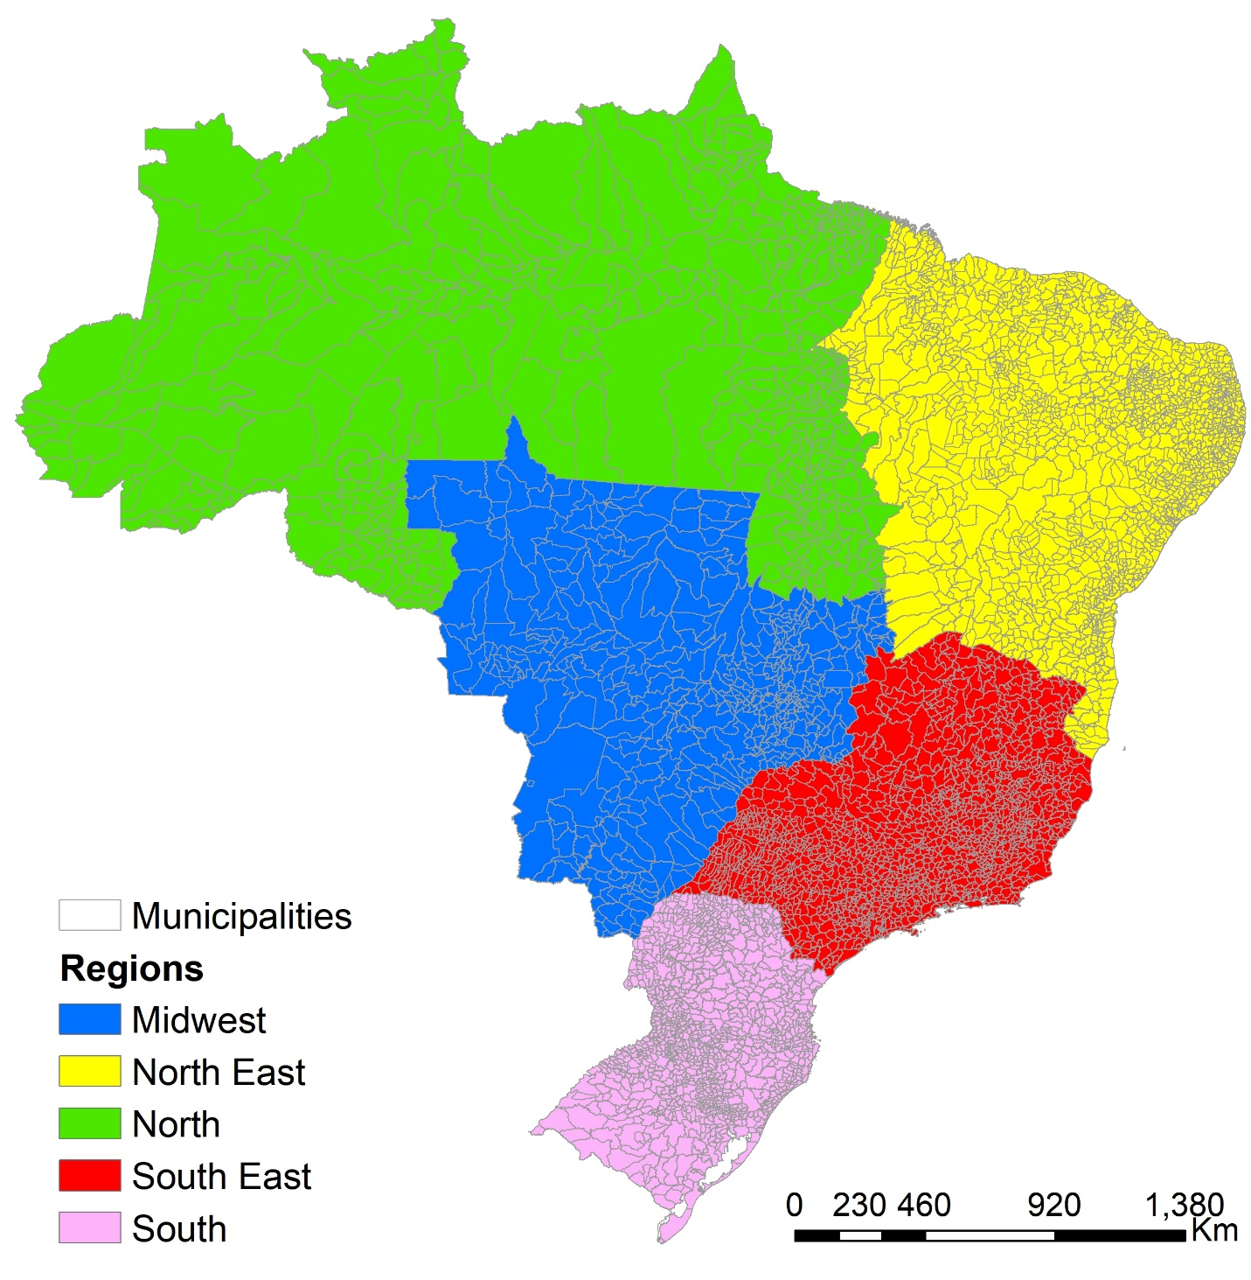

Figure S1: Spatial distribution of the municipalities and regions in Brazil.
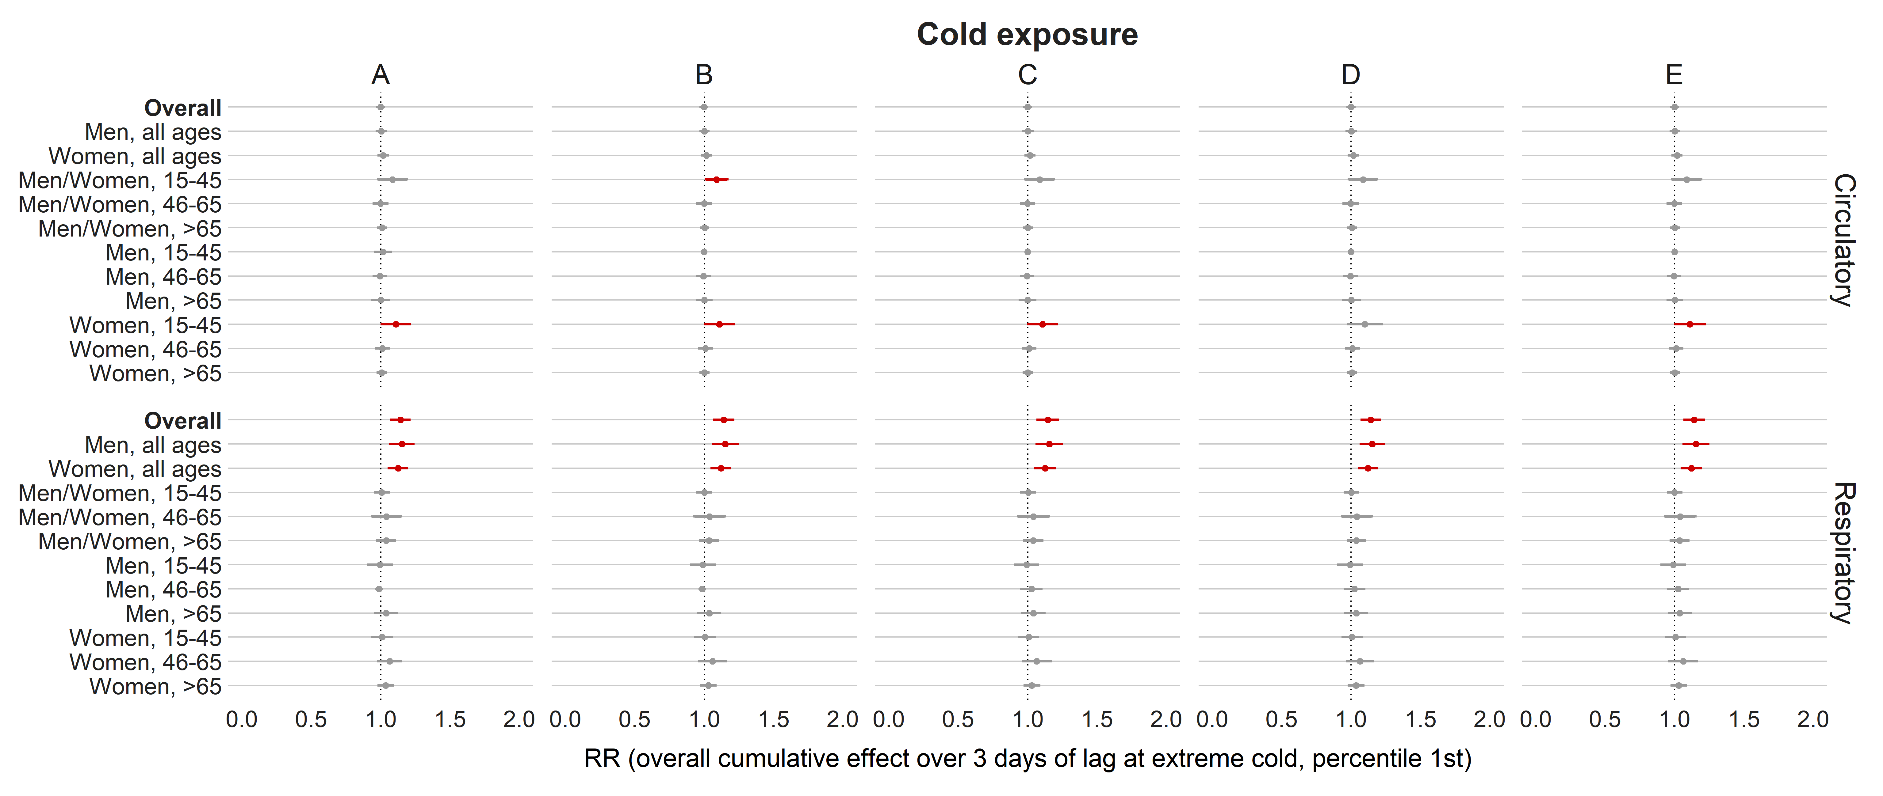
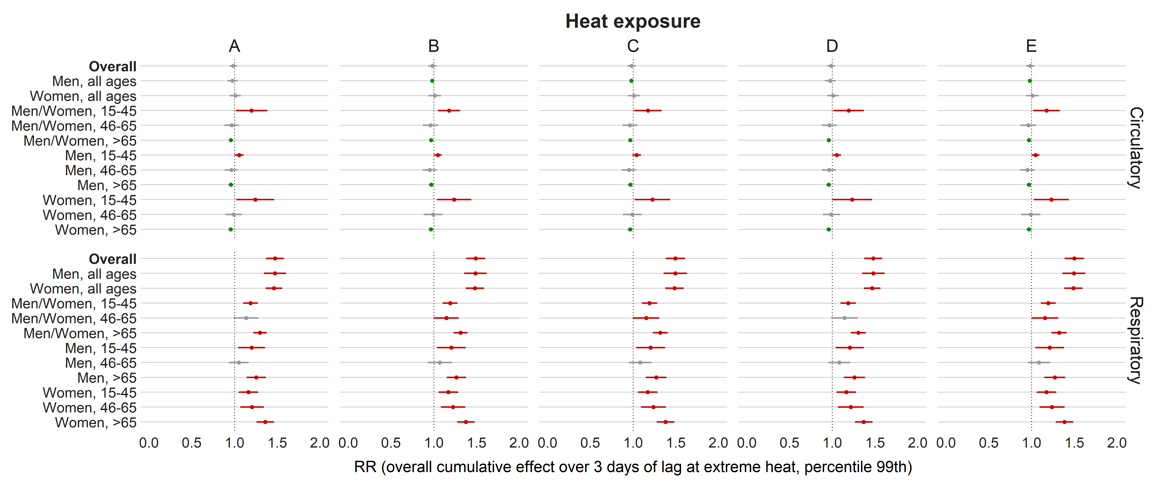
Figure S2 – Relative risks (95%CI) from the primary model and sensitivity analysis for cardiorespiratory admissions considering the cold (percentile 1st) and heat (percentile 99th) exposure in Brazil (from meta-analysis). This is the overall cumulative effect over 3 days of lag (summing all the contributions up to the maximum lag). Note 1: primary model, adjusted for PM_{2.5}, O₃, humidity, and temporal factors (A); model adjusted only for PM_{2.5} (B); model adjusted only for O₃ (C); model adjusted only for humidity (D); model adjusted only for temporal terms (E). Note 2: gray color represents the insignificant coefficients (which the RR includes the value 1), red color represents the significant positive associations, and green color represents the significant negative associations.
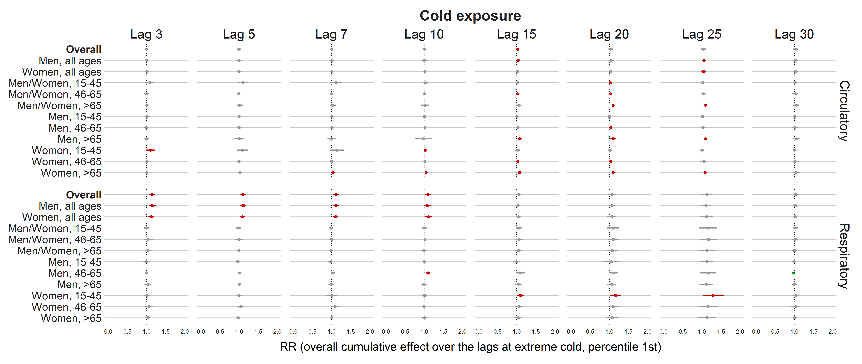
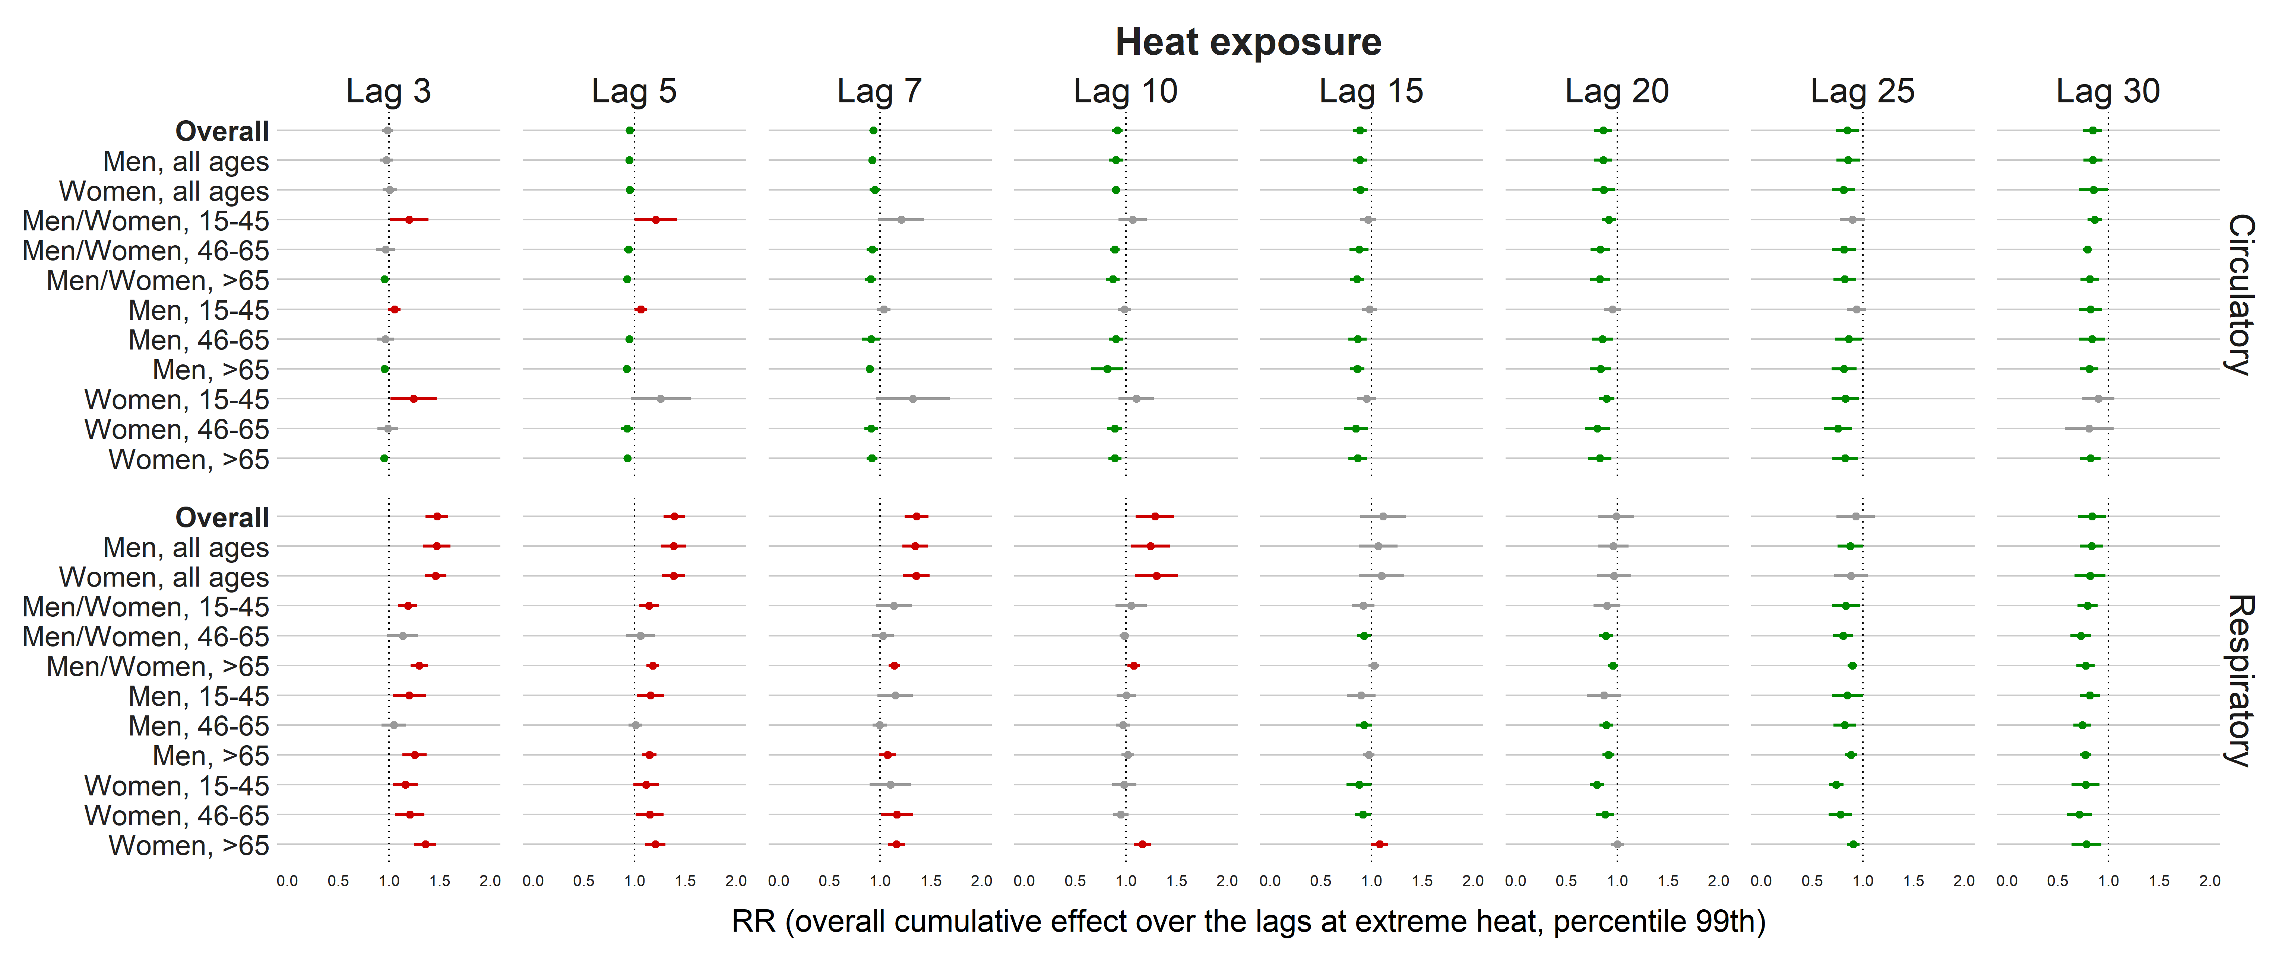
Figure S3 – Relative risks (95%CI) for different lags (3 [note that the lag 3 was the primary model], 5, 7, 10, 15, 20, 25, and 30) considering the cold (percentile 1st) and heat (percentile 99th) exposure in Brazil (from meta-analysis). This is the overall cumulative effect over the lags (summing all the contributions up to the maximum lag). Note 1: all the models were adjusted for PM_{2.5}, O₃, humidity, and temporal factors (the same covariates used in the primary model). The only difference was the lag. Note 2: gray color represents the insignificant coefficients (which the RR includes the value 1), red color represents the significant positive associations, and green color represents the significant negative associations.

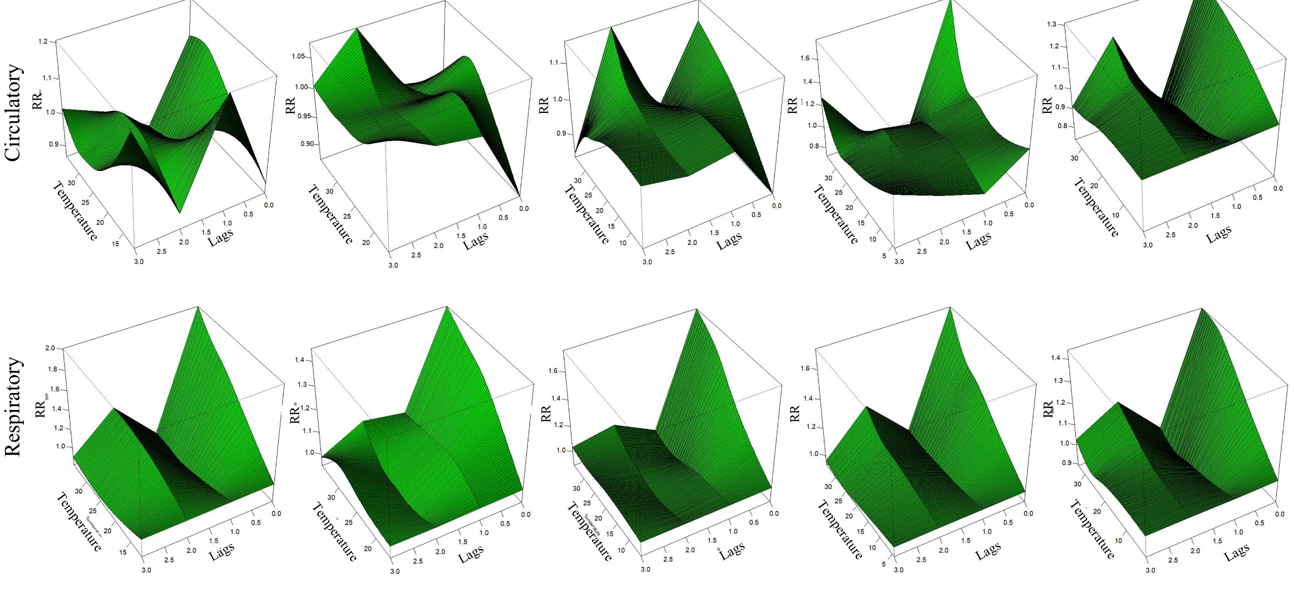
Figure S4 – Bi-dimensional exposure-lag-response association stratified by regions for circulatory and respiratory admissions (charts were created for the overall analysis, including all ages and sex).
Table S1 - Relative risks (95%CI) for cold (percentile 10st) and heat (percentile 99th) exposure stratified by regions, health effects, age, and sex. Note 1: This is the overall cumulative effect (primary model) over 3 days of lag (summing all the contributions up to the maximum lag). Note 2: The reference of the RR in is based on the minimum risk temperature (MRT).
Region | Outcome | Group | Cold |  |  | Heat |  |  | Maximum  crosspred | Minimum  crosspred | MRT
 |  |  | RR | 95%CI |  | RR | 95%CI
Midwest | Circulatory | Overall | 0.98 | 0.96 | 0.99 | 0.97 | 0.94 | 1.00 | 30.60 | 16.10 | 19.70
Midwest | Circulatory | Men, all ages | 0.99 | 0.98 | 1.00 | 0.99 | 0.95 | 1.04 | 30.60 | 16.10 | 17.80
Midwest | Circulatory | Women, all ages | 0.97 | 0.95 | 0.99 | 0.95 | 0.91 | 1.00 | 30.60 | 16.10 | 19.70
Midwest | Circulatory | Men/Women, 15-45 | 1.42 | 1.12 | 1.81 | 1.67 | 1.26 | 2.20 | 30.60 | 16.10 | 5.20
Midwest | Circulatory | Men/Women, 46-65 | 0.99 | 0.96 | 1.01 | 0.93 | 0.88 | 0.98 | 30.60 | 16.10 | 19.70
Midwest | Circulatory | Men/Women, >65 | 0.99 | 0.97 | 1.00 | 0.96 | 0.91 | 1.01 | 30.60 | 16.10 | 18.50
Midwest | Circulatory | Men, 15-45 | 1.43 | 1.00 | 2.03 | 1.75 | 1.16 | 2.63 | 30.60 | 16.10 | 5.20
Midwest | Circulatory | Men, 46-65 | 1.00 | 0.97 | 1.03 | 0.96 | 0.89 | 1.03 | 30.60 | 16.10 | 19.70
Midwest | Circulatory | Men, >65 | 0.99 | 0.97 | 1.00 | 0.96 | 0.89 | 1.03 | 30.60 | 16.10 | 17.90
Midwest | Circulatory | Women, 15-45 | 1.40 | 1.01 | 1.95 | 1.58 | 1.08 | 2.32 | 30.60 | 16.10 | 5.20
Midwest | Circulatory | Women, 46-65 | 0.97 | 0.93 | 1.00 | 0.90 | 0.83 | 0.97 | 30.60 | 16.10 | 19.70
Midwest | Circulatory | Women, >65 | 0.98 | 0.95 | 1.01 | 0.95 | 0.89 | 1.03 | 30.60 | 16.10 | 19.70
North | Circulatory | Overall | 0.97 | 0.93 | 1.01 | 0.94 | 0.88 | 1.01 | 31.00 | 22.70 | 19.90
North | Circulatory | Men, all ages | 0.83 | 0.73 | 0.95 | 0.81 | 0.70 | 0.94 | 31.00 | 22.70 | 17.50
North | Circulatory | Women, all ages | 1.03 | 0.96 | 1.09 | 1.00 | 0.90 | 1.11 | 31.00 | 22.70 | 19.90
North | Circulatory | Men/Women, 15-45 | 1.53 | 0.76 | 3.07 | 1.59 | 0.78 | 3.24 | 31.00 | 22.70 | 11.60
North | Circulatory | Men/Women, 46-65 | 0.86 | 0.77 | 0.97 | 0.82 | 0.71 | 0.95 | 31.00 | 22.70 | 18.60
North | Circulatory | Men/Women, >65 | 0.89 | 0.75 | 1.05 | 0.84 | 0.69 | 1.01 | 31.00 | 22.70 | 16.80
North | Circulatory | Men, 15-45 | 1.23 | 0.77 | 1.97 | 1.24 | 0.75 | 2.06 | 31.00 | 22.70 | 16.40
North | Circulatory | Men, 46-65 | 0.87 | 0.80 | 0.95 | 0.79 | 0.68 | 0.92 | 31.00 | 22.70 | 19.90
North | Circulatory | Men, >65 | 0.80 | 0.67 | 0.96 | 0.78 | 0.63 | 0.96 | 31.00 | 22.70 | 17.50
North | Circulatory | Women, 15-45 | 1.54 | 0.60 | 3.95 | 1.63 | 0.63 | 4.24 | 31.00 | 22.70 | 11.60
North | Circulatory | Women, 46-65 | 0.93 | 0.75 | 1.16 | 0.94 | 0.73 | 1.22 | 31.00 | 22.70 | 17.80
North | Circulatory | Women, >65 | 1.03 | 0.93 | 1.13 | 0.92 | 0.79 | 1.08 | 31.00 | 22.70 | 19.90
Northeast | Circulatory | Overall | 0.99 | 0.97 | 1.02 | 0.98 | 0.96 | 1.00 | 30.60 | 20.60 | 26.30
Northeast | Circulatory | Men, all ages | 1.02 | 0.99 | 1.05 | 0.98 | 0.95 | 1.01 | 30.60 | 20.60 | 25.30
Northeast | Circulatory | Women, all ages | 1.07 | 0.99 | 1.16 | 1.09 | 0.98 | 1.21 | 30.60 | 20.60 | 16.30
Northeast | Circulatory | Men/Women, 15-45 | 1.08 | 0.94 | 1.23 | 1.22 | 1.02 | 1.46 | 30.60 | 20.60 | 16.30
Northeast | Circulatory | Men/Women, 46-65 | 1.04 | 0.95 | 1.15 | 1.06 | 0.93 | 1.21 | 30.60 | 20.60 | 16.30
Northeast | Circulatory | Men/Women, >65 | 1.03 | 1.00 | 1.06 | 0.95 | 0.92 | 0.97 | 30.60 | 20.60 | 26.30
Northeast | Circulatory | Men, 15-45 | 1.00 | 0.82 | 1.23 | 1.04 | 0.80 | 1.37 | 30.60 | 20.60 | 16.30
Northeast | Circulatory | Men, 46-65 | 1.01 | 0.96 | 1.05 | 1.02 | 0.96 | 1.08 | 30.60 | 20.60 | 24.10
Northeast | Circulatory | Men, >65 | 1.07 | 1.03 | 1.12 | 0.96 | 0.92 | 1.00 | 30.60 | 20.60 | 26.30
Northeast | Circulatory | Women, 15-45 | 1.14 | 0.95 | 1.36 | 1.38 | 1.09 | 1.76 | 30.60 | 20.60 | 16.30
Northeast | Circulatory | Women, 46-65 | 1.14 | 0.99 | 1.30 | 1.17 | 0.97 | 1.41 | 30.60 | 20.60 | 16.30
Northeast | Circulatory | Women, >65 | 1.00 | 0.96 | 1.04 | 0.94 | 0.90 | 0.98 | 30.60 | 20.60 | 26.30
South | Circulatory | Overall | 1.04 | 1.00 | 1.07 | 1.07 | 1.02 | 1.12 | 28.00 | 7.70 | 1.30
South | Circulatory | Men, all ages | 1.02 | 0.98 | 1.07 | 1.05 | 0.98 | 1.13 | 28.00 | 7.70 | 1.30
South | Circulatory | Women, all ages | 1.05 | 1.00 | 1.09 | 1.09 | 1.02 | 1.16 | 28.00 | 7.70 | 1.30
South | Circulatory | Men/Women, 15-45 | 1.12 | 1.03 | 1.22 | 1.20 | 1.05 | 1.36 | 28.00 | 7.70 | 1.30
South | Circulatory | Men/Women, 46-65 | 1.05 | 1.00 | 1.10 | 1.06 | 0.99 | 1.15 | 28.00 | 7.70 | 1.30
South | Circulatory | Men/Women, >65 | 1.00 | 0.95 | 1.04 | 1.04 | 0.97 | 1.11 | 28.00 | 7.70 | 1.30
South | Circulatory | Men, 15-45 | 1.08 | 0.95 | 1.23 | 1.09 | 0.90 | 1.33 | 28.00 | 7.70 | 1.30
South | Circulatory | Men, 46-65 | 1.04 | 0.97 | 1.11 | 1.04 | 0.94 | 1.16 | 28.00 | 7.70 | 1.30
South | Circulatory | Men, >65 | 0.99 | 0.93 | 1.06 | 1.04 | 0.94 | 1.14 | 28.00 | 7.70 | 1.30
South | Circulatory | Women, 15-45 | 1.15 | 1.03 | 1.28 | 1.28 | 1.08 | 1.51 | 28.00 | 7.70 | 1.30
South | Circulatory | Women, 46-65 | 1.06 | 0.98 | 1.14 | 1.09 | 0.97 | 1.21 | 28.00 | 7.70 | 1.30
South | Circulatory | Women, >65 | 1.00 | 0.94 | 1.07 | 1.04 | 0.94 | 1.14 | 28.00 | 7.70 | 1.30
Southeast | Circulatory | Overall | 1.02 | 1.02 | 1.02 | 0.97 | 0.96 | 0.98 | 28.90 | 14.50 | 16.50
Southeast | Circulatory | Men, all ages | 1.02 | 1.02 | 1.03 | 0.97 | 0.96 | 0.99 | 28.90 | 14.50 | 16.50
Southeast | Circulatory | Women, all ages | 1.02 | 1.01 | 1.02 | 0.97 | 0.96 | 0.99 | 28.90 | 14.50 | 16.60
Southeast | Circulatory | Men/Women, 15-45 | 1.00 | 0.99 | 1.01 | 1.04 | 1.01 | 1.07 | 28.90 | 14.50 | 15.90
Southeast | Circulatory | Men/Women, 46-65 | 1.02 | 1.01 | 1.02 | 0.97 | 0.95 | 0.98 | 28.90 | 14.50 | 16.70
Southeast | Circulatory | Men/Women, >65 | 1.03 | 1.03 | 1.04 | 0.96 | 0.94 | 0.97 | 28.90 | 14.50 | 16.60
Southeast | Circulatory | Men, 15-45 | 1.00 | 0.99 | 1.01 | 1.05 | 1.00 | 1.10 | 28.90 | 14.50 | 15.70
Southeast | Circulatory | Men, 46-65 | 1.02 | 1.01 | 1.02 | 0.97 | 0.95 | 0.99 | 28.90 | 14.50 | 16.40
Southeast | Circulatory | Men, >65 | 1.04 | 1.03 | 1.05 | 0.96 | 0.94 | 0.98 | 28.90 | 14.50 | 16.80
Southeast | Circulatory | Women, 15-45 | 1.00 | 0.86 | 1.16 | 1.02 | 0.86 | 1.21 | 28.90 | 14.50 | 4.20
Southeast | Circulatory | Women, 46-65 | 1.01 | 1.00 | 1.03 | 0.96 | 0.93 | 0.98 | 28.90 | 14.50 | 17.10
Southeast | Circulatory | Women, >65 | 1.03 | 1.02 | 1.04 | 0.96 | 0.94 | 0.98 | 28.90 | 14.50 | 16.50
Midwest | Respiratory | Overall | 1.15 | 1.07 | 1.23 | 1.54 | 1.42 | 1.68 | 30.60 | 16.10 | 5.20
Midwest | Respiratory | Men, all ages | 1.22 | 1.11 | 1.34 | 1.59 | 1.42 | 1.78 | 30.60 | 16.10 | 5.20
Midwest | Respiratory | Women, all ages | 1.08 | 0.97 | 1.19 | 1.50 | 1.33 | 1.68 | 30.60 | 16.10 | 5.20
Midwest | Respiratory | Men/Women, 15-45 | 0.95 | 0.80 | 1.13 | 1.09 | 0.90 | 1.33 | 30.60 | 16.10 | 5.20
Midwest | Respiratory | Men/Women, 46-65 | 1.02 | 0.86 | 1.22 | 1.13 | 0.92 | 1.39 | 30.60 | 16.10 | 5.20
Midwest | Respiratory | Men/Women, >65 | 1.04 | 0.90 | 1.19 | 1.31 | 1.12 | 1.53 | 30.60 | 16.10 | 5.20
Midwest | Respiratory | Men, 15-45 | 1.05 | 0.82 | 1.34 | 1.19 | 0.90 | 1.57 | 30.60 | 16.10 | 5.20
Midwest | Respiratory | Men, 46-65 | 0.99 | 0.96 | 1.03 | 0.99 | 0.90 | 1.08 | 30.60 | 16.10 | 19.70
Midwest | Respiratory | Men, >65 | 1.04 | 0.86 | 1.25 | 1.30 | 1.05 | 1.61 | 30.60 | 16.10 | 5.20
Midwest | Respiratory | Women, 15-45 | 0.89 | 0.73 | 1.09 | 1.04 | 0.82 | 1.32 | 30.60 | 16.10 | 6.40
Midwest | Respiratory | Women, 46-65 | 1.03 | 0.80 | 1.33 | 1.28 | 0.95 | 1.72 | 30.60 | 16.10 | 5.20
Midwest | Respiratory | Women, >65 | 1.04 | 0.85 | 1.26 | 1.33 | 1.06 | 1.66 | 30.60 | 16.10 | 5.20
North | Respiratory | Overall | 1.28 | 1.03 | 1.60 | 1.63 | 1.31 | 2.03 | 31.00 | 22.70 | 11.60
North | Respiratory | Men, all ages | 1.39 | 1.04 | 1.85 | 1.75 | 1.31 | 2.34 | 31.00 | 22.70 | 11.60
North | Respiratory | Women, all ages | 1.18 | 0.86 | 1.61 | 1.51 | 1.10 | 2.07 | 31.00 | 22.70 | 11.60
North | Respiratory | Men/Women, 15-45 | 1.44 | 0.88 | 2.35 | 1.69 | 1.03 | 2.78 | 31.00 | 22.70 | 11.60
North | Respiratory | Men/Women, 46-65 | 0.91 | 0.51 | 1.63 | 1.03 | 0.57 | 1.86 | 31.00 | 22.70 | 11.60
North | Respiratory | Men/Women, >65 | 1.10 | 0.70 | 1.73 | 1.23 | 0.78 | 1.94 | 31.00 | 22.70 | 11.60
North | Respiratory | Men, 15-45 | 1.55 | 0.77 | 3.11 | 1.76 | 0.87 | 3.56 | 31.00 | 22.70 | 11.60
North | Respiratory | Men, 46-65 | 0.85 | 0.43 | 1.68 | 0.90 | 0.45 | 1.81 | 31.00 | 22.70 | 12.90
North | Respiratory | Men, >65 | 1.41 | 0.77 | 2.60 | 1.50 | 0.81 | 2.78 | 31.00 | 22.70 | 11.60
North | Respiratory | Women, 15-45 | 1.38 | 0.70 | 2.72 | 1.67 | 0.84 | 3.33 | 31.00 | 22.70 | 11.60
North | Respiratory | Women, 46-65 | 1.00 | 0.43 | 2.33 | 1.22 | 0.52 | 2.88 | 31.00 | 22.70 | 11.60
North | Respiratory | Women, >65 | 0.88 | 0.58 | 1.34 | 1.04 | 0.67 | 1.60 | 31.00 | 22.70 | 14.80
Northeast | Respiratory | Overall | 1.16 | 1.11 | 1.22 | 1.50 | 1.42 | 1.60 | 30.60 | 20.60 | 16.30
Northeast | Respiratory | Men, all ages | 1.16 | 1.09 | 1.23 | 1.50 | 1.38 | 1.63 | 30.60 | 20.60 | 16.30
Northeast | Respiratory | Women, all ages | 1.17 | 1.10 | 1.24 | 1.51 | 1.39 | 1.64 | 30.60 | 20.60 | 16.30
Northeast | Respiratory | Men/Women, 15-45 | 0.96 | 0.88 | 1.06 | 1.12 | 0.98 | 1.27 | 30.60 | 20.60 | 16.70
Northeast | Respiratory | Men/Women, 46-65 | 0.97 | 0.89 | 1.06 | 1.00 | 0.87 | 1.14 | 30.60 | 20.60 | 17.50
Northeast | Respiratory | Men/Women, >65 | 1.13 | 1.03 | 1.24 | 1.27 | 1.12 | 1.44 | 30.60 | 20.60 | 16.30
Northeast | Respiratory | Men, 15-45 | 0.92 | 0.85 | 1.00 | 1.05 | 0.91 | 1.22 | 30.60 | 20.60 | 18.00
Northeast | Respiratory | Men, 46-65 | 0.98 | 0.95 | 1.01 | 0.96 | 0.85 | 1.08 | 30.60 | 20.60 | 19.70
Northeast | Respiratory | Men, >65 | 1.15 | 1.00 | 1.31 | 1.23 | 1.03 | 1.47 | 30.60 | 20.60 | 16.30
Northeast | Respiratory | Women, 15-45 | 1.04 | 0.91 | 1.20 | 1.22 | 1.01 | 1.48 | 30.60 | 20.60 | 16.30
Northeast | Respiratory | Women, 46-65 | 1.01 | 0.85 | 1.20 | 1.08 | 0.86 | 1.36 | 30.60 | 20.60 | 16.30
Northeast | Respiratory | Women, >65 | 1.11 | 0.98 | 1.27 | 1.30 | 1.09 | 1.55 | 30.60 | 20.60 | 16.30
South | Respiratory | Overall | 1.05 | 1.02 | 1.08 | 1.33 | 1.28 | 1.39 | 28.00 | 7.70 | 1.30
South | Respiratory | Men, all ages | 1.04 | 1.00 | 1.08 | 1.30 | 1.23 | 1.38 | 28.00 | 7.70 | 1.30
South | Respiratory | Women, all ages | 1.06 | 1.02 | 1.10 | 1.36 | 1.28 | 1.44 | 28.00 | 7.70 | 1.30
South | Respiratory | Men/Women, 15-45 | 1.03 | 0.96 | 1.10 | 1.25 | 1.13 | 1.40 | 28.00 | 7.70 | 1.30
South | Respiratory | Men/Women, 46-65 | 1.00 | 0.94 | 1.06 | 1.11 | 1.01 | 1.22 | 28.00 | 7.70 | 1.30
South | Respiratory | Men/Women, >65 | 0.99 | 0.95 | 1.03 | 1.26 | 1.18 | 1.35 | 28.00 | 7.70 | 2.10
South | Respiratory | Men, 15-45 | 1.05 | 0.95 | 1.16 | 1.35 | 1.16 | 1.57 | 28.00 | 7.70 | 1.30
South | Respiratory | Men, 46-65 | 0.98 | 0.94 | 1.02 | 1.08 | 0.98 | 1.19 | 28.00 | 7.70 | 4.50
South | Respiratory | Men, >65 | 0.98 | 0.97 | 1.00 | 1.19 | 1.11 | 1.27 | 28.00 | 7.70 | 5.50
South | Respiratory | Women, 15-45 | 1.01 | 0.92 | 1.11 | 1.16 | 1.00 | 1.35 | 28.00 | 7.70 | 1.30
South | Respiratory | Women, 46-65 | 1.04 | 0.96 | 1.13 | 1.16 | 1.02 | 1.32 | 28.00 | 7.70 | 1.30
South | Respiratory | Women, >65 | 1.03 | 0.96 | 1.10 | 1.39 | 1.26 | 1.53 | 28.00 | 7.70 | 1.30
Southeast | Respiratory | Overall | 1.19 | 1.14 | 1.25 | 1.51 | 1.43 | 1.59 | 28.90 | 14.50 | 4.20
Southeast | Respiratory | Men, all ages | 1.19 | 1.12 | 1.27 | 1.49 | 1.39 | 1.60 | 28.90 | 14.50 | 4.20
Southeast | Respiratory | Women, all ages | 1.19 | 1.11 | 1.27 | 1.52 | 1.41 | 1.64 | 28.90 | 14.50 | 4.20
Southeast | Respiratory | Men/Women, 15-45 | 1.04 | 0.93 | 1.18 | 1.21 | 1.06 | 1.38 | 28.90 | 14.50 | 4.20
Southeast | Respiratory | Men/Women, 46-65 | 1.23 | 1.10 | 1.37 | 1.35 | 1.19 | 1.53 | 28.90 | 14.50 | 4.20
Southeast | Respiratory | Men/Women, >65 | 1.05 | 0.96 | 1.14 | 1.40 | 1.27 | 1.54 | 28.90 | 14.50 | 4.20
Southeast | Respiratory | Men, 15-45 | 1.02 | 0.87 | 1.21 | 1.23 | 1.02 | 1.48 | 28.90 | 14.50 | 4.20
Southeast | Respiratory | Men, 46-65 | 1.19 | 1.03 | 1.39 | 1.30 | 1.10 | 1.54 | 28.90 | 14.50 | 4.20
Southeast | Respiratory | Men, >65 | 1.06 | 0.94 | 1.20 | 1.39 | 1.21 | 1.59 | 28.90 | 14.50 | 4.20
Southeast | Respiratory | Women, 15-45 | 1.07 | 0.90 | 1.27 | 1.19 | 0.98 | 1.44 | 28.90 | 14.50 | 4.20
Southeast | Respiratory | Women, 46-65 | 1.27 | 1.07 | 1.50 | 1.41 | 1.17 | 1.70 | 28.90 | 14.50 | 4.20
Southeast | Respiratory | Women, >65 | 1.03 | 0.91 | 1.16 | 1.41 | 1.23 | 1.61 | 28.90 | 14.50 | 4.20

Table S2 – National average relative risks (95%CI) for cold (percentile 1st) exposure in Brazil stratified by health outcome, age, and sex. Note 1: This is the overall cumulative effect over 3 days of lag (summing all the contributions up to the maximum lag).
Outcome | Group | RR | 95%CI |  | I² | I² (p-value)
Circulatory | Overall | 0.999 | 0.975 | 1.023 | 90.356 | 1.13E-09
Circulatory | Men, all ages | 1.002 | 0.971 | 1.033 | 93.472 | 2.25E-08
Circulatory | Women, all ages | 1.017 | 0.985 | 1.050 | 84.234 | 1.74E-04
Circulatory | Men/Women, 15-45 | 1.086 | 0.983 | 1.189 | 69.049 | 7.93E-03
Circulatory | Men/Women, 46-65 | 0.998 | 0.950 | 1.046 | 91.177 | 1.42E-03
Circulatory | Men/Women, >65 | 1.010 | 0.982 | 1.037 | 86.069 | 3.17E-08
Circulatory | Men, 15-45 | 1.017 | 0.960 | 1.074 | 14.379 | 3.34E-01
Circulatory | Men, 46-65 | 0.994 | 0.950 | 1.037 | 86.555 | 7.70E-03
Circulatory | Men, >65 | 1.001 | 0.940 | 1.061 | 96.115 | 9.42E-09
Circulatory | Women, 15-45 | 1.109 | 1.007 | 1.211 | 16.314 | 3.70E-01
Circulatory | Women, 46-65 | 1.011 | 0.965 | 1.057 | 74.301 | 1.43E-02
Circulatory | Women, >65 | 1.007 | 0.980 | 1.033 | 64.473 | 7.06E-03
Respiratory | Overall | 1.142 | 1.077 | 1.206 | 81.764 | 3.13E-06
Respiratory | Men, all ages | 1.153 | 1.070 | 1.235 | 78.740 | 9.27E-05
Respiratory | Women, all ages | 1.124 | 1.059 | 1.189 | 64.627 | 1.63E-02
Respiratory | Men/Women, 15-45 | 1.007 | 0.959 | 1.056 | 0.099 | 4.98E-01
Respiratory | Men/Women, 46-65 | 1.042 | 0.937 | 1.146 | 71.402 | 3.35E-02
Respiratory | Men/Women, >65 | 1.039 | 0.977 | 1.102 | 46.951 | 1.50E-01
Respiratory | Men, 15-45 | 0.995 | 0.912 | 1.079 | 33.500 | 2.64E-01
Respiratory | Men, 46-65 | 0.987 | 0.968 | 1.006 | 0.000 | 2.53E-01
Respiratory | Men, >65 | 1.038 | 0.960 | 1.116 | 43.223 | 1.61E-01
Respiratory | Women, 15-45 | 1.009 | 0.941 | 1.078 | 0.000 | 5.96E-01
Respiratory | Women, 46-65 | 1.065 | 0.982 | 1.148 | 11.346 | 3.75E-01
Respiratory | Women, >65 | 1.037 | 0.985 | 1.088 | 0.000 | 7.76E-01

Table S3 – National average relative risks (95%CI) for heat (percentile 99th) exposure in Brazil stratified by health outcome, age, and sex. Note 1: This is the overall cumulative effect over 3 days of lag (summing all the contributions up to the maximum lag).
Outcome | Group | RR | 95%CI |  | I² | I² (p-value)
Circulatory | Overall | 0.986 | 0.950 | 1.022 | 88.962 | 3.98E-03
Circulatory | Men, all ages | 0.976 | 0.926 | 1.027 | 87.245 | 1.14E-02
Circulatory | Women, all ages | 1.009 | 0.952 | 1.066 | 80.938 | 5.80E-03
Circulatory | Men/Women, 15-45 | 1.198 | 1.023 | 1.374 | 73.275 | 7.51E-03
Circulatory | Men/Women, 46-65 | 0.967 | 0.890 | 1.044 | 87.666 | 3.47E-03
Circulatory | Men/Women, >65 | 0.956 | 0.943 | 0.969 | 0.830 | 1.04E-01
Circulatory | Men, 15-45 | 1.054 | 1.010 | 1.099 | 0.003 | 4.10E-01
Circulatory | Men, 46-65 | 0.963 | 0.893 | 1.032 | 84.004 | 7.94E-03
Circulatory | Men, >65 | 0.957 | 0.939 | 0.976 | 0.718 | 1.36E-01
Circulatory | Women, 15-45 | 1.242 | 1.029 | 1.455 | 49.910 | 1.22E-01
Circulatory | Women, 46-65 | 0.989 | 0.900 | 1.078 | 77.503 | 2.35E-02
Circulatory | Women, >65 | 0.955 | 0.936 | 0.973 | 0.086 | 4.49E-01
Respiratory | Overall | 1.473 | 1.376 | 1.570 | 78.494 | 1.11E-04
Respiratory | Men, all ages | 1.472 | 1.351 | 1.593 | 74.381 | 1.34E-03
Respiratory | Women, all ages | 1.461 | 1.371 | 1.550 | 50.771 | 9.54E-02
Respiratory | Men/Women, 15-45 | 1.187 | 1.109 | 1.265 | 0.009 | 4.19E-01
Respiratory | Men/Women, 46-65 | 1.135 | 0.997 | 1.274 | 66.037 | 3.42E-02
Respiratory | Men/Women, >65 | 1.298 | 1.228 | 1.368 | 13.528 | 5.37E-01
Respiratory | Men, 15-45 | 1.201 | 1.053 | 1.348 | 39.447 | 1.94E-01
Respiratory | Men, 46-65 | 1.049 | 0.942 | 1.156 | 62.684 | 6.29E-02
Respiratory | Men, >65 | 1.253 | 1.149 | 1.358 | 29.580 | 3.61E-01
Respiratory | Women, 15-45 | 1.162 | 1.055 | 1.269 | 0.000 | 7.68E-01
Respiratory | Women, 46-65 | 1.205 | 1.076 | 1.335 | 15.132 | 4.33E-01
Respiratory | Women, >65 | 1.359 | 1.265 | 1.452 | 0.004 | 6.38E-01

