Impact of comorbidities on the safety and effectiveness of hip and knee replacement surgery: a national observational study
Bélène Podmore, Andrew Hutchings, John A Skinner, Alexander J MacGregor, Jan van der Meulen

Bélène Podmore (Corresponding Author), PhD, Research Fellow, Department of Health Services Research & Policy, London School of Hygiene & Tropical Medicine, UK, 15-17 Tavistock Place, WC1H 9SH. UK. Clinical Effectiveness Unit, The Royal College of Surgeons of England, UK, 35-43 Lincoln’s Inn Fields, WC2A 3PE. UK. Belene.Podmore@lshtm.ac.uk

Andrew Hutchings, MSc, Assistant Professor, Department of Health Services Research & Policy, London School of Hygiene & Tropical Medicine, UK, 15-17 Tavistock Place, WC1H 9SH. London. UK. Clinical Effectiveness Unit, The Royal College of Surgeons of England, UK, 35-43 Lincoln’s Inn Fields, WC2A 3PE. UK. Andrew.Hutchings@lshtm.ac.uk

John, A Skinner, MB BS FRCS(Eng) FRCS(Orth), Professor, Institute of Orthopaedics and Musculoskeletal Science, University College London and the Royal National Orthopaedic Hospital, Stanmore, London, UK. John.Skinner@ucl.ac.uk

Alexander, J. MacGregor, PhD, Professor, Norwich Medical School, University of East Anglia, Norwich, UK. A.Macgregor@uea.ac.uk

Jan van der Meulen, PhD FFPH FRCOG FRCS, Professor, Department of Health Services Research & Policy, London School of Hygiene & Tropical Medicine, UK, 15-17 Tavistock Place, WC1H 9SH. UK. Clinical Effectiveness Unit, The Royal College of Surgeons of England, UK, 35-43 Lincoln’s Inn Fields, WC2A 3PE, London, UK. Jan.vandermeulen@lshtm.ac.uk

Contribution
BP designed the study, conducted the main study, analysis and wrote the manuscript. AH and JVM helped design the study design, analysis and with the drafting of the manuscript. JS and AJM reviewed the manuscript. All authors approved the final version of the manuscript for publication.

Impact of comorbidities on the safety and effectiveness of hip and knee replacement surgery: a national observational study

Abstract
Aims: Access to joint replacement is being restricted for patients with comorbidities in a number of high-income countries. However, there is little evidence on the impact of comorbidities on outcomes. The purpose of this study was to determine the safety and effectiveness of hip and knee replacement in patients with and without comorbidities.
Patients and Methods: 312 079 hip-replacement and 328 753 knee-replacement patients were included. Eleven common comorbidities were identified in administrative hospital records. Safety risks were measured by assessing length of hospital stay (LOS) and 30-day emergency readmissions and mortality. Effectiveness outcomes were changes in Oxford Hip or Knee Scores (OHS/OKS) (scale from 0 (worst) to 48 (best)) and in health-related quality of life (EQ-5D) (scale from 0 (death) to 1 (full health)) from immediately before to 6 months after surgery. Regression was used to estimate adjusted mean differences (LOS, change in OHS/OKS/EQ-5D) and risk differences (readmissions and mortality).
Results: Patients with comorbidities had longer LOS and higher readmission and mortality rates than patients without. In hip-replacement patients with heart disease for example, LOS was 1·20 days (95% CI 1·15-1·25) longer and readmission rate was 1·52% (1·34-1·71) and mortality 0·19% (0·15-0·23) higher. Similar patterns were observed for knee-replacement patients. Patients without comorbidities reported large improvements in function (mean improvement OHS 21·3 and OKS 15·9). Patients with comorbidities reported only slightly smaller improvements. In patients with heart disease, improvement in OHS was 0·39 (0·27-0·51) and in OKS 0·56 (0·45-0·67) smaller than in patients without comorbidities. There were no differences in EQ-5D improvement.
Conclusions: Comorbidities were associated with small increases in adverse safety risks but they have little impact on improvements in pain and function in patients undergoing hip or knee replacements. These results do not support restricting access to hip and knee replacement for patients with common comorbidities.

Introduction
Joint replacement surgery has become one of the most successful and cost-effective surgical interventions in medicine offering substantial improvements in pain and function and in turn quality of life in patients with osteoarthritis or inflammatory arthritis.¹ Despite this, in England, as well as in other countries like Canada² and New Zealand³, access to hip and knee replacement surgery has been restricted by commissioners of healthcare due to financial constraints. Eligibility criteria introduced to restrict access included that a patient’s body mass index (BMI) is lower than 30kg/m² ⁴ and that comorbidities are optimised⁵ despite these criteria not being supported by any clinical evidence⁶ or UK national clinical guidelines.⁷ There is also no evidence that restricting access in this way would reduce costs in the long-term as denying patients functional improvement and pain relief could lead to increased costs of treating patients with advanced osteoarthritis of the hip and knee. Advanced hip and knee osteoarthritis has been associated with increased health service use, increased opioid use, decreased mobility and deteriorating mental health.^{8, 9}
Clinicians and patients need to balance the risks against the benefits when deciding to undergo a hip or knee replacement surgery. An increasing number of patients receiving hip and knee replacement surgery have at least one comorbidity.¹⁰ Currently, the criteria to assess the safety risks and the potential improvements in pain and function for patients with comorbidity who are candidates for hip and knee replacement surgery are based on limited evidence¹¹. It is therefore important to understand the impact of comorbidities on both the risks and benefits of joint replacement surgery in order to evaluate whether restrictions on access surgery are justified.
Our systematic review and meta-analysis of 70 studies published up until May 2017 found that individual comorbidities had an impact on short-term outcomes related to safety of joint replacement surgery.¹² However, the results presented an inconsistent picture with a variable impact of comorbidities on surgical complications. In addition, the 15 studies that examined patient-reported outcomes related to effectiveness – with five reporting health-related quality of life – were all relatively small single-centre studies (<2000 patients). The availability of patient-reported outcome measures (PROMs) data, collected since 2009 for all patients undergoing an elective hip or knee replacement in the English National Health Service (NHS) linked to administrative hospital data, provides a unique opportunity to examine the impact of comorbidities on both the short-term outcomes related to safety risks and longer-term outcomes reported by patients related to effectiveness.
The aim of our study was to address these gaps in evidence on outcomes of joint replacement surgery for patients with common comorbidities. We assessed the impact of eleven comorbidities on the safety risks (length of hospital stay, 30-day readmission rate and mortality) and effectiveness (change in OHS/OKS and EQ-5D from immediately before to 6 months after surgery) of hip and knee replacement surgery.

Patients and Methods

Data sources
We used data from the National PROMs Programme for patients undergoing elective hip or knee replacement surgery between April 2009 and November 2016 in the English NHS¹³. All patients participating in this PROMS programme were given a questionnaire to complete before surgery, either on admission or at preoperative assessment, and then were then mailed a follow-up questionnaire 6 months after surgery asking the same questions on the severity of their joint problems and health-related quality of life.
PROMs data were linked at a patient level to data about their hospital admissions extracted from the Hospital Episode Statistics dataset (HES), an administrative database of hospital admissions to NHS hospitals and NHS-funded patients treated in independent sector which also includes date of death according to the Office for National Statistics database for all deaths registered in England¹⁴. To ensure we only had one record per patient we only included the first primary hip or knee surgery and excluded revision surgeries. In the study of benefits, we also excluded patients who had not returned a postoperative questionnaire with complete information on the main outcome and patients who had a second primary operation before they completed their postoperative questionnaire (Fig 1).

Outcomes
Safety was measured by exploring length of stay (LOS) in hospital and the risk of an emergency readmission or death within 30 days following hip or knee replacement surgery. LOS was measured in days from the date of the operation to the date of hospital discharge according to HES or, if available, the date the patient was ready for discharge. Emergency readmissions and deaths were identified by checking linked HES records for each patient.
Effectiveness was measured using the change (improvement) in the Oxford Hip (OHS), Oxford Knee (OKS) and EQ-5D scores reported by patients immediately before surgery and six months thereafter. The OHS and OKS produce disease-specific scores that are derived from patient responses to 12 questions about pain and limits on physical functioning and everyday activities. Responses to each question are measured on a 5-point scale, and values associated with each response are added up to produce an overall score with the range 0 (worst) to 48 (best). Both scales have been shown to be internally consistent, reliable and to correlate with surgeon-assessed measures of symptoms and disability in patients undergoing hip or knee replacement¹⁵. The EQ-5D score was used to measure health-related quality of life (HRQoL) and is derived from the EQ-5D profiles. The score ranges from -0.594 (worst) to 1 (best) with 0 reflecting ‘death’. Change scores (differences between the preoperative and postoperative scores ) were chosen as the outcome measure instead of postoperative scores adjusted for preoperative scores, because in nonrandomised studies of pre-existing group (e.g. patients with and without comorbidities) change scores have been shown to be less biased than adjusted postoperative scores ¹⁶. This approach – the analysis of change scores – assumes that without treatment the groups would have had equal change over time, which is a plausible assumption for patients with joint problems, especially with a six months period for patients with and without comorbidities.

Comorbidities
Eleven comorbidities were identified from the list of 12 self-reported comorbidities from the pre-operative PROMs questionnaires included in the questionnaires used by the National PROMs Programme¹³. Arthritis was excluded because it was the reason for surgery rather than a comorbidity. The 11 comorbidities comprised: heart disease; high blood pressure; problems caused by a stroke; leg pain when walking due to poor circulation; lung disease; diabetes; kidney disease; nervous system disease; liver disease; cancer and depression (Supporting Information 1). Each comorbidity was mapped to its relevant, International Classification of Diseases, Tenth Revision, (ICD-10) diagnosis codes in hospital records as described in a previous study¹⁷. The presence of a comorbidity was indicated if a mapped code appeared in any diagnosis field in any hospital admission up to one year prior to a patient’s surgery.

Statistical analysis
We conducted multivariable regression exploring the association between the 11 comorbidities and the risk and effectiveness outcomes comparing those patients with and without each comorbidity. We used a linear regression model to estimate adjusted mean differences in LOS in days between for patients with each of the 11 comorbidities compared to patients without comorbidities with adjustment age, sex, ethnicity and socioeconomic status (Index of Multiple Deprivation¹⁸), other comorbidities and hospital variation fitted as a random effect. We used the same statistical approach to estimate adjusted mean differences in the change scores for OHS/OKS and EQ-5D scores. We used generalised linear regression model for the binomial family with the identity link function to estimate adjusted absolute risk differences in 30-day emergency readmission rates. Given the low event rates, only unadjusted 30-day mortality could be estimated. We also investigated the association between number of comorbidities and all outcomes to explore the effect of having multiple comorbidities.
Multiple imputation using chained equations was used to deal with missing values for ethnicity, age, sex and socioeconomic status.¹⁹ Analyses were run on each of the ten imputed data sets and estimated parameters were combined using Rubin’s rules. Descriptive results are presented as means and percentages. Regression results are presented as adjusted differences with 95% confidence intervals (95% CI). All statistical analyses were carried out using Stata v.15.

Results

Study population
We included 640 832 patients who had a primary hip or knee replacement (312 079 hip operations and 328 753 knee operations) between April 2009 and March 2016 in the analyses of the safety risks. Due to missing postoperative questionnaire responses, only 479 632 patients (234 432 hip operations and 245 200 knee operations) were included in the analyses of effectiveness (Fig 1). Patients who had a hip replacement were on average 68 years of age and 58·2% were women. Of the patients with available information about their ethnicity, 98·3% of hip-replacement patients and 94·5% knee-replacement patients were reported to have a white ethnic background (Table 1).
63·6% of patients who had a hip replacement and 71·3% of those who had a knee replacement had at least one comorbidity. High blood pressure was by far the most prevalent comorbidity (48·4% in hip replacement patients and 57·1% in knee replacement patients; Table 2), followed by heart disease (17·1% and 18·5%), lung disease (13·9% and 15·6%), and diabetes (9·5% and 13·6%, respectively).

Safety risks
Safety risk outcomes after hip and knee replacement surgery were associated with all 11 comorbidities. Compared to patients who had a hip replacement without comorbidities, patients who had heart disease for example had an increase in LOS (from 3·7 to 6·0 days; Table 2), readmission rates (from 1·6% to 4·2%), and mortality (from 0·01% to 0·21%). A similar pattern of results was observed for patients who had a knee replacement.
The adjusted differences for all three safety risk outcomes are presented in Figure 2. Compared to patients without comorbidities, patients with comorbidities were more likely to have a longer LOS but the difference varied from 0·14 days (95% CI 0·08, 0·20) for patients with high blood pressure to 2·08 days (95% CI 1·79, 2·37) for stroke patients. Patients with stroke and diseases of the nervous system had the longest stay in hospital compared to patients without comorbidities.
Across both hip and knee patients, the presence of comorbidity was associated with an increased risk in emergency readmission within 30 days, ranging from 0·30% (95% CI 0·19%, 0·61%) increased risk for patients with hypertension to 2·58% (95% CI 1·78%, 3·38%) for stroke patients compared to patients without comorbidities. In both hip and knee patients, the highest risk of an emergency readmission within 30 days was for patients with stroke, liver disease; diseases of the nervous system and depression.
There were 347 deaths in the 30 days after elective hip or knee replacement surgery. Across both hip and knee patients, compared to patients without comorbidities, the presence of comorbidity was associated with an increased risk in mortality within 30 days, ranging from -0·01% (95% CI -0·05%, 0·02%) increased risk for patients with depression to 0·52% (95% CI 0·27%, 0·77%) for stroke patients. The highest risk of mortality within 30 days was for patients with stroke, liver disease, diseases of the nervous system and kidney disease.

Effectiveness
On average, hip patients reported a 20-point improvement in the OHS and knee patients reported a 15-point improvement in the OKS after their hip or knee replacement surgery. Similarly, hip patients reported a 0·43-point and knee patients a 0·31-point improvement in the EQ-5D score (Table 3).
Patients with comorbidities tended to have slightly less improvement in pain and mobility issues in their hip or knee than patients without comorbidities. In hip patients, all comorbidities were associated with a slightly smaller improvement in OHS score except for patients with high blood pressure; kidney disease and cancer (Fig 3). For hip replacement, the adjusted differences in the OHS score ranged from 0·40 (95% CI 0·21, 0·60) for kidney disease to -0·74 (95% CI -1·17, -0·31) for stroke. For knee replacement surgery, all patients with comorbidities except high blood pressure, kidney disease and cancer were more likely to report a smaller improvement in OKS score. The adjusted differences in the OKS score ranged from 0·32 (95% CI 0·14, 0·51) for kidney disease to -1·15 (95% CI -1·72, -0·58) for liver disease.
In contrast, improvement in HRQoL scores did not vary significantly between patients with and without comorbidities. For hip replacement surgery, only patients with high blood pressure (0·02; 95% CI 0·01, 0·02) and kidney disease (0·02; 95% CI 0·01, 0·02) had more improvement in HRQoL than patients without comorbidities but the difference was very small. Similarly, for knee replacement surgery, only patients with high blood pressure (0·01; 95% CI 0·00, 0·01), kidney disease (0·01; 95% CI 0·00, 0·01) and disease of the nervous system (0·01; 95% CI 0·00, 0·01) had more improvement in HRQoL than patients without comorbidities but again the difference was marginal.

Multiple comorbidities
The risk of a longer LOS in hospital and emergency readmissions within 30 days increased and the reported improvement in severity of joint problems decreased with increasing number of comorbidities for both hip and knee replacements (Table 4). There was no difference in HRQoL with increasing number of comorbidities. Hip-replacement patients with four or more comorbidities stayed three days longer in hospital (3·40; 95% CI 3·29, 3·51) and had a 4·50% (95% CI 3·97, 5·03) higher risk of an emergency readmission within 30 days, a 0·49% (95% CI 0·43, 0·54) increased risk of death in 30 days, had a smaller improvement in the OHS (adjusted difference -0·91; 95% CI -1·19, -0·64) and a slightly larger improvement in HRQoL (0·01; 95% CI 0·00, 0·02) compared to patients with no comorbidities. A similar pattern was observed for patients who had a knee replacement.

Discussion
Our results demonstrate that while the presence of a comorbidity in patients undergoing hip or knee replacement was associated with slightly higher safety risks, patients with common comorbidities reported only slightly smaller improvements in joint problems than patients without comorbidities. The differences in improvement of the joint problems and in adverse safety risks were more pronounced in patients with multiple comorbidities.
The observed differences in improvement of the joint problems between patients with and without comorbidities observed six months after a hip or need replacement need to be compared against established ‘minimal important differences’ (MIDs), which are the smallest differences in an outcome that a patient would perceive as beneficial. The differences that we observed are much smaller than the suggested MID value of 5 for the OHS and OKS²⁰, and 0·08 for the EQ-5D²¹. Even in patients with four or more comorbidities, the differences were much smaller than the established MIDs. As a result, our findings demonstrate that patients with comorbidities benefit from hip and knee replacement surgery to an extent that is very similar compared to patients without comorbidities.
Our study is the first to focus on the impact of common comorbidities on outcomes that reflect the safety risks as well as on outcomes that reflect the effectiveness of hip and knee replacement in a large national sample of patients. With respect to safety risks, most of the previous research focused on determining the impact of comorbidity on surgical complications¹². However, the validity and reliability of the coding of these surgical complications in administrative data has been called into question^{22, 23}. In our study, we have therefore not explored specific clinical outcomes that are based on diagnosis or procedure codes and instead focused on process measures such as hospital LOS, emergency readmissions and mortality.
Our results reflecting the impact of comorbidities on short-term safety outcomes are in line with other studies. Our previous systematic review demonstrated that the impact of comorbidities on readmissions within 90 days and mortality within 90 days was highest for patients with liver disease, heart disease, stroke and diseases of the nervous system ¹². Our findings also corroborate a recent large US study of 516 745 patients undergoing knee replacement that showed that increasing number of comorbidities was associated with longer LOS ²⁴.
Previous research on the impact of comorbidities on the effectiveness outcomes of hip and knee replacement surgery has been inconclusive and relied predominantly on single-centre studies or on relatively small multi-centred registries¹². Studies with fewer than 500 patients predominantly found no significant differences. A multicentre study including 1 431 patients, who had been followed up for five years after a hip replacement in England, reported an impact of the number comorbidities on the OHS between one and five years after hip or knee replacement which was also observed in a Canadian study of 14 573 patients after hip or knee replacement^{25, 26}. However, in both studies even with two or more comorbidities the reported differences always remained below established MID values. Our national study, including almost half a million patients, is the only study to date large enough to allow an estimation of the impact of individual comorbidities.
Orthopaedic surgeons have to operate on increasingly more complex patients who often have more than one comorbidity.¹⁰ Restricting access to joint replacement surgery would be to deny significant pain relief and functional improvement to an increasing number of patients with potentially far-reaching consequences on their physical and mental health⁸ and healthcare use, including increased prescriptions of analgesics such as opioids. ⁹
Our study provides quantitative information that can inform decisions about the appropriateness of hip and knee replacement in individual patients. Overall, the increases in the risks of hip or knee replacement surgery in patients with comorbidities are very small compared to its benefits. For example, 30-day mortality after hip replacement surgery increased from 0.01% in patients without comorbidities to 0.21% in patients with heart disease (Table 2). This suggests one death in about 500 hip replacements in patients with heart disease that would not have happened in patients without comorbidities. However, this increase in 30-day mortality needs to be balanced against a 0·43-point increase in HRQoL on a scale with 0 reflecting death and 1 reflecting full health. This means that in patients with heart disease undergoing hip replacement, each expected year of life following surgery contributes 0.4 quality-adjusted life years more to a patient’s life expectancy than without hip replacement. This quantitative example demonstrates that huge gains in health outcome can be expected if joint replacement surgery is provided to patients with comorbidities.
Our study has several methodological limitations. The first relates to potential selection bias because we could not account for unobserved confounders, including the severity of the comorbidities or the frailty of the patient, that are not captured in patient-reported or administrative hospital data. For example, some patients with one or more comorbidities may not be selected for joint replacement surgery because of the severity of their conditions. This may lead to an underestimation of the impact of comorbidity, which is sometime referred to as the ‘healthy-surgical patient effect’. ²⁷
Secondly, in the analysis of effectiveness outcomes only patients that returned a postoperative questionnaire were included. A previous study found that non-responders were likely to have more severe osteoarthritis and to be more likely to have comorbidities, and potentially led to an underestimation of the differences in effectiveness outcomes between patients with and without comorbidities.²⁸ The impact of this selection bias one would expect however would be more on isolated comorbidities rather than on patients with multiple comorbidities that are likely to represent a more severe health profile. Contrary to expectations, there was no significant diminishing effect on effectiveness with increasing number of comorbidities. However, adjustment for observed patient characteristics had very little effect on our results, which makes it unlikely that unobserved confounders, related to either the healthy-surgical patient effect or selective non-response, will have had a significant impact on our results.
The third limitation relates to the availability of data on potential confounders. There is a lack of information on other risk factors such as BMI and smoking status in administrative hospital data. We did however have information about comorbidities that are associated with obesity such as diabetes, heart disease and high blood pressure. Furthermore, a previous study of 2 180 patients, which compared patients with normal weight against patients with a BMI>25kg/m², reported that functional outcomes after knee replacement surgery were not influenced by BMI. ²⁹ Also, only comorbidities are considered to be relevant for the treatment that patients have received are recorded in administrative hospital data which indicates that our results reflect the impact of comorbidities that are relatively severe.³⁰
In conclusion, our findings suggest that patients undergoing hip and knee replacement surgery with comorbidities have an increased safety risk compared to patients without comorbidities. This increase in risk is small compared to the large improvements in functional outcomes and HRQoL, even in patients with multiple comorbidities. These findings do not support restrictions in access to hip and knee replacement for patients with common comorbidities.

Funding
This work was supported by the National Institute for Health Research (NIHR) at Barts Health NHS Trust. The views expressed are those of the authors and not necessarily those of the NHS, the NIHR or the Department of Health and Social Care. The funders had no role in study design, data collection and analysis, decision to publish, or preparation of the manuscript.

Conflicts of Interest
The authors declare that no competing interests exist.

Ethical Approval
The study received approval from the ethics committee from the Health Research Authority NHS Research Ethics Committee (Reference: 16/WA/0241).

Data sharing
Data are available from NHS Digital for researchers who meet the criteria for access to confidential data.

Acknowledgements
The authors acknowledge NHS Digital for the Patient Reported Outcome Measures data and the Hospital Episode Statistics Inpatient Admissions data linkage.

References
1. Ng, C.Y., J.A. Ballantyne, and I.J. Brenkel, Quality of life and functional outcome after primary total hip replacement. A five-year follow-up. Journal of Bone & Joint Surgery - British Volume, 2007. 89(7): p. 868-73.
2. Hudak, P.L., et al., "Not everyone who needs one is going to get one'': the influence of medical brokering on patient candidacy for total joint arthroplasty. Med Decis Making, 2008. 28(5): p. 773-80.
3. Gwynne-Jones, D. and E. Iosua, Rationing of hip and knee replacement: effect on the severity of patient-reported symptoms and the demand for surgery in Otago. N Z Med J, 2016. 129(1432): p. 59-66.
4. Rawlinson, K., Decision to deny surgery to obese patients is like 'racial discrimination' in The Guardian. 2016.
5. CCGs, S.E., Service Restriction Policy. 2014: South Essex.
6. Ponnusamy, K.E., et al., Cost-Effectiveness of Total Knee Arthroplasty vs Nonoperative Management in Normal, Overweight, Obese, Severely Obese, Morbidly Obese, and Super-Obese Patients: A Markov Model. The Journal of Arthroplasty, 2018. 33(7, Supplement): p. S32-S38.
7. NICE, Osteoarthritis: care and management [CG177], NICE, Editor. 2014.
8. Ozcakir, S., et al., Relationship between radiological severity and clinical and psychological factors in knee osteoarthritis. Clin Rheumatol, 2011. 30(12): p. 1521-6.
9. Weick, J., et al., Preoperative Opioid Use Is Associated with Higher Readmission and Revision Rates in Total Knee and Total Hip Arthroplasty. J Bone Joint Surg Am, 2018. 100(14): p. 1171-1176.
10. Kurtz, S., et al., Projections of primary and revision hip and knee arthroplasty in the United States from 2005 to 2030. J Bone Joint Surg Am, 2007. 89(4): p. 780-5.
11. Gademan, M.G.J., et al., Indication criteria for total hip or knee arthroplasty in osteoarthritis: a state-of-the-science overview. BMC musculoskeletal disorders, 2016. 17(1): p. 463-463.
12. Podmore, B., et al., Impact of comorbid conditions on outcomes of hip and knee replacement surgery: a systematic review and meta-analysis. BMJ Open, 2018. 8(7).
13. Digital, N. Patient Reported Outcome Measures (PROMs). 2019 [cited; Available from: https://digital.nhs.uk/data-and-information/data-tools-and-services/data-services/patient-reported-outcome-measures-proms.
14. Digital, N. Linked HES-ONS mortality data. 2019 [cited; Available from: https://digital.nhs.uk/data-and-information/data-tools-and-services/data-services/linked-hes-ons-mortality-data#ons-mortality-data.
15. Bream, E., et al., Relationship between patients' and clinicians' assessments of health status before and after knee arthroplasty. Qual Saf Health Care, 2010. 19(6): p. e6.
16. Van Breukelen, G.J., ANCOVA versus change from baseline: more power in randomized studies, more bias in nonrandomized studies [corrected]. J Clin Epidemiol, 2006. 59(9): p. 920-5.
17. Podmore, B., et al., The agreement between chronic diseases reported by patients and derived from administrative data in patients undergoing joint arthroplasty. BMC Medical Research Methodology, 2019. 19(1): p. 87.
18. Government, D.f.C.a.L., The English Index of Multiple Deprivation (IMD) 2015- Guidance C.a.L. Government, Editor. 2015, Ministry of Housing, Communities & Local Government London.
19. White, I.R., P. Royston, and A.M. Wood, Multiple imputation using chained equations: Issues and guidance for practice, in Statistics in Medicine. 2011. p. 377-399.
20. Beard, D., et al., Meaningful changes for the Oxford hip and knee scores after joint replacement surgery. Journal of Clinical Epidemiology, 2014. 68.
21. Luo, N., J.A. Johnson, and S.J. Coons, Using Instrument-Defined Health State Transitions to Estimate Minimally Important Differences for Four Preference-Based Health-Related Quality of Life Instruments. Medical Care, 2010. 48(4): p. 365-371.
22. Rosen, A.K., et al., Evaluating the Patient Safety Indicators: How Well Do They Perform on Veterans Health Administration Data? Medical Care, 2005. 43(9): p. 873-884.
23. Rolfson, O., et al., Defining an International Standard Set of Outcome Measures for Patients With Hip or Knee Osteoarthritis: Consensus of the International Consortium for Health Outcomes Measurement Hip and Knee Osteoarthritis Working Group. Arthritis Care & Research, 2016. 68(11): p. 1631-1639.
24. Pugely, A.J., et al., Comorbidities in patients undergoing total knee arthroplasty: do they influence hospital costs and length of stay? Clin Orthop Relat Res, 2014. 472(12): p. 3943-50.
25. Judge, A., et al., The association of patient characteristics and surgical variables on symptoms of pain and function over 5 years following primary hip-replacement surgery: a prospective cohort study. BMJ Open, 2013. 3(3).
26. Zhang, L., et al., The effect of multimorbidity on changes in health-related quality of life following hip and knee arthroplasty. Bone Joint J, 2018. 100-b(9): p. 1168-1174.
27. Hunt, L.P., et al., 45-day mortality after 467 779 knee replacements for osteoarthritis from the National Joint Registry for England and Wales: an observational study. The Lancet, 2014. 384(9952): p. 1429-1436.
28. Hutchings, A., et al., Factors associated with non-response in routine use of patient reported outcome measures after elective surgery in England. Health and Quality of Life Outcomes, 2012. 10: p. 34-34.
29. O’Neill, S.C., et al., Effect of body mass index on functional outcome in primary total knee arthroplasty - a single institution analysis of 2180 primary total knee replacements. World Journal of Orthopedics, 2016. 7(10): p. 664-669.
30. Charlson, M.E., et al., A new method of classifying prognostic comorbidity in longitudinal studies: development and validation. J Chron Dis, 1987. 40.

Tables

Table 1. Study population characteristics
 | Hip replacement | Knee replacement
Number of patients, n (%) | 312 079 (48·7) | 328 753 (51·3)
Age (mean, range) | 68 (18-105) | 69 (18-102)
Gender, n (%)
Male | 126 925 (40·7) | 140 971 (43·0)
Female | 184 982 (59·3) | 187 525 (57·0)
Missing, not stated | 172 | 257
Socioeconomic status by national quintile, n (%)
1 (least deprived) | 74 380 (23·4) | 69 582 (21·2)
2 | 76 164 (24·4) | 74 799 (22·8)
3 | 55 793 (17·9) | 62 851 (19·1)
4 | 52 194 (16·7) | 60 177 (18·3)
5 (most deprived) | 50 408 (16·2) | 58 327 (17·7)
Missing | 3 140 | 3 017
Ethnicity, n (%)
White or White British | 271 959 (98·3) | 279 159 (94·5)
Mixed background | 546 (0·2) | 836 (0·3)
Asian or Asian British | 1239 (0·5) | 10 445 (3·5)
Black or Black British | 1703 (0·6) | 3347 (1·1)
Chinese or other ethnic | 1150 (0·4) | 1706 (0·6)
Missing | 35 482 | 33 260
Count of comorbidity, n (%)
0 | 113 479 (36·4) | 94 290 (28·7)
1 | 107 139 (34·3) | 119 012 (36·2)
2 | 59 976 (19·2) | 75 202 (22·9)
3 | 22 929 (7·4) | 29 761 (9·1)
4+ | 8556 (2·7) | 10 488 (3·2)

Table 2. Safety Risks: Length of stay, emergency readmissions and mortality within 30 days (unadjusted)
 | Hip replacement (n=312 079) |  |  |  | Knee replacement (n=328 753)
 | Prevalence of comorbidities  n (%) | Length of stay /days  Mean (SD) | Emergency readmissions within 30 days  n (%) | Mortality  within 30 days  n (%) | Prevalence of comorbidities  n (%) | Length of stay  / days  Mean (SD) | Emergency readmissions within 30 days  n (%) | Mortality within 30 days  n (%)
Patients without comorbidities | .. | 3·7 (4·4) | 1835 (1·6) | 6 (0·01) | .. | 3·9 (3·0) | 1635 (1·7) | 12 (0·01)
Heart disease | 53 277 (17·1) | 6·3 (5·7) | 2236 (4·2) | 113 (0·21) | 60 755 (18·5) | 5·9 (10·2) | 2615 (3·3) | 105 (0·17)
High Blood pressure | 151 163 (48·4) | 5·0 (5·5) | 4630 (3·1) | 125 (0·08) | 187 815 (57·1) | 5·0 (9·4) | 5912 (3·2) | 133 (0·07)
Stroke | 3227 (1·03) | 7·7 (8·9) | 190 (5·9) | 14 (0·43) | 3530 (1·1) | 7·9 (10·1) | 189 (5·4) | 20 (0·57)
Leg pain due to poor circulation | 5140 (1·7) | 6·1 (6·1) | 244 (4·8) | 16 (0·31) | 4955 (1·5) | 6·1 (7·5) | 231 (4·7) | 9 (0·18)
Lung Disease | 43 481 (13·9) | 5·2 (4·7) | 1674 (3·9) | 54 (0·12) | 51 176 (15·6) | 5·3 (13·8) | 1933 (3·8) | 57 (0·11)
Diabetes | 29 535 (9·5) | 5·4 (5·1) | 990 (3·4) | 41 (0·14) | 44 813 (13·6) | 5·4 (8·2) | 1637 (3·7) | 37 (0·08)
Kidney Disease | 16 428 (5·3) | 6·5 (7·4) | 765 (4·7) | 45 (0·27) | 18 000 (5·5) | 6·5 (17·8) | 848 (4·7) | 47 (0·26)
Diseases of the Nervous System | 8483 (2·7) | 6·9 (7·5) | 413 (4·9) | 11 (0·13) | 9741 (3·0) | 6·9 (15·4) | 516 (5·3) | 23 (0·24)
Liver Disease | 1888 (0·6) | 6·0 (6·1) | 92 (4·9) | 6 (0·32) | 1931 (0·6) | 5·7 (5·7) | 92 (4·7) | 9 (0·47)
Cancer | 6354 (2·0) | 5·4 (4·9) | 255 (4·0) | 8 (0·13) | 5545 (1·7) | 5·3 (4·3) | 252 (4·5) | 5 (0·09)
Depression | 13 367 (4·3) | 4·8 (5·4) | 559 (4·2) | 3 (0·02) | 14 814 (4·5) | 4·8 (4·5) | 651 (4·4) | 6 (0·04)

Table 3. Effectiveness: Improvement in OHS, OKS and EQ-5D (unadjusted)
 | Hip replacement (n=234 432) |  |  | Knee replacement (n=245 200)
 | Prevalence of comorbidities  n (%) | Improvement  in OHS  Mean (SD) | Improvement in EQ-5D  Mean (SD) | Prevalence of comorbidities  n (%) | Improvement in OKS  Mean (SD) | Improvement in EQ-5D  Mean (SD)
Patients without comorbidities | .. | 21·3 (9·91) | 0·42 (0·33) | .. | 15·9 (10·0) | 0·31 (0·32)
Heart disease | 39 594 (16·9) | 20·4 (10·6) | 0·43 (0·35) | 44 914 (18·3) | 15·1 (10·4) | 0·30 (0·33)
High Blood pressure | 114 373 (48·8) | 20·9 (10·4) | 0·44 (0·34) | 139 931 (57·1) | 15·7 (10·1) | 0·31 (0·33)
Stroke | 2423 (1·0) | 19·8 (11·1) | 0·43 (0·35) | 3723 (1·6) | 14·4 (10·8) | 0·31 (0·35)
Leg pain due to poor circulation | 3723 (1·6) | 20·1 (10·9) | 0·42 (0·36) | 3686 (1·5) | 14·9 (10·5) | 0·29 (0·33)
Lung Disease | 30 989 (13·2) | 20·6 (10·9) | 0·44 (0·35) | 36 672 (15·0) | 15·2 (10·4) | 0·31 (0·34)
Diabetes | 21 621 (9·2) | 20·4 (10·7) | 0·44 (0·35) | 32 247 (13·5) | 14·7 (10·6) | 0·31 (0·34)
Kidney Disease | 11 916 (5·1) | 21·0 (10·5) | 0·43 (0·36) | 12 992 (5·3) | 15·8 (10·4) | 0·32 (0·33)
Diseases of the Nervous System | 5723 (2·4) | 20·2 (10·9) | 0·43 (0·35) | 6735 (2·8) | 15·2 (10·8) | 0·32 (0·35)
Liver Disease | 1147 (0·5) | 20·8 (11·1) | 0·45 (0·37) | 1219 (0·5) | 14·2 (10·4) | 0·29 (0·35)
Cancer | 4633 (2·0) | 20·9 (10·4) | 0·43 (0·34) | 4167 (1·7) | 15·6 (10·1) | 0·30 (0·35)
Depression | 8288 (3·5) | 20·6 (11·1) | 0·43 (0·37) | 9549 (3·9) | 14·9 (10·6) | 0·31 (0·36)

Table 4. Impact of number of comorbidities on safety risks and effectiveness of hip and knee replacement. All results, excepts those for mortality, are presented with adjustment for age, sex, ethnicity and socioeconomic status
 | Safety Risks |  |  |  |  |  |  | Effectiveness
Number of comorbidities | Frequency  n  (%) | Length of stay  (days) |  | Emergency Readmission within 30 days |  | Mortality within 30 days |  | Frequency  n (%) | Improvement in OHS/OKS |  | Improvement in EQ-5D
 |  | Mean (SD) | Adjusted mean difference  (95% CI) | n  (%) | Adjusted absolute risk difference  (95% CI) | n  (%) | Unadjusted absolute risk difference  (95% CI) |  | Mean (SD) | Adjusted mean difference  (95% CI) | Mean (SD) | Adjusted mean difference  (95% CI)
Hip replacement
0 | 113 479 (36·4) | 3·70 (4·4) | Reference** | 1835 (1·6) | Reference** | 6 (0·01) | Reference** | 86 104 (36·7) | 21·3 (9·9) | Reference** | 0·42 (0·33) | Reference
1 | 107 139 (34·3) | 4·29 (5·0) | 0·28 (0·24, 0·32) | 2509 (2·3) | 0·54 (0·42, 0·66) | 32 (0·03) | 0·02 (0·005, 0·04) | 81 505 (34·8) | 21·1 (10·2) | 0·02 (-0·08, 0·12) | 0·44 (0·34) | 0·01 (0·01, 0·01)
2 | 59 976 (19·2) | 5·16 (5·1) | 0·99 (0·94, 1·04) | 1921 (3·2) | 1·29 (1·13, 1·46) | 44 (0·07) | 0·06 (0·04, 0·09) | 44 789 (19·1) | 20·7 (10·5) | -0·24 (-0·36, -0·12) | 0·44 (0·35) | 0·02 (0·01, 0·02)
3 | 22 929 (7·4) | 6·24 (6·0) | 1·98 (1·91, 2·06) | 1095 (4·8) | 2·80 (2·51, 3·09) | (44 (0·19) | 0·19 (0·15, 0·22) | 16 352 (7·0) | 20·3 (10·9) | -0·58 (-0·76, -0·41) | 0·44 (0·35) | 0·02 (0·01, 0·03)
4+ | 8556  2·7) | 7·71 (7·3) | 3·40 (3·29, 3·51) | 557 (6·5) | 4·50 (3·97, 5·03) | 42 (0·49) | 0·49 (0·43, 0·54) | 5682  (2·4) | 19·9 (11·3) | -0·91 (-1·19, -0·64) | 0·43 (0·36) | 0·01 (0·00, 0·02)
Knee replacement

0 | 94 290 (28·7) | 3·91 (3·0) | Reference** | 1635 (1·7) | Reference** | 12 (0·01) | Reference** | 71 472 (29·2) | 15·9 (10·0) | Reference** | 0·31 (0·32) | Reference
1 | 119 012 (36·2) | 4·35 (8·0) | 0·23 (0·15, 0·30) | 2849 (2·4) | 0·52 (0·40, 0·64) | 33 (0·03) | 0·02 (-0·00, 0·03) | 89 798 (36·6) | 15·8 (10·1) | -0·10 (-0·20, 0·00) | 0·31 (0·33) | 0·01 (0·00, 0·01)
2 | 75 202 (22·9) | 5·11 (12·6) | 0·89 (0·80, 0·97) | 2462 (3·3) | 1·29 (1·13, 1·44) | 47 (0·06) | 0·05 (0·03, 0·07) | 55 636 (22·7) | 15·4 (10·3) | -0·52 (-0·63, -0·40) | 0·31 (0·33) | 0·00 (0·00, 0·01)
3 | 29 761 (9·1) | 6·02 (9·9) | 1·73 (1·61, 1·84) | 1393 (4·7) | 2·60 (2·34, 2·85) | 45 (0·15) | 0·14 (0·11, 0·17) | 21 225 (8·7) | 15·0 (10·6) | -0·91 (-1·07,-0·75) | 0·31 (0·34) | 0·01 (0·00, 0·01)
4+ | 10 488 (3·2) | 7·37 (9·5) | 3·03 (2·86, 3·21) | 687 (6·6) | 4·43 (3·96, 4·92) | 42 (0·40) | 0·39 (0·34, 0·43) | 7069  (2·9) | 14·4 (10·9) | -1·42 (-1·67, -1·17) | 0·31 (0·36) | 0·00 (0·01, 0·01)
*Test for trend: ** denotes p value <0.001

Figure Captions

Fig 1. Flow chart
Fig 2. Safety Risks: Forest plot for length of stay (days) and risk of an emergency readmission and mortality in 30 days comparing patients with and without comorbidity after hip and knee replacement. Results for length of stay and emergency readmissions are presented with adjustment for age, sex, ethnicity, socioeconomic status, and other comorbidities.

Fig 3. Effectiveness: Forest plot for improvement in joint problems and health-related quality of life (HRQoL) comparing patients with and without comorbidities after hip and knee replacement with adjustment for age, sex, ethnicity, socioeconomic status, and other comorbidities.

Figure 1
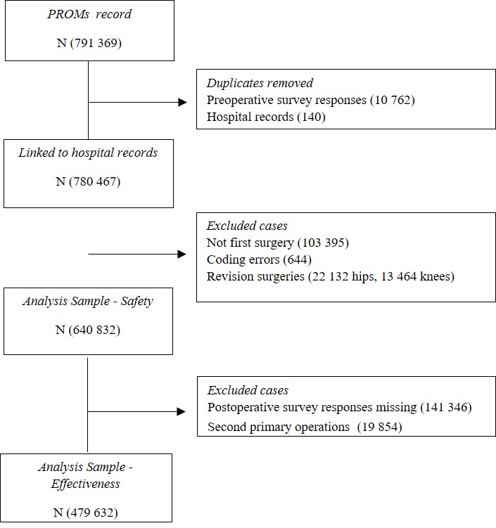
Figure 2
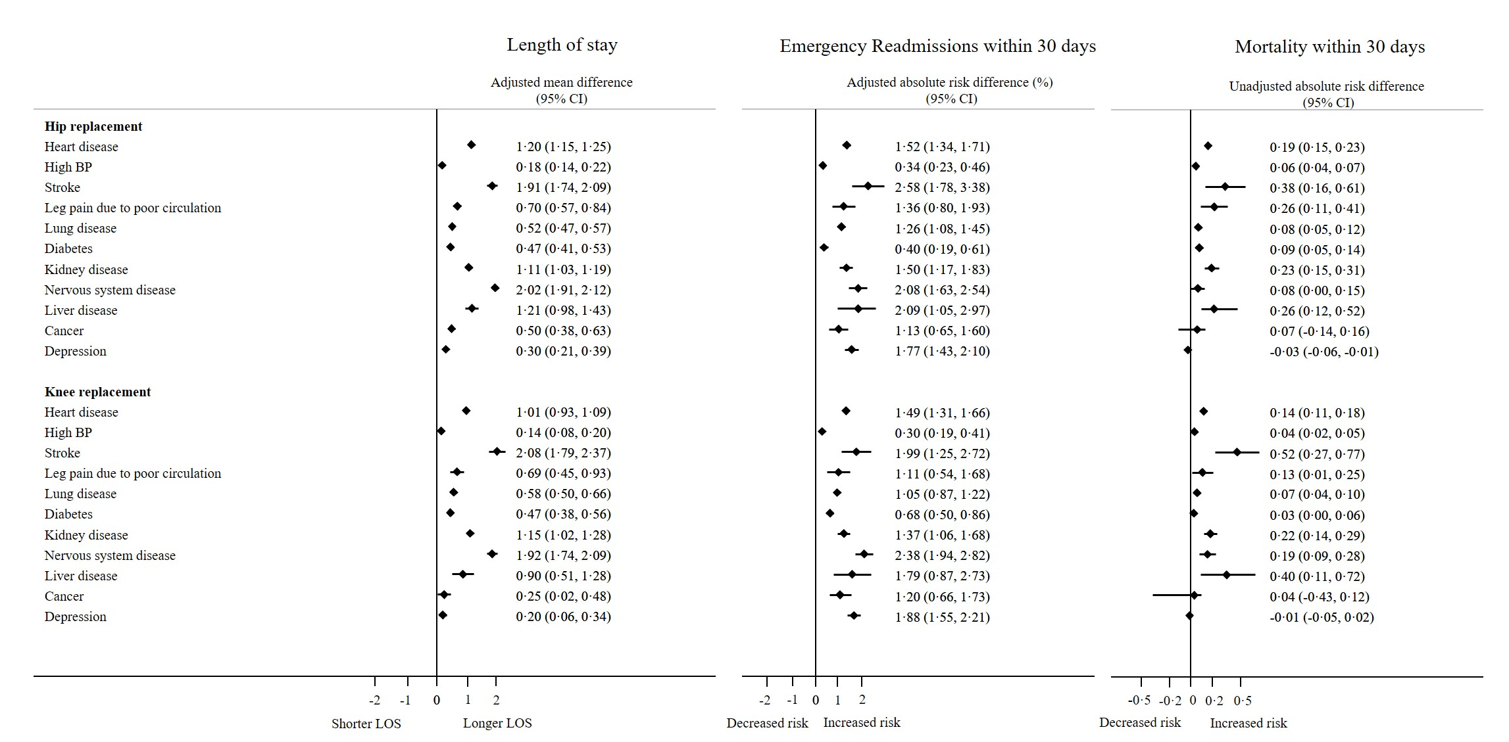
Figure 3
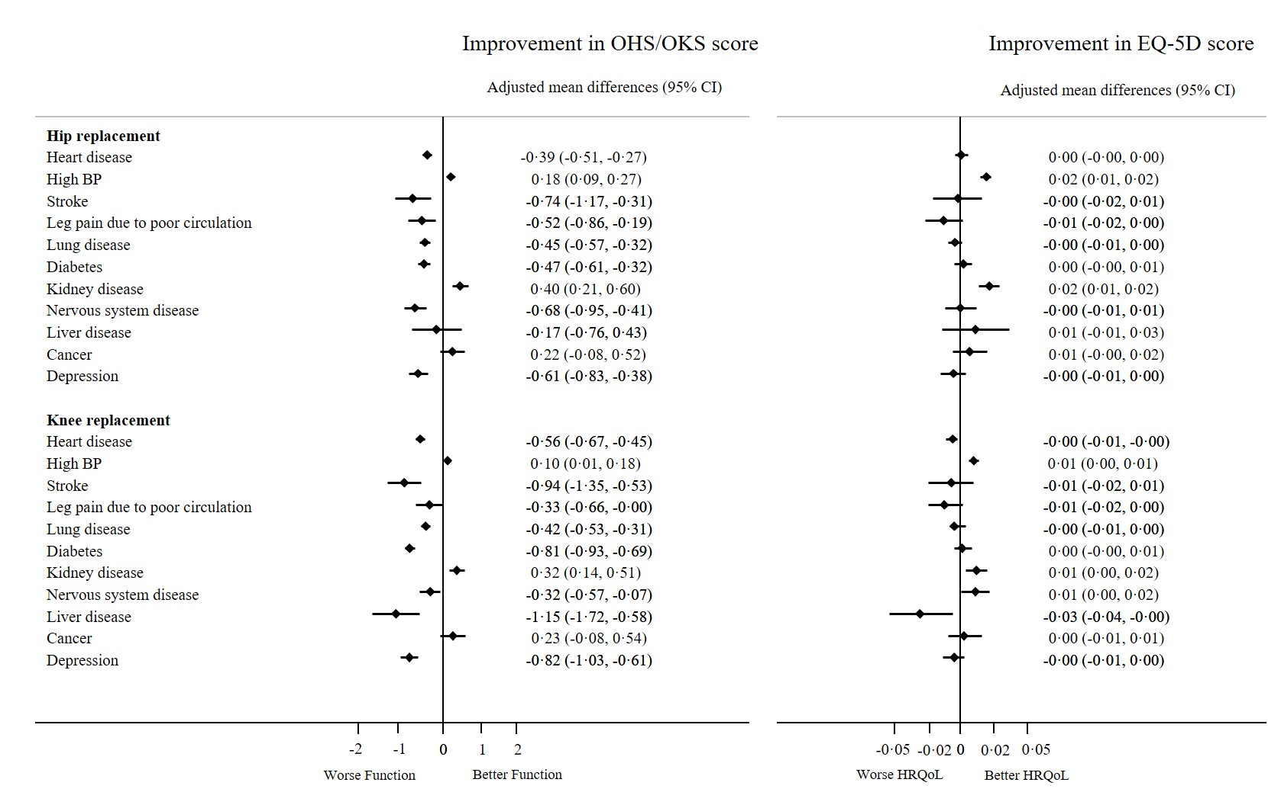

Supplementary Material Caption

Supporting Material 1. Comorbidity profiles

Comorbidity | Comorbidity sub-category | n | %
Heart disease | Ischemic heart disease | 48 555 | 57·0
 | Cardiac arrhythmias | 38 492 | 45·5
 | Valvular disease | 9377 | 11·0
 | Congestive heart failure | 7566 | 8·9
Stroke | Ischemic stroke | 2156 | 46·3
 | Transient Ischemic Attack | 745 | 16·0
 | Subarachnoid haemorrhage | 52 | 1·1
 | Other Stroke | 1806 | 38·8
Leg pain due to poor circulation | Peripheral vascular diseases | 3861 | 52·1
 | Vascular implants | 2214 | 29·9
 | Aortic diseases | 1844 | 24·9
 | Gangrene | 105 | 1·4
High BP | Primary hypertension | 235 890 | 92·7
 | Secondary hypertension | 4323 | 1·7
Nervous system  diseases | Epilepsy | 4912 | 39·4
 | Parkinsonism | 2779 | 22·3
 | Dementia | 1713 | 13·7
 | Neuropathies | 1004 | 8·1
 | Demyelinating diseases | 790 | 6·3
 | Other nervous system (e.g. paralysis, huntington's disease) | 1534 | 12·3
Lung disease | Asthma | 47 728 | 70·5
 | COPD | 20 574 | 30·4
 | Pulmonary heart diseases | 1661 | 2·5
 | Other lung disease (e.g. due to external agents) | 1024 | 1·5
Diabetes | Non-insulin-dependent diabetes | 51 787 | 96·1
 | Insulin-dependent diabetes | 2290 | 4·2
 | Other | 597 | 1·1
Kidney disease | Chronic renal failure | 21 122 | 84·8
 | Glomerular disease | 3177 | 12·7
 | Acute renal failure | 1191 | 4·7
Liver disease | Cirrhosis | 583 | 24·6
 | Alcoholic liver disease | 401 | 16·9
 | Hepatitis | 361 | 15·2
 | Hepatic failure | 37 | 1·6
 | Any other liver disease | 1123 | 47·4
Cancer | Cancer without metastasis | 6934 | 78·8
 | Lymphoma | 1708 | 19·4
 | Metastatic cancer | 921 | 10·5
Depression | Depression | 16 322 | 91·5
 | Depression linked to anxiety and stress | 1721 | 9·6
 | Other depression (linked to schizophrenia and BAD) | 15 | 0·1

