How to link yourself to a Grant
- Go to your profile edit page
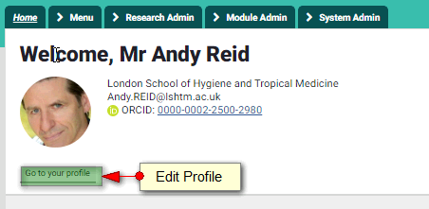
- View all links
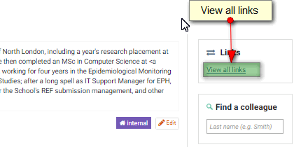
- Create Links – Grant…
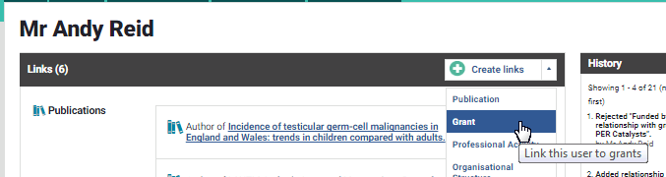
- Select link type and search by keywords or grant codes
