Figure 2: Hypothesised effect of HIV infection on respiratory function (adapted from reference 20) (A), bone mass (adapted from reference 46) (B) and muscle strength (C) across the life-course

A

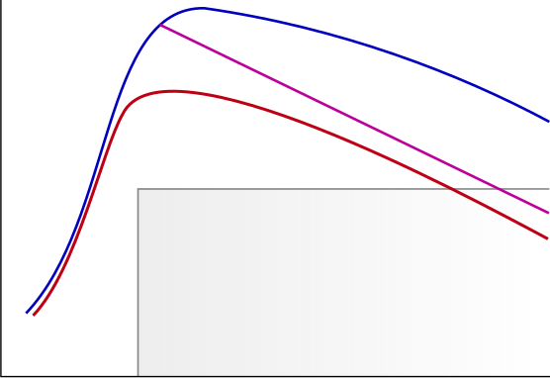
Respiratory symptoms
FEV1 (% normal level at age 20 years)
HIV-ve
HIV+ve
(reduced lung growth)
HIV+ve
(premature decline)
0
10
20
30
40
50
60
70
80
Age (years)
I. Early Life
II. Adult Life
III. Older Life
B
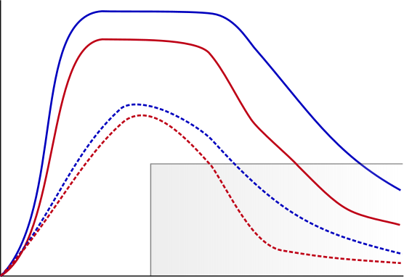
Bone mass (g)
HIV-ve Male
I. Early Life
II. Adult Life
III. Older Life
HIV+ve Male
HIV-ve Female
HIV+ve Female
Fracture
risk window
Peak Bone Mass (PBM)
0
10
20
30
40
50
60
70
80
Age (years)
C
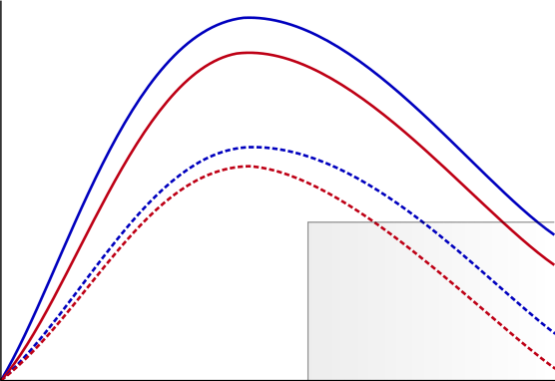
Grip Strength (kg)
HIV-ve Male
0
10
20
30
40
50
60
70
80
Age (years)
II. Adult Life
I. Early Life
III. Older Life
Reduced
physical performance
HIV+ve Male
HIV-ve Female
HIV+ve Female
Peak Muscle Mass

