**Activity *in vitro* and *in vivo* against *Trypanosoma cruzi* of a furofuran lignan isolated from *Piper jericoense***

Paola García-Huertasa, Francisco Olmob, Manuel Sánchez-Morenob, Jorge Dominguezc, Rachid Chahbound, Omar Triana-Cháveza*_:::;﷽﷽﷽﷽﷽*CH groups, and eight . acigion encias Exactas y Naturales, Universidad de Antioquiatura rhas 28oC. unos arti

a. Grupo Biología y Control de Enfermedades Infecciosas – BCEI, Universidad de Antioquia, Medellín, Colombia. [paolaalexandrag@gmail.com](mailto:paolaalexandrag@gmail.com)

b. Departamento de Parasitología, Instituto de Investigación Biosanitaria (IBS, Granada), Hospitales Universitarios de Granada, Universidad de Granada, Granada, España. [folmoarevalo@ugr.es](mailto:folmoarevalo@ugr.es), [msanchezm@gr.es](mailto:msanchezm@gr.es)

c. Grupo de Química Orgánica de Productos Naturales, Universidad de Antioquia, Medellín, Colombia. [jorgejuandominguez@gmail.com](mailto:jorgejuandominguez@gmail.com)

d. Department of Organic Chemistry, Institute of Biotechnology, University of Granada,  
 Avda. Fuentenueva, 18071 Granada, Spain. [rachid@ugr.es](mailto:rachid@ugr.es)

* Corresponding author: Omar Triana-Chávez, Grupo Biología y Control de Enfermedades Infecciosas, Laboratorio 620, Universidad de Antioquia, Calle 70 No. 52-21, Medellin, Antioquia, Colombia. 57-4-2196520, [omar.triana@udea.edu.co](mailto:omar.triana@udea.edu.co)

Graphical abstract. A new lignan isolated from *Piper jericoense* showing activity against all *Trypanosoma cruzi* stages

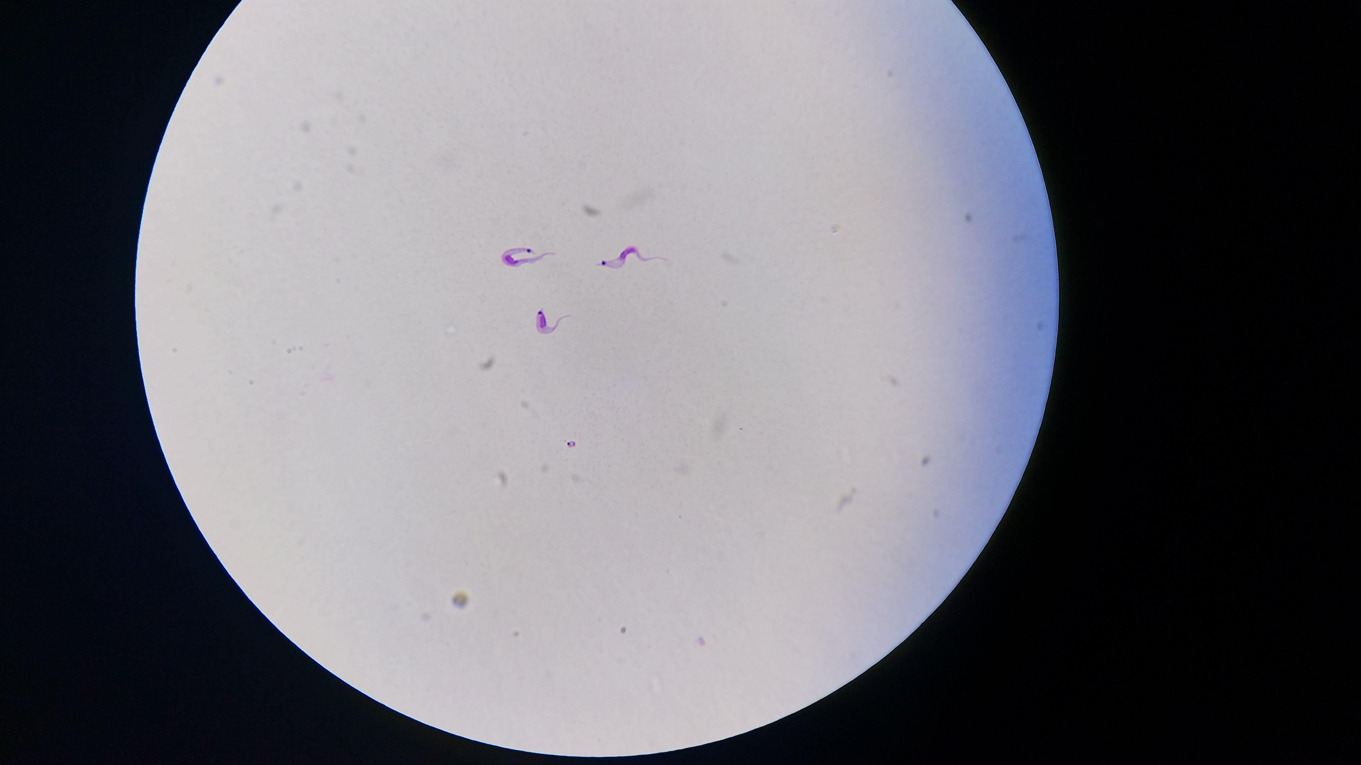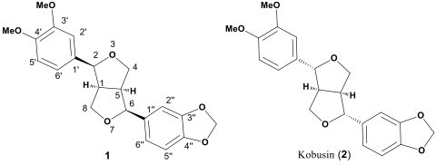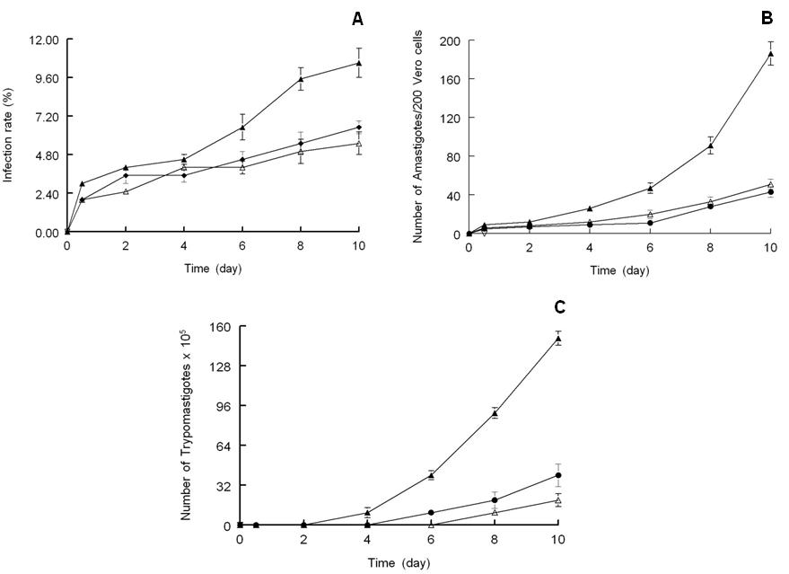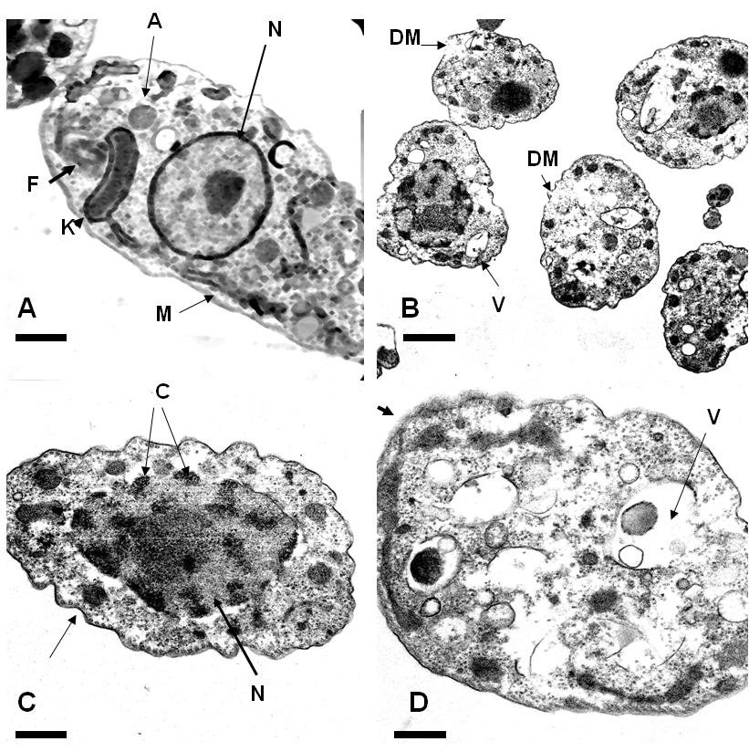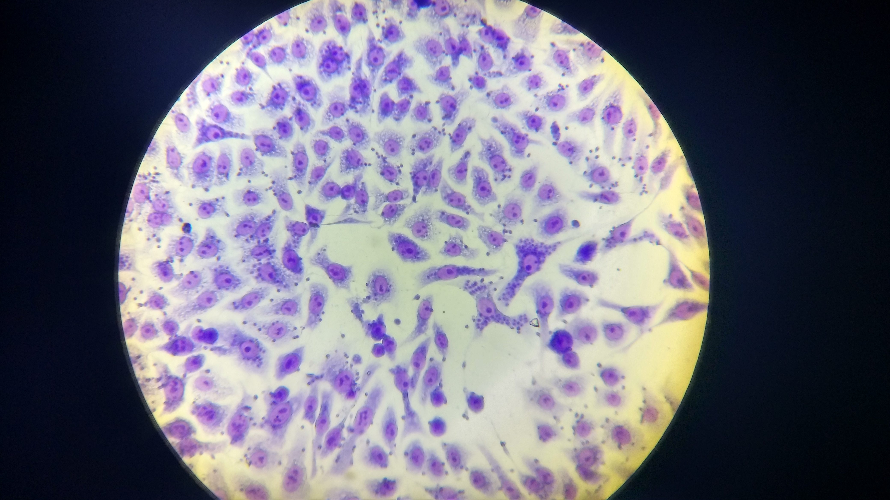

Highlights

* A furofuran lignan was obtained from *Piper jericoense* with activity against *Trypanosoma cruzi*
* The lignan showed activity against epimastigotes, amastigotes and trypomastigotes
* This compound showed higher activity than benznidazole and it was less toxic.

**ABSTRACT**

Piperaceae species are abundant in the tropics and are important components of secondary vegetation. Many of these plants have received considerable attention due to their wide range of biological activities. Here, the trypanocidal activity of extracts and fractions with different polarities obtained from Colombian *Piper jericoense* plant was evaluated. A furofuran lignan, (1S,3aS,4S,6aS)-1-(3',4'-dimethoxyphenyl)-4-(3",4"-methylendioxyphenyl)hexahydrofuro[3,4-c]furan, (**1**), was isolated from Colombian *Piper jericoense* leaves ethyl acetate extract. Its relative configuration at the stereogenic centers was established on the basis of various spectroscopic analyses, including 1D- (1H, 13C, and DEPT) and 2D-NMR (COSY, NOESY, HMQC and HMBC) and a 2D INADEQUATE NMR experiment as well as by comparison of their spectral data with those of related compounds such as (+)-Kobusin (**2**). The activity against *Trypanosoma cruzi* indicated that compound **1** was active against all parasite forms (epimastigote, amastigote and trypomastigote) and presented lower toxicity than the reference drug, benznidazole. Moreover, this compound inhibited the infectious process, and it was active in infected mice in the acute phase. This compound significantly inhibited the *T. cruzi* Fe-SOD enzyme, whereas Cu/Zn-SOD from human cells was not affected. Ultrastructural analyses, together with metabolism-excretion studies in the parasite, were also performed to identify the possible mechanism of action of the tested compound. Interestingly, the lignan affected the parasite structure, but it did not alter the energetic metabolism.

Keywords: *Piper jericoense*; lignan; Biological activity, Chagas disease, *Trypanosoma cruzi*, (1*S*,3a*S*,4*S*,6a*S*)-1-(3',4'-dimethoxyphenyl)-4-(3",4"-methylendioxyphenyl)hexahydrofuro[3,4-c]furan

**1. Introduction**

Chagas disease, caused by infection with *Trypanosoma cruzi*, is one of the most significant parasitic infections in Latin America.To date, there is no vaccine to prevent *T. cruzi* infection, and the treatment of this disease is based on two drugs, nifurtimox and benznidazole, which have limited efficacy and severe side effects (Dias, 2015; Patterson and Guhl, 2010). The development of more effective and less toxic new drugs for the treatment of Chagas disease is a challenging research goal.

The plant genus *Piper* (Piperaceae) is a pantropical group of plants with nearly 2000 species, constituting an important element of montane and low land forests (Flores et al., 2009). Piperaceae species are abundant in the tropics and are important components of secondary vegetation and they have been described as therapeutically potentials for drug discovery (Mgbeahuruike EE, Yyjönen T, Vuorela H, 2017). Many of these plants have shown activity against *Trypanosoma cruzi*, such as *Piper heterophyllum, P. aduncum* (Flores et al., 2009), *P. solmsianum* (Martins et al., 2003), *Peperomia obtusifolia* (Da Silva Mota et al., 2009), and *P. regnellii*(P S Luize et al., 2006), among others. Phytochemical investigations of *Piper* species have led to the identification of typical classes of compounds, such as amides, terpenes, benzoic acid derivatives, carotenes, and hydroquinones, in addition to lignans, neolignans and a few alkaloids (Flores et al., 2009; P S Luize et al., 2006; Patrícia Shima Luize et al., 2006; Martins et al., 2003). These compounds have received considerable attention due to their wide range of biological activities. Most of these studies have been directed toward the detection of secondary plant metabolites with trypanocidal activity and have been performed using the extracellular form of epimastigote, due to its easier maintenance under *in vitro* conditions. However, because the extracellular forms are not the developed form of the parasite in vertebrate hosts, preliminary evaluations must be complemented using intracellular (amastigotes) and extracellular infective forms (trypomastigotes). At the same time, assessment of the possible cytotoxicity of the metabolite should be conducted using non-parasitized host cells to establish whether the *in vitro* activity of the metabolite is due to its general cytotoxic activity or if it is selectively active against the parasite.

*P. jericoense* is a plant with promissory activity against parasites. Recently, extracts from this plant were examined against *Plasmodium falciparum* (Mesa Vanegas et al., 2012) and *T. cruzi* (Hamedt et al., 2014), where was demonstrated its potential activity for Malaria and Chagas disease. The aim of the present study was to determine the trypanocidal activity of a new lignan isolated from this plant. The effects of this compound were evaluated using some of the excreted metabolites in the glycolytic pathway and analysis of their inhibition on *T. cruzi* iron superoxide dismutase (Fe-SOD) and the parasite ultrastructure. The cytotoxicity against human cells was also determined to establish their selective profile. Here, we also describe the structural elucidation of this compound.

**2. Material and Methods**

**2.1 General Experimental Procedures**

Optical rotations were measured on a Perkin-Elmer 341 polarimeter (Perkin-Elmer, Wellesley, USA) at room temperature. Ultraviolet (UV) spectra were recorded on a Shimadzu UV-2550 spectrophotometer (Shimadzu, Tokyo, Japan). Infrared (IR) spectra were recorded on a Perkin-Elmer 577 IR spectrometer (Perkin-Elmer, Wellesley, USA). 1H and 13C NMR spectra were recorded at room temperature with a Varian Direct Drive (500 MHz) spectrometer. Chemical shifts are given in ppm and referenced to internal CDCl3 or C5D5N; J values are given in Hz.

NMR spectra were established on the basis of the NOES shown by the NOESY spectrum (Table 1) as well as by chemical correlations with TMS as an internal standard. HRESIMS was performed on a Bruker instrument (Bruker, Karlsruhe, Germany). All chemical shifts (δ) were expressed in ppm with reference to the solvent signal (CDCl3: δH 7.26 for 1H, δC 77.23 for 13C), and coupling constants (J) are reported in hertz. All of the solvents used were of analytical grade. Column chromatography (CC) was performed on silica gel (200-300 mesh ASTM).

**2.2 Plant material**

The leaves of *P. jericoense* were collected in Puerto Triunfo, Antioquia Department, Colombia. A voucher specimen (CF 1879) was identified and deposited in the herbarium at Universidad de Antioquia, Medellin, Colombia.

**2.3 Extraction and Isolation**

The dried leaves of *P. jericoense* (0.1 kg) were powdered and extracted with benzene, dichloromethane, ethyl acetate (EtOAc), and Methanol (MeOH) at room temperature. After 72 h, we proceeded to the concentration of the extract under reduced pressure in a rotary evaporator. The covered solvent was added back to the plant material, and the process was repeated until exhaustion of extraction. All of the extracts were analyzed by thin layer chromatography (TLC) with chromatoplates in silica gel (Merck®).

The ethyl acetate extract fraction obtained from *Piper* *jericoense* was first subjected to silica gel chromatography and was eluted with n-hexane-EtOAc (7:3) to yield 8 fractions. According to the results from biological activity, fraction 4 was analyzed with NMR, and its structure was identified.

**2.4 Parasite culture**

The Colombian *T. cruzi* strains DA (MHOM/CO/01/DA), HA (MHOM/CO/97/HA), W3534 (MHOM/CO/98/W3534) and SP (MHOM/CO/05/SP), isolated from *Homo sapiens,* were used. Epimastigote forms were grown in axenic Grace's Insect Medium (Gibco®) supplemented with 10% inactivated fetal bovine serum (FBS) at 28 °C in tissue-culture flasks.

**2.5 Epimastigote assay**

Epimastigote forms were collected in the exponential growth phase and were distributed in microplates (with 24 wells) to a final concentration of 5x104 parasites/well. Extracts, fractions and benznidazole were dissolved in culture medium and were tested at 100, 50, 25, 10, and 1 μg/mL. The effects of each extract and compound against epimastigote forms were tested at 48 h using a Neubauer chamber. The trypanocidal effect was expressed as the 50% inhibition concentration (IC50), calculated by linear-regression analysis of the *K*c values of the concentrations employed (Sánchez-Moreno et al., 2011).

**2.6 Cytotoxicity assay on Vero cells**

Vero cells were grown in RPMI 1640 (Gibco) medium, supplemented with 10% inactivated fetal bovine serum in humidified 95% air and 5% CO2 at 37 ºC. For the cytotoxicity testing, the cells were prepared to a final concentration of 1x105 cells/mL. The assay was performed in 24-well microplates, with each well receiving 100 μL of cells and extracts, fractions and benznidazole (at concentrations of 300, 150, 75, 37.5, and 19 μg/mL), and each compound was tested in duplicate. After 72 h of treatment, cell viability was determined by flow cytometry according to the methodology of Marin et al. (2011) (Marín et al., 2011). Percentages of viability were calculated compared to that of the control culture, and IC50 values were calculated by linear regression analysis of the Kc values at the concentrations employed. The selectivity index (SI) was calculated as the ratio of the IC50 in Vero cellsto theIC50 in epimastigotes.

A more detailed analysis of the most active fraction (fraction 4 ) was performed with the *T. cruzi* DA strain, which is a highly infectious strain that is naturally resistant to benznidazole. The methodology used is shown below.

**2.7 Transformation of epimastigote to metacyclic forms and biological assay**

Metacyclogenesis was induced by culturing the parasites at 28 ºC in TAU (190 mM NaCl, 17 mM KCl, 2 mM MgCl2, 2 mM CaCl2, 8 mM phosphate buffer, pH 6.0) medium for 12 days, as described previously (Cardoso and Soares, 2010). Twelve days after cultivation at 28 ºC, the metacyclic forms were counted in a Neubauer chamber. The metacyclic forms were prepared to 1x107 parasites/mL and distributed in microplates (with 96 wells). The compound **1** was diluted in culture medium (at concentrations of 160, 80, 40, 20, and 10 μg/mL) and were incubated for 24 h at 37 ºC in 5% CO2 with the parasites. Subsequently, the trypomastigotes were counted in methanol-fixed slides and Giemsa stained (Osuna et al., 1990). The data were represented as the IC50 values obtained by linear regression analysis of the Kc values at the concentrations employed. The benznidazole was used as a reference drug.

**2.8 Amastigote assay**

Vero cells were cultured as described above and seeded at a density of 1x104 cells/well in 24-well microplates (Nunc) with rounded coverslips on the bottom. Next, the cells were infected with metacyclic forms of *T. cruzi* at a ratio of 1:10 and were maintained for 24 h at 37 ºC in 5% CO2. The extracellular parasites were removed by washing, and the infected cultures were incubated with compound **1** and benznidazole (at concentrations of 300, 150, 75, 37.5, and 19 μg/mL). The compounds’ activities were determined from the percentage of the amastigote number reduction in treated and untreated cultures in methanol-fixed and Giemsa-stained preparations. The values are the means of four separate determinations, and the trypanocidal effect is expressed as the IC50 (González et al., 2005).

**2.9 Infectiousness assay**

Vero cells were cultured in RPMI medium as described above. The cells were infected with *T. cruzi* metacyclic forms at a ratio of 1:10. Compound **1** and benznidazole (IC25 concentration) were added immediately after the parasites and were incubated for 12 h at 37 ºC in a 5% CO2 atmosphere. The extracellular parasites and the test compounds were removed by washing, and the infected cultures were grown for 10 days in fresh medium. Fresh culture medium was added every 48 h (Marín et al., 2011). The activity of the compound **1** was determined from the percentage of infected cells and the number of amastigotes per cell infected in the treated and untreated cultures in methanol-fixed and Giemsa-stained preparations. The percentage of infected cells and the mean number of amastigotes per infected cell were determined by analyzing more than 100 host cells distributed in randomly chosen microscopic fields. The values are the means of four separate determinations. The number of trypomastigotes in the medium was determined as described previously (Osuna et al., 1990).

**2.10 *In vivo* trypanocidal activity assay**

Seven groups of three female BALB/c mice (6 to 8 weeks old; 20-25 g) maintained under standard conditions were infected with 5x105 *T. cruzi* metacyclic forms by the intraperitoneal route. The groups were as follows: mice infected with *T. cruzi* but not treated; mice infected and treated with 5, 15 and 30 mg/kg of body mass of the compound **1**; and mice treated with benznidazole at the same three concentrations. The treatments were started five days after animal infection, and they were supplied via five doses every three days intraperitoneally (González et al., 2005). A blood sample (5 μL) drawn from the mandibular vein of each treated mouse was obtained and diluted 1:15 (50 μL of citrate buffer: citric acid 0.1 M, sodium citrate 0.1 M and 20 μL of lysis buffer at pH 7.2:Tris-Cl 2 M, MgCl2). The parasites were counted using a Neubauer chamber under an optical microscope. The number of bloodstream trypomastigotes, expressed as parasites per milliliter, was recorded every five days from 5 to 55 days post-infection. The animal experiments were performed with the approval of the ethical committee of the University of Antioquia, Medellin, Colombia.

**2.11 SOD enzymatic inhibition**

The parasites cultured at 1x107 parasites/mL were centrifuged as described above. The pellet was suspended in 3 mL of STE buffer (0.25 M sucrose, 25 mM Tris–HCl, 1 M EDTA, pH 7.8) and was disrupted by 3 cycles of sonic disintegration, each of which was 30 s at 60 V. The sonicated homogenate was centrifuged at 1500 g for 5 min at 4 ºC, and the pellet was washed three times with ice-cold STE buffer. This fraction was centrifuged (2500 g for 10 min at 4 ºC), the supernatant was collected, and solid ammonium sulfate was added. The protein fraction, which precipitated between 35% and 85% salt concentration, was centrifuged (9000 g for 20 min at 4 °C), redissolved in 2.5 mL of 20 mM potassium phosphate buffer (pH 7.8) containing 1 mM EDTA (buffer 2), and dialyzed in a Sephadex G-25 column (Pharmacia, PD 10), previously balanced with buffer 2, bringing it to a final volume of 3.5 mL (fraction of the homogenate). The protein concentrations were determined by the Bradford method (Bradford, 1976).

Iron superoxide dismutase (Fe-SOD) activity was determined by NAD(P)H oxidation, according to Paoletti and Mocali (Paoletti et al., 1986). One unit was the amount of enzyme required to inhibit the rate of NAD(P)H reduction by 50%. In each bucket was placed stock solution (phosphate buffer 50 mM, pH 7.8, 54 mL, L-methionine 3 mL, NBT 2 mL, Triton-X-100 1.5 mL), the compound **1** at different concentrations (IC10, IC25 and IC50) and riboflavin. The absorbance was determined at 560 nm in a spectrophotometer. After 10 minutes in agitation and light, the absorbance was determined again. The CuZn-SOD from humans, coenzymes and substrates used in these assays were obtained from Sigma Chemical Co. Benznidazole was used as a reference drug. The data obtained were analyzed according to the Newman-Keuls test.

**2.12 Metabolite excretion**

*T. cruzi* epimastigote cultures (initial concentration 5×105 parasites/mL) received IC50 of the compound **1** (except for control cultures), and after incubation for 96 h at 28 °C, the cells were centrifuged at 400 *g* for 10 min. The supernatants were collected to determine the excreted metabolites by 1H-NMR, and the chemical shifts were expressed in parts per million (ppm), using sodium 2,2-dimethyl-2-silapentane-5-sulfonate as the reference signal. The chemical displacements used to identify the respective metabolites were consistent with those described previously (Sanchez-Moreno et al., 1996).

**2.13 Ultrastructural alterations**

The parasites were cultured at a density of 5×105 cells/mL in the corresponding medium, each of which contained the compound **1** tested at the IC50 concentration. After 96 h, these cultures were centrifuged at the rate of 400 *g* for 10 min, and they produced pellets that were washed in PBS and then mixed with 2% (v/v) *p-*formaldehyde/glutaraldehyde in 0.05 M cacodylate buffer (pH 7.4) for 4 h at 4 ºC. Subsequently, the pellets were prepared for transmission electron microscopy study employing the technique previously reported (González et al., 2005).

**3. Results and discussion**

**3.1 *P. jericoense* leaves extract present different activity against *T. cruzi***

Extracts from leaves *P. jericoense* were prepared with the solvents EtOAc (A), benzene (B), dichloromethane and methanol, as described in experimental section*.* The trypanocidal activity and cytotoxicity of each of these extracts are presented in Table 1. All of the extracts were active against *T. cruzi* strains (DA, HA, SP, W3534), but a higher selectivity index (SI) was observed with EtOAc with SI values of >7.9, >6.4, >4.4 and >3.5 for the SP, W3534, DA and HA strains, respectively (Table 1).

Table 1.*In vitro* activity, toxicity, and selectivity index for *Piper jericoense* leave extracts and benznidazole on epimastigotes of *Trypanosoma cruzi* strains*.*

|  |  |  |  |  |  |  |  |  |  |
| --- | --- | --- | --- | --- | --- | --- | --- | --- | --- |
| **EXTRACT** | **Vero*a*** | **DA** | | **HA** | | **SP** | | **W3534** | |
| **LC50 ± SD** | **IC50 ± SD** | **SI** | **IC50 ± SD** | **SI** | **IC50 ± SD** | **SI** | **IC50 ± SD** | **SI** |
| **EtOAc** | >400 ± 17.9 | 90.8 ± 6.6 | **>4.4** | 114.9 ± 12.2 | **>3.5** | 50.2 ± 3.5 | **>7.9** | 62.4 ± 3.4 | **>6.4** |
| **Benzene** | 52.4 ± 1.7 | 27.7 ± 1.4 | 1.9 | 37.3 ± 2.6 | 1.4 | 37.2 ± 0.6 | 1.4 | 21.5 ± 1.9 | 2.4 |
| **Dichloro-methane** | 15.9 ± 0.8 | 32.3 ± 3.1 | 0.5 | 43.5 ± 3.5 | 0.4 | 38.2 ± 2.4 | 0.4 | 28.9 ± 1.5 | 0.6 |
| **Methanol** | 211.9 ± 9.6 | 61.8 ± 5.5 | 3.4 | 204.6 ± 7.7 | 1.0 | 154.1 ± 12.5 | 1.4 | 275.9 ± 18.8 | 0.8 |
| **Bzb** | - | 32.75 |  | 4.66 |  | 6.41 |  | 14.01 |  |

aToxicity on Vero cells after 72 h of culture expressed as LC50.

IC50 expressed in µg/mL is the concentration required to result in 50% inhibition of parasite growth, and it was calculated by linear regression analysis from the *K*c values at the concentrations employed (1, 10, 25, 50 and 100 µg/mL). SI: Selectivity index = LC50 Vero cells**/**IC50 epimastigote form. SD: Standard deviation. b: IC50to Bz expressed in µM. Bz: Benznidazole

**3.2 F4 fraction from ethyl acetate extract present a good selective activity against Trypanosoma** **cruzi**

In order to analyze the biological activity of ethyl acetate extract, this was fractionated to identify the chemical compound responsible for the trypanocidal activity. Eight fractions were obtained, which were subjected to new activity against *T. cruzi* and cytotoxicity screening. The IC50 values were widely different, with values between 14.3±0.13 and 102.2±7.4 μg/mL. Fraction F4 showed an SI of 18.4, indicating its low toxicity and high trypanocidal activity (Table 2).

Table 2. Biological activity of fractions obtained from *Piper jericoense* leaves EtOAc extract

|  |  |  |  |
| --- | --- | --- | --- |
| **FRACTION** | **VERO CELLS**  **(LC50)** | ***T. cruzi* DA strain (IC50)** | **SI** |
| **F1** | 34.62 ± 1.9 | 35.2 ± 1.5 | 1.0 |
| **F2** | 54.32 ± 2.1 | 102.2 ± 7.4 | 0.5 |
| **F3** | 54.83 ± 3.2 | 39 ± 1.7 | 1.4 |
| **F4** | **263.6±4.4** | **14.3 ± 0.13** | **18.4** |
| **F5** | 47.745 ± 2.4 | 24.2 ± 2.3 | 2.0 |
| **F6** | 47.14 ± 1.3 | 16.6 ± 3.1 | 2.8 |
| **F7** | 103.305 ± 11.6 | 22 ± 0.9 | 4.7 |
| **F8** | 115.4 ± 9.2 | 76.3 ± 4.5 | 1.5 |

**3.3** **A lignan is present in F4 fraction**

The chemical analysis of fraction 4 showed that it consisted of only one compound (**1**). The structure of **1** was established on the basis of the 1D- (1H, 13C, and DEPT) and 2D NMR (INADEQUATE, DQF-COSY, HMBC and NOESY) spectra and by comparison of its spectral data with those of related compounds. Compound **1** was isolated as yellow syrup that displayed a molecular-ion peak at *m/z* 370 (M+) in the EI-MS. Its molecular formula, C21H22O6, was deduced from the HR-EI-MS peak at *m/z* 370.1499 (M+). The 13C NMR spectrum indicated 21 carbon signals, which were distinguished by DEPT experiments as two methyls, three methylenes, ten methines, and six quaternary carbons. The 1H-NMR spectrum indicated signals for two CH groups at d(H) 3.08–3.11 (m, 2 H), two benzylic OCH- moieties at ****(H) 4.74 (d, *J* = 4.8 Hz, 1H) and 4.75 (d, *J* = 4.7 Hz, 1H), two oxygenated CH2 groups at ****(H) 3.88 (dd, *J* =9.0, 4.0 Hz, 1H), 3.90 (dd, *J* =9.0, 4.0 Hz, 1H), 4.25 (dd, *J* =9.0, 6.0 Hz, 1H) and 4.27 (dd, *J* =9.0, 6.0 Hz, 1H) and two 1,3,4,5-tetrasubstituted benzene rings at ****(H) 6.79 (d, *J* = 8.0 Hz, 1H), 6.82 (dd, *J* = 8.0, 1.6 Hz, 1H), 6.85 (d, *J* = 8.2 Hz, 1H), 6.87 (d, *J* = 1.6 Hz, 1H), 6.88 (dd, *J* = 8.2, 1.9 Hz, 1H) and 6.91 (d, *J* = 1.9 Hz, 1H) which were assigned to a lignan of the furofuran type by comparison with data reported previously (Da Silva Mota et al., 2009). The lignan **1** has a structure similar to (+)-Kobusin (**2**) (Figure 1) that was identified in other plants, such as *Leucophyllum ambiguum* (Rojas et al., 2003), *Artemisia gorgonum*(Ortet et al., 2011), and *Magnolia fargesii* (Kim et al., 2010)*,* among others.



**Figure 1.** Selected nOe and HMBC correlations of compound **1** and comparison with kobusin (2).

The Kobusin has been reported to be active against *Plasmodium falciparum* with low *in vitro* toxicity (Ortet et al., 2011), and it was proposed that this compound might be beneficial for the treatment of neuro-inflammatory diseases through its inhibition of iNOS expression and its peroxynitrite scavenging potential (Kim et al., 2010). Several lignans and neolignans have been isolated from *Piperaceae* plants, and they have shown activity against *T. cruzi*, but most of these studies used the epimastigote form, and the mechanism of action of these compounds are unknown (Da Silva Mota et al., 2009; P S Luize et al., 2006; Patrícia Shima Luize et al., 2006).

The 1H and 13C NMR signals of compound **1** (Table 3) were assigned based on the interpretation of the DEPT, COSY, NOESY, HMQC, and HMBC data. On the basis of this spectroscopic evidence and comparison with lignans of the furofuran type3 and the (+)-sesamin type4, compound **1** was characterized as (1*S*,3a*S*,4*S*,6a*S*)-1-(3',4'-dimethoxyphenyl)-4-(3",4"-methylendioxyphenyl)hexahydrofuro[3,4-c]furan.

This observation was further confirmed by the corresponding 13C-NMR signals at ****(C) 55.19 and 55.34 (2 CH), 86.52 and 86.54 (2 benzylic OCH), and 72.37 and 71.43 (2 oxygenated CH2) as well as 107.68, 108.94, 111.29, 112.82, 119.40 and 120.32 (6 aromatic CH), 135.27, 136.80, 147.94, 148.91, 149.98 and 150.69 (6 aromatic C), two methyl groups at 56.43 and 56.36 and methylenedioxy at 102.07, as established by DEPT and 1H, 13C one-bond (HMQC) experiments. The 13C NMR data were assigned through the analysis of the HSQC and HMBC spectra. The observed correlations in the DQF-COSY spectrum are indicated in Table 2. The relative stereochemistry of **1** was established on the basis of the chemical shift data on CDCl3 and C6D5N observed in the 1H and 13C NMR spectra and the nOes shown in the NOESY spectrum (Table 3, Figure 1).

Table 3. 1H (500 MHz) and 13C NMR (120 MHz) chemical shift data (CDCl3) for compound **1**

|  |  |  |  |  |  |
| --- | --- | --- | --- | --- | --- |
| **nº C** | **H (*J* in Hz)** | **C /**  **HSQC/ HMBC** | **DQF-COSY** | **HMBC** | **NOESY** |
| 1 | 3.08, m | 55.34 (CH) | 4.30; 4.63; 5.21 | 55.19; 136.80; 72.37 | 4.30; 4.63; 5.21; 7.27; 7.43 |
| 2 | 4.74, d(4.8) | 86.54 (CH) | 3.42; 7.43 | 107.68; 120.32; 136.80 | 3.42; 4.30; 7.27; 7.43 |
| 4a | 4.25, dd (9.0, 6.0) | 72.37 (CH2) | 4.29; 3.50 | 55.34; 86.52 | 3.50; 4.29; 7.27; 7.43 |
| 4b | 3.90, dd (9.0; 4.0) | 72.37 (CH2) | 4.59; 3.50 | 55.34 | 4.59 |
| 5 | 3.11, m | 55.19 (CH) | 4.59; 4.29; 5.24 | 55.34; 72.43; 135.27 | 4.29; 4.59; 5.24; 7.40; 7.52 |
| 6 | 4.75, d (4.7) | 86.52 (CH) | 3.50; 7.40; 7.52 | 111.29; 119.40; 135.27 | 4.29; 4.59; 7.40; 7.52 |
| 8a | 4.27, dd (9.0; 6.0) | 72.43 (CH2) | 4.30; 3.42 | 55.19; 86.54 | 3.42; 4.30; 7.40; 7.52 |
| 8b | 3.88, dd (9.0; 4.0) | 72.43 (CH2) | 4.63; 3.42 | 55.19 | 4.63 |
| 1’ | - | 136.80 (C) | - |  |  |
| 2’ | 6.87, d (1.6) | 107.68 (CH) | 7.27 | 86.54; 148.91; 147.94; 120.32 | 3.42; 4.30; 5.21; 4.59; |
| 3’ | - | 148.91 (C) | - |  |  |
| 4’ | - | 147.94 (C) | - |  |  |
| 5’ | 6.79, d (8.0) | 108.94 (CH) | 7.27 | 86.54; 136.80; 148.91 |  |
| 6’ | 6.82, dd (8.0: 1.6) | 120.32 (CH) | 7.24; 7.43 | 107.68; 147.94 | 3.42; 4.30; 4.59; 5.21 |
| OCH2O | 5.96, s | 102.07 (CH2) | - | 147.94; 148.91 |  |
| 1” | - | 135.27 (C) | - |  |  |
| 2” | 6.91, d (1.9) | 111.29 (CH) | 7.40 | 86.52; 119.40; 150.69 | 3.50; 4.29; 4.63; 5.24 |
| 3” | - | 150.69 (C) | - |  |  |
| 4” | - | 149.98 (C) | - |  |  |
| 5” | 6.85, d (8,2) | 112.82 (CH) | 7.40 | 135.27; 150.69 |  |
| 6” | 6.88, dd (8.2; 1.9) | 119.40 (CH) | 7.30; 7.52 | 86.52; 111.29; 150.69 | 3.50; 4.29; 4.63; 5.24 |
| OCH3 | 3.89, s | 56.43 (CH3) | 7.30 | 149.98 | 7.30 |
| OCH3 | 3.91, s | 56.36 (CH3) | 7.52 | 150.69 | 7.52 |

**3.4 The lignan 1 is active against other *T. cruzi* stages**

The activity of compound **1** against amastigote and trypomastigote forms was also examined. The results are presented in Table 4. The lignan was active against all *T. cruzi* forms, but it was more effective against epimastigotes (IC50: 14.29 µg/mL) and less effective against trypomastigotes (IC50: 97.62 µg/mL) (Tables 2 and 4). However, compound **1** showed SIs of 4.7 and 2.7 with amastigotes and trypomastigotes, respectively. This result is very interesting taking in count that benznidazole and nifurtimox are the only drugs used to the treatment of Chagas disease, and its side effects are broadly reported.

Table 4. *In vitro* activity, toxicity, and selectivity index found for compound **1** against the amastigote and trypomastigote forms of *Trypanosoma cruzi* strain DA*.*

|  |  |  |  |  |  |  |
| --- | --- | --- | --- | --- | --- | --- |
|  |  |  |  |  |  |  |
| Treatment | (IC50 µg/mL) | | Toxicity (IC50 µg/mL) to Vero cells*b* | SI*a* | |  |
| Amastigote | Trypomastigote | Amastigote | Trypomastigote |  |
|  |  |  |  |  |  |  |
| Benznidazole | 21±1.4 | 27.8±1.6 | 57.49±2.8 | 2.7 | 2.1 |  |
| Compound **1** | 55.88±2.5 | 97.62±3.1 | 263.6±4.4 | 4.7 (1.7) | 2.7 (1.3) |  |

**a**Selectivity index = IC50 Vero cells**/**IC50 amastigote or trypomastigote forms. Note: average of three separate determinations. In brackets: number of times the compound **1** SI exceeded the reference drug SI.

**b**On Vero cells, after 72 h of culture. IC50 = the concentration required to result in 50% inhibition, calculated by linear regression analysis of the *K*c values at the concentrations employed (1, 10, 25, 50 and 100 µg/mL).

**3.5 The lignan 1 decreases the *T. cruzi* infection rate to cells**

In order to evaluate the effect on infection in Vero cells, the number of amastigotes and trypomastigotes was evaluated at different time post-infection. Interestingly, the compound **1** decreased significantly the number of Vero cells infected and also the number of amastigotes and trypomastigotes per cell (Figure 2A, 2B and 2C).



**Figure 2.** Effect of the activity of compound 1 on the infection rate and *T. cruzi* growth. (**A**) Rate of infection. (**B**) Mean number of amastigotes per infected Vero cell. (**C**) Number of trypomastigotes in the culture medium. Control (-▲-); benznidazole (-Δ-); compound 1 (-●-), (at IC25 concentration). The values are the means of three separate experiments.

**3.6 Activity *in vivo* of compound 1**

Due to the trypanocidal effect *in vitro* of the lignan*, in vivo* studies were performed to evaluate their activity against *T. cruzi* infection in mice. The results showed a decrease in the number of bloodstream trypomastigotes in mice treated with compound **1** at different concentrations (Figure 3). This pattern was also observed with benznidazole, but the cytotoxicity of compound **1** is much lower, as was demonstrated above. Interestingly, similar results were found when compounds isolated from *P. cubeba* were evaluated (Esperandim et al., 2013), demonstrating the potential activity against *T. cruzi* of compounds from *Piperaceae* plants.



**Figure 3.** Parasitemia in the murine model of acute Chagas disease. The values represent the average of three mice used in each treatment. The arrows indicate the beginning and end of the treatment. The treatments were Benznidazole (Benz) and F4 fraction (F4) at 5, 15 and 30 mg/kg, respectively. The control mice were infected but not treated.

**3.7 Effects of compound 1 on *T. cruzi* metabolism and ultrastructural**

In order to evaluate the action of compound **1** on some metabolic pathways from parasite and any damage in the cell ultrastructure we studied the role of this compound on antioxidant enzymes, excretion metabolites and cell structure. Superoxide dismutases (SODs) are a group of antioxidant enzymes that have strong antioxidant properties and have been shown to protect normal cells, as well as a number of pathogens, from reactive oxygen species (ROS). A significant reduction in the enzymatic activity of Fe-SOD was observed in the presence of compound **1** (Figure 4). Compound **1** inhibited enzymatic activity in 35%, 57% and 69% to IC10, IC25 and IC50, respectively. No effect on human erythrocyte Cu/Zn-SOD was observed.



**Figure 4.** *In vitro* inhibition (%) of Fe-SOD of *T. cruzi* epimastigotes and Cu/Zn-SOD in human erythrocytes for compound **1** at concentrations of 0.21, 1.01 and 14.29 µg/mL (IC10, IC25 and IC50, respectively). Values are the average of three separate determinations.

To gain information concerning the effect of the compound **1** lignan on metabolite excretion, 1H NMR spectra were measured from the epimastigotes treated with this compound at an IC50 of 14.29 µg/mL for 96 hours (Figure 5A and B). When parasites were treated with this lignan, there was not a significant alteration in the level of metabolites excreted. According to these results, the lignan appeared not to alter the energy metabolism of the parasite.

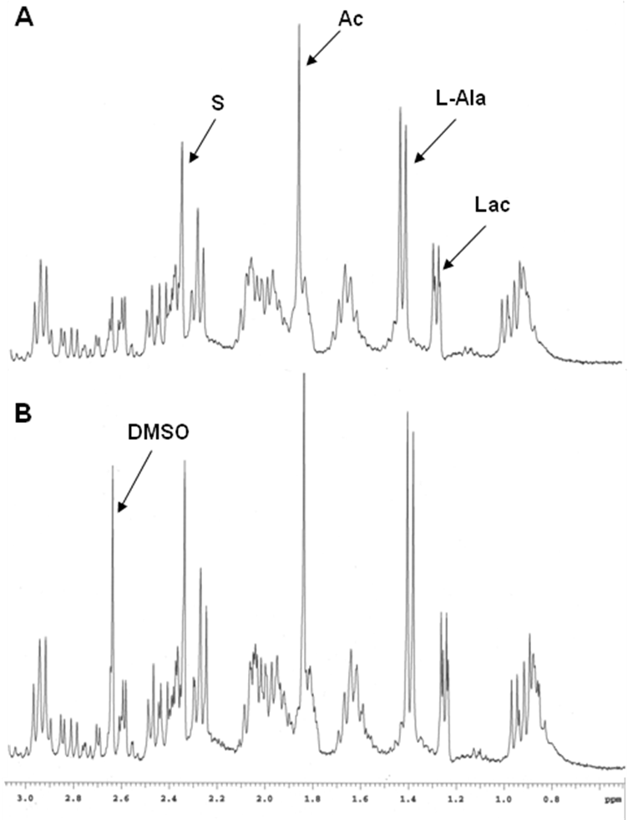

**Figure 5.** 1H-NMR spectra of the epimastigote forms of *T. cruzi* treated against fraction 4 (at a concentration of IC50): (A) controls (parasites untreated) and (B) parasites treated with fraction 4. Lac, L-lactate; Ala, L-alanine; Ac, acetate; S, succinate; DMSO, dimethylsulfoxide.

Moreover, the electronic microscopic analysis showed that compound **1** (IC50: 14.29 µg/mL) produced notable ultrastructural alterations in *T. cruzi*, as reflected in Figure 6 (panels B-D). As shown in panel C, an inflated nucleus was observed to occupy most of the cytoplasm of the parasite as well as accumulations of chromatin, most of which were attached to the nuclear membrane, an undulating cytoplasm membrane and the microtubules interrupted in some areas. Most of the epimastigotes had large, empty vacuoles, while others had a strongly electrodense cytoplasm (Panel D), which might have been remnants of the metabolism of parasites.



**Figure 6.** Ultrastructural alterations by TEM in epimastigotes forms of *T. cruzi* strain DA treated with compound 1 at IC50 concentration (14.29 µg/mL).(**A**): control parasite showing organelles with their characteristic aspects, such as kinetoplast (K), mitochondrion (M), acidocalcisomal (A), flagellum (F) and nucleus (N) (Bar = 1 µm). (**B**): epimastigotes of *T. cruzi* treated with fraction 4 (IC50) strongly vacuolated (V), with dilated nucleus (N) and disrupted membrane (DM) (Bar = 500 nm)**. (C)** *T. cruzi* parasites treated with waving cytoplasmic membrane (arrow), dilated nucleus (N) and strongly condensed chromatin (C) (Bar = 500 nm). **(D)** epimastigotes of *T. cruzi* treated with strongly dilated forms, vacuolated (V) and cytoskeleton disrupted in some areas of the cytoplasmic membrane (arrow) (Bar = 500 nm).

Finally, although the mechanism of action of the compound **1** is unknown, we propose that it could be related to the alteration of parasite antioxidant defenses and subsequent cell death. These studies contributed to the search for new therapeutic options to treat Chagas disease that are safe, effective and economical through the rational use of Colombian plants and their products.

**4. Conclusion**

A new lignan with activity against *Trypanosoma cruzi*, agent causal of American trypanosomiasis was identified. The compound **1** was effective against all *T. cruzi* forms without being toxic to Vero cells. Additionally, we observed that this compound inhibited the infectious process, and it was active in infected mice.

**Acknowledgments**

We are grateful to the Department of Parasitology of the University of Granada and the transmission electron microscopy and NMR spectroscopy services of the CIC-University of Granada. F.O. is grateful for an FPU Grant (AP2010-3562) from the Ministry of Education, Spain.

**Funding**

The authors acknowledge financial support from Colciencias under Grant number 111545921472; Universidad de Antioquia, UdeA; and Junta de Andalucía – España (P11-CTS-7651).

**References**

Bradford, M.M., 1976. A rapid and sensitive method for the quantitation of microgram quantities utilizing the principle of …. Anal Biochem.

Cardoso, J., Soares, M.J., 2010. In vitro effects of citral on Trypanosoma cruzi metacyclogenesis. Mem. Inst. Oswaldo Cruz 105, 1026–1032. doi:10.1590/S0074-02762010000800012

Da Silva Mota, J., Leite, A.C., Batista, J.M., López, S.N., Ambrósio, D.L., Passerini, G.D., Kato, M.J., Bolzani, V.D.S., Cicarelli, R.M.B., Furlan, M., 2009. In vitro trypanocidal activity of phenolic derivatives from Peperomia obtusifolia. Planta Med. 75, 620–623. doi:10.1055/s-0029-1185364

Dias, J.C.P., 2015. Evolution of Chagas Disease Screening Programs and Control Programs Historical Perspective. Glob. Heart. doi:10.1016/j.gheart.2015.06.003

Esperandim, V.R., da Silva Ferreira, D., Rezende, K.C.S., Cunha, W.R., Saraiva, J., Bastos, J.K., e Silva, M.L.A., de Albuquerque, S., 2013. Evaluation of the in vivo therapeutic properties of (−)-cubebin and (−)-hinokinin against Trypanosoma cruzi. Exp. Parasitol. 133, 442–446. doi:10.1016/j.exppara.2012.12.005

Flores, N., Jiménez, I.A., Giménez, A., Ruiz, G., Gutiérrez, D., Bourdy, G., Bazzocchi, I.L., 2009. Antiparasitic activity of prenylated benzoic acid derivatives from Piper species. Phytochemistry 70, 621–627. doi:10.1016/j.phytochem.2009.03.010

González, P., Marín, C., Rodríguez-González, I., Hitos, A.B., Rosales, M.J., Reina, M., Díaz, J.G., González-Coloma, A., Sánchez-Moreno, M., 2005. In vitro activity of C20-diterpenoid alkaloid derivatives in promastigotes and intracellular amastigotes of Leishmania infantum. Int. J. Antimicrob. Agents 25, 136–141. doi:10.1016/j.ijantimicag.2004.08.010

Hamedt, A.L., Ortiz, I.C., García-Huertas, P.A., Sáenz, J., Araujo, A.C. de, De Mattos, J.C.P., Rodríguez-Gazquez, M.A., Triana-Chávez, O., 2014. Cytotoxic, mutagenic and genotoxic evaluation of crude extracts and fractions from Piper jericoense with trypanocidal action. Acta Trop. 131, 92–97. doi:10.1016/j.actatropica.2013.12.008

Kim, J.S., Kim, J.Y., Lee, H.J., Lim, H.J., Lee, D.Y., Kim, D.H., Ryu, J.H., 2010. Suppression of inducible nitric oxide synthase expression by furfuran lignans from flower buds of Magnolia fargesii in BV-2 microglial cells. Phyther. Res. 24, 748–753. doi:10.1002/ptr.3028

Luize, P.S., Ueda-Nakamura, T., Dias Filho, B.P., Cortez, D.A., Nakamura, C. V, 2006. Activity of neolignans isolated from Piper regnellii (MIQ.) C. DC. var. pallescens (C. DC.) YUNCK against Trypanosoma cruzi. Biol Pharm Bull 29, 2126–2130. doi:JST.JSTAGE/bpb/29.2126 [pii]

Luize, P.S., Ueda-Nakamura, T., Filho, B.P.D., Cortez, D.A.G., Morgado-Díaz, J.A., De Souza, W., Nakamura, C.V., 2006. Ultrastructural alterations induced by the neolignan dihydrobenzofuranic eupomatenoid-5 on epimastigote and amastigote forms of Trypanosoma cruzi. Parasitol. Res. 100, 31–37. doi:10.1007/s00436-006-0241-9

Marín, C., Ramírez-Macías, I., López-Céspedes, A., Olmo, F., Villegas, N., Díaz, J.G., Rosales, M.J., Gutiérrez-Sánchez, R., Sánchez-Moreno, M., 2011. In vitro and in vivo trypanocidal activity of flavonoids from delphinium staphisagria against chagas disease. J. Nat. Prod. 74, 744–750. doi:10.1021/np1008043

Martins, R.C.C., Lago, J.H.G., Albuquerque, S., Kato, M.J., 2003. Trypanocidal tetrahydrofuran lignans from inflorescences of Piper solmsianum. Phytochemistry 64, 667–670. doi:10.1016/S0031-9422(03)00356-X

Mesa Vanegas, A.M., Toro Suaza, J.F., Cardona Naranjo, F., Blair Trujillo, S., 2012. Antiplasmodial and cytotoxic activity of ethanol extracts of species of the genus Piper . Bol. Latinoam. y del Caribe Plantas Med. y Aromat. 11, 154–162.

Mgbeahuruike EE, Yyjönen T, Vuorela H, H.Y., 2017. Bioactive compound from medicinal plants: focus on Piper species. South African J. Bot. 112, 54–69. doi:https://doi.org/10.1016/j.sajb.2017.05.007

Ortet, R., Prado, S., Regalado, E.L., Valeriote, F.A., Media, J., Mendiola, J., Thomas, O.P., 2011. Furfuran lignans and a flavone from *Artemisia gorgonum* Webb and their *in vitro* activity against *Plasmodium falciparum*. J. Ethnopharmacol. 138, 637–640.

Osuna, A., Adroher, F.J., Lupiáñez, J.A., 1990. Influence of electrolytes and non-electrolytes on growth and differentiation of Trypanosoma cruzi. Cell Differ. Dev. 30, 89–95. doi:10.1016/0922-3371(90)90077-A

Paoletti, F., Aldinucci, D., Mocali, A., Caparrini, A., 1986. A sensitive spectrophotometric method for the determination of superoxide dismutase activity in tissue extracts. Anal. Biochem. 154, 536–541. doi:10.1016/0003-2697(86)90026-6

Patterson, J.S., Guhl, F., 2010. Geographical Distribution of Chagas Disease, American Trypanosomiasis Chagas Disease One Hundred Years of Research. doi:10.1016/B978-0-12-384876-5.00005-8

Rojas, S., Acevedo, L., Macías, M., Toscano, R.A., Bye, R., Timmermann, B., Mata, R., 2003. Calmodulin inhibitors from Leucophyllum ambiguum. J. Nat. Prod. 66, 221–224. doi:10.1021/np020346i

Sanchez-Moreno, M., Entrala, E., Janssen, D., Fernandez-Becerra, C., Salas-Peregrin, J.M., Osuna, A., 1996. Inhibition of superoxide dismutase from Ascaris suum by benzimidazoles and synthesized pyrimidine and glycine derivatives. Pharmacology.

Sánchez-Moreno, M., Sanz, A.M., Gómez-Contreras, F., Navarro, P., Marín, C., Ramírez-Macias, I., Rosales, M.J., Olmo, F., Garcia-Aranda, I., Campayo, L., Cano, C., Arrebola, F., Yunta, M.J.R., 2011. In vivo trypanosomicidal activity of imidazole- or pyrazole-based benzo[ g ]phthalazine derivatives against acute and chronic phases of chagas disease. J. Med. Chem. 54, 970–979. doi:10.1021/jm101198k