Diagnostic Ability and Inappropriate Antibiotic Prescriptions: A Quasi-Experimental Study of Primary Care Providers in Rural China

Authors: Hao XUE,¹ Yaojiang SHI,² Lei HUANG, ² Hongmei YI,³ Huan ZHOU,^{4,*} Chengchao ZHOU,⁵ Sarah KOTB,⁶ Joseph D. TUCKER, ^{7, 8} Sean Y SYLVIA ⁹

¹ School of Economics and Management, Northwest University, Xi'an, Shaanxi, China
² Center for Experimental Economics in Education, Shaanxi Normal University, Xi’an, China
³ School of Advanced Agricultural Sciences, Peking University, Beijing, China
⁴ Department of Health and Social Behavior, West China School of Public Health, Sichuan University, Chengdu, China
⁵ Institute of Social Medicine and Health Administration, School of Public Health, Shandong University, Jinan, China
⁶ Stanford Law School, Stanford University, Stanford, USA
⁷ University of North Carolina Project China, Guangdong, China
⁸ Faculty of Infectious and Tropical Diseases, London School of Hygiene and Tropical Medicine, London, UK
⁹ Department of Health Policy and Management, University of North Carolina at Chapel Hill, Chapel Hill, USA

Correspondence to: H ZHOU kathy0228@163.com
West China School of Public Health, Sichuan University, #16, Section 3, Renmin South Road, Chengdu City, Sichuan Province, 610041, P. R. China, Ph: +86 138 8220 6576

Running title: Inappropriate Antibiotic Prescription in Rural China

Synopsis
Background: China has one of the highest rates of antibiotic resistance. Existing studies document high rates of antibiotic prescription by primary care providers, but there is little direct evidence on clinically-inappropriate use of antibiotics or the drivers of antibiotic prescription.

Methods: To assess clinically-inappropriate antibiotic prescriptions among rural primary care providers, we employed unannounced standardized patients (SPs) who presented three fixed disease cases, none of which indicated antibiotics. We compare antibiotic prescriptions of the same providers in interactions with SPs and matching vignettes assessing knowledge of diagnosis and treatment to assess over-prescription attributable to deficits in diagnostic knowledge, therapeutic knowledge, and factors that lead providers to deviate from their knowledge of best practice.

Results: Overall, antibiotics were inappropriately prescribed in 221 out of 526 (42%) SP cases. Compared to SP interactions, prescription rates were 29% lower in matching clinical vignettes (42% versus 30%, p<0.0001). Compared to vignettes assessing diagnostic and therapeutic knowledge jointly, rates were 67% lower in vignettes with the diagnosis revealed (30% versus 10%, p<0.0001). Antibiotic prescription in vignettes was inversely related to measures of diagnostic process quality (completion of checklists).

Conclusion: Clinically-inappropriate antibiotic prescription is common among primary care providers in rural China. While a large portion of over-prescription may be due to factors such as financial incentives tied to drug sales and perceived patient demand, our findings suggest that deficits in diagnostic knowledge are a major driver of unnecessary antibiotic prescriptions. Interventions to improve diagnostic capacity among providers in rural China are needed.

Introduction
Antimicrobial resistance (AMR) is a major threat to global public health, and is driven, in part, by unnecessary antibiotic prescription.¹ As of 2010, China followed India as the second largest consumer of antibiotics globally.² Surveillance studies in China have also documented the fast spread of drug-resistant strains for a variety of common bacteria, making the country one of the largest contributors to AMR.³

Excessive prescription of antibiotics in primary care settings is a major source of antibiotic consumption.⁴ Previous studies have estimated that nearly one half of all outpatients in China, and up to 85% of patients in rural Chinese areas, are prescribed antibiotics.^{4–7} Studies attempting to identify clinically inappropriate prescriptions using clinic records estimated that 61% of antibiotic prescriptions to rural outpatients were inappropriate.⁵ Identifying inappropriate antibiotic prescriptions using symptoms and diagnoses reported in patient records, however, may be complicated by inaccurate or incomplete records and diagnostic errors. Differences in disease case and patient mix across providers can further bias estimates of the determinants of over-prescription.

In this study, we use direct measures of clinically inappropriate antibiotic prescriptions to document the degree of over-prescription among primary care providers in rural China and to analyze the amount of over-prescription attributable to deficits in provider diagnostic and therapeutic knowledge. To identify inappropriate antibiotic prescriptions, we employed unannounced standardized patients (SPs), regarded as the gold standard for the assessment of clinical practice, in a representative survey of primary care providers. We then compare the prescription practices of the same providers in treating SPs with their practices in clinical vignettes with identical disease cases, allowing us to isolate the proportion of inappropriate prescriptions due to deficits in diagnostic and therapeutic knowledge.

This study adds to the previous literature by providing direct measures of the extent of inappropriate antibiotic prescription in a representative sample of providers. Our use of a quasi-experimental approach to identify how deficits in diagnostic and therapeutic knowledge contribute to overuse also extends previous studies of antibiotic prescription practices in resource-poor settings, which have largely focused on provider incentives or knowledge of appropriate antibiotic use.^{8–10} Notably, qualitative studies have highlighted the role of diagnostic uncertainty,¹¹ but this cause has been unexplored quantitatively in a representative sample of providers.

Methods
Setting and Study design
This study takes place in village clinics and township health centers, the two lower tiers of China’s three-tiered rural health system. Village clinics and township health centers are the first point of contact with the health system for a large and increasing proportion of rural patients.¹² Consequently, they are likely to account for a substantial portion of total antibiotic prescriptions. Although China has implemented a series of policies designed to curb excessive use of antibiotics, including establishment of a national surveillance system,¹³ guidelines for the use of antibiotics in clinical settings,¹⁴ and an Essential Drug List policy,¹⁵ available evidence suggests that over-prescription remains a significant concern.¹⁶

This study has three objectives. First, we describe the antibiotic prescription practices of primary care providers when visited by unannounced SPs. If managed correctly, none of the disease cases presented should be prescribed any antibiotics. The SP methodology offers a number of advantages over the use of facility records to study prescription practices.¹⁷ First, SPs guarantee a high level of accuracy and completeness as they allow for direct observation of the care received by actual patients without influencing provider behavior. Second, SPs allow for comparison across providers because disease cases are fixed and presentation standardized. Third, data from SP interactions can be used to isolate prescription practice due to provider rather than patient behavior. Finally, SPs allow for detailed observation of the stages of the clinical process, which are typically unobservable in clinic records.

Our second objective is to isolate the amount of inappropriate prescriptions due to deficits in provider knowledge versus other factors. By comparing prescriptions of the same providers in interactions with SPs and in vignettes designed to assess provider knowledge of the full clinical process for the same disease cases (both diagnostic and therapeutic – henceforth, “full vignettes”), we assess the amount of over-prescription that is driven by deficits in provider knowledge and the amount that is driven by other factors like misaligned provider incentives (for instance, due to financial incentives tied to drug sales), perceived patient demand, drug availability, and lack of diagnostic equipment.
Finally, we compare prescription practices in full vignettes with prescription practices in vignettes evaluating only knowledge of appropriate treatment for a given diagnosis (henceforth, “treatment-only vignettes”). Because prescription practice in full vignettes depends on provider knowledge of both the diagnostic process and appropriate treatment, comparing full vignettes with treatment-only vignettes isolates the amount of inappropriate prescription due to provider diagnostic uncertainty, or inability to reach the correct diagnosis, from deficits in knowledge of appropriate treatment.

Selection of facilities, data collection and study size
Facilities included in the study were from three prefectures (the administrative level below the province and above the county) in three provinces located in western, central, and eastern China, respectively. Across the three regions, we randomly sampled 209 township health centers and 139 village clinics. The supplementary text describes the sampling process in detail.

We conducted three separate waves of data collection with village and township level providers (Figure S1). Information on facility and provider characteristics was collected through a survey in June 2015. In August 2015, we conducted the SP visits. Finally, we conducted a follow-up survey in early September 2015. In this final survey, we assessed whether providers had detected any SPs and administered clinical vignettes.

Standardized patients
All SPs included in this study were recruited from local areas and each was intensively trained to consistently and covertly present a case of pulmonary TB, viral gastroenteritis, or unstable angina. The SPs were randomly assigned to facilities and, within each facility, they visited the provider following the normal procedures for any walk-in patient.

Upon presenting to the provider, SPs made an opening statement of the primary symptom(s) of the disease case (fever and cough for TB, diarrhea for viral gastroenteritis, and chest pain for angina). For the viral gastroenteritis case, SPs presented the case of a son/daughter who was not present. The SPs responded to all questions by the providers following a pre-determined script, purchased all medications prescribed (which are sold by providers in China), and paid providers their fee. After each visit, the SP was debriefed using a structured questionnaire and SP responses were confirmed against a recording of the interaction taken using a concealed recording device.

The selected disease cases are well-suited to assess the relationship between provider diagnostic ability and inappropriate antibiotic prescriptions. Both TB and viral gastroenteritis cases exhibit chief symptoms that alone may be indicative of common illnesses requiring antibiotics (persistent cough and fever for TB and diarrhea for viral gastroenteritis); yet, upon appropriate questioning, the SP would reveal symptoms suggesting that antibiotics should not be prescribed. For TB, these symptoms include cough durations for 2-3 weeks, fever with night sweats, and loss of appetite and weight, which are consistent with a classic case of presumed TB and, according to national guidelines, should not be prescribed appropriate antibiotics until confirmation. For viral gastroenteritis, appropriate questioning would reveal symptoms of a two-year old child consistent with a viral infection (including watery diarrhea without blood or mucus, no fever or vomiting and little change in behavior). The chief complaint of the angina case, chest-pain, is less likely consistent with a disease requiring antibiotics but provides insight into antibiotic prescription for less ambiguous cases.

Clinical vignettes
Full Vignettes
Two to three weeks after SP visits, we administered vignettes presenting the same disease cases to the same providers. Vignettes were administered by two enumerators, one playing the role of the patient and the other providing instructions and recording the interaction. At the start, providers were asked to proceed as they would with a real patient and told that the patient would answer any questions and comply with any instructions. The enumerator playing the role of the patient then made an opening statement, and providers proceeded with the interaction including diagnosis and treatment. The prescription practices observed in these “full vignettes” reflect providers’ knowledge of both diagnosis and appropriate treatment – the two components of the clinical process.

We compare antibiotic prescriptions of providers in these vignettes, when they know they are being observed, to their antibiotic prescriptions in unannounced SP interactions when they do not. The difference between the two reflects the proportion of inappropriate prescriptions due to factors such as misaligned provider incentives, perceived patient demand, drug availability and unavailability of diagnostic equipment.

Treatment-only Vignettes
Following these full vignettes testing provider knowledge of both diagnosis and treatment, we tested provider knowledge of appropriate treatment only, independent of their diagnostic ability. If a provider gave an incorrect diagnosis at the end of the full vignette, they were provided the correct diagnosis for the disease case and were asked to suggest a treatment. Comparing treatments given in these “treatment-only vignettes” to those in full vignettes gives an estimate of the proportion of inappropriate antibiotic prescription due to deficits in diagnostic ability versus knowledge of appropriate treatment.

Outcomes
We examine two primary outcomes. First, we assess the overall rate of antibiotic prescription. Second, we examine the rate of broad-spectrum antibiotic prescription because unnecessary broad-spectrum antibiotics may contribute to antibiotic resistance more than more targeted therapies.^{18,19} We also report antibiotic prescriptions conditional on prescription of any medicine, that is, the fraction of providers prescribing antibiotics among the group of providers prescribing any medicines. Similarly, we report the prescription of broad-spectrum antibiotics conditional on prescription of any antibiotics, as the fraction of providers prescribing broad-spectrum antibiotics among the group of providers prescribing any antibiotics.

Statistical analysis
For each of the three disease cases, we calculated the proportion and 95% CI of the primary outcomes: antibiotic prescription and broad-spectrum antibiotics prescription. We present these outcomes for the entire sample and compare them, using logistic regressions, by facility type (village clinics and township health centers).

To understand the different drivers of antibiotic prescription, we compare prescription outcomes for the SP interactions, the full vignettes, and the treatment-only vignettes using logistic regressions with provider individual and SP disease case fixed effects.

Finally, we examine how outcomes are associated with the accuracy of diagnosis and percentage of checklist items completed by providers in SPs and full vignettes. To do so, we use local polynomial regression to plot the non-parametric relationship and use logistic regression to estimate correlations with and without adjusting for provider characteristics (age, gender, education, monthly salary, medical certification, and training on antibiotic use) and county fixed effects. All analyses were done using Stata 14 (Stata Corporation, College Station, TX).

The supplementary text discusses the details of sample selection, assignment of SPs to providers, SP script development, SP recruitment and training, SP detection rates, the administration of surveys and vignettes, diagnostic checklists, diagnostic standards, and drug identification.

Results
Completion rates for each phase of data collection are shown in Figure S1. Out of 557 attempted SP interactions, 545 were successfully completed (132 in village clinics and 413 in township health centers). No providers were present at the time of SP visits 7 times in sampled village clinics and 5 times in township health centers. Of the 545 completed SP interactions, matching vignettes were completed for 526. Basic facility and provider characteristics are shown in Table S1. In the analysis below, we do not attempt to impute the 2% (12 out of 557) of missing SP interactions and 3.6% (19 out of 545) of missing vignettes.

Antibiotic Prescription to SPs
Pooling disease cases, antibiotics were inappropriately prescribed in 43% of SP interactions in village clinics and 42% of interactions in township health centers (Table 1, column 1). Combining the village clinic and township health center samples, antibiotics were inappropriately prescribed to SPs presenting with TB symptoms in 162 of 253 interactions (64%, 95% CI 58–69) (Table S2). Of these interactions with SPs presenting the TB case, 142 (56% of all interactions, 95% CI 50–62) were prescribed broad-spectrum antibiotics. Antibiotics were prescribed less often in the viral gastroenteritis case (48 of 137 interactions; 35%, 95% CI 28– 43) and in the angina case (17 of 155 interactions; 11%, 95% CI 7–17). Nearly all antibiotics prescribed to viral gastroenteritis and angina SPs were broad-spectrum antibiotics. Table S5 lists the classes of antibiotics prescribed for each disease case. Macrolides were most commonly prescribed for TB symptoms, Aminoglycosides for viral gastroenteritis, and Penicillin for Angina.
Comparison between SPs and Full Vignettes
To isolate the proportion of inappropriate prescriptions due to deficits in provider knowledge, Figure 1 and columns 1,2, and 4 of Table 1 present prescriptions by the same providers in clinical vignettes presenting the same disease cases and compare these to the outcomes of these providers in interactions with SPs. Pooling across disease cases and facility levels, antibiotics were inappropriately prescribed in 157 out of 526 vignettes (30%, 95% CI 26–34), 29% lower than in SP interactions (42% versus 30%, p<0.0001). Rates of inappropriate antibiotic prescription were 19% lower (43% versus 35%, p=0.0513) for village providers and 33% lower (42% versus 28%, p<0.0001) among township providers. Conditional on prescription of antibiotics, providers were equally likely to prescribe broad-spectrum antibiotics during full vignettes and SPs interactions.

Comparison between Full Vignettes and Treatment-only Vignettes
Compared to full vignettes, antibiotics were prescribed 67% (from 30% to 10%, p<0.0001) less often in treatment-only vignettes in which providers were given the diagnosis and were only required to suggest the treatment (Figure 1 and Table 1). Significant reductions were found in both village clinics (from 35% to 15%, p<0.0001) and township health centers (from 28% to 9%, p<0.0001). Conditional on prescription of any antibiotic, the use of broad-spectrum antibiotic prescriptions fell from 91% to 53% (p<0.0001).

Diagnostic Ability and Antibiotic Prescriptions
Figure 2 shows the correlation between the two prescription outcomes and the correctness of diagnoses by providers in full vignettes. Providers who made a correct diagnosis (34% of interactions) were significantly less likely to prescribe antibiotics compared with those who made a wrong diagnosis (OR 0.08, 95% CI 0.04–0.14, p<0.0001). Results are similar for the prescription of broad-spectrum antibiotics. Table S4 (row 3, columns 1—3) shows that this relationship is robust to controlling for provider characteristics as well as disease and county fixed effects.

Consistent with the correlation between antibiotic prescription and correct diagnosis, Figure 3 shows that antibiotic prescription declines as providers complete more checklist items of recommended questions and exams in SP interactions and full vignettes. The highest performing providers in terms of diagnostic process complete 60% of checklist items on average and prescribe antibiotics 10% of the time compared to the lowest performing who prescribe antibiotics 40% of the time. Regressions estimating the relationship between checklist completion and antibiotic prescription (Table S4, row 1 and 2, columns 1—3) show an average marginal effect of -0.9 (p<0.0001) in full vignettes, which remains consistent when controlling for provider characteristics and disease and county fixed effects.

Discussion
To our knowledge, this study is the first to use unannounced SPs to evaluate inappropriate antibiotic prescriptions in rural China,^{20,21} complementing previous studies assessing the management of these disease cases generally. We present two key findings. First, we found that clinically inappropriate antibiotic use was common among rural providers in China. This is consistent with previous observational literature based on clinic records. Though we cannot directly compare the rates of over-prescription we find with previous studies, our study confirms a substantial amount of overuse, including widespread reliance on broad spectrum antibiotics.

Second, our results suggest that diagnostic uncertainty play a major role in driving inappropriate antibiotic use. Previously, studies in China and other developing counties have focused on the role of misaligned profit-related incentives facing providers,^{8,10,22} as well as therapeutic errors or provider knowledge of appropriate antibiotic use.^{9,10,23} Thus, diagnostic errors may be one reason that studies conducted after the implementation of prescription-related reforms continue to find high levels of inappropriate prescribing.^{24–26} We similarly find that inappropriate antibiotic prescription remains common in clinical vignettes when providers are presumably performing to the best of their knowledge. Just 29% of inappropriate antibiotic prescriptions can be attributed to a so-called `know-do gap’ between knowledge and practice as has been documented similarly in a variety of other contexts.^{27,28} Conversely, we find a more substantial decrease in antibiotic prescription in vignettes where providers are given the diagnoses and asked to provide treatment, suggesting an important role of diagnostics. Of the total amount of inappropriate antibiotic prescriptions in vignettes, we estimate that around 64% is due to deficits in diagnostic rather than therapeutic knowledge.

A portion of antibiotic prescription may be due to providers simply misdiagnosing diseases that do not require antibiotics as ones that do; however, a more important mechanism for the relationship between diagnostic knowledge and antibiotic use could be that when providers face diagnostic uncertainty arising from deficits in diagnostic knowledge, a common response is to prescribe antibiotics.¹¹ In other words, antibiotics provide a stopgap in cases of diagnostic uncertainty and act as a substitute for diagnostic knowledge. Consistent with this mechanism, the results show that providers were less likely to prescribe antibiotics the more they adhered to guidelines for diagnostic process in full vignettes. Moreover, we find that, conditional on prescribing an antibiotic, providers are 42% less likely to prescribe broad-spectrum antibiotics in vignettes where they are only required to treat a given diagnosis, potentially reflecting that broad-spectrum antibiotics cover a larger range of possible disease states.

Limitations
Our study has several limitations. First, we examined a limited set of disease cases and results may not be representative of other diseases. However, the selected disease cases are all common problems in rural China and span a range of disease types relevant for antibiotic prescribing.^{29–31} Second, we study how providers prescribe to SPs presenting fixed cases and do not test the effects of varying patient behavior.⁸ Third, though our study sample is not nationally representative, we included three geographically diverse regions (western, central, and eastern China) and a rigorous sampling methodology within each selected prefecture. Fourth, some bias may have resulted from missing SP and vignette interactions. The amount of bias, however, is likely limited given the small number of missing observations (2% in SP interactions and 3.6% in vignettes). A bounding analysis (assuming that none or all missing observations would have prescribed antibiotics if observed) suggests that the maximum influence on antibiotic prescriptions in SP and vignette interactions for the full sample would be -1 to 1 and -1 to 2 percentage points respectively.

Finally, it is important to note that our study does not test how resolving uncertainty affects actual prescription behavior. Our findings are nevertheless consistent with a recent study that found pharmacists in urban India substantially less likely to prescribe antibiotics to patients presenting symptoms of TB when patients presented a laboratory report showing microbiological confirmation of TB.¹⁷

Implications for Research and Policy
A key implication of the results of this study is that only training providers on the appropriate use of antibiotics is unlikely to have a substantial impact on the overuse of antibiotics in rural primary care settings. Of the substantial amount of overuse observed in the treatment of SPs, our results imply that a relatively small portion of this (24% of inappropriate prescriptions, pooling diseases) is plausibly due to providers being unaware that antibiotics are inappropriate for a given disease case. Moreover, given low levels of diagnostic ability, encouraging the judicious use of antibiotics could be harmful to patients if antibiotics are not prescribed when needed.³²

A more promising approach could be interventions that aim to increase the diagnostic ability of providers. Without further evidence, however, it is difficult to say whether interventions targeting only diagnostic knowledge would translate into reductions in over-prescription. It is possible, for instance, that even with increased diagnostic knowledge, misuse is unaffected due to misaligned provider incentives or because providers use antibiotics as a `labor-saving’ technology, substituting antibiotics for their own effort. Experimental studies are needed to test the effect of interventions targeting the different factors highlighted here.

In summary, this study finds that clinically inappropriate prescription of antibiotics is substantial among primary care providers in rural China. While a large portion of over-prescription may be due to factors such as financial incentives tied to drug sales and perceived patient demand, a larger portion appears driven by deficits in diagnostic knowledge. Results suggest that interventions training providers only on the risks of AMR and appropriate antibiotic use are likely to be ineffective. However, interventions to improve general diagnostic ability among grassroots providers in rural China could significantly reduce inappropriate antibiotic prescription at less risk to patients.

Acknowledgements
We thank the SPs for their hard work and dedication; Alexis Medina for assistance managing the project. The authors are also grateful to Jishnu Das for his support and guidance.

Funding
The authors are supported by the 111 Project (Grant No. B16031), the Laboratory of Modern Teaching Technology of the Ministry of Education, Shaanxi Normal University, National Natural Science Foundation of China (Grant No. 71703083), the National Social Science Fund Youth Project (Grant No. 15CJL005), the National Natural Science Foundation of China (Grant No. 71703084), and the Knowledge for Change program at The World Bank (Grant Number: 7172469).

Transparency declaration
None to declare.

Supporting Information
Figure S1. STROBE flowchart.
Table S1. Facility and Provider Characteristics.
Table S2. Antibiotic prescription of interactions with SPs, by disease.
Table S3. Comparisons of antibiotic prescription between SPs and two types of Vignettes, by disease.
Table S4. Correlates of antibiotics prescriptions in SPs and two types of vignettes.
Table S5. List of antibiotic prescribed, by disease.
Supplementary text. Methodological appendix.pdf

Data sharing
Replication files (including data and code) are available on the Harvard Dataverse:
https://doi.org/10.7910/DVN/HJMNTS

Ethics approval
Approvals from the institutional review boards of Stanford University, USA (protocol number: 25904) and Sichuan University, China (protocol number: K2015025) were obtained. Informed consent was obtained verbally from all providers participating in the study. To prevent influence on the study, both IRBs approved a procedure whereby providers consented to SP visits “at some point in the next six months.” Consent from village and township providers was obtained as part of the facility survey approximately 5 weeks before SP visits. All individuals who participated as SPs were trained to protect themselves from any invasive tests or procedures.

References
1. WHO 2018. Antimicrobial resistance. http://www.who.int/mediacentre/factsheets/fs194/en/
2. Van Boeckel TP, Gandra S, Ashok A et al. Global antibiotic consumption 2000 to 2010: an analysis of national pharmaceutical sales data. Lancet Infect Dis 2014; 14: 742–750.
3. Xiao Y-H, Giske CG, Wei Z-Q et al. Epidemiology and characteristics of antimicrobial resistance in China. Drug Resist Updat 2011; 14: 236–50.
4. Yin X, Song F, Gong Y, et al. A systematic review of antibiotic utilization in China. J Antimicrob Chemother 2013; 68: 2445–2452.
5. Wang J, Wang P, Wang X et al. Use and prescription of antibiotics in primary health care settings in China. JAMA Intern Med 2014; 174: 1914–1920.
6. Dong L, Yan H, Wang D. Antibiotic prescribing patterns in village health clinics across 10 provinces of Western China. J Antimicrob Chemother 2008; 62: 410–415.
7. Wei X, Zhang Z, Walley JD et al. Effect of a training and educational intervention for physicians and caregivers on antibiotic prescribing for upper respiratory tract infections in children at primary care facilities in rural China: a cluster-randomised controlled trial. Lancet Glob Health 2017; 5: e1258–e1267.
8. Currie J, Lin W, Meng J. Addressing antibiotic abuse in China: An experimental audit study. J Dev Econ 2014; 110: 39–51.
9. Srinivasan A, Song X, Richards A et al. A survey of knowledge, attitudes, and beliefs of house staff physicians from various specialties concerning antimicrobial use and resistance. Arch Intern Med 2004; 164: 1451–1456.
10. Reynolds L, McKee M. Factors influencing antibiotic prescribing in China: an exploratory analysis. Health Policy 2009; 90: 32–36.
11. Kotwani A, Wattal C, Katewa S et al. Factors influencing primary care physicians to prescribe antibiotics in Delhi India. Fam Pract 2010; 27: 684–690.
12. Xue H, Shi Y, Medina A. Who are rural China’s village clinicians? China Agric Econ Rev 2016; 8: 662–676.
13. Wang L, Zhang X, Liang X et al. Addressing antimicrobial resistance in China: policy implementation in a complex context. Glob Health 2016; 12: 30.
14. National Health and Family Planning Commission of the People’s Republic of China. National Action Plan to Contain Antimicrobial Resistance (2016– 2020). 2016. http://www.nhfpc.gov.cn/yzygj/s3593/201608/f1ed26a0c8774e1c8fc89dd481ec84d7.shtml
15. The State Council of China. Implementation Plan for the Recent Priorities of the Health Care System Reform (2009–2011). 2009. http://www.gov.cn/jrzg/2009-04/06/content_1278721.htm
16. Liu GG, Vortherms SA, Hong X. China’s Health Reform Update. Annu Rev Public Health 2017; 38: 431–48.
17. Satyanarayana S, Kwan A, Daniels B et al. Use of standardised patients to assess antibiotic dispensing for tuberculosis by pharmacies in urban India: a cross-sectional study. Lancet Infect Dis 2016; 16: 1261–1268.
18. Neu HC. The crisis in antibiotic resistance. Science 1992; 257: 1064–1073.
19. McNulty C. Management and treatment of common infections. London: Public Health England, 2015:150.
20. Sylvia S, Shi Y, Xue H, et al. Survey using incognito standardized patients shows poor quality care in China’s rural clinics. Health Policy Plan 2015; 30: 322–33.

21. Sylvia S, Xue H, Zhou C et al. Tuberculosis detection and the challenges of integrated care in rural China: A cross-sectional standardized patient study. PLOS Med. 2017; 14: e1002405.
22. Currie J, Lin W, Zhang W. Patient knowledge and antibiotic abuse: Evidence from an audit study in China. J Health Econ 2011; 30: 933–49.
23. Cho H-J, Hong S-J, Park S. Knowledge and beliefs of primary care physicians, pharmacists, and parents on antibiotic use for the pediatric common cold. Soc Sci Med 2004; 58: 623–629.
24. Yao Q, Liu C, Ferrier JA et al. Urban-rural inequality regarding drug prescriptions in primary care facilities-a pre-post comparison of the National Essential Medicines Scheme of China. Int J Equity Health 2015; 14: 58–58.
25. Yang L, Liu C, Ferrier JA et al. The impact of the National Essential Medicines Policy on prescribing behaviours in primary care facilities in Hubei province of China. Health Policy Plan 2013; 28: 750–60.
26. Li Y, Ying C, Sufang G et al. Evaluation, in three provinces, of the introduction and impact of China’s National Essential Medicines Scheme. Bull World Health Organ 2013; 91: 184–194.
27. Mohanan M, Vera-Hernández M, Das V, et al. The Know-Do Gap in Quality of Health Care for Childhood Diarrhea and Pneumonia in Rural India. JAMA Pediatr 2015; 169: 349.

28. Das J, Kwan A, Daniels B, et al. Use of standardised patients to assess quality of tuberculosis care: a pilot, cross-sectional study. Lancet Infect Dis 2015; 15: 1305–1313.

29. Wan L, Zhang H, Ruan Y et al. Tuberculosis prevalence in China, 1990–2010; a longitudinal analysis of national survey data. The Lancet 2014; 383: 2057–2064.
30. He J, Gu D, Wu X et al. Major causes of death among men and women in China. N Engl J Med 2005; 353: 1124–1134.
31. Orenstein EW, Fang ZY, Xu J et al. The epidemiology and burden of rotavirus in China: a review of the literature from 1983 to 2005. Vaccine 2007; 25: 406–413.
32. Laxminarayan R, Matsoso P, Pant S et al. Access to effective antimicrobials: a worldwide challenge. The Lancet 2016; 387: 168–175.

Table 1. Comparisons of antibiotic prescription between SPs and two types of vignettes.
 | Standardized Patient (SPs) |  | Full Vignettes |  | Treatment-Only Vignettes |  | SPs versus Full Vignettes |  | Full versus Treatment-only Vignettes
 | % (95% CI) |  | % (95% CI) |  | % (95% CI) |  | P value |  | P value
 | (1) |  | (2) |  | (3) |  | (4) |  | (5)
Panel A: Total (n=526)
Antibiotics prescribed | 42 |  | 30 |  | 10 |  | <0.0001 |  | <0.0001
 | (38 - 47) |  | (26 - 34) |  | (8 - 13)
Broad-spectrum antibiotics prescribed | 39 |  | 27 |  | 6 |  | <0.0001 |  | <0.0001
 | (35 - 43) |  | (24 - 31) |  | (0 - 8)
Antibiotics prescribed, if any medicines prescribed | 62 |  | 43 |  | 23 |  | <0.0001 |  | <0.0001
 | (57 - 67) |  | (38 - 49) |  | (18 - 29)
Broad-spectrum antibiotics prescribed, if antibiotics prescribed | 91 |  | 91 |  | 53 |  | 0.4066 |  | <0.0001
 | (87 - 94) |  | (86 - 95) |  | (40 - 65)
Panel B: Village Clinics (n=129)
Antibiotics prescribed | 43 |  | 35 |  | 15 |  | 0.0513 |  | <0.0001
 | (34 - 51) |  | (27 - 43) |  | (10 - 22)
Broad-spectrum antibiotics prescribed | 40 |  | 33 |  | 10 |  | 0.0706 |  | <0.0001
 | (32 - 48) |  | (25 - 41) |  | (0 - 16)
Antibiotics prescribed, if any medicines prescribed | 58 |  | 45 |  | 30 |  | 0.3186 |  | <0.0001
 | (48 - 67) |  | (36 - 55) |  | (20 - 42)
Broad-spectrum antibiotics prescribed, if antibiotics prescribed | 93 |  | 93 |  | 68 |  | -- |  | <0.0001
 | (83 - 97) |  | (82 - 98) |  | (46 - 85)
Panel C: Township Health Centers (n=397)
Antibiotics prescribed | 42 |  | 28 |  | 9 |  | <0.0001 |  | <0.0001
 | (38 - 47) |  | (24 - 33) |  | (7 - 12)
Broad-spectrum antibiotics prescribed | 38 |  | 25 |  | 4 |  | <0.0001 |  | <0.0001
 | (34 - 43) |  | (21 - 30) |  | (0 - 6)
Antibiotics prescribed, if any medicines prescribed | 64 |  | 43 |  | 21 |  | <0.0001 |  | <0.0001
 | (58 - 69) |  | (37 - 49) |  | (15 - 27)
Broad-spectrum antibiotics prescribed, if antibiotics prescribed | 90 |  | 90 |  | 44 |  | 0.3723 |  | <0.0001
 | (85 - 94) |  | (83 - 94) |  | (30 - 60)
Notes: Data are % (95% CI). P values are the results of logistic regressions. Full vignettes refer presented identical disease cases to the same providers, administering the full clinical process (both the diagnosis and treatment). Treatment-only Vignettes were providers given a diagnosis and were only required to suggest the treatment. Provider individual fixed effect and SP disease case fixed effects were included in logistic regressions

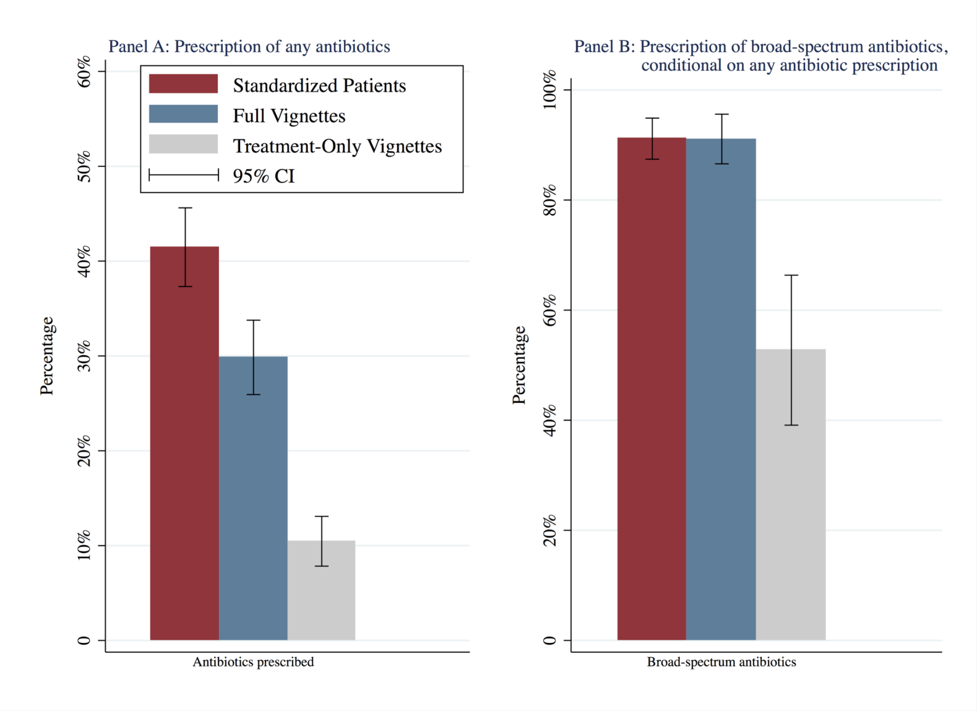
Figure 1. Antibiotic prescription in SPs visits and vignettes. This figure appears in colour in the online version of JAC and in black and white in the printed version of JAC.
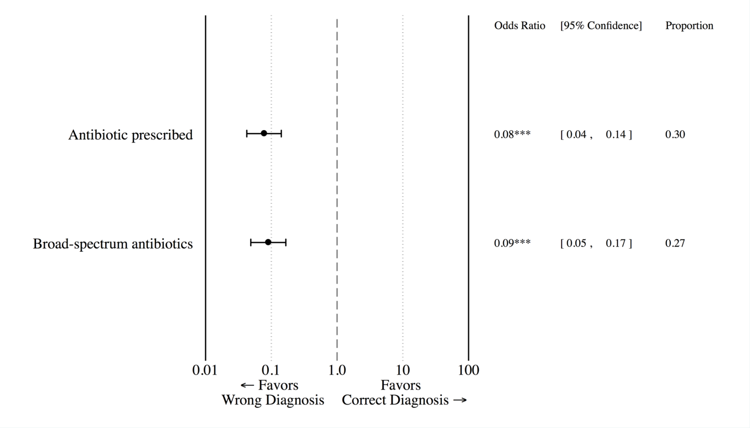
Figure 2. Correlation between antibiotic prescription and correct diagnosis in full vignettes.
Notes: This figure shows the relationship between correct diagnoses and antibiotic prescriptions in vignettes. Odds Ratios were estimated using logistic regression and adjusted for SP disease case fixed effect.
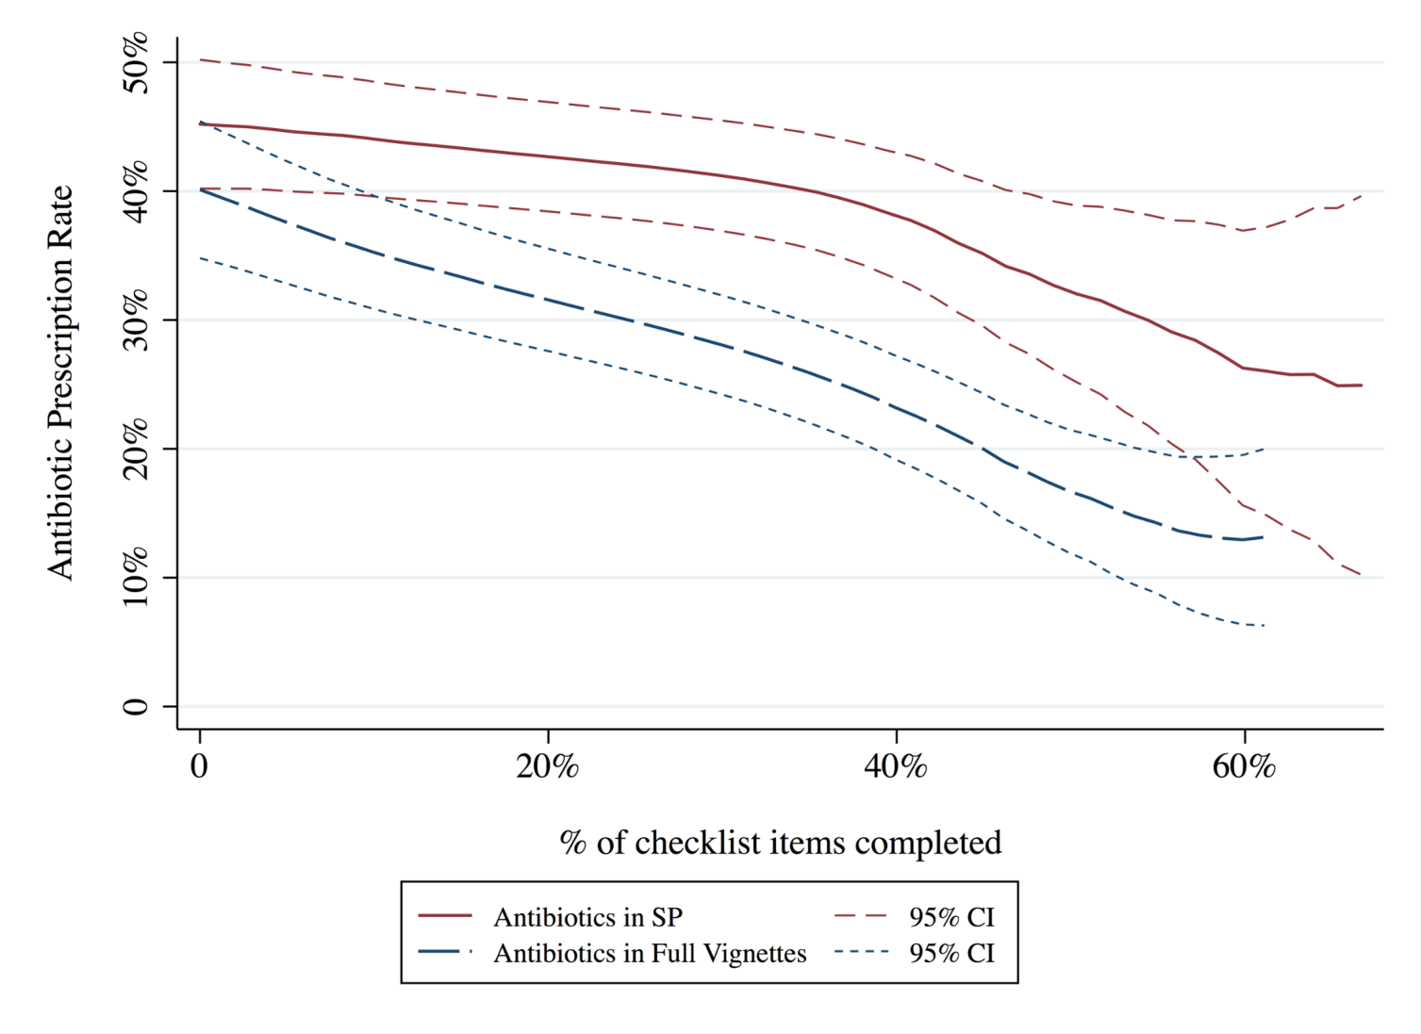
Figure 3. Association between antibiotic prescription and diagnostic checklist completion. This figure appears in colour in the online version of JAC and in black and white in the printed version of JAC.
Notes: This figure shows the nonparametric relationship between antibiotic prescriptions and checklist completion in SP and vignette interactions. These were estimated using local polynomial regressions with a bandwidth of 0.135 and are not adjusted for additional characteristics.

