515 removed (numbers in brackets represent primary exclusion reason):
17 (17) no abstract
19 (19) case reports
406 (383) cancer incidence not the outcome
386 (93) diabetes treatments not an exposure
53 (2) non-diabetic populations
29 (0) diabetic therapy use in cancer patients
3 (0) restricted to type 1 diabetes
8 (0) non-clinical cancer outcome
88 (1) reviews/comments/editorial articles
Relevant non-original data articles kept at this stage and reference lists checked.
107 no original data
36 cancer incidence not an outcome (solely mortality or effect of treatment after cancer diagnosis)
51 No age adjusted effect of metformin presented
14 comparison to non-diabetics
10 not in general population (e.g. post menopausal women, those undergoing colonoscopy)
4 no exact quantification of risk for comparison of interest. E.g. summary statistics only, comparison of incidence between trials.
1 same data source and analysis as another paper

4 identified from reference list search of systematic reviews and meta-analyses
1 identified from expert knowledge
822 studies exported
779 after removal of duplicates
264 remaining for full text scan
41 Met inclusion critreria
46 Included

Figure 1: Flow chart of screening process detailing number of studies excluded at each stage and reason for exclusions.

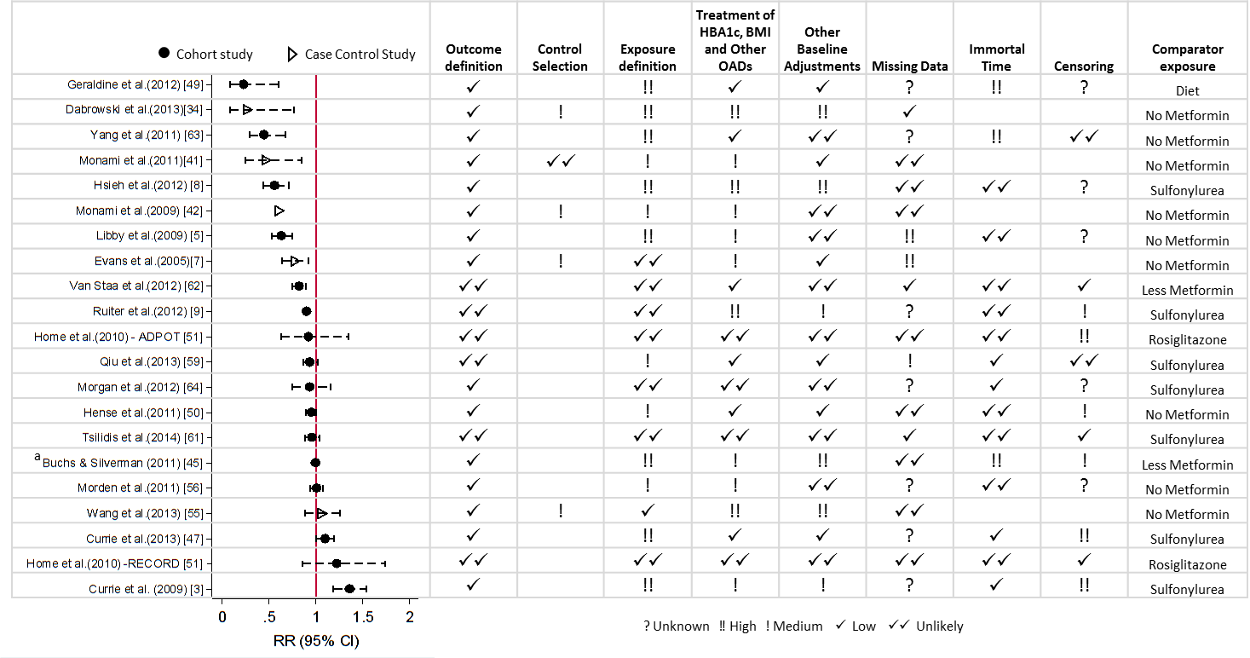Figure 2: Estimated relative risk (odds Ratio or hazard Ratio) with 95% CI for the 21 studies examining use of metformin and risk of all cancers, and corresponding assessment of bias according to pre-specified criteria. ªRepresents the hazard ratio for cancer risk per one extra prescription of metformin

Figure 3: Estimated relative risk (odds ratio or hazard ratio) with 95% CI for 4 most commonly studied site specific cancers
Case control studies are represented by hollow triangle, Cohort studies by filled circles.
Figure 4: Estimates of relative risk of cancer from metformin use, ordered by risk of bias from exposure assessment only (left) and by overall risk of bias (right).
Overall bias score is sum of bias risk over all domains, with unlikely = 0, low = 1, medium = 2, high = 3. Case control studies are represented by hollow triangle, Cohort studies by filled circle.
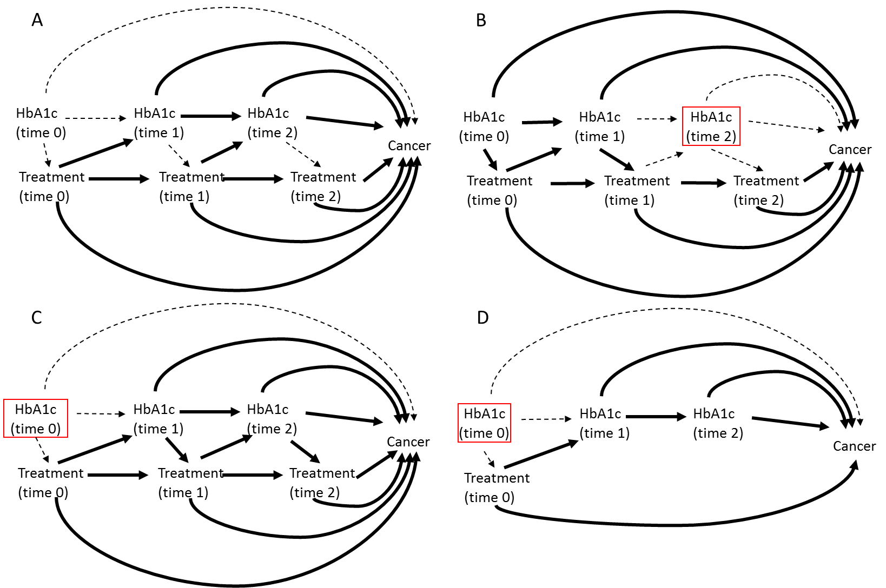

Figure 5. Directed Acyclic Graphs (DAGs) to represent estimated causal pathways for A) the desired total causal effect of treatment on cancer risk, and B)-D) the estimated effect under different methods of adjustment for time dependent confounders affected by prior treatment.
Box indicates adjustment.
Dotted line represents causal associations that are present but not included in the desired/estimated effect.
A Solid lines represent the pathways needed to estimate the total causal effect of time varying treatment on cancer.
B HbA1c measured at a single time point during the measurement window (usually the most recent value). Exposure may be time updated or assumed fixed from cohort entry. Solid line represents the pathways included in the estimate of effect under this approach.
C HbA1c measured once at/before cohort entry, exposure modelled as time varying. Solid line represents the pathways included in the estimate of effect under this approach.
D Exposure is assigned at cohort entry and assumed fixed (Intention to treat (ITT) principle), HbA1c measured once at/before cohort entry. Solid line represents the pathways included in the estimate of effect under this approach.

