**ANALYSIS**

Excluded presumed TB patients with inconclusive diagnostics

n = 34

Eligible study participants

n = 356

n =

Enrolled presumed TB patients with complete diagnosis

n = 322

n =

**Definite**

TB culture +ve

AFB positive

n = 85

**Probable**

TB culture -ve

AFB positive

n = 21

**Non TB**

TB culture -ve

AFB negative

n = 216

**Non TB**

n = 216

**Confirmed TB**

n = 106

**Figure 1**. Standards for Reporting of Diagnostic Accuracy (STARD) flow diagram for recruitment of participants with presumed TB, enrolment and exclusion. Three hundred and fifty-six individuals presumed to have pulmonary TB were enrolled from different African field sites and WBA performed. Participants were later classified as definite TB cases, probable TB cases and non TB cases using a pre-established diagnostic algorithm. Thirty-four individuals with inconclusive diagnosis were excluded from the analysis. +ve = positive, -ve = negative.

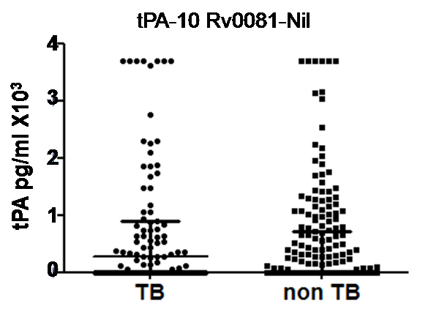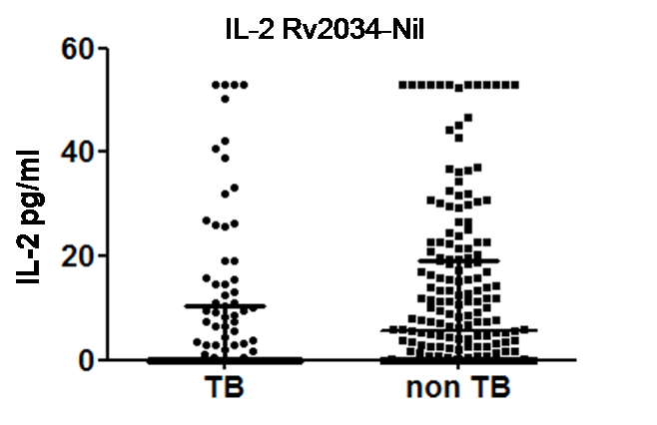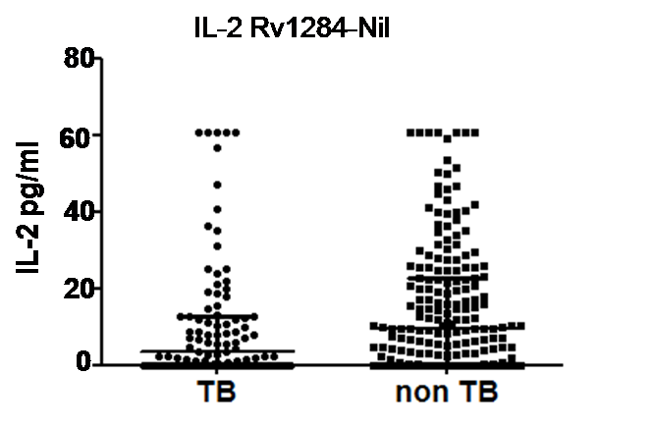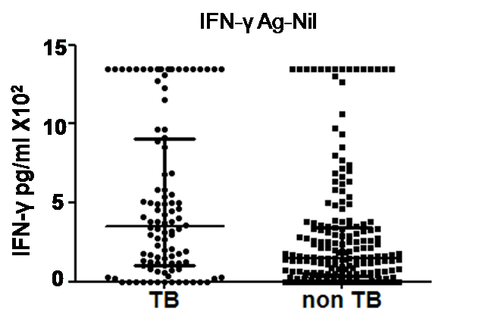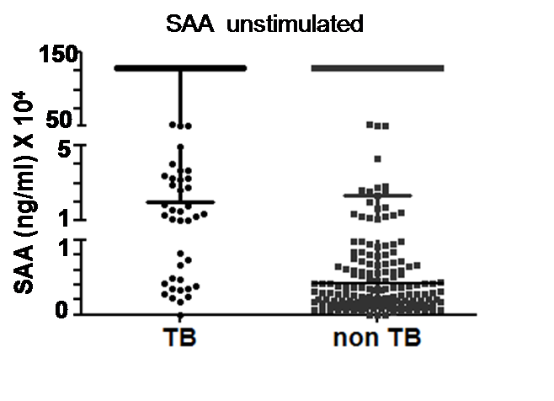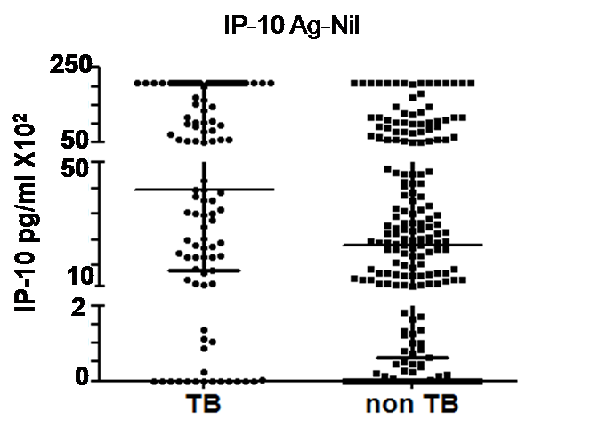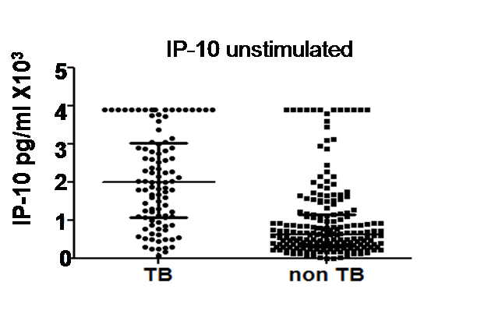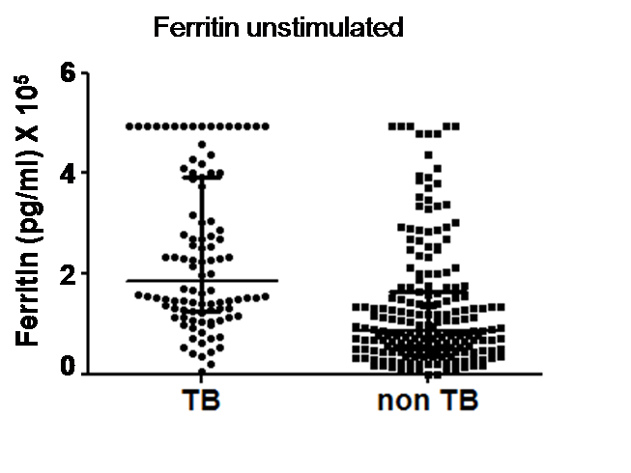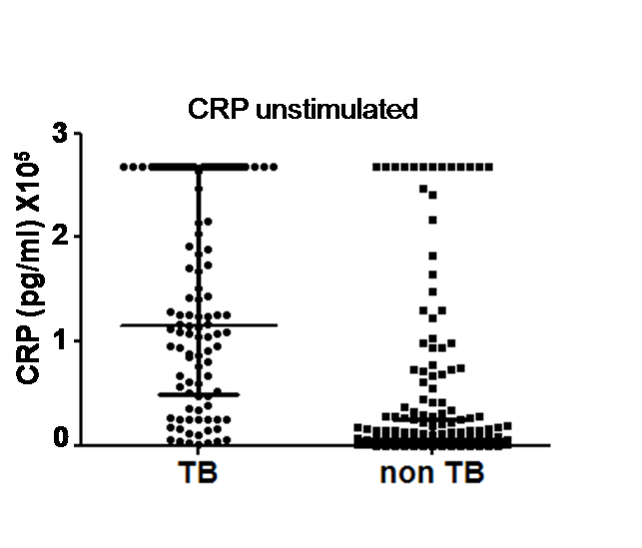**Figure 2.** Scatter-dot plots of host markers detected in unstimulated and antigen-specific overnight WBA supernatants. Statistical differences in analyte levels were evaluated by the Mann Whitney U test for non-parametric data analysis. Representative plots show the levels of analytes in the overnight whole blood culture supernatants of participants with and without TB disease. Bars in the scatter dot plots represent the median plus interquatile range of the concentration of analyte. Nil= unstimulated marker levels, Ag=ESAT-6/CFP-10 stimulated marker levels CRP=C reactive protein, SAA=Serum amyloid A, IFN=Interferon gamma, IP-10=Interferon-inducible protein-10.

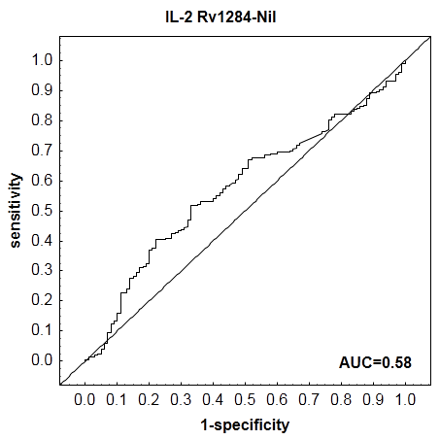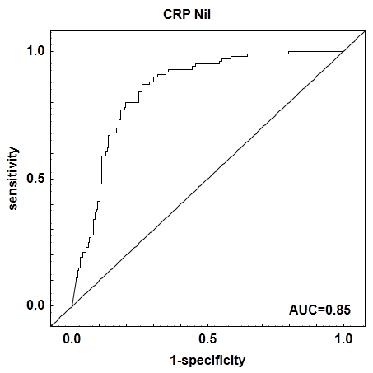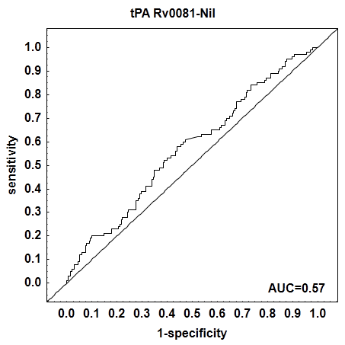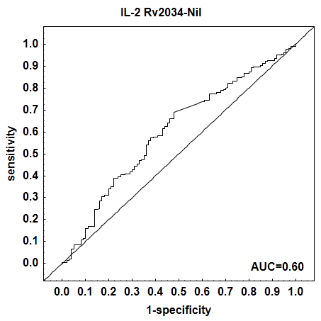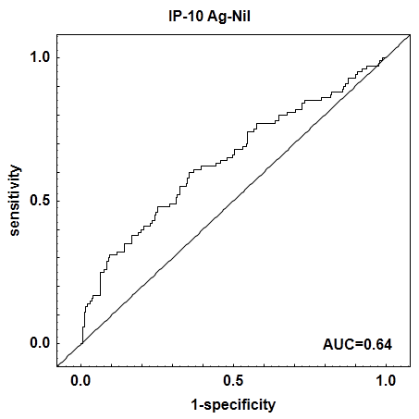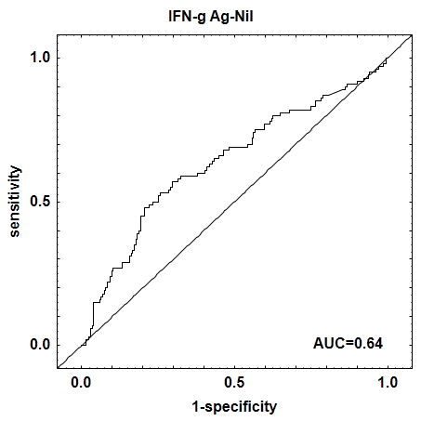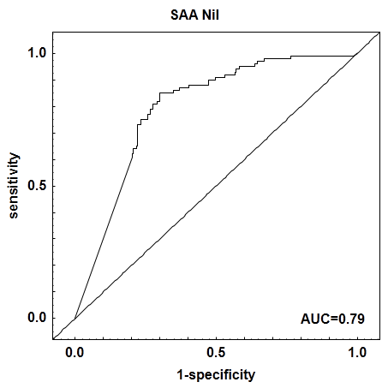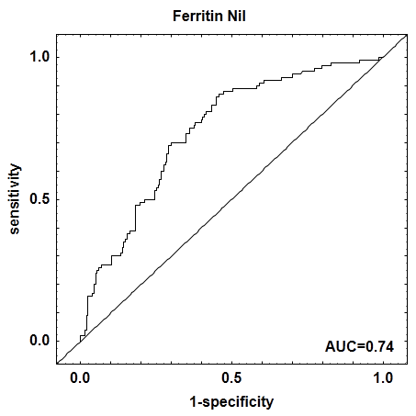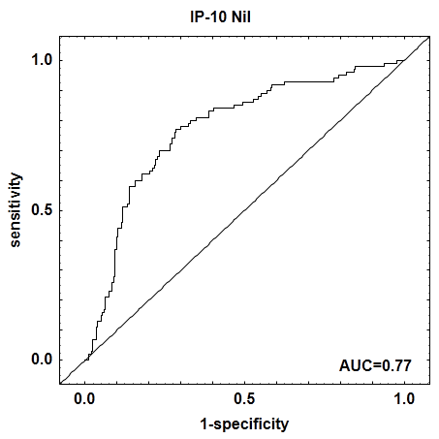**Figure 3.** Receiver operating characteristic (ROC) curvesof host markers detected in stimulated overnight WBA supernatants. Representative ROC curves showing the accuracy of the markers in discriminating between TB and non TB. All markers had area under the curve (AUC) ≥0.70 except IP-10Ag-Nil, IFN-γAg-Nil, EotaxinRv1284-Nil, IL-2Rv2334-Nil and tPARv0081-Nil. CRP=C reactive protein, SAA=Serum amyloid A, IFN-γ=Interferon gamma, IP-10=Interferon-inducible protein-10, IL= (Interleukin)-2, tPA= tissue plasminogen activator.

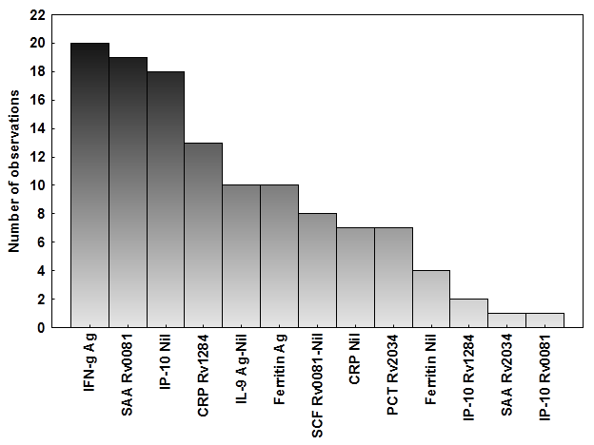

**Figure 4.** Frequency of analytes in the top 20 most accurate GDA predictive models for the classification of study participants as TB disease or non TB. Using best subsets method of variable selection, unstimulated and antigen-specific host markers were fitted into general discriminant analysis prediction models. The columns represent the number of times each analyte occurred in the top 20 general discriminatory models. Nil= unstimulated marker levels, Ag=ESAT-6/CFP-10 stimulated marker levels.