Pharyngeal carriage of Neisseria species in the African meningitis belt
Supplementary methods

General Sanger Sequencing protocol

A reaction mixture of 50μl was prepared for the PCR amplification step containing 10μl of Q Solution Buffer (Quiagen), 5μl of 10X Buffer (Quiagen), 1μl of dNTPs (Quiagen), 1μl of each primer (10uM stocks), 0.25μl Taq DNA polymerase (Quiagen) and 2μl of DNA, with the following reaction conditions: one cycle at 95 °C for 3 min, followed by 35 cycles of a sequence of three temperatures, 95°C for 30 s, 55°C for 30 s and 72°C for 1 min and a final incubation of one cycle at 72 °C for a further 10 min. The amplified reactions were purified using the PEG-NaCl precipitation method [32]. Sequencing of the cleaned DNA precipitate was done in a 10μl reaction mix containing the following: 0.5μl BigDye ready reaction mix (Life Technologies), 1.75μl of 5X dilution buffer (Life Technologies), 4μl of primer (10μM 1:15) and 2μl of DNA, with cycling condition as follow: 30 cycles of a sequence of tree temperatures, 96°C for 10 s, 50°C for 5 s and 60°C for 2 min. Sequence reactions were cleaned before sequencing on an Applied Biosystems 3730 DNA analyzer (Life Technologies).

fetA_VR sequencing protocol

Primers S1 and S8 [37] were used for the PCR amplification with the following reaction conditions: one cycle at 95 °C for 3 min, followed by 30 cycles of a sequence of three temperatures, 94°C for 1 min, 55°C for 1 min and 72°C for 1 min and a final incubation of one cycle at 72 °C for a further 5 min. The cleaned amplicons were sequenced using primer S12 (forward sequencing) and primer S15 (reverse sequencing) [37].

fnl sequencing protocol

Primers CM21 and CM24 were used for both amplification and sequencing; however, the reaction mixture was slightly different from the general method described above, in that it did not contain the Q Solution Buffer (Quiagen) and the cycling conditions were as follows: one cycle at 95°C for 3 min, followed by 35 cycles of a sequence of three temperatures, 95°C for 30 s, 56°C for 30 s and 72°C for 5 minutes and a final incubation at 72 °C for a further 10 minutes. Sequencing was done as for the other targets

Supplementary Tables
Table S1: Number of isolates identified as a Neisseria species per country
 | N meningitidis | Prevalence  [CI] | N lactamica | Prevalence  [CI] | N polysaccharea | Prevalence  [CI] | N bergeri | Prevalence  [CI] | N subflava | Prevalence  [CI] | Total | Prevalence  [CI]
*Chad N=13396 | 131 | 0.9 [0.8-1.1] | 467 | 3.5 [3.1-3.8] | 40 | 0.3 [0.2-0.4] | 47 | 0.3 [0.2-0.5] | 10 | 0.1 [0.03-0.1] | 695 | 5.3 [4.9-5.7]
Ethiopia N=5970 | 388 | 6.3 [5.6-7.1] | 268 | 4.4 [3.8-5.0] | 179 | 3.0 [2.5-3.5] | 0 | - | 3 | 0.05 [-0.01-0.1] | 838 | 13.8 [12.8-14.8]
Ghana N=5209 | 193 | 3.7 [3.1-4.3] | 217 | 4.1 [3.5-4.7] | 10 | 0.2 [0.1-0.3] | 26 | 0.5 [0.3-0.7] | 0 | - | 446 | 8.5 [7.6-9.4]
*Mali N=8837 | 79 | 0.9 [0.7-1.1] | 170 | 1.9 [1.6-2.2] | 9 | 0.1 [0.03-0.2] | 37 | 0.4 [0.3-0.6] | 3 | 0.03 [-0.004-0.] | 298 | 3.4 [2.9-3.9]
*Niger N=8213 | 532 | 6.4 [5.8-7.0] | 1094 | 13.3 [12.5-14.1] | 13 | 0.2 [0.1-0.2] | 3 | 0.04 [-0.005-0.01] | 2 | 0.02 [-0.01-0.05] | 1644 | 19.9 [18.9-20.9]
Senegal N=4409 | 356 | 8.0 [7.1-9.0] | 372 | 8.4 [7.4-9.3] | 39 | 0.9 [0.6-1.2] | 0 | - | 6 | 0.1 [0.03-0.2] | 773 | 17.5 [16.1418.8]
Total | 1679 | 3.6 [3.4-3.8] | 2588 | 5.6 [5.3-5.8] | 290 | 0.6 [0.5-0.7] | 113 | 0.2 [0.2-0.3] | 24 | 0.05 [0.03-0.1] | 4694 | 10.2 [9.8-10.5]
N corresponds to the total number of subject studied; CI: Confidence Interval
*Countries that received the serogroup A conjugate vaccine (MenAfriVac) during the study

Table S2: Frequency of f_rplf alleles by species
f_rplF | Neisseria bergeri | Neisseria lactamica | Neisseria meningitidis | Neisseria polysaccharea | Neisseria subflava | Total
6 | - | 1453 | - | - | - | 1453
2 | - | - | 749 | - | - | 749
1 | - | - | 707 | - | - | 707
52 | - | 453 | - | - | - | 453
33 | - | 318 | - | - | - | 318
9 | - | - | - | 207 | - | 207
32 | - | 186 | - | - | - | 186
34 | - | 132 | - | - | - | 132
67 | - | - | 83 | - | - | 83
63 | - | - | - | 72 | - | 72
4 | - | - | 62 | - | - | 62
62 | 57 | - | - | - | - | 57
69 | 46 | - | - | - | - | 46
88 | - | - | 41 | - | - | 41
3 | - | - | 15 | - | - | 15
43 | - | - | - | - | 15 | 15
8 | - | - | 10 | - | - | 10
112 | 9 | - | - | - | - | 9
51 | - | 8 | - | - | - | 8
80 | - | 7 | - | - | - | 7
86 | - | 6 | - | - | - | 6
90 | - | - | - | 6 | - | 6
18 | - | - | 5 | - | - | 5
65 | - | 5 | - | - | - | 5
81 | - | 5 | - | - | - | 5
96 | - | - | - | 5 | - | 5
113 | - | 4 | - | - | - | 4
64 | - | - | 3 | - | - | 3
82 | - | - | - | - | 3 | 3
91 | - | - | 3 | - | - | 3
92 | - | 3 | - | - | - | 3
94 | - | 3 | - | - | - | 3
97 | - | - | - | - | 2 | 2
111 | - | 2 | - | - | - | 2
0 | - | - | 1 | - | - | 1
16 | 1 | - | - | - | - | 1
31 | - | - | - | - | 1 | 1
38 | - | - | - | - | 1 | 1
58 | - | - | - | - | 1 | 1
85 | - | 1 | - | - | - | 1
89 | - | 1 | - | - | - | 1
93 | - | 1 | - | - | - | 1
95 | - | - | - | - | 1 | 1
Total | 113 | 2588 | 1679 | 290 | 24 | 4694

TableS3: Frequency of feta_VR alleles by countries
fetA_VR | Chad | Ethiopia | Ghana | Mali | Niger | Senegal | Total
ND | 92 | 109 | 48 | 80 | 278 | 36 | 643
fnl | 31 | 135 | 2 | 10 | 321 | 20 | 519
F1-1 | 2 | 4 | 77 | 6 | 132 | 239 | 460
F1-31 | 15 | 15 | 2 | 1 | 199 | 3 | 235
F5-1 | 13 | 1 | 95 | 8 | 17 | 4 | 138
F1-62 | 10 | - | 79 | 9 | 30 | 2 | 130
F1-72 | 2 | 5 | 1 | 9 | 34 | 42 | 93
F1-29 | 14 | 26 | 3 | 2 | 25 | 21 | 91
F1-3 | 4 | 42 | 3 | 6 | 4 | 30 | 89
F1-21 | 37 | 24 | - | - | 19 | - | 80
F4-5 | 7 | 4 | 13 | 3 | 23 | 16 | 66
F4-6 | 15 | 1 | 1 | 4 | 32 | 12 | 65
F1-100 | 3 | - | 7 | 1 | 16 | 32 | 59
F5-133 | 6 | 3 | - | 2 | 2 | 44 | 57
F2-24 | 2 | 42 | 4 | 2 | 1 | 5 | 56
F5-34 | 20 | 14 | 1 | 6 | 10 | 3 | 54
F3-1 | 44 | 1 | - | - | - | 7 | 52
F6-3 | 1 | - | - | 30 | 5 | 16 | 52
F7-3 | 2 | 44 | - | - | 3 | - | 49
F3-60 | - | 47 | - | - | - | - | 47
F6-2 | 12 | 3 | 1 | 2 | 20 | 8 | 46
F4-17 | 14 | - | 9 | - | 19 | 3 | 45
F1-24 | 8 | 11 | - | - | 25 | - | 44
F5-84 | 4 | - | 2 | 22 | 2 | 13 | 43
F1-120 | 14 | - | 1 | 3 | 22 | 1 | 41
F5-12 | 8 | 2 | 3 | 9 | 13 | 3 | 38
F2-17 | - | - | - | 1 | 34 | 2 | 37
F3-22 | 5 | 10 | - | 4 | 14 | 2 | 35
F1-155 | 10 | - | 4 | 17 | - | 3 | 34
F5-5 | 1 | 27 | 2 | - | - | 4 | 34
F2-23 | 3 | - | 6 | 1 | 20 | 3 | 33
F1-101 | 16 | - | 3 | 2 | 11 | - | 32
F1-153 | 12 | 17 | - | - | 1 | 1 | 31
F1-160 | 15 | - | 1 | 1 | 11 | 2 | 30
F4-19 | 21 | 4 | - | - | 4 | - | 29
F1-7 | - | 20 | 1 | - | 3 | 4 | 28
F5-66 | 14 | - | 6 | 1 | 5 | 2 | 28
F1-145 | 9 | 9 | 1 | 2 | 6 | - | 27
F1-38 | - | - | - | 3 | 1 | 23 | 27
F5-18 | 10 | - | 9 | - | 8 | - | 27
F4-23 | 14 | 9 | 2 | - | 1 | - | 26
F5-88 | 6 | - | 1 | - | 13 | 6 | 26
F1-104 | 3 | - | 11 | 2 | - | 9 | 25
F1-58 | - | - | - | 6 | 3 | 16 | 25
F1-84 | 2 | 11 | - | 1 | 11 | - | 25
F11-4 | - | 25 | - | - | - | - | 25
F1-156 | 5 | - | 2 | 4 | 6 | 4 | 21
F1-46 | - | - | - | - | 21 | - | 21
F1-49 | 7 | 6 | - | - | 6 | 2 | 21
F3-57 | - | - | - | 2 | 17 | 1 | 20
F4-28 | 3 | 2 | 1 | - | 11 | 3 | 20
F1-186 | 3 | 10 | - | - | 6 | - | 19
F5-127 | 2 | 4 | 1 | 1 | 5 | 6 | 19
F4-2 | - | - | - | 1 | - | 17 | 18
F5-25 | 1 | - | - | - | 17 | - | 18
F3-3 | 6 | 6 | 1 | 3 | - | 1 | 17
F5-69 | 4 | 1 | 6 | - | 5 | 1 | 17
F5-8 | - | 14 | 2 | - | - | - | 16
F6-7 | - | 16 | - | - | - | - | 16
F1-173 | 10 | - | - | - | 4 | - | 14
F1-35 | - | 8 | - | - | 6 | - | 14
F1-81 | - | - | - | - | - | 14 | 14
F3-56 | - | - | 2 | - | 12 | - | 14
F4-1 | 1 | 7 | - | 1 | - | 5 | 14
F1-89 | 1 | - | - | - | 10 | 1 | 12
F3-43 | 4 | 4 | - | 1 | 1 | 2 | 12
F5-101 | - | - | - | 1 | 8 | 2 | 11
F5-140 | 6 | - | 1 | - | 4 | - | 11
F6-6 | 1 | 4 | - | - | 6 | - | 11
F1-28 | - | 8 | 1 | - | 1 | - | 10
F3-18 | - | 9 | - | 1 | - | - | 10
F5-77 | 1 | - | - | - | 8 | 1 | 10
F1-197 | - | - | - | - | 6 | 3 | 9
F4-51 | 2 | - | - | 2 | 5 | - | 9
F5-24 | - | - | - | 8 | 1 | - | 9
F1-22 | 8 | - | - | - | - | - | 8
F3-12 | 2 | 1 | - | - | - | 5 | 8
F5-149 | - | - | 4 | - | 4 | - | 8
F5-9 | 1 | 5 | 2 | - | - | - | 8
F1-174 | 7 | - | - | - | - | - | 7
F1-192 | - | - | - | - | 6 | 1 | 7
F2-14 | - | 6 | - | - | - | 1 | 7
F2-6 | - | - | - | - | - | 7 | 7
F4-38 | 5 | - | 1 | - | 1 | - | 7
F5-70 | 4 | - | 1 | - | 2 | - | 7
F5-87 | 1 | - | - | - | 6 | - | 7
F1-170 | 6 | - | - | - | - | - | 6
F1-172 | 4 | - | - | - | 2 | - | 6
F1-5 | 2 | 2 | 1 | - | - | 1 | 6
F2-32 | - | - | - | - | - | 6 | 6
F7-2 | 5 | - | - | - | 1 | - | 6
F1-183 | - | - | 2 | - | 2 | 1 | 5
F1-20 | - | 5 | - | - | - | - | 5
F1-209 | - | - | 4 | - | 1 | - | 5
F1-55 | - | 5 | - | - | - | - | 5
F3-28 | - | - | - | - | 4 | 1 | 5
F5-132 | 3 | - | - | 1 | 1 | - | 5
F5-17 | 1 | 2 | - | - | - | 2 | 5
F5-71 | - | - | - | 3 | 1 | 1 | 5
F6-4 | - | - | - | 1 | - | 4 | 5
F1-152 | 4 | - | - | - | - | - | 4
F1-177 | 4 | - | - | - | - | - | 4
F1-189 | - | - | 4 | - | - | - | 4
F1-47 | - | 1 | - | - | 3 | - | 4
F1-51 | - | 4 | - | - | - | - | 4
F1-80 | - | 1 | - | - | - | 3 | 4
F1-96 | 4 | - | - | - | - | - | 4
F11-3 | 1 | - | 3 | - | - | - | 4
F2-9 | - | 4 | - | - | - | - | 4
F5-137 | - | - | - | - | - | 4 | 4
F5-145 | 4 | - | - | - | - | - | 4
F5-4 | - | 1 | - | - | 2 | 1 | 4
F5-59 | - | 4 | - | - | - | - | 4
F5-91 | 2 | 2 | - | - | - | - | 4
F1-176 | 1 | - | - | - | 2 | - | 3
F1-181 | 3 | - | - | - | - | - | 3
F1-182 | 3 | - | - | - | - | - | 3
F1-184 | - | 3 | - | - | - | - | 3
F1-187 | - | 1 | - | - | 2 | - | 3
F1-196 | - | - | - | - | 2 | 1 | 3
F1-37 | - | - | - | 1 | - | 2 | 3
F1-52 | - | - | - | - | - | 3 | 3
F11-1 | 1 | - | - | 2 | - | - | 3
F11-7 | 2 | - | - | - | 1 | - | 3
F2-31 | - | 3 | - | - | - | - | 3
F3-6 | - | - | - | - | - | 3 | 3
F3-9 | 1 | 2 | - | - | - | - | 3
F5-134 | - | 3 | - | - | - | - | 3
F5-142 | 1 | - | - | - | 2 | - | 3
F5-146 | 3 | - | - | - | - | - | 3
F5-95 | - | - | - | 1 | - | 2 | 3
F1-158 | - | - | - | 2 | - | - | 2
F1-175 | 2 | - | - | - | - | - | 2
F1-178 | 2 | - | - | - | - | - | 2
F1-18 | - | 2 | - | - | - | - | 2
F1-190 | - | - | 2 | - | - | - | 2
F1-199 | - | - | - | - | 2 | - | 2
F1-2 | 2 | - | - | - | - | - | 2
F1-200 | - | - | - | - | 2 | - | 2
F1-64 | - | 2 | - | - | - | - | 2
F1-90 | - | - | - | 2 | - | - | 2
F11-2 | - | - | 1 | - | 1 | - | 2
F11-5 | - | - | - | - | 1 | 1 | 2
F11-8 | 2 | - | - | - | - | - | 2
F2-12 | 2 | - | - | - | - | - | 2
F2-13 | 2 | - | - | - | - | - | 2
F3-13 | - | 2 | - | - | - | - | 2
F3-59 | 2 | - | - | - | - | - | 2
F4-57 | - | - | 2 | - | - | - | 2
F4-60 | - | 2 | - | - | - | - | 2
F4-63 | - | - | - | - | 2 | - | 2
F4-64 | - | - | - | - | 2 | - | 2
F4-65 | - | - | - | - | 2 | - | 2
F4-66 | - | - | - | - | 2 | - | 2
F5-143 | 2 | - | - | - | - | - | 2
F5-151 | - | 2 | - | - | - | - | 2
F5-154 | - | - | - | - | - | 2 | 2
F5-155 | - | - | - | - | - | 2 | 2
F5-160 | - | - | - | - | 2 | - | 2
F5-19 | - | - | - | - | - | 2 | 2
F1-119 | - | - | - | - | - | 1 | 1
F1-15 | 1 | - | - | - | - | - | 1
F1-157 | - | - | - | 1 | - | - | 1
F1-159 | - | - | - | 1 | - | - | 1
F1-167 | - | - | - | 1 | - | - | 1
F1-169 | 1 | - | - | - | - | - | 1
F1-171 | 1 | - | - | - | - | - | 1
F1-179 | 1 | - | - | - | - | - | 1
F1-180 | 1 | - | - | - | - | - | 1
F1-185 | - | 1 | - | - | - | - | 1
F1-188 | - | 1 | - | - | - | - | 1
F1-19 | - | - | 1 | - | - | - | 1
F1-191 | - | - | - | - | - | 1 | 1
F1-193 | - | - | - | - | - | 1 | 1
F1-194 | - | - | - | - | - | 1 | 1
F1-195 | - | - | - | - | - | 1 | 1
F1-198 | - | - | - | - | 1 | - | 1
F1-201 | - | - | - | - | 1 | - | 1
F1-202 | - | - | - | - | 1 | - | 1
F1-203 | - | - | - | - | 1 | - | 1
F1-204 | - | - | - | - | 1 | - | 1
F1-205 | - | - | - | - | 1 | - | 1
F1-206 | - | - | - | - | 1 | - | 1
F1-207 | - | - | - | - | 1 | - | 1
F1-208 | - | - | - | - | 1 | - | 1
F1-33 | - | - | - | - | - | 1 | 1
F1-68 | - | 1 | - | - | - | - | 1
F1-94 | - | - | - | - | - | 1 | 1
F1-99 | - | 1 | - | - | - | - | 1
F10-1 | 1 | - | - | - | - | - | 1
F11-6 | - | - | - | - | 1 | - | 1
F2-33 | - | - | - | - | 1 | - | 1
F2-7 | - | - | - | - | 1 | - | 1
F3-5 | - | 1 | - | - | - | - | 1
F3-61 | - | 1 | - | - | - | - | 1
F3-62 | - | 1 | - | - | - | - | 1
F3-63 | - | - | - | - | - | 1 | 1
F3-64 | - | - | - | - | - | 1 | 1
F3-65 | - | - | - | - | 1 | - | 1
F3-66 | - | 1 | - | - | - | - | 1
F4-12 | - | - | - | - | 1 | - | 1
F4-21 | - | - | - | - | - | 1 | 1
F4-24 | 1 | - | - | - | - | - | 1
F4-25 | - | - | - | - | - | 1 | 1
F4-58 | - | - | 1 | - | - | - | 1
F4-59 | - | 1 | - | - | - | - | 1
F4-61 | - | - | - | - | - | 1 | 1
F4-62 | - | - | - | - | - | 1 | 1
F5-115 | - | - | - | - | 1 | - | 1
F5-118 | 1 | - | - | - | - | - | 1
F5-13 | - | - | - | - | - | 1 | 1
F5-131 | - | - | - | 1 | - | - | 1
F5-139 | 1 | - | - | - | - | - | 1
F5-141 | 1 | - | - | - | - | - | 1
F5-144 | 1 | - | - | - | - | - | 1
F5-147 | 1 | - | - | - | - | - | 1
F5-150 | - | 1 | - | - | - | - | 1
F5-152 | - | - | 1 | - | - | - | 1
F5-153 | - | - | - | - | - | 1 | 1
F5-156 | - | - | - | - | - | 1 | 1
F5-157 | - | - | - | - | 1 | - | 1
F5-158 | - | - | - | - | 1 | - | 1
F5-159 | - | - | - | - | 1 | - | 1
F5-161 | 1 | - | - | - | - | - | 1
F5-162 | - | - | - | - | 1 | - | 1
F5-163 | - | - | - | - | 1 | - | 1
F5-164 | 1 | - | - | - | - | - | 1
F5-165 | 1 | - | - | - | - | - | 1
F5-166 | 1 | - | - | - | - | - | 1
F5-2 | - | - | - | - | - | 1 | 1
F5-67 | 1 | - | - | - | - | - | 1
F5-68 | - | 1 | - | - | - | - | 1
F5-81 | - | 1 | - | - | - | - | 1
F6-5 | - | - | - | 1 | - | - | 1
F7-4 | 1 | - | - | - | - | - | 1
Total | 715 | 841 | 446 | 299 | 1645 | 773 | 4699

Table S4: Frequency of fetA_VR alleles by survey

fetA_VR | survey 1 | survey 2 | survey 3 | Total
ND | 247 | 221 | 175 | 643
fnl | 280 | 104 | 130 | 514
F1-1 | 56 | 61 | 342 | 459
F1-31 | 122 | 65 | 48 | 235
F5-1 | 26 | 68 | 44 | 138
F1-62 | 27 | 67 | 36 | 130
F1-72 | 36 | 42 | 15 | 93
F1-29 | 32 | 34 | 25 | 91
F1-3 | 28 | 43 | 18 | 89
F1-21 | 19 | 39 | 22 | 80
F4-5 | 25 | 22 | 19 | 66
F4-6 | 30 | 18 | 17 | 65
F1-100 | 16 | 25 | 18 | 59
F5-133 | 19 | 22 | 16 | 57
F2-24 | 9 | 27 | 19 | 55
F5-34 | 15 | 27 | 12 | 54
F3-1 | 10 | 40 | 2 | 52
F6-3 | 9 | 14 | 29 | 52
F7-3 | 15 | 13 | 20 | 48
F3-60 | 6 | 24 | 17 | 47
F6-2 | 18 | 12 | 16 | 46
F4-17 | 11 | 17 | 17 | 45
F1-24 | 9 | 23 | 12 | 44
F5-84 | 22 | 9 | 12 | 43
F1-120 | 16 | 17 | 8 | 41
F2-17 | 26 | 4 | 7 | 37
F5-12 | 20 | 9 | 8 | 37
F3-22 | 18 | 9 | 8 | 35
F1-155 | 15 | 14 | 5 | 34
F5-5 | 16 | 11 | 7 | 34
F2-23 | 12 | 15 | 6 | 33
F1-101 | 5 | 18 | 9 | 32
F1-153 | 4 | 17 | 10 | 31
F1-160 | 5 | 11 | 14 | 30
F4-19 | 2 | 23 | 4 | 29
F1-7 | 12 | 9 | 7 | 28
F5-66 | 4 | 15 | 9 | 28
F1-145 | 6 | 13 | 8 | 27
F1-38 | 8 | 16 | 3 | 27
F5-18 | 3 | 13 | 11 | 27
F4-23 | 7 | 10 | 9 | 26
F5-88 | 7 | 5 | 14 | 26
F1-104 | 2 | 11 | 12 | 25
F1-58 | 11 | 10 | 4 | 25
F1-84 | 8 | 5 | 12 | 25
F11-4 | 12 | 7 | 6 | 25
F1-156 | 7 | 12 | 2 | 21
F1-46 | 11 | 2 | 8 | 21
F1-49 | 7 | 8 | 6 | 21
F3-57 | 10 | 9 | 1 | 20
F4-28 | 8 | 9 | 3 | 20
F5-127 | 8 | 7 | 4 | 19
F1-186 | 5 | 8 | 5 | 18
F4-2 | 5 | 13 | - | 18
F5-25 | 13 | 5 | - | 18
F3-3 | 4 | 11 | 2 | 17
F5-69 | 2 | 13 | 2 | 17
F5-8 | 12 | 4 | - | 16
F6-7 | 7 | 5 | 4 | 16
F1-173 | 1 | 9 | 4 | 14
F1-35 | 7 | 3 | 4 | 14
F1-81 | 4 | 8 | 2 | 14
F3-56 | 5 | 4 | 5 | 14
F4-1 | 6 | 5 | 3 | 14
F1-89 | 9 | 3 | - | 12
F3-43 | 6 | 6 | - | 12
F5-101 | 6 | 4 | 1 | 11
F5-140 | 3 | 5 | 3 | 11
F6-6 | 1 | 4 | 6 | 11
F1-28 | - | 8 | 2 | 10
F3-18 | 3 | 5 | 2 | 10
F5-77 | 3 | 3 | 4 | 10
F1-197 | 6 | 1 | 2 | 9
F4-51 | 4 | 4 | 1 | 9
F5-24 | 5 | 4 | - | 9
F1-22 | 1 | 6 | 1 | 8
F3-12 | 1 | 5 | 2 | 8
F5-149 | 3 | 4 | 1 | 8
F5-9 | 2 | 4 | 2 | 8
F1-174 | - | 3 | 4 | 7
F1-192 | 5 | - | 2 | 7
F2-14 | 1 | 2 | 4 | 7
F2-6 | 1 | 4 | 2 | 7
F4-38 | - | 5 | 2 | 7
F5-70 | - | 6 | 1 | 7
F5-87 | 3 | 3 | 1 | 7
F1-170 | 1 | 5 | - | 6
F1-172 | 2 | 3 | 1 | 6
F1-5 | - | 4 | 2 | 6
F2-32 | 3 | 2 | 1 | 6
F7-2 | - | 4 | 2 | 6
F1-183 | 2 | 2 | 1 | 5
F1-20 | - | 3 | 2 | 5
F1-209 | 1 | - | 4 | 5
F1-55 | 3 | 2 | - | 5
F3-28 | 2 | - | 3 | 5
F5-132 | - | 4 | 1 | 5
F5-17 | 2 | 2 | 1 | 5
F5-71 | 2 | 2 | 1 | 5
F6-4 | 2 | - | 3 | 5
F1-152 | - | 1 | 3 | 4
F1-177 | - | 2 | 2 | 4
F1-189 | - | 1 | 3 | 4
F1-47 | - | 1 | 3 | 4
F1-51 | - | 3 | 1 | 4
F1-80 | 2 | 2 | - | 4
F1-96 | - | 2 | 2 | 4
F11-3 | - | 4 | - | 4
F2-9 | 2 | 2 | - | 4
F5-137 | - | 1 | 3 | 4
F5-145 | - | 2 | 2 | 4
F5-4 | 2 | 1 | 1 | 4
F5-59 | - | - | 4 | 4
F5-91 | - | 2 | 2 | 4
F1-176 | 1 | 2 | - | 3
F1-181 | - | 3 | - | 3
F1-182 | - | 3 | - | 3
F1-184 | 1 | - | 2 | 3
F1-187 | 2 | 1 | - | 3
F1-196 | - | 1 | 2 | 3
F1-37 | 1 | 2 | - | 3
F1-52 | - | 3 | - | 3
F11-1 | 1 | 1 | 1 | 3
F11-7 | - | 2 | 1 | 3
F2-31 | - | 2 | 1 | 3
F3-6 | 3 | - | - | 3
F3-9 | 1 | 1 | 1 | 3
F5-134 | 1 | 1 | 1 | 3
F5-142 | - | 2 | 1 | 3
F5-146 | - | 2 | 1 | 3
F5-95 | - | - | 3 | 3
F1-158 | - | 2 | - | 2
F1-175 | - | 2 | - | 2
F1-178 | - | 1 | 1 | 2
F1-18 | 2 | - | - | 2
F1-190 | - | - | 2 | 2
F1-199 | 2 | - | - | 2
F1-2 | 1 | 1 | - | 2
F1-200 | 1 | - | 1 | 2
F1-64 | 1 | 1 | - | 2
F1-90 | - | 1 | 1 | 2
F11-2 | - | - | 2 | 2
F11-5 | - | 1 | 1 | 2
F11-8 | - | 2 | - | 2
F2-12 | - | 1 | 1 | 2
F2-13 | - | - | 2 | 2
F3-13 | 2 | - | - | 2
F3-59 | - | 2 | - | 2
F4-57 | - | 2 | - | 2
F4-60 | - | 1 | 1 | 2
F4-63 | 2 | - | - | 2
F4-64 | 2 | - | - | 2
F4-65 | 1 | 1 | - | 2
F4-66 | - | 2 | - | 2
F5-143 | - | 1 | 1 | 2
F5-151 | - | - | 2 | 2
F5-154 | - | 2 | - | 2
F5-155 | - | 1 | 1 | 2
F5-160 | 1 | - | 1 | 2
F5-19 | - | 2 | - | 2
F1-119 | - | 1 | - | 1
F1-15 | 1 | - | - | 1
F1-157 | - | 1 | - | 1
F1-159 | 1 | - | - | 1
F1-167 | 1 | - | - | 1
F1-169 | 1 | - | - | 1
F1-171 | - | 1 | - | 1
F1-179 | - | - | 1 | 1
F1-180 | - | - | 1 | 1
F1-185 | - | 1 | - | 1
F1-188 | - | - | 1 | 1
F1-19 | - | - | 1 | 1
F1-191 | 1 | - | - | 1
F1-193 | 1 | - | - | 1
F1-194 | 1 | - | - | 1
F1-195 | 1 | - | - | 1
F1-198 | 1 | - | - | 1
F1-201 | 1 | - | - | 1
F1-202 | 1 | - | - | 1
F1-203 | 1 | - | - | 1
F1-204 | 1 | - | - | 1
F1-205 | - | - | 1 | 1
F1-206 | - | - | 1 | 1
F1-207 | 1 | - | - | 1
F1-208 | 1 | - | - | 1
F1-33 | 1 | - | - | 1
F1-68 | - | - | 1 | 1
F1-94 | - | - | 1 | 1
F1-99 | - | - | 1 | 1
F10-1 | - | - | 1 | 1
F11-6 | - | 1 | - | 1
F2-33 | - | 1 | - | 1
F2-7 | 1 | - | - | 1
F3-5 | - | 1 | - | 1
F3-61 | - | 1 | - | 1
F3-62 | - | - | 1 | 1
F3-63 | - | 1 | - | 1
F3-64 | - | - | 1 | 1
F3-65 | 1 | - | - | 1
F3-66 | - | - | - | 1
F4-12 | 1 | - | - | 1
F4-21 | - | 1 | - | 1
F4-24 | - | - | 1 | 1
F4-25 | 1 | - | - | 1
F4-58 | - | - | 1 | 1
F4-59 | 1 | - | - | 1
F4-61 | - | - | - | 1
F4-62 | - | - | 1 | 1
F5-115 | 1 | - | - | 1
F5-118 | - | 1 | - | 1
F5-13 | - | 1 | - | 1
F5-131 | - | 1 | - | 1
F5-139 | - | 1 | - | 1
F5-141 | - | 1 | - | 1
F5-144 | - | 1 | - | 1
F5-147 | - | - | 1 | 1
F5-150 | - | 1 | - | 1
F5-152 | - | 1 | - | 1
F5-153 | 1 | - | - | 1
F5-156 | - | - | 1 | 1
F5-157 | 1 | - | - | 1
F5-158 | 1 | - | - | 1
F5-159 | - | 1 | - | 1
F5-161 | 1 | - | - | 1
F5-162 | 1 | - | - | 1
F5-163 | 1 | - | - | 1
F5-164 | - | 1 | - | 1
F5-165 | - | 1 | - | 1
F5-166 | - | - | 1 | 1
F5-2 | 1 | - | - | 1
F5-67 | - | 1 | - | 1
F5-68 | - | 1 | - | 1
F5-81 | - | - | 1 | 1
F6-5 | - | 1 | - | 1
F7-4 | - | - | 1 | 1
fnl;F1-1 | 1 | - | - | 1
fnl;F1-186 | - | 1 | - | 1
fnl;F2-24 | - | 1 | - | 1
fnl;F5-12 | - | - | 1 | 1
fnl;F7-3 | - | 1 | - | 1
Total | 1,573 | 1,660 | 1,461 | 4,694

Table S5: Frequency of fetA_VR alleles by species

fetA_VR allele | Neisseria bergeri | Neisseria lactamica | Neisseria meningitidis | Neisseria polysaccharea | Neisseria subflava | Total
ND | 67 | 375 | 118 | 75 | 7 | 642
fnl | - | 2 | 517 | - | - | 519
F1-1 | - | 1 | 459 | - | - | 460
F1-31 | 1 | 229 | 3 | - | 2 | 235
F5-1 | - | - | 138 | - | - | 138
F1-62 | 4 | 122 | 2 | 1 | 1 | 130
F1-72 | - | 63 | 3 | 27 | - | 93
F1-29 | - | 90 | 1 | - | - | 91
F1-3 | - | 7 | 81 | 1 | - | 89
F1-21 | - | 66 | 11 | 2 | 1 | 80
F4-5 | 2 | 59 | 5 | - | - | 66
F4-6 | - | 56 | 3 | 5 | 1 | 65
F1-100 | - | 58 | - | - | 1 | 59
F5-133 | - | 54 | 3 | - | - | 57
F2-24 | 1 | 13 | 10 | 32 | - | 56
F5-34 | - | 50 | 3 | 1 | - | 54
F3-1 | - | - | 52 | - | - | 52
F6-3 | - | 25 | 25 | 2 | - | 52
F7-3 | - | 3 | 2 | 44 | - | 49
F3-60 | - | 46 | 1 | - | - | 47
F6-2 | 3 | 36 | 1 | 5 | 1 | 46
F4-17 | - | 44 | 1 | - | - | 45
F1-24 | - | 43 | 1 | - | - | 44
F5-84 | - | 43 | - | - | - | 43
F1-120 | - | 40 | - | - | 1 | 41
F5-12 | - | 35 | 3 | - | - | 38
F2-17 | - | 37 | - | - | - | 37
F3-22 | 1 | 24 | 10 | - | - | 35
F1-155 | - | 34 | - | - | - | 34
F5-5 | - | - | 34 | - | - | 34
F2-23 | 1 | 30 | 2 | - | - | 33
F1-101 | 4 | 28 | - | - | - | 32
F1-153 | - | 20 | 6 | 5 | - | 31
F1-160 | 1 | 28 | - | - | 1 | 30
F4-19 | - | 28 | - | - | 1 | 29
F5-66 | - | 16 | 12 | - | - | 28
F1-7 | - | 1 | 27 | - | - | 28
F5-18 | - | 27 | - | - | - | 27
F1-38 | - | 25 | 2 | - | - | 27
F1-145 | 2 | 18 | - | 7 | - | 27
F5-88 | 1 | 25 | - | - | - | 26
F4-23 | - | 2 | 24 | - | - | 26
F1-84 | - | 22 | 2 | - | 1 | 25
F1-58 | 2 | 20 | - | 3 | - | 25
F1-104 | 7 | 16 | 1 | 1 | - | 25
F11-4 | - | - | - | 25 | - | 25
F1-46 | - | 21 | - | - | - | 21
F1-49 | - | 19 | 2 | - | - | 21
F1-156 | - | 16 | 2 | 3 | - | 21
F3-57 | - | 20 | - | - | - | 20
F4-28 | - | 13 | 4 | 3 | - | 20
F1-186 | - | 18 | 1 | - | - | 19
F5-127 | - | 14 | 4 | 1 | - | 19
F4-2 | - | 18 | - | - | - | 18
F5-25 | - | 18 | - | - | - | 18
F3-3 | - | 15 | 2 | - | - | 17
F5-69 | 3 | 11 | 3 | - | - | 17
F5-8 | - | - | 16 | - | - | 16
F6-7 | - | - | - | 16 | - | 16
F3-56 | - | 14 | - | - | - | 14
F1-81 | - | 12 | 1 | 1 | - | 14
F1-173 | - | 11 | - | 3 | - | 14
F1-35 | - | 11 | 3 | - | - | 14
F4-1 | - | - | 14 | - | - | 14
F1-89 | - | 12 | - | - | - | 12
F3-43 | - | 10 | 1 | 1 | - | 12
F5-101 | - | 11 | - | - | - | 11
F5-140 | - | 11 | - | - | - | 11
F6-6 | - | 9 | - | 2 | - | 11
F1-28 | - | 10 | - | - | - | 10
F3-18 | - | 10 | - | - | - | 10
F5-77 | - | 10 | - | - | - | 10
F1-197 | - | 9 | - | - | - | 9
F5-24 | - | 8 | - | - | 1 | 9
F4-51 | 2 | 7 | - | - | - | 9
F1-22 | - | 8 | - | - | - | 8
F3-12 | - | 8 | - | - | - | 8
F5-149 | - | 5 | - | 3 | - | 8
F5-9 | - | 3 | 5 | - | - | 8
F1-192 | - | 7 | - | - | - | 7
F2-6 | - | 7 | - | - | - | 7
F5-70 | - | 7 | - | - | - | 7
F2-14 | - | 6 | 1 | - | - | 7
F4-38 | - | 6 | - | - | 1 | 7
F5-87 | - | 6 | 1 | - | - | 7
F1-174 | - | 1 | - | 6 | - | 7
F1-170 | - | 6 | - | - | - | 6
F1-172 | - | 6 | - | - | - | 6
F1-5 | - | - | 6 | - | - | 6
F2-32 | - | 5 | 1 | - | - | 6
F7-2 | 2 | 2 | - | 2 | - | 6
F1-20 | - | 5 | - | - | - | 5
F1-209 | - | 5 | - | - | - | 5
F6-4 | - | 5 | - | - | - | 5
F1-55 | - | - | 5 | - | - | 5
F1-183 | - | 4 | 1 | - | - | 5
F3-28 | - | 4 | 1 | - | - | 5
F5-17 | - | 4 | - | 1 | - | 5
F5-71 | - | 4 | - | - | 1 | 5
F5-132 | - | 2 | - | 3 | - | 5
F1-177 | - | 4 | - | - | - | 4
F1-51 | - | 4 | - | - | - | 4
F1-80 | - | 4 | - | - | - | 4
F1-96 | - | 4 | - | - | - | 4
F5-137 | - | 4 | - | - | - | 4
F5-145 | - | 4 | - | - | - | 4
F5-59 | - | 4 | - | - | - | 4
F1-189 | 1 | 3 | - | - | - | 4
F2-9 | - | - | 4 | - | - | 4
F1-47 | - | 3 | 1 | - | - | 4
F5-91 | - | 3 | - | - | 1 | 4
F5-4 | - | 2 | 2 | - | - | 4
F1-152 | - | 1 | 3 | - | - | 4
F11-3 | 3 | 1 | - | - | - | 4
F1-176 | - | 3 | - | - | - | 3
F1-181 | - | 3 | - | - | - | 3
F1-182 | - | 3 | - | - | - | 3
F1-184 | - | - | 3 | - | - | 3
F1-187 | - | 3 | - | - | - | 3
F1-37 | - | 3 | - | - | - | 3
F1-52 | - | 3 | - | - | - | 3
F2-31 | - | 3 | - | - | - | 3
F5-142 | - | 3 | - | - | - | 3
F11-7 | 2 | - | - | 1 | - | 3
F5-146 | - | 3 | - | - | - | 3
F3-6 | - | - | 3 | - | - | 3
F3-9 | - | - | 3 | - | - | 3
F5-95 | - | 3 | - | - | - | 3
F1-196 | - | 2 | - | - | 1 | 3
F5-134 | - | 2 | 1 | - | - | 3
F11-1 | 2 | 1 | - | - | - | 3
F1-158 | - | 2 | - | - | - | 2
F1-175 | - | 2 | - | - | - | 2
F1-178 | - | 2 | - | - | - | 2
F1-18 | - | - | 2 | - | - | 2
F1-190 | - | - | 2 | - | - | 2
F1-199 | - | 2 | - | - | - | 2
F1-2 | - | - | 2 | - | - | 2
F1-200 | - | 2 | - | - | - | 2
F1-64 | - | - | 2 | - | - | 2
F1-90 | - | 2 | - | - | - | 2
F2-12 | - | 2 | - | - | - | 2
F11-5 | - | - | - | 2 | - | 2
F11-8 | - | - | - | 2 | - | 2
F2-13 | - | 2 | - | - | - | 2
F3-59 | - | 2 | - | - | - | 2
F4-57 | - | 2 | - | - | - | 2
F4-63 | - | 2 | - | - | - | 2
F4-64 | - | 2 | - | - | - | 2
F4-60 | - | - | 2 | - | - | 2
F4-65 | - | 2 | - | - | - | 2
F4-66 | - | 2 | - | - | - | 2
F5-143 | - | 2 | - | - | - | 2
F5-151 | - | 2 | - | - | - | 2
F5-154 | - | 2 | - | - | - | 2
F5-155 | - | 2 | - | - | - | 2
F5-160 | - | 2 | - | - | - | 2
F11-2 | - | 1 | - | 1 | - | 2
F3-13 | - | 1 | 1 | - | - | 2
F5-19 | - | - | 2 | - | - | 2
F1-119 | - | - | - | 1 | - | 1
F1-15 | - | - | 1 | - | - | 1
F1-157 | - | 1 | - | - | - | 1
F1-159 | - | 1 | - | - | - | 1
F1-167 | - | 1 | - | - | - | 1
F1-169 | 1 | - | - | - | - | 1
F1-171 | - | 1 | - | - | - | 1
F1-179 | - | 1 | - | - | - | 1
F1-180 | - | 1 | - | - | - | 1
F1-185 | - | 1 | - | - | - | 1
F1-188 | - | 1 | - | - | - | 1
F1-19 | - | 1 | - | - | - | 1
F1-191 | - | 1 | - | - | - | 1
F1-193 | - | - | - | - | 1 | 1
F1-194 | - | 1 | - | - | - | 1
F1-195 | - | 1 | - | - | - | 1
F1-198 | - | 1 | - | - | - | 1
F1-201 | - | 1 | - | - | - | 1
F1-202 | - | 1 | - | - | - | 1
F1-203 | - | 1 | - | - | - | 1
F1-204 | - | 1 | - | - | - | 1
F1-205 | - | 1 | - | - | - | 1
F1-206 | - | 1 | - | - | - | 1
F1-207 | - | 1 | - | - | - | 1
F1-208 | - | 1 | - | - | - | 1
F1-33 | - | 1 | - | - | - | 1
F1-68 | - | 1 | - | - | - | 1
F1-94 | - | - | 1 | - | - | 1
F1-99 | - | 1 | - | - | - | 1
F10-1 | - | 1 | - | - | - | 1
F11-6 | - | 1 | - | - | - | 1
F2-33 | - | 1 | - | - | - | 1
F2-7 | - | 1 | - | - | - | 1
F3-5 | - | - | 1 | - | - | 1
F3-61 | - | - | - | 1 | - | 1
F3-62 | - | 1 | - | - | - | 1
F3-63 | - | 1 | - | - | - | 1
F3-64 | - | - | 1 | - | - | 1
F3-65 | - | 1 | - | - | - | 1
F3-66 | - | - | 1 | - | - | 1
F4-12 | - | 1 | - | - | - | 1
F4-21 | - | - | 1 | - | - | 1
F4-24 | - | 1 | - | - | - | 1
F4-25 | - | 1 | - | - | - | 1
F4-58 | - | 1 | - | - | - | 1
F4-59 | - | - | 1 | - | - | 1
F4-61 | - | 1 | - | - | - | 1
F4-62 | - | 1 | - | - | - | 1
F5-115 | - | 1 | - | - | - | 1
F5-118 | - | - | 1 | - | - | 1
F5-13 | - | - | 1 | - | - | 1
F5-131 | - | 1 | - | - | - | 1
F5-139 | - | 1 | - | - | - | 1
F5-141 | - | 1 | - | - | - | 1
F5-144 | - | 1 | - | - | - | 1
F5-147 | - | 1 | - | - | - | 1
F5-150 | - | 1 | - | - | - | 1
F5-152 | - | 1 | - | - | - | 1
F5-153 | - | - | 1 | - | - | 1
F5-156 | - | 1 | - | - | - | 1
F5-157 | - | 1 | - | - | - | 1
F5-158 | - | 1 | - | - | - | 1
F5-159 | - | 1 | - | - | - | 1
F5-161 | - | 1 | - | - | - | 1
F5-162 | - | 1 | - | - | - | 1
F5-163 | - | 1 | - | - | - | 1
F5-164 | - | 1 | - | - | - | 1
F5-165 | - | 1 | - | - | - | 1
F5-166 | - | 1 | - | - | - | 1
F5-2 | - | - | 1 | - | - | 1
F5-67 | - | 1 | - | - | - | 1
F5-68 | - | - | 1 | - | - | 1
F5-81 | - | 1 | - | - | - | 1
F6-5 | - | - | 1 | - | - | 1
F7-4 | - | - | - | 1 | - | 1
Total | 113 | 2588 | 1683 | 290 | 24 | 4698

Table S6: Frequency of the most common meningococci strain types
meningo_strain_type | frequency
cnl:P1.18-11,42-1:fnl | 438
W:P1.5,2:F1-1 | 432
W:P1.5-1,2-36:F5-1 | 105
A:P1.20,9:F3-1 | 38
cnl:P1.18-11,42-1:ND | 36
W:P1.5,2:F6-3 | 25
Y:P1.5-1,10-62:F1-3 | 24
cnl:P1.18-11,ND:fnl | 24
ND:P1.18-11,42-1:fnl | 23
cnl:P1.ND,ND:ND | 23
X:P1.5-1,10-1:F4-23 | 21
Y:P1.5-1,10-8:F1-3 | 21

Supplementary Figures

Supplemental Figure 1. Prevalence of Neisseria species carriage per survey, for each country

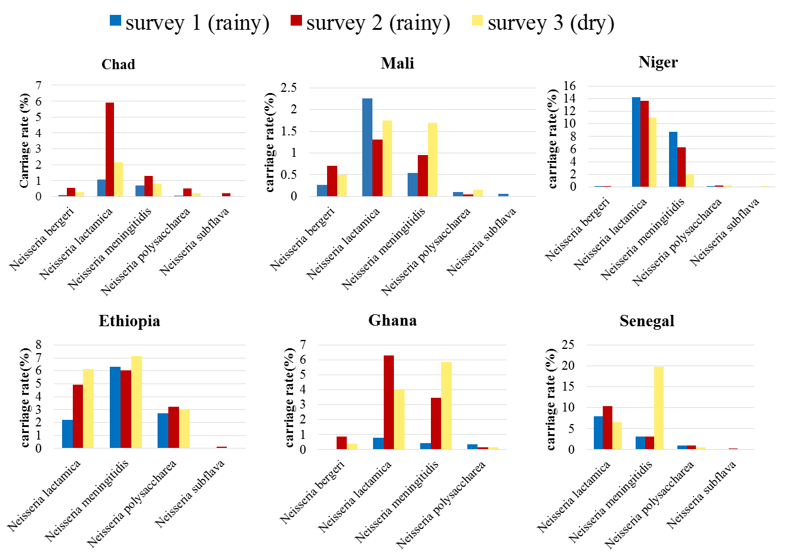

Supplemental figure 2. Neisseria species carriage rate pre and post vaccine administration

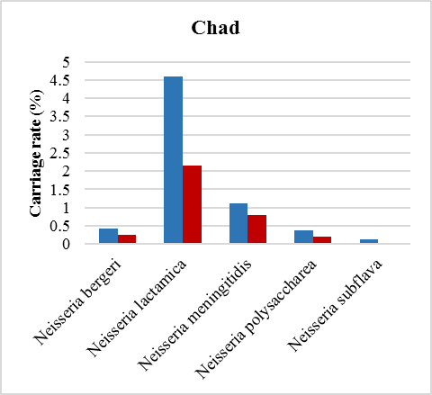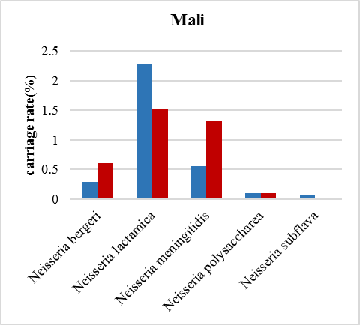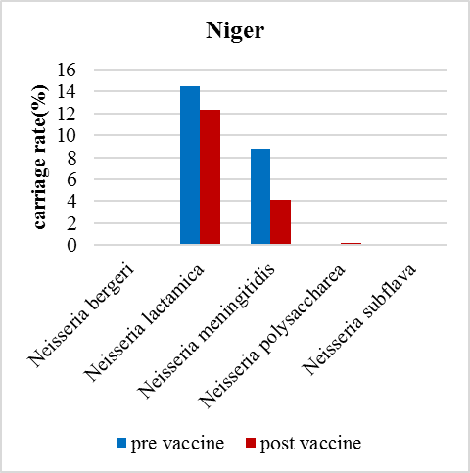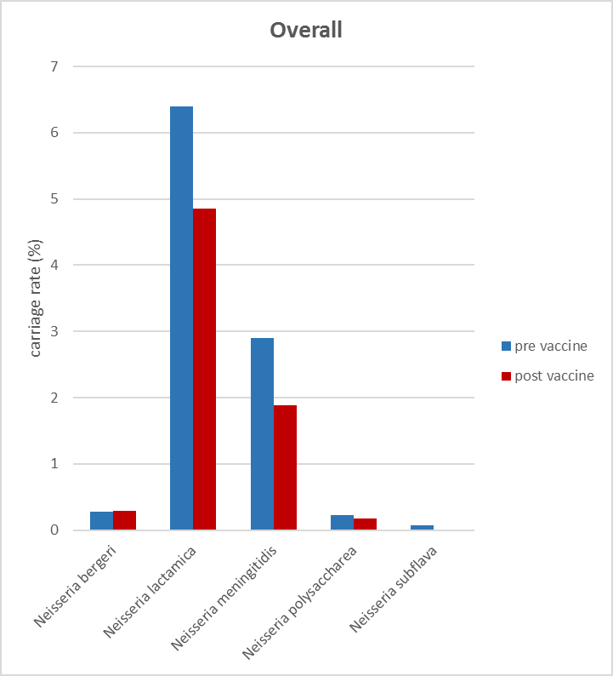
D
C
A
B

Supplemental Figure 3: Evolutionary relationship of the Neisseria isolates based on f_rplF

Neighbor Joining tree representing the phylogeny based on the different f_rplF allele. The colors correspond to each species covered in this study: Nm (red), Nl (yellow), Np (purple), Nb (blue) and Ns (orange). The circles correspond to the isolates used in the Bennett et al (2014) paper and the squares to the isolates described in this current work.

See attached pdf

