Title: Post-treatment effect of isoniazid preventive therapy on tuberculosis incidence in HIV-infected individuals on antiretroviral therapy

Authors: Sumner, T.¹, Houben, RM.¹, Rangaka, MX.^{2,3}, Maartens, G.^{4,5}, Boulle, A.⁶, Wilkinson, R.J.^{7,8,9},White, RG¹.

Affiliations

- Department of Infectious Disease Epidemiology, TB Modelling Group, TB Centre, and Centre for the Mathematical Modelling of Infectious Diseases, London School of Hygiene and Tropical Medicine, UK
- Centre for Infectious Disease Epidemiology, Department of Infection & Population Health, University College London, London, UK
- Institute of Infectious Disease and Molecular Medicine, Department of Medicine, University of Cape Town, South Africa
- Division of Clinical Pharmacology, University of Cape Town, South Africa;
- Tuberculosis Research Section, Laboratory of Clinical Infectious Diseases, National Institute of Allergy and Infectious Diseases (NIAID), National Institutes of Health (NIH), Bethesda, MD, USA
- Centre for Infectious Disease Epidemiology and Research, School of Public Health and Family Medicine, University of Cape Town, South Africa.
- Department of Medicine, Imperial College London W2 1PG, UK
- The Francis Crick Institute Mill Hill Laboratory, London NW7 1AA
- Institute of Infectious Diseases and Molecular Medicine, University of Cape Town, Observatory 7925, South Africa

Corresponding Author: Tom Sumner, London School of Hygiene and Tropical Medicine, London, WC1E 7HT, UK; Tel: +44(0)20 7927 2957; email: tom.sumner@lshtm.ac.uk

Keywords: preventive therapy; IPT; HIV; South Africa
Running Title: Post-treatment effect of INH on tuberculosis

Summary

Using mathematical modelling of trial data, we show IPT cures around one third of Mycobacterium tuberculosis infections in HIV-infected individuals on ART. These results are important for determining appropriate clinical guidelines for IPT use in varying epidemiological settings.

Conflict of interest

We confirm that none of the authors has any conflict of interest

Word count: 2848
Abstract
Background
In HIV-uninfected individuals, isoniazid preventive therapy (IPT) has been associated with long-term protection against tuberculosis (TB). For HIV-infected/ART-naïve individuals, high TB rates have been observed following completion of IPT, consistent with a lack of “cure” of infection. Recent trial data of IPT among HIV-infected individuals on ART in Khayelitsha, South Africa has suggested that the effect of IPT persisted following completion of IPT.
Methods
Using mathematical modelling we explored if this increased duration of protection may be due to an increased curative ability of IPT when given in combination with ART. The model was used to estimate the annual risk of infection (ARI) and proportion of individuals whose latent infection was “cured” by IPT, defined such that they must be re-infected to be at risk of disease.
Results
The estimated ARI was 4.0% (2.6-5.8) and the estimated proportion of individuals whose latent infection (LTBI) was cured following IPT was 35.4% (2.4-76.4%), higher than that previously estimated for HIV-infected/ART- naïve individuals. Our results suggest that IPT can cure LTBI in approximately one third of HIV-infected individuals on ART, and therefore provide protection beyond the period of treatment.
Conclusions
Among HIV-infected individuals on ART in low incidence settings, 12 months of IPT may provide additional long term benefit. Among HIV-infected individuals on ART in high incidence settings, the durability of this protection will be limited due to continued risk of re-infection, and continuous preventive therapy together with improved infection control efforts will be required to provide long-term protection against TB.
Introduction
Isoniazid (INH) preventive therapy (IPT) has been shown to reduce the risk of tuberculosis (TB) in people living with HIV (PLHIV) [1] and the WHO strongly recommends that PLHIV who do not have active TB disease should receive at least 6 months of IPT as part of HIV care [2]. However evidence from clinical trials in high TB incidence settings has shown that the duration of protection following 6-12 months IPT is limited [3-5] and that continuation of therapy (up to 36 months) provides increased protection against TB disease [6]. This has led to the conditional recommendation that PLHIV in high TB transmission areas should take at least 36 months of INH [2].

Following completion of a course of preventive therapy, TB disease can result from reactivation of a previous infection or through acquisition of a new infection. If, following therapy, INH results in lifelong protection against reactivation of existing infections (referred to here as “cure”) then reinfection must occur before individuals can progress to disease. If INH does not “cure”, then previously infected individuals will be at immediate risk of progressing to TB disease. In practice, TB disease observed following completion of therapy is likely due to a combination of these mechanisms.

Evidence from trials in immunocompetent individuals suggests that a 9 month course of IPT is sufficient to “cure” infection in most individuals [7]. In contrast, in a previous analysis of trial data from the pre-antiretroviral therapy (ART) era we found that the high rates of TB following completion of 6-12 months IPT in PLHIV were consistent with an almost complete lack of “cure” of latent M. tuberculosis infection (LTBI) [8]. Mathematical modelling of a trial of community wide INH in South African gold mines reached similar conclusions about the effectiveness of IPT in PLHIV [9]. This lack of cure from IPT in PLHIV not on ART suggests that regimens with better curative potential (for example containing rifampicin or rifapentine) [10] could be considered to reduce the risk of reactivation disease. However, these regimens carry increased risk of adverse effects and drug-drug interactions in individuals taking ART [11].

ART provides additional protection against TB disease over IPT alone, in patients starting ART after, or during, a course of INH [6, 12-14]. Recently published data from a pragmatic trial of IPT conducted among people established on, or starting, ART in Khayelitsha, Cape Town, South Africa [15], suggested that the protective effect of IPT persisted in the year following completion of IPT, longer than observed in trials in HIV-infected/ART- naïve individuals [3, 4]. However this trial was not powered to determine the duration of benefit. Given the implementation of new criteria for starting ART earlier in HIV disease, it is important to explore the potential reasons for this apparent increased duration of protection of IPT with concomitant ART in high incidence TB settings. Quantifying the curative ability of IPT in HIV infected individuals on ART is a critical step in estimating the potential long-term individual and population level benefits of IPT in different epidemiological settings.

In this paper we use an extension of the approach presented in [8] to analyse data from the Khayelitsha trial [15], to estimate the proportion of HIV infected individuals on ART that were “cured” by IPT.

Methods
The model is based on a previously published model [8] and is similar in structure to a number of other TB models [16, 17]. It describes the tuberculosis dynamics in a preventive therapy trial cohort of HIV infected individuals on ART after the cessation of IPT or placebo. The model structure is shown in figure 1.
Following the completion of drug the population is divided between susceptible (never infected, S), recently infected (defined as infected for the first time in the previous 2 years, I), recently reinfected (again, in the last 2 years, R), latently infected (last (re)infected 2 or more years ago, L) and those cured by IPT (C). The model structure is the same for both placebo and INH trial arms and differs only in the initial conditions (see below).
The proportion of the population that are cured following IPT (p) can only develop disease if they are reinfected with M. tuberculosis. Cured, susceptible and latent individuals are (re)infected at rate λ and move to the recently (re)infected classes. The risk of infection is assumed to be constant for the short duration of the trial. This is based on the assumption that the trial population mixes homogenously with the non-trial population and is consistent with data from Cape Town which suggests that the annual risk of infection (ARI) has been relatively constant over the last 15 years [18].
Recently infected, recently reinfected and latently infected individuals can progress to disease at rates d_{p}, d_{n} and d_{x} respectively representing primary, endogenous (reactivation) and exogenous (reinfection) disease. The risk of disease following (re)infection is assumed to decline with time since (re)infection [16] [19]. This is modelled by dividing the recently infected and recently reinfected compartments into 2 sub-compartments representing years since (re)infection with different risks of disease. After 2 years recently (re)infected individuals progress to the latent class where they experience a much reduced risk of progression to disease. The model equations are given in the supporting information.
ART reduces the risk of TB in HIV-infected individuals. We assume that this effect is due only to related changes in CD4 count. Following Williams et al. [20] we assume that the relative risk of TB increases exponentially with decreasing CD4 cell count at a rate α for each decline of 100 cells/μL. CD4 values in the model were taken from the trial data.
The model is initialised to represent the population in the intervention and placebo arms at cessation of IPT. The proportions of individuals in each compartment at this time depend on the annual risk of infection (ARI), the proportion cured by IPT (p), the level of drug resistance (δ) in the population and the average age of the cohort (a). Expressions for the populations in each state are given in table 1.
In our primary analysis, a 12 month course of INH is assumed to suppress recent infection (to a latent state) in all individuals completing therapy and to clear latent infection in a proportion, p. We also assume that INH can have no effect in individuals infected with INH resistant strains of TB. Results of a cross-sectional survey of adult clinic attendees in Khayelitsha found prevalence of isoniazid resistance of 10.4 and 15.7% in new and previously treated TB cases respectively [21]. Approximately 40% of the trial cohort had history of previous TB therefore we assumed a baseline prevalence of INH resistance of 12.5%. We do not allow for mixed infections in the model.
The model was calibrated to the prevalence of LTBI in the placebo arm and the TB incidence rate observed in the placebo and INH arms during the post treatment period [15]. Estimates of LTBI prevalence were based on analysis of a similar high incidence setting to the trial location [22] which estimated prevalence of infection of 74.3% (61.2-87.4) in individuals of 35 years of age, the median age in the trial cohort [15]. The prevalence of infection was assumed to be normally distributed with a mean and 95% confidence interval determined by the values presented in [22].
Model calibration was based on the Bayesian melding method [23] implemented using a sampling/importance resampling algorithm [24]. First we generated a large number of samples from the prior parameter distributions. Then the model was run for each parameter set and the likelihood calculated. The parameter sets were then resampled with replacement using the likelihood as weights. The following results are based on 100,000 model runs, a resample size of 200,000.
Table S2 (supporting information) shows the prior distributions of the model parameters used in the calibration process. We used uniform priors for the ARI and proportion cured (p) as we have limited or no information on their values. The priors for risk of developing primary disease in the first year post infection and the protective effect of previous infection were based on earlier studies [16] with wider uncertainly ranges to reflect potential differences between populations. These values, together with estimates of the relative risk of disease in subsequent years were used to calculate the risks of primary (d_{p}), endogenous (d_{n}) and exogenous disease (d_{x}) (see supporting information for further details). CD4 values in HIV negative individuals and the increase in TB risk with declining CD4 were based on previous analysis of sub-saharan African populations [20, 25]
Sensitivity analysis was conducted to explore the impact of assumptions about the prevalence of drug resistance and the efficacy of INH against drug resistant strains on the model results. We considered two alternative assumptions for the level of drug resistance: that all LTBI was drug susceptible (resistance 0%); the prevalence of resistance was based on the results of drug susceptibility testing of cases of active disease in the trial cohort (25 out of 34 cases were cultured; of these 6 (24%) were resistant to INH (2) or multiple drugs (4). We also explored the assumption that INH can not cure infections with resistant strains of M. tuberculosis but is effective in suppressing recent infections with such strains. Further details can be found in the supporting information.
Results
Figure 2 shows the fit of the model to the data. The model estimate of the prevalence of LTBI infection in the placebo was 75.2% (61.9-88.7) compared with empirical estimates of 74.3% (61.2-87.4) [22] (figure 2a).
The model captures the trends in incidence in the placebo and intervention arms observed in the trial during the follow-up period (figure 2b). In the placebo arm incidence declines over time consistent with an increase in time spent on ART by trial participants (and hence increasing CD4 counts) resulting in a reduced risk of TB. In the intervention arm the model predicts a lower incidence immediately after cessation of IPT compared to the placebo arm (as seen in the trial data). During the follow-up period the incidence rate increases to similar levels to those observed in the placebo arm. Table 2 shows the hazard ratios (HR) estimated from the model for different time periods following completion of treatment compared to the values observed during the trial. Model estimates were within the 95% CI observed in the trial.
In the primary analysis the model estimated ARI was 4.0% (2.6-5.8) and the estimated proportion cured (p) was 35.4% (2.4-76.4%). The posterior distributions of these parameters are shown in figure 3 (posterior distributions of the other model parameters can be found in the supporting information). Table S4 (supporting information) compares the model predictions for the ARI and p under different assumptions about drug resistance. Model estimates of the ARI were similar across all scenarios. In the limiting case that all infections in the population were drug susceptible the estimate cure rate was lower at 23.2% (0.1-61.5%).
In the placebo arm, 53.7% (32.4-66.2) of TB disease is estimated to be due to recent transmission (classed as occurring within 2 years of (re)infection). This is in line with empirical estimates from similar high HIV-prevalent settings in southern Africa ranging from 35% to 68% [26-30]. The model also allows us to look at the proportion of disease occurring via different routes over time in the intervention arm (see supplementary figure S3). Initially the majority of cases are due to reactivation in individuals who were not cured following IPT. Over time there is an increase in disease due to recent infection as individuals who were either cured by IPT or whose infection was suppressed to a latent state are reinfected. The cumulative proportion of disease that occurs in individuals cured by IPT, in the 2 years following completion of therapy, was estimated to be 7.8% (0.4-32.1).
Discussion
Our results suggest that in HIV-infected persons on ART IPT may cure existing LTBI in approximately one third of individuals, although there is uncertainty in the estimated value. This is a consequence of the uncertainty observed in the trial results and the importance of reinfection in driving TB incidence following completion of IPT. Earlier analysis of trials from the pre-ART era suggested that INH was unlikely to result in cure of LTBI in ART naive individuals [8]. Together, these findings are consistent with the hypothesis that INH requires a (better) functioning immune system to ‘cure’ existing infection [31, 32].
The model outputs indicate that immediately following completion of therapy the majority of cases occur due to reactivation of ineffectively treated latent infection. While this is in part a consequence of our assumption that IPT is at least sufficient to suppress recent infections to a latent state in all individuals, it is interesting that this effect persists for approximately 50 weeks at which point disease due to reinfection starts to dominate. Several trials of IPT in PLHIV, including a comparison of 6m vs 36m IPT in Botswana [6, 12] and the THRio study in ART clinics in Brazil [33], have reported a significant increase in TB rates shortly after completion of therapy. Whether these cases are due to reactivation or reinfection is unclear. Our results strengthen the hypothesis [33] that the majority of TB occurring in HIV-infected individuals during the first year following completion of IPT is due to reactivation of existing infections.
Our results also suggest that, while lack of cure is necessary to reproduce the TB incidence observed in the trial intervention arm, in the longer-term reinfection is responsible for the majority of TB disease. This may partly explain the differences observed in the duration of effect following completion of IPT between trials in high incidence settings (such as South Africa) where the effect was lost quickly and those conducted in lower incidence settings such as Brazil where the benefit persisted for longer [33].
Given that a significant proportion of TB disease is due to recent transmission it is likely that even with a preventive therapy regimen that did cure latent infection, the duration of protection would be limited due to the risk of re-exposure in such high incidence settings. In such circumstances the use of continuous IPT together with improved infection control efforts to reduce exposure to repeated Mycobacterium tuberculosis infections may be necessary to provide long term protection against TB disease.
We have assumed that the effect of ART on TB risk is solely due to increases in CD4 cell counts. Differences in CD4 count, and hence risk of TB, between the control and intervention arms were based on trial observations and therefore differences in observed TB incidence due to different CD4 distributions are accounted for in the model. By controlling for the effect of different CD4 counts in this way we can exclude the possibility that the observed effect of IPT is derived from a confounding effect of ART. However it is possible that time on ART modifies disease risk in other ways independent of CD4 count which would not be captured in our model.
Drop out (due to death, drug toxicity, or loss to follow-up) was modelled based on rates of drop out observed in the trial and was assumed to be independent of TB status in the model. If this was not the case, for example individuals were more likely to be lost to follow-up if they were at higher risk of disease, this may have influenced our findings. However, numbers of deaths, adverse events and other loss to follow-up were similar by trial arm [15].
The prevalence of drug resistant infections in the model was based on the numbers of drug resistant cases observed in individuals developing active disease in the same setting as the trial. It has been suggested that the use of IPT may select for INH resistance, although a systematic review of the risk of acquired INH resistance following IPT found no conclusive evidence for a link between INH resistance and the use of IPT [34]. We also assumed that INH had no effect in individuals infected with drug resistant strains. Evidence from treatment of active disease suggests that first line drugs, including high dose isoniazid, can be effective in treating drug resistance tuberculosis [35-37] but there is limited data on the efficacy of INH in individuals thought to be infected with drug resistant strains of TB [38].
In sensitivity analysis we explored the impact of assuming zero drug resistance, equivalent to assuming INH is effective against drug resistant strains, and found a lower estimate of the proportion cured by INH. As a larger proportion of the latently infected population could potentially be cured by INH so a lower effective cure rate is required to result in the same number of individuals being protected. Conversely, if the prevalence of resistance in the INH arm was higher, the estimated proportion cured would be higher as a greater proportion of those with INH-susceptible infections would need to be successfully cured to produce the levels of TB incidence observed in the trial.
Conclusion
Our results suggest that IPT can cure LTBI in approximately one third of HIV infected persons also taking ART and therefore provide protection beyond the period of IPT. In low incidence settings, 12 months of IPT in combination with ART may provide additional long term benefit to HIV-infected persons. However the durability of this protection will be limited in high incidence settings where there is a continued risk of exposure to re-infection, and continuous preventive therapy together with improved infection control will be required to provide long-term protection against TB.

Author contributions: TS, RMH, MXR, GM and RGW conceived and designed the study. TS and RMH constructed the model and carried out the analysis. MXR and AB analysed and prepared the primary data. TS, RMH, MXR, GM, AB, RJW and RGW wrote the paper.

References
1. Akolo, C., et al., Treatment of latent tuberculosis infection in HIV infected persons (Review). Cochrane Database Syst Rev, 2010. 20(1).
2. WHO, WHO policy on collaborative TB/HIV activities: Guidelines for national programmes and other stakeholders, 2012, WHO: Geneva.
3. Hawken, M.P., et al., Isoniazid preventive therapy for tuberculosis in HIV-1-infected adults: results of a randomized controlled trial. AIDS, 1997. 11(7): p. 875-82.
4. Johnson, J.L., et al., Duration of efficacy of treatment of latent tuberculosis infection in HIV-infected adults. AIDS, 2001. 15(16): p. 2137-47.
5. Churchyard, G.J., et al., A trial of mass isoniazid preventive therpay for tuberculosis control. NEJM, 2014. 370(4).
6. Samandari, T., et al., 6-month versus 36-month isoniazid preventive treatment for tuberculosis in adults with HIV infection in Botswana: a randomised, double-blind, placebo-controlled trial. Lancet, 2011. 377: p. 1588-1598.
7. Comstock, G.W., How much isoniazid is needed for prevention of tuberculosis among immunocompetent adults? International Journal of Tuberculosis and Lung Disease, 1999. 31(10): p. 847-850.
8. Houben, R.M., et al., Ability of preventive therapy to cure latent Mycobacterium tuberculosis infection in HIV-infected individuals in high-burden settings. Proc Natl Acad Sci U S A, 2014. 111(14): p. 5325-30.
9. Vynnycky, E., et al., Tuberculosis control in South African goldmines: mathematical modelling of a trial of community wide IPT. American Journal of Epidemiology, 2014.
10. Jereb, J.A., et al., Recommendations for Use of an Isoniazid-Rifapentine Regimen with Direct Observation to Treat Latent Mycobacterium tuberculosis Infection, in Morbidity and Mortality Weekly Report2011, CDC. p. 1650.
11. Maartens, G., E. Decloedt, and K. Cohen, Effectiveness and safety of antiretrovirals with rifampicin: crucial issues for high-burden countries. Antiviral Therapy, 2009. 14(8).
12. Samandari, T., et al., Tuberculosis incidence after 36 months' isoniazid prophylaxis in HIV-infected adults in Botswana: a posttrial observational analysis. AIDS, 2015. 29: p. 351-359.
13. Golub, J., et al., Isoniazid preventive therapy, HAART and tuberculosis risk in HIV-infected adults in South Africa: a prospective cohort. AIDS, 2009. 23(5): p. 631-636.
14. Golub, J., et al., The impact of antiretroviral therapy and isoniazid preventive therapy on tuberculosis incidence in HIV-infected patients in Rio de Janeiro, Brazil. AIDS, 2007. 21(11): p. 1441-1448.
15. Rangaka, M.X., et al., Isoniazid plus antiretroviral therpay to prevent tuberculosis: a randomised double-blind, placebo-controlled trial. Lancet, 2014. 384(9944): p. 682-690.
16. Vynnycky, E. and P.E.M. Fine, The natural history of tuberculosis: the implications of age-dependent risks of disease and the role of reinfection. Epidemiology and Infection, 1997. 119: p. 183-201.
17. Ziv, E., C.L. Daley, and S.M. Blower, Early therapy for latent tuberculosis infection. Am J Epidemiol, 2001. 153(4): p. 381-5.
18. Kritzinger, F.E., et al., No decrease in annual risk of tuberculosis infection in endemic area in Cape Town, South Africa. Trop Med Int Health, 2009. 14(2): p. 136-42.
19. Sutherland, I., E. Svandova, and S. Radhakrishna, The development of clinical tuberculosis following infection with tubercle bacilli. Tubercle, 1982. 62(4): p. 255-68.
20. Williams, B.G., et al., Antiretroviral therapy for tuberculosis control in nine African countries. Proceedings of the National Academy of Sciences of the United States of America 2010. 107(45): p. 19485-19489.
21. Cox, H., et al., Epidemic levels of drug resistant tuberculosis (MDR and XDR-TB) in a high HIV prevalence setting in Khayelitsha, South Africa. PloS One, 2010. 5(11): p. e13901.
22. Wood, R., et al., Changing prevalence of TB infection with increasing age in high TB burden townships in South Africa. IJTLD, 2010. 14(4): p. 406-412.
23. Alkema, L., A.E. Raftery, and S.J. Clark, Probabilistic projections of HIV prevalence using Bayesian melding. The annals of applied statistics, 2007. 1(1): p. 229-248.
24. Rubin, D., Using the SIR algorithm to simulate posterior distributions, in Bayesian Statistics 3, M.H. DeGroot, D.V. Lindley, and A.F.M. Smith, Editors. 1988, OUP: Oxford. p. 395-402.
25. Williams, B.G., et al., HIV infection, antiretroviral therapy, and CD4+ cell count distributions in African populations. J Infect Dis, 2006. 194(10): p. 1450-8.
26. Verver, S., et al., Transmission of tuberculosis in a high incidence urban community in South Africa. International Journal of Epidemiology, 2004. 33(2): p. 351-357.
27. Glynn, J.R., et al., The importance of recent infection with Mycobacterium tuberculosis in an area wuth high HIV prevalence: a long term molecular epidemiological study in Northern Malawi. JID, 2005. 192(3): p. 480-487.
28. Lockman, S., et al., Molecular and conventional epidemiology of Mycobacterium tuberculiosis in Botswana: a population-based prospective study of 301 pulmonary tuberculosis patients. J. Clin. Microbiol, 2001. 39(3): p. 1042-1047.
29. Houben, R.M., et al., Human immunodeficiency virus increases the risk of tuberculosis due to recent re-infection in individuals with latent infection. Int J Tuberc Lung Dis, 2010. 14(7): p. 909-15.
30. Middelkoop, K., et al., Transmission of Tuberculosis in a South African Community With a High Prevalence of HIV Infection. JID, 2015. 211(1): p. 53-61.
31. Esmail, H., C. Barry, and R.J. Wilkinson, Understanding latent tuberculosis: the key to improved diagnostic and novel treatment strategies. Drug Discovery Today, 2012. 17(9-10).
32. Wilkinson, K.A., et al., Effect of treatment of latent tuberculosis infection on the T cell response to Mycobacterium tuberculosis antigens. The Journal of Infectious Diseases, 2006. 193(3): p. 354-359.
33. Golub, J.E., et al., Long-term protection from isoniazid preventive therapy for tuberculosis in HIV-infected patients in a medium burden tuberculosis setting: the TB/HIV in Rio (THRio) Study. CID, 2015. 60(4): p. 639-645.
34. Balcells, M.E., et al., Isoniazid preventive therapy and risk for resistant tuberculosis. Emerg Infect Dis, 2006. 12(5): p. 744-51.
35. Espinal, M.A., et al., Standard short-course chemotherapy for drug-resistant tuberculosis: treatment outcomes in 6 countries. JAMA, 2000. 283(19): p. 2537-45.
36. Katiyar, S.K., et al., A randomised controlled trial of high-dose isoniazid adjuvant therapy for multidrug-resistant tuberculosis. Int J Tuberc Lung Dis, 2008. 12(2): p. 139-45.
37. Caminero, J.A., et al., Best drug treatment for multidrug-resistant and extensively drug-resistant tuberculosis. Lancet Infect Dis, 2010. 10(9): p. 621-9.
38. van der Werf, M.J., et al., Lack of evidence to support policy development for management of contacts of multidrug-resistant tuberculosis patients: two systematic reviews. Int J Tuberc Lung Dis, 2012. 16(3): p. 288-96.

Tables
State |  | Placebo Arm (p=0) | INH Arm
Cured | C | 0 | (1-(1-ARI)ª) p (1-δ)
Never Infected | S | (1-ARI)ª | (1-ARI)ª
Recently infected | I_{i=1,2} | ((1-ARI)^{(a-i)})(1-(1-ARI)) | ((1-ARI)^{(a-i)})(1-(1-ARI))(1-δ)
Recently reinfected | R_{i=1,2} | (1-(1-ARI^{)(a-i)})(1-(1-ARI)) | (1-(1-ARI^{)(a-i)})(1-(1-ARI))(1-δ)
Latently infected | L | 1-C-S-I-R | 1-C-S-I-R
Primary TB | T_{p} | 0 | 0
Endogenous TB | T_{n} | 0 | 0
Exogenous TB | T_{x} | 0 | 0
Table 1 – Initial conditions in the model. ARI=Annual risk of infection; p=proportion cured following IPT; a=average age of the cohort; δ=proportion of individuals with drug resistance in the model population; i indicates time since infection (years).

 | 0-11 months | >12months
Trial observations [15] | 0.61 (0.30-1.21) | 0.78 (0.39-2.0)
Model | 0.48 (0.29-0.65) | 0.75 (0.53-0.92)
Table 2 – Hazard Ratios. Comparison of model and observed hazard ratios at different trial time periods. Months are time after study drug course completion.

Figure Legends
Figure 1 – Schematic of the model. The model structure is the same for placebo and INH trial arms but differs in initial conditions (see table 1). Dashed arrows indicate the distribution of cases at the start of the trial follow-up period (after IPT cessation) and represents the initial state of the model. The recently infected and recently reinfected compartments are subdivided into two stage but these are not shown here for clarity
Figure 2 – Fit of the model to data. a) Fit to LTBI prevalence. Solid line shows data, dashed shows distribution from 200,000 re-sampled model runs. b) Fit to TB incidence. Points show incidence rate measured in the trial together with 95% confidence intervals (data points are offset to aid visualisation). Lines show the median model output and shaded regions the 95% credible interval calculated from the 200,000 re-sampled model runs.
Figure 3 – Posterior distributions of the annual risk of infection (ARI) and proportion of LTBI cured following IPT (p). Uniform prior distributions shown by horizontal dotted lines. Posterior distributions are shown by the solid curves. Dashed vertical lines indicate the median values. 95% and 75% credible intervals (highest density probability) are shown by light and dark shaded areas respectively. Results are shown for the default scenario (resistance =12.5%).

Figures

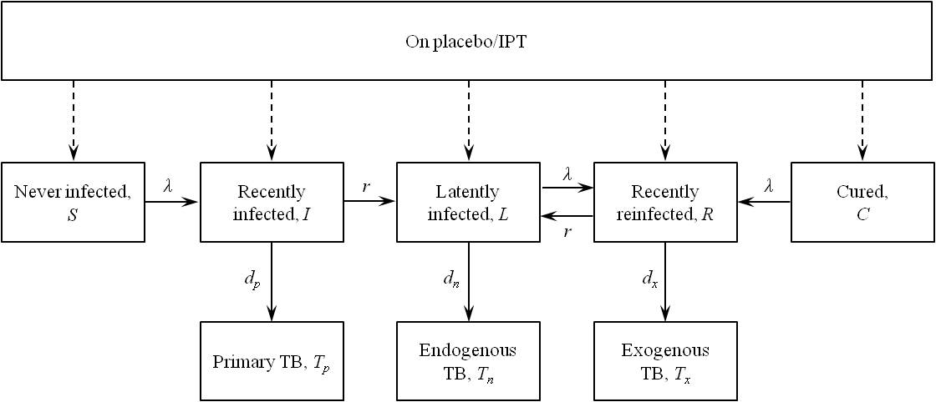
Figure 1

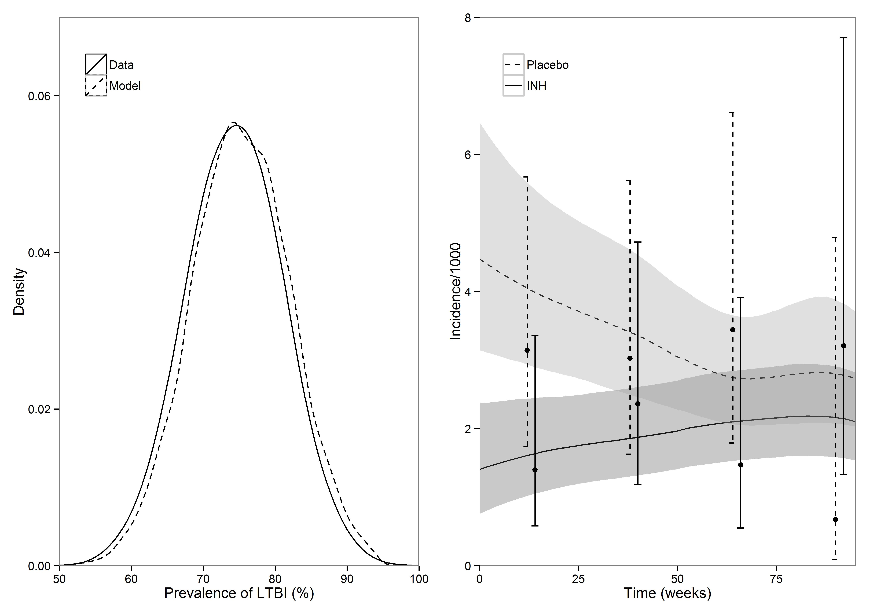
b)
a)
Figure 2

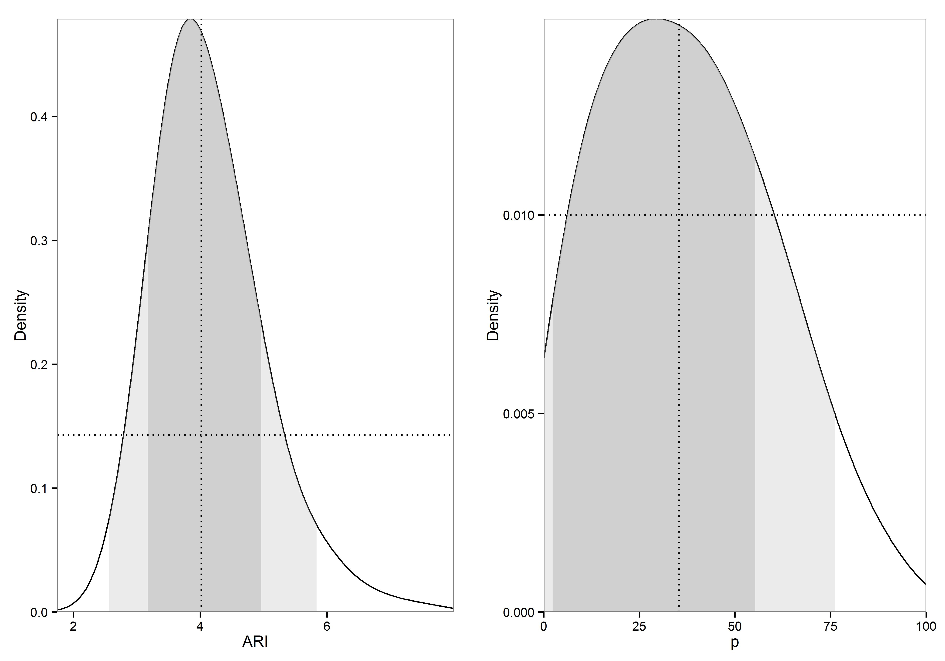
a)
b)
Figure 3

