Figure 1
Flow diagram of search strategy

Additional records identified through other sources
(n = 338 )
Records identified through database searching
(n = 442)

Records after duplicates removed
(n = 662)

Records screened
(n = 662)
Records excluded
(n = 465)

Studies included in qualitative synthesis of prevalence
(n = 82)
Studies included in discrete populations
(n = 19)
Full-text articles (n=86) excluded
- Not a prevalence study (n=46)
- Review only (n=26)
- Duplicate publication (n=12)
- Doubtful population estimate (n=1)
- Nazi eugenics programme (n=1)

Full-text articles assessed for eligibility
(n = 187)

Figure 2

Forest plot of prevalence: Africa

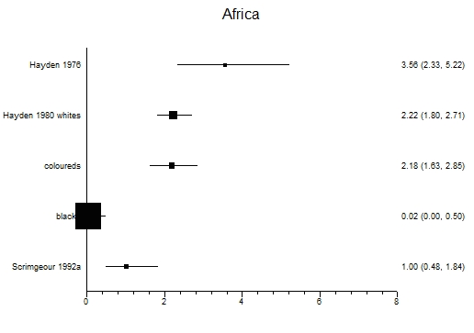

Prevalence per 100,000 population

Figure 3
Forest plot of prevalence: America
(I² = 98.9% (CIs 98.6% to 99.0%)
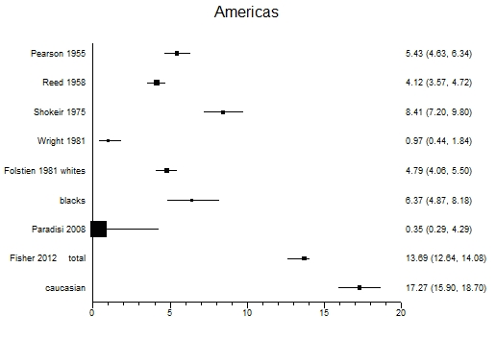

Prevalence per 100,000 population

Figure 4
Forest plot of prevalence Asia
(I² = 49.0% CI 0% to 76.6%)
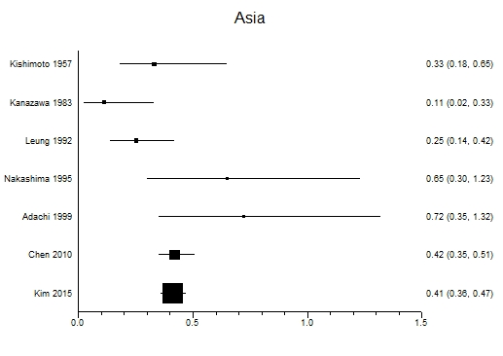
Prevalence per 100,000

Figure 5
Forest plot of prevalence: Central and Eastern Europe
(I² = 94.6% CI 92.1% to 96.0%)

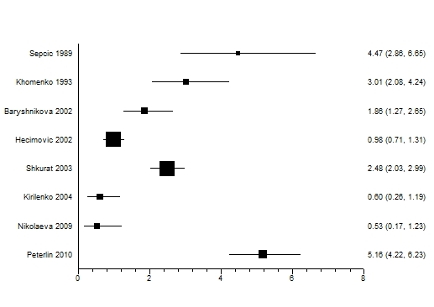
Prevalence per 100,000

Figure 6
Forest plot of prevalence: Oceania
(I² = 94.9% CI 92.6% to 96.0%)
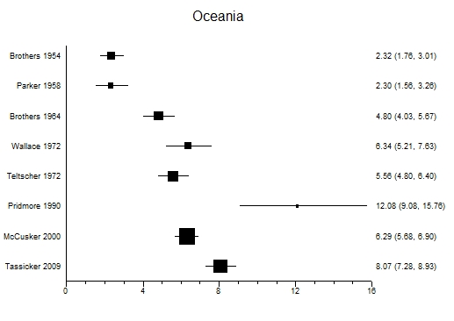

Prevalence per 100,000 population

Figure 7
Forest plot of prevalence: United Kingdom
(I² = 95.0% CI 93.7 to 95.8%)

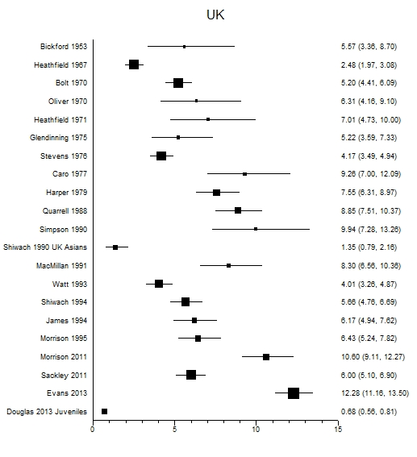
Prevalence per 100,000

Figure 8
Forest plot of prevalence: Western Europe (excluding the United Kingdom)
(I² = 97.5 CI 97.2% to 97.8%)

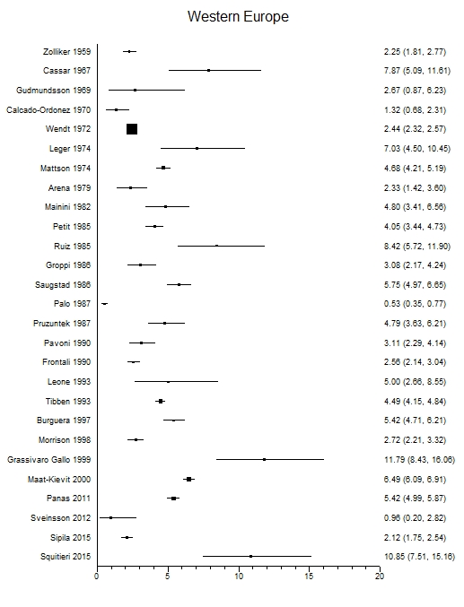

Prevalence per 100,000 population

