S3. Additional analyses
Figure S1: Association between small-area deprivation and change between 2001 and 2011 in the prevalence of travelling to work by walking, public transport and driving
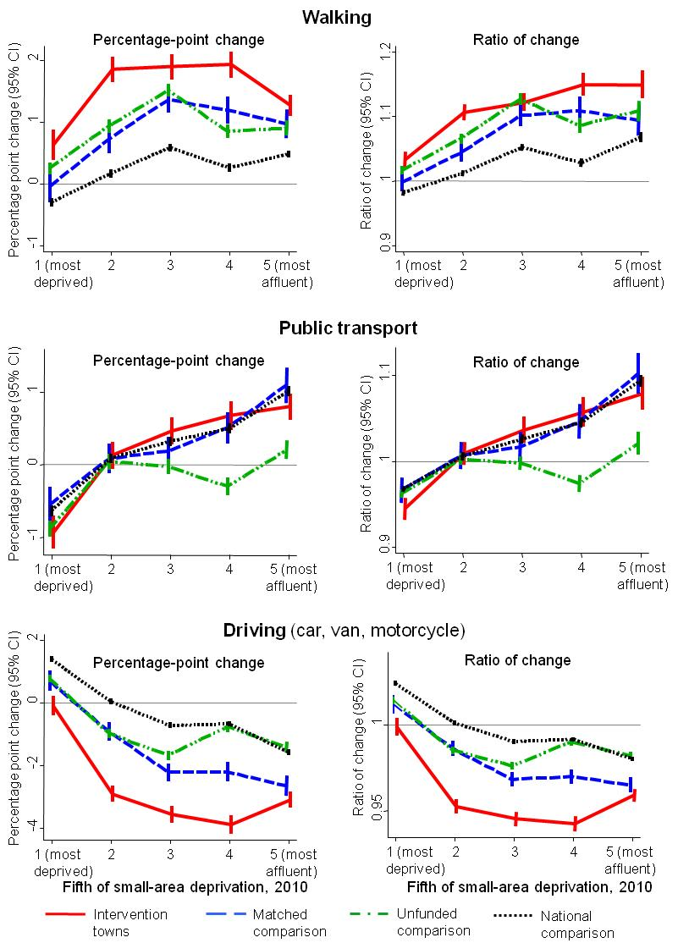

CI=confidence intervals, fifths defined relative to national quintiles

Figure S2: Association between selected town characteristics and intervention effect size in each intervention town (N=18)
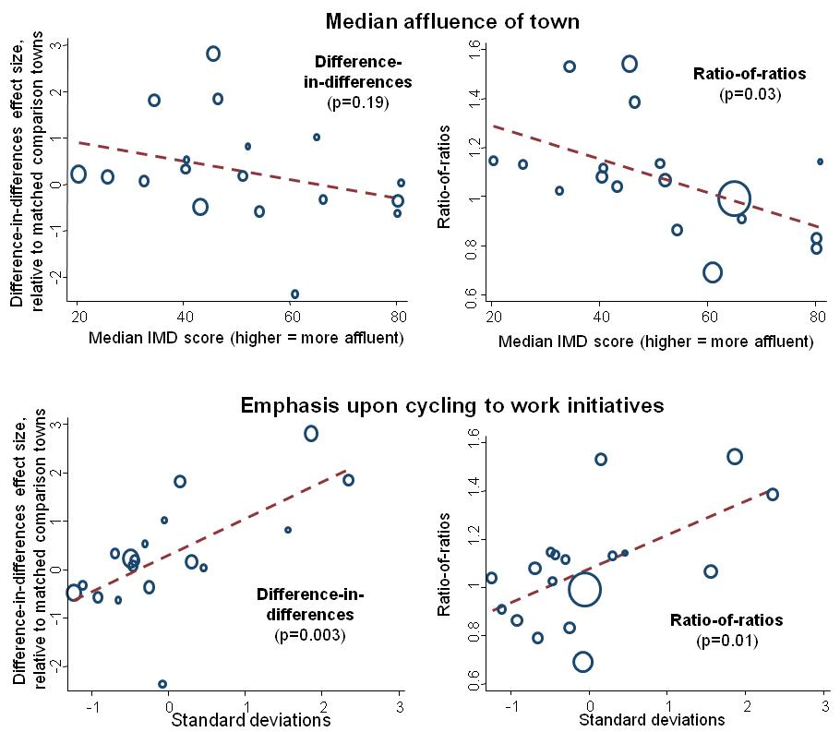
IMD=Indices of Multiple Deprivation, with higher IMD scores indicating more affluent towns. Larger circles represent more precise estimates, with the size of the circles equal to the inverse of the within-town variance. The red line indicates the line of best fit from univariable random effects meta-regression, and the p-value indicates the significance of the meta-regression analysis.

