Supplementary Materials
Time to scale-up PrEP beyond the highest-risk populations? Modelling insights from high-risk women in sub-Saharan Africa

Hannah Grant (PhD)^{1,2}, Gabriela B. Gomez (PhD)¹, Katharine Kripke (PhD)³, Ruanne V. Barnabas (PhD)⁴, Charlotte Watts (PhD)¹, Graham F. Medley (PhD) ^{1,2}, Zindoga Mukandavire (PhD)^{5,6}.
¹ Department of Global Health and Development, Faculty of Public Health and Policy, London School of Hygiene and Tropical Medicine, London, UK
² Centre for Mathematical Modelling of Infectious Diseases, London School of Hygiene and Tropical Medicine, London, UK
³ Avenir Health, Washington, D.C., USA
⁴ Global Health and Medicine, University of Washington, Seattle, WA, USA
⁵ Center for Data Science, Coventry University, Coventry, UK
⁶ School of Computing, Electronics and Mathematics, Coventry University, Coventry, UK

Supplementary Materials: Supplementary Methods

Model Structure

We use a static Bernoulli formulation of HIV risk¹. The sexual partners of high-risk women from population $j$ are assumed to come from populations $i$in which the proportion HIV infected is $p_{i}$. We assume an average probability of HIV transmission, $β_{f}$, per sexual contact with an HIV infected male partner. High risk women are assumed to have $C_{i}$ number of partners from each population a year, with whom they have an average of $n_{i}$ sex acts a year each. Condoms are assumed to be used with partners from each population with consistency $γ_{ij}$ and have an HIV risk reduction efficacy$, ε$, including slippage and breakage. Upon introduction, high-risk women from population $j$ are assumed to adhere to PrEP at an average level $α_{j}$, which corresponds to a level of HIV risk reduction, $θ_{α_{j}}.$ They are assumed to have 12-month program retention levels $r_{j}.$ Sex acts are assumed to be peno-vaginal, the predominant pathway of HIV transmission to heterosexual women in sub-Saharan Africa.²

1.0 Individual level - Simple tools to help guide PrEP programme decision making
1.1 Assessment of HIV risk by risk factor
For the first analysis of HIV risk, we consider a simple model of HIV risk to a single high-risk woman with partners drawn from a single male population. HIV risk to an individual high-risk woman in the absence of PrEP is given by
${π(0)=1-\left({p\left( 1-β_{f}\left(1-εγ\right)\right)}^{n}+(1-p)\right)}^{C}$ ,
(S1.1)
and on PrEP is
${π(θ_{α_{j}})=1-\left({p\left( 1-β_{f}\left(1-r_{j}θ_{α_{j}}\right)\left(1-εγ\right)\right)}^{n}+(1-p)\right)}^{C}$
(S1.2)
Using equations (S1.1) and (S1.2), HIV risk reduction on PrEP is given by
$$π(0)-π(θ_{α_{j}})$$
(S1.3)
Heatmaps to estimate HIV incidence in women
Heatmaps were developed using equation (S1.1) to help decision makers estimate the annual HIV incidence in women by number of monthly sex acts, average condom use and underlying epidemic setting. We demonstrated four different example epidemic settings: underlying HIV prevalence in partner populations of 5%, 10%, 20% and 40%. In many sub-Saharan African contexts, 5% HIV prevalence is illustrative of HIV prevalence in males 15-24 years, 5-20% the HIV prevalence in males 25-49 years, and 20-40% the HIV prevalence in the clients of FSW (Supporting Information: Table S2).
In order to parameterise the model to the spectrum of HIV risk faced by women in sub-Saharan Africa, equation (S1.1) was simulated across the parameter ranges set out in Supplementary Materials: Methods – Table S2, yielding 720,000 distinct parameter sets.

1.2 Simple rule to estimate relative cost-effectiveness
In estimating the relative cost-effectiveness among women at risk, we considered two high-risk women of different risk. One woman is drawn from a traditionally higher-risk population (e.g. female sex workers (FSW)) and the other from a relatively lower-risk female population (e.g. adolescent girls and young women aged 15-24 years (AGYW)), denoted $H$and $L$ respectively. For simplicity, each high-risk woman is assumed to draw their partners from one population group.
Cost-effectiveness is defined as the incremental cost of PrEP for a woman retained at level $r_{j}$ in a PrEP program over a 12-month period, divided by the risk reduction achieved on PrEP when adhered to at level $α$ with retention $r_{j}$over the 12-month period. In the absence of willingness-to-pay thresholds, relative cost-effectiveness was assessed by comparing these estimates of cost per infection averted between populations.
Analysis was conducted over a one-year timeframe, as PrEP is intended for seasons of risk, and few PrEP demonstration programs have achieved significant retention in women in this context beyond the first 12 months.^{3,4} Let $π_{H}$ and $π_{L}$ denote the respective HIV risk for each woman, with subscripts $H$and $L$ denoting high and low risk groups Let ${\$X}_{H}$ and ${\$X}_{L}$be the 12-month unit costs of PrEP for each woman (the incremental cost of PrEP for a woman retained in a PrEP program over a 12-month period).
Then the cost of averting one HIV infection with PrEP per year is $\frac{{\$X}_{H}}{π_{H}\left(0\right)-π_{H}\left(θ_{α_{H}}\right)}$ and $\frac{{\$X}_{L}}{π_{L}\left(0\right)-π_{L}\left(θ_{α_{L}}\right)}$ respectively. PrEP will become equally cost-effective in the lower-risk group as it is in the higher-risk group where:
$\frac{{\$X}_{L}}{π_{L}\left(0\right)-π_{L}\left(θ_{α_{L}}\right)}=\frac{{\$X}_{H}}{π_{H}\left(0\right)-π_{H}\left(θ_{α_{H}}\right)}$
(S1.4)
Equation (S1.4) can be expressed as
$\frac{{\$X}_{L}}{{\$X}_{H}}=\frac{π_{L}\left(0\right)-π_{L}\left(θ_{α_{L}}\right)}{π_{H}\left(0\right)-π_{H}\left(θ_{α_{H}}\right)}$
(S1.5)
To derive a simple formulation of equation (S1.5) that is intuitive for policy makers and programmers in practical real-world settings, we simplify equations (S1.1) and (S1.2) using binomial theorem. Using the example of equation (S1.2), where $β\left(1-{rθ}_{α}\right)\left(1-εγ\right)≪1$ we have:
${π(θ_{α_{j}})≈1-\left(p\left( 1-nβ_{f}\left(1-{r_{j}θ}_{α_{j}}\right)\left(1-εγ\right)\right)+(1-p)\right)}^{C}$
${ ≈1-\left(1-pnβ\left(1-{r_{j}θ}_{α_{j}}\right)\left(1-εγ\right)\right)}^{C}$
for $pnβ\left(1-r_{j}θ_{α_{j}}\right)\left(1-εγ\right)≪1$,
$π(θ_{α_{j}})≈Cpnβ\left(1-r_{j}θ_{α_{j}}\right)\left(1-εγ\right)$.
(S1.6)
In other words, the HIV risk reduction to an individual on PrEP can be approximated by the total number of sex acts per unit time multiplied by the partner HIV prevalence, the basic risk of HIV transmission through peno-vaginal sex (0.0006 - 0.0011⁵), the average proportion of sex acts not protected by condoms, and the use-effectiveness of PrEP. The use-effectiveness of PrEP is defined as the HIV-risk reduction through use of PrEP at a given level of adherence, for a population with a given average program retention level.

Thus the risk reduction in equation (S1.3) is approximately
$Cpnβ\left(1-εγ\right)-Cpnβ\left(1-{r_{j}θ}_{α_{j}}\right)\left(1-εγ\right)$, and simplifies to
$Cpnβ\left(1-εγ\right)r_{j}θ_{α_{j}}$.
(S1.7)
Therefore, when $β\left(1-{r_{j}θ}_{α_{j}}\right)\left(1-εγ\right)≪1$ and $pnβ\left(1-{r_{j}θ}_{α_{j}}\right)\left(1-εγ\right)≪1$,the condition for equal cost-effectiveness in equation (S1.5) between two populations with different risk levels becomes:
$\frac{{\$X}_{L}}{{\$X}_{H}}=\frac{C_{L}n_{L}p_{L}\left(1-εγ_{L}\right)r_{L}θ_{α_{L}}}{C_{H}n_{H}p_{H}\left(1-εγ_{H}\right){r_{H}θ}_{α_{H}}}$
(S1.8)
The relationship on relative cost of PrEP is summarised as follows.
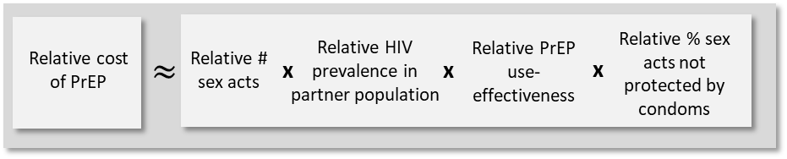
Simple rule to draw insights around relative cost-effectiveness of PrEP
This rule may help policy makers draw qualitative program insights around conditions under which it may be equally cost-effective to roll out PrEP in a lower-risk group as in a higher-risk group. This rule can be approximated based on information typically estimated by PrEP programs⁶. The relative measures stated are for lower-risk women compared to higher-risk women.

1.3 Relative risk reduction on PrEP
Heatmaps to estimate the relative unit cost at which PrEP scale-up from higher- to lower-risk women is cost-effective
Heatmaps were developed using equation (S1.5) to help decision makers estimate the relative unit cost at which it will be cost-effective to scale up PrEP from a comparatively higher- (e.g. FSW) to comparatively lower-risk woman (e.g. AGYW), also using the number of monthly sex acts, average condom use and underlying epidemic setting. Different epidemic settings were illustrated by taking HIV prevalence in the higher-risk women’s partner population of either 20% or 40%. For each of these scenarios, HIV prevalence in the lower-risk women’s partner population was then simulated at 1/4, 1/2, 3/4 and 1 times the prevalence of the higher-risk women’s partner population (i.e. 5%, 10%, 15% and 20%; and 10%, 20%, 30% and 40% respectively). These scenarios span a range of epidemic settings in sub-Saharan Africa⁷.
It was assumed that the higher-risk group had 22% PrEP program retention levels and all women retained had PrEP adherence levels of 70-85% (corresponding to risk-reduction of 73-99%⁸), consistent with the South African TAPS demonstration project in FSW³. PrEP program retention for the lower-risk group was simulated between $±$25% of the 22% retention levels of the higher-risk group (i.e. 16.5%-27.5%), consistent with the difference between AGYW and FSW retention in Kenya⁴. For lower-risk women retained in the PrEP program, it was assumed that PrEP adherence was the same as the higher-risk group.
To obtain a spectrum of HIV risk faced by both populations reflective of the sub-Saharan African settings, we simulated across the parameter ranges set out in Supplementary Materials: Methods – Table S2, yielding 7,920,000 distinct parameter sets.

2.0 Population level – country case studies
We modify the risk equations (S1.1) and (S1.2) to consider HIV risk and the scale-up of PrEP at a population rather than individual level.
The total population size of high-risk women of type $j$ is $N_{j}$, in which the prevalence of HIV is $p_{j}.$ The coverage of PrEP in the population is $ω_{j}.$
In the process of parameterising the model to specific high-risk women populations, we develop the risk equations to also account for population-specific STI levels, levels of viral load suppression due to ART in HIV positive partners and male circumcision.
The parameter $s_{ij}$ is the probability that at least one person in the partnership between high risk woman from population $j$ and partner from population $i$has an STI and $δ$ is the multiplicative increase in per sex act probability of HIV transmission in the presence of an STI.
Parameter $ϑ_{i}$ is the proportion of HIV+ partners from population $i$that are virally suppressed on ART and $ϱ$models the average reduction in the probability of HIV transmission due to viral suppression on ART. The parameter $τ_{i}$ is the proportion of male partner population $i$that are circumcised and $σ$is the average reduction in probability HIV transmission to women, when the male partner has been circumcised.
Where high-risk women from population $j$ have partners drawn from a single male population, their HIV risk for a 12-month period is in the absence of PrEP is given by (leaving the j denotation to improve readability):
${Π(0)=1-\left(p(ψ_{\left(1-τ\right),0}+ψ_{τ,0})+(1-p)\right)}^{C}$
Where:
$$ψ_{\left(1-τ\right),0}=\left(1-τ\right)\left(\left(1-ϑ\right)s{\left( 1-δς\right)}^{n}+\left(1-ϑ\right)\left(1-s\right){\left( 1-ς\right)}^{n}+ϑs{\left( 1-\left(1-ϱ\right)δς\right)}^{n}+ϑ\left(1-s\right){\left( 1-\left(1-ϱ\right)ς\right)}^{n}\right)$$
$$ψ_{τ,0}=τ\left(\left(1-ϑ\right)s{\left( 1-\left(1-σ\right)δς\right)}^{n}+\left(1-ϑ\right)\left(1-s\right){\left( 1-\left(1-σ\right)ς\right)}^{n}+ϑs{\left( 1-\left(1-σ\right)\left(1-ϱ\right)δς\right)}^{n}+ϑ\left(1-s\right){\left( 1-\left(1-σ\right)\left(1-ϱ\right)ς\right)}^{n}\right)$$
and $ς=β_{f}\left(1-εγ\right)$
(S2.1)
For women on PrEP we have
${Π(rθ_{α})=1-\left(p(ψ_{\left(1-τ\right){, rθ}_{α}}+ψ_{τ,{ rθ}_{α}})+(1-p)\right)}^{C}$
Where:
$$ψ_{\left(1-τ\right),{ rθ}_{α}}=\left(1-τ\right)\left(\left(1-ϑ\right)s{\left( 1-δκ\right)}^{n}+\left(1-ϑ\right)\left(1-s\right){\left( 1-κ\right)}^{n}+ϑs{\left( 1-\left(1-ϱ\right)δκ\right)}^{n}+ϑ\left(1-s\right){\left( 1-\left(1-ϱ\right)κ\right)}^{n}\right)$$
$$ψ_{τ,{ rθ}_{α}}=τ\left(\left(1-ϑ\right)s{\left( 1-\left(1-σ\right)δκ\right)}^{n}+\left(1-ϑ\right)\left(1-s\right){\left( 1-\left(1-σ\right)κ\right)}^{n}+ϑs{\left( 1-\left(1-σ\right)\left(1-ϱ\right)δκ\right)}^{n}+ϑ\left(1-s\right){\left( 1-\left(1-σ\right)\left(1-ϱ\right)κ\right)}^{n}\right)$$
and ${κ=β}_{f}\left(1-{rθ}_{α}\right)\left(1-εγ\right)$
(S2.2)
Similarly, when high-risk women from population $j$ have partners drawn from two male populations $i=1, 2$, their HIV risk for a 12-month period is in the absence of PrEP is given by
${Π(0)=1-\left(p_{1}(ψ_{\left(1-τ\right),0}^{1}+ψ_{τ,0}^{1})+(1-p_{1})\right)}^{C_{1}}{\left(p_{2}(ψ_{\left(1-τ\right),0}^{2}+ψ_{τ,0}^{2})+(1-p_{2})\right)}^{C_{2}}$
Where
$$ψ_{\left(1-τ\right),0}^{1}=\left(1-τ_{1}\right)\left(\left(1-ϑ_{1}\right)s_{1}{\left( 1-δς_{1}\right)}^{n_{1}}+\left(1-ϑ_{1}\right)\left(1-s_{1}\right){\left( 1-ς_{1}\right)}^{n_{1}}+ϑ_{1}s_{1}{\left( 1-\left(1-ϱ\right)δς_{1}\right)}^{n_{1}}+ϑ_{1}\left(1-s_{1}\right){\left( 1-\left(1-ϱ\right)ς_{1}\right)}^{n_{1}}\right)$$
$$ψ_{τ,0}^{1}=τ_{1}\left(\left(1-ϑ_{1}\right)s_{1}{\left( 1-\left(1-σ\right)δς_{1}\right)}^{n_{1}}+\left(1-ϑ_{1}\right)\left(1-s_{1}\right){\left( 1-\left(1-σ\right)ς_{1}\right)}^{n_{1}}+ϑ_{1}s_{1}{\left( 1-\left(1-σ\right)\left(1-ϱ\right)δς_{1}\right)}^{n_{1}}+ϑ_{1}\left(1-s_{1}\right){\left( 1-\left(1-σ\right)\left(1-ϱ\right)ς_{1}\right)}^{n_{1}}\right)$$
$$ς_{1}=β_{f}\left(1-εγ_{1}\right)$$
and
$$ψ_{\left(1-τ\right),0}^{2}=\left(1-τ_{2}\right)\left(\left(1-ϑ_{2}\right)s_{2}{\left( 1-δς_{2}\right)}^{n_{2}}+\left(1-ϑ_{2}\right)\left(1-s_{2}\right){\left( 1-ς_{2}\right)}^{n_{2}}+ϑ_{2}s_{2}{\left( 1-\left(1-ϱ\right)δς_{2}\right)}^{n_{2}}+ϑ_{2}\left(1-s_{2}\right){\left( 1-\left(1-ϱ\right)ς_{2}\right)}^{n_{2}}\right)$$
$$ψ_{τ,0}^{2}=τ_{2}\left(\left(1-ϑ_{2}\right)s_{2}{\left( 1-\left(1-σ\right)δς_{2}\right)}^{n_{2}}+\left(1-ϑ_{2}\right)\left(1-s_{2}\right){\left( 1-\left(1-σ\right)ς_{2}\right)}^{n_{2}}+ϑ_{2}s_{2}{\left( 1-\left(1-σ\right)\left(1-ϱ\right)δς_{2}\right)}^{n_{2}}+ϑ_{2}\left(1-s_{2}\right){\left( 1-\left(1-σ\right)\left(1-ϱ\right)ς_{2}\right)}^{n_{2}}\right)$$
$$ς_{2}=β_{f}\left(1-εγ_{2}\right)$$
(S2.3)
When enrolled on a PrEP program:
${Π(rθ_{α})=1-\left(p_{1}(ψ_{\left(1-τ\right),{ rθ}_{α}}^{1}+ψ_{τ,{ rθ}_{α}}^{1})+(1-p_{1})\right)}^{C_{1}}{\left(p_{2}(ψ_{\left(1-τ\right),{ rθ}_{α}}^{2}+ψ_{τ,{ rθ}_{α}}^{2})+(1-p_{2})\right)}^{C_{2}}$
Where
$$ψ_{\left(1-τ\right),{ rθ}_{α}}^{1}=\left(1-τ_{1}\right)\left(\left(1-ϑ_{1}\right)s_{1}{\left( 1-δκ_{1}\right)}^{n_{1}}+\left(1-ϑ_{1}\right)\left(1-s_{1}\right){\left( 1-κ_{1}\right)}^{n_{1}}+ϑ_{1}s_{1}{\left( 1-\left(1-ϱ\right)δκ_{1}\right)}^{n_{1}}+ϑ_{1}\left(1-s_{1}\right){\left( 1-\left(1-ϱ\right)κ_{1}\right)}^{n_{1}}\right)$$
$$ψ_{τ,{ rθ}_{α}}^{1}=τ_{1}\left(\left(1-ϑ_{1}\right)s_{1}{\left( 1-\left(1-σ\right)δκ_{1}\right)}^{n_{1}}+\left(1-ϑ_{1}\right)\left(1-s_{1}\right){\left( 1-\left(1-σ\right)κ_{1}\right)}^{n_{1}}+ϑ_{1}s_{1}{\left( 1-\left(1-σ\right)\left(1-ϱ\right)δκ_{1}\right)}^{n_{1}}+ϑ_{1}\left(1-s_{1}\right){\left( 1-\left(1-σ\right)\left(1-ϱ\right)κ_{1}\right)}^{n_{1}}\right)$$
$${κ_{1}=β}_{f}\left(1-{rθ}_{α}\right)\left(1-εγ_{1}\right)$$
And
$$ψ_{\left(1-τ\right),{ rθ}_{α}}^{2}=\left(1-τ_{2}\right)\left(\left(1-ϑ_{2}\right)s_{2}{\left( 1-δκ_{2}\right)}^{n_{2}}+\left(1-ϑ_{2}\right)\left(1-s_{2}\right){\left( 1-κ_{2}\right)}^{n_{2}}+ϑ_{2}s_{2}{\left( 1-\left(1-ϱ\right)δκ_{2}\right)}^{n_{2}}+ϑ_{2}\left(1-s_{2}\right){\left( 1-\left(1-ϱ\right)κ_{2}\right)}^{n_{2}}\right)$$
$$ψ_{τ,{ rθ}_{α}}^{2}=τ_{2}\left(\left(1-ϑ_{2}\right)s_{2}{\left( 1-\left(1-σ\right)δκ_{2}\right)}^{n_{2}}+\left(1-ϑ_{2}\right)\left(1-s_{2}\right){\left( 1-\left(1-σ\right)κ_{2}\right)}^{n_{2}}+ϑ_{2}s_{2}{\left( 1-\left(1-σ\right)\left(1-ϱ\right)δκ_{2}\right)}^{n_{2}}+ϑ_{2}\left(1-s_{2}\right){\left( 1-\left(1-σ\right)\left(1-ϱ\right)κ_{2}\right)}^{n_{2}}\right)$$
$${κ_{2}=β}_{f}\left(1-{rθ}_{α}\right)\left(1-εγ_{2}\right)$$
(S2.4)
All models were programmed in R version 3.3.2⁹.

2.1 Country case studies
We apply the models to South Africa, Zimbabwe and Kenya, which are have generalised high prevalence HIV epidemics.^{10–13} These countries were chosen as case studies as they span a range of HIV burden levels in the region, they have each have adopted a national PrEP strategy,^{14,15,16} and been at the forefront of PrEP roll-out in sub-Saharan Africa¹⁷.
In each country, we consider four groups of women at high risk of HIV through heterosexual transmission^{2,10,11,12}: $j=\{$FSW, adolescent girls and young women aged 15-24 years (AGYW), women 25-34 years and women 35-49 years}.
FSW are assumed to have partners drawn from two populations: regular partners and clients. AGYW are assumed to have partners drawn from their own age group and also the 25-34 years age group, given that 17% and 14% women 15-19 years report relationships with men at least 10 years older in Zimbabwe¹⁸ and Kenya¹⁹ respectively, and 36% South African women 15-19 years report relationships with men at least 5 years older.¹⁰ Women 25-34 years and women 35-49 years are assumed to have partners drawn from their own age groups.

Data ranges to parameterise the models of HIV risk for each high-risk female group were drawn from the latest available in the literature and fitted to the latest national estimates of HIV incidence by group (see Supplementary Materials: Methods: Table S2) using Latin Hypercube Sampling (R PSE Package²⁰) to yield at least 200 sets of parameter fits for each high-risk woman population modelled.

2.2 Assessment of cost-effectiveness of scaling-up PrEP
Given the significantly higher individual HIV risk faced by FSW,² a priority group for PrEP roll-out in these settings,^{14,15,16} we assumed FSW as the benchmark for assessment of cost-effectiveness.
Let $\$Y_{j}$ be the unit cost per high risk woman from population $j≠FSW$ retained in a PrEP program for population $j$, with 12-month retention level $r_{j},$ and ${\$Y}_{FSW}$ the equivalent unit cost for a FSW PrEP program per FSW retained with 12-month retention level $r_{FSW}$.
Then the program’s cost to avert 1 infection per year due to PrEP in each population is $\frac{\$Y_{j}}{Π_{j}(0)-Π_{j}(r_{j}θ_{α_{j}})}$ and $\frac{\$Y_{FSW}}{Π_{FSW}(0)-Π_{FSW}(r_{FSW}θ_{α_{FSW}})}$ respectively.
A PrEP program for high risk population $j≠FSW$ will then be equally as cost-effective per infection averted due to PrEP, as it is for FSW where
$\frac{\$Y_{j}}{\$Y_{FSW}}=\frac{Π_{j}(0)-Π_{j}(r_{j}θ_{α_{j}})}{Π_{FSW}(0)-Π_{FSW}(r_{FSW}θ_{α_{FSW}})}$
(S2.5)
To determine the coverage, $ω_{j},$ of PrEP in high-risk woman population $j≠FSW$ needed to achieve the same risk reduction as coverage $ω_{FSW}$ in FSW, we have:
$ω_{j}N_{j}(1-p_{j})\left(Π_{j}(0)-Π_{j}(r_{j}θ_{α_{j}})\right)=ω_{FSW}N_{FSW}(1-p_{FSW})\left(Π_{FSW}(0)-Π_{FSW}(r_{FSW}θ_{α_{FSW}})\right)$ ,
(S2.6)
when
$ω_{j}=ω_{FSW}\frac{N_{FSW}(1-p_{FSW})\left(Π_{FSW}(0)-Π_{FSW}(r_{FSW}θ_{α_{FSW}})\right) }{N_{j}(1-p_{j})\left(Π_{j}(0)-Π_{j}(r_{j}θ_{α_{j}})\right)}$ .
(S2.7)
These levels of coverage would be at a relative total cost given by
$\frac{\$Y_{j}ω_{j}N_{j}(1-p_{j})}{\$Y_{FSW}ω_{FSW}N_{FSW}(1-p_{FSW})}$
(S2.8)
If PrEP were scaled up at equal coverage in both populations, then the relative number of infections averted per year in high-risk woman population $j≠FSW$with respect to the FSW population would be:
$\frac{N_{j}(1-p_{j}){(Π}_{j}(0)-Π_{j}(r_{j}θ_{α_{j}}))}{N_{FSW}(1-p_{FSW}){(Π}_{FSW}(0)-Π_{FSW}(r_{FSW}θ_{α_{FSW}}))}$
(S2.9)
This is equivalent to the relative total maximum number of infections averted per year if PrEP programs were scaled up to all HIV negative women in each population.

For each $\$100k$ available for PrEP programming for each population, the estimated number of infections averted a year in each population would be:
In high-risk women $j≠FSW$
$\frac{\$100k}{\$Y_{j}}(Π_{j}(0)-Π_{j}(r_{j}θ_{α_{j}}))$,
and in FSW
$\frac{\$100k}{\$Y_{FSW}}(Π_{FSW}(0)-Π_{FSW}(r_{FSW}θ_{α_{FSW}}))$
(S2.10)
The proportion of the potential total number of infections that could be averted a year in each population with $\$100k$ is:
In high-risk women $j≠FSW$
$\frac{\$100k.(Π_{j}(0)-Π_{j}(r_{j}θ_{α_{j}})) }{\$Y_{j}.N_{j}(1-p_{j}).Π_{j}(0)}$ ,
and in FSW
$\frac{\$100k.(Π_{FSW}(0)-Π_{FSW}(r_{FSW}θ_{α_{FSW}}))}{\$Y_{FSW}.N_{FSW}(1-p_{FSW}).Π_{FSW}(0)}$
(S2.11)

Estimating costs of PrEP to each high-risk group of women
We estimated the costs of offering PrEP to each high-risk group of women. FSW were assumed to be offered PrEP through programmes with outreach and community mobilisation components. All other women were assumed to be offered PrEP through sexual and reproductive health services, with services for AGYW having larger counselling components. We reviewed cost data from demonstration projects and previous PrEP costing publications in Kenya^{21,22} and South Africa.³ We disaggregated cost estimates into service delivery and drug costs. For our calculations, we replaced reported drug costs by a range of USD57-80 per year. The lower bound is the internationally traded value of USD3.75 with a 25% top up of freight and distribution costs in country (15% shipping and handling charges, and 10% for drug distribution costs).²³ The high bound is the highest reported price for drugs in the demonstration projects - 30 days TDF/FTC at USD6.75. For Zimbabwe, in addition to drug costs, we transferred non-tradable components of South African estimates using purchasing power parities²⁴ following standard methods.²⁵ In each case, the costs per person retained at 12-months account for costs associated with drop out of individuals from the same population group enrolled but not retained in PrEP programs by month 12, consistent with previous studies.^{3,21,22} We adjusted all previously published costs to USD 2017.²⁶ The amounts and detailed assumptions underpinning the estimated unit costs for each high-risk women group by country are set out in Table S1 below.

Table of Estimated Unit Costs for High-Risk Women Populations in South Africa, Zimbabwe and Kenya
Country | Population | Unit cost  (min - max) | Service delivery excl. drugs | Drugs only  (min - max) | Comments
South Africa | FSW | 190 – 210 | 130 | 57 - 80 | Unit costs measured during a demonstration project in Johannesburg and Pretoria via FSW clinics. Costs reported by Eakle et al³ included direct costs (eg, antiretrovirals, laboratory tests and consumables, labour and equipment) and indirect costs (eg, management, utilities, and transportation). We allocated outreach, demand creation and HCT costs to a unit cost of per person-year on PrEP as these were reported separately.
South Africa | AGYW (15-24y) | 149 – 169 | 89 | 57 - 80 | Unit costs estimated from local data and with input from several demonstration projects in South Africa. Costs reported by Meyer-Rath et al²⁷ included direct costs (eg, antiretrovirals, laboratory tests and consumables, labour and equipment), indirect costs (eg, management, utilities, and transportation), and outreach, demand creation and HCT costs. These estimates reflect the authors’ estimation of costs among female adolescents.
South Africa | Women (25-34y) | 128 – 148 | 68 | 57 - 80 | Unit costs estimated from local data and with input from several demonstration projects in South Africa. Costs reported by Meyer-Rath et al²⁷ included direct costs (eg, antiretrovirals, laboratory tests and consumables, labour and equipment), indirect costs (eg, management, utilities, and transportation), and outreach, demand creation and HCT costs. These estimates reflect the authors’ estimation of costs among young women.
South Africa | Women (35-49y) | 87 – 107 | 27 | 57 - 80 | Unit costs estimated from local data and with input from several demonstration projects in South Africa. Costs reported by Meyer-Rath et al²⁷ included direct costs (eg, antiretrovirals, laboratory tests and consumables, labour and equipment), indirect costs (eg, management, utilities, and transportation), and outreach, demand creation and HCT costs. These estimates reflect the authors estimation of costs among pregnant women - we assumed for this lowest risk population, the cost will be similar to those attending ANC.
Zimbabwe | FSW | 293 – 317 | 237 | 57 - 80 | Drug costs were kept constant and we adjusted service costs in South Africa using PPP index.²⁸
Zimbabwe | AGYW (15-24y) | 219 – 243 | 163 | 57 - 80 | Drug costs were kept constant and we adjusted service costs in South Africa using PPP index.²⁸
Zimbabwe | Women (25-34y) | 181 - 204 | 124 | 57 - 80 | Drug costs were kept constant and we adjusted service costs in South Africa using PPP index.²⁸
Zimbabwe | Women (35-49y) | 106 - 130 | 50 | 57 - 80 | Drug costs were kept constant and we adjusted service costs in South Africa using PPP index.²⁸
Kenya | FSW | 399 - 423 | 343 | 57 - 80 | Unit costs measured in preparation for a demonstration project in Nairobi via SWOP clinics (for FSW). Costs reported by Cremin et al²¹ included direct costs (eg, antiretrovirals, laboratory tests and consumables, labour and equipment), related costs (eg, outreach and demand creation), and indirect costs (eg, management, utilities, and transportation).
Kenya | AGYW (15-24y) | 358 - 382 | 302 | 57 - 80 | Unit costs measured as part of a demonstration project aiming to integrate PrEP into routine maternal and child health and family planning clinics in western Kenya. Costs reported by Roberts et al²² included fixed (start-up costs, such as microplanning and training, capital, overheads (e.g. building costs, transportation, and airtime) and administrative and supervisory personnel) or variable (drugs, clinical personnel direct service costs, laboratory testing, and other supplies). These estimates reflect the authors measurement of costs among the highest risk subpopulation in the general population.
Kenya | Women (25-34y) | 294 - 318 | 238 | 57 - 80 | Unit costs measured as part of a demonstration project aiming to integrate PrEP into routine maternal and child health and family planning clinics in western Kenya. Costs reported by Roberts et al²² included fixed (start-up costs, such as microplanning and training, capital, overheads (e.g. building costs, transportation, and airtime) and administrative and supervisory personnel) or variable (drugs, clinical personnel direct service costs, laboratory testing, and other supplies). These estimates reflect the authors measurement of costs among all women.
Kenya | Women (35-49y) | 185 - 209 | 129 | 57 - 80 | Unit costs measured as part of a demonstration project aiming to integrate PrEP into routine maternal and child health and family planning clinics in western Kenya. Costs reported by Roberts et al²² included fixed (start-up costs, such as microplanning and training, capital, overheads (e.g. building costs, transportation, and airtime) and administrative and supervisory personnel) or variable (drugs, clinical personnel direct service costs, laboratory testing, and other supplies). These estimates reflect the authors measurement of costs among all women excluding screening costs.
Table S1: Table of Estimated Unit Costs for High-Risk Women Populations in South Africa, Zimbabwe and Kenya. The estimated unit costs for FSW, AGYW, women 25-34 years and women 35-49 years are shown disaggregated by the portion that is service delivery costs and the portion that is drug costs. The costs were calculated in line with the methodology set out in Supplementary Materials: Methods. The far right hand side column of the table sets out addition comments about specific assumptions made in calculating the data.
*For our calculations, we replaced reported drug costs by a range of USD57-80. The low bound is the internationally traded value of USD3.75 (https://www.theglobalfund.org/media/5813/ppm_arvreferencepricing_table_en.pdf) plus 25% top up of freight and distribution costs in country (15% shipping and handling charges, and 10% for drug distribution costs). The high bound is the highest reported price for drugs in the demonstration projects - 30 days TDF/FTC at USD6.75.
**transferability of costs between countries followed standard guidelines (https://pdfs.semanticscholar.org/36ab/74fd24fb883db703c475364c34ad574a3f35.pdf)
*** Purchasing Power Parities (PPP)

Model calibration
The data used in the parameterisation and fitting of the models for all 3 country case studies shown in Table S2.
Parameter | Symbol | Kenya |  | Zimbabwe |  | South Africa
 |  | Estimate  (Low-High) | References | Estimate  (Low-High) | References | Estimate  (Low-High) | References
Epidemic parameters
FSW: HIV incidence, per 100 person years | $$i_{FSW}$$ | 3.9 (2.2-5.6) | Nairobi, 2011²⁹  Nairobi, 2008³⁰  Estimate is mid-point.  For context, 2.6 Mombasa, 2006³¹ | 5.87 (5.55-6.21) | 2017 estimates³². 95% confidence intervals (CIs) estimated assuming binomially distributed, based on population size and proportion HIV- | 7.2 (4.5-9.8) | CAPRISSA 002 2008³³
AGYW: HIV incidence, per 100 person years | $$i_{AGYW}$$ | 0.28 (0.137 – 0.490) | UNAIDS 2018 Estimates³⁴ | 0.53 (0.13, 0.93) | 2016 estimates³⁵ | 1.51 (1.31-1.71) | National estimates, 2017³⁶
Women 25-34 years: HIV incidence, per 100 person years | $$i_{W25-34}$$ | 0.25 (0.120 –0.431) | UNAIDS 2018 Estimates³⁴ | 1.11 (0.41, 1.80) | 2016 estimates³⁵ | 1.045 (0.87-1.22) | 2017 estimates³⁷. Low and High are min and max across all ages within range.
Women 35-49 years: HIV incidence, per 100 person years | $$i_{W35-49}$$ | 0.16 (0.078–0.282) | UNAIDS 2018 Estimates³⁴ | 0.42 (0.00, 0.92) | 2016 estimates³⁵ | 0.665 (0.49-0.84) | 2017 estimates³⁷. Low and High are min and max across all ages within range.
FSW: Population size, in 1,000s of women | $$N_{FSW}$$ | 134 | 2013 size estimation³⁸ | 45 | 2017 estimates³² | 138 | 2013 size estimation³⁹
AGYW: Population size, in 1,000s of women | $$N_{AGYW}$$ | 4,067 | 2009 census⁴⁰ | 1,304 | 2012 census⁴¹ | 4,901 | 2018 mid-year estimates⁴²
Women 25-34 years: Population size, in 1,000s of women | $$N_{W25-34}$$ | 2,935 | 2009 census⁴⁰ | 1,089 | 2012 census⁴¹ | 5,366 | 2018 mid-year estimates⁴²
Women 34-49 years: Population size, in 1,000s of women | $$N_{W35-49}$$ | 2,374 | 2009 census⁴⁰ | 817 | 2012 census⁴¹ | 5,354 | 2018 mid-year estimates⁴²
Clients of FSW: HIV prevalence | $$p_{c}$$ | 0.165 (0.135-0.194) | Truck drivers, Kenya, 2005⁴³  Maximum county male prevalence (Siaya, males, 15-49 years), 2017¹²  Estimate is mid-point. | 0.273 (0.248, 0.295) | Long distance truck drivers, 2005⁴⁴ | 0.339 (0.275 – 0.410) | Non-residents (study proxy for migrant work), men, from KwaZulu-Natal, South Africa, 2004.⁴⁵
Men in general population 15-49 years: HIV prevalence | $$sp_{M15-49}$$ | 0.045 (0.0448-0.0451) | 0.045 Males 15-49, 2017¹².  0.044 (0.036-0.052) males 15-64 years, KAIS, 2012⁴⁶. Use KAIS estimates as consistent with estimates used for individual age ranges below. No CI for 2017 estimate, but fits within CI of KAIS | 0.107 (0.1066-0.1074) | 2016 estimates³⁵  95% CI estimated assuming binomially distributed, based on population size⁴¹ | 0.148 (0.133 – 0.165) | National estimates, 2017¹⁰
Men 15-24 years: HIV prevalence | $$p_{M15-24}$$ | 0.011 (0.005-0.018) | KAIS, 2012⁴⁶ | 0.030 (0.0297-0.03030) | 2016 estimates³⁵  95% CI estimated assuming binomially distributed, based on population size⁴¹ | 0.039 (0.014 – 0.06) | AIDSInfo 2017³⁴
Men 25-34 years: HIV prevalence | $$p_{M25-34}$$ | 0.054 (0.039-0.068) | KAIS, 2012⁴⁶ | 0.060 (0.0595-0.0605) | 2016 estimates³⁵  95% CI estimated assuming binomially distributed, based on population size⁴¹ | 0.124-0.184 | Min and max of 5-year age categories (full national results not yet released). National estimates, 2017³⁶
Men 35-49 years: HIV prevalence | $$p_{M35-49}$$ | 0.064 (0.051-0.076) | 35 years+, KAIS, 2012⁴⁶ | 0.237 (0.236-0.238) | 2016 estimates³⁵  95% CI estimated assuming binomially distributed, based on population size⁴¹ | 0.224-0.248 | Min and max of 5-year age categories (full national results not yet released). National estimates, 2017³⁶
FSW: HIV prevalence | $$p_{FSW}$$ | 0.293 (0.290,0.295) | 2013 size estimation³⁸  95% CI estimated assuming binomially distributed, based on population size | 0.571 (0.566-0.576) | AIDSInfo 2017³⁴  95% CI estimated assuming binomially distributed, based on population size⁴¹ | 0.689 (0.565-0.812) | FSW Johannesburg, South Africa, 2014.⁴⁷  Estimate is midpoint.0.10
AGYW: HIV prevalence | $$p_{AGYW}$$ | 0.03 (0.022-0.038) | KAIS, 2012⁴⁶ | 0.059 (0.0586-0.0594) | 2016 estimates³⁵ | 0.102 (0.046–0.148) | AIDSInfo 2017³⁴
Women 25-34 years: HIV prevalence | $$p_{W25-34}$$ | 0.073 (0.06-0.087) | KAIS, 2012⁴⁶ | 0.182 (0.1813-0.1827) | 2016 estimates³⁵ | 0.275-0.347 | Min and max of 5-year age categories (full national results not yet released). National estimates, 2017³⁶
Women 35-49 years: HIV prevalence | $$p_{W35-49}$$ | 0.093 (0.083-0.113) | 35 years+, KAIS, 2012⁴⁶ | 0.282 (0.281-0.283) | 2016 estimates³⁵ | 0.303-0.394 | Min and max of 5-year age categories (full national results not yet released). National estimates, 2017³⁶
Behavioural parameters
FSW: number of client partners/ year | $$C_{c_FSW}$$ | 320 (276-364) | Monthly liaisons x12, FSW at hotspots along Mombasa-Kampala highway, 2007⁴³  Median number in last 7 days x52 Nairobi, 2010⁴⁸  Estimate is midpoint. | 360 (234-486) | Across studies^{49,50}  Estimate is midpoint. | 424 (312 – 504) | Mean monthly reported number of clients per FSW, multiplied by 12.⁵¹
FSW: number of regular partners from male population 15-49 years/ year | $$C_{M15-49_FSW}$$ | (1-4) | Nairobi, 2010⁴⁸  Point estimate not deducible as categorical data. | 2.0 (0.74-4.0) | Imputed from South Africa, due to lack of data. Number of main sexual partners per 6 months, multiplied by 2.⁵² | 2.0 (0.74-4.0) | Number of main sexual partners per 6 months, multiplied by 2.⁵²
FSW: number of sex acts per client/ year | $$n_{c_FSW}$$ | 1.59 (1-2.17) | FSW at hotspots along Mombasa-Kampala highway, 2007⁴³  Estimate is midpoint. | 1 (1-1.2) | Imputed from South Africa, due to lack of data. Number of sexual encounters per client.⁵³ | 1 (1-1.2) | Number of sexual encounters per client.⁵³
FSW: number of sex acts with regular partners/ year | $$n_{M15-49_FSW}$$ | 96 (48-144) | Imputed from South Africa, due to lack of data. | 96 (48-144) | Imputed from South Africa, due to lack of data. | 96 (48-144) | Mean monthly frequency of sex acts in main partnerships, multiplied by 12.⁵¹
FSW: average condom consistency with clients | $$γ_{c_FSW}$$ | 0.773 (0.626-0.92) | Paying clients, FSW Nairobi, 2010⁴⁸  UNAIDS, 2017³⁴  Estimate is mid-point. | 0.708 (0.455-0.961) | % reporting full adherence to condom use⁵⁴  2017 estimates³²  Estimate is mid-point. | 0.764 (0.609-0.902) | FSW Johannesburg, South Africa, 2014.⁴⁷
FSW: average condom consistency with regular partners | $$γ_{M15-49_FSW}$$ | 0.463 (0.386-0.540) | Non-paying partner, Mombasa, 2007⁵⁵  Non-paying partner, Nairobi, 2010⁴⁸  Estimate is mid-point. | 0.3375 (0.333-0.342) | Survey, 2011⁵⁶  Estimate is mid-point. | 0.345 (0.173-0.548) | FSW Johannesburg, South Africa, with non-paying partner, 2014.⁴⁷
FSW: probability at least 1 person in partnership has an STI – with clients | $$s_{c_FSW}$$ | 0.011 (0.004-0.021) | Prevalence of Neisseria gonorrhoea, FSW Nairobi, 2010⁴⁸ | 0.019 (0.005-0.034) | Prevalence of Neisseria gonorrhoea, 2005⁵⁷ | 0.21 (0.15-0.30) | Low: Prevalence of Chlamydia trachomatis & Neisseria gonorrhoea in Hillbrow FSW.⁵³  High: FSW STI prevalence, Durban.³³
FSW: probability at least 1 person in partnership has an STI – with regular partners | $$s_{M15-49_FSW}$$ | 0.011 (0.004-0.021) | Prevalence of Neisseria gonorrhoea, FSW Nairobi, 2010⁴⁸ | 0.019 (0.005-0.034) | Prevalence of Neisseria gonorrhoea, 2005⁵⁷ | 0.21 (0.15-0.30) | Low: Prevalence of Chlamydia trachomatis & Neisseria gonorrhoea in Hillbrow FSW.⁵³  High: FSW STI prevalence, Durban.³³
AGYW: number of male partners 15-24 years/ year | $$C_{M15-24_AGYW}$$ | (0-4) | Estimated range, Women 15-24, 2014¹⁹, accounting for the proportion who have never had sexual intercourse and mean lifetime partners.  Point estimate not deducible as categorical data. A wider parameter range was considered in the fitting process (0-10). | (0-4) | Estimated range, Women 15-24, 2015¹⁸, accounting for the proportion who have never had sexual intercourse and mean lifetime partners.  Point estimate not deducible as categorical data. A wider parameter range was considered in the fitting process (0-10). | (0-4) | Estimated range, Women 15-24, 2016⁵⁸, accounting for the proportion who have never had sexual intercourse and mean lifetime partners.  Point estimate not deducible as categorical data. A wider parameter range was considered in the fitting process (0-10).
AGYW: number of male partners 25-34 years/ year | $$C_{M25-34_AGYW}$$ | (0-4) | Estimated range, Women 15-24, 2014¹⁹, accounting for the proportion of age-discordant relationship.  Point estimate not deducible as categorical data. A wider parameter range was considered in the fitting process (0-10). | (0-4) | Estimated range, Women 15-24, 2015¹⁸, accounting for the proportion of age-discordant relationship.  Point estimate not deducible as categorical data. A wider parameter range was considered in the fitting process (0-10). | (0-4) | Estimated range, Women 15-24, 2016⁵⁸, accounting for the proportion of age-discordant relationships.  Point estimate not deducible as categorical data. A wider parameter range was considered in the fitting process (0-10).
AGYW: number of sex acts male partners 15-24 years/ year | $$n_{M15-24_AGYW}$$ | 182 (156-208) | Imputed based on South Africa, due to lack of data | 82 (156-208) | Imputed based on South Africa, due to lack of data | 182 (156-208) | 3-4 a week x 52, youth, with regular partner, 2000⁵⁹ Estimate is mid-point.
AGYW: number of sex acts male partners 24-34 years / year | $$n_{M25-34_AGYW}$$ | 48 (36-60) | Imputed based on South Africa, due to lack of data | 48 (36-60) | Imputed based on South Africa, due to lack of data | 48 (36-60) | 3 sex acts a month, youth, non-spousal partner, 2000⁵⁹  5 sex acts a month x12, married 18-20 year old, average number sex acts per short term partner formation, 2016⁶⁰  Estimate is mid-point
AGYW: average condom consistency with male partners 15-24 years | $$γ_{M15-24_AGYW}$$ | 0.355 (0.11-0.60) | Condom use at last sexual encounter with partner of unknown status⁶¹  Condom use at last sexual intercourse, Women 15-24, 2014¹⁹  Estimate is mid-point. | 0.406 (0.213- 0.599) | % who had intercourse in the past 12 months with a non-marital, non-cohabiting partner¹⁸  1-[Trial control arm, did not use condom at last sex, females,18-22 year olds⁶²]  Estimate is mid-point. | 0.588 (0.498 - 0.677) | 0.498, 0.677. Females, males. 15-24 years, condom use at last sex, 2017. ¹⁰  Estimate is mid-point.
AGYW: average condom consistency with male partners 25-34 years | $$γ_{M25-34_AGYW}$$ | 0.292 (0.11-0.474) | Condom use at last sexual encounter with partner of unknown status⁶¹  Condom use at last transactional sex, Women 15-64 years, 2012⁶³  Estimate is mid-point. | 0.299 (0.1-0.498) | Females aged <25, males aged 25+, 2005⁶⁴  Never married women, % who used condom at last sexual intercourse¹⁸  Estimate is mid-point. | 0.504 (0.473-0.534) | 0.473 females 15-24 years, condom use last sex, those with more than 1 partner in the last year, 2017.¹⁰  Estimate is mid-point.
AGYW: probability at least 1 person in partnership has an STI – with male partners 15-24 years | $$s_{M15-24_AGYW}$$ | 0.018 (0.002 – 0.062) | Gonorrhoea prevalence 15-24 year olds (combined study with Tanzania), 2010⁶⁵ | 0.018 (0.01 – 0.029) | Gonorrhoea prevalence 15-24 year olds, 2001⁶⁵ | 0.018 (0.008–0.041) | Maximum of prevalence of gonorrhoea in 15-24 year old males and females
AGYW: probability at least 1 person in partnership has an STI – with male partners 25-34 years | $$s_{M25-34_AGYW}$$ | 0.009 (0.001 -0.032) | Gonorrhoea prevalence 25-49 year olds (combined study with Tanzania), 2010⁶⁵ | 0.025 (0.018 – 0.036) | Gonorrhoea prevalence 25-49 year olds, 2001⁶⁵ | 0.05 (0.022-0.04) | Gonorrhoea prevalence 25-49 year olds, 2010⁶⁵ (greater than 15-24 years estimate above)
Women 25-34 years: number of male partners 25-34 years/ year | $$C_{M25-34_W25-34}$$ | 1.96 (0.92-3.0) | Lower bound as for Zimbabwe  Estimated upper bound, Women 25-29, 30-39, accounting for mean lifetime partners, 2014¹⁹  Estimate is mid-point. A wider parameter range was considered in the fitting process (0-10). | 1.96 (0.92-3.0) | Total partnerships in last 12 months reported by adult women, 2005⁶⁶  Estimated upper bound, Women 25-29, 30-39, accounting for mean lifetime partners, 2015¹⁸  Estimate is mid-point. A wider parameter range was considered in the fitting process (0-10). | 2.02 (1.03–3.0) | Total partnerships in last 12 months reported by adult women, 2006⁶⁶  Estimated upper bound, Women 25-29 and 30-39, accounting for mean lifetime partners, 2016⁵⁸  Estimate is mid-point. A wider parameter range was considered in the fitting process (0-10).
Women 25-34 years: number of sex acts male partners 24-34 years / year | $$n_{M25-34_W25-34}$$ | 93 (54-132) | Average number of sex acts per partner per year, before intervention, 1998, Kenya⁶⁷  Upper bound imputed from South Africa due to lack of data  Estimate is mid-point. | 96 (60-132) | Imputed from South Africa due to lack of data | 96 (60-132) | Mean 5 sex acts a month x 12, 18-40 year old women, KwaZulu-Natal, 2010⁶⁸  2.54 mean sex acts a week x52, women, 2007⁶⁹  Estimate is mid-point.
Women 25-34 years: average condom consistency with male partners 25-34 years | $$γ_{M25-34_W25-34}$$ | 0.183 (0.038-0.328) | Women 15-64 years, Married/ Coinhabiting, 2012⁶³  Women 15-64 years, Casual/Other, 2012⁶³  Estimate is mid-point. | 0.295 (0.07-0.520) | Females ages 25+, males aged 25+, 2005⁶⁴  Condom use during last sexual intercourse, women reporting 2+ partners in last 12 months, max(25-29 year olds, 30-39 year olds)¹⁸  Estimate is mid-point. | 0.344 (0.324–0.366) | Condom use at last sex, 25-49 years, 2012⁷⁰
Women 25-34 years: probability at least 1 person in partnership has an STI – with male partners 25-34 years | $$s_{M25-34_W25-34}$$ | 0.009 (0.001 -0.032) | Gonorrhoea prevalence 25-49 year olds (combined study with Tanzania), 2010⁶⁵ | 0.025 (0.018 – 0.036) | Gonorrhoea prevalence 25-49 year olds, 2001⁶⁵ | 0.05 (0.022-0.04) | Gonorrhoea prevalence 25-49 year olds, 2010⁶⁵
For model structural sensitivity analysis:  Women 25-34 years: number of male partners 35-49 years/ year | $$C_{M35-49_W25-34}$$ | 50% of $$C_{M35-49_W35-49}$$ | As below | 50% of $$C_{M35-49_W35-49}$$ | As below | 50% of $$C_{M35-49_W35-49}$$ | As below
For model structural sensitivity analysis:  Women 25-34 years: number of sex acts male partners 35-49 years / year | $$n_{M35-49_W25-34}$$ | $n_{M35-49_W35-49}$ | As below | $$n_{M35-49_W35-49}$$ | As below | $$n_{M35-49_W35-49}$$ | As below
For model structural sensitivity analysis:  Women 25-34 years: average condom consistency with male partners 35-49 years | $$γ_{M35-49_W25-34}$$ | $$γ_{M25-34_W25-34}$$  (same parameter value as $$γ_{M35-49_W35-49})$$ | As above | $γ_{M25-34_W25-34}$ (minimum of this and parameter value of$$γ_{M35-49_W35-49})$$ | As above | $γ_{M25-34_W25-34}$ (same parameter value as $$γ_{M35-49_W35-49})$$ | As above
For model structural sensitivity analysis:  Women 25-34 years: probability at least 1 person in partnership has an STI – with male partners 35-49 years | $$s_{M35-49_W25-34}$$ | $s_{M25-34_W25-34}$(same parameter value as $s_{M35-49_W35-49}$) | As above | $s_{M25-34_W25-34}$(same parameter value as $s_{M35-49_W35-49}$) | As above | $s_{M25-34_W25-34}$(same parameter value as $s_{M35-49_W35-49}$) | As above
Women 35-49 years: number of male partners 35-49 years/ year | $$C_{M35-49_W35-49}$$ | 1.96 (0.92-3.0) | Lower bound as for Zimbabwe  Estimated upper bound, Women 30-39, 40-49, accounting for mean lifetime partners, 2014¹⁹  Estimate is mid-point. A wider parameter range was considered in the fitting process (0-10). | 1.96 (0.92-3.0) | Total partnerships in last 12 months reported by adult women, 2005⁶⁶ (no data to calc 95% CI)  Estimated upper bound for maximum women 30-30, 40-49, accounting for mean lifetime partners, 2015¹⁸ Estimate is mid-point. A wider parameter range was considered in the fitting process (0-10). | 2.02 (1.03–3.0) | Total partnerships in last 12 months reported by adult women, 2006⁶⁶  Estimated upper bound, Women 30-39, 40-49, accounting for mean lifetime partners, 2016⁵⁸  Estimate is mid-point. A wider parameter range was considered in the fitting process (0-10).
Women 35-49 years: number of sex acts male partners 35-49 years / year | $$n_{M35-49_W35-49}$$ | 93 (54-132) | Average number of sex acts per partner per year, before intervention, 1998, Kenya⁶⁷  Upper bound imputed from South Africa due to lack of data  Estimate is mid-point. | 96 (60-132) | Imputed from South Africa due to lack of data | 96 (60-132) | Mean 5 sex acts a month x 12, 18-40 year old women, KwaZulu-Natal, 2010⁶⁸  2.54 mean sex acts a week x52, women, 2007⁶⁹  Estimate is mid-point.
Women 35-49 years: average condom consistency with male partners 35-49 years | $$γ_{M35-49_W35-49}$$ | 0.183 (0.038-0.328) | Women 15-64 years, Married/ Coinhabiting, 2012⁶³  Women 15-64 years, Casual/Other, 2012⁶³  Estimate is mid-point. | 0.354 (0.07-0.638) | Females ages 25+, males aged 25+, 2005⁶⁴  Condom use during last sexual intercourse, women reporting 2+ partners in last 12 months, max(30-39year olds, 40-49) year olds¹⁸  Estimate is mid-point. | 0.344 (0.324–0.366) | Condom use at last sex, 25-49 years, 2012⁷⁰
Women 35-49 years: probability at least 1 person in partnership has an STI – with male partners 35-49 years | $$s_{M35-49_W35-49}$$ | 0.009 (0.001 -0.032) | Gonorrhoea prevalence 25-49 year olds (combined study with Tanzania), 2010⁶⁵ | 0.025 (0.018 – 0.036) | Gonorrhoea prevalence 25-49 year olds, 2001⁶⁵ | 0.05 (0.022-0.04) | Gonorrhoea prevalence 25-49 year olds, 2010⁶⁵
Clients of FSW: proportion of HIV+ individuals virally supressed | $$ϑ_{c}$$ | 0.358 (0.3222-0.3938) | All ages, not disaggregated by sex (only data available), 2017⁷¹.  Low and high values not reliably calculable binomially, as calculated based on ART cascade with unknown range at higher cascade levels, so taking low and high to be +/-10% of point estimate Same for below viral suppression data. | 0.489 (0.4401-0.5379) | 2016 estimates³⁵.  Low and high values not reliably calculable binomially, as calculated based on ART cascade with unknown range at higher cascade levels, so taking low and high to be +/-10% of point estimate  Same for below viral suppression data. | 0.508 (0.451 – 0.564) | Prevalence of viral load suppression, 15-49 years, 2017.¹⁰  Estimate is mid-point
Men in general population 15-49 years: proportion of HIV+ individuals virally supressed | $$ϑ_{M15-49}$$ | 0.358 (0.3222-0.3938) | All ages, not disaggregated by sex (only data available), 2017⁷¹ | 0.489 (0.4401-0.5379) | 2016 estimates³⁵ | 0.508 (0.451 – 0.564) | Prevalence of viral load suppression, 2017.¹⁰  Estimate is mid-point
Men 15-24 years: proportion of HIV+ individuals virally supressed | $$ϑ_{M15-24}$$ | 0.358 (0.3222-0.3938) | All ages, not disaggregated by sex (only data available), 2017⁷¹ | 0.401 (0.3609-0.4411) | 2016 estimates³⁵ | 0.491 (0.4419-0.5401) | Prevalence of viral load suppression, 2017.¹⁰  Low and high values not reliably calculable binomially, as calculated based on ART cascade with unknown range at higher cascade levels, so taking low and high to be +/-10% of point estimate.  Same for below viral suppression data.
Men 25-34 years: proportion of HIV+ individuals virally supressed | $$ϑ_{M25-34}$$ | 0.358 (0.3222-0.3938) | All ages, not disaggregated by sex (only data available), 2017⁷¹ | 0.365 (0.3285-0.4015) | 2016 estimates³⁵ | 0.415 (0.3735-0.4565) | Prevalence of viral load suppression, 2017.¹⁰
Men 35-49 years: proportion of HIV+ individuals virally supressed | $$ϑ_{M35-49}$$ | 0.358 (0.3222-0.3938) | All ages, not disaggregated by sex (only data available), 2017⁷¹ | 0.562 (0.5058-0.6182) | 2016 estimates³⁵ | 0.522 (0.4698-0.5742) | Prevalence of viral load suppression, 35-44 years, 2017.¹⁰
Clients of FSW: proportion circumcised | $$τ_{c}$$ | 0.962 (0.9618-0.9621) | Males 15-49, 2014¹⁹  95% CI estimated assuming binomially distributed, based on population size⁴⁰ | 0.143 (0.1426-0.1434) | Males 15-49, 2015¹⁸  95% CI estimated assuming binomially distributed, based on population size⁴¹ | 0.138 (0.1378-0.1382) | 15-64 years, 2017.¹⁰  95% CI estimated assuming binomially distributed, based on population size⁴²
Men in general population 15-49 years: proportion circumcised | $$τ_{M15-49}$$ | 0.962 (0.9618-0.9621) | Males 15-49, 2014¹⁹  95% CI estimated assuming binomially distributed, based on population size⁴⁰ | 0.143 (0.1426-0.1434) | Males 15-49, 2015¹⁸ | 0.138 (0.1378-0.1382) | 15-64 years, 2017.¹⁰  95% CI estimated assuming binomially distributed, based on population size⁴²
Men 15-24 years: proportion circumcised | $$τ_{M15-49}$$ | 0.914 (0.9136-0.9144) | Males 15-24, 2014¹⁹  95% CI estimated assuming binomially distributed, based on population size⁴⁰ | 0.188 (0.1873-0.18878) | Males 15-24, 2015¹⁸ | 0.702 (0.7014-0.7026) | 2017.¹⁰  95% CI estimated assuming binomially distributed, based on population size⁴²
Men 25-34 years: proportion circumcised | $$τ_{M25-34}$$ | 0.939 (0.934-0.946) | Males 25-29 and Males 30-39, 2014¹⁹  Estimate is weighted average | 0.107 (0.10-0.116) | Males 25-29 and Males 30-39, 2015¹⁸  Estimate is weighted average | 0.628 (0.6280-0.6284) | 2017.¹⁰  95% CI estimated assuming binomially distributed, based on population size⁴²
Men 35-49 years: proportion circumcised | $$τ_{M35-49}$$ | 0.931 (0.919-0.94) | Males 30-39 and Males 40-49, 2014¹⁹  Estimate is weighted average | 0.111 (0.104-0.116) | Males 30-39 and Males 40-49, 2015¹⁸ | 0.626 (0.6255-0.6265) | 35-44 years, 2017.¹⁰  95% CI estimated assuming binomially distributed, based on population size⁴²
PrEP parameters
FSW: average 12-month PrEP program retention | $$r_{FSW}$$ |  |  |  |  | 22% | TAPS³
FSW: average self-reported adherence | $$α_{FSW}$$ |  |  |  |  | 70-85% | TAPS³
FSW: HIV prevention-effective PrEP adherence | $$θ_{FSW}$$ | Risk reduction of 0.79–0.99  $≥$4 out 7 ($≥57\%$) reported daily doses of PrEP a week  Risk reduction of 0.73–1.06  $≥$6 out 7 ($≥86\%)$reported daily doses of PrEP a week  For self-reported adherence of 70-85%, assume risk reduction range spanning range of both risk reduction estimates: 0.73-0.99 |  |  | Partners Demonstration Project prevention-effective adherence analysis - females⁸
Transmission Probabilities
Per sex act probability of HIV transmission from a chronically infected female to a male partner | $$β_{f}$$ | 0.00085 (0.0006 - 0.0011) | Per-act HIV-1 transmission probability, male to female⁵  Estimate is mid-point | As stated
Average reduction in probability HIV transmission on ART | $$ϱ$$ | 0.945 (0.9 – 0.99) | Minimum and maximum across studies⁷²  Estimate is mid-point
HIV risk-reduction efficacy of condoms | $$ε$$ | 0.85 (0.8 - 0.9) | With consistent use⁷³ and with consistent use⁷⁴  Estimate is mid-point
Multiplicative increase in per sex act probability of HIV transmission in the presence of an STI | $$δ$$ | 4 (2-6) | Combined study effectiveness estimate across STDs, and range spanning individual STD combined study effect estimates⁷⁵  Estimate is mid-point
Average reduction in probability of HIV transmission to women, when the male partner has been circumcised | $$σ_{f}$$ | 0.1 (0–0.2) | Male circumcision; estimates of HIV infection in women.⁷⁶  Estimate is mid-point
Table S2: Parameters and data sources used in the parameterisation and fitting of the models. Point estimates are stated first with lower and upper bounds used in the latin hypercube fitting in brackets.

Supplementary Materials: Supplementary Results

Model calibration
The model fits to HIV incidence for each country and high-risk women population are shown in Figures S1-3.

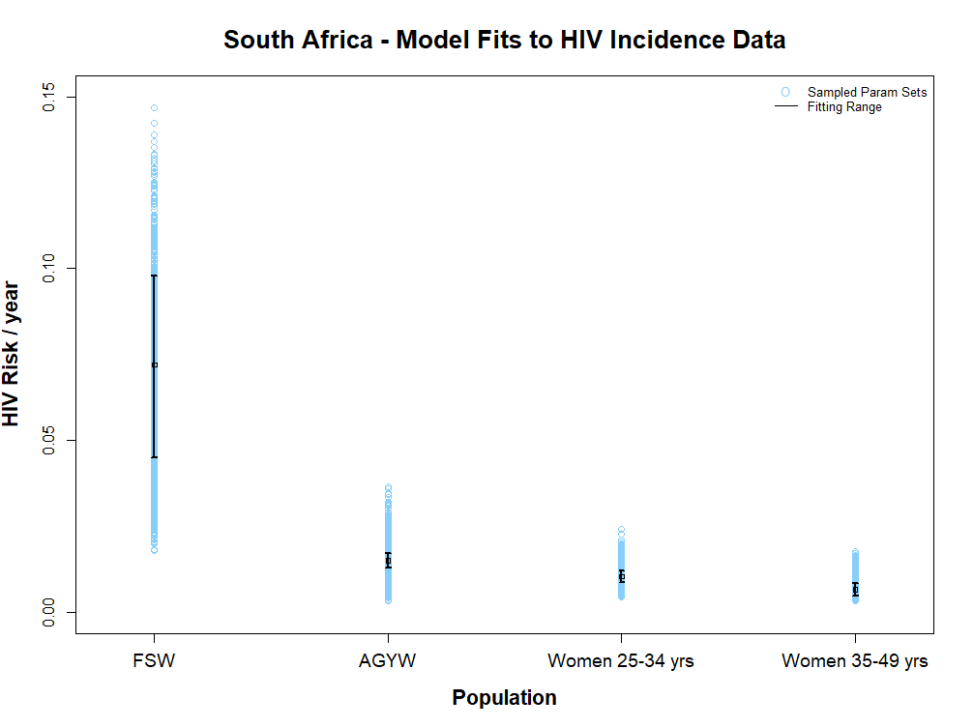
Figure S1: Model Fits to HIV Incidence Data for South Africa. The model outcomes across the parameter ranges simulated through latin hypercube sampling are show in blue. The black book-ended lines show the 95% confidence intervals around national HIV incidence estimates (HIV risk per year), and the model outcomes that fit within this range are considered to be fits to data. The model outcomes and fitting ranges are shown distinctly for the four high-risk women populations: female sex workers (FSW), adolescent girls and young women aged 15-24 years (AGYW), women aged 25-34 years and women aged 35-49 years.
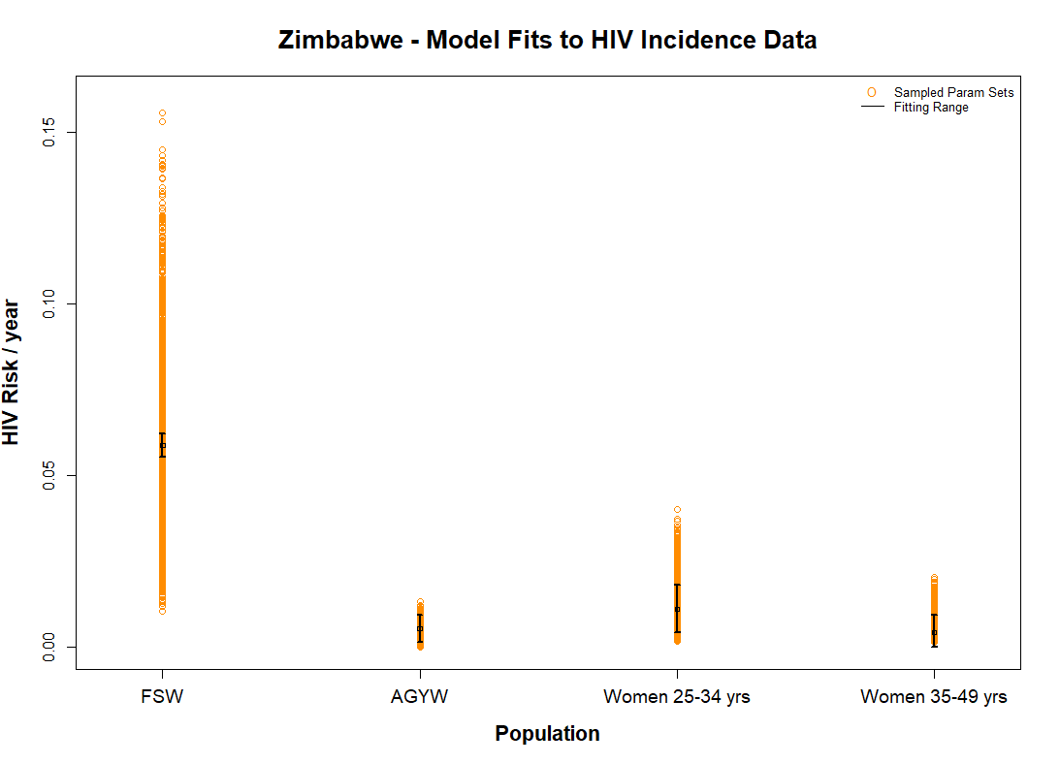
Figure S2: Model Fits to HIV Incidence Data for Zimbabwe. The model outcomes across the parameter ranges simulated through latin hypercube sampling are show in orange. The black book-ended lines show the 95% confidence intervals around national HIV incidence estimates (HIV risk per year), and the model outcomes that fit within this range are considered to be fits to data. The model outcomes and fitting ranges are shown distinctly for the four high-risk women populations: female sex workers (FSW), adolescent girls and young women aged 15-24 years (AGYW), women aged 25-34 years and women aged 35-49 years.

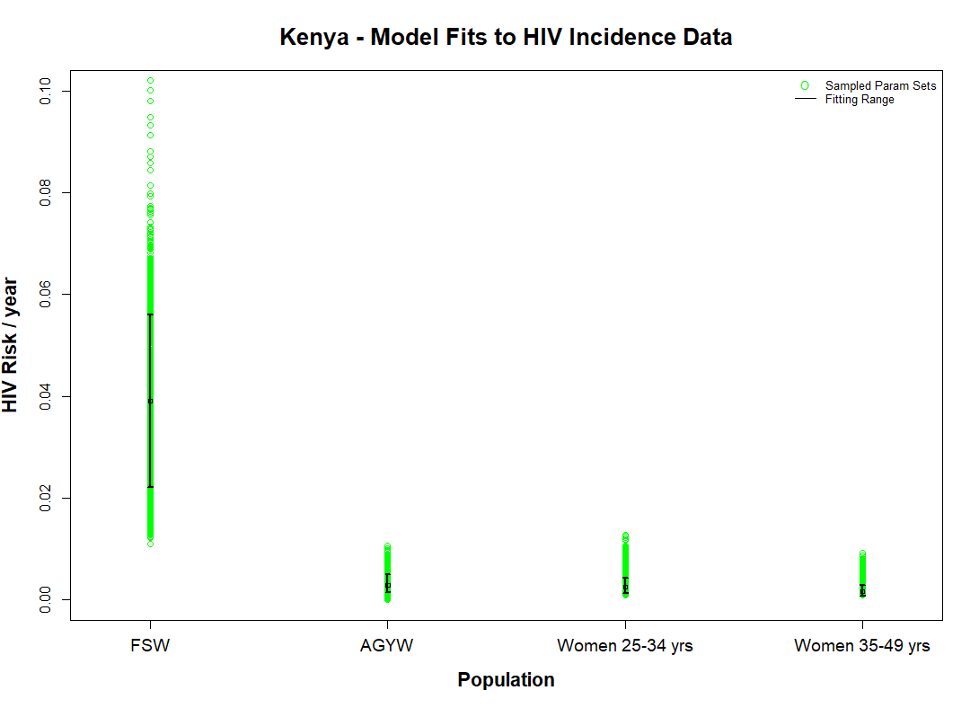
Figure S3: Model Fits to HIV Incidence Data for Kenya. The model outcomes across the parameter ranges simulated through latin hypercube sampling are show in green. The black book-ended lines show the 95% confidence intervals around national HIV incidence estimates (HIV risk per year), and the model outcomes that fit within this range are considered to be fits to data. The model outcomes and fitting ranges are shown distinctly for the four high-risk women populations: female sex workers (FSW), adolescent girls and young women aged 15-24 years (AGYW), women aged 25-34 years and women aged 35-49 years.

Supplementary Results
Figure S4 illustrates the relative cost at which PrEP will be equally as cost-effective to scale-up in a lower-risk group as it will be in a high-risk group, in the case that HIV prevalence in the higher-risk women partner population is 20%. It is demonstrated in four scenarios: underlying HIV prevalence in the lower-risk women’s partner population of 5%, 10%, 15% and 20%. This figure corresponds to Figure 2 in the main text, which demonstrates that case that HIV prevalence in the higher-risk women’s partner population is 40%.

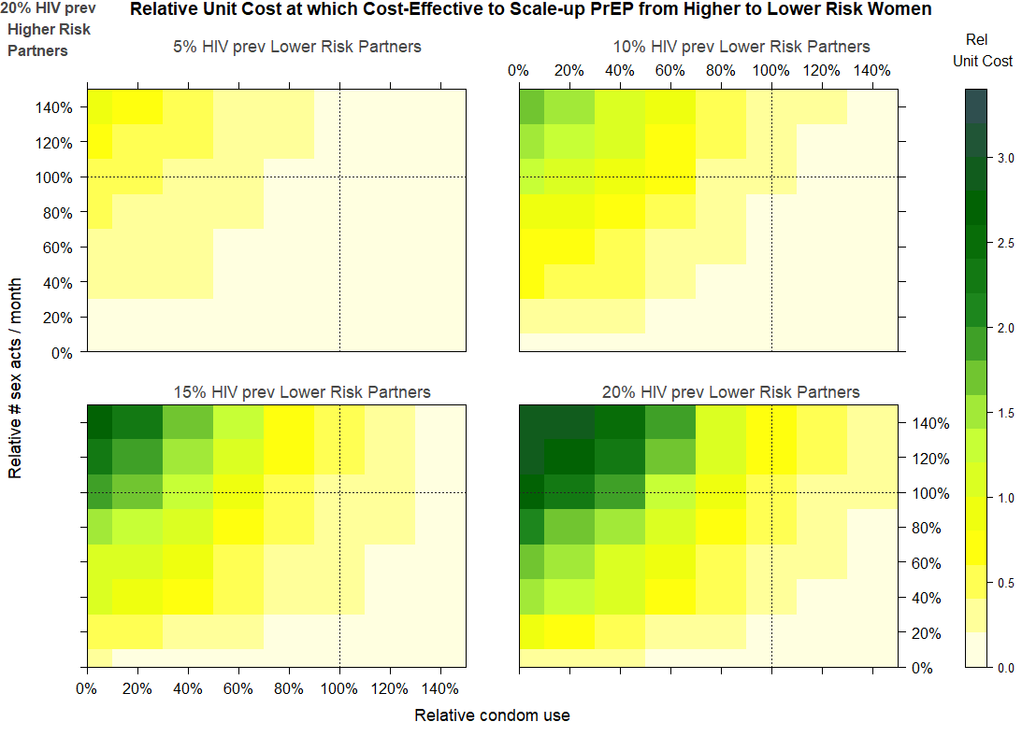
Figure S4: Relative unit cost at which it is cost-effective to scale-up PrEP from a higher- to lower-risk women group. The heatmaps show the relative unit cost at which it is cost-effective to scale-up PrEP from a higher- to a lower-risk group. The relative unit cost at which PrEP is cost-effective is shown by the relative average condom use in the lower-risk group compared to the higher-risk group (x-axis), and the relative number of sex acts a month for women in the lower-risk group compared to the higher-risk group (y-axis). The unit cost of PrEP in the lower-risk group relative to the higher-risk group at which PrEP is equally cost-effective between the two groups is shown by colour, according to the colour key on the right-hand side of the graph. A colour within the yellow spectrum denotes that the relative unit cost of PrEP in the lower-risk group relative to the higher-risk group has to be less than 1 for it to be equally as cost cost-effective. A colour within the green spectrum denotes that the relative unit cost of PrEP in the lower-risk group relative to the higher-risk group will be greater than 1 for it to be equally as cost cost-effective. The 4 heatmaps correspond respectively (left to right, top to bottom) to underlying partner HIV prevalence of 5%, 10%, 15% and 20% in the lower-risk group’s partner population and all of them corresponding to 20% HIV prevalence in the higher-risk women’s partner population. The heatmaps are calculated using equation (S1.5) from the Supplementary Materials: Methods, assuming that women’s partners are drawn from a single population each. The higher-risk group are assumed to have 12-month PrEP program retention levels of 22%³ and adherence levels of 70-85% (corresponding to a risk reduction of 73-99%⁸). The PrEP program retention levels for the lower-risk group were simulated between +/- 25% the retention of the higher-risk group.⁴ For those lower-risk women retained in the PrEP program, it was assumed that PrEP adherence was the same as the higher-risk group.

Comparison of the Maximum Unit Costs of PrEP in Lower-Risk Groups Relative to Unit Costs FSW to be Equally as Cost-Effective, with Estimates of Current Relative Unit Costs
 |  | High Risk Women Population
Country | Unit Cost Relative to FSWs | AGYW | Women 25-34 years | Women 35-49 years
South Africa | Maximum Relative Unit Cost to be Cost-Effective | 23.3 % ( 13.3 % , 36.8 % ) | 16.2 % ( 9.1 % , 26 % ) | 10.5 % ( 5.7 % , 18 % )
 | Estimated Current Relative Unit Cost | 79.6 % ( 72.4 % , 86.7 % ) | 68.7 % ( 62.7 % , 75.8 % ) | 48.3 % ( 42.4 % , 54.7 % )
 | Difference (relative to FSW Unit Cost) | -56.2 % ( -69.2 % , -40.4 % ) | -52.2 % ( -62.5 % , -41.4 % ) | -37.6 % ( -45.8 % , -28.7 % )
 | Difference (relative to own Unit Cost) | -70.8 % ( -83.4 % , -53.2 % ) | -76.2 % ( -87.0 % , -62.6 % ) | -78.4 % ( -88.1 % , -61.8 % )
Zimbabwe | Maximum Relative Unit Cost to be Cost-Effective | 7.1 % ( 2.7 % , 14.9 % ) | 17.7 % ( 7.1 % , 31.2 % ) | 11 % ( 5.5 % , 17.2 % )
 | Estimated Current Relative Unit Cost | 75.6 % ( 70.8 % , 80.8 % ) | 63 % ( 58 % , 67.7 % ) | 38.8 % ( 34.1 % , 42.7 % )
 | Difference (relative to FSW Unit Cost) | -67.7 % ( -75.1 % , -60.1 % ) | -44.6 % ( -58.3 % , -31.1 % ) | -28.1 % ( -35.3 % , -18.7 % )
 | Difference (relative to own Unit Cost) | -90.4 % ( -96.5 % , -80.6 % ) | -71.8 % ( -88.9 % , -50.8 % ) | -72 % ( -86.1 % , -53.6 % )
Kenya | Maximum Relative Unit Cost to be Cost-Effective | 8.1 % ( 3.9 % , 18.5 % ) | 9.1 % ( 3.6 % , 17.7 % ) | 6.4 % ( 3.1 % , 11.6 % )
 | Estimated Current Relative Unit Cost | 90.3 % ( 86.2 % , 94.8 % ) | 74.9 % ( 71.1 % , 78.4 % ) | 48.1 % ( 45.1 % , 51.6 % )
 | Difference (relative to FSW Unit Cost) | -81.5 % ( -89 % , -71 % ) | -66 % ( -73.4 % , -57.5 % ) | -41.7 % ( -46.4 % , -36.2 % )
 | Difference (relative to own Unit Cost) | -91 % ( -95.7 % , -79.6 % ) | -88 % ( -95.3 % , -76.6 % ) | -86.7 % ( -93.7 % , -75.4 % )
Table S3: Comparison of the Maximum Unit Costs of PrEP in Lower-Risk Groups Relative to Unit Costs FSW to be Equally as Cost-Effective, with Estimates of Current Relative Unit Costs. The table shows the maximum relative unit costs of PrEP in AGYW, women 25-34 years and women 35-49 years relative to the unit costs of PrEP for FSW, for PrEP to be equally as cost-effective (calculated using equation S1.5 in Supplementary Materials: Methods). It compares this to the estimated current relative unit costs between the populations, calculated using the data set out in Table S2. The table shows the difference between these two estimates (relative to the FSW unit cost of PrEP). It also shows what this difference represents relative to the group’s (i.e. AGYW, women 25-34 years or women 35-49 years) own unit cost, which is equivalent to the % the unit cost would have to drop for PrEP to be equally as cost-effective as for FSW. The comparisons are shown separately for South Africa, Zimbabwe and Kenya. The values shown in the table outside the brackets are the median values, and the values shown in the brackets are the 95% credible intervals (CrIs).

 | Median relative Cost of Equal Coverage of PrEP between stated female population group and FSW
Country | AGYW | Women 25-34 years | Women 35-49 years
South Africa | 28.3 | 26.7 | 18.7
Zimbabwe | 21.9 | 15.2 | 7
Kenya | 27.4 | 16.4 | 8.5
Table S4a: Median relative cost of equal coverage of PrEP between stated female population group and FSW. The table shows the median cost of equal coverage of PrEP between FSW, AGYW, women 25-34 years or women 35-49 years and FSW. It is calculated as (population size of female group*unit cost of PrEP for female group)/ (population size of FSW*unit cost of PrEP for FSW). The unit costs of PrEP for each high-risk woman group are as stated in Table S2. AGYW is used as shorthand for adolescent girls and young women 15-24 years.

Table S4 sets out the estimated number of infections that could be averted a year due to PrEP in each high-risk women population group, in each country, for every $100,000 available for PrEP programming, at the PrEP unit costs stated in Table S2. These data correspond to Figure 4 in the main text.

For each $100k available for PrEP programming a year,
the number of HIV infections that could be averted due to PrEP
 | High Risk Women Population
Country | FSW | AGYW | Women 25-34 years | Women 35-49 years
South Africa | 5.7 ( 3.8 , 8.8 ) | 1.7 ( 1.1 , 2.4 ) | 1.3 ( 0.9 , 2 ) | 1.2 ( 0.8 , 2 )
Zimbabwe | 3.4 ( 2.9 , 4.1 ) | 0.3 ( 0.1 , 0.7 ) | 1 ( 0.4 , 1.8 ) | 0.9 ( 0.5 , 1.6 )
Kenya | 1.5 ( 0.9 , 2.4 ) | 0.1 ( 0.1 , 0.3 ) | 0.2 ( 0.1 , 0.3 ) | 0.2 ( 0.1 , 0.3 )
Table S4: Median and 95% credible intervals (95% CrIs) of the relative number of infections that could be averted a year due to PrEP for each $100k available for PrEP programming. The table shows the median (value outside the brackets) and 95% CrIs (inside the brackets) of the number of HIV infections that could be averted a year due to PrEP, for each $100k available for PrEP programming, for FSW, AGYW, women 25-34 years or women 35-49 years. The relative number of infections that could be averted is calculated using equation S2.10 from Supplementary Materials and assumes that 12-month PrEP program retention in AGYW, women 25-34 years or women 35-49 years is within +/-25% of retention levels for FSW, taken to be 22%, in line with the results of the TAPS demonstration project.³ The unit costs of PrEP for each high-risk woman group are as stated in Table S2. AGYW is used as shorthand for adolescent girls and young women 15-24 years.

In South Africa, $100,000 could avert a median 5.7 infections a year or 0.2% (95% CrI: 0.1%, 0.4%)
of the total infections a year due to PrEP in FSW; median 1.7 infections a year or <0.1% (95% CrI: <0.1%, <0.1%) of the total infections a year in AGYW; mediaan 1.3 infections a year or <0.1% (95% CrI: <0.1%, <0.1%) of total infections a year in women 25-34 years; and median 1.2 infections a year or <0.1% (95% CrI: <0.1%, <0.1%) of total infections a year in women 35-49 years. This highlights, that to maximise cost-effectiveness on an individual basis, PrEP would be scaled-up first in FSW, then AGYW, then women 35-49 years, then women 25-34 years.
In Zimbabwe, $100,000 could avert a median 3.4 infections a year or 0.3% (95% CrI: 0.3%, 0.4%)
of the total infections a year due to PrEP in FSW; median 0.3 infections a year or <0.1% (95% CrI: <0.1%, <0.1%) of the total infections a year in AGYW; median 1.0 infections a year or <0.1% (95% CrI: <0.1%, <0.1%) of total infections a year in women 25-34 years; and median 0.9 infections a year or <0.1% (95% CrI: <0.1%, <0.1%) of total infections a year in women 35-49 years. This highlights, that to maximise cost-effectiveness on an individual basis, PrEP would be scaled-up first in FSW, then women 25-34 years, then women 35-49 years, then AGYW.
In Kenya, $100,000 could avert a median 1.5 infections a year or <0.1% (95% CrI: <0.1%, 0.1%) of the total infections a year due to PrEP in FSW; median 0.1 infections a year or <0.1% (95% CrI: <0.1%, <0.1%) of the total infections a year in AGYW; median 0.2 infections a year or <0.1% (95% CrI: <0.1%, <0.1%) of total infections a year in women 25-34 years; and median 0.2 infections a year or <0.1% (95% CrI: <0.1%, <0.1%) of total infections a year in women 35-49 years. This highlights, that to maximise cost-effectiveness on an individual basis, PrEP would be scaled-up first in FSW, then women 25-34 years and women 35-49 years, and then AGYW.

Figure S5 shows, the proportion of the total number of HIV infections that could be averted a year for each $100k available for PrEP programming.. The corresponding data to the figure are set out in Table S5 below.
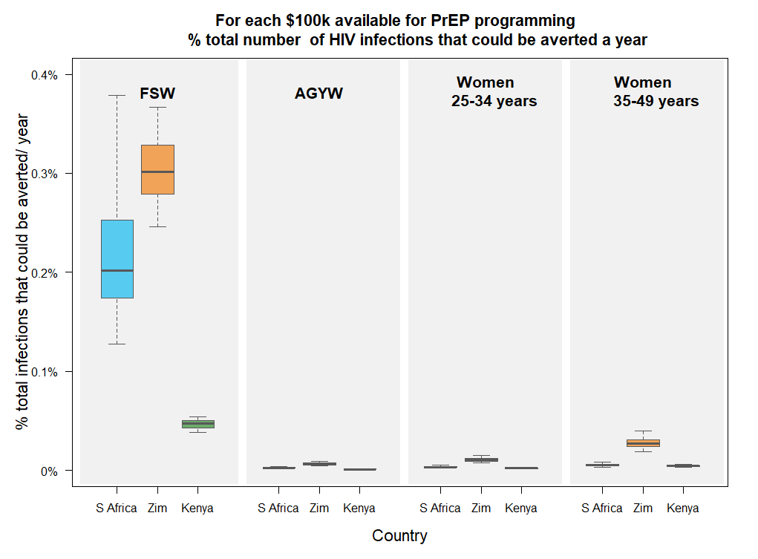
Figure S5: Boxplot showing for each $100k available for PrEP programming, the proportion of the total number of HIV infections that could be averted a year with these funds. The boxplot shows for each $100k available for PrEP programming, the proportion of infections that could be averted a year with these funds for each of HIV negative FSW, AGYW, women 25-34 years or women 35-49 years. The proportion of total infections that could be averted a year are shown, grouped left to right, for FSW, AGYW, women 25-34 years and women 35-49 years. Within each age grouping, the results are show by country, left to right, for South Africa (in blue), Zimbabwe (in orange) and Kenya (in blue). The proportion of total infections that could be averted a year are calculated using equation S2.11 from Supplementary Materials and assumes that 12-month PrEP program retention in AGYW, women 25-34 years or women 35-49 years is within +/-25% of retention levels for FSW, taken to be 22%, in line with the results of the TAPS demonstration project.³ The abbreviations used in the graph are as follows: AGYW denotes adolescent girls and young women 15-24 years, S Africa denotes South Africa and Zim denotes Zimbabwe.
For each $100k available for PrEP programming,
the proportion of HIV infections that could be averted a year
 | High Risk Women Population
Country | FSW | AGYW | Women 25-34 years | Women 35-49 years
South Africa | 0.2 % ( 0.1 % , 0.4 % ) | 0 % ( 0 % , 0 % ) | 0 % ( 0 % , 0 % ) | 0 % ( 0 % , 0 % )
Zimbabwe | 0.3 % ( 0.3 % , 0.4 % ) | 0 % ( 0 % , 0 % ) | 0 % ( 0 % , 0 % ) | 0 % ( 0 % , 0 % )
Kenya | 0 % ( 0 % , 0.1 % ) | 0 % ( 0 % , 0 % ) | 0 % ( 0 % , 0 % ) | 0 % ( 0 % , 0 % )
Table S5: Median and 95% credible intervals (95% CrIs) of the proportion of the total number of HIV infections that could be averted a year with each $100k available for PrEP programming. The table shows the median (value outside the brackets) and 95% CrIs (inside the brackets) of the proportion of the total number of HIV infections that could be averted a year with each $100k available for PrEP programming for FSW, AGYW, women 25-34 years or women 35-49 years. The proportion of the total number of HIV infections that could be averted is calculated using equation S2.11 from Supplementary Materials and assumes that 12-month PrEP program retention in AGYW, women 25-34 years or women 35-49 years is within +/-25% of retention levels for FSW, taken to be 22%, in line with the results of the TAPS demonstration project.³ The unit costs of PrEP for each high-risk woman group are as stated in Table S2. AGYW is used as shorthand for adolescent girls and young women 15-24 years.

Figure S6 sets out the number of HIV negative individuals in each high-risk woman population that would need to be enrolled on PrEP to avert the same number of infections as 10% PrEP program coverage in HIV negative FSW. The corresponding data to the figure are set out in Table S6.
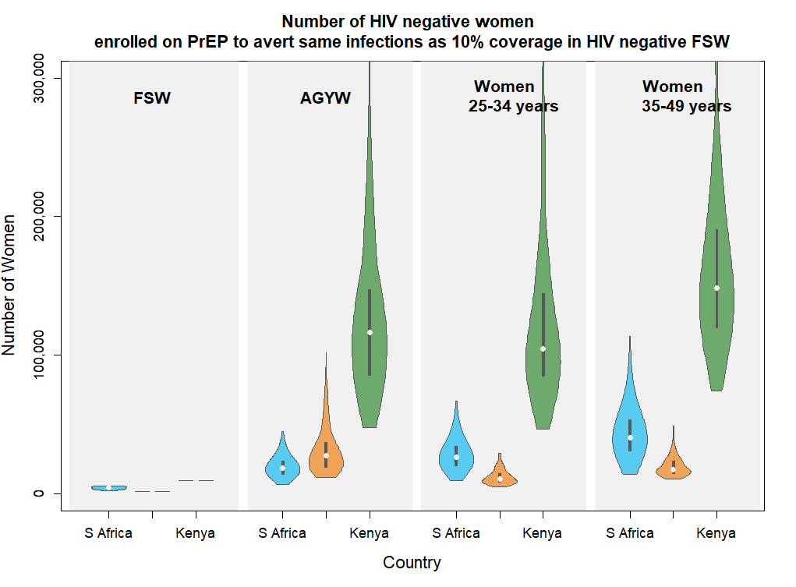
Figure S6: Number of HIV negative women needed to be enrolled on PrEP to avert the same number of infections as 10% PrEP program coverage in HIV negative FSW. The violin plot shows number of HIV negative AGYW, women 25-34 years or women 35-49 years in the population that would have to be enrolled in a PrEP program in order to achieve the same number of infections averted over 12 months as with 10% of the HIV negative FSW population enrolled in a PrEP program. As a comparison, the number of women represented by 10% of HIV negative FSW is shown in the far left hand side block of the figure. The number of HIV negative women needed to be enrolled on PrEP to avert the same number of infections as 10% PrEP program coverage in HIV negative FSW is then grouped left to right, for AGYW, women 25-34 years or women 35-49 years. Within each age grouping, the results are show by country, left to right, for South Africa (in blue), Zimbabwe (in orange) and Kenya (in blue). In the violin plots, the white dots represent the median values, the thick black vertical lines represent the interquartile range, the vertical length of the violin represents the range of values and the width of the violin represents the frequency with which those values occur. Where two horizontal grey lines are shown instead of a violin, it indicates that the range of values is limited in variation. The number of HIV negative women needed to be enrolled on PrEP to avert the same number of infections averted as 10% PrEP program coverage in HIV negative FSW is calculated using equation S2.7 from Supplementary Materials and assumes that 12-month PrEP program retention in AGYW, women 25-34 years or women 35-49 years is within +/-25% of retention levels for FSW, taken to be 22%, in line with the results of the TAPS demonstration project.³ The abbreviations used in the graph are as follows: AGYW denotes adolescent girls and young women 15-24 years, S Africa denotes South Africa and Zim denotes Zimbabwe.

Number of HIV negative women needed to be enrolled on PrEP
to avert the same number of infections as 10% PrEP program coverage in HIV negative FSW
 | High Risk Women Population
Country | FSW (comparator) | AGYW | Women 25-34 years | Women 35-49 years
South Africa | 4359 (2774, 5914 ) | 18531 (9594, 37052 ) | 31798 (16411, 65199) | 52240 (26287 , 111053)
Zimbabwe | 1933 (1910, 1953) | 27496 (12962, 72904) | 14933 (8535, 37453) | 36978 (23578, 73838)
Kenya | 9477 (9449, 9513) | 116565 (51258, 246376) | 151830 (78163, 380590) | 274531 (149378, 567706)
Table S6: Median and 95% credible interval (CrIs) of the number of HIV negative women needed to be enrolled on PrEP to avert the same number of infections as 10% PrEP program coverage in HIV negative FSW. The table shows the median (value outside the brackets) and 95% CrIs (inside the brackets) of the number of HIV negative AGYW, women 25-34 years or women 35-49 years in the population that would have to be enrolled in a PrEP program in order to achieve the same number of infections averted over 12 months as with 10% of the HIV negative FSW population enrolled in a PrEP program. As a comparison, the median and 95% CrIs of the numbers of women represented by 10% of HIV negative FSW is shown in the far left column of the table. The median and 95% CrIs of the numbers of HIV negative women needed to be enrolled on PrEP to avert the same number of infections as 10% PrEP program coverage in HIV negative FSW is then grouped left to right in the 2nd to 4th columns of the table, for AGYW, women 25-34 years or women 35-49 years respectively. Within each age grouping, the results are show by country, for South Africa, Zimbabwe and Kenya in rows 1 to 3 respectively. The number of HIV negative women needed to be enrolled on PrEP to avert the same number of infections averted as 10% PrEP program coverage in HIV negative FSW is calculated using equation S2.7 from Supplementary Materials and assumes that 12-month PrEP program retention in AGYW, women 25-34 years or women 35-49 years is within +/-25% of retention levels for FSW, taken to be 22%, in line with the results of the TAPS demonstration project.³

Figure S7 shows PrEP program coverage in HIV negative individuals in each high-risk woman population that would need to be enrolled on PrEP to avert the same number of infections as 10% PrEP program coverage in HIV negative FSW. The corresponding data are shown in Table S7 below.
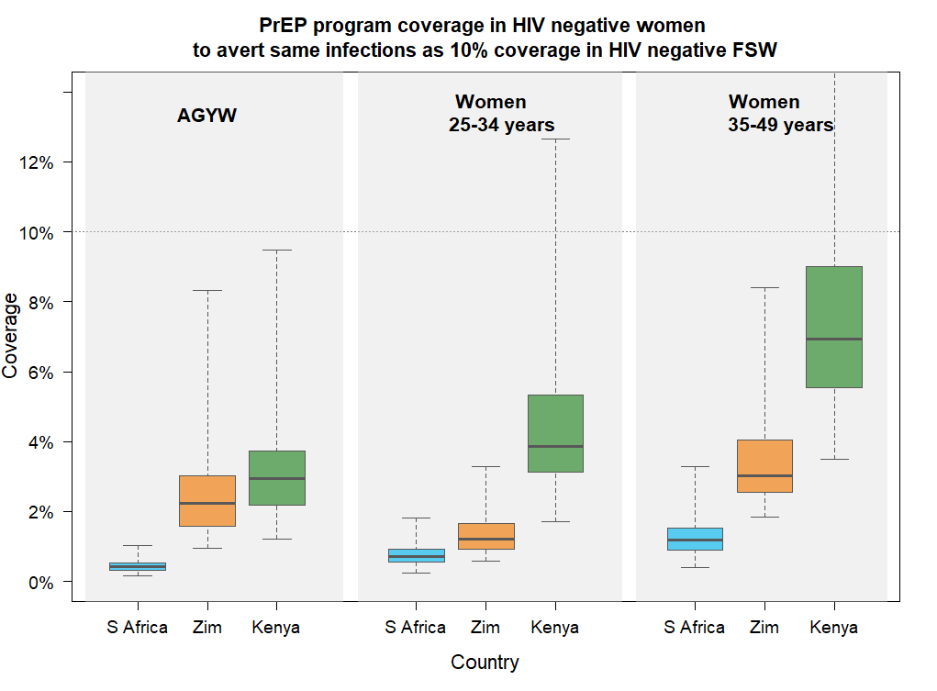
Figure S7: Boxplot of the PrEP program coverage in HIV negative women needed to avert the same number of HIV infections as 10% coverage in HIV negative FSW. The boxplot shows the PrEP program coverage in HIV negative AGYW, women 25-34 years or women 35-49 years to avert the same number of infections as 10% program coverage in HIV negative FSW. The PrEP program coverage levels are shown, grouped left to right, for AGYW, women 25-34 years or women 35-49 years. Within each age grouping, the results are show by country, left to right, for South Africa (in blue), Zimbabwe (in orange) and Kenya (in blue). The coverage levels are calculated using equation S2.7 from Supplementary Materials and assumes that 12-month PrEP program retention in AGYW, women 25-34 years or women 35-49 years is within +/-25% of retention levels for FSW, taken to be 22%, in line with the results of the TAPS demonstration project.³ The abbreviations used in the graph are as follows: AGYW denotes adolescent girls and young women 15-24 years, S Africa denotes South Africa and Zim denotes Zimbabwe.

PrEP program coverage in HIV negative women to avert the same number of infections
as 10% coverage in HIV negative FSW
 | High Risk Women Population
Country | AGYW | Women 25-34 | Women 35-49 years
South Africa | 0.4 % ( 0.2 % , 0.8 % ) | 0.7 % ( 0.4 % , 1.4 % ) | 1.2 % ( 0.6 % , 2.5 % )
Zimbabwe | 2.2 % ( 1.1 % , 5.9 % ) | 1.2 % ( 0.7 % , 3.1 % ) | 3 % ( 1.9 % , 6 % )
Kenya | 2.9 % ( 1.3 % , 6.3 % ) | 3.8 % ( 2 % , 9.7 % ) | 6.9 % ( 3.8 % , 14.4 % )
Table S7: Median and 95% credible intervals (95% CrIs) of the PrEP program coverage in HIV negative women to avert the same number of infections as with 10% PrEP program coverage in HIV negative FSW. The table shows the median (value outside the brackets) and 95% CrIs (inside the brackets) of the PrEP program coverage in AGYW, women 25-34 years or women 35-49 years to achieve the same number of infections a year as 10% PrEP program coverage in HIV negative FSW. The PrEP program coverage is calculated using equation S2.7 from Supplementary Materials and assumes that 12-month PrEP program retention in AGYW, women 25-34 years or women 35-49 years is within +/-25% of retention levels for FSW, taken to be 22%, in line with the results of the TAPS demonstration project.³ AGYW is used as shorthand for adolescent girls and young women 15-24 years.

Table S8 shows the relative number of infections that could be averted a year with PrEP at equal coverage levels in AGYW, women 25-34 years and women 35-49 years as in FSW. These data correspond to Figure 5 in the main text.

Relative number of infections that could be averted a year on PrEP
with equal program coverage as in FSW
 | High Risk Women Population
Country | AGYW | Women 25-34 years | Women 35-49 years
South Africa | 24 ( 12 , 45 ) | 14 ( 7 , 27 ) | 8 ( 4 , 17 )
Zimbabwe | 4 ( 2 , 9 ) | 8 ( 3 , 14 ) | 3 ( 2 , 5 )
Kenya | 3 ( 2 , 8 ) | 3 ( 1 , 5 ) | 1 ( 1 , 3 )
Table S8: Median and 95% credible intervals (95% CrIs) of the relative number of infections that could be averted a year on PrEP with equal program coverage as in FSW. The table shows the median (value outside the brackets) and 95% CrIs (inside the brackets) of the relative number of infections that could be averted a year on PrEP in AGYW, women 25-34 years or women 35-49 years relative to the number that could be averted in FSW with equal PrEP program coverage. The relative number of infections that could be averted is calculated using equation S2.9 from Supplementary Materials and assumes that 12-month PrEP program retention in AGYW, women 25-34 years or women 35-49 years is within +/-25% of retention levels for FSW, taken to be 22%, in line with the results of the TAPS demonstration project.³ AGYW is used as shorthand for adolescent girls and young women 15-24 years.

Sensitivity analysis

25% less PrEP-adherence-related HIV risk reduction across all women groups

Table S9 shows the percentage change in the maximum unit cost at which PrEP will be equally cost-effective in other high-risk women groups (AGYW, women 25-34 years and women 35-49 years) as in FSW, if 25% less PrEP-adherence-related HIV risk reduction were assumed across all women groups. These results are a comparison of the results set out in Table S3 (top row for each country) with what the results would be if the same analysis were repeated with 25% less PrEP-adherence-related HIV risk reduction across all women groups.

% Change in Maximum Unit Cost at which PrEP is equally as Cost-Effective as for FSW,
with 25% reduced HIV risk-reduction across all Groups
 | High Risk Women Population
Country | AGYW | Women 25-34 | Women 35-49 years
South Africa | 0.001% (0.000%, 0.003%) | -0.002% (-0.002%, 0.000%) | 0.000% (-0.002%, 0.000%)
Zimbabwe | 0.001% (-0.002%, 0.002%) | -0.002% (-0.001%, 0.001%) | -0.001% (-0.002%, -0.001%)
Kenya | 0.000% (0.000%, 0.001%) | 0.001% (0.000%, 0.002%) | 0.000% (0.000%, 0.000%)
Table S9: Percentage change in the maximum unit cost at which PrEP will be equally cost-effective in other high-risk women groups (AGYW, women 25-34 years and women 35-49 years) as in FSW, if 25% less PrEP-adherence-related HIV risk reduction were assumed across all women groups. The table shows the percentage change in the maximum relative unit costs of PrEP in AGYW, women 25-34 years and women 35-49 years relative to the unit costs of PrEP for FSW, for PrEP to be equally as cost-effective (calculated using equation S1.5 in Supplementary Materials: Methods), if the PrEP-adherence-associated HIV risk reduction were reduced by 25% compared to the baseline analysis presented in Table S3 (top row for each country). The comparisons are shown separately for South Africa, Zimbabwe and Kenya. AGYW is used as shorthand for adolescent girls and young women 15-24 years. The values shown in the table outside the brackets are the median values, and the values shown in the brackets are the 95% credible intervals (CrIs). All values are shown rounded to the nearest 3 decimal places.
Table S10 sets out the percentage change in the in the relative number of infections averted a year on PrEP with equal coverage as with FSW, if 25% less PrEP-adherence-related HIV risk reduction were assumed across all women groups. These results are a comparison of the results set out in Table S8 with what the results would be if the same analysis were repeated with 25% less PrEP-adherence-related HIV risk reduction across all women groups.

% Change in Relative Number of Infections Averted a Year on PrEP with equal coverage as with FSW,
with 25% reduced PrEP-adherence-related HIV-risk reduction across Groups
 | High Risk Women Population
Country | AGYW | Women 25-34 years | Women 35-49 years
South Africa | 0.000 % (-0.001% , 0.000 % ) | -0.001 % ( -0.001% , -0.001%) | -0.001 % ( -0.001 % , 0.000 % )
Zimbabwe | 0.000% (-0.001 % , 0.002 %) | -0.002% (-0.001 % , 0.001%) | -0.001% (-0.002 % , -0.001 %)
Kenya | 0.000% (0.000% , 0.001 %) | 0.001% (0.000% , 0.002%) | 0.000% (0.000 % , 0.000 %)

Table S10: Percentage change in the relative number of infections averted a year on PrEP with equal coverage as with FSW, with 25% reduced PrEP-adherence-related HIV-risk reduction across groups. The table shows the median (value outside the brackets) and 95% CrIs (inside the brackets) of the percentage change in the relative number of infections that could be averted a year on PrEP in AGYW, women 25-34 years or women 35-49 years relative to the number that could be averted in FSW with equal PrEP program coverage, if the PrEP-adherence-associated HIV risk reduction were reduced by 25% compared to the baseline analysis presented in Table S8. For the underlying analyses, the relative number of infections that could be averted is calculated using equation S2.9 from Supplementary Materials. AGYW is used as shorthand for adolescent girls and young women 15-24 years. All values are shown rounded to the nearest 3 decimal places.

25% less PrEP-adherence-related HIV risk reduction across all non-FSW women groups

Table S11 sets out the percentage change in the maximum unit cost at which PrEP will be equally cost-effective in other high-risk women groups (AGYW, women 25-34 years and women 35-49 years) as in FSW, if 25% less PrEP-adherence-related HIV risk reduction were assumed across all non-FSW women groups (i.e. AGYW, women 25-34 years and women 35-49 years). These results are a comparison of the results set out in Table S3 (top row for each country) with what the results would be if the same analysis were repeated with 25% less PrEP-adherence-related HIV risk reduction across all non-FSW women groups.

% Change in Maximum Unit Cost at which PrEP is equally as Cost-Effective as for FSW,
with 25% reduced HIV risk-reduction across all non-FSW women groups
 | High Risk Women Population
Country | AGYW | Women 25-34 | Women 35-49 years
South Africa | 0.253 % (0.252 %, 0.252 %) | 0.253 % (0.252 %, 0.252% ) | 0.252 % (0.251%, 0.251%)
Zimbabwe | 0.254 % (0.253 %, 0.253 %) | 0.253 % (0.253% ,0.254%) | 0.252 % (0.252%,0.252%)
Kenya | 0.258 % (0.260 %, 0.256 %) | 0.257 % (0.257%,0.258%) | 0.256 % (0.255%,0.258%)
Table S11: Percentage change in the maximum unit cost at which PrEP will be equally cost-effective in other high-risk women groups (AGYW, women 25-34 years and women 35-49 years) as in FSW, if 25% less PrEP-adherence-related HIV risk reduction were assumed across all non-FSW women groups (i.e. AGYW, women 25-34 years and women 35-49 years). The table shows the percentage change in the maximum relative unit costs of PrEP in AGYW, women 25-34 years and women 35-49 years relative to the unit costs of PrEP for FSW, for PrEP to be equally as cost-effective (calculated using equation S1.5 in Supplementary Materials: Methods), if the PrEP-adherence-associated HIV risk reduction were reduced by 25% for all non-FSW women groups compared to the baseline analysis presented in Table S3 (top row for each country). The comparisons are shown separately for South Africa, Zimbabwe and Kenya. AGYW is used as shorthand for adolescent girls and young women 15-24 years. The values shown in the table outside the brackets are the median values, and the values shown in the brackets are the 95% credible intervals (CrIs). All values are shown rounded to the nearest 3 decimal places.

Table S12 sets out the percentage change in the in the relative number of infections averted a year on PrEP with equal coverage as with FSW, if 25% less PrEP-adherence-related HIV risk reduction were assumed across all non-FSW women groups (i.e. AGYW, women 25-34 years and women 35-49 years). These results are a comparison of the results set out in Table S8 with what the results would be if the same analysis were repeated with 25% less PrEP-adherence-related HIV risk reduction across all non-FSW women groups.

% Change in Relative Number of Infections Averted a Year on PrEP with equal coverage as with FSW,
with 25% reduced PrEP-adherence-related HIV-risk reduction across all non-FSW women groups
 | High Risk Women Population
Country | AGYW | Women 25-34 years | Women 35-49 years
South Africa | 0.252 % ( 0.250 % , 0.252 % ) | 0.251 % ( 0.252 % , 0.252 % ) | 0.252 % ( 0.251 % , 0.251 % )
Zimbabwe | 0.253 % ( 0.254 % , 0.254 % ) | 0.253 % ( 0.253 % , 0.254 % ) | 0.252 % ( 0.252 % , 0.253 % )
Kenya | 0.257 % ( 0.260 % , 0.256 % ) | 0.26 % ( 0.257 % , 0.258 % ) | 0.256 % ( 0.255 % , 0.258 % )

Table S12: Percentage change in the relative number of infections averted a year on PrEP with equal coverage as with FSW, with 25% reduced PrEP-adherence-related HIV-risk reduction across all non-FSW women groups (i.e. AGYW, women 25-34 years and women 35-49 years). The table shows the median (value outside the brackets) and 95% CrIs (inside the brackets) of the percentage change in the relative number of infections that could be averted a year on PrEP in AGYW, women 25-34 years or women 35-49 years relative to the number that could be averted in FSW with equal PrEP program coverage, if the PrEP-adherence-associated HIV risk reduction were reduced by 25% for all non-FSW women groups compared to the baseline analysis presented in Table S8. For the underlying analyses, the relative number of infections that could be averted is calculated using equation S2.9 from Supplementary Materials. AGYW is used as shorthand for adolescent girls and young women 15-24 years. All values are shown rounded to the nearest 3 decimal places.

Structural sensitivity analysis: women 25-34 years have partners from males 35-49 years, in addition to 25-34 years

Table S13 sets out the percentage change in the maximum unit cost at which PrEP will be equally cost-effective in other high-risk women groups (AGYW, women 25-34 years and women 35-49 years) as in FSW, under the structural sensitivity analysis exploring the case that women 25-34 years draw partners from males 35-49 years, in addition to 25-34 years. These results are a comparison of the results set out in Table S3 (top row for each country) with what the results would be if the same analysis were repeated with women 25-34 years drawing partners from males 35-49 years, in addition to 25-34 years (assumed to be the only partner population, in Table S3). Whilst the structural sensitivity analysis directly affects the model outcomes for women 25-34 years, it also indirectly affects the mean and 95% CrI outcomes for FSW, AGYW and women 35-49 year through changes to the number of underlying fitted parameter sets across all women groups.

% Change in Maximum Unit Cost at which PrEP is equally as Cost-Effective as for FSW,
with women 25-34 years having partners drawn from 2 populations
 | High Risk Women Population
Country | AGYW | Women 25-34 | Women 35-49 years
South Africa | -0.017 % (-0.063%, 0.017%) | -0.091% (-0.157%, -0.089%) | 0.016% (-0.009%, 0.060%)
Zimbabwe | 0.003% (0.015%, 0.018%) | -0.299% (-0.476%, -0.081%) | 0.075% (-0.015%, 0.128%)
Kenya | 0.020% (-0.004%, 0.000%) | -0.205% (-0.596%, 0.023%) | 0.038% (0.030%, 0.059%)
Table S13: Percentage change in the maximum unit cost at which PrEP will be equally cost-effective in other high-risk women groups (AGYW, women 25-34 years and women 35-49 years) as in FSW, under the structural sensitivity analysis exploring the case that women 25-34 years draw partners from males 35-49 years, in addition to 25-34 years. The table shows the percentage change in the maximum relative unit costs of PrEP in AGYW, women 25-34 years and women 35-49 years relative to the unit costs of PrEP for FSW, for PrEP to be equally as cost-effective (calculated using equation S1.5 in Supplementary Materials: Methods), if women 25-34 years are assumed to draw partners from males 35-49 years, in addition to 25-34 years, compared to the baseline analysis presented in Table S3 (top row for each country). The comparisons are shown separately for South Africa, Zimbabwe and Kenya. AGYW is used as shorthand for adolescent girls and young women 15-24 years. The values shown in the table outside the brackets are the median values, and the values shown in the brackets are the 95% credible intervals (CrIs). All values are shown rounded to the nearest 3 decimal places.

Table S14 sets out the percentage change in the in the relative number of infections averted a year on PrEP with equal coverage as with FSW, if women 25-34 years are assumed to draw partners from males 35-49 years, in addition to 25-34 years. These results are a comparison of the results set out in Table S8 with what the results would be if the same analysis were repeated with women 25-34 years drawing partners from males 35-49 years, in addition to 25-34 years (assumed to be the only partner population, in Table S8). Whilst the structural sensitivity analysis directly affects the model outcomes for women 25-34 years, it also indirectly affects the mean and 95% CrI outcomes for FSW, AGYW and women 35-49 year through changes to the number of underlying fitted parameter sets across all women groups.

% Change in Relative Number of Infections Averted a Year on PrEP with equal coverage as with FSW,
with women 25-34 years having partners drawn from 2 populations
 | High Risk Women Population
Country | AGYW | Women 25-34 years | Women 35-49 years
South Africa | 0.044 % (-0.091 %, -0.03 %) | -0.024 % (-0.176 % , -0.12 %) | 0.039 % (-0.054 %, 0.061 %)
Zimbabwe | 0.001 % (0.008 %, 0.015 %) | -0.297 % (-0.483 %, -0.087 %) | 0.064 % (-0.018 %, 0.125 %)
Kenya | 0.023 % (-0.004 %, -0.002 %) | -0.223 % (-0.593 %, 0.023 %) | 0.048 % (0.042 % , 0.074 %)

Table S14: Percentage change in the relative number of infections averted a year on PrEP with equal coverage as with FSW, under the structural sensitivity analysis exploring the case that women 25-34 years draw partners from males 35-49 years, in addition to 25-34 years. The table shows the median (value outside the brackets) and 95% CrIs (inside the brackets) of the percentage change in the relative number of infections that could be averted a year on PrEP in AGYW, women 25-34 years or women 35-49 years relative to the number that could be averted in FSW with equal PrEP program coverage, if women 25-34 years are assumed to draw partners from males 35-49 years, in addition to 25-34 years, compared to the baseline analysis presented in Table S8. For the underlying analyses, the relative number of infections that could be averted is calculated using equation S2.9 from Supplementary Materials. AGYW is used as shorthand for adolescent girls and young women 15-24 years. All values are shown rounded to the nearest 3 decimal places.

References
1. Grant H, Mukandavire Z, Eakle R, Prudden H, Gomez GB, Rees H, et al. When are declines in condom use while using PrEP a concern ? Modelling insights from a Hillbrow , South Africa case study. J Int AIDS Soc. 2017;20(1):1–8.
2. UNAIDS. Miles to Go: Closing Gaps, Breaking Barriers, Righting Injustices. Global AIDS Update 2018. Geneva; 2018.
3. Eakle R, Gomez GB, Naicker N, Bothma R, Mbogua J, Cabrera Escobar MA, et al. HIV pre-exposure prophylaxis and early antiretroviral treatment among female sex workers in South Africa: Results from a prospective observational demonstration project. Bekker L-G, editor. PLOS Med. 2017 Nov 21;14(11):e1002444.
4. Kyongo J. How long will they take it? Oral pre-exposure prophylaxis (PrEP) retention for female sex workers, men who have sex with men and young women in a demonstration project in Kenya. In: 22nd International AIDS Conference. Amsterdam; 2018.
5. Patel P, Borkowf CB, Brooks JT, Lasry A, Lansky A, Mermin J. Estimating per-act HIV transmission risk: a systematic review. AIDS. 2014;28(10):1509–19.
6. World Health Organization. WHO Implementation Tool for Pre-Exposure Phrophylaxis (PrEP) of HIV Infection, July 2017. 2017.
7. UNAIDS. Communities at the Centre: Defending Rights, Breaking Barriers, Reaching People With HIV Services. Global AIDS Update 2019. Geneva; 2019.
8. Jessica E. Haberer, Lara Kidoguchi, Renee Heffron, Nelly Mugo, Elizabeth Bukusi, Elly Katabira, Stephen Asiimwe, Katherine K. Thomas, Connie Celum JMB. Alignment of adherence and risk for HIV acquisition in a demonstration project of pre-exposure prophylaxis among HIV serodiscordant couples in Kenya and Uganda: a prospective analysis of prevention-effective adherence. J Int AIDS Soc. 2017;20:21842.
9. R: A language and environment for statistical computing. Vienna, Austria: R Foundation for Statistical Computing; 2016.
10. Human Science Research Council. South African National HIV Prevalence, Incidence, Behaviour and Communication Survey, 2017, Summary. 2018.
11. Zimbabwe National and Sub-National AIDS & TB Programme MOHACC. HIV Estimates Report 2017. 2018.
12. National AIDS Control Council, Ministry of Health K. Kenya HIV Estimates Report 2018. 2018.
13. Kerrigan D, Wirtz A, Semini I, N’Jie ND, Stanciole A, Butler J, Oelrichs R BC. The global HIV epidemics among sex workers. The World Bank; 2012.
14. Department of Health R of SA. National Policy on HIV Pre-exposure Prophylaxis (PrEP) and Test and Treat (T&T). 2016.
15. Ministry of Health and Child Care. Implementation Plan for HIV Pre-Exposure Prophylaxis in Zimbabwe 2018-2020.
16. Kenya Ministry of Health; Kenya National AIDS and STI Control Programme. Framework for the Implementation of Pre-Exposure Prophylaxis of HIV In Kenya. 2017;1–84.
17. Rivet Amico K, Bekker L-G. Global PrEP roll-out: recommendations for programmatic success. lancet HIV. 2019 Feb 1;6(2):e137–40.
18. Zimbabwe National Statistics Agency. Zimbabwe Demographic and Health Survey, 2015. 2016.
19. Kenya National Bureau of Statistics. Kenya 2014 Demographic and Health Survey. 2015;
20. Chalom, Andre and PI de K de P. Parameter space exploration of ecological models. arXiv Prepr arXiv12106278. 2012;
21. Cremin I, McKinnon L, Kimani J, Cherutich P, Gakii G, Muriuki F, et al. PrEP for key populations in combination HIV prevention in Nairobi: a mathematical modelling study. Lancet HIV. 2017 May 1;4(5):e214–22.
22. Allen Roberts, Ruanne V. Barnabas, Felix Abuna, Harrison Lagat, John Kinuthia, Jillian Pintye, Aaron Bochner, Jared Baeten, Grace John-Stewart CL. The Cost of PrEP Delivery in Kenyan Antenatal, Postnatal, and Family Planning Clinics. In: CROI. 2019.
23. The Global Fund to Fight AIDS T and M. Pooled Procurement Mechanism Reference Pricing: ARVs. Geneva, Switzerland;
24. Group TWB. PPP conversion factor, GDP (LCU per international $), 2017 [Internet]. 2019 [cited 2019 Apr 15]. Available from: https://data.worldbank.org/indicator/PA.NUS.PPP
25. Hutton G, Baltussen R. Hutton, G., &amp; Baltussen, R. M. (2003). Valuation of goods in cost-effectiveness analysis: notions of opportunity costs and transferability across time and countries. Switzerland; 2003.
26. Group TWB. Consumer price index (2010 = 100), 2017 [Internet]. 2019 [cited 2019 Apr 15]. Available from: https://data.worldbank.org/indicator/fp.cpi.totl
27. Meyer-Rath G, van Rensburg C, Chiu C, Leuner R, Jamieson L, Cohen S. The per-patient costs of HIV services in South Africa: Systematic review and application in the South African HIV Investment Case. McCreesh N, editor. PLoS One. 2019 Feb 26;14(2):e0210497.
28. World Bank. PPP conversion factor, GDP (LCU per international $) | Data [Internet]. 2018 [cited 2019 Feb 24]. Available from: https://data.worldbank.org/indicator/PA.NUS.PPP
29. McKinnon LR, Izulla P, Nagelkerke N, Munyao J, Wanjiru T, Shaw SY, et al. Risk Factors for HIV Acquisition in a Prospective Nairobi-Based Female Sex Worker Cohort. AIDS Behav. 2015 Dec 20;19(12):2204–13.
30. Priddy FH, Wakasiaka S, Hoang TD, Smith DJ, Farah B, del Rio C, et al. Anal sex, vaginal practices, and HIV incidence in female sex workers in urban Kenya: implications for the development of intravaginal HIV prevention methods. AIDS Res Hum Retroviruses. 2011 Oct;27(10):1067–72.
31. Chersich MF, Bosire W, King’ola N, Temmerman M, Luchters S. Effects of hazardous and harmful alcohol use on HIV incidence and sexual behaviour: a cohort study of Kenyan female sex workers. Global Health. 2014 Apr 3;10(1):22.
32. GLOBAL AIDS RESPONSE PROGRESS REPORT 2018 GAM ZIMBABWE COUNTRY REPORT. 2017.
33. Van Loggerenberg, F., Mlisana, K., Williamson, C., Auld, S. C., Morris, L., Gray, C. M., Karim, Q. A., Grobler, A., Barnabas, N. & Iriogbe I. Establishing a cohort at high risk of HIV infection in South Africa: challenges and experiences of the CAPRISA 002 acute infection study. PLoS One. 2008;3:e1954.
34. UNAIDS. UNAIDS 2018 Estimates [Internet]. 2017 [cited 2019 Jan 30]. Available from: http://aidsinfo.unaids.org/
35. Ministry of Health and Child Care Z. Zimbabwe Population-Based HIV Impact Assessment: ZIMPHIA 2016. 2017.
36. Human Sciences Research Council SA. HIV IMPACT ASSESSMENT SUMMARY. 2018.
37. Johnson LF, Dorrington RE, Moolla H. Progress towards the 2020 targets for HIV diagnosis and antiretroviral treatment in South Africa. South Afr J HIV Med. 2017;18(1):694.
38. Ministry of Health K. Most At Risk Populations Size Estimate Consensus report. 2013.
39. Konstant TL, Rangasami J, Stacey MJ, Stewart ML, Nogoduka C. Estimating the Number of Sex Workers in South Africa: Rapid Population Size Estimation. AIDS Behav. 2015 Feb 13;19(S1):3–15.
40. Statistics KNB of. Kenya Population by Sex and Age Groups. 2009.
41. UN Data. UNdata | record view | Population by age, sex and urban/rural residence [Internet]. 2012 [cited 2019 Feb 8]. Available from: http://data.un.org/Data.aspx?d=POP&f=tableCode%3A22
42. Statistics South Africa. Mid-year population estimates 2018. 2018.
43. Morris CN, Morris SR, Ferguson AG. Sexual Behavior of Female Sex Workers and Access to Condoms in Kenya and Uganda on the trans-Africa Highway. AIDS Behav. 2009 Oct 30;13(5):860–5.
44. Cowan FM, Langhaug LF, Hargrove JW, Jaffar S, Mhuriyengwe L, Swarthout TD, et al. Is Sexual Contact With Sex Workers Important in Driving the HIV Epidemic Among Men in Rural Zimbabwe? JAIDS J Acquir Immune Defic Syndr. 2005 Nov;40(3):371–6.
45. Welz T, Hosegood V, Jaffar S, Baetzing-Feigenbaum J, Herbst K, Newell M-L. Continued very high prevalence of HIV infection in rural KwaZulu-Natal, South Africa: a population-based longitudinal study. AIDS. 2007 Jul;21(11):1467–72.
46. Kimanga DO, Ogola S, Umuro M, Ng’ang’a A, Kimondo L, Murithi P, et al. Prevalence and incidence of HIV infection, trends, and risk factors among persons aged 15-64 years in Kenya: results from a nationally representative study. J Acquir Immune Defic Syndr. 2014 May 1;66 Suppl 1(Suppl 1):S13-26.
47. South African National AIDS Council. SAHMS Survey on female sex workers in South Africa. 2014.
48. Musyoki H, Kellogg TA, Geibel S, Muraguri N, Okal J, Tun W, et al. Prevalence of HIV, sexually transmitted infections, and risk behaviours among female sex workers in Nairobi, Kenya: results of a respondent driven sampling study. AIDS Behav. 2015 Feb;19 Suppl 1(Suppl 1):S46-58.
49. Wilson D, Chiroro P, Lavelle S et al. Sex worker, client sex behaviour and condom use in Harare, Zimbabwe. AIDS Care. 1989;(1):269–80.
50. Benedikt C, Chikeya A, Chirambira P, Chirwa C, Chowera T, Gregson S, et al. Estimating the Size and HIV Prevalence of Female Sex Worker Populations In Zimbabwe: Guidelines Based on Studies in Manicaland. 2012.
51. Vickerman, P., Watts, C., Delany, S., Alary, M., Rees H and HL. The Importance of Context: Model Projections on How Microbicide Impact Could be Affected by the Underlying Epideiologic and Behavioural Situation in 2 African Settings. Sex Transm Dis. 2006;33(6):397–405.
52. Vickerman, P., Terris-Prestholt, F., Delany, S., Kumaranayake, L., Rees, H. & Watts C. Are targeted HIV prevention activities cost-effective in high prevalence settings? Results from a sexually transmitted infection treatment project for sex workers in Johannesburg, South Africa. Sex Transm Dis. 2006;33:S122–32.
53. Vickerman, P., Ndowa, F., O’Farrell, N., Steen, R., Alary, M., Delany-Moretlwe S. Using mathematical modelling to estimate the impact of periodic presumptive treatment on the transmission of sexually transmitted infections and HIV among female sex workers. Sex Transm Infect. 2010;86:163–8.
54. Elizabeth Fearon, Andrew Phillips, Sibongile Mtetwa ST, Chabata, Phillis Mushati, Valentina Cambiano, Joanna Busza S, Napierala, Bernadette Hensen, Stefan Baral, Sharon S Weir B, Rice, Frances M Cowan JRH. How can programmes better support female sex workers to avoid HIV infection in Zimbabwe? A prevention cascade analysis. Submitted-Accepted. 2019;
55. S.P. Tegang, S. Abdallah, G. Emukule, S. Luchters, N. Kingola, M. Barasa, S. Mucheke PM. Concurrent sexual and substance-use risk behaviours among female sex workers in Kenya’s Coast Province: Findings from a behavioural monitoring survey. SAHARA-J J Soc Asp HIV/AIDS. 2010;7(4).
56. Cowan FM, Mtetwa S, Davey C, Fearon E, Dirawo J, Wong-Gruenwald R, et al. Engagement with HIV Prevention Treatment and Care among Female Sex Workers in Zimbabwe: a Respondent Driven Sampling Survey. He W, editor. PLoS One. 2013 Oct 15;8(10):e77080.
57. Ranganathan M, Heise L, Pettifor A, Silverwood RJ, Selin A, MacPhail C, et al. Transactional sex among young women in rural South Africa: prevalence, mediators and association with HIV infection. J Int AIDS Soc. 2016;19(1):20749.
58. Statistic South Africa. South Africa Demographic and Health Survey 2016: Key Indicator Report. 2017.
59. Johnson LF, Dorrington RE, Bradshaw D, Wyk VP-V, Rehle TM. Sexual behaviour patterns in South Africa and their association with the spread of HIV: Insights from a mathematical model. Demogr Res. 2009;21(11):289–340.
60. Johnson LF, Dorrington RE, Moolla H. HIV epidemic drivers in South Africa: A model-based evaluation of factors accounting for inter-provincial differences in HIV prevalence and incidence trends. South Afr J HIV Med. 2017 Jul 28;18(1).
61. Ministry of Health K. Kenya’s Fast Track Plan to End HIV and AIDS Among Adolescents and Young People. 2015.
62. Cowan FM, Pascoe SJS, Langhaug LF, Mavhu W, Chidiya S, Jaffar S, et al. The Regai Dzive Shiri project: results of a randomized trial of an HIV prevention intervention for youth. AIDS. 2010 Oct 23;24(16):2541–52.
63. National AIDS and STI Control Programme (NASCOP) K. Kenya AIDS Indicator Survey (KAIS) 2012. Nairobi; 2014.
64. Hallett TB, Aberle-Grasse J, Bello G, Boulos L-M, Cayemittes MPA, Cheluget B, et al. Declines in HIV prevalence can be associated with changing sexual behaviour in Uganda, urban Kenya, Zimbabwe, and urban Haiti. Sex Transm Infect. 2006 Apr 1;82 Suppl 1(suppl 1):i1-8.
65. Torrone EA, Morrison CS, Chen P-L, Kwok C, Francis SC, Hayes RJ, et al. Prevalence of sexually transmitted infections and bacterial vaginosis among women in sub-Saharan Africa: An individual participant data meta-analysis of 18 HIV prevention studies. PLoS Med. 2018;15(2):e1002511.
66. Todd J, Cremin I, McGrath N, Bwanika J-B, Wringe A, Marston M, et al. Reported number of sexual partners: comparison of data from four African longitudinal studies. Sex Transm Infect. 2009 Apr 1;85(Suppl 1):i72–80.
67. Sweat M, Gregorich S, Sangiwa G, Furlonge C, Balmer D, Kamenga C, et al. Cost-effectiveness of voluntary HIV-1 counselling and testing in reducing sexual transmission of HIV-1 in Kenya and Tanzania. Lancet. 2000 Jul 8;356(9224):113–21.
68. Abdool Karim Q, Abdool Karim SS, Frohlich JA, Grobler AC, Baxter C, Mansoor LE, et al. Effectiveness and safety of tenofovir gel, an antiretroviral microbicide, for the prevention of HIV infection in women. Science. 2010 Sep 3;329(5996):1168–74.
69. Skoler-Karpoff S, Ramjee G, Ahmed K, Altini L, Plagianos MG, Friedland B, et al. Efficacy of Carraguard for prevention of HIV infection in women in South Africa: a randomised, double-blind, placebo-controlled trial. Lancet. 2008 Dec 6;372(9654):1977–87.
70. Council HSR. South African National HIV Prevalence, Incidence and Behavioural Study, 2012. Cape Town, South Africa.; 2014.
71. National AIDS Control Council, Ministry of Health K. Kenya AIDS Response Progress Report 2018. 2018.
72. Eaton JW, Johnson LF, Salomon JA, Bärnighausen T, Bendavid E, Bershteyn A, et al. HIV treatment as prevention: Systematic comparison of mathematical models of the potential impact of antiretroviral therapy on HIV incidence in South Africa. PLoS Med. 2012;9(7).
73. R. PSD and AP. Effectiveness of condoms in preventing HIV transmission. Soc Sci Med. 1997;44:1303–1312.
74. Pinkerton S. D., Abramson P. R. and Turk ME. Updated estimates of condom effectiveness. J Assoc Nurses AIDS Care. 1998;9:88–89.
75. Rottingen, J.-A., Cameron, D. W. and Garnett GP. A Systematic Review of the Epidemiological Interactions Between Classic Sexually Transmitted Diseases and HIV: How Much Really Is Known? Sex Transm Dis. 2001;28(10):579–97.
76. Weiss HA, Dickson KE, Agot K, Hankins CA. Male circumcision for HIV prevention: current research and programmatic issues. AIDS. 2010 Oct;24 Suppl 4(0 4):S61-9.

