Did the 2008 Wenchuan Earthquake Trigger a Change in the Conduct of Research on Seismic Risk?

Qiang Zhang^{a,b}, Qibin Lu^{c,*}, Xuanting Ye^{d}, Shiling Xu^{e}, Leesa K. Lin^{f,g}, Qian Ye^{h}, An Zeng^{i}
ª School of Social Development and Public Policy / Innovation Center for Risk Resilience at Beijing Normal University, Beijing 100875, China
^{b} Center for Crisis Management Research at Tsinghua University, Beijing 100084, China
^{c} School of Social Development and Public Policy / Innovation Center for Risk Resilience, Beijing Normal University, Beijing 100875, China
^{d} School of Management and Economics, Beijing Institute of Technology, Beijing 100081, China
^{e} Innovation Center for Risk Resilience, Beijing Normal University, Beijing 100875, China
^{f} Department of Public Health, Environments and Society, London School of Hygiene & Tropical Medicine, 15-17 Tavistock Place, London WC1H 9SH, UK
^{g} Department of Global Health and Social Medicine, Harvard Medical School, 641 Huntington Avenue, Boston, MA 02115, USA
^{h} Faculty of Geographical Science, Beijing Normal University, Beijing 100875, PR China
^{i} School of Systems Science, Beijing Normal University, Beijing 100875, PR China

A R T I C L E I N F O

Keywords: Knowledge evolution Disasters
Wenchuan earthquake Bibliometrics
A B S T R A C T

This study aims to address how the 2008 Wenchuan Earthquake influenced knowledge generation and diffusion compared to the research stemming from the 1989 Loma Prieta Earthquake in the United States and the 1995 Hanshin Awaji Earthquake in Japan, for the three countries are exposed to high seismic risk. The findings show that (1) regarding research quantity, the influence of the Wenchuan Earthquake on disaster-related knowledge generation is just beginning compared with the gradual decreases in research on the other earthquakes; (2) regarding disciplinary development, the proportion of studies relating to the Wenchuan Earthquake in natural sciences and engineering technology is gradually decreasing, while the proportion of studies in medical science, social sciences and economics is increasing; (3) the quantity of earthquake-related studies is not solely related to the influence of a specific disaster but associated with the national financial support offered by the affected country. One reason why China experiences the high research output is that Chinese national finance strongly supports such research, similar to the United States and Japan. This phenomenon corresponds with the fact that the major research institutions in China are national institutions rather than universities. Finally, (4) inter- disciplinary research on the Wenchuan Earthquake mainly involves interactions between natural sciences and engineering technology. Interactions between other disciplines need to be enhanced. Thus, this research argues that, although disaster knowledge generation and diffusion is imbalanced, the multidimensional nature of earthquakes has been recognized in the literature.

- Introduction

The Sendai Framework for Disaster Risk Reduction 2015–2030 ad- dresses knowledge-related issues and highlights the critical role knowledge plays in disaster risk reduction (UN, 2015). Knowledge of disaster risk in all its dimensions, such as vulnerability, capacity, hazard characteristics and the environment, can be leveraged for disaster risk assessment, prevention and mitigation, and for the development and implementation of effective response to disasters. Earthquakes, though rare and interruptive, trigger waves of learning, as they expose weak- nesses and reveal previously unrealized potentials for change (Christianson et al. 2009). However, less knowledge has been generated

from earthquakes than from other natural disasters (Housner, 1983).
To address this gap, Liu et al. (2012) applied bibliometric methods to identify developments in disaster research. This study demonstrated that the quantity of disaster research has grown, including inter- disciplinary research on the subject. Research in this area has focused on evolution, California, deformation, model, inversion, seismicity, tectonics, crustal structure, fault, zone, lithosphere, and attenuation. The Elsevier (2017) report on global disaster science demonstrated that research is increasingly focused more on prevention and preparedness and less on recovery. Countries’ scholarly output is also related to the disasters they face; for instance, Japan has more research focused on earthquakes and Tsunamis, the US on meteorological and biological

* Corresponding author.
E-mail address: luqibin@bnu.edu.cn (Q. Lu).
https://doi.org/10.1016/j.ssci.2020.104628 Received 4 July 2018; Accepted 26 December 2019
0925-7535/2020(OVHYLHU/WG.$OOULJKWVUHVHUYHG.

disasters, Brazil and India on environmental disasters, and China on meteorological disasters. The report also concluded that countries heavily affected by disasters did not appear to conduct more disaster- related research than did other countries, and raised questions re- garding whether local research, knowledge diffusion, and multisectoral and multidisciplinary collaborations are needed to effectively reduce disaster risk and impact and assist in responding to the growing global challenges in disaster risk (Elsevier, 2017). These questions merit fur- ther exploration.
With a Richter scale magnitude of 8.0, the 2008 Wenchuan Earthquake in Sichuan China caused the largest number of geohazards ever recorded, including more than 200,000 landslides and 800 quake lakes, and claimed over 69,000 lives. (Lin et al, 2014). The earthquake provides a window of opportunity to investigate the evolution of a knowledge system triggered by a disaster. There has been a large amount of research conducted to illustrate the experiences and lessons learned across different perspectives experiencing a disaster. However, we still lack a holistic understanding of how disaster knowledge systems evolve when triggered by a focus event. This study aims to address this gap from an integrated perspective by exploring whether the 2008 Wenchuan earthquake induced (1) a wave of new concepts i.e. knowledge generation, (2) disaster knowledge diffusion among dif- ferent disciplines, and (3) the development of a new learning paradigm. In this manuscript, we compare the influence of the 2008 Wenchuan Earthquake on knowledge generation and diffusion is compared with the 1989 Loma Prieta earthquake in the US and the 1995 Hanshin Awaji earthquake in Japan, and we discuss how knowledge on the global scale has been stimulated by disasters.
Disasters are recognized as focus events which arouse a complex policy learning process, which is closely related to policy change (Birkland 2004, Birkland 2006, Moore et al. 2009). Natural disasters, such as earthquakes, cause notable learning behaviors in knowledge systems. Earthquakes are considered as interruptions which trigger learning because they expose weaknesses and reveal unrealized beha- vioral potential (Christianson et al. 2009).
Although disasters have promoted human knowledge development, the knowledge generated is far from sufficient to meet humanity′s needs to fully cope with disasters. In particular, regarding natural disasters such as earthquakes which are uncertain in time, location and magni- tude, there remains a gap between what is known about natural hazards and disaster mitigation and how research findings can be translated into disaster risk reduction (DRR) policies and programs (White et al. 2001; Lin et al. 2014).
As the world has progressed from an industrial society to a “risk society”, as described by Beck in 1992 and Luhmann in 1993 (Beck, 1992; Luhmann, 1993), large scale emergencies have had a tremendous influence on knowledge generation, presented in various forms in- cluding disasters (Quarantelli, 1966), crises (Hermann, 1969), public safety, and other synthetic concepts about health risks and hazards. The mechanism of knowledge generation presents some unanswered ques- tions: First, do breakthroughs which results from various disastrous scenarios occur in a single discipline, or is it a systems-level learning process involving all related disciplines? Second, should we take a re- sponsive approach to knowledge generation or should we be proactive and attempt to predict and manage risks? Third, is it possible to so accurately describe disasters as to reveal and predict them in the future or do we take an emergent perspective and accept that there is no order in these events? Fourth, how do disastrous situations spread across different regions? Fifth, when knowledge is used in cross-border com- munication, how do cultural differences, institutional barriers, science inaccessibility and conventional approaches to knowledge exchange contribute to knowledge generation and diffusion? Liu et al. (2012) evaluated earthquake research performance based on a bibliometric analysis of 84,051 documents published from 1900 to 2010. Their study found an uneven distribution of publications at the authorial, institu- tional, and national levels, and the high frequency keywords discussed
in the articles included: evolution, California, deformation, model, inver- sion, seismicity, tectonics, crustal structure, fault, zone, lithosphere, and attenuation. Their findings give us a macroscopic overview of large amounts of earthquake research, from which we can deeply explore the evolution of knowledge generation and diffusion.
The current theories and discussions on knowledge generation and diffusion apply to normal times and may not be applicable to disaster scenarios, as disasters such as earthquakes are not predictable before they hit and are not fully understandable after they have occurred; data regarding disasters are not always available or complete. This re- presents a barrier to understand the mechanism of knowledge genera- tion and diffusion in response to a disaster. Therefore, knowledge generation during and regarding disaster scenarios is pessimistically considered to be “knowing better and losing even more” (White et al., 2001).
The core question of this study is as follows: what influence did the Wenchuan Earthquake exert on knowledge and learning regarding earthquakes. We try to answer this question from three perspectives:

- How did the Wenchuan Earthquake influence the content of knowledge related to disasters?
- Did the Wenchuan Earthquake influence the key subjects (institu- tions) of earthquake research?
- How did the Wenchuan Earthquake influence knowledge connec- tions between different disciplines?

- Data and methodology

This study is based on the SCI (Science Citation Index) and SSCI (social sciences citation index) thesis databases of the Web of Science (WoS) platform. The data processing and analysis flow chart is pre- sented in Fig. 1. Thomson Data Analyzer was used for data cleaning and analysis. Data cleaning mainly involves identifying and sorting in- stitutional and funding information. Three criteria were given to identify the dataset: the term “earthquake” was present in the title, keywords and/or abstract, the study occurred between 1900 and 2017, and the document was an “article.” In total, the search yields 75,747 results. Following this process, we setup two groups of sub-datasets. One group included papers regarding the three aforementioned earth- quake events, ‘Loma Prieta’ (n = 554), ‘Hanshin-Awaji’ (n = 564) and ‘Wenchuan’ (n = 964). The other group were selected based on dis- cipline. Five disciplines were identified: natural sciences (56,949 re- cords), engineering and technology (23,154 records), medical science (2,930 records), economics (266 records), and social sciences (2,133 records). The data generated were used for the descriptive analysis and bibliometric analysis in this study.
Focus groups were conducted to identify five disciplinary categories for the analysis: natural sciences, engineering technology, medicine, social sciences and economics. Experts with different disciplinary backgrounds were invited to participate in the focus groups, including geophysics, sociology, biology, meteorology, public administration, risk management, intelligence, psychology and business. 232 disciplines were identified as related to disaster research out of the 252 WoS dis- cipline categories (see Table 1).
With the aim of generating event-specific subsets in mind, the Wenchuan Earthquake, Hanshin Awaji Earthquake and Loma Prieta Earthquake were selected as key events for the study. The reasons for selecting these three events are follows.

- The United States, Japan, and China are three countries heavily affected by disasters and have the largest scholarly output in disaster science (Elsevier, 2017). This may represent the earthquakes’ impact on knowledge diffusion.
- Earthquakes seriously affect human learning. The 1989 Loma Prieta Earthquake was the second-most serious earthquake in the United States history, surpassed only by the great 1906 San Francisco

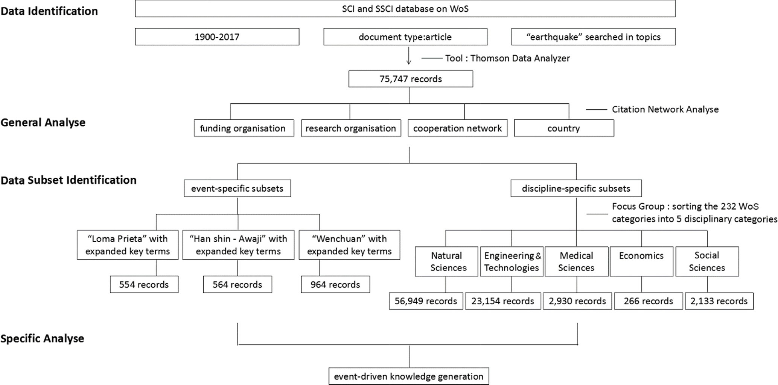
Fig. 1. Flow diagram of bibliometric analysis.

Earthquake. More than 60 people were killed, and it caused massive damage (Pennebaker and Harber, 2010). While the 1906 San Francisco Earthquake was more serious, data relating to that dis- aster are not adequate for the analysis. Similarly, the Hanshin Awaji Earthquake not only raised awareness of disaster science in Japan, but also affected the Japanese politics. The Sendai Framework for Disaster Risk Reduction 2015–2030 was one of the outcomes of the Hanshin Awaji Earthquake. The Wenchuan earthquake was the most serious earthquake experienced in China since the establishment of the People’s Republic of China in 1949, and impacted the country in many ways.
- These three earthquakes have many similarities in terms of the disaster type and scope of damage. They all occurred on land and caused heavy loss of life and economic damage. These similarities help in reducing potential confounders between the different cases.
- Study of knowledge diffusion requires sufficient research to take place. Some countries heavily affected by disasters do not appear to have the disaster science research output experienced by the United States, Japan, and China. For example, the Mexico Earthquake of 1985 and the Izmit/Turkey Earthquake of 1999 were also quite serious events, but resulted in less knowledge generation than did the Wenchuan Earthquake, Hanshin Awaji Earthquake, and Loma Prieta Earthquake.
This paper employs bibliometrics and social network analysis. Bibliometrics is employed to statistically analyze publication char- acteristics, such as time, discipline, organization and country/region distribution. Social network analysis is used to build complex citation networks based on DOI information, in order to discover the network relationships of global and typical earthquake studies and to grasp the pathways of knowledge learning and diffusion.

- Findings

This section presents bibliometric analysis of all 75,747 targeted articles, including changes in the earthquake research landscape over time. Citation analysis was applied to 45,754 articles with DOIs. As shown in Fig. 2, the line chart represents the amount of earthquake research generated by year. Changes in the slope represent crucial periods of earthquake research development.
While earthquake research in general increased throughout its 118- year time span, large growths in knowledge started to occur only in the 1960s, with a series of sharper increases seen since 1990. Notably, the field has seen constant rapid growth in the field since 2010. Such in- creases in the quantity of articles reflects a growth in academic interest in earthquake research.
Findings from the bibliometric analysis are presented below and organized according to the guiding questions presented in the

Table 1
Clustering of five disciplinary categories.
Categories Principles (sample)

Natural sciences Geochemistry & Geophysics, Meteorology & Atmospheric Sciences, Water Resources, Multidisciplinary Sciences, Geology, Environmental Sciences, Oceanography, Remote Sensing, Paleontology, Ecology, Neurosciences, Mineralogy, Marine & Freshwater Biology, Mathematics, Optics, Biology, Electrochemistry, etc.
Engineering technology Nuclear Science & Technology, Planning & Development, Mining & Mineral Processing, Energy & Fuels, Telecommunications, Architecture, Transportation, Communication, Information Science & Library Science, etc.,
Medical science Cardiac & Cardiovascular Systems, Orthopedics, Health Care Sciences & Services, Infectious Diseases, Rehabilitation, Pharmacology & Pharmacy, Peripheral Vascular Disease, Obstetrics & Gynecology, Audiology & Speech-Language Pathology, Gerontology, Tropical Medicine,
Geriatrics & Gerontology, Hematology, Endocrinology & Metabolism, Nutrition & Dietetics, Immunology, Toxicology, Dermatology, Transplantation, etc.
Social sciences Anthropology, Sociology, Education & Educational Research, Health Policy & Services, International Relations, Social Sciences, Biomedical, History & Philosophy Of Science, etc.
Economics Economics, Business, Business/Finance, etc.

5000

4000

3000

2000

1000

0
Fig. 2. Earthquake research generated over time.

methodology. Firstly, regarding the influence of the Wenchuan Earthquake on the content of knowledge related to earthquakes, com- parisons are made between the proportional structure of research re- lated to the Wenchuan Earthquake, Hanshin Awaji Earthquake, and Loma Prieta Earthquake. Secondly, regarding the influence of the Wenchuan Earthquake on the subjects of earthquakes, analyses are presented on the differences between countries/regions in research quantity, citation network, and financial support, on the cooperation networks between research institutions, and on the proportion of re- search related to the Wenchuan Earthquake, Hanshin Awaji Earthquake, and Loma Prieta Earthquake produced by the affected country/region, respectively. Thirdly, regarding interactions between disciplines in research related to the Wenchuan Earthquake, compar- isons are made regarding interdisciplinary research descriptions related to the Wenchuan Earthquake, Hanshin Awaji Earthquake, and Loma Prieta Earthquake.

  - Wenchuan earthquake influences the content of knowledge on disaster

    - Influences on research quantity
While we observed a significant increase in earthquake research, the influence of the Wenchuan Earthquake specifically still needs to be determined. In order to accomplish this, we evaluated the influence of the 2008 Wenchuan Earthquake on knowledge generation and diffusion in comparison to the 1989 Loma Prieta Earthquake in the United States and the 1995 Hanshin Awaji Earthquake in Japan. As shown in Fig. 3, we assessed the proportion of the research related to the three events in comparison to global earthquake research in the year and observed their continuous change. Analysis of research related to the 1989 Loma Prieta Earthquake (the United States) and the 1995 Hanshin Awaji Earthquake (Japan) reveals a life cycle of knowledge creation following a specific disaster event, involving cycles of growth and decline. A disaster event stimulates a ‘rippling effect' on knowledge. In this view, knowledge generation related to the 2008 Wenchuan Earthquake is still growing. An n-shape curve can be observed both in the life cycle of researched related to Hanshin Awaji Earthquake and Loma Prieta Earthquake, indicating a very fast increase in related research in the years immediately following the disaster, which then decrease at a certain point. The situation of research related to the Wenchuan Earthquake is similar; significant increases are observed, but so far the curve has not shown a turning point. This trend indicates a very broad
research space remains open for studies regarding the Wenchuan Earthquake.
Fig. 3 reveals a life cycle, marking growth in research related to a specific earthquake event in the first years and a gradual fade away from academic interests later.
As demonstrated in Fig. 3, research relating to the 2008 Wenchuan Earthquake is still in the growth process; furthermore, the percentage of total research relating to the 2008 Wenchuan Earthquake sees a higher peak, indicating a larger contribution in research quantity to the overall academic community than was observed in the other earthquakes.

    - The influences on disciplines
In order to understand earthquake-related knowledge generation, observations are made through the lens of five disciplines. These five disciplines are natural sciences, engineering technology, medical sci- ence, social sciences and economics. As shown in Fig. 4, by sorting all the targeted articles into five disciplines–natural science, engineering & technology, medical science, social science, and economics, the line chart explicitly reveals how different disciplines entered into earth- quake research at differing times. Specifically, natural and engineering studies dominated earthquake research throughout the studied time span. Medical science and social science began to demonstrate aca- demic interest in earthquakes beginning in the late 1990s and have experienced slow increases. Economic research on disasters has also increased in recent years. Generally, earthquake research mainly fo- cuses on natural sciences and engineering technology.
Further comparisons between the influences of the disciplines on research relating to the three earthquakes is shown in Figs. 5–7. Re- search relating to the Loma Prieta Earthquake strongly resides in the natural sciences and engineering technology. Research on this topic in economics, social sciences, and other fields is rare. For research re- garding the Hanshin Awaji Earthquake, natural science studies still constitute the majority of all related research, but make up a far smaller proportion than is seen with the Loma Prieta Earthquake. Engineering technology studies makes up a much bigger portion of Hanshin-related research, with medical research also making up a significant portion of the literature. Research stemming from the Wenchuan Earthquake re- sembles that relating to the Hanshin Awaji Earthquake, but with a proportional increase in natural sciences research and a proportional decrease in engineering technology. The proportions of literature re- presenting social sciences research and medical studies are relatively

4
=e
.5
ate
3

.5

2

.5

1 0.72

.5

0
%
06
0.

%

34

0.
%
%
6
0
2.
%
59
2.
%
61
3.
ies
ud
st
ke
ua
hq
rt
ea
al
lob
/g
rs
e
ap
p
d
l
re
t-
en
v
%
3

2

1

0

Loma Prieta earthquake Hanshin Awaji earthquake Wenchuan earthquake
1991
1992
1993
1994
1995
1996
1997
1998
1999
2000
2001
2002
2003
2004
2005
2006
2007
2008
2009
2010
2011
2012
2013
2014
2015
2016
2017
Fig. 3. Comparison of the trends of knowledge generation of the three earthquakes.

higher than was observed in the corresponding research related to the Loma Prieta Earthquake.

  - The change of research subject after Wenchuan earthquake

    - The comparison on the research subjects of Wenchuan earthquake
Differences are observed between differing countries/regions’ re- search quantity. Observations of the top 10 countries/regions’ manu- script production by year (Fig. 8) and top five countries/regions’ pro- duction proportion across the five included disciplines (Fig. 9) reveals evident gaps in manuscript production in a few countries/regions. This analysis revealed the United States. Consistently publishes the largest quantity of earthquake research, with Japan, Italy, France, United Kingdom, India, and Germany increasing their research production in the first half of the 1900s. However, China′s earthquake research pro- duction experienced a sharp increase only after 2008. Presently, China produces roughly the same amount of earthquake related research as the United States, which indicates that the Wenchuan Earthquake had a
huge trigger effect on earthquake research in the Chinese context.
Fig. 9 describes earthquake research production across the five studied disciplines. The top five countries/regions in earthquake re- search production create more than a half of the total earthquake re- search in all five disciplines. When broken down by discipline, natural science is still the most prevalent research field, with engineering technology and medical science following it in earthquake research production, and social sciences and economics being relatively less studied.

    - Citation network analysis
Citation network analysis have been used to assess knowledge dif- fusion by analyzing associations among references. We applied citation network analysis to measure the knowledge diffusion in disaster re- search. 45,754 records with DOIs were found and used in the citation network analysis. Each dot was a paper and linked lines showed their citation relationships, different colors represent different characteristics (e.g. nation, discipline). By doing this, the different communities of

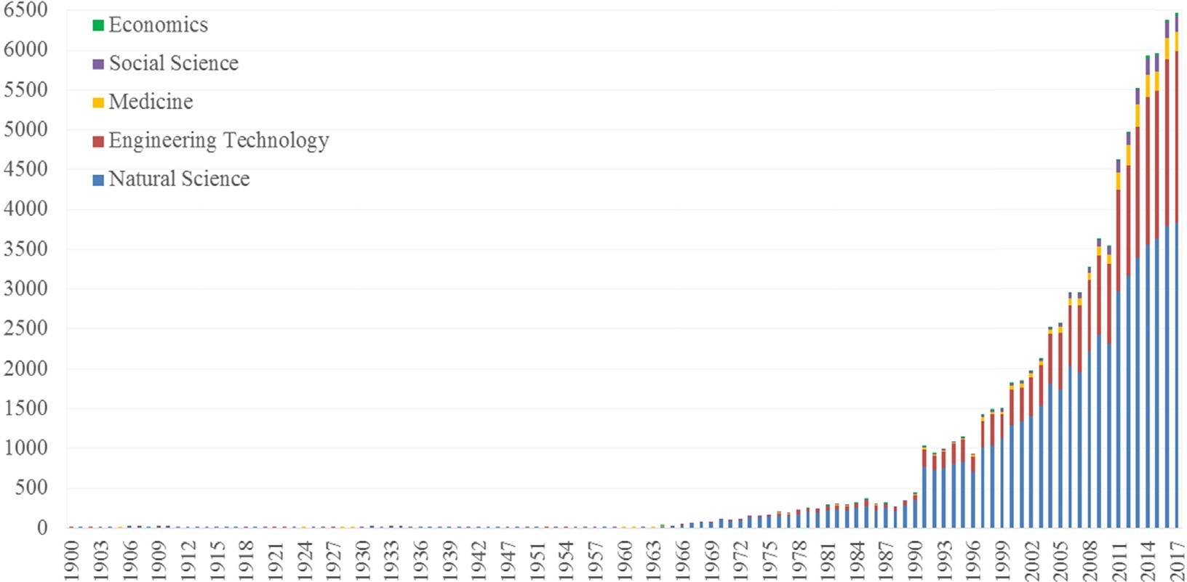
Fig. 4. Earthquake researches divided in disciplines increased by time.

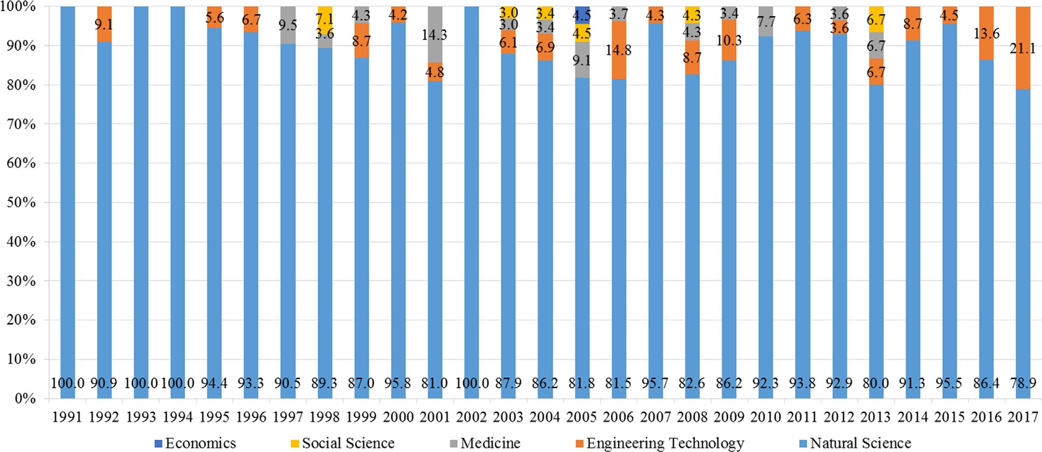
Fig. 5. Disciplinary structure in the Loma Prieta Earthquake researches.

citations were observed. As the citation networks are stable, we were able to identify interesting findings by studying different character- istics.
The distribution of production across the five disciplines is pre- sented in Fig. 17. Fig. 10 shows the authors′ nation and discipline as selecting characteristics. We can conclude from this analysis that the ambiguous community structure indicates extensive and active knowledge diffusion across countries, but that research led by US scholars sees the widest citation/diffusion in every discipline. Still, small clusters of dense links can be observed, which refers to relative isolation within a country (e.g. Japan and Italy in natural science, China in natural and medical science). Based on Fig. 10, the United States has the widest global knowledge diffusion network and has been playing an important role in knowledge generation regarding earthquake research. Japan is relatively active in natural sciences cooperation. China sees wide international influence in natural and medical sciences related to earthquakes.
    - Financial support
When examining financial support, the National Natural Sciences Foundation of China supports the largest quantity of research, and is followed by the National Natural Sciences Foundation of the U.S. and the U.S. Geological Research Institution. The Educational Culture and Physical Exercise Science Department of Japan also provides strong support. Earthquake research in China, Japan, and the U.S. all benefit from strong national financial support. In this ranking, according to amount of research funded, seven of the top funding organizations are Chinese (plus 1 of Taiwan), five are from the US, 3 are European, and 2 Japanese. We discovered that earthquake-research production rankings are more related to funding, and therefore to national economic per- formance, to a certain degree, and not necessarily correlated to earth- quake risk. It is important to note that this ranking does not consider funding volumes.

    - Key research institution and cooperation
For research institutions working on earthquake research, the

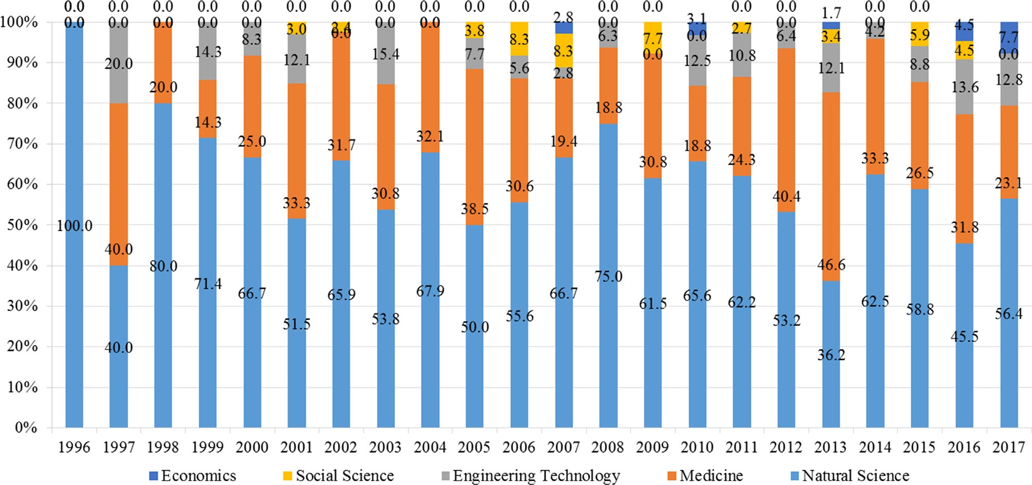
Fig. 6. Disciplinary structure in the Hanshin Awaji Earthquake researches.

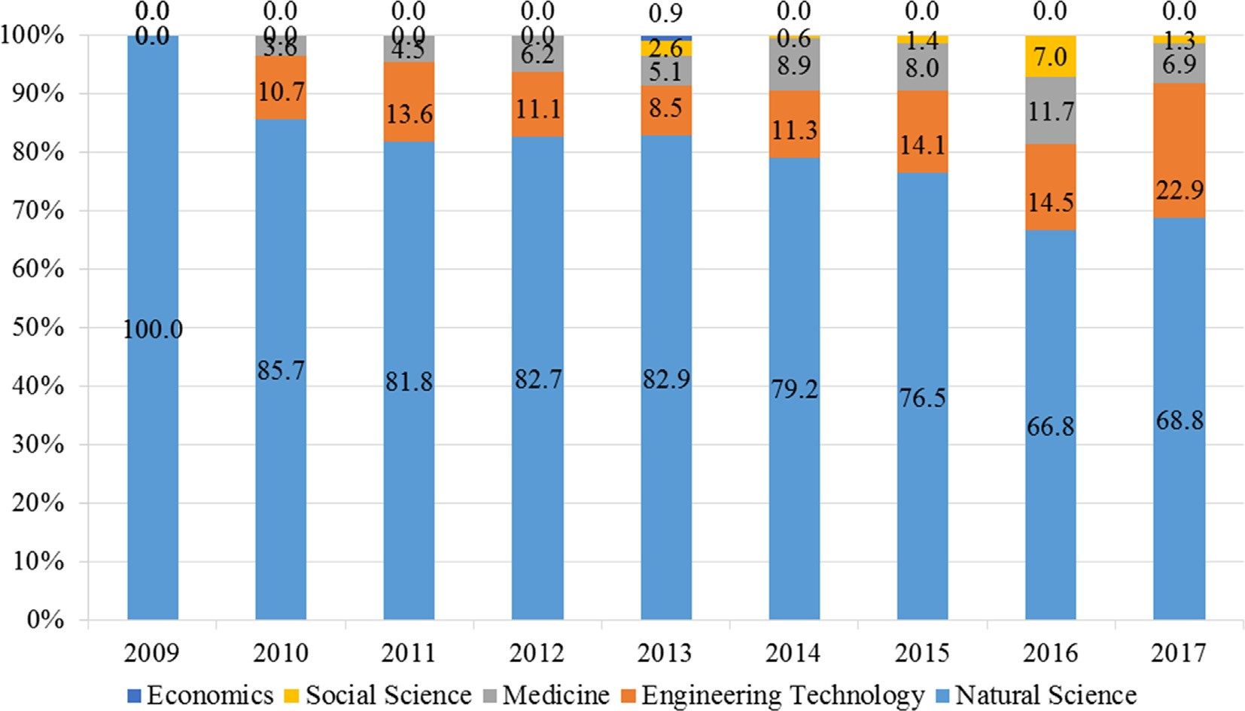
Fig. 7. Disciplinary structure in the Wenchuan Earthquake researches.

Geographic Survey Institution of the United States ranks number one by largest production, followed by the University of Tokyo in Japan and the Academy of Science in Russia. Production from the China Earthquake Administration is also abundant. Analyzing earthquake- research production by country reveals some differentiating features. In the United States, the key institute of research are national govern- mental institutions and universities; in Japan, the key institutes are universities; in China, the key institutes are national science institu- tions. Generally, universities/colleges surpasses other types of academic organizations (e.g. institutes, research branches in administrational agencies) in both research production and cooperation. Chinese uni- versities are less active in earthquake research, both in terms of pro- duction and cooperation. The most frequent cooperation link is found to be almost monopolizing between the China Earthquake Administration and the Chinese Academy of Sciences.
There are many academic institutions engaged in earthquake re- search, but the 20 institutions among them with the highest scholarly output (seven countries / regions) produced 22,912 articles, accounting for 30.25% of total research output. Table 2 demonstrates the link be- tween earthquake research and capital investment. Table 3 reveals how the implementation of earthquake research is concentrated in several
leading countries, and the degree of imbalance in research production is even greater than that observed in research funding.
Universities/colleges are presumed to be more comprehensive in regards to their disciplinary constitution and more open and active in cooperation. 13 of the 20 of the top research organizations in earth- quake studies are universities/colleges. Remarkably, five universities/ colleges in California are among the top 20, marking the state as a hub of earthquake research. The situation in China is somewhat different: Chinese organizations in the table are mainly administrational agencies (China Earthquake Administration) and national academic institutes (Chinese Academy of Sciences). The only Chinese university in the top 50 is Tongji University, ranked 27.
Within the top 50 institutions worldwide, as shown in Fig. 11, the University of Tokyo in Japan has a high-level of cooperation compared with other institutions. In the United States, the National Geographic Survey Institution has active cooperation with many universities and other institutions in California. In China, cooperation is mainly con- centrated inside the country/region, such as the China Earthquake Administration and Chinese Academy of Sciences. China has relatively lower levels of cooperation with other countries/regions.
We noticed that 37 of the top 50 organizations are universities/

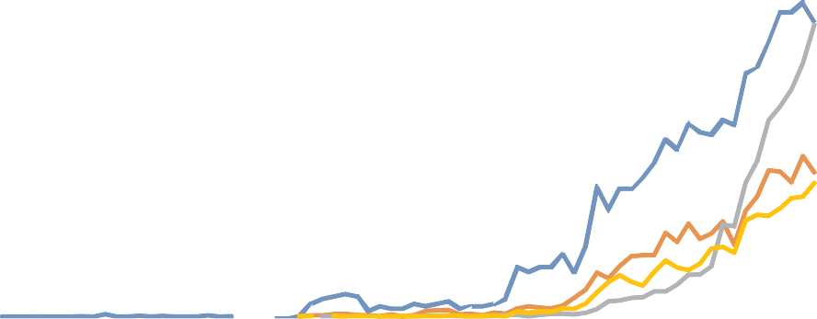1600
USA UK
Japan India
China Germany
Italy Russia
France Taiwan

1400

1200

1000

800

600

400

200

0
1900
1908
1926
1928
1930
1933
1935
1937
1939
1941
1944
1966
1968
1971
1973
1975
1977
1979
1981
1983
1985
1987
1989
1991
1993
1995
1997
1999
2001
2003
2005
2007
2009
2011
2013
2015
2017

Fig. 8. Paper production in top 10 countries/Regions increase by year.

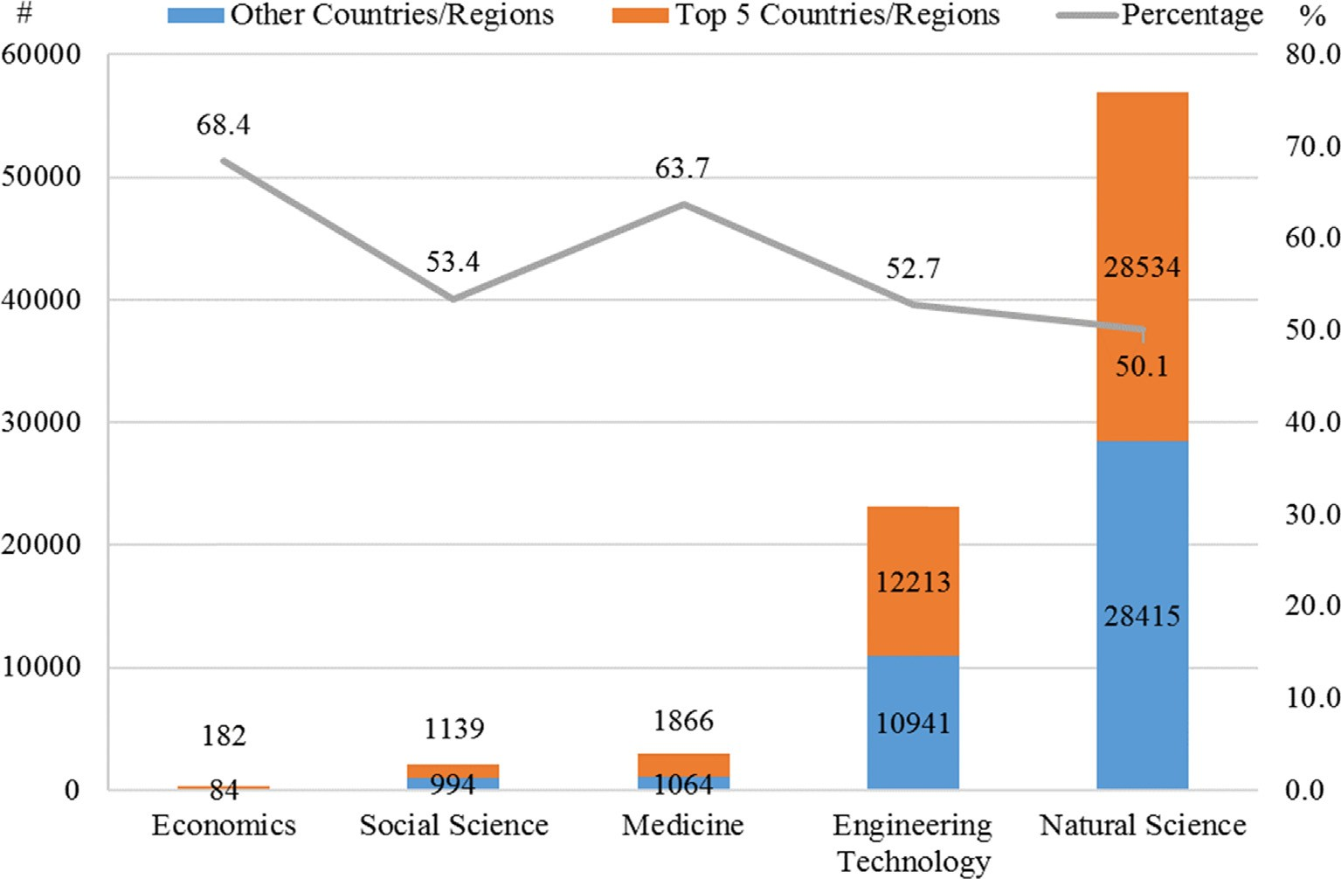
Fig. 9. Top five countries/regions production proportion in the five disciplines.

colleges. Among the three Chinese organizations, the strongest link is found between China Earthquake Administration and Chinese Academy of Sciences. Cooperation with universities is weak. By contrast, strong links are observed between universities/colleges and other types of organizations in the United States, Japan, and Taiwan.
When analyzed across nationality, the United States has the highest level of international cooperation. Cooperation between Japan and
China is relatively rare, which does not correspond to the levels of production of academic essays by these two countries.
The United States experiences more international cooperation than other countries, followed by France, the United Kingdom, and Italy. China and Japan’s levels of international cooperation are relatively low, disproportionate to their large production of research.
When further analyzing the citation network of the top 20

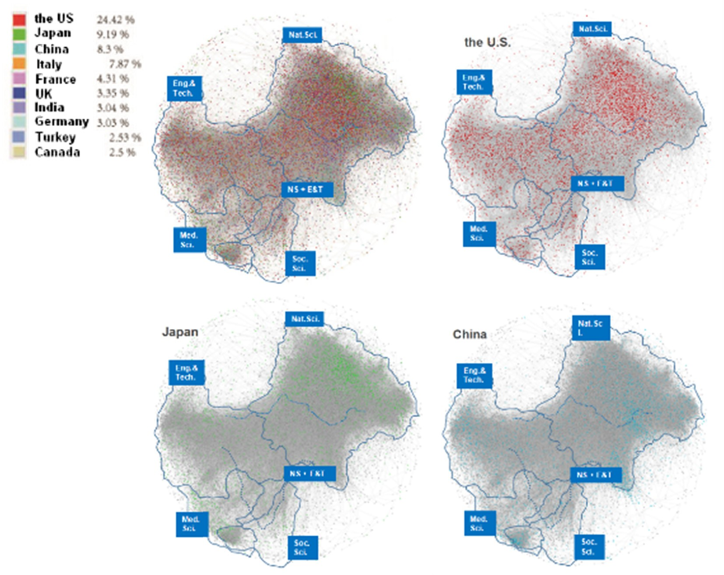
Fig. 10. Citation network, marking countries/regions of the first authors.

Table 2
Top 20 funding organizations.
Rank | No. of articles | Funding organization | Country/region
1 | 3572 | National Natural Science Foundation of China (NSFC) | China
2 | 3270 | The United States National Science Foundation (NSF) | the United States
3 | 1049 | The United States Geological Survey (USGS) | the United States
4 | 1048 | Ministry of Education, Culture, Sport, Science and Technology of Japan (MEXT) | Japan
5 | 927 | Japan Society for the Promotion of Science (JSPS) | Japan
6 | 636 | 973 Program | China
7 | 483 | European Union (EU) | EU
8 | 453 | Southern California Earthquake Center | the United States
9 | 446 | Natural Science and Engineering Research Council of Canada | Canada
10 | 401 | Russian Foundation for Basic Research | Russia
11 | 356 | Fundamental Research Fund for the Central University | China
12 | 335 | NASA | the United States
13 | 315 | National Science Council of Taiwan | Taiwan, China
14 | 307 | European Commission | EU
15 | 279 | Chinese Academy of Science (CAS) | China
16 | 242 | ANR French National Research Agency | France
17 | 237 | Ministry of Science and Technology of China | China
18 | 216 | The United States Department of Energy (DOE) | the United States
19 | 201 | China Postdoctoral Science Foundation | China
20 | 191 | China Scholarship Council | China
Sum. | 14,964 | N/A | N/A

Table 3
Top 20 research organizations with most production.
Rank No. of articles Author affiliations
but experiences decreases every year.
There are some differences in the Wenchuan Earthquake; first, it compromises a bigger proportion of research production compared

with the previous two earthquakes. Second, the trend for research re-
lating to the Wenchuan Earthquake is still increasing. There has also been a difference in local stimulation in knowledge creation: the Wenchuan Earthquake makes up a far bigger share of research led by Chinese scholars (up to 15.6% in 2015), thus demonstrating stronger national stimulation.
1 | 2479 | the United States Geological Survey
2 | 1902 | Tokyo University
3 | 1874 | Russian Acad Sci
4 | 1755 | Ist Nazl Geofis & Vulcanol
5 | 1656 | China Earthquake Administration
6 | 1485 | Chinese Academy of Sciences
7 | 1316 | Kyoto University
8 | 1212 | CALTECH
9 | 1072 | CNR
10 | 1047 | University California Berkeley
11 | 1023 | Tohoku University
12 | 808 | Natl Taiwan University
13 | 803 | Indian Inst Technol
14 | 791 | University So California
15 | 756 | University California Los Angeles
16 | 756 | University California San Diego
17 | 744 | Stanford University
18 | 712 | University Washington
19 | 660 | Natl Cent University
20 | 619 | Academy Sinica
Sum. | 22,912 | N/A

We can explain the trend differences in trend of domestic research proportion between the Hanshin Awaji Earthquake, the Loma Prieta Earthquake, and the Wenchuan Earthquake by analyzing the position of these three countries in world disaster research and the frequency of earthquakes happening in the three countries. Research on earthquakes in the United States is not completely confined to its own country and to specific earthquakes; United States researchers study large earthquakes occurring globally. Research in Japan, a country with frequent earth- quakes, shows a gradual decline in the specific study of an earthquake, but a renewed focus on the general discussion of the earthquake itself. The Wenchuan Earthquake in China represents a unique situation. With China being in transition, the 2008 Wenchuan Earthquake had a pro-
found impact on China's national governance and social governance
structure, leading to more thinking about China′s future development.

countries/regions, the United States still appears to be the most em- bracing of embrace international cooperation the most. China, Japan, and the United States have formed a deep cooperation network, de- monstrated in Fig. 12 in what appears to be an “iron triangle.”
We narrowed down the attention to cooperation among the top 20 countries/regions. A cooperative triangle is observed between the United States, China and Japan, although strong links still of the United States with other top countries/regions are remarkable. As such, we identified one major earthquake in each of these three countries for further analysis.

    - The comparison between Wenchuan earthquake and other earthquakes
We have compared the domestic research conditions between Wenchuan Earthquake, Hanshin Awaji Earthquake, and Loma Prieta Earthquake, as shown in Figs. 13–15. The result shows that research relating to the Hanshin Awaji and Loma Prieta Earthquakes do not compromise a big proportion of domestic earthquake research. Such research has a relatively big proportion subsequent to the earthquake,
(Lin et al, 2014) Therefore, the research interest in the Wenchuan Earthquake will inevitably continue for a longer period of time when taken in the context of the country's transformation and development. In addition, the Chinese government's financial support for Wenchuan Earthquake research and its relatively recent occurrence compared to other two earthquakes (~10 years ago) have also kept Wenchuan Earthquake research from reach the stage of decline.

  - The interaction between different subjects

    - The comparison between Wenchuan Earthquake and the whole
By sorting all the targeted articles into five disciplines–natural sci- ence, engineering & technology, medical science, social science, and economics, Fig. 4 explicitly reveals that different disciplines enter earthquake research at different times. Specifically, natural sciences and engineering studies have dominated earthquake research throughout its existence. Medical and social scientists began to share academic interest in earthquake beginning in the late 1990s and has seen a slow increase in interest. Interdisciplinary studies on earthquakes

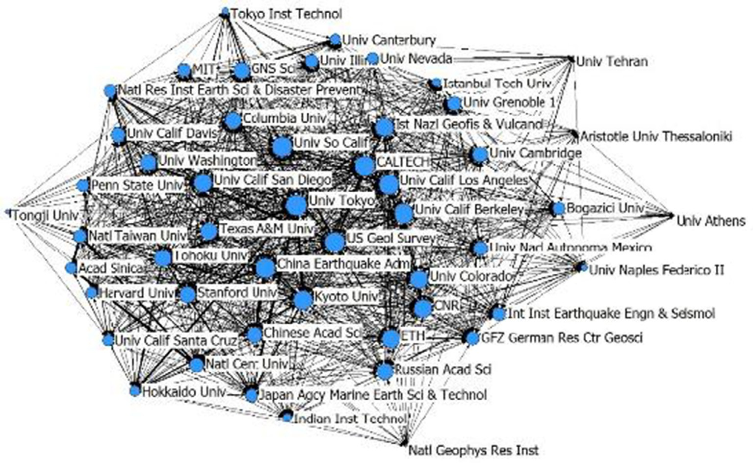
Fig. 11. Cooperation network of top 50 organizations with most production.
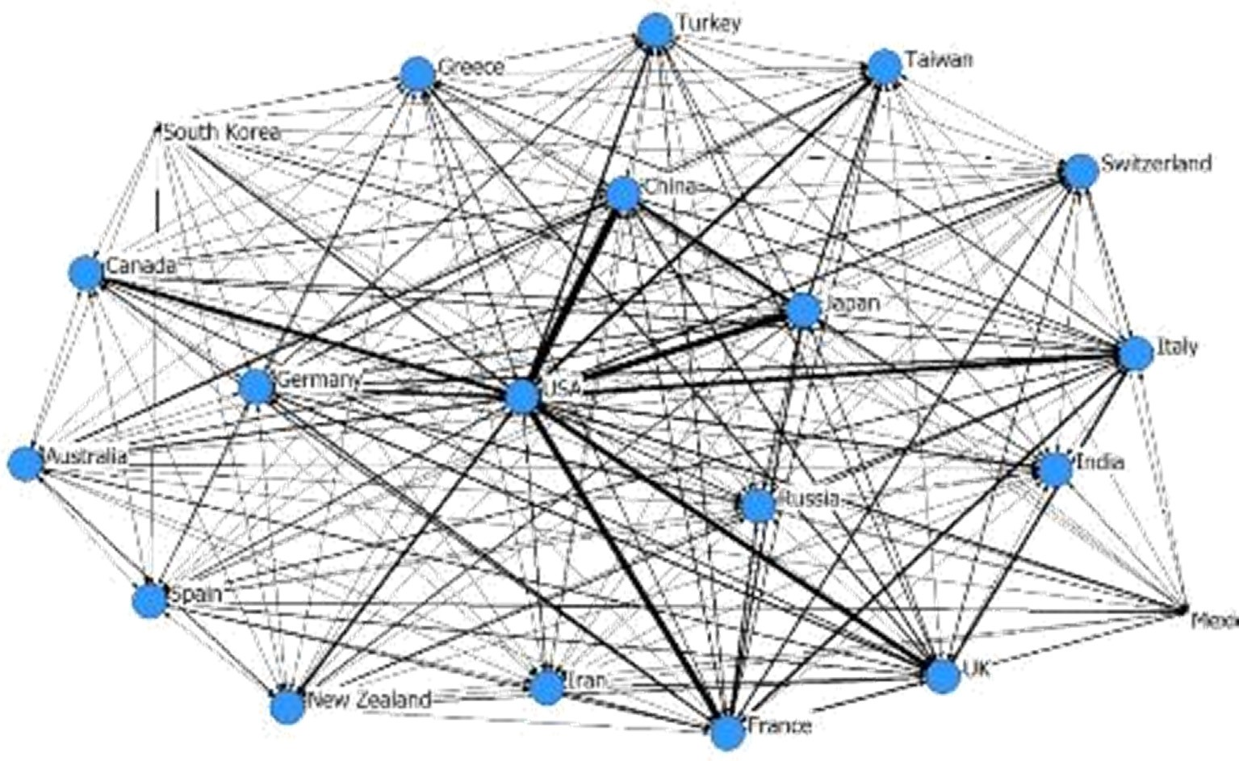
Fig. 12. Cooperation Network between Top 20 Countries/Regions.

are mainly concentrated between natural sciences and engineering technology. The next highest levels of interdisciplinary cooperation are between engineering technology and social sciences, followed by in- teractions between natural and medical sciences (See Fig. 16).
Observing the community of nodes reveals evident imbalances in disciplinary development. In particular, natural scientific studies re- present 68.5% of all earthquake research. Engineering and technology studies follow with 16.47% of all earthquake research. The interactions between these two disciplines produced another 10.28% of the identi- fied studies. Therefore, over 90% of academic production regarding earthquakes explores its natural mechanisms and physical/technical influences.
Interaction between disciplines are particularly noticeable. One in- teresting finding from this analysis was that social studies (orange nodes, Fig. 17) were scattered across medical(black)/natural(purple)/ engineering(green) studies, which indicates intensive citation between the disciplines. As observable in Fig. 2, Social sciences have experienced
a recent rise in earthquake research; in Fig. 17 we can identify the lo- cation of social science studies in the citation network and their close link with other disciplines, creating a picture of the ongoing generation of social science research based off of previous achievements in other disciplines. These nodes imply a strong need to include social science in disaster research, a gap for multi-disciplinary approach, and an inter- esting innovation mechanism across disciplines.

    - The comparison between Wenchuan Earthquake and other earthquakes
As observable in Fig. 18, research relating to the Wenchuan Earth- quake (red nodes) is mainly concentrated on natural sciences and in- terdisciplinary studies between natural sciences and engineering tech- nology. In Japan, (green nodes) studies are mainly concentrated on medical sciences. In the United States, there are many studies (blue nodes) in both the natural and medical sciences.
We explored whether studies of previous earthquake events

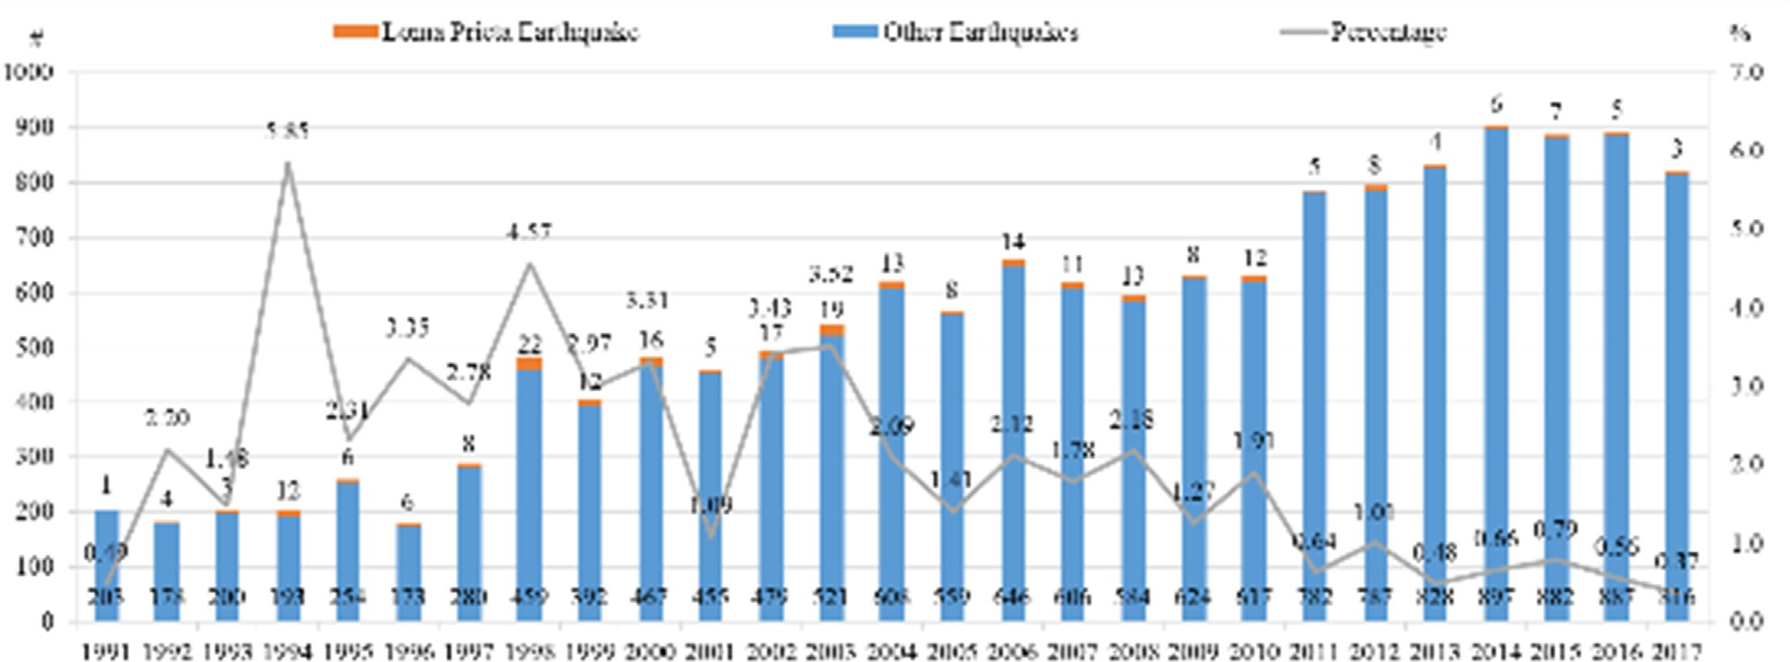
Fig. 13. The proportion of Loma Prieta Earthquake in domestic earthquake researches.

contributed to studies of later events. In the citation network, clusters can be observed in Wenchuan research (in natural science) and Hanshin Awaji research (in medical) with relative density. Research analyzing the Loma Prieta Earthquake are more disperse. This indicates citation/ knowledge diffusion between researches on the same disaster.
Mixtures of three types of nodes (in red circle) are observed in natural and medical sciences, which indicates citation/knowledge dif- fusion from previous mega-disaster research to later-occurring dis- asters.
In summary, our analysis reveals that knowledge diffusion from previous mega-disasters to later-occurring disasters are relatively un- common. This may be partly due to current discipline structure of the literature. This structure emphasizes natural science, indicating studies on seismic mechanisms, which vary across geography. One could pos- tulate that growth in social science research on earthquakes would in- crease knowledge diffusion/learning from event to event.

- Conclusion

In this paper, we explored a paradigm shift on disaster knowledge generation and diffusion from 1900 to 2017 was explored based on a bibliometric analysis of 75,747 SCI and SSCI articles about earthquakes in Web of Science databases. Below is a summary of our major findings: Compared with the gradual decreases in research based on other earthquakes, the production of disaster knowledge from the
Wenchuan earthquake is just beginning. Earthquake research has a life cycle, where there is growth in research related to a specific earthquake event in the first years following its occurrence and a gra- dual fade away later. The 2008 Wenchuan Earthquake studies are still in their growth phase. There was an early start in research production quantity by the United States, which still holds a leading role in earthquake research, and followed by a collective rise of the top countries/regions, including Japan, Italy, France, UK, India, Germany, in the first half of the 1900s. China’s earthquake research production only started to experience its sharp increase following 2008.
Across the five main disciplines, the Wenchuan Earthquake has differing impacts on knowledge production. The proportion of research in natural sciences and engineering technology is gra- dually decreasing, while the proportion of research in the fields of medical sciences, social sciences, and economics are gradually in- creasing. Natural and engineering studies have dominated earthquake research throughout its existence. Medical and social scientists began to share academic interest in earthquake in the late 1990s and have ex- perienced a slow increase in interest. Over 90% of academic production explores the natural mechanisms and physical/technical influences of earthquakes.
The amount of earthquake research is not determined solely by the severity of the disaster but by was influenced by the national financial support offered by the countries where the earthquake occurred. Similar to the United States, Japan, and other countries/

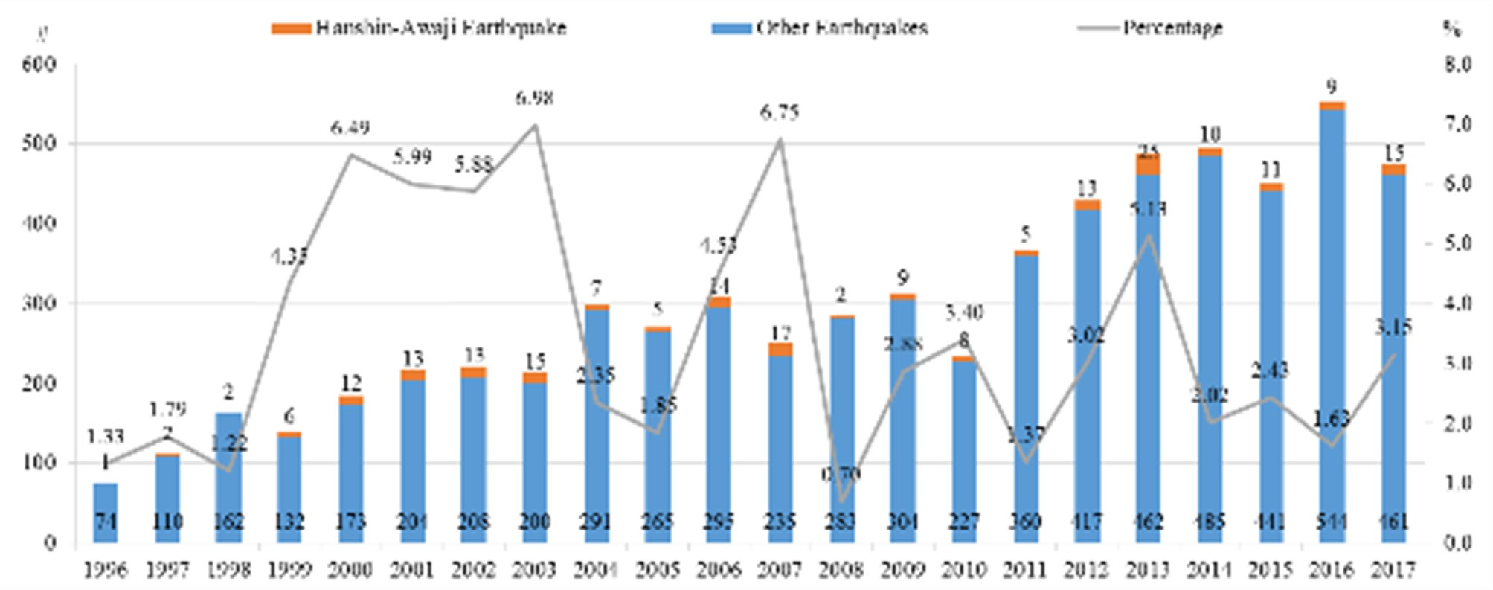
Fig. 14. The proportion of Hanshin Awaji Earthquake in domestic earthquake researches.

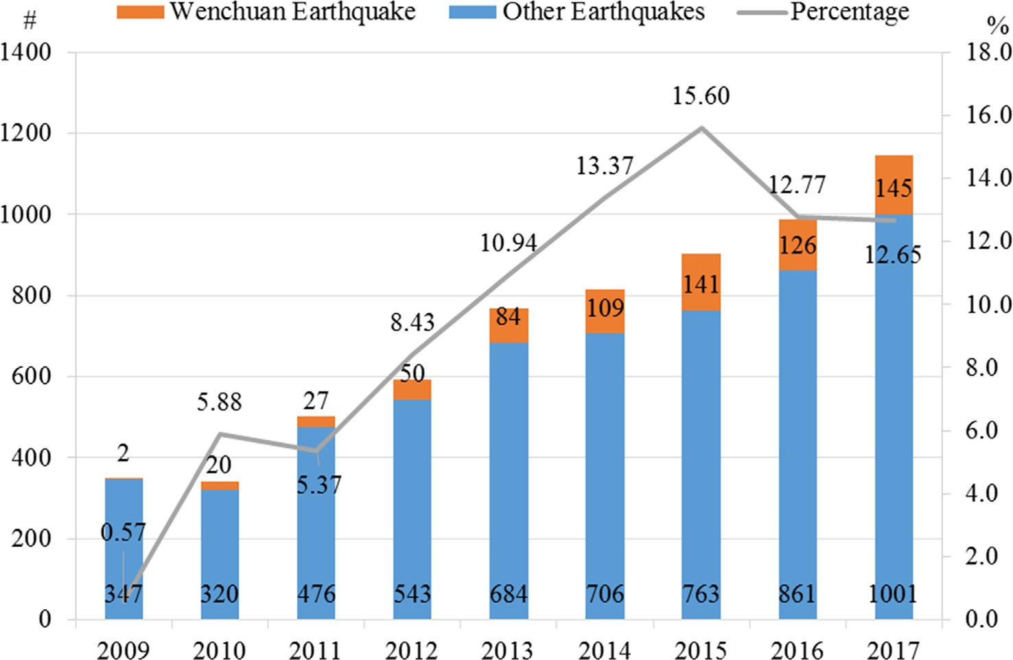
Fig. 15. The proportion that Wenchuan Earthquake compromises in domestic earthquake researches.
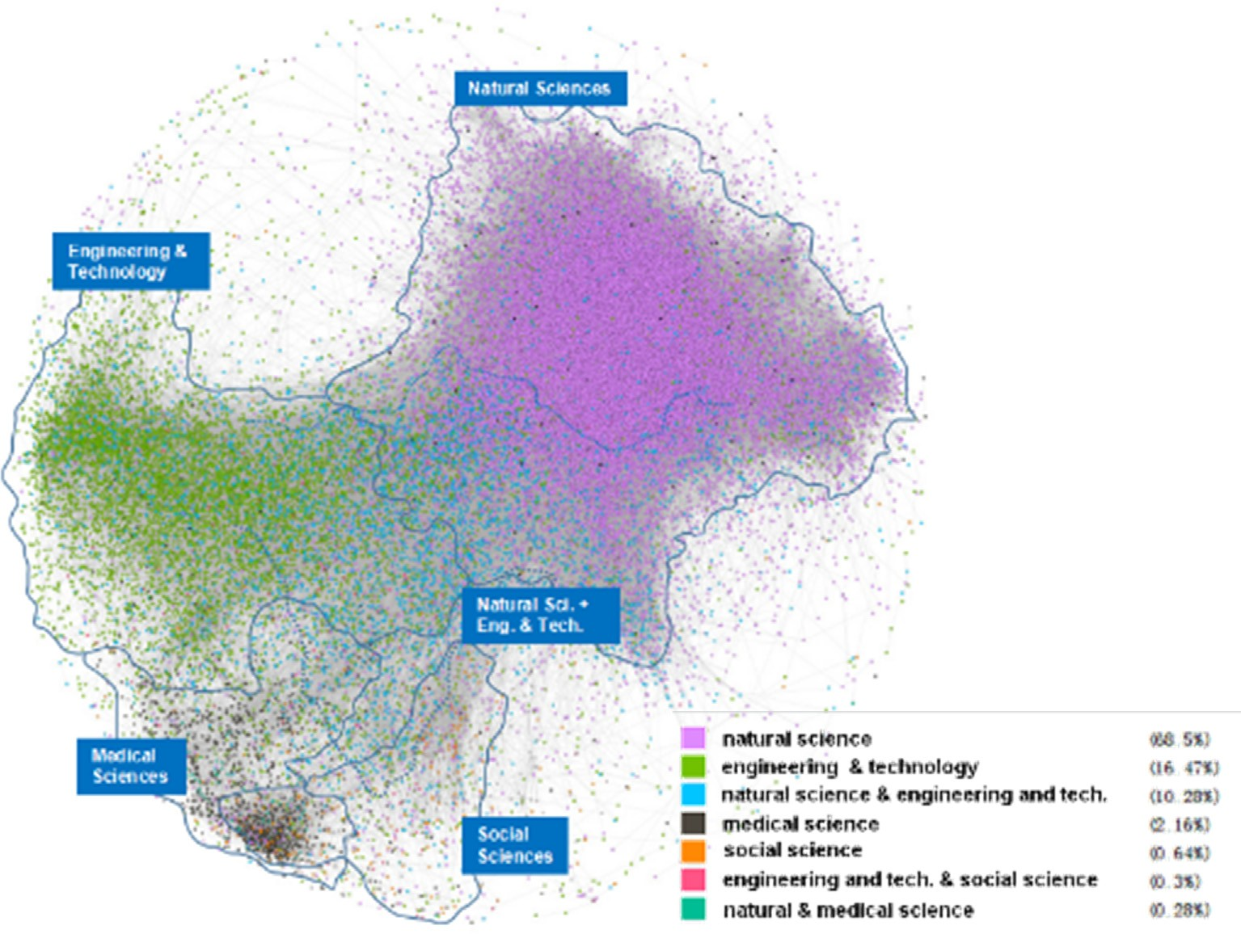
Fig. 16. Citation network, marking disciplines and papers of the highest page rank.

regions, China leads in research regarding the Wenchuan Earthquake, which is benefits from strong financial support offered by national in- stitutions. This phenomenon corresponds to the fact that the main re- search institutions in China are national research institutions rather than universities. We also observed differences in local stimulation in knowledge creation: the Wenchuan Earthquake experienced a far bigger share (up to 15.6% in 2015) of research led by Chinese scholars, indicating stronger stimulation. The United States, China, and Japan stand at the forefront in both production quantity and funding. High disaster risk in country/region is not necessarily ta driving factor for earthquake research. Research led by United States scholars see the
widest citation/diffusion in every discipline. Still, small clusters of dense links can be observed, which refers to relative isolation within country/region (e.g. Japan, Italy in natural science, China in medical science). Production rankings are more related to funding, therefore corresponding to national economic strength, and not necessarily re- lated to earthquake risk. Note that this ranking does not consider the funding volume. Universities/colleges surpass other types of academic organizations (e.g. institutes, administrational agencies) in both re- search production and cooperation. When particular attention is paid to China, we found that, among the 3 Chinese organizations, the strongest link was observed between CEA and CAS. Cooperation with universities

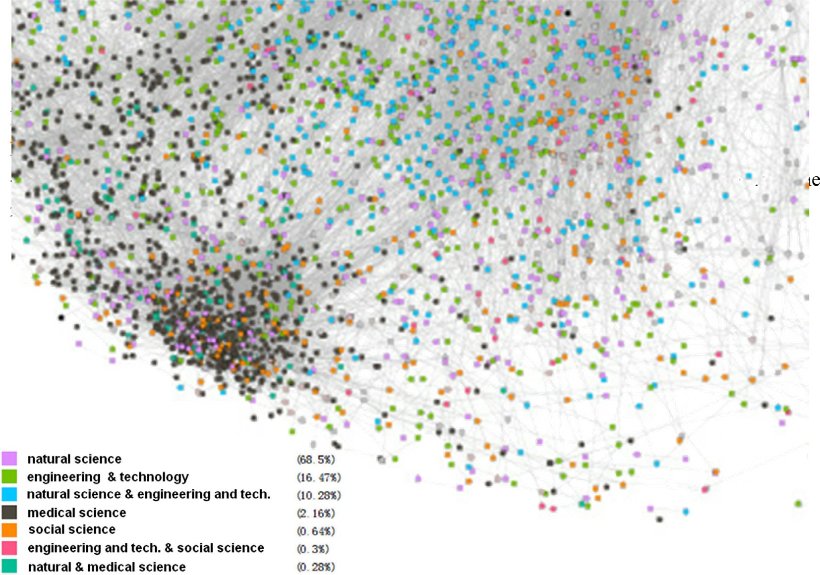
Fig. 17. Partial citation network, marking disciplines.

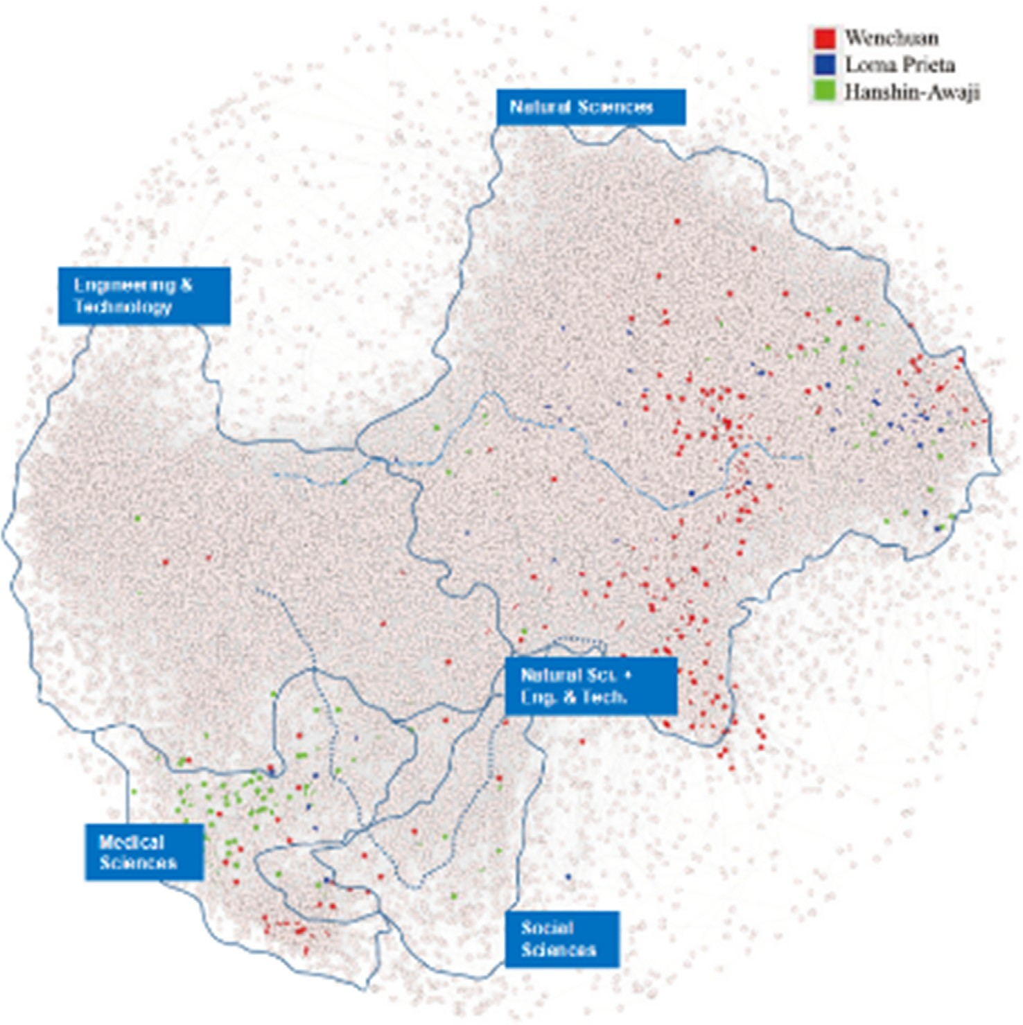
Fig. 18. Citation network, marking the researches of the 3 major earthquakes.

was weak. By contrast, strong links are observed between universities/ colleges and other types of organizations in the United States, Japan, and Taiwan. The United States extends more international cooperation than other countries/regions, followed by France, United Kingdom, and Italy. China’s and Japan’s international cooperation levels are relatively low, not in proportion with their large production of research. A co- operative triangle is observed between the United States, China and Japan, although strong links exists between the United States and other top countries/regions.
When examining interdisciplinary studies, research relating to the Wenchuan Earthquake is mainly concentrated between nat- ural sciences and engineering technology. Interdisciplinary studies between other disciplines need to be enhanced. In the citation network, clusters can be observed in Wenchuan research (in natural science) and Hanshin Awaji research (in medical), though with relative density. Loma Prieta-related research is more dispersed. The location of social scientific studies in the citation network and their close link with other disciplines demonstrate the ongoing generation of social science studies on the basis of previous achievement in other disciplines.

- Discussion

The analysis in this manuscript sheds light on the influence of un- certain disasters, such as earthquakes, on the evolution of human knowledge generation and diffusion.
Although we only selected the three major disasters of the Loma Prieta Earthquake in 1989, the Hanshin Awaji Earthquake in 1995, and the Wenchuan Earthquake in 2008, we can see a significant increase in the annual quantitative change trend in the earthquake research lit- erature after the three earthquakes, which is particularly noticeable after 2008. However, the academic community gradually weakens its research on these earthquakes as time passes. The number of research documents in connection with the Loma Prieta Earthquake and the Hanshin Awaji Earthquake showed a rapid upward trend in the period right after the earthquakes occurred, with research production de- clining in subsequent years. Judging from the time sequence of earth- quake response in different disciplines, there also exists a discipline diffusion path of “natural science - engineering technology - medical science - social science.” Apparently, disasters are like a stone thrown into the human “lake of knowledge”; knowledge generated from each disaster will continue to spread across various disciplines and will di- minish gradually. It is clear that disasters are an important external factor for triggering and promoting learning. While a large body of research focuses on trying to identify the mechanism of an earthquake with the aim of managing risk during an earthquake disaster, our un- derstanding of the mechanisms by which earthquakes occur is still very limited (Fig. 19). We recommend moving away from an excessive re- liance on natural science and engineering studies of earthquakes and towards a multidisciplinary approach to earthquake knowledge pro- duction.
Our data showed that the body of earthquake literature demon- strates a major imbalance in the production and diffusion of knowledge across the globe. From the perspective of countries and regions, the United States, China, and Japan have created the “iron triangles” of knowledge generation. Among these three countries, cooperation be- tween the United States and other countries is significantly stronger than was observed in China and Japan. Judging from the top 50 countries in the global cooperation network, the United States is the most highly-cooperating country. Although China and Japan have re- latively high knowledge generation, cooperation between these two countries and other countries is not proportionate to their knowledge production.
From a disciplinary point of view, all disciplines examined present a positive trend in knowledge generation and diffusion, but their re- spective strengths are different. Natural science and engineering tech- nology are the two earliest- and fastest-growing disciplines, as well as

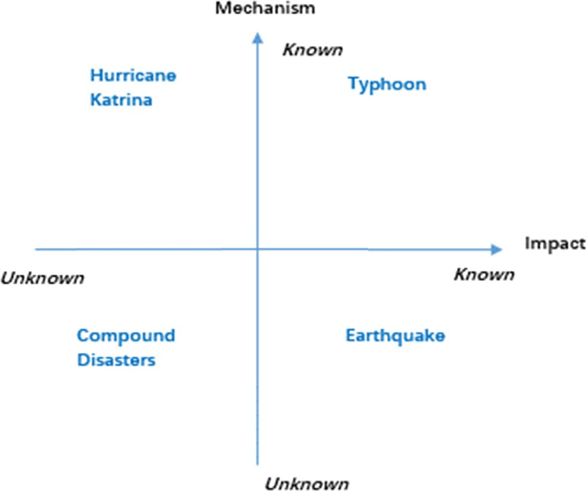
Fig. 19. Disaster mechanism and influence matrix.

the most studied. It was only around late 1990s when the three dis- ciplines of medicine, social science and economics began to pay more attention to earthquakes.
Presently, human responses to earthquake disasters largely consists of reactive thinking. Most interdisciplinary cooperation studies occur between two disciplines: natural sciences and engineering technology, as these two disciplines attempt to understand the natural attributes of earthquakes. However, prevention and management of disasters is more closely related to human behavior, economics, cultural factors and local society. As such, integrating social sciences, including so- ciology, psychology and economics, in disaster research is of critical importance. Only then can our understanding of earthquakes shift from reactive responses to proactive prevention.
Although the 2008 Wenchuan Earthquake has greatly promoted the development of knowledge on disasters among Chinese scholars, it has generated very minimal influence internationally. Even within China, most research and cooperation networks related to the Wenchuan Earthquake are constrained within the China Earthquake Administration and the Chinese Academy of Sciences, while uni- versities, which are important driving forces of knowledge generation and diffusion, have a relatively small degree of research participation. This study has several limitations. First, it has not thoroughly ana- lyzed the keywords and abstracts of each document. This analysis will help us understand, in depth and detail, the study of earthquake dis- asters and how disaster learning has emerged over time, developed across regional and national distributions and different disciplines and spread. Second, the selected research materials are limited to academic articles, but patents, research reports, books, news comments and other relevant documents have not yet been addressed. These documents are also important record carriers for the production and diffusion of human knowledge. In particular, the study of patents can intuitively reflect the diffusion path of human earthquake disaster learning in the area of application. Third, this study has only conducted a comparative study of the 2008 Wenchuan Earthquake in China, the 1995 Hanshin Awaji Earthquake in Japan, and the 1989 Loma Prieta Earthquake in the United States; it has not yet explored the influence of other earth- quakes on the history of these three countries in knowledge generation
and diffusion.
In the future, researchers should conduct comparative studies fol- lowing the Loma Prieta, Hanshin and Wenchuan Earthquakes, to ex- plain the different driving factors that influence research production, interdisciplinary distribution and research funding sources across dif- ferent countries. Furthermore, researchers should continue to analyze the influence of disasters on global knowledge networks and develop

knowledge creation and diffusion models for different types of dis- asters, such as typhoons and floods. In addition, exploring the re- lationship between policy learning and disaster learning represents an important direction for future research. We plan to conduct content analyses by using keywords, abstracts, conclusions and discussions of selected articles to continue to examine the impact of the 2008 Wenchuan Earthquake on the knowledge generation.

Acknowledgments

The authors are grateful to special issue guest editor Lousie Comfort and Haibo Zhang, and two anonymous reviewers for their insightful and constructive comments on previous versions of this article. The research is supported by the China Scholarship Council and funded by Fundamental Research Funds for the Central Universities. The authors thank Samantha Ye, Hao Tang and Lin Lin for their hard work.

References

Beck, U., 1992. From industrial society to the risk society: Questions of survival, social structure and ecological enlightenment. Theory, Cult. Soc. 9 (1), 97–123.
Birkland, T.A., 2004. Learning and policy improvement after disaster: the case of aviation security. Am. Behav. Scientist 48 (3), 341–364.

Birkland, Thomas A., 2006. Lessons of disaster: Policy change after catastrophic events.
Georgetown University Press.
Christianson, Marlys K., Farkas, Maria T., Sutcliffe, Kathleen M., Weick, Karl E., 2009.
Learning through rare events: significant interruptions at the Baltimore & Ohio Railroad Museum. Organ. Sci. 20 (5), 846–860.
Elsevier. (2017). A global outlook on disaster science.
Hermann, C.F., 1969. Crises in Foreign Policy: A Simulation Analysis. Bobbs-Merrill Company.
Housner, G.W., 1983. Learning from earthquakes: the great experiment. Paper presented at the International Symposium on Earthquake Engineering, Tokyo, Japan.
Lin, L., Ashkenazi, I., Dorn, B.C., Savoia, E., 2014. The public health system response to the 2008 Sichuan province earthquake: a literature review and interviews. Disasters 38 (4), 753–773.
Liu, Xingjian, Zhan, F Benjamin, Hong, Song, Niu, Beibei, Liu, Yaolin, 2012. A biblio- metric study of earthquake research: 1900–2010. Scientometrics 92 (3), 747–765.
Luhmann, N., 1993. Risk: A Sociological Theory. A. de Gruyter, New York.
Moore, Melinda, Trujillo, Horacio R., Stearns, Brooke K, Basurto-Davila, Ricardo, Evans, David K., 2009. Learning from exemplary practices in international disaster man- agement: a fresh avenue to inform US policy? J. Homeland Security Emerg. Manage. 6 (1).
Pennebaker, J.W., Harber, K.D., 2010. A social stage model of collective coping: the loma prieta earthquake and the persian gulf war. J. Social Issues 49 (4), 125–145.
Quarantelli, E.L., 1966. Organization under Stress. Ohio State University, Disaster Research Center.
White, G.F., Kates, R.W., Burton, I., 2001. Knowing better and losing even more: the use of knowledge in hazard management. Global Environ. Change Part B: Environ.
Hazards 3 (3–4), 81–92.

