## How to link yourself to a Grant

1. Go to your profile page

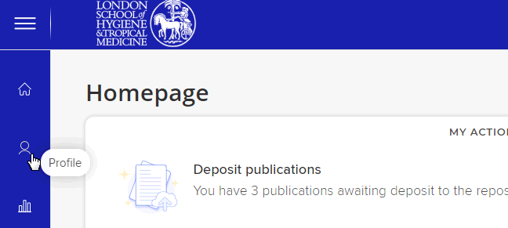

1. View all links

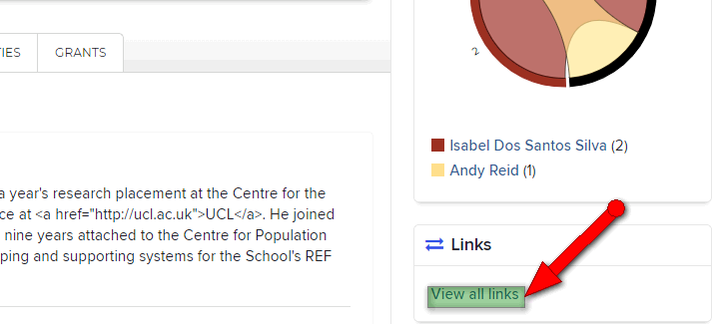

1. Create Links – Grant…

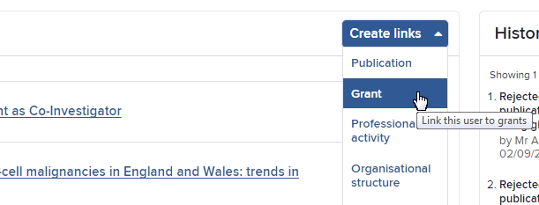

1. Select link type and Slect from suggested…search by keywords or grant codes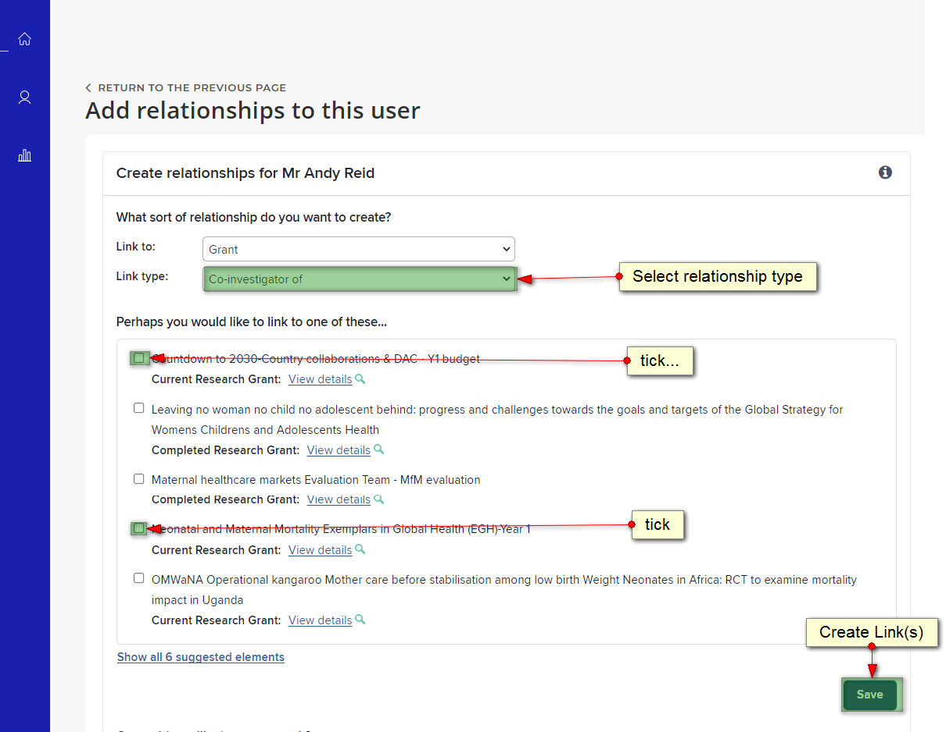
2. Or search by keywords or grant codes 