# Title Page

**Evaluating the cost-effectiveness of existing needle and syringe programmes in preventing Hepatitis C transmission in people who inject drugs**

Sedona Sweeney, research fellow1ǂ; Zoe Ward, senior research associate2*ǂ; Lucy Platt, associate professor1; Lorna Guinness, honorary assistant professor1; Matthew Hickman, professor2; Vivian Hope, professor3; Lisa Maher, professor4; Jenny Iversen, research fellow4; Sharon J Hutchinson, professor5; Josie Smith research scientist6; Rachel Ayres, business development worker; 7, Ingrid Hainey, manager8; Peter Vickerman, professor2

ǂ Joint first authors

* Correspondence to: Zoe Ward, University of Bristol, Oakfield House, Oakfield Grove, Clifton BS8 2BN

Author Affiliations: 1Faculty of Public Health and Policy, London School of Hygiene & Tropical Medicine, 15-17 Tavistock Place, London WC1H 9SH; 2 Bristol Medical School, Population Health Sciences, University of Bristol, Oakfield House, Oakfield Grove, Clifton BS8 2BN; 3 Public Health Institute, Liverpool John Moores University, Liverpool, UK; 4 Kirby Institute for Infection and Immunity, UNSW Sydney, Australia; 5 Glasgow Caledonian University, UK; 6Public Health Wales, 2 Capital Quarter, Tyndall Street, Cardiff CF10 4BZ; 7 Bristol Drugs Project, 11 Brunswick Square, Bristol, BS2 8PE; 8 Cair Scotland, 12 Rattray Street, Dundee, DD1 1NA

Word Count: 3612

# Abstract

**Aim** To evaluate the cost-effectiveness of needle and syringe programmes (NSPs) compared to no NSPs on hepatitis C virus (HCV) transmission in the United Kingdom.

**Design** Cost-effectiveness analysis from NHS/ health-provider perspective, utilising a dynamic transmission model of HCV infection and disease progression, calibrated using city-specific surveillance and survey data, and primary data collection on NSP costs. The effectiveness of NSPs preventing HCV acquisition was based on empirical evidence.

**Setting** UK settings with different chronic HCV prevalence among people who inject drugs (PWID): Dundee (26%), Walsall (18%), and Bristol (45%)

**Population** PWID

**Interventions** Current NSP provision is compared to a counterfactual scenario where NSPs are removed for 10 years and then returned to existing levels with effects collected for 40 years.

**Measurements** HCV infections, and cost per quality adjusted life year (QALY) gained through NSPs over 50 years

**Findings** Compared to a willingness-to-pay threshold of £20,000 per QALY gained, NSPs were highly cost-effective over a time-horizon of 50 years and decreased the number of HCV incident infections. The mean incremental cost-effectiveness ratio was cost-saving in Dundee and Bristol, and £596 per QALY gained in Walsall, with 78%, 46% and 40% of simulations being cost-saving in each city, respectively, with differences driven by coverage of NSP and HCV prevalence (lowest in Walsall). Over 90% of simulations were cost-effective at the willingness-to-pay threshold. Results were robust to sensitivity analyses including varying the time-horizon, HCV treatment cost and numbers of HCV treatments per year.

**Conclusions** We projected NSPs avert HCV infections and are highly cost-effective in the UK and could be cost-saving to the NHS and other health care providers. NSPs will remain cost-effective in the UK irrespective of changes in HCV treatment cost and scale-up, meaning that NSPs will continue to be an efficient strategy for preventing HCV transmission in the future.

**Abbreviations**:

HCV, Hepatitis C Virus; PWID, People who inject drugs; NSP, Needle and syringe programmes; IPED, image and performance enhancing drugs; OST, opioid substitution therapy; HCNSP, high coverage needle and syringe provision; QALY, quality adjusted life year; ICER, incremental cost effectiveness ratio; WTP, willingness to pay; NMB, Net monetary benefit; HIV Human Immunodeficiency Virus

# Main Text

## Introduction

Hepatitis C virus (HCV) is a global public health issue, with an estimated 71 million people living with HCV[1, 2]. In the UK, approximately 200,000 are chronically infected, with 90% of new infections occurring among people who inject drugs (PWID)[3, 4]. Similar epidemics exist in other high-income settings[5]. To reduce the burden of HCV, it is crucial to reduce the incidence of HCV among PWID[6].

In most settings, needle and syringe programmes (NSPs) are the primary intervention for reducing the transmission of blood borne viruses among PWID. NSPs provide sterile needles, syringes, injecting equipment, and other prevention and support services. There is good evidence that NSPs reduce injecting risk behaviours, and can prevent the acquisition of HCV and HIV amongst PWID[7-13].

Previous research has shown that NSPs are a cost-effective intervention to reduce HIV incidence in multiple settings[14-21]. However, only two studies have considered their cost-effectiveness in reducing HCV incidence[22, 23], with no studies from western Europe. In the UK, funding for NSPs is under threat due to budget cuts and shifting emphasis of drug policy to recovery and abstinence-based treatment programmes[24]. To improve the evidence base and inform policy choices, it is therefore important to assess the cost-effectiveness of NSP. We evaluated the cost-effectiveness of current levels of NSP provision on the transmission and disease burden of HCV in three UK settings, compared to a counterfactual of no NSP provision.

## Methods

### Setting and Intervention

The intervention considered was needle and syringe distribution services to prevent HCV transmission. NSPs in the UK can be provided through several modalities, including pharmacies, mobile vans, or fixed sites. The cost-effectiveness analysis focused on three settings in the UK: Bristol, Dundee and Walsall. These settings were selected based on differences in HCV prevalence, access to intervention coverage data, and feasibility of conducting a cost-effectiveness analysis. Table 1 summarises key attributes of these settings. The chronic prevalence of HCV in the three settings (18-45%) ranges across the UK average of 40%[3]. Coverage of harm reduction interventions varies from 72-81% for opioid substitution therapy (OST) and 30-57% for high coverage needle and syringe provision (HCNSP, taken to be at least one clean needle for every injection) compared with an average of 65% for OST and 48%-77% for HCNSP across UK[3, 25]. Although data is limited, PWID size estimates across our cities (750-2295) suggest they have moderate sized injecting populations[26, 27].

We collected cost data from NSP in each area. We only considered needle and syringe distribution to people who inject psychoactive drugs (such as opioids and stimulants; now denoted as PWID), not those injecting image and performance-enhancing drugs (IPEDs), as they have greater risk of HCV infection[28]. Other services provided by NSPs were not considered, including HCV testing, condom provision, and referral to community drug treatment programmes. In addition, we do not consider the impact of NSPs on HIV transmission.

[Insert Table 1]

### Estimation of Costs

The cost-effectiveness analysis uses a UK NHS (health and social care provider) perspective[29]. We estimated the incremental economic cost of NSP provision in each area for 2013-2014[30] in 2014 pounds sterling (GBP). Cost data collection took place between March 2014 and July 2015 at several sites in each city, including the fixed-site NSP, two randomly selected pharmacy-based NSPs, and any additional NSP modalities operating in the area. Costs were estimated for the 2013-14 financial year. We took a bottom-up approach in collecting cost data, first estimating resource use and then valuing those resources according to their opportunity cost[31]. Resource use was measured using direct observation and reviewing programme records. We incorporated all resources: staff salaries, training, equipment, supplies, utilities, and building costs. Current market prices (2014 GBP) were applied to all resources; we estimated a ‘shadow cost’ for volunteer time or subsidized equipment. Overhead and support costs were estimated from programme records, and a portion allocated to NSP provision based on building space and management/support time. Human resource use was estimated through interviews and direct observations. Research costs were not included. All interviewees provided written consent, and the study received ethical approval by the London School of Hygiene and Tropical Medicine Research Ethics Committee (Reference: 6527).

Cost inputs were defined as fixed costs (do not vary with output) and variable costs (vary with the level of output). Total costs for 2014 were estimated including all NSP modalities in each area, using their total fixed costs, plus an average variable cost for sterile injecting equipment (estimated per needle distributed to PWID).

The costs of HCV care for HCV-related disease came from published estimates for the UK (Table S1)[32, 33], inflated to 2014 prices[34]. We assumed HCV treatment delivery costs for people currently injecting were 20% higher than for ex-injectors (extra nurse time)[35], and assumed treatment with 12-week direct acting antiviral (DAA) regimens after 2016[36] at a total drug cost of £39,600[37](Table S1). We assumed an annual cost for OST[38].

### Model Description for Estimating Impact and Cost-effectiveness

A dynamic model of HCV transmission and treatment was developed to estimate the impact of needle and syringe distribution in each city; described elsewhere[10] and in the supplementary materials. Briefly, the model incorporates HCV transmission among PWID and disease progression in PWID and ex-injectors. The model is a deterministic compartmental model using ordinary differential equations, stratified by injecting duration, intervention status (OST and/or NSP, or not), risk status (homeless and/or crack injecting or not), currently injecting or not, infection status and disease stage. New initiates to injecting are initially susceptible to HCV and become infected at a per-capita rate depending on their intervention state, injecting duration category, risk category and prevalence of HCV infection in the population. Risk, whether increased (injecting duration and high-risk categories) or decreased (if on OST and HCNSP), is assumed to apply both to HCV transmission and acquisition. We assume random mixing between all subgroups. The model includes HCV disease progression (Fig 1)[39]. Following successful treatment (sustained viral response), continued slower progression occurs among those with compensated cirrhosis or more severe disease[40-42]. We account for re-infection amongst PWID and re-treatment.

[Insert Figure1]

### Model parameterisation and calibration

Epidemiological, demographic and harm reduction related parameters common to both the intervention and counterfactual scenarios for all three cities are in Table S2. The model was further parameterized for each city using context-specific survey data and data from the literature, and calibrated using intervention coverage and HCV prevalence data in three steps. Firstly, the model was calibrated to PWID population size estimates using a PWID demographic sub-model without infection by varying the numbers initiating injecting each year and cessation rates. Secondly, the coverage of HCNSP and OST were fitted using a sub-model that includes HCV transmission but no disease progression (allowing recruitment rates onto HCNSP and OST to vary). Thirdly, the HCV prevalence was fitted using the full model with disease progression by varying the transmission rate for those with no increased or decreased risk (see supplementary information for more details). Additional HCV prevalence and incidence data were used to validate the model projections (Tables S2, S3 and Fig S1). Based on a recent pooled analysis of UK and Australian data, currently being on HCNSP or OST were assumed to reduce the risk of HCV transmission by 41% and 59%, respectively[30], with the risk reduced multiplicatively for those on OST with HCNSP. Service data on the number of needles and syringes distributed in 2014 were used to estimate the proportion of injections utilising sterile injecting equipment (coverage) per PWID in each area to proxy the proportion of PWID on HCNSP. Survey data was used to estimate the proportion of PWID currently on OST.

The model was used to estimate the number of new infections and person-years spent in each HCV disease stage. Quality adjusted life year (QALY) utility weights came from the literature (Table S3)[32, 33], with the baseline quality of life for PWID being lower (0.85) than for other individuals (0.94)[33].

For 2014, the model directly used the total estimated area-level costs of NSP. For other years, total annual costs were adjusted for changes in the number of PWID while assuming the same NSP cost (inflation adjusted) and coverage. Costs of HCV care and treatment were attached to each HCV disease stage. We assumed that half of all mild or moderate patients are diagnosed[3] and incur a cost, whereas all individuals in more progressed disease stages incurred care costs. All costs and QALYs were discounted at 3.5% per year[29].

To reflect parameter uncertainty, distributions were assigned to many model and cost parameters, which were randomly sampled to obtain 1000 model fits (see supplementary materials).

### Cost-effectiveness analysis

For the NSP intervention scenario we assumed the coverage of HCNSP remained stable for 50 years (2016-2065). In contrast, the counterfactual scenario (‘no NSP’) removed the costs and benefits of HCNSP for 10-years (2016-2025), and then re-instated them for 40 years (2026-2065) to capture the future effects of the lack of HCNSP on HCV transmission and disease morbidity. A time-horizon of 50 years is standard practice to consider the lifetime of individuals impacted by the intervention and to fully capture the effects of HCV disease progression[29]. The incremental costs, disease outcomes and QALYs of NSPs compared to ‘no NSPs’ were estimated over 2016-2065 for all 1000 model fits. Mean incremental cost effectiveness ratios (ICER=incremental costs/incremental effects) were compared to the £20,000 per QALY willingness-to-pay (WTP) threshold recommended by NICE[43]. Mean net monetary benefit (NMB = (incremental effectiveness*WTP threshold)-incremental costs) was also estimated for each area. Cost-effectiveness acceptability curves were plotted to determine the proportion of simulations that are cost-effective at the WTP threshold.

### Sensitivity analysis

We carried out multiple sensitivity analyses to test the impact of assumptions on the ICER. These included assuming: no diagnosis for pre-cirrhotic chronic HCV disease (50% diagnosed in main analysis); same HCV treatment cost for people currently and no longer injecting (increased cost for people currently injecting in main analysis); 0% discount rate for costs and QALYs (3.5% in main analysis) and increased time-horizon of 100 years (50 years in main analysis). A threshold analysis also considered the minimum time-horizon over which NSP are cost-effective at a WTP threshold of £20,000 per QALY. To assess the likely impact of the changing landscape of HCV treatment we conducted analyses assuming 50% or 75% lower cost of HCV treatment from 2016; doubling and quadrupling the low HCV treatment rates in Bristol and Walsall from 2016 (Dundee already has a high treatment rate); and quadrupling the treatment rates in Bristol and Walsall from 2016 while also reducing HCV treatment costs by 75%.

A linear regression analysis of covariance [44] was undertaken to determine which parameter uncertainties contributed most to variability in incremental costs and QALYs.

## Results

### Cost Analysis for NSP

The size and cost of NSPs varied across the areas (Table 2), as did the number of needles distributed per PWID (Tables S4, S5). Although the annual fixed costs of NSPs varied (£35,983-£49,143 in Bristol to £8,672-£11,807 in Dundee), the average variable cost of injecting equipment was more consistent (median £0.26/needle in Bristol; £0.78/needle in Dundee). Overall, total estimated costs for 2014 range from a median of £79.45/PWID in Walsall to £159.21/PWID in Dundee. Uncertainty in NSP costs were largely driven by assumptions on the wastage of injecting equipment (Fig S2).

[Insert Table2]

### Impact projections for NSP

Compared to the counterfactual of no NSP over the next 10 years, projections suggest a median of 84-199 infections (8% of infections in Bristol and Walsall, 40% in Dundee) and 2-20 deaths (1% of deaths in each area) would be averted in each area by continuing provision of NSP over this period, with benefits tracked over a further 40 years. Area-level differences in infections averted are due to variations in HCV treatment coverage (greater in Dundee), with wide uncertainty around the impact projections for each area being due to uncertainty in many model parameters, as discussed later. Despite this uncertainty, all simulations projected deaths and infections averted for the NSP intervention scenario(Table S6).

### Cost-effectiveness analysis

In all three settings, over the 50-year time-horizon, healthcare and treatment costs are lower in the baseline NSP scenario than in the no NSP counterfactual scenario (Table S7). Overall, the NSP scenario is cost saving in Bristol and Dundee, saving an average of £159,712 in Bristol and £2.5 million in Dundee over 50-years and gaining 502 and 195 incremental QALYs, respectively (Table 3). In Walsall, the mean incremental cost of the NSP scenario is £114,442 and gains 192 incremental QALYs (ICER £596 per QALY gained). Using a willingness-to-pay (WTP) threshold of £20,000 per QALY gained[29], this represents a NMB of £10.2 million in Bristol, £6.4 million in Dundee and £3.7 million in Walsall over 50 years.

[Insert Table3]

In each city, all simulations suggest the NSP scenario gains QALYs compared with the no NSP scenario. In Dundee, most simulations (78%) suggest that NSP is cost saving; for Bristol and Walsall, 46% and 40% of simulations respectively are cost saving (Fig 2 and S3). Over 90% of simulations for each area are below the WTP threshold of £20,000 per QALY saved(Fig 2).

[Insert Figure 2]

### Sensitivity analysis

The sensitivity analyses indicated that our cost-effectiveness projections are robust to variations in parameter assumptions (Fig 3). Increasing the time-horizon to 100 years made the NSP scenario cost saving in all three cities, as did reducing the discount rate to 0% (costs and QALYs). The threshold analysis revealed that NSP becomes cost-effective in Bristol and Walsall if the time horizon is longer than 2- or 6-years post-intervention, respectively, while in Dundee it is cost-saving even with no years of follow-up.

The highest ICERs for all three settings occurred when the cost of HCV treatment was reduced by 75% (Bristol and Walsall: £1518 and £2812 per QALY respectively, Dundee still cost-saving), but the mean ICERs remained well below the WTP threshold. Quadrupling the treatment rate improved the NSP ICER because of an added prevention benefit in terms of reducing re-infections after successful HCV treatment (All three are cost-saving).

[Insert Figure 3]

Analysis of covariance (Fig S4) suggests that most of the variability in the incremental costs and QALYs in each setting is due to uncertainty in the efficacy of HCNSP (accounting for 52%, 50% and 27% of the variability in incremental costs and 80%, 73% and 20% of variability in incremental QALYs in Bristol, Walsall, and Dundee, respectively). The more effective HCNSP is at reducing HCV transmission the lower the incremental costs and higher the incremental QALYS (see Fig S5 for Bristol example). In Dundee, uncertainty in the prevalence of HCV also caused considerable variability (57% for incremental costs and 61% for incremental QALYs). A higher initial HCV prevalence results in lower incremental costs and higher incremental QALYS resulting in NSP being more cost-effective(see Fig S5). Otherwise, uncertainty in the cost of injecting equipment in Bristol and Walsall was an important cause of variability in incremental costs (10% and 28% respectively), while uncertainty in the coverage of HCNSP was an important cause of variability in the incremental QALYs for Bristol and Walsall (9% and 5% respectively).

## Discussion

### Main Findings

Our analyses suggest that NSPs are highly cost-effective in the UK, and in some settings cost-saving. We found variation in NSP costs across the three areas; there is no ‘standard’ structure for NSP services in the UK, and as such, each area had different service modalities and organisational structures. Differences in cost-effectiveness were also driven by variations in the impact achieved; fewest deaths were averted in Walsall due to its lower HCV prevalence[10], whilst more deaths and infections were averted in Bristol due to the higher HCV prevalence and larger PWID population. The largest proportion of infections averted was in Dundee where there is higher coverage of HCV treatment with HCNSP preventing re-infection. These differences did not affect our finding that NSPs are highly cost-effective. Our results were also robust to varied assumptions, including a lower cost for HCV treatment and a scale-up in HCV treatment, both of which are likely to occur in the near future.

### Comparison with Existing Evidence

This is the first study evaluating the cost-effectiveness of NSPs in western Europe, and the first ever study to use empirical estimates of the efficacy of NSP for reducing HCV transmission risk[9]. Two other studies have considered the cost-effectiveness of NSP for averting HCV transmission; a study from Baltimore[22] estimated a cost of several hundred thousand dollars per averted HCV infection, and an Australian study indicated that NSPs are cost-saving in preventing HIV and HCV infection due to averted healthcare costs[23]. Unfortunately, it is difficult to compare these findings to our projections. The US study did not collect primary cost data, but assumed a cost of US$5 per NSP client per day, contrasting with our estimates of £0.16-£0.42 per PWID per day. The results of the Australian analysis were driven by the reduction in HIV transmission, which we did not include in our analysis.

### Strengths and Limitations

A strength of our analysis lies in our use of primary cost data to reflect the ‘real-world’ costs of implementing NSPs in the UK. Although this ensures their relevance to the UK, uncertainties still existed due to gaps in the data. This was especially true for pharmacy-based NSP services, where detailed records were not available. These uncertainties in the cost of NSPs were included in our projections, and our findings were robust (i.e. were all cost-effective) despite this. Standardised reporting of number of visits and numbers of needles and syringes distributed would facilitate comparison across different NSP sites, while implementing a system to record the number of individual clients reached would greatly facilitate estimation of unit costs and intervention coverage.

A second potential weakness is that the assessment of health impact is based on model projections rather than study outcomes, and so caution is advised in the interpretation of our cost-effectiveness findings. This is common to all NSP evaluations, with our study improving on previous analyses by using empirical effect estimates for how NSP reduces HCV transmission risk rather than relying on self-reported behaviour change. We incorporated uncertainty in these empirical effect estimates in our analysis, as well as other parameters, which contributed to the large variation in both incremental costs and QALYs. Uncertainty in the HCV prevalence in Dundee also contributed to the variation in incremental costs and QALYs in that setting. Despite this uncertainty, our results were robust, with over 90% of simulations under the UK willingness-to-pay threshold of £20,000 per QALY.

Thirdly, there was uncertainty in the NSP coverage for each area. We used conservative service provision estimates of NSP coverage, which were lower or comparable to survey estimates from each setting, and also included uncertainty around these coverage estimates. More accurate estimates of syringe coverage are needed, as is consistent monitoring of NSPs and the services they provide[12].

Our approach to estimating the cost-effectiveness of NSPs was highly conservative: we did not incorporate other potential health benefits of NSP, or impact on people injecting IPEDs. We did not incorporate the health benefits associated with NSPs reducing the risk of HIV acquisition[45] because of difficulty in reliably modeling the transmission of an infection that is at low-levels. Incorporating HIV infections averted would improve our cost-effectiveness estimates[15, 46]. The analysis also did not include the health benefits from reducing injection-site infections and injuries [47], which may result through engaging the client in discussions about safer injecting behaviour. Our analysis also did not reflect the potential impact of NSPs in addressing the complex mental health and social support issues that PWID experience[48, 49]. When considering other potential benefits of NSPs, such as preventing HIV infection or skin and soft tissue infections, and addressing the psychosocial and welfare needs of PWID, NSPs are likely to be highly cost-saving.

### Implications and conclusions

NSP services are a highly effective low cost intervention to reduce HCV transmission, and in some settings are cost-saving. For example, in Dundee, we estimate long-term savings of up to 250% of the initial investment. In a recent analysis of public health interventions considered by NICE between 2006 and 2010, only 15% were cost-saving[50]. In this context, NSPs can be considered a very strong investment choice.

These findings clearly point to the need to maintain funding for NSP services in the UK and elsewhere – while at the same time emphasising the need to strengthen the evidence for their effectiveness, including how the level of NSP provision and other NSP characteristics affect its efficacy. Further work should also investigate what strategies or factors improve the cost-effectiveness of NSP and what can aid its scale-up. The findings also highlight the importance of joint commissioning and decision-making between agencies in the UK to meet the needs of local populations. Due to recent NHS reforms, the agencies responsible for commissioning NSPs are often different from those incurring any cost-savings. A co-financing approach would better represent the overall societal benefits of such an investment[51]. Different agencies may also need outcomes on different time frames; a lifetime horizon is recommended in NICE guidance for economic evaluations, while policy-makers and funders are more concerned with short-term outcomes. We found that shorter time-horizons remained cost-effective in Bristol and Walsall (after 2- and 6-years of follow-up), and cost-saving in Dundee. Short-term returns may also be accrued through psychosocial and welfare benefits of NSPs as mentioned above.

These findings, whilst having limited generalisability for low and middle-income countries, are likely to be highly generalisable to other high-income settings with comparable HCV prevalence and harm reduction coverage such as Australasia and Western Europe[52], and therefore support the recommendations of WHO to develop and implement policies to support harm reduction among PWID[53]. These interventions should be delivered in combination with and complemented by prioritisation of drug treatment and expansion of HCV and HIV treatment[24].

**Fig 1**Disease progression model



F0-F4 are Metavir liver disease stages, with F0-F1 being mild disease, F2-F3 being moderate disease and F4 being compensated cirrhosis. Progression through the disease states occurs at a rate determined by the current disease state, as are the disease related death rates. All states have a cessation rate from injecting drug use and a non-disease related background death rate. Infection can occur from all disease states but are not shown for clarity. Those who spontaneously clear the infection are assumed to remain in the susceptible category.

**Table 1** Coverage of OST and NSP and epidemiology of HCV among PWID in each city in 2014

|  |  |  |  |
| --- | --- | --- | --- |
| **Baseline Characteristics** | **Bristol** | **Dundee** | **Walsall** |
| PWID population size (2011) | 2295 (2025-2564) a | 750 (675-825) b | 1460 (1296-1623) c |
| Total adult population size (aged 15-59)[54] | 286,000 | 99,000 | 170,898 |
| Prevalence of current injecting drug use in adult population (%) | 0.8 | 0.75 | 0.85 |
| Chronic HCV Prevalence in PWID population | 45% (40-50%) d | 26% (19-32%) e | 18% (11-26%) d |
| Proportion of PWID on OST | 81% (77-86%) f | 73% (65-79%) e | 72% (61-82%) d |
| Proportion of PWID with HCNSP (from service provision calculation) | 57% (38-82%) d | 49% (34-79%) e | 30% (21-42%) d |
| Number PWID treated for HCV per year | 18 g | 40 h | 2 i |

a adjusted from [26]; b local estimate adjusted from [27]; c unpublished PWID prevalence for West Midlands; d Data extracted from unlinked anonymous monitoring survey [4]; e data extracted from Needle Exchange Surveillance Initiative [55]; f Mills, 2012 [56]; g Martin, 2015 [57]; h from 2015, personal communication John Dillon (Professor of Hepatology and Gastroenterology); i assumed similar rate per infected PWID as Bristol as conservative estimate; HCNSP high coverage needle and syringe provision; PWID people who inject drugs; OST, opioid substitution therapy; HCV, hepatitis C virus

**Table 2** NSP related costs for PWID by city in 2014 GBP: Inputs for the model

|  |  |  |  |  |  |  |  |  |  |  |  |  |
| --- | --- | --- | --- | --- | --- | --- | --- | --- | --- | --- | --- | --- |
|  | **Total Needles distributed** | | | **Total Annual**  **Fixed Costs** | | | **Average Variable Cost per Needle** | | | **Total Annual Cost** | | |
| **City** | **Median** | **Min** | **Max** | **Median** | **Min** | **Max** | **Median** | **Min** | **Max** | **Median** | **Min** | **Max** |
| **Bristol** | 820,593 | 786,540 | 844,650 | £44,142 | £35,983 | £49,143 | £0.26 | £0.15 | £0.41 | £262,762 | £147,761 | £391,409 |
| **Dundee** | 142,098 | 138,250 | 145,770 | £10,159 | £8,672 | £11,807 | £0.78 | £0.37 | £1.19 | £120,797 | £62,123 | £180,050 |
| **Walsall** | 231,457 | 225,270 | 237,110 | £21,068 | £16,321 | £26,319 | £0.45 | £0.20 | £1.03 | £110,715 | £66,667 | £153,667 |

(for more information on derivation see supplementary information and [30]); NSP, needle and syringe provision; PWID, people who inject drugs.

**Table 3** Cost-effectiveness results: average total costs (2014 GBP), QALYs and incremental effectiveness ratios for the baseline NSP scenario compared with the no NSP scenario over 50 years

|  |  |  |  |  |  |  |
| --- | --- | --- | --- | --- | --- | --- |
|  | **Total Cost** | **Incremental Cost** | **Total QALYs** | **Incremental QALYs** | **Mean ICER** | **NMB** |
| **Bristol** |  |  |  |  |  |  |
| no NSP | £304,157,179 |  | 187,663 |  |  |  |
| NSP | £303,997,467 | -£159,712 | 188,165 | 502 | dominant | £ 10,201,117 |
| **Dundee** |  |  |  |  |  |  |
| no NSP | £94,951,896 |  | 83,904 |  |  |  |
| NSP | £92,455,470 | -£2,496,426 | 84,099 | 195 | dominant | £ 6,390,222 |
| **Walsall** |  |  |  |  |  |  |
| no NSP | £153,697,867 |  | 142,702 |  |  |  |
| NSP | £153,812,309 | £114,442 | 142,894 | 192 | £596 | £ 3,722,890 |

QALY, quality adjusted life year; ICER, incremental cost effectiveness ratio; NMB, net monetary benefit; NSP, needle and syringe programmes.

**Figure 2** Cost-effectiveness acceptability curves for each city

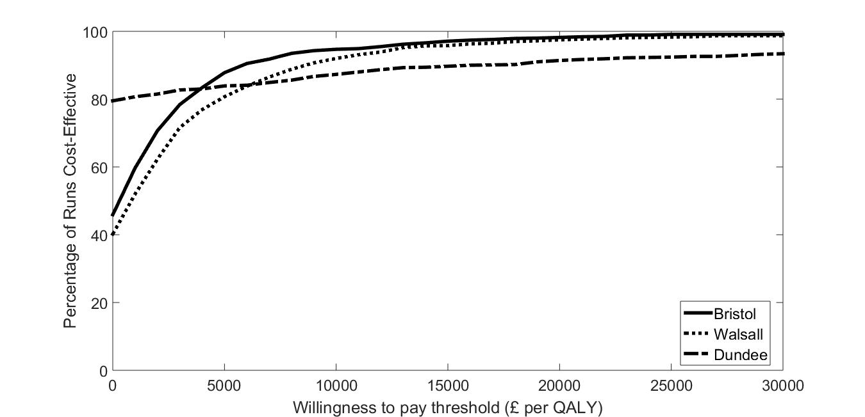

**Fig 3** Univariate Sensitivity Analysis

Bristol

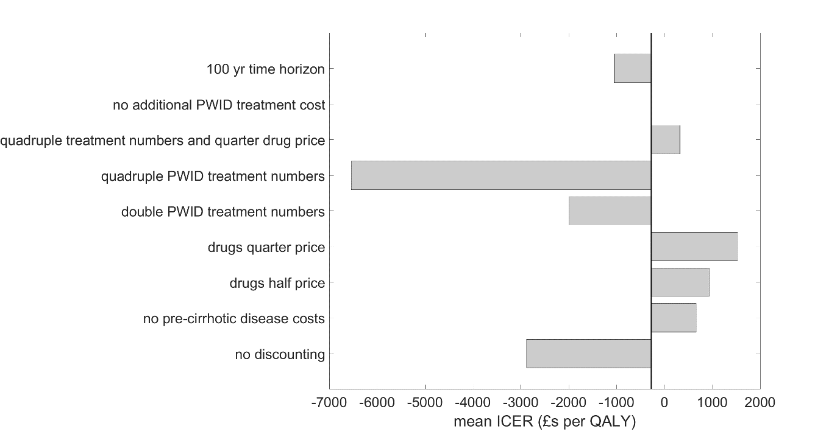

Dundee

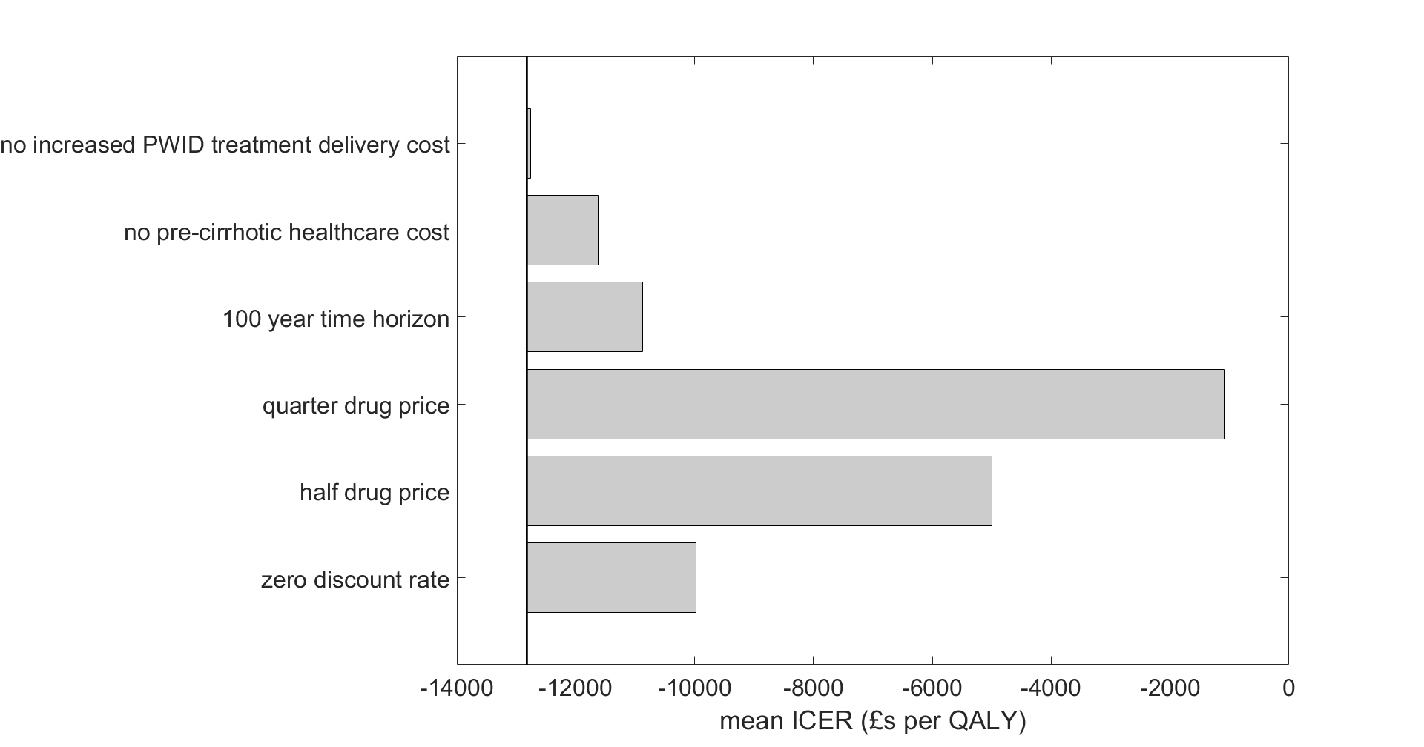

Walsall

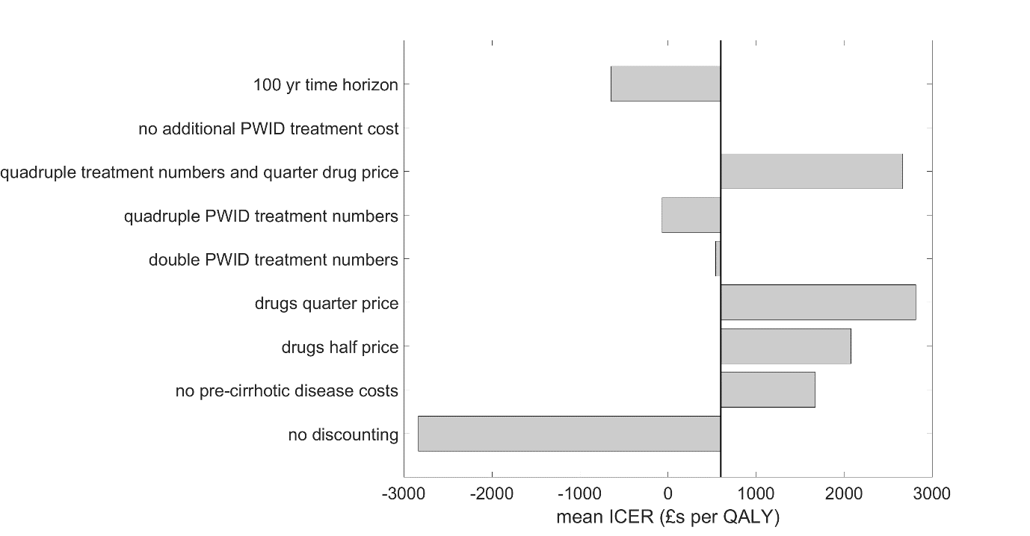

ICER, incremental cost effectiveness ratio; QALY, quality adjusted life year

**Supporting Information**

S1 Appendix. Technical Supplement

References

1. Mohd Hanafiah K, Groeger J, Flaxman AD, Wiersma ST. Global epidemiology of hepatitis C virus infection: new estimates of age-specific antibody to HCV seroprevalence. Hepatology. 2013;57.

2. Perz JF, Armstrong GL, Farrington LA, Hutin YJ, Bell BP. The contributions of hepatitis B virus and hepatitis C virus infections to cirrhosis and primary liver cancer worldwide. J Hepatol. 2006;45(4):529-38.

3. Public Health England. Hepatitis C in the UK 2015 Report. 2015.

4. Public Health England. People who inject drugs: HIV and viral hepatitis unlinked anonymous monitoring survey tables (pyschoactive): 2016 update. London; 2016.

5. Degenhardt L, Charlson F, Stanaway J, Larney S, Alexander LT, Hickman M, et al. Estimating the burden of disease attributable to injecting drug use as a risk factor for HIV, hepatitis C, and hepatitis B: findings from the Global Burden of Disease Study 2013. The Lancet Infectious Diseases. 2016;16(12):1385-98.

6. Hellard M, Doyle JS, Sacks-Davis R, Thompson AJ, McBryde E. Eradication of hepatitis C infection: the importance of targeting people who inject drugs. Hepatology. 2014;59(2):366-9.

7. Turner KME, Hutchinson S, Vickerman P, Hope V, Craine N, Palmateer N, et al. The impact of needle and syringe provision and opiate substitution therapy on the incidence of hepatitis C virus in injecting drug users: Pooling of UK evidence. Addiction. 2011;106:1978-88.

8. Vickerman P, Martin N, Turner K, Hickman M. Can needle and syringe programmes and opiate substitution therapy achieve substantial reductions in hepatitis C virus prevalence? Model projections for different epidemic settings. Addiction. 2012;107(11):1984-95.

9. Platt L, Minozzi S, Reed J, Vickerman P, Hagan H, French C, et al. Needle and syringe programmes and opioid substitution therapy for preventing HCV transmission among people who inject drugs: findings from a Cochrane Review and meta-analysis. Addiction. 2018;113(3):545-63.

10. Ward Z, Platt L, Sweeney S, Hope VD, Maher L, Hutchinson S, et al. Impact of current and scaled-up levels of hepatitis C prevention and treatment interventions for people who inject drugs in three UK settings—what is required to achieve the WHO's HCV elimination targets? 2018;113(9):1727-38.

11. Palmateer N, Kimber J, Hickman M, Hutchinson S, Rhodes T, Goldberg D. Evidence for the effectiveness of sterile injecting equipment provision in preventing hepatitis C and human immunodeficiency virus transmission among injecting drug users: a review of reviews. Addiction. 2010;105(5):844-59.

12. Iversen J, Wand H, Topp L, Kaldor J, Maher L. Extremely low and sustained HIV incidence among people who inject drugs in a setting of harm reduction. AIDS. 2014;28(2):275-8.

13. Wodak A, Cooney A. Do needle syringe programs reduce HIV infection among injecting drug users: a comprehensive review of the international evidence. Subst Use Misuse. 2006;41(6-7):777-813.

14. Guinness L, Vickerman P, Quayyum Z, Foss A, Watts C, Rodericks A, et al. The cost-effectiveness of consistent and early intervention of harm reduction for injecting drug users in Bangladesh. Addiction. 2010;105:319-28.

15. Kwon JA, Anderson J, Kerr CC, Thein HH, Zhang L, Iversen J, et al. Estimating the cost-effectiveness of needle-syringe programs in Australia. AIDS. 2012;26(17):2201-10.

16. Jones L, Pickering L, Sumnall H, Mcveigh J, Mark A, Bellis M. A review of the effectiveness and cost-effectiveness of needle and syringe programmes for injecting drug users. NICE; 2008. p. 1-79.

17. Vickerman P, Kumaranayake L, Balakireva O, Guinness L, Artyukh O, Semikop T, et al. The cost-effectiveness of expanding harm reduction activities for injecting drug users in Odessa, Ukraine. Sex Transmitted Dis. 2006;33:S89-102.

18. Kumaranayake L, Vickerman P, Walker D, Samoshkin S, Romantzov V, Emelyanova Z, et al. The cost-effectiveness of HIV preventive measures among injecting drug users in Svetlogorsk, Belarus. Addiction. 2004;99:1565-76.

19. Kaplan EH. Economic analysis of needle exchange. AIDS. 1995;9(10):1113-20.

20. Laufer FN. Cost-effectiveness of syringe exchange as an HIV prevention strategy. JAIDS Journal of Acquired Immune Deficiency. 2001;28:273-8.

21. Jacobs P, Calder P, Taylor M, Houston S, Saunders LD, Albert T. Cost effectiveness of Streetworks' needle exchange program of Edmonton. Canadian journal of public health = Revue canadienne de santé publique. 1999;90:168-71.

22. Pollack Ha. Cost-effectiveness of Harm Reduction in Preventing Hepatitis C among Injection Drug Users. Medical Decision Making. 2001;21:357-67.

23. Kwon JA, Anderson J, Kerr CC, Thein H-H, Zhang L, Iversen J, et al. Estimating the cost-effectiveness of needle-syringe programs in Australia. AIDS. 2012;26:2201-10.

24. National Treatment Agency for Substance Misuse. Drug Treatment in England: The road to recovery. London; 2012.

25. Palmateer NE, Taylor A, Goldberg DJ, Munro A, Aitken C, Shepherd SJ, et al. Rapid decline in HCV incidence among people who inject drugs associated with national scale-up in coverage of a combination of harm reduction interventions. PLoS One. 2014;9(8):e104515.

26. Jones HE, Welton NJ, Ades A, Pierce M, Davies W, Coleman B, et al. Problem drug use prevalence estimation revisited: heterogeneity in capture–recapture and the role of external evidence. Addiction. 2015.

27. King R, Bird SM, Overstall A, Hay G, Hutchinson SJ. Injecting drug users in Scotland, 2006: Listing, number, demography, and opiate-related death-rates. Addict Res Theory. 2013;21(3):235-46.

28. Hope VD, McVeigh J, Marongiu A, Evans-Brown M, Smith J, Kimergård A, et al. Prevalence of, and risk factors for, HIV, hepatitis B and C infections among men who inject image and performance enhancing drugs: a cross-sectional study. BMJ open. 2013;3:e003207.

29. NICE. Guide to the methods of technology appraisal 2013. 2013.

30. Platt L, Sweeney S, Ward Z, Guinness L, Hickman M, Hope V, et al. Assessing the impact and cost-effectiveness of needle/syringe provision on hepatitis C transmission among people who inject drugs in the United Kingdom: analysis of pooled datasets and economic modelling Public Health Research. 2017;5(5).

31. Vassall A, Sweeney S, Kahn J, Gomez GB, Bollinger L, Marseille E, et al. Reference Case for Estimating the Costs of Global Health Services and Interventions 2017.

32. Wright M, Grieve R, Roberts J, Main J, Thomas HC, Investigators UKMHCT. Health benefits of antiviral therapy for mild chronic hepatitis C: randomised controlled trial and economic evaluation. Health technology assessment (Winchester, England). 2006;10:1-113, iii.

33. Martin NK, Vickerman P, Dore GJ, Grebely J, Miners A, Cairns J, et al. How should HCV treatment be prioritized in the direct-acting antiviral era? An economic evaluation including population prevention benefits. Journal of hepatology. 2016.

34. PSSRU. Unit Costs of Health & Social Care 2013. 2013:226.

35. Martin NK, Miners A. Assessing the cost-effectiveness of interventions aimed at promoting and offering hepatitis C testing to injecting drug users : An economic modelling report 2012:1-102.

36. NHS England. Policy Statement : Clinical Commissioning Policy Statement : Treatment of chronic Hepatitis C in patients with cirrhosis. 2015:1-19.

37. British Medical Association. British National Formulary. 2014.

38. Personal Social Services Research Unit. Unit costs of services 2013.

39. Shepherd J, Jones J, Hartwell D, Davidson P, Price A, Waugh N. Interferon alfa (pegylated and non-pegylated) and ribavirin for the treatment of mild chronic hepatitis C: a systematic review and economic evaluation. Health Technol Asses. 2007;11(11):1-+.

40. Bruno S, Zuin M, Crosignani A, Rossi S, Zadra F, Roffi L, et al. Predicting Mortality Risk in Patients With Compensated HCV-Induced Cirrhosis: A Long-Term Prospective Study. American Journal of Gastroenterology. 2009;104(5):1147-58.

41. Morgan RL, Baack B, Smith BD, Yartel A, Pitasi M, Falck-Ytter Y. Eradication of Hepatitis C Virus Infection and the Development of Hepatocellular Carcinoma: A Meta-analysis of Observational Studies. Annals of Internal Medicine. 2013;158(5):329-37.

42. van der Meer AJ, Veldt BJ, Feld JJ, et al. Association between sustained virological response and all-cause mortality among patients with chronic hepatitis c and advanced hepatic fibrosis. JAMA. 2012;308(24):2584-93.

43. Claxton K, Martin S, Soares M, Rice N, Spackman E, Hinde S, et al. Methods for the estimation of the National Institute for Health and Care Excellence cost-effectiveness threshold. 2015.

44. Briggs A, Sculpher M, Claxton K. Decision modelling for health economic evaluation: OUP Oxford; 2006.

45. Aspinall EJ, Nambiar D, Goldberg DJ, Hickman M, Weir A, Van Velzen E, et al. Are needle and syringe programmes associated with a reduction in HIV transmission among people who inject drugs: a systematic review and meta-analysis. Int J Epidemiol. 2014;43(1):235-48.

46. Salmon AM, Dwyer R, Jauncey M, van Beek I, Topp L, Maher L. Injecting-related injury and disease among clients of a supervised injecting facility. Drug & Alcohol Dependence.101(1):132-6.

47. Hope V, Kimber J, Vickerman P, Hickman M, Ncube F. Frequency, factors and costs associated with injection site infections: findings from a national multi-site survey of injecting drug users in England. BMC Infect Dis. 2008;8:120.

48. Topp L, Iversen J, Baldry E, Maher L, Collaboration of Australian N. Housing instability among people who inject drugs: results from the Australian needle and syringe program survey. J Urban Health. 2013;90(4):699-716.

49. Morgan K, Lee J, Sebar B. Community health workers: a bridge to healthcare for people who inject drugs. Int J Drug Policy. 2015;26(4):380-7.

50. Owen L, Morgan A, Fischer A, Ellis S, Hoy A, Kelly MP. The cost-effectiveness of public health interventions. Journal of Public Health. 2012;34(1):37-45.

51. Remme M, Vassall A, Lutz B, Luna J, Watts C. Financing structural interventions: going beyond HIV-only value for money assessments. AIDS. 2014;28(3):425-34.

52. Larney S, Peacock A, Leung J, Colledge S, Hickman M, Vickerman P, et al. Global, regional, and country-level coverage of interventions to prevent and manage HIV and hepatitis C among people who inject drugs: a systematic review. The Lancet Global Health. 2017;5(12):e1208-e20.

53. WHO. Combating hepatitis B and C to reach elimination by 2030. 2016.

54. Office for National Statistics. Population Estimates for UK, England and Wales, Scotland and Northern Ireland, Mid-2015.

55. Information Services Division Scotland. Injecting equipment provision in Scotland survey 2013/14. Scotland; 2015.

56. Mills HL, Colijn C, Vickerman P, Leslie D, Hope V, Hickman M. Respondent driven sampling and community structure in a population of injecting drug users, Bristol, UK. Drug Alcohol Depend. 2012;126(3):324-32.

57. Martin NK, Foster GR, Vilar J, Ryder S, Cramp ME, Gordon F, et al. HCV treatment rates and sustained viral response among people who inject drugs in seven UK sites: real world results and modelling of treatment impact. J Viral Hepat. 2015;22(4):399-408.