HIV Drug Resistance Levels in Adults Failing First Line Antiretroviral Therapy in an Urban and Rural Setting in South Africa

Theresa M Rossouw^{1*}, Martin Nieuwoudt², Justen Manasa^{3,4}, Glen Malherbe¹ , Richard J. Lessells^{4,5}, Sureshnee Pillay⁴, Siva Danaviah⁴, Phetole Mahasha¹, Gisela van Dyk¹, Tulio de Oliveira^{4,6}

¹ Institute for Cellular and Molecular Medicine, Department of Immunology, University of Pretoria, South Africa.
² South African Dept of Science and Technology/National Research Foundation Centre of Excellence in Epidemiological Modelling and Analysis (SACEMA), Stellenbosch University, Stellenbosch, South Africa.
³ Department of Infectious Diseases, Stanford University, CA, USA.
⁴ Africa Centre for Health and Population Studies, University of KwaZulu-Natal, Mtubatuba, South Africa.
⁵ Department of Clinical Research, London School of Hygiene and Tropical Medicine, London, UK.
⁶ Research Department of Infection, University College London, UK

* Corresponding author:
Prof. Theresa Rossouw
Institute for Cellular and Molecular Medicine
Department of Immunology
University of Pretoria
South Africa.
Phone: +27 12-319-2626
Email: theresa.rossouw@up.ac.za

Running head: HIV drug resistance in urban and rural settings
Article type: Original article
Word count: 3184 words (main text); 250 (abstract)
Tables/Figures: 3 Tables, 2 Figures
References: 44
Keywords: HIV-1; drug resistance; rural; urban.
Source of funding: This work was supported by the European Union (SANTE 2007 147–790). The Hlabisa HIV Treatment and Care Programme has received support through the United States Agency for International Development (USAID) and the President’s Emergency Plan (PEPFAR) under the terms of Award No. 674-A-00-08-00001-00. Data analysis and curation were also supported by a Flagship grant from the Medical Research Council (MRC) of the Republic of South Africa (MRC- RFA-UFSP-01-2013/UKZN HIVEPI). The funders had no role in study design, data collection and analysis, decision to publish, or preparation of the manuscript.

Abstract
Objectives
Urban and rural HIV treatment programmes face different challenges in the long-term management of patients. There are few studies comparing drug resistance profiles in patients accessing treatment through these programmes.
Methods
HIV drug resistance data and associated treatment and monitoring information from adult patients failing first-line therapy in an urban and rural programme were collected. Data were curated and managed in SATuRN RegaDB before statistical analysis using Microsoft Excel 2013 and Stata Ver14 where clinical parameters, resistance profiles and predicted treatment responses were compared.
Results
Data from 595 patients were analyzed: 492 rural and 103 urban. The urban group had lower CD4 counts at treatment initiation (98 versus 126 cells/µl, p=0.05), had more viral loads done per year (median 3 versus 1.4, p< 0.01) and was more likely to have no drug resistance mutations detected (35.9% versus 11.2%, p<0.01). Patients in the rural group were more likely to have been on first-line treatment for a longer period, failed for longer, and have thymidine analogue mutations. Notwithstanding these differences, both groups had a comparable predicted response to standard second-line regimen, based on the genotypic susceptibility score. Mutations accumulated in a sigmoidal fashion over failure duration.
Conclusions
The frequency and patterns of drug resistance, as well the intensity of virological monitoring, in adults with first-line therapy failure differed between the urban and rural site. Despite these differences, based on the genotypic susceptibility scores, the majority of patients across both sites would be expected to respond well to the standard second-line regimen.

Introduction

Highly-active antiretroviral therapy (HAART) significantly decreases morbidity and mortality associated with HIV-1 infection, transforming it from an inevitably fatal illness into a manageable, chronic condition [1-4]. Significant increases in patient lifespan and quality of life are a result of reduced HIV-1 viremia with a corresponding partial reconstitution of the immune system. The development of HIV-associated drug resistant (HIVDR) in the presence of suboptimal drug levels, however, poses a threat to the long-term success of the HIV treatment programme as it limits treatment options, increases cost and constitutes a reservoir of resistant virus that can be transmitted to other individuals [5].

Similar treatment responses to HAART have been reported across HIV-1 subtypes [6]. Most data on drug resistance, however, concern subtype B, the predominant subtype found in the developed world. In contrast, there is still relatively little information on subtype C, which accounts for the majority of infections worldwide [7] and is predominantly found in sub-Saharan Africa. More research is needed, especially since it has been reported that subtype C might have a higher propensity for the development of drug resistance mutations to common first line drugs [8-10]. For instance, is has been shown that subtype C contains a valine codon 106 polymorphism (GTG) that facilitates a V106M mutation (GTG<--ATG) after selection with efavirenz (EFV), which confers high-level cross-resistance to the class of non-nucleoside reverse transcriptase inhibitors (NNRTIs) [11]. In addition, subtype C has a different template nucleotide sequence around codon 65 that causes transcription errors in this region with the subsequent rapid development of resistance to tenofovir (TDF) [12,13].

Even a relatively small increase in HIVDR in subtype C might be significant when considering the magnitude of the treatment programme in countries such as South Africa, where approximately 2.5 million people were accessing HAART by the end of 2013 [14]. Up to 85% of patients failing first-line line HAART have evidence of at least one drug resistance-associated mutation [15]. Overall, based on data from 12 studies in 8 countries, between 3.7% and 49% of individuals on first-line HAART in sub-Saharan Africa fail virologically due to drug resistance [16].

Although South Africa has a few, large, highly-populated urban centers, much of the population (38%) is rural [17]. Nevertheless, most published studies on ART treatment outcomes and HIVDR in South Africa have come from urban treatment cohorts or from provinces with primarily urban populations [10,15,18-26]. Rural HIV treatment programmes face different, and possibly deleterious, challenges such as: i) longer travel distances to access healthcare facilities coupled with inadequate access to transportation; ii) limited access to virological monitoring; iii) increased stigma; and iv) significant human resource challenges [16,27-30]. Human resource constraints may impact on the ability to provide sufficient adherence counselling and the latter has repeatedly been shown to account for the majority of treatment failures [3,29].

Very few studies have investigated whether treatment outcomes, and specifically HIVDR, are different in rural compared to urban areas. The aim of this study was therefore to describe and compare select clinical and HIVDR profiles of patients failing first line HAART across two sites in South Africa – one urban and one rural. The urban site was a district hospital in central Pretoria (Tshwane District Hospital) and the rural site was located in northern KwaZulu-Natal (Hlabisa sub-district). We also examined the accumulation of resistance mutations as a function of the duration of treatment failure.

Methods

The terms ‘urban’ and ‘rural’ were defined according to Urban Influence codes as described by Larson & Fleishman (2003) [31]. The urban group is from a large metropolitan statistical area of more than 1 million people, Pretoria of the Gauteng province The rural group is from the Hlabisa sub-district (1430 km²) of the KwaZulu-Natal province, a geographic setting that is very heterogeneous in terms of population density, 2-3000 people/km². The sub-district is served by one district hospital and 17 primary health care clinics [13].

All patients were 18 years or older, had started HAART after 2004 as part of the South African national HIV treatment plan and were treated according to the National Department of Health HIV guidelines (2004 and 2010) operative during this time. All patients had failed a first-line NNRTI-based HAART regimen as defined by at least one HIV-1 RNA (VL) measurement of more than 1000 RNA copies/ml plasma after at least 6 months of HAART. The duration of virological failure was estimated from the date of the first VL >1000 copies/ml until the date of the genotype. If there was a VL <50 copies/ml between the above dates, duration was then measured from the next VL >1000 copies/ml. If all VL values were >1000 copies/ml then the duration was taken from the baseline until the date of the genotype. Immunological failure was defined according to WHO criteria as: i) a decline of CD4+ T-cell count to lower than or equal to the baseline; ii) persistent CD+ T-cell count of less than 100 cell/µl or iii) a decline of 50% or more from the on-treatment peak value.

Genotypic drug resistance testing (DRT) became available to the urban group in 2008 as part of a drug resistance surveillance project. Samples were collected between the beginning of 2008 and the end of 2012. This was a doctor-based programme and patients were referred for DRT after two VL >1000 copies/ml when interventions to improve adherence had failed to result in virological suppression and if the clinician was satisfied that all other obvious causes of treatment failure had been excluded. Clinicians sent 3 EDTA tubes of blood to the Department of Immunology at the University of Pretoria together with a patient’s history consisting of all available CD4+ T-cell counts, VLs and HAART history.

DRT started in the rural group in December 2010 as part of the implementation of genotypic resistance testing in 17 primary healthcare clinics in the area [13,32] and samples were collected between the end of 2010 and the beginning of 2013. Details of the rural programme have been published previously [33]. In summary, routine HIV treatment, care and monitoring were delivered largely by nurses and HIV counsellors at each primary health care clinic. People with complications of treatment or evidence of treatment failure were referred to the medical officer that made weekly visits to each clinic. Patients were referred for DRT after one VL >1000 copies/ml. Clinicians or nurses collected 1 EDTA tube of blood, which was sent to the Africa Centre virology laboratory, together with a detailed clinical history.

For HIV drug resistance genotyping, the rural group used the open access SATuRN Life Technology HIV drug resistance testing [34]. Briefly the method involved generating cDNA using the Superscript III kit (Invitrogen Corporation, Carlsbad, CA, USA) and a gene specific primer. This was followed by a nested PCR using Platinum taq polymerase (Invitrogen Corporation, Carlsbad, CA, USA) to amplify a 1315bp pol fragment. The purified amplicons were sequenced using four bidirection primers covering the full protease gene and the first 300 codons of the RT gene. Sequencing electrophoresis was done on a 3130 xl genetic analyzer (Applied Biosystems Inc, Forster City, CA, USA). This method was produced in collaboration with Life Technologies (Applied Biosystems Inc, Forster City, CA, USA) as an affordable method to be implemented in resource-limitted settings [35]. It has been validated against the commercial and FDA aproved, Viroseq genotyping method [36]. The SatuRN Life Technologies method has been validated with a panel of proficiency testing samples obtained from the French National Agencies for Research on AIDS and Viral Hepatitis (ANRS). The SATuRN Life Technologies and ViroSeq methods were 100% concordant in identifying all clinically important drug resistance-associated mutations [34]. In addition the laboratory participates in an HIV-1 drug resistance genotyping proficiency testing programme from Quality Control for Molecular Diagnostics (QCMD). Genotying for the urban group was done using the commercial and FDA approved Trugene ® HIV-1 genotyping kit as per manufacturer’s protocol. Sequences were assembled and manually edited using CLC DNA Workbench 5.7.1 software (CLC bio, Denmark).

Both groups followed the same protocol for sequence quality assessment and analysis which has also been previously described [34]. Briefly, the quality of the sequences was assessed using the quality analysis tool and the HIVDB programme on the Stanford HIV database [37]. HIV subtyping was done using the Rega HIV-1 subtyping tool version 3.0 [38]. In addition, phylogetic analysis was used to assess possible contamination. All sequence data were anonymously managed in a relational database, the SATuRN RegaDB [39].

Genotypic susceptibility scores (GSS) were calculated for each antiretroviral agent using the Stanford HIVSeq algorithm version 6.0.5 [40] and a total score was then calculated for the standard second-line regimens. This was done to assess the impact of observed drug resistance mutations on the predicted effectiveness of standard second-line regimens. Total GSS for the standard second-line regimen was calculated depending on the patient’s treatment history: for participants on d4T or AZT at the time of genotyping, GSS was calculated for a regimen of TDF, 3TC and lopinavir/ritonavir (LPVr); while for those on TDF at the time of genotyping, GSS was calculated for a regimen of AZT, 3TC and LPVr. These standard second-line regimens were consistent with the recommendations in the 2013 South African national HIV treatment guidelines [41]. For the purposes of this analysis, a compromised second-line regimen was defined as GSS<2. Data from the two groups were combined to assess the accumulation of resistance mutations to the various drug classes as a function of treatment failure.

The urban and rural group data were exported from SATuRN RegaDB into Excel 2013 files. Pivot tables with IF/AND and VLOOKUP functions were used to calculate variable categories while the Solver function, using the minimization of the square of the residuals, was used to fit specified non-linear functions to the accumulated mutations data (Figure 2). Excel data was also exported to Stata version 14 (Statacorp, 4905 Lakeway Drive College Station, Texas 77845-4512,USA) where descriptive statistics were calculated and to Statistix version 9 where p-values were calculated for differences between variables. For count data Two-Proportion tests were used and for continuous data Wilcoxon Rank Sum tests were used. Alpha (α) was set on the 95th percentile and a p-value <0.05 was considered significant.

The study was approved by the research ethics committees of the Faculty of Health Sciences at the University of Pretoria (46/2011) and the University of KwaZulu Natal (BF052/10). No personal participant information was entered in the database and all participants were allocated an unique identifying code. Results of the DRT were made available to the treating doctors and nurses in real time and support was given regarding selection of next regimens and access to newer medication, as needed.

Results
Demographic and clinical characteristics of the two patient groups are presented in Table 1. There was a large difference in size, 492 in the rural versus 103 in the urban groups. Patient proportions were not significantly different in terms of sex and age. In the urban group, the median CD4+ T-cell count prior to ART initiation was significantly lower than that of the rural group (98 versus 126 cells/µl; p=0.05), however, the range was large in both groups.

At the time of genotyping, the difference in CD4+ cell T-counts and the proportion of patients with immunological failure in the two groups was not significant, but the median CD4+ T-cell count was still very low (in the 130-140 range) and over 41% or patients had immunological failure in both groups. Both groups reported VL values above 4.0 log₁₀; however, the urban group had a higher median value than the rural group (4.18 versus 4.08 log₁₀, p=0.03). The urban group had more intense monitoring as evidenced by the significantly larger number of VL tests per year (3 for urban versus 1.4 for rural, p< 0.01). Consequently, the majority in the urban group had less than 6 months of virological treatment failure, while the majority of patients from the rural group had been failing for more than 24 months.

Table 2 shows the comparison of the HAART regimens, number of patients with resistance mutations and GSS in the two groups. Consistent with the duration of virological failure, the duration of treatment in the two institutions was significantly different: the median for the urban group was 31.0 (± 20.5) versus 45.0 (± 18.8) months for the rural group. Initial ART regimens were essentially comparable although a larger proportion of rural patients had been started on regimens consisting of d4T/3TC/EFV and TDF/3TC/EFV while a larger proportion of urban patients had been started on AZT-based regimens. Similarly, at genotyping, a significantly larger proportion of rural patients were still on d4T-containing regimens, while more urban patients were on AZT-based regimens. Urban patients were more likely to have changed regimen, either in terms of a nucleos(t)ide reverse transcriptase inhibitor (NRTI) substitution or both NRTI and NNRTI substitutions (p<0.01). Urban patients also had a significantly shorter time before the first treatment change and had more regimen changes during the course of treatment (p<0.01).

At genotype, all patients, except one in the urban group who was infected with subtype B, were found to have HIV-1 subtype C infection. A significantly larger proportion of urban patients had no HIVDR mutations detected, indicating wild-type virus (35.9% versus 11.2%; p<0.01). In addition, a larger proportion of urban patients had fewer than 2 RT mutations detected, while rural patients were more likely to have between 2 and 6 mutations. The proportion with more than 6 mutations was, however, comparable in both groups (14.6% in the urban versus 18.7% in the rural group; p=0.54). Rural patients were more likely to have thymidine analogue mutations (TAMs) (30.9% versus 14.6%; p<0.01) as well as multiple (three or more) TAMs (12.6% versus 3.9%; p=0.02). The exact resistance mutations are depicted in Figure 1. The most common mutations in both groups were: M184V, K103NS and V106AM. Interestingly, the GSS for second line regimens were essentially identical with 88% of the rural and 83.1% of the urban group having scores equal to or above 2.

By combining the results of the two groups we also assessed whether the duration of treatment failure is associated with the number of drug resistance mutations. Table 3 demonstrates a pattern of increasing numbers of NRTI mutations between patients failing for less than 6 months versus those failing between 6 and 12 months (mean of 1.1 versus 1.4) and further increased in patients failing for between 13 and 24 months (mean of 1.8), after which time there was a slight decline (mean of 1.6 if failure >24 months). NNRTI mutations accumulated slightly slower than NRTI mutations in patients failing for <6 months or between 6 and 12 months (mean of 1 versus 1.1), while those failing for more than 1 or 2 years had means of 1.3 and 1.2 respectively. TAMs followed a similar pattern and tended to accumulate mostly after 1 year of failure (0.38 if failure <6 months; 0.45 if failure 6-12 months; 0.85 if failure 13-24 months; and 0.81 if failure >24 months). Figure 2 demonstrates a sigmoidal accumulation of mutations over failure duration. Using the minimization of the square of residuals the following function provided a near ideal fit to the total mutations data:
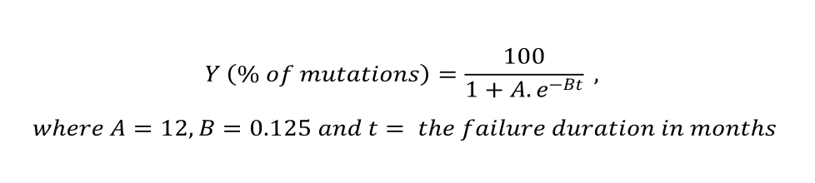
Given that the sigmoidal is also the integral of a logistic function, mutation accumulation would appear to follow a binary additive pattern over time. Analysis of the data did not reveal any relationship between the VL at the time of genotyping and the number of mutations (data not shown).

Discussion

To our knowledge, this is the first study to compare HIVDR profiles in patients failing first-line NNRTI-based HAART in an urban and rural setting in South Africa. Urban patients were more aggressively managed than their rural counterparts: they had more therapy switches within a shorter duration of therapy, more VL tests per annum and had been failing for a shorter time before being referred for DRT. The HIVDR results reflect these different approaches to monitoring and treatment, although causation cannot be claimed; there were significantly more urban patients with no resistance mutations and rural patients had higher percentages of NNRTI and NRTI mutations. The proportion of patients with wild type virus despite repeat viral load testing and an adherence intervention in the urban group is higher than previously reported in the literature (36% versus 19 - 30%) [19,20,23] and may be due to more intensive monitoring, coupled with the absence of skilled adherence counsellors and objective adherence measurement tools.

Although the individual percentages were different in the urban and rural environments, the overall patterns of resistance formation were similar. Taken together with the findings shown in Figure 1, the underlying trend is the accumulation of similar mutations with increasing duration of failure in both environments, with the rural group having accumulated more mutations due to the longer time spent with actively replicating virus while on HAART. This is consistent with other studies that observed that prolonged HAART failure leads to the accumulation of drug resistance [42,43].

The more aggressive management of urban patients might be due to the different management approaches, access to information, increased access to treatments, and better human resource allocation. Differential management might also be due to the ease of referring patients to tertiary services and requesting blood investigations, due to the proximity of the referral hospital and laboratory in the urban setting. A Ugandan study assessing pediatric responses to ART similarly found that urban children were more likely to be switched to second-line regimens than their rural counterparts [44].

It is interesting to note that despite more significant HIVDR in the rural group, both groups had comparable predicted GSS for second-line therapy. This is in keeping with the effectiveness of second line protease inhibitor-based therapy in suppressing VL, at least in the short term, even in the absence of a fully active NRTI backbone [24,45,46]. When the two groups were combined and mutations assessed versus the duration of failure, it was apparent that a sigmoidal accumulation of mutations occurred in the population. This observation has value in that a per mutation ‘cost value’, be it health or financial, might be associated with this accumulation giving the public health practitioner an ability to plan for the future of the particular patient population. Further, a higher proportion of patients in the urban setting received AZT versus TDF at the time of genotyping, with the converse in the rural setting. TAMs are expected to accumulate more on AZT and d4T (potentially causing cross resistance to TDF) and less so on TDF [47]. This may in part explain why GSS scores were similar in the urban and rural groups despite longer average failure duration in the latter.

This study has limitations. It did not assess the larger groups receiving ART at the different sites, or all the patients failing ART in the clinics, but rather focused on the sub-groups that had been referred for DRT; hence, there are no clinic denominators or mortality statistics. Variables that might have impacted on the development of HIVDR, such as adherence and use of traditional medication or alcohol, were not routinely collected and could thus not be compared between the groups. There was also no active follow-up of patients in the research studies after change to second line regimens and so we don’t have data on actual treatment responses on second-line ART. There were some methodological differences in terms of referral pathways and eligibility criteria at the two sites, but these have been taken into account. In addition, DRT methodology differered between the urban and rural centers, but this is not expected to make a difference to the DRT results [48]. Despite these limitations, this study presents one of the largest datasets of HIVDR results in sub-Saharan Africa and addresses an important, yet understudied, area of HIV research.

In conclusion, this study showed that urban and rural patients received significantly different HIV care, with urban patients being more aggressively managed. This translated into fewer patients with evidence of HIVDR and, specifically, severe HIVDR at the time of genotyping and supports the notion that increased duration on failing HAART increases drug resistance. Despite these differences, the expected response to second-line ART remained comparable between the groups. These findings have important implications for management of patients in large treatment programs where financial constraints may limit the feasibility of intense patient monitoring. It seems that a balance can be obtained between limited virological monitoring on the one hand and prevention of severe, treatment-limiting HIVDR on the other. Future studies might investigate the impact on the rate and type of mutations accumulated as a function of the cumulative (integrated) viral load, i.e. the ‘viral fitness’, during the treatment failure duration.

Acknowledgements
The authors would like to thank the patients in the two groups as well as the clinics, nurses and counsellors who identified patients and referred them for the study. This work was supported by the European Union (SANTE 2007 147–790). The Hlabisa HIV Treatment and Care Programme has received support through the United States Agency for International Development (USAID) and the President’s Emergency Plan (PEPFAR) under the terms of Award No. 674-A-00-08-00001-00. The funders had no role in study design, data collection and analysis, decision to publish, or preparation of the manuscript.

Table 1. Patient demographic and clinical characteristics compared
Characteristic | Unit | Africa Centre (N=492) | Pretoria (N=103) | p-value Ɨ
Sex, male  female | N(%) | 136(27.7)  355(72.3) | 26(27.4)  69(72.6) | 0.95
Age  < 20  20-29  30-39  40-49  50+ | years, median (IQR)  N(%) | 36(31-42)  19(3.9)  90(18.3)  212(43.2)  105(21.4)  19(3.9) | 36(31-40)  1(1.1)  19(20.0)  53(55.8)  19(20.0)  3(3.2) | 0.27
CD4+count at entry  <50  50-99  100-149  150-199  200-249  250+ | cells/µl,median (IQR)  N(%) | 126(60-191)  98(19.9)  97(19.7)  94(19.1)  95(19.3)  36(7.3)  72(14.6) | 98(40-185)  30(29.7)  21(20.8)  12(11.9)  16(15.8)  12(11.9)  10(9.9) | 0.05
CD4+ at genotype  <50  50-99  100-149  150-199  200-249  250+ | cells/µl median (IQR)  N(%) | 138(110-173)  51(10.4)  4(0.8)  237(48.2)  128(26.0)  31(6.3)  41(8.3) | 131(103-162)  17(16.5)  0(0)  53(51.5)  17(16.5)  9(8.7)  7(6.8) | 0.12
*Immunological failure at time of genotype | N(%) | 203(41.3) | 43(41.7) | 0.56
VL at time of genotype# | log copies/ml  median (IQR) | 4.08(3.08-4.48) | 4.18(3.19-5.11) | 0.03
VLs per patient per year | median | 1.4(1.1-1.8) | 3.0(1.9-5.4) | <0.01
Viral suppression,  Ever < 1000 copies/ml  Ever < 50 copies/ml | N(%) | 344(70.1)  267(54.4) | 78(75.8)  62(60.2) | 0.37  0.40
**Duration of virological failure  <6  6-12  13-24  >24 | months  median (IQR)  N(%) | 20.0(10.8-33.2)  48(9.8)  84(17.1)  168(34.2)  192(39.0) | 8.2(3.1-17.7)  38(36.9)  26(25.2)  26(25.2)  13(12.6) | <0.01  <0.01  0.07  0.10  <0.01

N = number, IQR = interquartile range, VL = HIV viral load
*Immunological failure was defined according to WHO criteria:
- Decline of CD4+ T-cell count to lower than or equal to the baseline
- Persistent CD+ T-cell count of less than 100 cell/ µl
- A decline of 50% or more from the on-treatment peak value.
**Virological failure was estimated from:
- Duration from the first VL > 1000 copies/ml until the date of the genotype,
- If there was a VL < 50 copies/ml between the above dates, duration was then measured from the next VL > 1000 copies/ml.
- If all VL values were > 1000 copies/ml then the duration was taken from the baseline until the date of the genotype
#HIV viral load tests were repeated at the time of genotyping in the urban group, while the rural group used the latest routine programme viral load, which was a median 3 months prior to genotype [32]
Ɨ Note: p-values were either the Wilcoxon rank sum test or Two-proportion tests

Table 2. Comparison of antiretroviral treatment regimens, Genotype Susceptibility Scores and number of resistance mutations
Characteristic | Unit | Rural | N(%) | Urban | N(%) | p-value Ɨ
Duration of ART  <24  24-48  >48 | months, median (IQR) | 49.2(36.7-61.0) | 54(11.0)  179(36.4)  259(52.6) | 25.9(14.2-41.5) | 40(43.5)  39(42.4)  13(14.1) | < 0.01  < 0.01  0.47  < 0.01
Initial ART regimen |  | d4T/3TC/EFV  d4T/3TC/NVP  TDF/3TC/EFV  TDF/3TC/NVP  AZT/3TC/EFV  AZT/3TC/NVP  Total | 297(60.4)  131(26.6)  48(9.8)  8(1.6)  5(1.0)  3(0.6)  492(100) | d4T/3TC/EFV  d4T/3TC/NVP  TDF/3TC/EFV  TDF/3TC/NVP  AZT/3TC/EFV  AZT/3TC/NVP  DDI/3TC/EFV  Total | 53( 52.0)  24(23.5)  3(3.1)  1(1)  11(10.8)  8(7.8)  1(1)  102(100) | 0.05  0.73  0.05  0.97  <0.01  <0.01
ART regimen at time of genotype |  | d4T/3TC/EFV  d4T/3TC/NVP  TDF/3TC/EFV  TDF/3TC/NVP  AZT/3TC/EFV  AZT/3TC/NVP  Total | 218(44.3)  109(22.2)  99(20.1)  22(4.5)  32(6.5)  12(2.4)  492(100) | d4T/3TC/EFV  d4T/3TC/NVP  TDF/3TC/ EFV  TDF/3TC/NVP  AZT/3TC/EFV  AZT/3TC/NVP  DDI/3TC/EFV  Total | 19(18.6)  10(9.8)  12(11.8)  7(6.9)  23(22.6)  16(15.7)  12(7.8)  102(100) | <0.01  <0.01  0.07  0.44  <0.01  <0.01
Number of patients:  with all substitutions*  with NRTI substitutions  with NNRTI substitutions  with both NRTI and NNRTI |  |  | 362/492(74.0)  105(21.3)  65(13.2)  19(4.0) |  | 87/102(85.3)  57(56.4)  18(17.8)  13(11.3) | <0.01  <0.01  0.31  <0.01
time from ART start to 1st substitution | months,  median (IQR) | 20.0(10.8-33.2) |  | 13.0(6.0-13.0) |  | <0.01
Any regimen  changes | median  (min-max) | 2(1-4) |  | 3(1-6) |  | <0.01
GSS to current regimen at genotyping  <2  >2 | median (IQR) | 1.0(0.5-1.0) | 409(83.3)  82(16.7) | 1.0(1.0-2.0) | 53(63.9)  30(36.1) | <0.01  <0.01
Predicted 2nd line GSS  <2  >2 | median (IQR) | 2.0(2.0-2.0) | 58(12.0)  433(88.0) | 2.0(2.0-3.0) | 14(16.9)  69(83.1) | 0.27  0.27
No mutations (wild type) |  |  | 55(11.2) |  | 37(35.9) | <0.01
N with NNRTI mutations |  |  | 418(84.4) |  | 57(55.3) | <0.01
N with NRTI mutations |  |  | 414(83.6) |  | 57(55.3) | <0.01
N with any RT mutations  <2  2-3  4-6  >6 |  |  | 82(16.7)  255(51.9)  62(12.7)  92(18.7) |  | 39(47.6)  28(34.1)  3(3.7)  12(14.6) | <0.01  0.01  0.03  0.54
N with TAMs  0  1-2  >3 |  |  | 152(30.9)  343(69.7)  90(18.3)  62(12.6) |  | 15(14.6)  87(84.5)  11(10.7)  4(3.9) | <0.01  <0.01  0.08  0.02
N with PI mutations |  |  | 4(0.8) |  | 3(2.9) | 0.45
N = number, ART = antiretroviral treatment, IQR = interquartile range, d4T = stavudine, 3TC = lamivudine, EFV = efavirenz, NVP = nevirapine, TDF = tenofovir, AZT = zidovudine, DDI = didanosine, GSS = genotypic susceptibility score, NNRTI = non-nucleoside reverse transcriptase inhibitor, NRTI = nucleos(t)ide reverse transcriptase inhibitor, RT = reverse transcriptase, TAMs = thymidine analogue mutations, PI = protease inhibitor
Ɨ p-values were either the Wilcoxon rank sum test or Two-proportion tests
* All substitutions were for reasons of toxicity/ intolerability and all occurred before drug resistance testing.
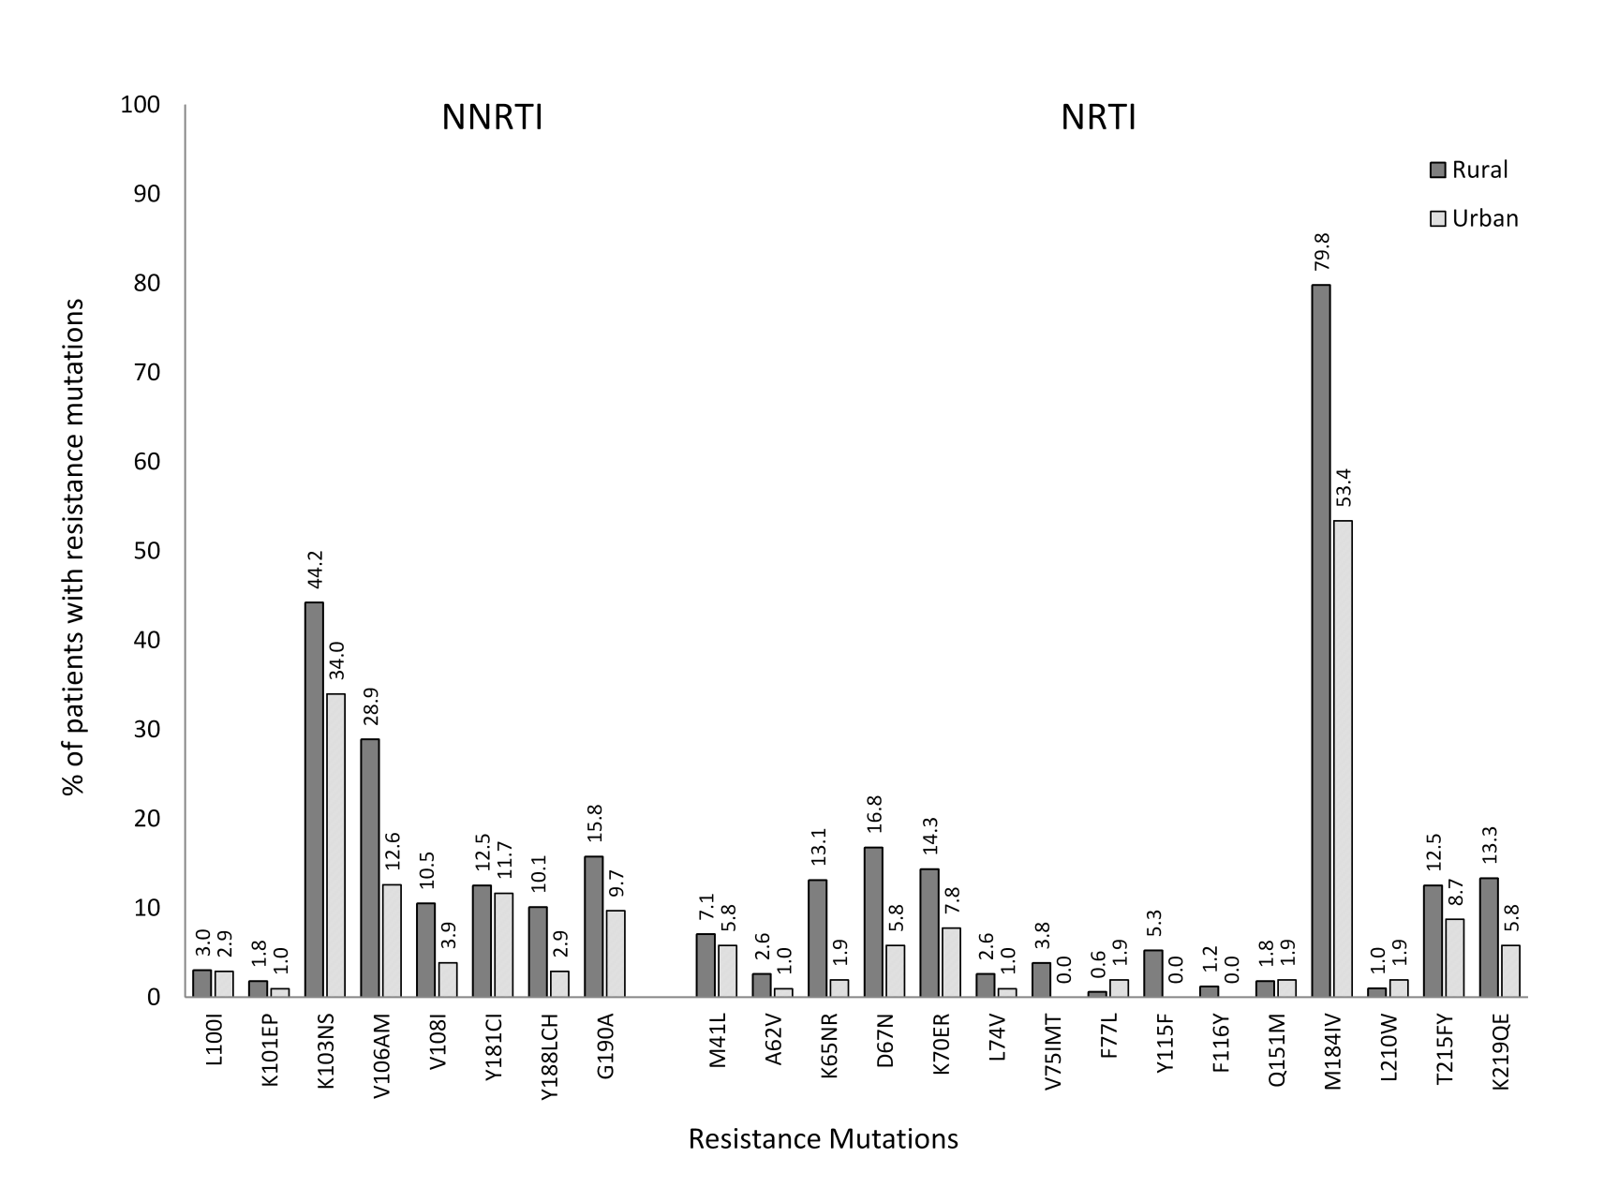
Figure 1. The patterns of drug resistance mutation formation in the two cohorts
Table 3. All patient data grouped by categorical failure duration
Note: Mutation percentages (%) total towards the right.
cat = category, GSS = genotypic susceptibility score, NNRTI = non-nucleoside reverse transcriptase inhibitor, NRTI = nucleos(t)ide reverse transcriptase inhibitor, BL = baseline, VL = HIV viral load, PI = protease inhibitor, TAM = thymidine analogue mutation, vs = versus.

 |  |  |  |  |  |  |  |  |  | Mutations
Failure  months_cat | genotype  GSS_cat  <2 vs >=2  count(%) | predicted  2nd GSS_cat  <2 vs >=2  count(%) | NRTI  substitution  No vs Yes  count(%) | NNRTI  substitution  No vs Yes  count(%) | Both  substitutions  No vs Yes  count(%) | BL VL  (mean+sd) | Genotype VL  (mean+sd) | NNRTI  mean+sd  sum(%) | NRTI  mean+sd  sum(%) | PI  mean+sd  sum(%) | TAM  mean+sd  sum(%) | All  mean+sd  sum(%) | N
<6 | 58(10.1)-19(3.3) | 9(1.6)-68(11.9) | 54(9.1)-31(5.2) | 71(12.0)-14(2.4) | 12(9.9)-8(6.6) | 3.891+1.122 | 3.708+1.232 | 1+0.78  90(41.5) | 1.1+1.1  94(43.3) | 0  0 | 0.38+0.94  33(15.2) | 2.5+2.3 217(10.5) | 86
6-12 | 80(14.0)-25(4.4) | 6(1.1)-99(17.3) | 83(14.0)-26(4.4) | 96(16.2)-13(2.2) | 21(17.4)-8(6.6) | 4.165+1.108 | 3.797+1.33 | 1.1+0.85  126(37.8) | 1.4+1.3  156(46.9) | 0.02+0.19  2(0.6) | 0.45+0.91  49(14.7) | 3+2.5  333(16.1) | 110
13-24 | 163(28.4)-25(4.4) | 23(4.0)-165(28.8) | 140(23.6)-54(9.1) | 170(28.7)-24(4.1) | 24(19.8)-10(8.3) | 4.086+1.068 | 3.818+1.139 | 1.3+0.73  245(32.1) | 1.8+1.4  347(45.5) | 0.04+0.31  7(0.9) | 0.85+1.4  164(21.5) | 3.9+2.8  763(37.0) | 194
>24 | 161(28.1)-42(7.3) | 34(5.9)-169(29.5) | 154(26.0)-5(0.8) | 173(29.2)-32(5.4) | 32(26.5)-6(5.0) | 4.437+0.953 | 4.05+1.114 | 1.2+0.77  247(32.9) | 1.6+1.4  331(44.1) | 0.029+0.3  6(0.8) | 0.81+1.3  166(22.1) | 3.7+3  750(36.4) | 205
Total | 462(80.6)-111(19.4) | 72(12.6)-501(87.4) | 431(72.7)-162(27.3) | 510(86.0)-83(14.0) | 89(73.6)-32(26.5) | 4.202+1.058 | 3.878+1.186 | 1.2+0.78  708(34.3) | 1.6+1.4  928(45.0) | 0.03+0.26  15(0.7) | 0.69+1.2  412(20.0) | 3.5+2.8  2063(100) | 595

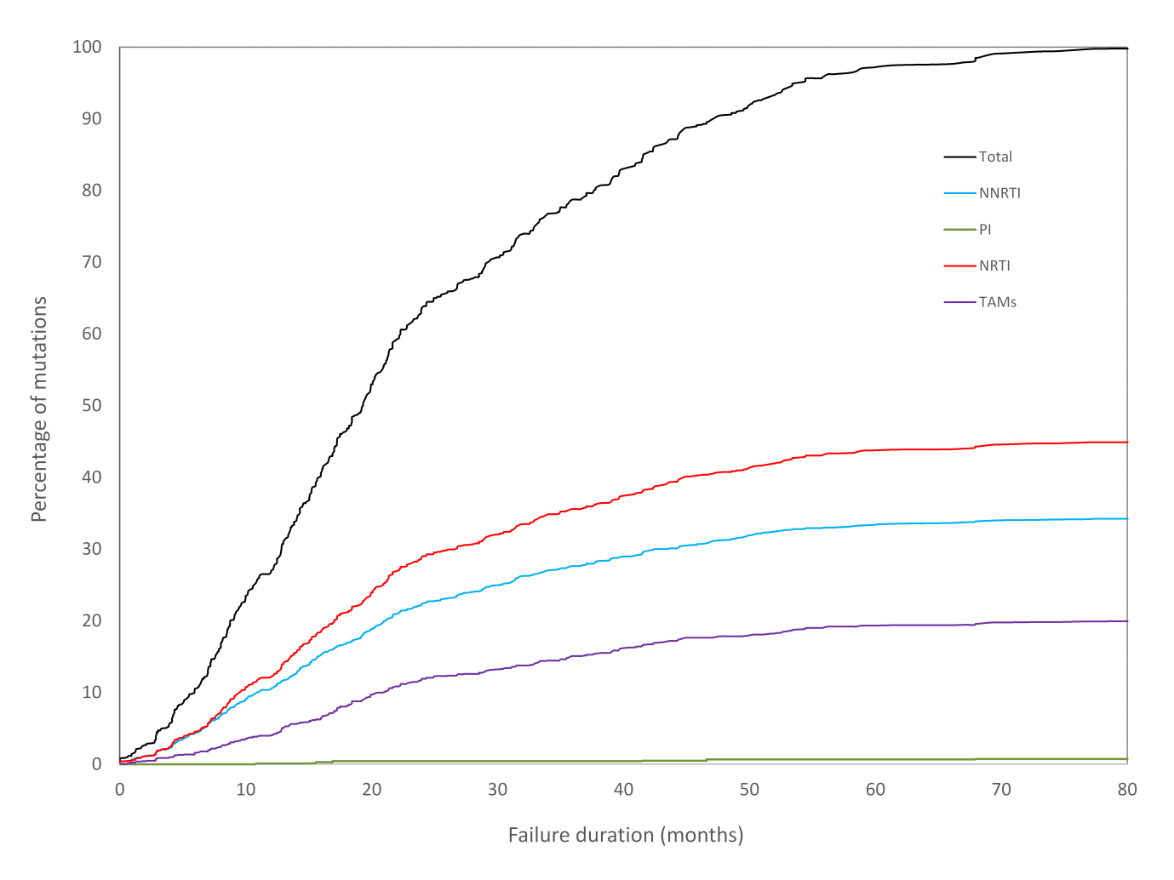
Figure 2. Accumulation of drug resistance mutations in all patients in different antiretroviral drug classes over time. The pattern of mutation accumulation followed a near ideal fit to an asymptotic sigmoidal

References

- Gulick RM, Mellors JW, Havlir D et al. Simultaneous vs sequential initiation of therapy with Indinavir, Zidovudine, and Lamivudine for HIV-1 infection. 100-week follow-up. JAMA 1998; 280: 35–41.

- Chen TK, Aldrovandi GM. Review of antiretroviral drug resistance. Pediatr Infect Dis J 2008; 27: 749–752.

- Zdanowicz MM. The pharmacology of HIV drug resistance. Am J Pharm Educ 2006; 70: 100.

- Miller CD, Crain J, Tran B, Patel N. Rilpivirine: a new addition to the anti-HIV-1 armamentarium. Drugs Today 2011; 47: 5–15.

- Hamers RL, Kityo C, Lange JMA, Rinke de Wit TF, Mugyenyi P. Global threat from drug resistant HIV in sub-Saharan Africa. BMJ 2012; 344: e4159.

- Nkengasong JN, Adje-Toure C, Weidle PJ. HIV antiretroviral drug resistance in Africa. AIDS Rev 2004; 6: 4–12.

- Abraha A, Nankya IL, Gibson R et al. CCR5- and CXCR4-tropic subtype C human immunodeficiency virus type 1 isolates have a lower level of pathogenic fitness than other dominant group M subtypes: implications for the epidemic. J Virol 2009; 83: 5592–5605.

- Tang M, Rhee S-Y, Bertagnolio S et al. Nucleoside Reverse Transcriptase Inhibitor Resistance Mutations Associated with First-Line Stavudine-Containing Antiretroviral Therapy: Programmatic Implications For Countries Phasing Out Stavudine. J Infect Dis. 2013; 207: S70–6.

- Brenner BG, Oliveira M, Doualla-Bell F et al. HIV-1 subtype C viruses rapidly develop K65R resistance to tenofovir in cell culture. AIDS 2006; 20: F9–F13.

- Sunpath H, Wu B, Gordon M et al. High rate of K65R for antiretroviral therapy-naive patients with subtype C HIV infection failing a tenofovir-containing first-line regimen. AIDS 2012; 26: 1679–84.

- Brenner B, Turner D, Oliviera M et al. A V106M mutation in HIV-1 clade C viruses exposed to efavirenz confers cross-resistance to non-nucleoside reverse transcriptase inhibitors. AIDS 2003; 17: F1–F5.

- Li JF, Lipscomb JT, Wei X, et al. Detection of low-level K65R variants in nucleoside reverse transcriptase inhibitor–naive chronic and acute HIV-1 subtype C infections. J Infect Dis 2011; 203: 798–802.

- Lessells RJ, Stott KE, Manasa J et al. Implementing antiretroviral resistance testing in a primary health care HIV treatment programme in rural KwaZulu-Natal, South Africa: early experiences, achievements and challenges. BMC Health Serv Res 2014; 14: 116.

- WHO: Global Update on HIV Treatment 2013: Results, Impact and Opportunities. www.who.int/hiv/data/global_treatment_report_presentation-2013.pdf

- El-Khatib Z, Delong AK, Katzenstein D, et al. Drug resistance patterns and virus re-suppression among HIV-1 subtype C infected patients receiving non-nucleoside reverse transcriptase inhibitors in South Africa. J AIDS Clin Res 2011; 2: 117.

- Hamers RL, Derdelinckx I, van Vugt M et al. The status of HIV-1 resistance to antiretroviral drugs in sub-Saharan Africa. Antiviral Therapy. 2008; 13: 625–639.

- Mahajan S. Economics of South African townships : special focus on Diepsloot. A World Bank study. 2014 Washington, DC ; World Bank Group. http://documents.worldbank.org/curated/en/2014/08/19925268/economics-south-african-townships-special-focus-diepsloot.

- Mutevedzi PC, Lessles RJ, Heller T, Bärnighausen T, Cooke GS, Newell ML. Scale-up of a decentralized HIV treatment programme in rural KwaZulu-Natal, South Africa: does rapid expansion affect patient outcomes? Bull World Health Organ 2010; 88: 593-600.

- Orrell C, Walensky RP, Losina E, Pitt J, Freedberg KA, Wood R. HIV type-1 clade C resistance genotypes in treatment-naive patients and after first virological failure in a large community antiretroviral therapy programme. Antivir Ther 2009; 14: 523–531.

- Wallis CL, Papathanasopolous MA, Fox M et al. Low rates of nucleoside reverse transcriptase inhibitor resistance in a well-monitored cohort in South Africa on antiretroviral therapy. Antivir Ther 2012; 17: 313–320.

- Marconi VC, Sunpath H, Lu Z et al. Prevalence of HIV-1 drug resistance after failure of a first highly active antiretroviral therapy regimen in KwaZulu Natal, South Africa. Clin Infect Dis 2008; 46: 1589–1597.

- Hoffmann CJ, Charalambous S, Sim J, et al. Viremia, resuppression, and time to resistance in human immunodeficiency virus (HIV) subtype C during first-line antiretroviral therapy in South Africa. Clin Infect Dis 2009; 49: 1928–1935.

- Hamers RL, Sigaloff KC, Wensing AM et al. Patterns of HIV-1 drug resistance after first-line antiretroviral therapy (ART) failure in 6 sub-Saharan African countries: implications for second-line ART strategies. Clin Infect Dis 2012, 54: 1660–1669.

- Sigaloff KC, Ramatsebe T, Viana R, de Wit TF, Wallis CL, Stevens WS. Accumulation of HIV drug resistance mutations in patients failing first-line antiretroviral treatment in South Africa. AIDS Res Hum Retroviruses 2012; 28: 171–175.

- El-Khatib Z, Ekstrom AM, Ledwaba J et al. Viremia and drug resistance among HIV-1 patients on antiretroviral treatment: a cross-sectional study in Soweto, South Africa. AIDS 2010; 24: 1679–1687.

- van Zyl GU, van der Merwe L, Claassen M, Zeier M, Preiser W. Antiretroviral resistance patterns and factors associated with resistance in adult patients failing NNRTI-based regimens in the Western Cape, South Africa. J Med Virol 2011; 83: 1764–1769.

- Heckman TG, Somlai AM, Peters J et al. Barriers to care among persons living with HIV/AIDS in urban and rural areas. AIDS Care 1998; 10: 365–375.

- Wilson DP, Kahn J, Blower SM. Predicting the epidemiological impact of antiretroviral allocation strategies, in KwaZulu-Natal: the effect of the urban-rural divide. Proc Natl Acad Sci U S A 2006; 103: 14228–14233.

- Bangsberg DR. Preventing HIV antiretroviral resistance through better monitoring of treatment adherence. J Infect Dis 2008; 197: S272–S278.

- Cooke R, Couper I, Versteeg M. Human Resources for Rural Health. In: Padarath A, English R, editors. South African Health Review 2011. Durban: Health Systems Trust; 2011. http://www.hst.org.za/publications/south-african-health-review-2011.

- Larson SL, Fleishman JA. Rural-urban differences in usual source of care and ambulatory service use: analyses of national data using Urban Influence Codes. Med Care 2003; 41: III65–III74.

- Manasa J, Lessles RJ, Skingsley A et al. High levels of acquired drug resistance in adult patients failing first-line antiretroviral therapy in a rural HIV treatment programme in Kwa-Zulu Natal, South Africa. PLoS One 2013; 8: e72152.

- Houlihan C, Bland R, Mutevedzi P, Lessells R, Ndirangu J, Thulare H, Newell ML. Cohort profile: Hlabisa HIV Treatment and Care Programme. Int J Epidemiol 2011; 40: 318-26. doi: 10.1093/ije/dyp402.

- Manasa J, Danaviah S, Pillay S et al. An affordable HIV-1 drug resistance monitoring method for resource limited settings. J Vis Exp 2014; 85.

- Life_Technologies. Life Technologies and SATuRN Collaborate to Increase Access to HIV Testing in Africa, https://ir.lifetechnologies.com/ releasedetail.cfm?releaseid=694585 (2012).

- Eshleman SH, Crutcher G, Petrauskene O , et al. Sensitivity and specificity of the ViroSeq human immunodeficiency virus type 1 (HIV-1):genotyping system for detection of HIV-1 drug resistance mutations by use of an ABI PRISM 3100 genetic analyzer. J Clin Microbiol. 2005;43:813–7

- Rhee SY Gonzales MJ, Kantor R, Betts BJ, Ravela J, Shafer RW. Human immunodeficiency virus reverse transcriptase and protease sequence database. Nucleic Acids Res 2003; 31: 298–303.

- Pineda-Peña AC, Faria NR, Imbrechts S et al. Automated subtyping of HIV-1 genetic sequences for clinical and surveillance purposes: performance evaluation of the new REGA version 3 and seven other tools. Infectious Genetics and Evolution 2013; 19: 337-48.

- Manasa J, Lessells R, Rossouw T et al. Southern African Treatment Resistance Network (SATuRN) RegaDB HIV drug resistance and clinical management database: supporting patient management, surveillance and research in southern Africa. Database 2014; 2014: bat082.

- Liu TF, Shafer RW. Web resources for HIV type 1 genotypic-resistance test interpretation. Clin Infect Dis 2006; 42: 1608–1618.

- National Department of Health. The South African antiretroviral treatment guidelines. 2013. http://www.sahivsoc.org/upload/documents/2013%20ART%20Treatment%20Guidelines%20Final%2025%20March%202013%20corrected.pdf

- Hosseinipour MC, van Oosterhout JJ, Weigel R, et al. The public health approach to identify antiretroviral therapy failure: high-level nucleoside reverse transcriptase inhibitor resistance among Malawians failing first-line antiretroviral therapy. AIDS 2009; 23: 1127–1134.

- Sigaloff KC, Hamers RL, Wallis CL et al. Second-line antiretroviral treatment successfully resuppresses drug-resistant HIV-1 after first-line failure: prospective cohort in Sub-Saharan Africa. J Infect Dis 2012; 205: 1739–1744.

- Musiime V, Kayiwa J, Kiconco M et al. Response to antiretroviral therapy of HIV type 1-infectedchildren in urban and rural settings of Uganda. AIDS Res Hum Retroviruses 2012; 28: 1647–1657.

- Hosseinipour MC, Kumwenda JJ, Weigel R, et al. Second-line treatment in the Malawi antiretroviral programme: high early mortality, but good outcomes in survivors, despite extensive drug resistance at baseline. HIV Med 2010; 11: 510–518.

- Paton NI, Kityo C, Hoppe A et al. Assessment of second-line antiretroviral regimens for HIV therapy in Africa. N Engl J Med 2014; 371: 234–247.

- Miller MD, Margot N, Lu B, et al. 2004. Genotypic and phenotypic predictors of the magnitude of response to tenofovir disoproxil fumarate treatment in antiretroviral-experienced patients. J Infect Dis 2004; 189: 837-846.

- Li J, Jiang Y, Lü C, Wang J, Yao J. Evaluation of the consistency of three methods for testing HIV-1 genotype drug resistance. Chinese Journal of Preventive Medicine 2013; 47: 1050–5.

