Appendices
Appendix 1: Further detail on defining risk factors
- Rheumatoid arthritis and systemic lupus erythematosis were defined as a diagnosis prior to the index date.
- Chronic obstructive pulmonary disorder patients were defined as those with a diagnosis of chronic obstructive pulmonary disorder, including chronic bronchitis and emphysema, prior to the index date and ≥35 years at first chronic obstructive pulmonary disorder diagnosis). Asthma patients were those with an asthma diagnosis before the index date and an asthma-related prescription [short and long-acting beta-2 agonists and antimuscarinics, inhaled corticosteroids, cromoglycates and nedocromil, theophyllines, leukotriene receptor agonists and omalizumab] within 12 months prior to the index date; patients with a chronic obstructive pulmonary disorder diagnosis ever in their medical history were not classified as asthmatic).
- Cardiovascular disease was defined as a patient having a diagnosis of any cardiovascular related disease (myocardial infarction, angina, revascularisation procedures, stroke, transient ischaemic attack, abdominal aortic aneurism, or intermittent claudication) before index date.
- Chronic kidney disease patients were those with a diagnosis of mild, moderate or severe chronic kidney disease, kidney transplant or kidney dialysis, at any time prior to the index date.
- Depression was defined as having a diagnosis or symptom of depression (such as “feeling depressed” or “sad mood”) or within one year prior to the index date.
- To define diabetes a definite diabetes diagnosis, or a possible diabetes code [e.g. self- monitoring of blood glucose] with a subsequent diabetes-specific prescription [insulin or oral anti- diabetics], or ≥2 diabetes drug prescriptions was required prior to the index date; gestational diabetes and drug- induced diabetes were excluded. Age at first diagnosis, age at first treatment and treatment received to classify patients into Type 1 or 2 diabetes were also included. Patients were categorised as type 1 or type 2 diabetes where possible. Distinguishing between type 1 and type 2 diabetes was not always possible from diabetes codes as patients are frequently given a non-specific code. Therefore we chose not to use this information, but instead use age at first diagnosis, age at first treatment and treatment received to classify diabetes type, as in previous Clinical Practice Research Datalink studies. Type 1 was assigned where; age at first diagnosis was ≤35 years and treatment ever was exclusively insulin, or patients received at least two insulin prescriptions ≤35 years, but had no diabetes diagnosis. Type 2 was assigned where; age at first diabetes diagnosis was >35; or patients received exclusively oral anti-diabetics’s >35 years. Patients with age at diagnoses >35 but treated exclusively with insulin and those not fitting into these categories were assigned as “Unknown type”.
- Severely immunosuppressive conditions determined by the Advisory Committee on Immunization Practices to be contraindications to vaccination included were, recent history (less than two years before index date) of leukaemia, or any history of HIV, haematopoietic stem cell transplantation, myeloma, or “other unspecified cellular immune deficiencies” (for example, pancytopenia).
- For immunosuppressive treatments, all relevant prescriptions before the index date were identified and duration of prescription was calculated (using data on quantity of tablets prescribed and numeric daily dose).
- Oral corticosteroid exposure was defined as a 14 day course of high dose (≥20 mg/day) oral corticosteroids in the month before the index date.
- For BMI, alcohol and smoking status, data were derived from medical Read codes and data from the additional details file. Read codes classifying patients by BMI category are very rarely recorded, therefore were not used. Where patients had multiple recordings, the nearest status in the period -1y to +1month from index was taken (best); if not available, then the nearest in the period +1month to +1y after index was taken (second best); if not available, then the nearest before -1y from index was taken (third best); if not available, then take nearest after +1y from index was taken (least best).

Appendix 2: Odds ratio for the association between length of most recent statin exposure and zoster, stratified by time since last exposure
 | Odds ratio (95% CI)
Statin Use | Model 1 | Model 2 | Model 3
Never | 1.00 | 1.00 | 1.00
Current
<12 months | 1.22 (1.19, 1.25) | 1.18 (1.15, 1.21) | 1.15 (1.12, 1.18)
>12 months | 1.21 (1.19, 1.24) | 1.17 (1.15, 1.20) | 1.14 (1.11, 1.17)
<12m since stopping statins
<12 months | 1.13 (1.08, 1.19) | 1.10 (1.05, 1.16) | 1.07 (1.02, 1.13)
>12 months | 1.23 (1.12, 1.35) | 1.20 (1.09, 1.32) | 1.15 (1.04, 1.27)
12-36m since stopping statins
<12 months | 1.18 (1.11, 1.25) | 1.15 (1.08, 1.23) | 1.12 (1.05, 1.19)
>12 months | 1.10 (0.96, 1.26) | 1.11 (0.96, 1.27) | 1.07 (0.93, 1.23)
36m+ since stopping statins
<12 months | 1.12 (1.05, 1.20) | 1.08 (1.01, 1.16) | 1.05 (0.97, 1.13)
>12 months | 1.20 (1.00, 1.43) | 1.20 (0.99, 1.45) | 1.16 (0.96, 1.41)
Model 1 - Unadjusted model
Model 2 - Unadjusted model, restricted to patients that had no missing data in all descriptive variables
Model 3 - Adjusted for BMI category, smoking status, alcohol use, CVD, HIV, lymphoma, leukaemia, myeloma, haematopoietic stem cell transplantation, other immunosuppressive therapy, other unspecified cellular immune deficiencies, oral corticosteroids, rheumatoid arthritis, systemic lupus erythematosus, COPD, asthma, CKD, depression, cancer, and diabetes

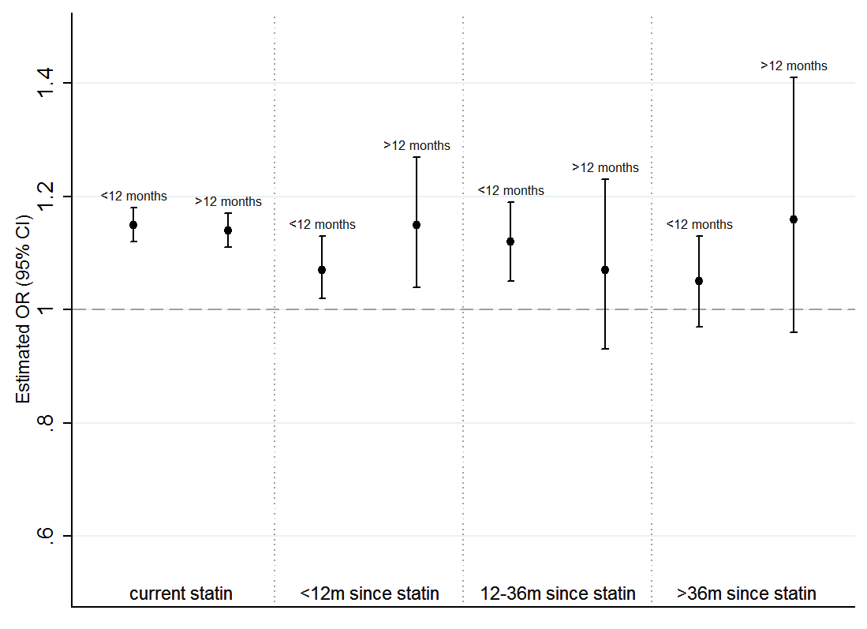
*The reference category for all estimations is patients that have never been prescribed a statin. All odds ratios are adjusted for BMI category, smoking status, alcohol use, CVD, HIV, lymphoma, leukaemia, myeloma, haematopoietic stem cell transplantation, other immunosuppressive therapy, other unspecified cellular immune deficiencies, oral corticosteroids, rheumatoid arthritis, systemic lupus erythematosus, COPD, asthma, CKD, depression, cancer, and diabetes

Appendix 3: Adjusted odds ratios for association dosage of last statin prescription and zoster, stratified by time since last statin prescription
Appendix 4: Odds ratio for the association between ever using a statin and zoster, stratified by age
 | Odds ratio (95% CI)
Statin Use | Model 1 | Model 2 | Model 3
Never | 1.00 | 1.00 | 1.00
Ever
<70 years | 1.21 (1.18, 1.23) | 1.17 (1.15, 1.20) | 1.12 (1.09, 1.15)
>70 years | 1.20 (1.17, 1.22) | 1.16 (1.13, 1.19) | 1.13 (1.10, 1.17)
Model 1 - Unadjusted model
Model 2 - Unadjusted model, restricted to patients that had no missing data in all descriptive variables
Model 3 - Adjusted for BMI category, smoking status, alcohol use, CVD, HIV, lymphoma, leukaemia, myeloma, haematopoietic stem cell transplantation, other immunosuppressive therapy, other unspecified cellular immune deficiencies, oral corticosteroids, rheumatoid arthritis, systemic lupus erythematosus, COPD, asthma, CKD, depression and diabetes

Appendix 5: Odds ratios for the association between both ever exposed to a statin time since last statin, and zoster
 | Odds ratio (95% CI)
Statin Use | Model 1 | Model 2 | Model 3
Never | 1.00 | 1.00 | 1.00
Ever | 1.20 (1.18, 1.22) | 1.17 (1.15, 1.19) | 1.13 (1.11, 1.15)
Current | 1.21 (1.19, 1.23) | 1.18 (1.15, 1.20) | 1.14 (1.12, 1.17)
≤3m since stopping statins | 1.16 (1.09, 1.23) | 1.13 (1.07, 1.21) | 1.09 (1.02, 1.16)
>3-12m since stopping statins | 1.15 (1.08, 1.22) | 1.11 (1.05, 1.19) | 1.08 (1.01, 1.15)
>12-36m since stopping statins | 1.17 (1.11, 1.23) | 1.15 (1.08, 1.21) | 1.11 (1.05, 1.18)
>36m since stopping statins | 1.13 (1.06, 1.21) | 1.09 (1.02, 1.17) | 1.06 (0.99, 1.14)
Model 1 - Unadjusted model
Model 2 - Unadjusted model, restricted to patients that had no missing data in all descriptive variables
Model 3 - Adjusted for BMI category, smoking status, alcohol use, CVD, HIV, lymphoma, leukaemia, myeloma, haematopoietic stem cell transplantation, other immunosuppressive therapy, other unspecified cellular immune deficiencies, oral corticosteroids, rheumatoid arthritis, systemic lupus erythematosus, COPD, asthma, CKD, depression, cancer, and diabetes

