IJE Special Edition Photo Essay

Andrew Bastawrous

Peek – the Portable Eye Examination Kit, was developed and validated alongside a cohort study of eye disease in Nakuru, Kenya.¹ In the cohort, the majority of participants with visual impairment were elderly, difficult to reach and had little or no access to eye care. Expertise and ophthalmic equipment required to perform a comprehensive eye examination in areas with poor or no road access, no electricity and considerable distances from the main towns and cities leads to an inverse relationship between eye care provision and eye care needs.²

In the past decade, mobile phone penetration has grown to reach near ubiquity in many of the most remote parts of the world. The growth has been greatest in LMIC with some countries having, on average, more than one connected device per person of population.³

Despite areas of Kenya and other LMIC having no access to clean running water and sanitation services, the majority do have mobile phone connectivity. Peek harnesses the portability and connectivity of mobile devices to enable task-shifting and the ability to undertake a comprehensive eye examinations at, or close to, the patient’s home.

The primary measure on which ophthalmic assessments are made is distance visual acuity. This is typically done using a Snellen chart or for research purposes, a LogMAR chart which overcomes many of the limitations of the commonly used Snellen chart. The LogMAR chart requires a power source, is not designed to travel and is not practical for use outside of a clinical setting. “Peek Acuity” is an accurate, repeatable and fast method to test acuity using a smartphone.⁴ The test uses the touchscreen interface to record participant’s responses without the user needing to see the screen. This makes the test both faster and more objective. The inbuilt luxmeter, usually used to control screen brightness, can give the user a warning when ambient light levels are too bright to provide a reliable reading.

“Peek Retina”, a low-cost smartphone adapter, makes it possible to examine the retina using a smartphone.⁵ The user only needs to be able to acquire images and expert graders can review images remotely and action decisions without having to be away from busy eye units.

With the majority of the world’s blind and visually impaired people living in LMIC and 80% having a condition that is reversible or preventable,⁶ it is vital that we reduce the barriers to accessing basic eye care.

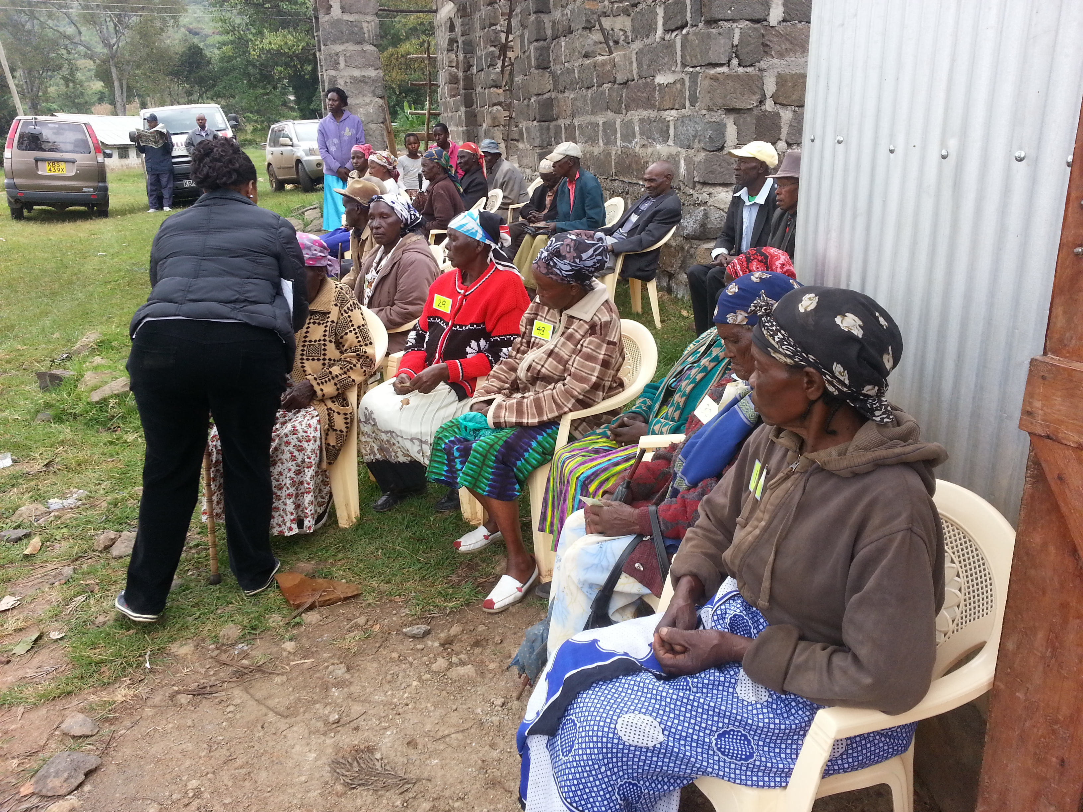

A long queue of patients awaiting assessment in a rural village in Kenya in the Nakuru Eye Disease Cohort Study and validation of Peek.

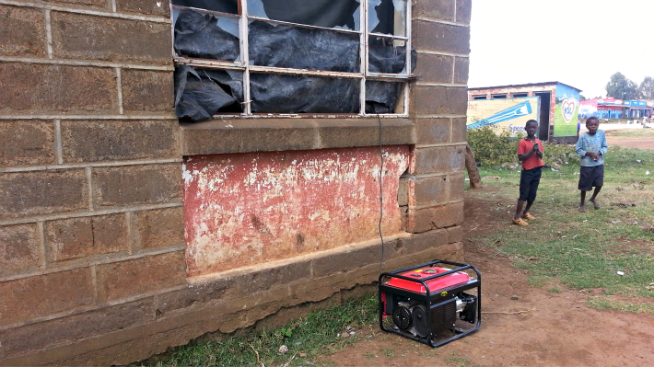

A secondary school used as a temporary clinic in the Nakuru Eye Disease Cohort Study and validation of Peek, note the use of blackout blinds and a generator for the ophthalmic equipment.
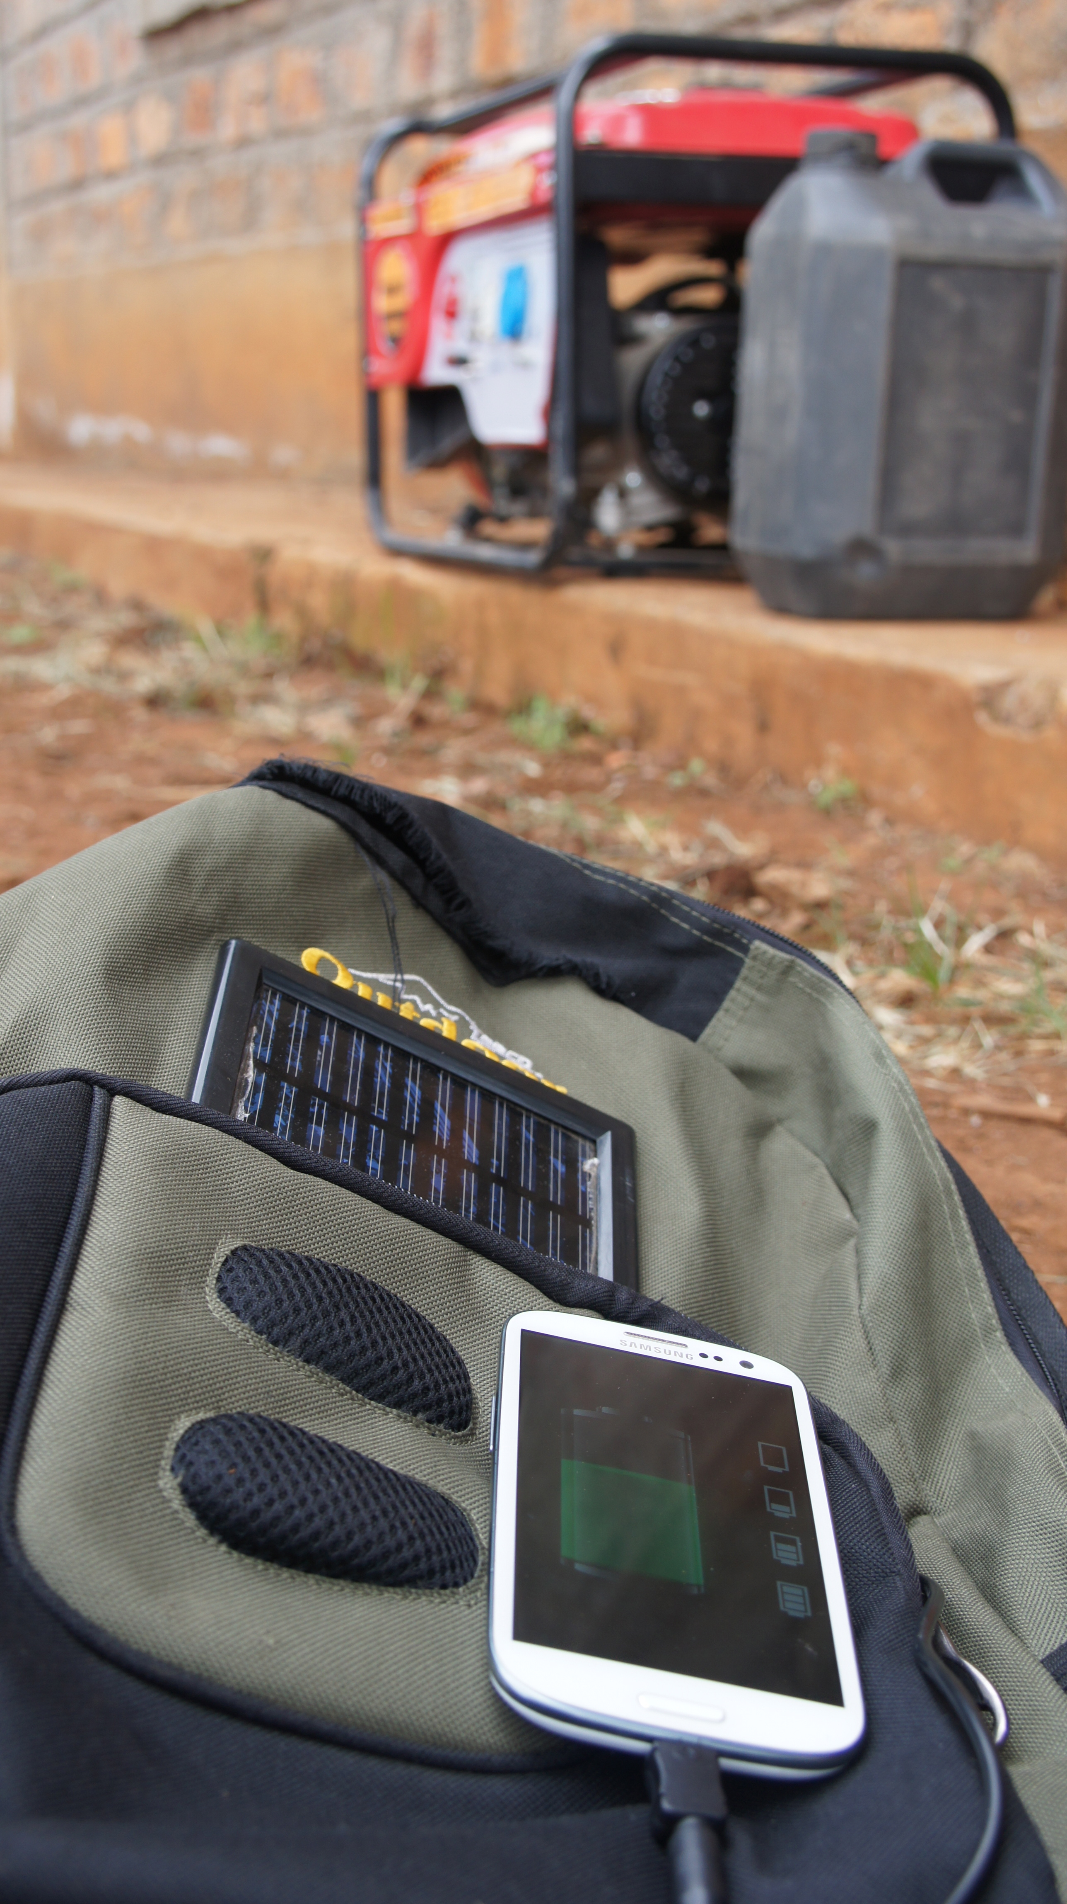

A solar powered rucksac as used by the Peek healthcare workers visiting patients door to door, negating the need for a mains power supply.
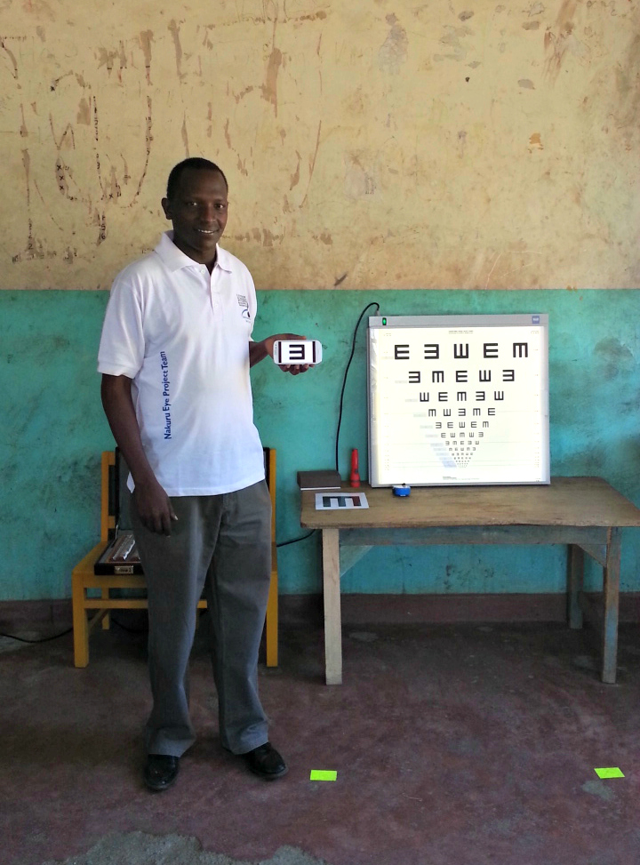
Validation of the Peek Acuity app measured against the reference standard LogMAR vision chart.
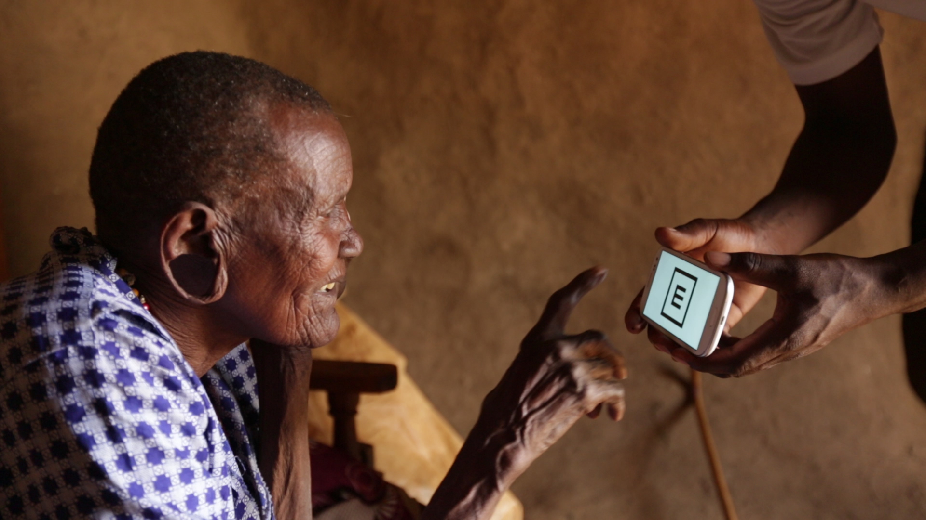

Peek Acuity being measured in a patient’s home in rural Kenya.
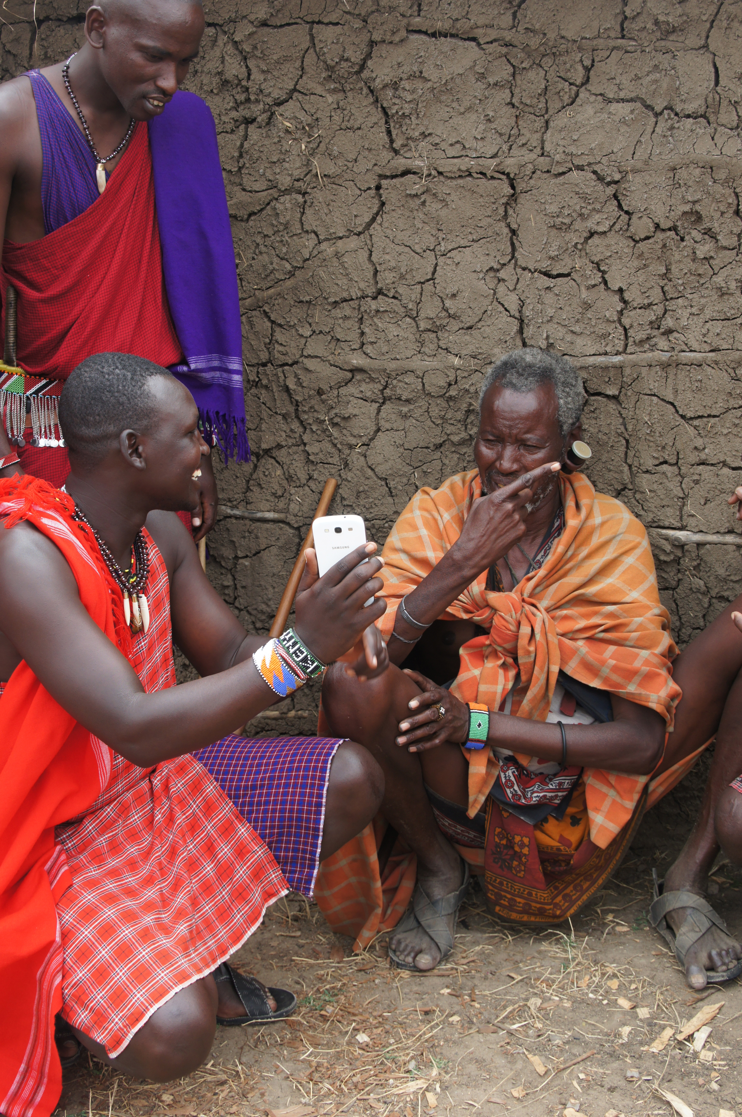

Peek Acuity being tested in the hands of a non-healthcare worker in the Massai Mara.
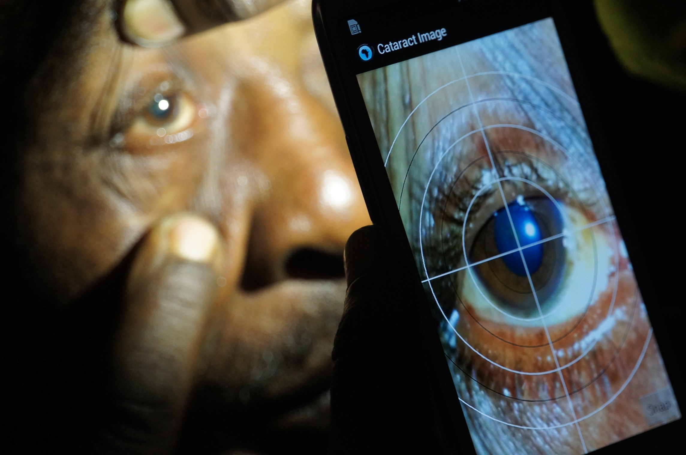

Examination of the lens for cataract using Peek in rural Kenya

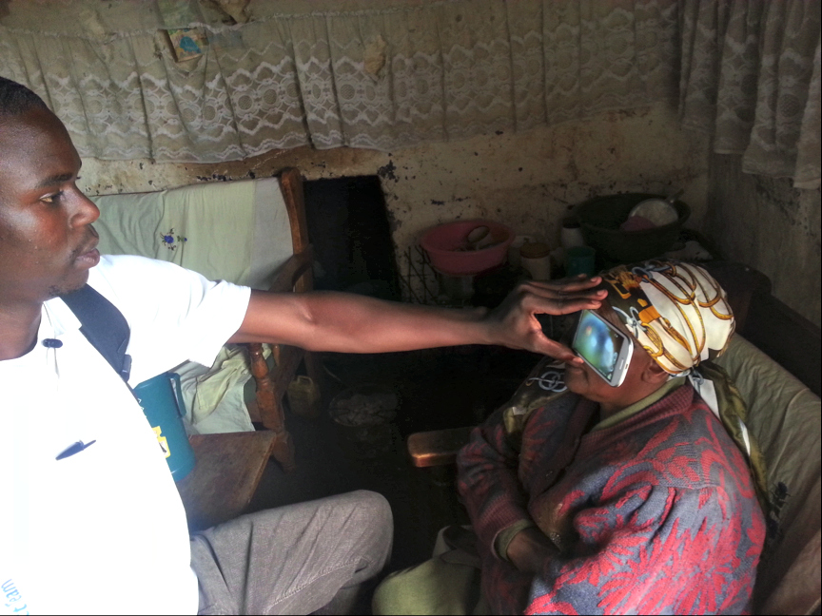

A Peek field worker examining a patient’s retina in their home in rural Kenya

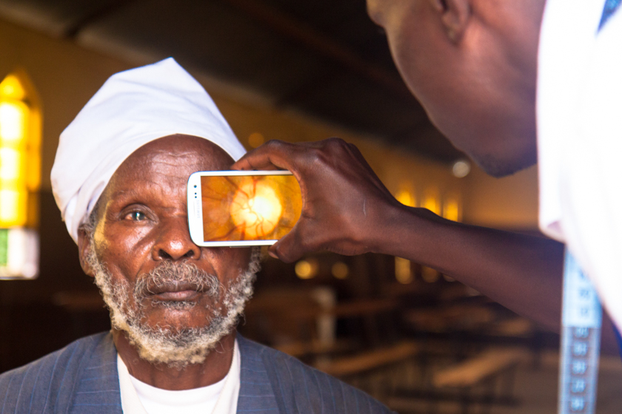

A Peek field worker examining a patient’s retina in the validation clinic in Kenya

References:

1. Bastawrous A, Mathenge W, Peto T, et al. The Nakuru eye disease cohort study: methodology & rationale. BMC Ophthalmol 2014;14(1):60.
2. Bastawrous A, Hennig BD. The global inverse care law: a distorted map of blindness. The British journal of ophthalmology 2012.
3. Bastawrous A, Hennig BD, L LI. mHealth Possibilities in a Changing World. Distribution of Global Cell Phone Subscriptions. Journal of Mobile Technology in Medicine 2013;2(1):22-25.
4. Bastawrous A, Rono HK, Livingstone IA, et al. Development and Validation of a Smartphone-Based Visual Acuity Test (Peek Acuity) for Clinical Practice and Community-Based Fieldwork. JAMA ophthalmology 2015.
5. Bastawrous A, Giardini ME, Bolster NM, et al. Clinical Validation of a Smartphone-Based Adapter for Optic Disc Imaging in Kenya. JAMA ophthalmology 2015:1-8.
6. Pascolini D, Mariotti SP. Global estimates of visual impairment: 2010. The British journal of ophthalmology 2011.

