683-2015.R1
Original Article (online only)
Determinants of stoma reversal in rectal cancer patients who had an anterior resection between 2009 and 2012 in the English National Health Service
AJ Kuryba, MB ChB, MSc, Quantitative Analyst ¹
NA Scott, MB ChB, Consultant Surgeon ²
J Hill, MB ChB, Consultant General and Colorectal Surgeon ³
JH van der Meulen, PhD, Professor of Clinical Epidemiology^{1,4}
K Walker, PhD, Lecturer of Medical Statistics^{1,4}

1 Clinical Effectiveness Unit, The Royal College of Surgeons of England, London, UK
2 Colorectal Surgical Department, Lancashire Teaching Hospitals NHS Foundation Trust, Royal Preston Hospital, Sharoe Green Lane, Fulwood, Preston PR2 9HT, UK
3 Department of General Surgery, Manchester Royal Infirmary, Central Manchester University Hospitals NHS Foundation Trust, Manchester, UK
4 Department of Health Services Research and Policy, London School of Hygiene and Tropical Medicine, London, UK

Corresponding author:
Name: Angela Kuryba
Email: akuryba@rcseng.ac.uk

Conflicts of interest:
No conflicts of Interest
Manuscript category:
Original article
Word Count:
2,089 words
Abstract
Aim: The rate of ileostomy reversal was estimated in patients undergoing an elective anterior resection for rectal cancer and factors associated with reversal were identified.

Method: The records of 4,879 rectal patients who had an ileostomy created during anterior resection between 2009 and 2012 were identified in the National Bowel Cancer Audit database and linked to administrative records of the Hospital Episode Statistics (HES). Patients were followed from surgery. Multivariable proportional hazards regression was used to estimate impact of patient and cancer characteristics on ileostomy reversal with death as the competing risk.

Results: Within 18 months from anterior resection, 3,536 (72.5%) patients had undergone ileostomy reversal. The reversal rate was lower in the following circumstances: older patients (Hazard Ratio (HR) 0.90; 95% CI 0.84 to 0.96, aged 80 vs 70 years), male gender (HR 0.90; 0.84 to 0.97), higher ASA grade (HR 0.64; 0.56 to 0.74, ASA 3+ vs 1), more advanced cancer (HR 0.77; 0.69 to 0.87, T3 vs T1 more socioeconomical deprivation (HR 0.83; 0.74 to 0.93, most vs least deprived quintile), comorbidity (HR 0.92; 0.84 to 1.00, one vs no comorbidity), and open surgical procedure (HR 0.90; 0.84 to 0.97, open vs laparoscopic).

Conclusion: Overall, two thirds of ileostomies were reversed within 18 months. Reversal rates were linked to patient and cancer characteristics (age, sex, fitness, and stage), mode of surgical access, and socioeconomic deprivation. Observed lower reversal rates in patients from poorer backgrounds may indicate inequity in access.

What does this paper add to the literature?
The proportion of patients whose ileostomy is reversed is currently unknown. This study estimates that approximately two thirds are reversed within 18 months of formation. Age, physical fitness, tumour stage and comorbidity were the strongest determinants of ileostomy reversal. Patients should be informed about their likelihood of non-reversal.

Introduction
Approximately one third of colorectal tumours are located in the rectum. A diverting stoma is used in sphincter saving surgery to reduce the consequences of anastomotic leakage, which occurs in 3% to 26 % of patients following bowel anastomosis and is associated with high mortality and morbidity [1]. Construction of a s

toma is, however, associated with morbidity while present and following reversal.[1, 2] The impact of having a stoma following colorectal cancer surgery has been explored by the NHS England national PROMS survey. This found that 43% of individuals with rectal cancer still had a stoma at 12-36 months after a diagnosis. The survey highlighted the effect on life of any type of stoma in colorectal cancer patients at this time point: 20% of all patients with a stoma reported being quite or very embarrassed by it and a lower proportion reported ‘perfect’ health using EQ-5D (19% of patients still with a stroma compared with 35% of patients who had had the stoma reversed and 40% of those who never had a stoma). They also reported higher levels of social distress using the Social Distress Inventory (SDI).[3]

Most surgeons aim to reverse a loop stoma within two to four months of the initial surgery,[2, 4] but a number of observational studies have shown that the actual time to reversal is often considerably longer, possibly due to post-operative complications, adjuvant chemotherapy or stoma reversal having a lower organisational priority than the initial cancer surgery.[4, 5]

Previous studies of stoma reversal have typically included small numbers of patients (<500) from individual hospitals,[2, 5-8] often receiving surgery for a variety of indications[6-8]. A larger national study of elective anterior resection patients in England observed that approximately one quarter of the 964 included patients who received an ileostomy at the time of their surgery had not had it reversed three years later [4]. Older patients and those with multiple comorbidities were less likely to undergo stoma reversal. As the study only used administrative hospital data the authors could only investigate the association with a limited number of factors.

The National Bowel Cancer Audit (NBOCA) is commissioned by the Healthcare Quality Improvement Partnership (HQIP) as part of the National Clinical Audit and Patient Outcomes Programme. It produces an annual snapshot of the care of newly diagnosed colorectal cancer patients in England and Wales [9]. In this study, records from the NBOCA database were linked to administrative records from the English Hospital Episode Statistics (HES) to investigate ileostomy reversal in patients with rectal cancer who had undergone an elective anterior resection and to identify factors associated with ileostomy reversal. The database contains clinical information about the initial diagnosis and treatment of patients with colorectal cancer such as tumour staging, ASA grade and surgical urgency which are not available in HES.
Method

Participants

The NBOCA database contained records of 12,688 patients who had undergone major bowel cancer surgery for rectal cancer between 1 April 2009 and 31 March 2012 in the English National Health Services (NHS) (Figure 1). 11,610 of these patients were recorded as having undergone an elective procedure and the records of 11,137 (96%) could be linked to HES, an administrative database of all admissions to English NHS hospitals.[10] Anterior resection was defined as an anterior resection recorded in NBOCA or a non-rectal procedure recorded in NBOCA and an anterior resection recorded in HES. 7,388 patients had undergone an anterior resection, with 4,879 (66%) of these receiving an ileostomy.

Data collection
Year of surgery, stoma type, sex, age at diagnosis, ASA grade,[11] TNM stage[12] and planned mode of surgical access (open or laparoscopic) were obtained from the NBOCA database. Eighty percent of records had complete data for gender, age at diagnosis, ASA grade, TNM stage and site of tumour (standard audit measure of data completeness [9]). Information about admission type, ethnicity, socio-economic deprivation, comorbidities and time of stoma reversal was obtained from the linked HES records.

In HES, diagnostic information is coded according to the International Classification of Diseases, Version 10 (ICD10),[13] and procedure information according to the Office of Population Censuses and Surveys classification, 4th revision.[14] An emergency admission was defined as one where the admission method for the first hospital admission for bowel cancer in the HES record was coded as one of the following: “Emergency: via Accident and Emergency (A&E) services” (21), “Emergency: via general practitioner (GP)” (22), “Emergency: via Bed Bureau, including the Central Bureau” (23), “Emergency: via consultant outpatient clinic” (24) or “Emergency: other means, including patients who arrive via the A&E department of another healthcare provider” (28).[15]

Socioeconomic deprivation was measured with the Index of Multiple Deprivation (IMD), which ranks small areas of England (with populations of approximately 1,500 people) according to their level of deprivation measured across seven domains.[16] These areas were grouped into five categories according to national quintiles of the IMD ranking. All comorbidities included in the RCS Charlson Score [17] except cancer, were considered to be present if the relevant ICD10 code was documented in the HES record for the first hospital admission for bowel cancer or in HES records of admissions in the preceding year.

A stoma was considered to be reversed if an HES record with OPCS codes indicating a reversal of ileostomy (G75.3) or colostomy (H15.4) was identified within 18 months of the initial surgical procedure, regardless of whether or not it matched the stoma type according to NBOCA data.

Statistical analysis
Patients were followed from the date of surgery. Four distinct patient groups were identified according to whether they were still alive and whether they still had a stoma. Multivariable competing-risks proportional hazards regression [18] was used to estimate the impact of patient and cancer characteristics and other clinical factors on the ileostomy reversal rates within 18 months of an anterior resection with death being the competing event. This method was used to accommodate the fact that if a patient dies it is subsequently impossible for the event of interest (stoma reversal) to occur (standard survival analysis assumes that a patient is still at risk of the event of interest occurring after a competing event has occurred).

The following factors available immediately after the anterior resection were included in the competing risk model: age (modelled as a linear plus quadratic), year of procedure, gender, TNM stage, ASA grade, co-morbidity,[19] along with ethnicity, IMD quintile, mode of hospital admission and planned mode of surgical access.
Multiple imputation by chained equations with ten imputed datasets, was used to account for missing values [20]. The imputation used all factors included in the model, an indicator for stoma reversal and 90-day mortality, and a number of additional variables (emergency admission according to NBOCA, number of lymph nodes extracted, number of positive lymph nodes extracted, length of hospital stay and days between diagnosis and surgery). Rubin’s rules were used to pool the regression coefficients and estimate their standard errors.

Results
Within 18 months of anterior resection, 3,536 (72.5%) of the 4,879 ileostomy patients had undergone stoma reversal (Table 1). The reversal rate was lower in older patients, in those with higher ASA grades, in those with more advanced cancer, in those who were more socio-economically deprived, in those who had comorbidity, and in those who had an open procedure. The ileostomy reversal rate increased slightly over the three years of the study from 70.3% in those who had their initial surgery between 1 April 2009 and 31 March 2010 to 74.5% in patients who had their initial surgery between 1 April 2011 and 31 March 2012 (Table 1).

The multivariable competing-risks proportional hazards regression confirmed these observed associations (Table 2). In addition, with risk adjustment men were found to be slightly less likely to have their ileostomy reversed than women.
Three months after surgery, only 8.5% of ileostomies had been reversed, increasing to 28% at 6 months and around 60% at 12 months (Figure 2). Very few ileostomies were reversed after 18 months. Of the patients whose ileostomy was reversed by 18 months, the median time to reversal was 32 weeks. Around 75% of patients who had died by 18 months died with an ileostomy present.
Discussion
Just over seventy percent of patients with rectal cancer who had received an ileostomy while undergoing an elective anterior resection had it reversed within 18 months. For most patients, the time to ileostomy reversal after elective anterior resection was longer than the two to four months commonly counselled to patients. Age, physical fitness (measured by ASA grade), tumour stage and comorbidity were the strongest determinants of ileostomy reversal.

The present study of over 7,000 patients reports a temporary diverting stoma rate after anterior resection of 66%, which is similar to the 57% reported in the Dutch TME randomised trial follow up study [21]. The ileostomy rates of 15% and 18% reported by David et al and Dodgion et al may not be in keeping with current practice.[4, 22]

The present findings reinforce those reported previously, with older age,[4, 8, 21, 22] presence of comorbidity,[4] more advanced stage disease,[2, 22, 23] lower socioeconomic status,[22] and open surgery[23] being identified as factors linked to lower stoma reversal rates. This study is the first to report lower reversal rates in patients with poor physical fitness. This may be partly explained by the use of the competing risk approach with stoma reversal and death as competing events. We also found that maIe patients have a slightly lower stoma reversal rate than females, an area where evidence to date has been conflicting.[21, 24]

One reason for a delay in stoma reversal in patients with advanced disease is that they are more likely to receive chemotherapy.[4, 5] They are also at higher risk of local recurrence, which may further reduce the stoma reversal rate [21, 23].

A potential explanation for the association of socioeconomic deprivation with lower stoma reversal rates is residual confounding. Patients living in more socioeconomically deprived areas may be in poorer overall health, for example from higher levels of smoking and obesity, neither of which is captured in our risk adjustment model. Other explanations are that patients from more deprived backgrounds may be less likely to access follow-up services after their initial surgery or that they may be more willing to live with a stoma to avoid further surgery.

Residual confounding is also a possible explanation for our finding that patients who had a planned open anterior resection were less likely to have their ileostomy reversed. Alternatively, it may be related to the location, nature and extent of the tumour which may have directly influenced both the mode of surgical access at the time of the anterior resection and the possibility of ileostomy reversal during follow-up. Lastly, it may be linked to the practice style of the surgical unit with units that are more inclined to carry out anterior resections laparoscopically being also more inclined to reverse stomas early.

Four per cent of patients included in the NBOCA database could not be linked to HES records. Although these unlinked patients tended to be younger and less deprived, it is unlikely that this had a substantial effect on the results given the small size of the unlinked group. Another issue related to the use of HES data to follow patients up is that it was possible only to capture stoma reversals that had taken place in the NHS and not those carried out in independent sector hospitals, potentially leading to an underestimate of the overall proportion of stoma reversals. This will, however, have had only a very small effect as patients who have their initial surgical procedure in the English NHS are likely to have their follow up care in the same hospital or in another NHS facility.

The present study, which is the largest reported to date, found that two thirds of the ileostomies created during anterior resection in patients with rectal cancer in the English NHS were reversed within 18 months. The potential for significant delay in ileostomy closure rate should be included in the preoperative patient counselling. Stomas are less frequently reversed in patients who were older, less physically fit and had more advanced rectal cancer. The finding that patients from poorer backgrounds were less likely to have a stoma reversal needs further examination to distinguish between the impact of inequity on access to health care, patient choice or unmeasured clinical factors.

Acknowledgements
We gratefully acknowledge the support provided by Kimberley Greenaway, Clinical Audit Manager at the Health and Social Care Information Centre in Leeds (UK).
HES data have been re-used with the permission of The Health and Social Care Information Centre. All rights reserved. Copyright © 2014.

References
1. Tan WS, Tang CL, Shi L, Eu KW. Meta-analysis of defunctioning stomas in low anterior resection for rectal cancer. The British journal of surgery. 2009;96(5):462-72. Epub 2009/04/10.
2. Gessler B, Haglind E, Angenete E. Loop ileostomies in colorectal cancer patients--morbidity and risk factors for nonreversal. The Journal of surgical research. 2012;178(2):708-14. Epub 2012/09/04.
3. Quality of Life of Colorectal Cancer Survivors in England: Report on a national survey of colorectal cancer survivors using Patient Reported Outcome Measures (PROMs). March 2015. Report No.: NHS England Gateway Reference 02777.
4. David GG, Slavin JP, Willmott S, Corless DJ, Khan AU, Selvasekar CR. Loop ileostomy following anterior resection: is it really temporary? Colorectal disease : the official journal of the Association of Coloproctology of Great Britain and Ireland. 2010;12(5):428-32. Epub 2009/02/20.
5. Floodeen H, Lindgren R, Matthiessen P. When are defunctioning stomas in rectal cancer surgery really reversed? Results from a population-based single center experience. Scandinavian journal of surgery : SJS : official organ for the Finnish Surgical Society and the Scandinavian Surgical Society. 2013;102(4):246-50. Epub 2013/09/24.
6. Cipe G, Erkek B, Kuzu A, Gecim E. Morbidity and mortality after the closure of a protective loop ileostomy: analysis of possible predictors. Hepato-gastroenterology. 2012;59(119):2168-72. Epub 2012/03/24.
7. O’Toole GC, Hyland JMP, Grant DC, Barry MK. Defunctioning loop ileostomy: a prospective audit. Journal of the American College of Surgeons. 1999;188(1):6-9.
8. Sier MF, van Gelder L, Ubbink DT, Bemelman WA, Oostenbroek RJ. Factors affecting timing of closure and non-reversal of temporary ileostomies. International journal of colorectal disease. 2015;30(9):1185-92. Epub 2015/06/10.
9. National Bowel Cancer Audit Report 2014. Health and Social Care Information Centre; 2014; Available from: http://www.hscic.gov.uk/bowel.
10. Hospital Episode Statistics. Health and Social Care information Centre; [29 January 2015]; Available from: http://www.hscic.gov.uk/hes.
11. ASA Physical Status Classification System. American Society of Anesthesiologists; [updated 15 October 2014 31 March 2015]; Available from: https://www.asahq.org/resources/clinical-information/asa-physical-status-classification-system.
12. Sobin LH, Fleming ID. TNM Classification of Malignant Tumors, fifth edition (1997). Union Internationale Contre le Cancer and the American Joint Committee on Cancer. Cancer. 1997;80(9):1803-4. Epub 1997/11/14.
13. World Health Organization: International Statistical Classification of Diseases and Related Health Problems (10th Revision). Geneva: World Health Organization; 1992.
14. NHS Classifications Service: OPCS Classifications of Interventions and Procedures Version 4.4. London: The Stationery Office; 2007.
15. HES Admitted Patient Data Dictionary. Health and Social Care Information Centre; [12 February 2015]; Available from: http://www.hscic.gov.uk/article/3965/HES-Admitted-Patient-Data-Dictionary.
16. Noble M MD, Wilkinson K,Whitworth A, Dibben C, Barnes H. The English Indices of Deprivation 2007. London: HMSO, 2008.
17. Armitage JN, van der Meulen JH. Identifying co-morbidity in surgical patients using administrative data with the Royal College of Surgeons Charlson Score. The British journal of surgery. 2010;97(5):772-81. Epub 2010/03/23.
18. Fine PJ, Gray RJ. A Proportional Hazards Model for the Subdistribution of a Competing Risk. Journal of the American Statistical Association. 1999;94(446):496-509.
19. Walker K, Finan PJ, van der Meulen JH. Model for risk adjustment of postoperative mortality in patients with colorectal cancer. The British journal of surgery. 2014. Epub 2014/12/20.
20. White IR, Royston P, Wood AM. Multiple imputation using chained equations: Issues and guidance for practice. Statistics in medicine. 2011;30(4):377-99. Epub 2011/01/13.
21. den Dulk M, Smit M, Peeters KC, Kranenbarg EM, Rutten HJ, Wiggers T, et al. A multivariate analysis of limiting factors for stoma reversal in patients with rectal cancer entered into the total mesorectal excision (TME) trial: a retrospective study. The lancet oncology. 2007;8(4):297-303. Epub 2007/03/31.
22. Dodgion CM, Neville BA, Lipsitz SR, Hu YY, Schrag D, Breen E, et al. Do older Americans undergo stoma reversal following low anterior resection for rectal cancer? The Journal of surgical research. 2013;183(1):238-45. Epub 2013/01/10.
23. Lim SW, Kim HJ, Kim CH, Huh JW, Kim YJ, Kim HR. Risk factors for permanent stoma after low anterior resection for rectal cancer. Langenbeck's archives of surgery / Deutsche Gesellschaft fur Chirurgie. 2013;398(2):259-64. Epub 2012/12/12.
24. Seo SI, Yu CS, Kim GS, Lee JL, Yoon YS, Kim CW, et al. Characteristics and risk factors associated with permanent stomas after sphincter-saving resection for rectal cancer. World journal of surgery. 2013;37(10):2490-6. Epub 2013/06/29.

Table 1: Ileostomy reversal rates in rectal cancer patients who had an elective anterior resection between 1 April 2009 and 31 March 2012 in the English National Health Service
 |  | Total |  | Stoma reversed within 18 months
 |  | N |  | N | %
 |  | 4,879 | 3,536 |  | 72.5
Year of surgery | 2009-2010 | 1,315 | 924 |  | 70.3
 | 2010-2011 | 1,718 | 1,237 |  | 72.0
 | 2011-2012 | 1,846 | 1,375 |  | 74.5
Gender | Female | 1,571 | 1,187 |  | 75.6
 | Male | 3,306 | 2,348 |  | 71.0
 | Missing | 2 | 1 |  | 50.0
Age | <= 60 years | 1,348 | 1,034 |  | 76.7
 | 61 - 70 years | 1,775 | 1,338 |  | 75.4
 | 71 - 80 years | 1,450 | 981 |  | 67.7
 | >= 81 years | 306 | 183 |  | 59.8
ASA grade | 1 | 870 | 709 |  | 81.5
 | 2 | 2,751 | 2,039 |  | 74.1
 | >=3 | 808 | 483 |  | 59.8
 | Missing | 450 | 305 |  | 67.8
Tumour stage | T1 | 512 | 410 |  | 80.1
 | T2 | 1,308 | 991 |  | 75.8
 | T3 | 2,256 | 1,575 |  | 69.8
 | T4 | 221 | 129 |  | 58.4
 | Missing | 582 | 431 |  | 74.1
Nodes | N0 | 2,907 | 2,212 |  | 76.1
 | N1 | 1,102 | 755 |  | 68.5
 | N2 | 501 | 305 |  | 60.9
 | Missing | 369 | 264 |  | 71.5
Metastasis | M0 | 4,276 | 3,151 |  | 73.7
 | M1 | 308 | 172 |  | 55.8
 | Missing | 295 | 213 |  | 72.2
IMD* quintile | Least deprived: 1 | 1,142 | 849 |  | 74.3
 | 2 | 1,123 | 828 |  | 73.7
 | 3 | 1,011 | 734 |  | 72.6
 | 4 | 813 | 592 |  | 72.8
 | Most deprived: 5 | 688 | 463 |  | 67.3
 | Missing | 102 | 70 |  | 68.6
Ethnicity | White | 4,356 | 3,141 |  | 72.1
 | Non-white | 170 | 128 |  | 75.3
 | Missing | 353 | 267 |  | 75.6
Mode of admission (HES) | Elective | 4,762 | 3,461 |  | 72.7
 | Emergency | 113 | 75 |  | 66.4
 | Missing | 4 | 0 |  | 0.0
Comorbidity (HES) | 0 | 3,465 | 2,593 |  | 74.8
 | 1 | 1,132 | 778 |  | 68.7
 | 2+ | 282 | 165 |  | 58.5
Planned mode of surgical access | Laparoscopic | 2,010 | 1,512 |  | 75.2
 | Open | 2,316 | 1,630 |  | 70.4
 | Missing | 553 | 394 |  | 71.3
* Index of Multiple Deprivation

Table 2: Factors associated with ileostomy reversal within 18 months of anterior resection
 |  | Hazard ratio | 95% CI
Year of surgery | 2009-2010 | 1
 | 2010-2011 | 0.99 | 0.91 to 1.08
 | 2011-2012 | 1.06 | 0.97 to 1.15
Gender | Female | 1
 | Male | 0.90 | 0.84 to 0.97
Age* | 50 years | 1.11 | 1.03 to 1.19
 | 60 years | 1.07 | 1.03 to 1.12
 | 70 years | 1
 | 80 years | 0.90 | 0.84 to 0.96
 | 90 years | 0.77 | 0.65 to 0.92
ASA Grade | 1 | 1
 | 2 | 0.85 | 0.78 to 0.93
 | 3+ | 0.64 | 0.56 to 0.74
Tumour stage | T1 | 1
 | T2 | 0.88 | 0.78 to 1.00
 | T3 | 0.77 | 0.69 to 0.87
 | T4 | 0.62 | 0.51 to 0.76
Nodes | N1 | 1
 | N2 | 0.68 | 0.63 to 0.73
 | N3 | 0.61 | 0.55 to 0.68
Metastasis | M0 | 1
 | M1 | 0.73 | 0.61 to 0.87
IMD** quintile | Least deprived: 1 | 1
 | 2 | 1.01 | 0.92 to 1.12
 | 3 | 0.97 | 0.87 to 1.07
 | 4 | 0.95 | 0.86 to 1.06
 | Most deprived: 5 | 0.83 | 0.74 to 0.93
Ethnicity | White | 1
 | Non-White | 1.10 | 0.92 to 1.31
Mode of Admission (HES) | Elective | 1
 | Emergency | 1.00 | 0.80 to 1.26
Comorbidities (HES) | 0 | 1
 | 1 | 0.92 | 0.84 to 1.00
 | 2+ | 0.79 | 0.67 to 0.94
Planned mode of surgical access | Laparoscopic | 1
 | Open | 0.90 | 0.84 to 0.97
* Age modelled as a linear and quadratic term
** Index of Multiple Deprivation
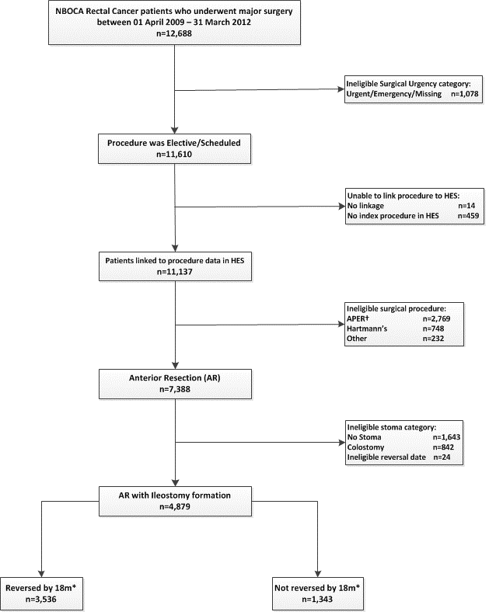

Figure 1: Patient Inclusion Flow Chart
Key:
† Abdominoperineal excision of the rectum
* 18m from date of major resection

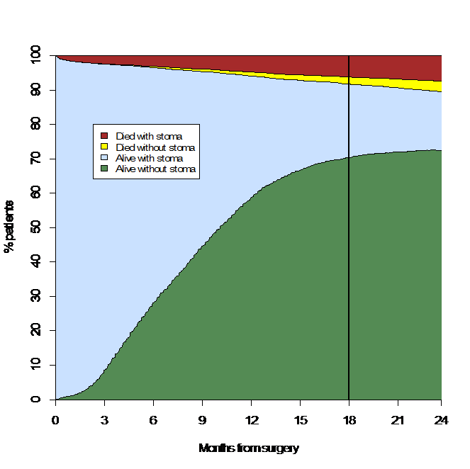
Figure 2: Time to ileostomy reversal/death for rectal cancer patients who had an anterior resection between 1 April 2009 and 31 March 2012

