Title: The Public Health Responsibility Deal: Has a public-private partnership brought about action on alcohol reduction?

Authors: Cécile Knai¹, Mark Petticrew¹, Mary Alison Durand¹, Courtney Scott¹, Lesley James¹, Anushka Mehrotra², Elizabeth Eastmure¹, Nicholas Mays¹
¹ Policy Innovation Research Unit, Faculty of Public Health and Policy, London School of Hygiene & Tropical Medicine, London, UK
² University Lewisham Hospital, London, UK

Cécile Knai, PhD, Senior Lecturer in Public Health Policy, Policy Innovation Research Unit, Faculty of Public Health and Policy, London School of Hygiene & Tropical Medicine, 15-17 Tavistock place, WC1H 9SH, London, UK, cecile.knai@lshtm.ac.uk
Mark Petticrew, PhD, Professor of Public Health Evaluation, Policy Innovation Research Unit, Faculty of Public Health and Policy, London School of Hygiene & Tropical Medicine, 15-17 Tavistock place, WC1H 9SH, London, UK, mark.petticrew@lshtm.ac.uk
Mary Alison Durand, PhD, Lecturer, Policy Innovation Research Unit, Faculty of Public Health and Policy, London School of Hygiene & Tropical Medicine, 15-17 Tavistock place, WC1H 9SH, London, UK, mary-alison.durand@lshtm.ac.uk
Courtney Scott, doctoral student, MPH, Policy Innovation Research Unit, Faculty of Public Health and Policy, London School of Hygiene & Tropical Medicine, 15-17 Tavistock place, WC1H 9SH, London, UK, Courtney.scott@lshtm.ac.uk
Lesley James, doctoral student, MPH, Policy Innovation Research Unit, Faculty of Public Health and Policy, London School of Hygiene & Tropical Medicine, 15-17 Tavistock place, WC1H 9SH, London, UK, Lesley.james@lshtm.ac.uk
Anushka Mehrotra, GP trainee, Lewisham VTS, MBBS, MPH, University Lewisham Hospital, Lewisham High street, London SE13 6LH anushkamehrotra2706@googlemail.com
Elizabeth Eastmure, MSc, Honorary research fellow, Policy Innovation Research Unit, Faculty of Public Health and Policy, London School of Hygiene & Tropical Medicine, 15-17 Tavistock place, WC1H 9SH, London, UK, elizabeth.eastmure@lshtm.ac.uk
Nicholas Mays, FPH, Professor of Health Policy, Policy Innovation Research Unit, Faculty of Public Health and Policy, London School of Hygiene & Tropical Medicine, 15-17 Tavistock place, WC1H 9SH, London, UK, nicholas.mays@lshtm.ac.uk

Corresponding author: Cécile Knai, PhD, Senior Lecturer in Public Health Policy, Policy Innovation Research Unit, Faculty of Public Health and Policy, London School of Hygiene & Tropical Medicine, 15-17 Tavistock place, WC1H 9SH, London, UK, cecile.knai@lshtm.ac.uk

Running head: Will the RD bring about action to reduce alcohol?

Author contributions: CK conceived, designed and planned the study, analysed data and led the production of the manuscript. MP, EE, NM, and MAD participated in study design. CK, LJ, AM, MP and CS contributed to data collection and CS and MP contributed to data analysis. All authors contributed to manuscript revisions.

Declarations of interest: The evaluation of the Public Health Responsibility Deal is part of the programme of the Policy Innovation Research Unit (http://www.piru.ac.uk/). This is an independent research unit based at the London School of Hygiene and Tropical Medicine, funded by the Department of Health Policy Research Programme. Sole responsibility for this research lies with the authors and the views expressed are not necessarily those of the Department of Health. The Department of Health played no role in the design of the study, the interpretation of the findings, the writing of the paper, or the decision to submit.
No author has a competing interest to declare.
Abstract
Background and Aims: The Public Health Responsibility Deal (RD) in England is a public-private partnership involving voluntary pledges between industry, government and other organisations, with the aim of improving public health. This paper aims to evaluate what action resulted from the RD alcohol pledges.
Methods: We analysed publically available data on organisations’ plans and progress towards achieving key alcohol pledges of the RD. We assessed the extent to which activities pledged by signatories could have been brought about by the RD, as opposed to having happened anyway (the counterfactual), using a validated coding scheme designed for the purpose.
Results: Progress reports were submitted by 92% of signatories in 2013 and 75% of signatories in 2014 and provided mainly descriptive feedback rather than quantifiable performance metrics. Approximately 14% of 2014 progress reports were identical to those presented in 2013. Most organisations (65%) signed pledges that involved actions to which they appear to have been committed already, regardless of the RD. A small but influential group of alcohol producers and retailers reported taking measures to reduce alcohol units available for consumption in the market. However, where reported, these measures appear to involve launching and promoting new lower alcohol products rather than removing units from existing products.
Conclusions: The RD is unlikely to have contributed significantly to reducing alcohol consumption since most alcohol pledge signatories appear to have committed to actions that they would have undertaken anyway, regardless of the RD. Irrespective of this, there is considerable scope to improve the clarity of progress reports and reduce the variability of metrics provided by RD pledge signatories.
Introduction
A common rationale for public-private partnerships (PPPs) in public health (1) is that health problems and their solutions should involve all key stakeholders, including corporate actors (2). However, the involvement of the alcohol industry in such partnerships is a point of contention as there are concerns about whether it leads to real change. The fundamental purpose and effectiveness of PPPs in relation to public health have also been called into question (3-14) due to inherent conflicts of interest (7, 15-17).
A recent scoping review conducted by the authors suggested that the promotion of such voluntary agreements is a common response by any industry when it perceives a threat to its business and interests, and raised concerns that such agreements allow potential for undue influence by industry over the public policy process (14). Though there can be benefits from PPPs such as raising an issue’s visibility, and facilitating access to essential care and products (18), they can also provide opportunities for product and brand promotion as well as enhancing corporate legitimacy and authority on health issues without necessarily improving public health, and perhaps even damaging it (18-20). In England, previous voluntary agreements relating to alcohol have attracted such criticism (21-26).
The Public Health Responsibility Deal in England (RD) was launched in March 2011 by the Department of Health as a public-private partnership involving voluntary agreements undertaken by a range of organisations including businesses, health and community organisations, and public bodies, in the areas of food, alcohol, physical activity, and health at work (27). At time of writing (January 2015), 753 organisations (hereafter referred to as signatories) had signed up to one or more of the RD pledges (27).
This paper reports on an analysis of the RD alcohol pledges. The RD is one of a range of policy initiatives implemented by the Government to tackle excessive alcohol consumption in England (28), as reflected in the Government’s latest alcohol strategy (29). Past governments have been criticized for prominently including industry interests in alcohol policymaking (22-25, 30) and this has also been one of the more controversial aspects of the RD (21).
The RD is currently being evaluated in terms of its process and its likely impact on the health of the English population. This current paper represents part of that wider evaluation (14, 31) which draws on published data, information gathered from interviews as well as a small number of case studies. A linked paper (32) reports that the alcohol pledges may be effective in improving consumers’ knowledge and awareness, but they are unlikely to affect alcohol consumption, and are thus unlikely to have a significant positive impact on population health.
This paper assesses whether the RD alcohol pledges appear to have brought about action by signatories that would not otherwise have taken place, based on an analysis of the alcohol pledges, and publically available delivery plans and progress reports.

Methods
Rationale for analysing four alcohol pledges
Although at the time of data collection there were eight alcohol pledges in all (27) we focussed our analysis on four key pledges: alcohol labelling (pledge A1), tackling under-age alcohol sales (pledge A4), advertising and marketing alcohol (pledge A6) and alcohol unit reduction (pledge A8). These were selected because they cover much of what is proposed in the remaining pledges. A2 and A3 focus on raising customer awareness (for example, awareness of units, calories, guidelines and health harms) in the on- and off-trade, by providing information through a variety of media. A5 focuses on financially supporting Drinkaware (33). Since including the Drinkaware website link is one of the ways in which the alcohol labelling pledge (A1) can be fulfilled, we reviewed the evidence underpinning initiatives such as Drinkaware. Finally, A7 (community actions to tackle alcohol harms) supports schemes, for example, to set consumption standards, increase safety and address under-age sales. The effectiveness of such schemes was covered in our analysis of tackling under-age alcohol sales (A4).
Data collection
Upon committing to a pledge, signatories are asked to provide a delivery plan, setting out their ideas and goals for fulfilling the pledge. Signatories are then asked to report their progress in the Spring of each year. The alcohol pledge delivery plans and progress reports are made publically available on the RD website (27). In November 2013, we collated all signatories, their alcohol pledges and delivery plans for those pledges into an Excel-based delivery plan analysis framework. The framework included the names, dates of joining, delivery plan text, progress report text, individual interventions proposed in the pledge document (e.g. adding unit alcohol content is an intervention suggested under the Alcohol Labelling pledge) and an assessment of ‘additionality’ (explained below).
We set out to 1) assess the activities committed to by signatories in relation to four alcohol pledges; 2) evaluate to what extent an activity could be credited to the RD; and 3) evaluate progress on delivery by analysing the 2013 and 2014 annual progress reports. Our approach is summarised in Figure 1. Four researchers (CK, LJ, AM and CS) first independently, then in pairs, analysed a delivery plan or progress report, and discussed and agreed their findings in pairs, and with a third researcher, if they could not agree.
We sought to minimise bias in the process by 1) pilot testing our data extraction tool to remove potential inconsistencies between raters before the main rating began; 2) considering a delivery plan to be a statement of intent by signatories, and progress reports to be a statement of achievements, to be taken at face value; 3) rating the delivery plans independently first (blind ratings) followed by 4) discussion and agreement in pairs and with a third rater in the event of disagreement); and 5) rotating the pairs of raters i.e. pair A-B coded delivery plans in pledge A1, Pair B-C coded delivery plans in pledge A3, and so forth.
[insert Figure 1]
Interventions selected by signatories
Each pledge document provides guidance and outlines a range of possible interventions that a partner can choose to implement in order to deliver the pledge. We calculated the proportion of signatories selecting certain interventions (i.e. stating in their delivery plans that they would carry out a particular action, for example, reducing the alcohol content of their products).
The use of additionality to establish the counterfactual
Traditionally an impact evaluation seeks to establish that the intervention has caused the effects observed and uses a counterfactual design to do so (i.e. to provide an estimate of what would have occurred without the intervention) (34) (35). However attributing causality to public policies that are implemented across an entire jurisdiction can be difficult because there is no obvious comparison that can be drawn (34, 36). However the counterfactual can also be constructed qualitatively by judging so called ‘additionality’, an approach which has been used in similar circumstances to assess whether projects add value (37-40) including as part of evaluations in the private sector (41).
In this study, we employed the concept of additionality to help establish the counterfactual; that is, additionality is defined in this analysis as the extent to which we judged that a planned or completed activity could have been brought about by the RD, as opposed to an activity which would have happened anyway, or which appeared to be already happening irrespective of the RD. Thus the counterfactual was derived from assessing signatories’ delivery plans to ascertain what actions signatories would have taken in the absence of the RD.
Criteria for assessing additionality
We developed criteria for judging the level of “additionality” in line with the Public Health Outcomes Framework’s assessment criteria for indicators (42, 43), coded from 1 to 5, where:
- “1” if all interventions mentioned were judged by assessors to be a result of the RD. A fictional example is “We will remove 30 million units from the market by Dec 2015 by developing new low alcohol products.”
- “2” if planned interventions (excluding those stated to be already completed) were judged by assessors to be potentially due to the RD. A fictional example is “We have made progress toward meeting the target. 100% of our wine products include the labelling elements. 70% of our beer products have the five elements. We plan to meet the target for all products by December 2013.”
- “3” if it was judged that all interventions were already implemented and/or not related to the RD. A fictional example is “We have already achieved this pledge. Since 2007, our products have followed labelling standards according to governmental agreements.”
- “4” if there was not enough information provided to make a judgement
- “5” if no delivery plan was provided by the signatory.
In practice, as noted above, delivery plans were considered to be a statement of intent by signatories and were taken at face value. This meant that our judgements erred in favour of identifying greater additionality.
Validation of the additionality coding scheme
In order to validate our additionality coding scheme, we sampled 20% of the 137 delivery plans (n=27 plans) which had been judged as involving no additionality (“3”). Two researchers independently conducted validity testing by comparing the delivery plans and reported progress, applying the same criteria as those used to assess progress on delivery plans (described below). We also assessed the 2014 progress reports in terms of whether they confirmed or were consistent with the initial delivery plan and the 2013 progress report in restating a version of their contents. Individual ratings were discussed and agreed.
The additionality coding system was found to be a valid approach to judging additionality: there was agreement among researchers that 26 out of 27 progress reports from 2013 were consistent with the initial delivery plan, and that one delivery plan could have been coded as “2” as the progress report provided information directly responding to the delivery plan. Of the 27 progress reports for 2014, four provided no update and 23 were consistent with the initial delivery plan and the 2013 progress report. Seven of the 23 reports from 2014 were virtually identical to their 2013 counterparts.
Progress on delivery of plans
We assessed the 2013 and 2014 progress reports of signatories which had demonstrated likely, or potential additionality (that is, they are coded as “1” or “2”) in terms of the type of progress (qualitatively or quantitatively reported) and implementation of plans. Progress reports were categorised as: a) not provided at all; b) demonstrating quantifiable progress; c) demonstrating progress through qualitative feedback; and d) qualitative or descriptive without demonstration of progress. Then, we assessed differences between delivery plans and their progress reports in terms of whether: 1) it was unclear whether the delivery plan had been implemented; 2) signatories reported that they were continuing to make progress against the pledge; and 3) the delivery plan had been implemented.
In addition, the A8 pledge (alcohol unit reduction) was further assessed in terms of the types of alcohol unit reduction efforts reported by signatories in their progress reports, including development of new lower alcohol products, promotion of lower alcohol products, removal of alcohol units, reducing production or promotion of higher alcohol products, and reducing serving measures (e.g. in pubs).
Finally, the manuscript was critically reviewed by an independent panel of international experts in alcohol policy (listed in the Acknowledgements).

Results
Which interventions did organisations list in their delivery plan?
The pledge documents proposed a total of 15 different interventions to organisations who signed up to the four pledges (Table 1). The proportion of signatories selecting one or more of these 15 interventions is reported in Table 1. The most commonly chosen intervention was the inclusion of the Chief Medical Officer’s (CMO’s) daily guidelines for lower-risk consumption on alcohol product labels, with 58 out of 92 signatories to A1 (63%) choosing this. Other frequently selected interventions were the inclusion of unit alcohol content (59%), and a pregnancy warning on alcohol product labels (59%), adhering to Drinkaware brand guidelines, and committing to improving the availability, marketing and promotion of lower alcohol products (56%).
[insert Table 1]
Additionality of the Responsibility Deal
We counted 432 instances of organisations mentioning interventions. Of these, 49 interventions (11%) were judged as likely having been brought about by the RD (coded as “1”). A further 104 interventions (24%) were judged as potentially having been brought about by the RD (“2”). Most interventions (n=279, 65%) were assessed as either appearing to have happened, or having already been underway when the RD was launched (“3”) (Figure 2).
Of signatories committing to reducing the alcoholic content of drinks (pledge A8), 36% were judged to have been brought about by the RD, and 43% were judged to have potentially been brought about to act or to change their existing plans to meet an RD goal. Most other interventions appear to have happened without the impetus of the RD (Figure 3).
[insert Figures 2 and 3]
Signatories’ progress
We selected the delivery plans which had indicated likely (“1”) or potential (“2”) ‘additionality’ of the RD (which would therefore presumably have some progress to report), and analysed the related April 2013 and 2014 progress reports (Table 2).
[insert Table 2]
Reporting of progress by signatories
In 2013 a relatively high proportion of signatories provided progress reports (overall 92% ). By 2014, the reporting had fallen from 95% to 78% for A1, 88% to 75% for A4, 83% to 61% for A6 and 100% to 82% for A8 (overall 75%).
Characteristics of progress reports
In 2013, approximately half (52%) of the progress reports provided descriptive feedback of progress, and 44% provided quantitative feedback. The pledge with the most quantitative information on progress was A8, with 15 out of 22 (68%) signatories providing quantifiable information about their progress on alcohol content reduction. In 2014, we analysed the progress reports in terms of demonstrations of changes since 2013. Overall 39% reported quantifiable progress and changes since 2013, and 16% reported progress through descriptive feedback, highlighting changes since 2013. Finally, a quarter of A4 and A6 2014 reports, and 14% of A1 reports, were repetitions of the 2013 reports.
Scope and nature of plan implementation
We evaluated 2013 progress reports of delivery which demonstrated likely or potential additionality (additionality code “1” or “2”) (n=93). Across all pledges, the majority of progress reports (n=59/93 or 63%) indicated that the initial delivery plan had been implemented. A further 25 progress reports (27%) indicated that signatories continued to make progress against the pledge. Finally, nine progress reports (10%) were unclear about whether the delivery plan had been implemented or not.
When analysing the 22 A8 signatories’ delivery plans in relation to alcohol unit reduction (Table 3), 10 reported the development of new lower alcohol products and 5 reported promoting lower alcohol products. Five signatories reported removing alcohol units from existing products; it was not possible to estimate the cumulative units removed because signatories reported these differently (i.e. some reported total estimated unit reduction, others per annum and others per week). Nevertheless, the reported unit reduction achieved ranged from 1.6 million to 111 million units removed, though it was unclear whether or not this had been solely achieved during the period of (and as a result of) the RD. Of the A8 (unit alcohol reduction) signatories reporting quantitative progress with changes since 2013, the majority of actions reported related to the launch (56%) and promotion (67%) of new lower alcohol products, 17% to reducing the production or promotion of alcohol products and 8% to actions to remove alcohol units from existing products.
[insert Table 3]
Discussion
Examining the range of interventions that organisations chose in their delivery plans provides some insight into why it might be that the majority (65 %) of interventions were assessed as already having happened before the RD, or having been underway when the RD started. Overall, the relatively low ‘additionality’ of the RD alcohol labelling pledge (A1) may be due to the fact that the alcohol industry had already entered into in 2007, and largely implemented by the start of the RD, a voluntary agreement with the Government to place the following information on alcohol containers: alcohol content in standard units; lower risk drinking guidelines; website address of the Drinkaware Trust: www.drinkaware.co.uk; a responsible drinking message such as “Know Your Limits”, “Enjoy Responsibly”, or “Drink Responsibly”; and a warning about pregnancy-related risks (44). Likewise, the fact that Challenge 21 and 25 (45) (commercial schemes in line with the Licensing Act of 2003 (46) to tackle under-age alcohol sales, as part of pledge A4) were well-established campaigns before the inception of the RD may explain the relatively low proportion of signatories selecting them as interventions to implement (33% and 40%, respectively) as part of the RD. Related to Pledge A1 (labelling) and A6 (advertising and marketing alcohol), Drinkaware has existed since 2006 (47), five years before the introduction of the RD, which may explain the low proportion of signatories selecting it as a new intervention.
It was judged that 11% of the alcohol-related interventions were likely to have been brought about by the RD. The largest proportion of such interventions was within pledge A8 on alcohol unit reduction. Within this pledge, nearly 45% of 32 signatories indicated that they were engaged in, or had already reduced, the alcoholic content of their drinks; and 41% reported working to develop new lower alcohol products. Even though this is a small number of signatories, with even fewer signatories reporting in 2014, it comprises major alcohol producers, distributors and retailers with a considerable share of the market, and therefore has the potential to benefit a considerable proportion of the population. However, as noted in the linked paper reporting the evidence synthesis (32), it will be important to understand the balance of reformulated products against the development of new products (potentially increasing the total number of alcohol products on the market), and the response of the market to these products (i.e. people drinking more as a result of increased product variety in the marketplace versus switching from higher to lower alcohol products). This is underlined by the decrease from 2013 to 2014 in A8 signatories reporting actions to remove alcohol units, and an increase in actions to launch (56%) and promote (67%) new lower alcohol products.
The fact that about half of the progress reports reported only qualitative information is significant because there appears to have been a shift away from quantitative measures of progress since the RD was originally implemented. For example, the April 2012 monitoring sheet for the alcohol labelling pledge (A1) included eight quantitative questions on progress, a comment box, and two quantitative questions on current and future plans for making progress, whereas monitoring in April 2013 only required the answering of one question: “Please describe the progress you have made on alcohol labelling, over the last year” (27). It is possible that alcohol pledges may have gone through a similar process to that reported in a separate study on the RD calorie reduction pledge (48): the authors found that during initial consultations about the monitoring of the pledge, quantitative monitoring metrics were removed. Indeed, the over-reliance on qualitative monitoring adds to the difficulty in evaluating whether or not RD objectives have been met. This is also illustrated by the fact that signatories to the A8 pledge reported removing alcohol units from existing products in different ways, making it difficult to estimate the extent of cumulative removal of alcohol units within a given period.
The limitations of this study relate firstly to the variable reporting standards and lack of quantifiable monitoring measures. Second, although we took care in designing and validating the assessment methods, these remain a judgement of delivery plans and progress reports written by organisations which may not initially have received much guidance on what and how to write their delivery plans. Thus it is possible, though we think unlikely, that organisations under-reported their achievements. Moreover, since the reports were produced by organisations that had chosen to join the RD, this is likely to have been more than offset by bias in the opposite direction with signatories making the best case for their achievements. As this is one component of a wider evaluation, further research to assess the implementation of the RD is ongoing.
Conclusions
The RD is likely to have added little to efforts to reduce alcohol consumption, since most alcohol pledge signatories appear to have committed to actions that they would have undertaken regardless of the RD. This study also demonstrates the importance of rigorous reporting using standard metrics, regardless of the governance mechanisms of a public health policy. These findings have important implications for how public health policies are designed, monitored and evaluated.

Acknowledgements: We would like to acknowledge the independent advice of Professor Thomas Babor, Professor Steven Cummins, Professor Gerard Hastings, Dr Lisa Jones, Ms Lorelei Jones, Professor Ken Judge, Dr S. Vittal Katikireddi, Professor Jim McCambridge, Dr Ellen Nolte, Ms Katherine Robaina, Professor Martine Stead, Professor Tim Stockwell, and Professor James Thomas.
References
1. Kraak, V. I. & Story, M. (2010) A public health perspective on healthy lifestyles and public-private partnerships for global childhood obesity prevention, J Am Diet Assoc, 110, 192-200.
2. The United Nations General Assembly (2011) Political Declaration of the High-Level Meeting of the General Assembly on the Prevention and Control of Non-communicable Diseases A/66/L1.
3. Babor, T., Caetano, R., Casswell, S. et al. (2010) Alcohol: no ordinary commodity: Research and public policy. 2nd Edition (Oxford, Oxford University Press).
4. Jernigan, D. H. (2012) Global alcohol producers, science, and policy: the case of the International Center for Alcohol Policies, Am J Public Health, 102, 80-9.
5. Miller, P. G., de Groot, F., McKenzie, S. et al. (2011) Vested interests in addiction research and policy. Alcohol industry use of social aspect public relations organizations against preventative health measures, Addiction, 106, 1560-7.
6. Marwick, C. (1994) Tobacco hearings: penetrating the smoke screen, JAMA, 271, 1562.
7. Moodie, R., Stuckler, D., Monteiro, C. et al. (2013) Profits and pandemics: prevention of harmful effects of tobacco, alcohol, and ultra-processed food and drink industries, Lancet, 381, 670-9.
8. Casswell, S. (2013) Vested interests in addiction research and policy. Why do we not see the corporate interests of the alcohol industry as clearly as we see those of the tobacco industry?, Addiction, 108, 680-5.
9. Jones, S. C., Hall, D. & Munro, G. (2008) How effective is the revised regulatory code for alcohol advertising in Australia?, Drug Alcohol Rev, 27, 29-38.
10. Wilde, P. (2009) Self-regulation and the response to concerns about food and beverage marketing to children in the United States, Nutr Rev, 67, 155-66.
11. World Health Organization, R. O. f. E. (2009) Evidence for the effectiveness and cost–effectiveness of interventions to reduce alcohol-related harm. Copenhagen: World Health Organization (http://www.euro.who.int/__data/assets/pdf_file/0020/43319/E92823.pdf).
12. Vendrame, A. & Pinsky, I. (2011) [Inefficacy of self-regulation of alcohol advertisements: a systematic review of the literature], Rev Bras Psiquiatr, 33, 196-202.
13. Anderson, P., Chisholm, D. & Fuhr, D. C. (2009) Effectiveness and cost-effectiveness of policies and programmes to reduce the harm caused by alcohol, Lancet, 373, 2234-46.
14. Bryden, A., Petticrew, M., Mays, N. et al. (2013) Voluntary agreements between government and business-A scoping review of the literature with specific reference to the Public Health Responsibility Deal, Health Policy, 110, 186-97.
15. Stuckler, D. & Nestle, M. (2012) Big Food, Food Systems, and Global Health, PLoS Med, 9, e1001242.
16. SHAAP (2013) The ‘(Ir)responsibility Deal’?: Public Health and Big Business. SHAAP - Scottish Health Action on Alcohol Problems.
17. Gilmore, A. B., Savell, E. & Collin, J. (2011) Public health, corporations and the new responsibility deal: promoting partnerships with vectors of disease?, J Public Health (Oxf), 33, 2-4.
18. Kraak, V. I., Harrigan, P. B., Lawrence, M. et al. (2012) Balancing the benefits and risks of public-private partnerships to address the global double burden of malnutrition, Public Health Nutr, 15, 503-17.
19. Marks, J. H. (2013) What's the Big Deal?: The Ethics of Public-Private Partnerships Related to Food and Health Edmond J. Safra Research Lab Working Papers (Harvard University).
20. Buse, K. & Harmer, A. M. (2007) Seven habits of highly effective global public-private health partnerships: practice and potential, Soc Sci Med, 64, 259-71.
21. Royal College of Physicians (2013) RCP position on the Responsibility Deal [http://www.rcplondon.ac.uk/policy/responding-nhs-reform/public-health-responsibility-deal].
22. McCambridge, J. (2012) Dealing responsibly with the alcohol industry in London, Alcohol Alcohol, 47, 635-7.
23. Room, R. (2004) Disabling the public interest: alcohol strategies and policies for England, Addiction, 99, 1083-9.
24. Drummond, D. C. (2004) An alcohol strategy for England: the good, the bad and the ugly, Alcohol Alcohol, 39, 377-9.
25. McCambridge, J., Hawkins, B. & Holden, C. (2014) Vested Interests in Addiction Research and Policy. The challenge corporate lobbying poses to reducing society's alcohol problems: insights from UK evidence on minimum unit pricing, Addiction, 109, 199-205.
26. Barbour, V., Clark, J., Jones, S. et al. (2011) Let's be straight up about the alcohol industry, PLoS Med, 8, e1001041.
27. Department of Health (2014) The Public Health Responsibility Deal https://responsibilitydeal.dh.gov.uk/.
28. Department of Health, E. (2013) Reducing harmful drinking [https://www.gov.uk/government/policies/reducing-harmful-drinking].
29. Government of Great Britain (2012) The Government's alcohol strategy. [https://www.gov.uk/government/uploads/system/uploads/attachment_data/file/224075/alcohol-strategy.pdf].
30. Gornall, J. (2014) Under the influence, BMJ, 348, g1166.
31. Petticrew, M., Eastmure, E., Mays, N. et al. (2013) The Public Health Responsibility Deal: how should such a complex public health policy be evaluated?, Journal of Public Health, 35, 495-501.
32. Knai, C., Petticrew, M., Durand, M. A. et al. (2015) Are the Public Health Responsibility Deal alcohol pledges likely to improve public health? An evidence synthesis, Addiction.
33. Drinkaware (2014) https://www.drinkaware.co.uk/.
34. Hind, J. (2010) Additionality: a useful way to construct the counterfactual qualitatively?, Evaluation Journal of Australasia 10, 28-35.
35. Mohr, L. (1999) The qualitative method of impact analysis, American Journal of Evaluation, 20, 69-84.
36. White, H. (2010) A contribution to current debates in impact evaluation, Evaluation, 16, 153–164.
37. Roldán, J. (2002) Designing a practical instrument for measuring developmental additionality: the IIC approach’, paper presented at inter-agency roundtable on additionality of private sector development programs and operations supported by the international financial institutions, Inter-American Investment Corporation, Washington, DC, 23 May.
38. International Finance Corporation (2009) IFC’s role and additionality: a primer. IFC, The World Bank Group, Washington, DC.
39. Närfelt, K.-H. & Wildberger, A. (2006) Additionality and funding agencies: opening the black box. Paper presented at the New Frontiers in Evaluation Conference, Vienna, 24–25 April.
40. Georghiou, L. & Clarysse, B. (2006) Introduction and synthesis’, in OECD (ed.), Government R&D funding and company behaviour: measuring behavioural additionality, OECD Publishing, Paris.
41. Heinrich, M. (2014) Demonstrating additionality in private sector development initiatives. A Practical Exploration of Good Practice for Challenge Funds and other Cost-Sharing Mechanisms. The Donor Committee for Enterprise Development (DCED) April 2014.
42. Department of Health (2013) Public Health Outcomes Framework. Improving outcomes and supporting transparency. Part 1B: Appendices.
43. Department of Health, E. (2012) The Public Health Outcomes Framework "Healthy lives, healthy people: Improving outcomes and supporting transparency".
44. Farke, W. & Veillard, P. (2011) Factsheet – Health warning labels on alcoholic beverages. (PROTECT project).
45. Drinkaware (2014) Buying Alcohol. https://www.drinkaware.co.uk/check-the-facts/alcohol-and-the-law/buying-alcohol.
46. Government of the United Kingdom (2003) Licensing Act 2003 (http://www.legislation.gov.uk/ukpga/2003/17/contents).
47. McCambridge, J., Kypri, K., Miller, P. et al. (2013) Be aware of Drinkaware, Addiction.
48. Panjwani, C. & Caraher, M. (2014) The Public Health Responsibility Deal: brokering a deal for public health, but on whose terms?, Health Policy, 114, 163-73.

Figure 1. Flow chart summarising methods
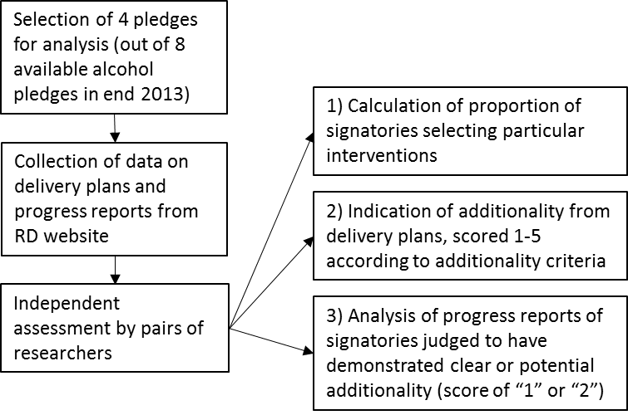

Table 1. Interventions proposed in pledges A1, A4, A6 and A8 and the number and proportion of interventions selected by signatories*
Pledge | Number of signatories who signed up to each pledge | Interventions proposed in each pledge | Number of signatories who selected these actions (%)
Alcohol Labelling: A1 | 92 signatories | - Unit alcohol content | 54 (59%)
 |  | - Chief Medical Officers’ daily guidelines for lower-risk consumption | 58 (63%)
 |  | - Pregnancy warning | 54 (59%)
 |  | - drinkaware.co.uk | 28 (30%)
 |  | - Responsibility statement | 22 (24%)
Tackling under-age alcohol sales: A4 | 63 signatories | - Challenge 21 | 21 (33%)
 |  | - Challenge 25 | 25 (40%)
Advertising and marketing alcohol: A6 | 92 signatories | - Promotion of responsible drinking | 34 (37%)
 |  | - No alcohol posters near schools | 46 (50%)
 |  | - Adhering to Drinkaware brand guidelines | 49 (53%)
Alcohol unit reduction: A8 | 32 signatories | - Reducing the alcohol content of drinks, even by small changes of 0.1% abv in a product | 14 (44%)
 |  | - development of new lower alcohol products | 13 (41%)
 |  | - Improving availability, better marketing and promotion of lower alcohol products | 18 (56%)
 |  | - On-trade premises and producers could also offer and promote smaller measures | 1 (3%)
 |  | - On trade premises reduce promotion of larger measures, making smaller measures default | 0 (0%)
*as at November 2013
Source: (27)

Table 2. Assessment of progress on delivery of plans (as at end 2013): characteristics of progress reports
 | # of partners judged as '1' or '2' ¹ | Progress reports provided² |  | Demonstration of quantifiable progress |  |  | Demonstration of progress through descriptive feedback |  |  | Descriptive feedback provided without demonstration of progress⁴ |  | same text as in 2013
Pledges |  | 2012/2013 | 2013/2014 | 2012/2013 | 2013/2014 |  | 2012/2013 | 2013/2014 |  | 2012/2013 | 2013/2014
 |  |  |  |  | with changes since 2013 | without changes since 2013 |  | with changes since 2013 | without changes since 2013³
A1 | 37 (of total 92) | 35 (95%) | 29 (78%) | 20 (57%) | 11 (38%) | 2 (7%) | 14 (40%) | 6 (21%) | 1 (3%) | 1 (3%) | 3 (10%) | 4 (14%)
A4 | 16 (of total 63) | 14 (88%) | 12 (75%) | 2 (14%) | 2 (17%) | 2 (17%) | 12 (86%) | 1 (8%) | 4 (33%) | 0 (0%) | 1 (8%) | 3 (25%)
A6 | 18 (of total 92) | 15 (83%) | 11 (61%) | 1 (7%) | 1 (9%) | 3 (27%) | 14 (93%) | 4 (36%) | 3 (27%) | 0 (0%) | 0 (0%) | 3 (27%)
A8 | 22 (of total 32) | 22 (100%) | 18 (82%) | 15 (68%) | 13 (72%) | 3 (17%) | 5 (23%) | 0 (0%) | 1 (6%) | 2 (9%) | 1 (6%) | 0 (0%)
TOTAL | N=93 | 86 (92%) | 70 (75%) | 38 (44%) | 27 (39%) | 10 (14%) | 45 (52%) | 11(16%) | 9 (13%) | 3 (3%) | 5 (7%) | 10 (14%)
¹ refers to progress reports of signatories who were judged (as at December 2013) as demonstrated likely (“1”) or potential (“2”) additionality in their delivery plans for A1, A4, A6 and A8
² refers to whether or not a progress report was provided at all. In 2012/2013, 7 signatories did not provide an update. In 2013/2014, 20 signatories did not provide an update, and three signatories were no longer listed.
³ refers to a narrative, qualitative report which reports on progress but without demonstrating changes since 2013, for example reiterating what was reported the previous year, but worded differently. This differs from the category “same text as in 2013” in that the texts are not identical to each other.
⁴ refers to a narrative report without qualitatively or quantitatively demonstrating progress. For example listing what they do but without discussing relevant achievements or progress.

Figure 2. Additionality: Proportion of interventions listed in delivery plans (n=432) across 4 alcohol pledges likely, potentially or unlikely to have been brought about by the RD
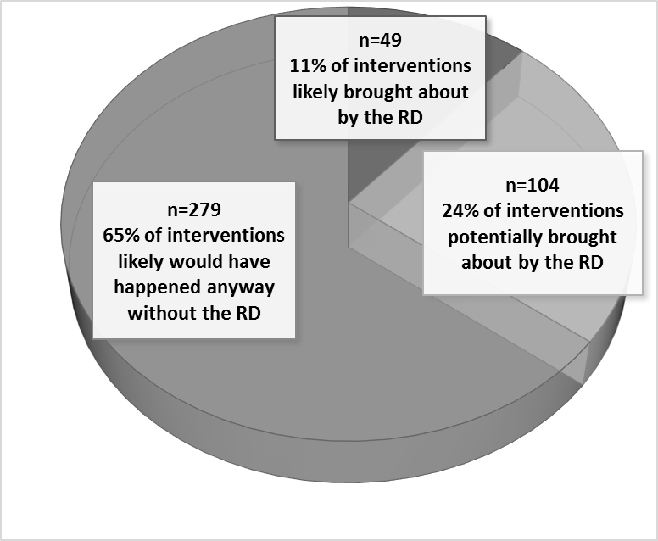

Figure 3. Additionality: proportion of interventions judlged as likely, potentially or unlikely to be brought about by the RD
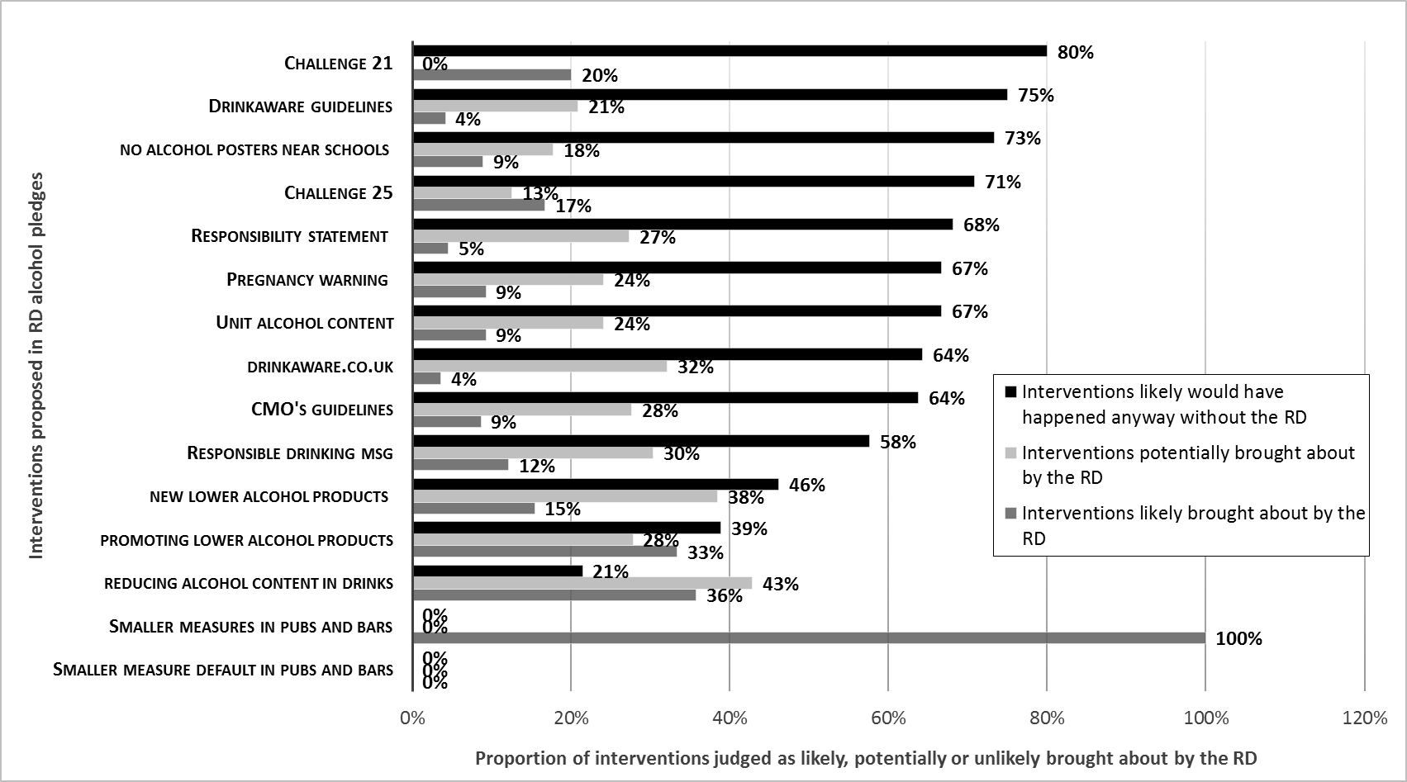

Table 3. Assessment of progress on delivery of plans: the reported implementation of pledge A8 “alcohol unit reduction”
Interventions under “alcohol unit reduction” pledge (A8) | 2013  N= 22 out of 32 A8 signatories total | 2014  N= 18 out of 32 A8 signatories total
New low alcohol product development | 12 (55%) | 10 (56%)
Promotion of low alcohol products | 11 (50%) | 12 (67%)
Removal of alcohol units | 10 (45%) | 5 (28%)
Reducing production or promotion of high alcohol products (including reducing bottle size) | 5 (23%) | 3 (17%)
Reducing serving measures | 2 (6%) | -

