Mortality After Repeat Revascularization Following Percutaneous Coronary Intervention or Coronary Artery Bypass Grafting for Left Main Coronary Artery Disease: The EXCEL Trial

Running Title: Repeat Revascularization After PCI or CABG

Gennaro Giustino, MD¹, Patrick W. Serruys, MD, PhD², Joseph F. Sabik III, MD³, Roxana Mehran, MD^{1,4}, Akiko Maehara, MD⁴, John D. Puskas, MD⁵, Charles A. Simonton, MD⁶, Nicholas J. Lembo, MD⁷, David E. Kandzari, MD⁸, Marie-Claude Morice, MD⁹, David P. Taggart, MD¹⁰, Anthony H. Gershlick, MD¹¹, Michael Ragosta III, MD¹², Irving L. Kron, MD¹², Yangbo Liu, MS⁴, Thomas McAndrew, PhD⁴, Ovidiu Dressler, MD⁴, Philippe Généreux, MD^{4,13,14}, Ori Ben-Yehuda, MD^{4,7}, Stuart J. Pocock, PhD¹⁵, Arie Pieter Kappetein, MD, PhD¹⁶, Gregg W. Stone, MD^{4,7}

From ¹The Zena and Michael A. Wiener Cardiovascular Institute, Icahn School of Medicine at Mount Sinai, New York, NY; ²Imperial College of Science, Technology and Medicine, London, United Kingdom; ³Department of Surgery, UH Cleveland Medical Center, Cleveland, OH; ⁴Clinical Trials Center, Cardiovascular Research Foundation, New York, NY; ⁵Mount Sinai Heart at Mount Sinai St Luke’s, New York, NY; ⁶Abbott Vascular, Santa Clara, CA; ⁷NewYork-Presbyterian Hospital/Columbia University Medical Center, New York, NY; ⁸Piedmont Heart Institute, Atlanta, GA; ⁹Ramsay Générale de Santé, Hopital Privé Jacques Cartier, Massy, France; ¹⁰Department Cardiac Surgery, John Radcliffe Hospital, Oxford, United Kingdom; ¹¹University Hospitals of Leicester, Leicester, United Kingdom; ¹²Division of Cardiovascular Medicine, University of Virginia Health System, Charlottesville, VA; ¹³Gagnon Cardiovascular Institute, Morristown Medical Center, Morristown, NJ; ¹⁴Hôpital du Sacré-Coeur de Montréal, Montréal, Québec, Canada; ¹⁵Department of Medical Statistics, London School of Hygiene and Tropical Medicine, London, United Kingdom; ¹⁶Erasmus University Medical Center, Rotterdam, The Netherlands.

Word count: 3,280

Corresponding Author
Gregg W. Stone, MD
Columbia University Medical Center
Cardiovascular Research Foundation
1700 Broadway, 9th Floor
New York, NY 10019
tel: 646-434-4134
fax: 646-434-4715
e-mail: gs2184@columbia.edu

ABSTRACT
BACKGROUND: The impact on mortality of the need for repeat revascularization following percutaneous coronary intervention (PCI) or coronary artery bypass grafting (CABG) in patients with unprotected left main coronary artery disease (LMCAD) is controversial.
METHODS: We characterized the incidence and impact on mortality of the need for repeat revascularization among 1,905 patients randomized to PCI (n=948) or CABG (n=957) for LMCAD and site-assessed low or intermediate SYNTAX scores from the EXCEL trial. All repeat revascularization events after the index procedure were adjudicated by an independent clinical even committee. The effect of repeat revascularization on 3-year mortality was estimated by means of time-varying Cox regression models adjusting by baseline confounders and the concomitant risk of myocardial infarction and stroke.
RESULTS: During 3 years of follow-up there were 346 repeat revascularization events among 185 patients. Median time to the first repeat revascularization was 347 days after PCI and 257 days after CABG (p=0.13). Overall, PCI was associated with higher rates of any repeat revascularization (12.9% versus 7.6%; hazard ratio [HR] 1.73; 95% confidence interval [CI] 1.28-2.33, p=0.0003). Any repeat revascularization was independently associated with increased risk of 3-year all-cause mortality (adjusted HR [adjHR] 2.05; 95% CI 1.13-3.70; p=0.02) and cardiovascular mortality (adjHR 4.22; 95% CI 2.10-8.48; p<0.0001) consistently after either PCI or CABG (p_{int}=0.85 for both endpoints).
CONCLUSIONS: Need for repeat revascularization was more common after PCI and was associated with increased all-cause and cardiovascular mortality after both PCI and CABG. Measures to prevent the need for repeat revascularization may improve prognosis in patients with LMCAD.

CLINICAL TRIAL REGISTRATION: NCT01205776

Key Words: percutaneous coronary intervention; coronary artery bypass grafting; left main coronary artery; repeat revascularization

Iterations in coronary stent technologies, techniques, and pharmacotherapies have enhanced the efficacy and safety of percutaneous coronary intervention (PCI) leading to lower rates over time of in-stent restenosis, stent thrombosis, and need for repeat revascularization.¹⁻⁶ Concomitantly, outcomes of coronary artery bypass grafting (CABG) also improved with the use of multiple arterial grafts and minimally invasive techniques.^{4, 7-9} However, the need for repeat revascularization is known to be more common after PCI than CABG and remains a controversial endpoint in clinical trials evaluating the comparative effectiveness of invasive revascularization strategies.¹⁰⁻¹³ While often considered a clinical endpoint of lesser importance compared with death, stroke or myocardial infarction (MI), the need for repeat revascularization is associated with worse quality of life and exposes patients to new hospitalizations and procedural risks.^{11, 14-16} In addition, the need for a repeat procedure after revascularization of the left main (LM) may be associated with substantial morbidity and mortality given the large amount of subtended myocardium at risk.¹⁷ Therefore, in the current analysis from the EXCEL (Evaluation of XIENCE versus Coronary Artery Bypass Surgery for Effectiveness of Left Main Revascularization) trial we aimed to characterize the incidence, predictors, and consequences of the need for repeat revascularization after the index PCI or CABG for LM coronary artery disease (LMCAD) using contemporary devices and surgical techniques.

METHODS
Study design. The EXCEL trial was an international, open-label, multicenter, randomized trial that compared PCI using cobalt-chromium fluoropolymer-based everolimus-eluting stents (XIENCE; Abbott Vascular, Santa Clara, CA) versus CABG in patients with LMCAD. The EXCEL trial design and principal results have been previously reported.¹⁷ In brief, inclusion criteria were LM coronary artery diameter stenosis of ≥70%, as estimated visually, or stenosis of 50% to <70% if hemodynamically significant by non-invasive or invasive testing. All patients were required to have low or intermediate anatomical complexity of coronary artery disease as defined by a site-determined SYNTAX (Synergy between PCI with Taxus and Cardiac Surgery) score of ≤32. Consensus among the members of the heart team regarding the eligibility for revascularization with either PCI or CABG was required. Clinical follow-up was performed at 1 month, 6 months, and 1 year and then annually through 5 years. At the time of the current analysis all patients have completed 3 years of follow-up. The primary endpoint of the EXCEL trial was the composite of death from any cause, stroke, or MI at a median follow-up time of 3 years. Major powered secondary endpoints included this composite rate at 30 days, and death, stroke, MI, or ischemia-driven revascularization at 3 years. Definitions of the primary and major secondary endpoints are reported elsewhere.¹⁷ Study monitors collected source documents of all primary and secondary endpoints for adjudication by an independent clinical events committee. The extent and complexity of CAD and the SYNTAX score at baseline were also assessed by an independent angiographic core laboratory. The investigation was approved by the ethics committee or institutional review board at each center, and all patients signed informed consent. The data, analytic methods, and study materials are proprietary to the sponsor and will not be made available to other researchers for purposes of reproducing the results or replicating the procedure.
The present study is a secondary analysis from the EXCEL trial investigating the incidence, risk factors, and prognostic impact of the need for repeat revascularization following PCI and CABG. The following type of revascularization events were considered in this analysis: Ischemia-driven revascularization, non–ischemia-driven revascularization, target lesion revascularization (TLR), target vessel revascularization (TVR), non-TVR, repeat revascularization with PCI, and repeat revascularization with CABG. A complete list of definitions for the different types of repeat revascularization endpoints is reported in Supplemental Table 1. We evaluated the effect of each type of repeat revascularization event on all-cause, cardiovascular, and non-cardiovascular mortality at 3-year follow-up.
Statistical analysis. All analyses were performed in the intention-to-treat population, including patients according to the group to which they were randomly assigned. Categorical variables were compared using the χ² test or Fisher exact test. Continuous variables were compared with using the Student t test or the Wilcoxon rank-sum test for non-normally distributed data. Event rates were based on Kaplan–Meier estimates in time-to-first-event analyses and were compared with the log-rank test. Hazard ratios (HR) with 95% confidence intervals (CI) for PCI versus CABG were generated with Cox regression models. Predictors of repeat revascularization events were evaluated with multivariable Cox regression models separately for patients randomized to PCI or CABG, including clinical, angiographic, and procedural characteristics that were significantly associated with the outcome by univariate analysis or were deemed to be clinically important for each type of index procedure (full list of covariates for each model is included in the footnote of the respective table). The association of repeat revascularization with the risk of mortality at 3 years was evaluated with multivariable Cox regression models entering repeat revascularization, any MI, and any stroke as time-varying covariates alongside other baseline covariates, including age, sex, SYNTAX score, diabetes, chronic kidney disease, congestive heart failure, anemia, and ST-segment elevation MI or non–ST-segment elevation MI at presentation. A 2-sided p value threshold of ≤0.05 was considered statistically significant. All analyses were performed using SAS software, version 9.4 (SAS Institute, Cary, North Carolina).

RESULTS
During 3 years of follow-up there were 346 repeat revascularization events among 185 patients (Supplemental Table 2). Of these, 259/346 (74.9%) were PCIs and 87/346 (25.1%) were CABGs. Overall, 102 (55.1%) patients had 1 repeat revascularization event, 41 (22.2%) had 2 events, and 42 (22.7%) had >2 events. Overall, the median time to the first repeat revascularization was 320 days (interquartile range [IQR]: 141 to 616 days). Baseline clinical, angiographic, and procedural characteristics in patients with versus without any repeat revascularization after the index PCI or CABG are reported in Supplemental Table 3, Supplemental Table 4, and Supplemental Table 5, respectively. There were no significant differences in SYNTAX score between patients with versus without any repeat revascularization at 3 years within both the PCI and the CABG groups. Medication use over 3 years is reported in Supplemental Table 6. Patients who required repeat revascularization were more likely to be on dual antiplatelet therapy over 3 years within both the PCI and the CABG arms. Patients who required repeat revascularization had higher rates of anginal symptoms at 3 years in both the PCI and the CABG arm (Supplemental Table 7).

Risk of Revascularization by PCI and CABG. Median time to the first repeat revascularization was 347 days (IQR: 182-570) after PCI and 257 days (IQR: 83-628) after CABG (p=0.13). Rates of time-to-first repeat revascularization over 3 years are reported in Table 1. Patients who underwent PCI had higher rates of any repeat revascularization at 3 years compared with CABG (12.9% versus 7.6%; HR 1.73; 95% CI 1.28-2.33; p=0.0003). Over time, differences in rates of repeated revascularization between PCI and CABG started emerging beyond the time period of 6 months (Figure 1A and 1B). Among those who underwent repeat revascularization, 8/117 patients (7.1%) had a definite or probable stent thrombosis in the PCI arm and 42/68 (62.7%) had a graft occlusion in the CABG arm (p<0.0001). Most of repeat revascularizations were performed by PCI in both the PCI and CABG group. More patients initially randomized to PCI underwent CABG over 3 years compared with those who underwent initial CABG (3.3% vs. 0.8%; HR: 4.25; 95% CI: 1.87-9.68; p=0.0002).

Predictors of Repeated Revascularization. Predictors of any repeat revascularization at 3 years after PCI or CABG are reported in Table 2. After PCI, higher body mass index, insulin-treated diabetes, and hemodynamic support during the procedure were associated with a higher risk of repeat revascularization. Conversely, statin use at discharge was protective (adjusted HR 0.30; 95% CI 0.16-0.50; p=0.0003). After CABG, female sex and peripheral vascular disease emerged as independent predictors of repeat revascularization.

Repeat Revascularization and Mortality. At 3 years, there were 128 all-cause deaths, 74 cardiovascular deaths and 54 non-cardiovascular deaths. Independent predictors of all-cause and cardiovascular mortality at 3 years in the overall population are reported in Table 3. Need for repeat revascularization was independently associated with increased risk of both all-cause (adjusted HR 2.05; 95% CI 1.13-3.70; p=0.02) and cardiovascular mortality (adjusted HR 4.22; 95% CI 2.10-8.48; p<0.0001). However, the magnitude of the association between repeat revascularization and all-cause mortality was smaller compared to that of myocardial infarction (adjusted HR: 4.03; 95% CI: 2.43-6.67; p<0.0001) or stroke (adjusted HR: 16.62; 95% CI: 9.97-27.69; p<0.0001). The risk of mortality after repeat revascularization peaked within 30 days and then declined over time (Figure 2A and Figure 2B, for all-cause and cardiovascular mortality, respectively). The adjusted risk of 3-year all-cause and cardiovascular mortality according to the various types of repeat revascularization events is illustrated in Figure 3A and Figure 3B, respectively. All types of repeat revascularization, except revascularization with PCI and non-TVR revascularization were associated with increased all-cause mortality. Conversely, only non-TVR was not associated with increased cardiovascular mortality. The effect of repeat revascularization on all-cause and cardiovascular mortality according to the index revascularization strategy is illustrated in Figure 4A and Figure 4B. The effect of any repeat revascularization and its subtypes on both all-cause and cardiovascular was uniform according to the index revascularization strategy, without evidence of interaction. Need for repeat revascularization was not associated with increased risk of non-cardiovascular mortality (Supplemental Table 8 and Supplemental Table 9).

DISCUSSION
The major findings of the present analysis from the EXCEL trial in which we characterized the timing and consequences of the need for repeat coronary revascularization following PCI or CABG for LMCAD are as follows: (i) the need for repeat revascularization over 3 years is more common after PCI than CABG, mostly secondary to TLR; of note, the need for revascularization in the PCI arm was infrequently due to stent thrombosis, while in the CABG arm occurred mostly in the setting of graft occlusion; (ii) overall, the need for any repeat revascularization was associated with an increased risk of all-cause and cardiovascular mortality at 3 years after both PCI and CABG, this risk peaked within 30 days after the repeat revascularization event and then declined over time; need for repeat revascularization was not associated with increased non-cardiac mortality; (iii) the magnitude and significance of the association between the need for repeat revascularization and mortality depended upon its subtype, with TVR, TLR and repeat revascularization with CABG being associated with increased all-cause mortality risk; conversely non-TVR was not associated with increased all-cause mortality.
Although developments in technologies, techniques, and pharmacotherapies have enhanced both the efficacy and safety of invasive revascularization strategies, the need for repeat revascularization remains a frequent adverse event after both PCI and CABG.^{1-5, 18} After PCI, stent-related complications or the development of new obstructive native coronary lesions outside of the stented vascular segment usually account for the need for repeat revascularization.¹⁻⁵ After CABG, the need for repeat revascularization is usually driven by the progression of native vessel disease distal to the site of anastomosis or by arterial or venous graft occlusion.^{1-5, 18} While the need for repeat revascularization is known to be more common after PCI than CABG, reasons for these differences remain a matter of debate. In addition, few studies have previously examined in detail the timing, mechanisms, and consequences of repeat revascularization after each type of revascularization strategy. In the era of first-generation drug-eluting stents, this subject was examined in a report from the SYNTAX trial in which 1,800 patients with multivessel CAD and/or LMCAD were randomized to CABG or PCI with the paclitaxel-eluting stents.¹⁴ In this study, PCI was associated with higher risk of repeat revascularization at 5 years, mostly due to TVR and TLR.^{11, 15} In addition, after multivariable adjustment, any repeat revascularization was an independent predictor of the composite of death, stroke, or MI after initial PCI but not after initial CABG, and mostly driven by increased risk of MI.¹⁴
Risk of Repeat Revascularization With PCI versus CABG. In the current analysis from the EXCEL trial we extend prior observations to a LMCAD cohort at low or intermediate anatomical complexity treated with contemporary PCI devices and surgical techniques. Consistent with prior studies, the rate of repeat revascularization was greater for PCI than for CABG, which was mostly driven by TLR. The advantage of CABG over PCI in terms of repeat revascularization is possibly related to the fact that by anastomosing bypass grafts distal to the obstructive epicardial coronary lesions, CABG makes the complexity of the coronary lesion itself less relevant and has a protective effect from repeat revascularization from lesions developing proximally to the anastomosed segment. Conversely, since PCI treats a target coronary lesion, it is influenced by both the complexity of the actual lesion and does not provide protection from future de novo lesions that can develop upstream or downstream from the stented vascular segment.¹⁹⁻²¹ However, it has also been shown that the thresholds for repeat revascularization based on anginal symptoms are different between PCI and CABG, which may also reflect a different suitability to further revascularization after the index procedure (better after PCI rather than CABG).^{11, 15, 22} In fact, in a secondary analysis from the SYNTAX trial, among patients who required repeat revascularization during follow-up, those who underwent initial CABG had substantially greater angina scores compared to those who initially underwent PCI.¹⁵ This finding suggests the existence of a differential threshold for referral to consider further repeat revascularization based on the index revascularization procedure, which may explain the more frequent use of repeat revascularization with PCI compared with CABG.^{11, 15, 22} However, in our study, the prevalence of anginal symptoms over 3 years among patients who required repeat revascularization was roughly similar between PCI and CABG. In addition, the absolute differences in rates of repeat revascularization between PCI and CABG in the EXCEL trial were lower than those reported in the SYNTAX trial which may reflect the lower anatomical complexity of the population included in EXCEL and the improved properties of new-generation metallic everolimus-eluting stent. Also, it should be noted, that despite the need for repeat revascularization was more frequent after PCI rather than CABG, in the EXCEL trial the health-status benefits over 3 years of the two revascularization strategies were not significantly different²³, in contrast with prior reports that suggested that CABG resulted in slightly better long-term angina relief than PCI^{24, 25}.

Effect of Repeat Revascularization on Mortality. Repeat revascularization was associated with increased risk of both all-cause and cardiovascular mortality irrespective of the index revascularization strategy. Of note, the effect on mortality following repeat revascularization was greater early after the event (within 30 days) and then attenuated over time, suggesting that the actual event of repeat revascularization per se is associated with increased risks. The association between repeat revascularization and mortality is likely multifactorial and can be both causative and correlative in nature: first, the need for repeat revascularization exposes patients to new hospitalizations and its inherent risks; second, a repeat revascularization by itself carries the intra- and periprocedural risk associated with the modality of revascularization; for this respect, the risk of mortality was greater for repeat revascularization using CABG rather than PCI, reflecting the different periprocedural morbidity related to each type of revascularization strategy; third, repeat revascularization (especially with PCI) requires prolonged dual antiplatelet therapy, which is associated with increased risk for bleeding and possibly mortality. Finally, the need for repeat revascularization could represent a marker of more extensive coronary artery disease and comorbidity burden; however, the baseline SYNTAX score did not differ between patients who required a repeat revascularization versus those who did not.
Types of Repeat Revascularization. Both TVR and TLR were significantly associated with increased risk of all-cause and cardiovascular mortality, consistently after both PCI and CABG. After LM-PCI, repeat revascularization of a previously stented unprotected LM lesion secondary to drug-eluting stent failure (e.g. in-stent restenosis or stent thrombosis) is inherently associated with high procedural risk due to the large area of subtended myocardium at risk. On the other hand, after CABG, in case of failure of a graft bypassing the LM complex either repeat revascularization through PCI of a diseased graft or of the native occluded coronary artery is associated with significant risk for adverse events. For this respect, data from the National Cardiovascular Data Registry and the Veterans Affairs Clinical Assessment, Reporting, and Tracking program suggest that most PCIs performed in prior CABG patients are done in native coronary arteries, and that, within this setting, bypass graft PCI is associated with higher risk of in-hospital mortality compared with native-vessel PCI.^{26, 27} Finally, similar to the prior report from the SYNTAX trial,¹⁴ non-TVR, which in this trial is essentially constituted by revascularizations of the right coronary artery, was not associated with increased risk of all-cause or cardiovascular mortality after either PCI or CABG.

Clinical Implications. Our findings in an unprotected LMCAD population suggest that the need for repeat revascularization carries prognostic significance, with a magnitude that depends upon its definition, indication and type of repeat revascularization procedure. It is therefore plausible that measures to reduce the rates of repeat revascularization over time including lifestyle modification and aggressive risk factors control with optimal medical therapy may improve prognosis of LMCAD after both PCI and CABG²⁸⁻³⁰.

Limitations. Our study has several limitations that need to be disclosed. First, since this is a post-hoc analysis from a prospective randomized controlled trial, our findings should be considered only hypothesis-generating. Second, detailed indications for repeat revascularization were not prospectively adjudicated; however, most repeat revascularization events were adjudicated as ischemia-driven. Third, at the time of this analysis only 3 years of follow-up were available; longer follow-up (currently planned for 5 years) may uncover further differences between revascularization strategies in terms of need for repeat revascularization and its prognostic significance. Fourth, residual confounding bias not accounted by our multivariable models may have persisted when evaluating the association between repeat revascularization and mortality over time.

CONCLUSIONS
In the EXCEL trial, repeat revascularization was overall more common with PCI than CABG. The need for repeat revascularization was associated with increased risk of both all-cause and cardiovascular mortality irrespective of the index revascularization strategy for LMCAD. The magnitude of risk associated with repeat revascularization depends upon its definition and type of repeat revascularization procedure. Prevention of the need for repeat revascularization over time may translate into improved survival after both PCI and CABG for LMCAD.
FUNDING SOURCES
The EXCEL trial was sponsored by Abbott Vascular (Santa Clara, CA).
CONFLICTS OF INTEREST
Gennaro Giustino: None.
Patrick W. Serruys: Consultant – Abbott, Biosensors, Medtronic, Micell Technologies, QualiMed, SINOMED, St. Jude Medical, Stentys, Svelte, Philips/Volcano, Xeltis.
Joseph F. Sabik: Consultant - Medtronic, Edwards, and Sorin. Advisory board - Medtronic Cardiac Surgery.
Roxana Mehran: Institutional research grant support - Eli Lilly/Daiichi-Sankyo, Inc., Bristol-Myers Squibb, AstraZeneca, The Medicines Company, OrbusNeich, Bayer, CSL Behring, Abbott Laboratories, Watermark Research Partners, Novartis Pharmaceuticals, Medtronic, AUM Cardiovascular, Inc., Beth Israel Deaconess Medical Center; executive committee - Janssen Pharmaceuticals, Osprey Medical Inc.; data safety monitoring board - Watermark Research Partners; consulting - Medscape, The Medicines Company, Boston Scientific, Merck & Company, Cardiovascular Systems, Inc. (CSI); Sanofi USA, LLC, Shanghai BraccoSine Pharmaceutical Corp.; AstraZeneca; equity - Claret Medical Inc., Elixir Medical Corporation.
Akiko Maehara: Institutional grant support - Boston Scientific, Abbott; consultant - Boston Scientific, OCT Medical Imaging Inc.; speaker fee - Abbott.
John D. Puskas: None.
Charles A. Simonton: Employee - Abbott Vascular.
Nicholas J. Lembo: Consultant and speakers bureau – Abbott Vascular, Boston Scientific, Medtronic.
David E. Kandzari: Consultant - Medtronic, Boston Scientific, Biotronik, Micell Technologies, Cardinal Health; institutional research/grant support - Medtronic, Boston Scientific, Biotronik, Micell Technologies, Medinol.
Marie-Claude Morice: None.
David P. Taggart: None.
Anthony H. Gershlick: None.
Michael Ragosta III: None.
Irving L. Kron: None.
Yangbo Liu: None.
Thomas McAndrew: None.
Ovidiu Dressler: None.
Philippe Genereux: Speaker's fees - Edwards Lifescience, Medtronic, Tryton Medical Inc., Cardinal Health, and Cardiovascular Systems Inc., consulting fees - Boston Scientific, Cardiovascular Systems Inc., and Pi-Cardia; institutional research grant - Boston Scientific. Equity - SIG.NUM, SoundBite Medical Solutions Inc., Saranas, and Pi-Cardia.
Ori Ben-Yehuda: None.
Stuart J. Pocock: Consultant - Abbott Vascular.
Arie Pieter Kappetein: Employee – Medtronic.
Gregg W. Stone: Employer, Columbia University, receives royalties for sale of the MitraClip.

REFERENCES
1. Dangas GD, Claessen BE, Caixeta A, Sanidas EA, Mintz GS and Mehran R. In-stent restenosis in the drug-eluting stent era. J Am Coll Cardiol. 2010;56:1897-907.
2. Giustino G, Baber U, Aquino M, Sartori S, Stone GW, Leon MB, Genereux P, Dangas GD, Chandrasekhar J, Kimura T, Salianski O, Stefanini GG, Steg PG, Windecker S, Wijns W, Serruys PW, Valgimigli M, Morice MC, Camenzind E, Weisz G, Smits PC, Kandzari DE, Galatius S, Von Birgelen C, Saporito R, Jeger RV, Mikhail GW, Itchhaporia D, Mehta L, Ortega R, Kim HS, Kastrati A, Chieffo A and Mehran R. Safety and Efficacy of New-Generation Drug-Eluting Stents in Women Undergoing Complex Percutaneous Coronary Artery Revascularization: From the WIN-DES Collaborative Patient-Level Pooled Analysis. JACC Cardiovasc Interv. 2016;9:674-84.
3. Giustino G, Baber U, Salianski O, Sartori S, Stone GW, Leon MB, Aquino M, Stefanini GG, Steg PG, Windecker S, M OD, Wijns W, Serruys PW, Valgimigli M, Morice MC, Camenzind E, Weisz G, Smits PC, Kandzari D, Von Birgelen C, Dangas GD, Cha JY, Galatius S, Jeger RV, Kimura T, Mikhail GW, Itchhaporia D, Mehta L, Ortega R, Kim HS, Kastrati A, Genereux P, Chieffo A and Mehran R. Safety and Efficacy of New-Generation Drug-Eluting Stents in Women at High Risk for Atherothrombosis: From the Women in Innovation and Drug-Eluting Stents Collaborative Patient-Level Pooled Analysis. Circ Cardiovasc Interv. 2016;9:e002995.
4. Piccolo R, Giustino G, Mehran R and Windecker S. Stable coronary artery disease: revascularisation and invasive strategies. Lancet. 2015;386:702-13.
5. Palmerini T, Biondi-Zoccai G, Della Riva D, Stettler C, Sangiorgi D, D'Ascenzo F, Kimura T, Briguori C, Sabate M, Kim HS, De Waha A, Kedhi E, Smits PC, Kaiser C, Sardella G, Marullo A, Kirtane AJ, Leon MB and Stone GW. Stent thrombosis with drug-eluting and bare-metal stents: evidence from a comprehensive network meta-analysis. Lancet. 2012;379:1393-402.
6. Giustino G, Chieffo A, Palmerini T, Valgimigli M, Feres F, Abizaid A, Costa RA, Hong MK, Kim BK, Jang Y, Kim HS, Park KW, Gilard M, Morice MC, Sawaya F, Sardella G, Genereux P, Redfors B, Leon MB, Bhatt DL, Stone GW and Colombo A. Efficacy and Safety of Dual Antiplatelet Therapy After Complex PCI. J Am Coll Cardiol. 2016;68:1851-1864.
7. Gaudino M, Taggart D, Suma H, Puskas JD, Crea F and Massetti M. The choice of conduits in coronary artery bypass surgery. J Am Coll Cardiol. 2015;66:1729-37.
8. Alexander JH and Smith PK. Coronary-artery bypass grafting. N Engl J Med. 2016;375:e22.
9. Gaudino M, Antoniades C, Benedetto U, Deb S, Di Franco A, Di Giammarco G, Fremes S, Glineur D, Grau J, He GW, Marinelli D, Ohmes LB, Patrono C, Puskas J, Tranbaugh R, Girardi LN, Taggart DP and Alliance A. Mechanisms, Consequences, and Prevention of Coronary Graft Failure. Circulation. 2017;136:1749-1764.
10. Capodanno D, Gargiulo G, Buccheri S, Chieffo A, Meliga E, Latib A, Park SJ, Onuma Y, Capranzano P, Valgimigli M, Narbute I, Makkar RR, Palacios IF, Kim YH, Buszman PE, Chakravarty T, Sheiban I, Mehran R, Naber C, Margey R, Agnihotri A, Marra S, Leon MB, Moses JW, Fajadet J, Lefevre T, Morice MC, Erglis A, Alfieri O, Serruys PW, Colombo A, Tamburino C and Investigators D. Computing methods for composite clinical endpoints in unprotected left main coronary artery revascularization: a post hoc analysis of the DELTA registry. JACC Cardiovasc Interv. 2016;9:2280-2288.
11. Kazi DS and Hlatky MA. Repeat revascularization is a faulty end point for clinical trials. Circ Cardiovasc Qual Outcomes. 2012;5:249-50.
12. Kip KE, Hollabaugh K, Marroquin OC and Williams DO. The problem with composite end points in cardiovascular studies: the story of major adverse cardiac events and percutaneous coronary intervention. J Am Coll Cardiol. 2008;51:701-7.
13. Stolker JM, Spertus JA, Cohen DJ, Jones PG, Jain KK, Bamberger E, Lonergan BB and Chan PS. Rethinking composite end points in clinical trials: insights from patients and trialists. Circulation. 2014;130:1254-61.
14. Parasca CA, Head SJ, Milojevic M, Mack MJ, Serruys PW, Morice MC, Mohr FW, Feldman TE, Colombo A, Dawkins KD, Holmes DR, Jr., Kappetein PA and Investigators S. Incidence, characteristics, predictors, and outcomes of repeat revascularization after percutaneous coronary intervention and coronary artery bypass grafting: The SYNTAX trial at 5 years. JACC Cardiovasc Interv. 2016;9:2493-2507.
15. Arnold SV, Magnuson EA, Wang K, Serruys PW, Kappetein AP, Mohr FW, Cohen DJ and Investigators S. Do differences in repeat revascularization explain the antianginal benefits of bypass surgery versus percutaneous coronary intervention?: implications for future treatment comparisons. Circ Cardiovasc Qual Outcomes. 2012;5:267-75.
16. Palmerini T, Della Riva D, Biondi-Zoccai G, Leon MB, Serruys PW, Smits PC, von Birgelen C, Ben-Yehuda O, Genereux P, Bruno AG, Jenkins P and Stone GW. Mortality Following Nonemergent, Uncomplicated Target Lesion Revascularization After Percutaneous Coronary Intervention: An Individual Patient Data Pooled Analysis of 21 Randomized Trials and 32,524 Patients. JACC Cardiovasc Interv. 2018;11:892-902.
17. Stone GW, Sabik JF, Serruys PW, Simonton CA, Genereux P, Puskas J, Kandzari DE, Morice MC, Lembo N, Brown WM, 3rd, Taggart DP, Banning A, Merkely B, Horkay F, Boonstra PW, van Boven AJ, Ungi I, Bogats G, Mansour S, Noiseux N, Sabate M, Pomar J, Hickey M, Gershlick A, Buszman P, Bochenek A, Schampaert E, Page P, Dressler O, Kosmidou I, Mehran R, Pocock SJ, Kappetein AP and Investigators ET. Everolimus-Eluting Stents or Bypass Surgery for Left Main Coronary Artery Disease. N Engl J Med. 2016;375:2223-2235.
18. Sawaya FJ, Morice MC, Spaziano M, Mehran R, Didier R, Roy A, Valgimigli M, Kim HS, Woo Park K, Hong MK, Kim BK, Jang Y, Feres F, Abizaid A, Costa RA, Colombo A, Chieffo A, Giustino G, Stone GW, Bhatt DL, Palmerini T and Gilard M. Short-versus long-term Dual Antiplatelet therapy after drug-eluting stent implantation in women versus men: A sex-specific patient-level pooled-analysis of six randomized trials. Catheter Cardiovasc Interv. 2017;89:178-189.
19. Fihn SD, Blankenship JC, Alexander KP, Bittl JA, Byrne JG, Fletcher BJ, Fonarow GC, Lange RA, Levine GN, Maddox TM, Naidu SS, Ohman EM and Smith PK. 2014 ACC/AHA/AATS/PCNA/SCAI/STS focused update of the guideline for the diagnosis and management of patients with stable ischemic heart disease: a report of the American College of Cardiology/American Heart Association Task Force on Practice Guidelines, and the American Association for Thoracic Surgery, Preventive Cardiovascular Nurses Association, Society for Cardiovascular Angiography and Interventions, and Society of Thoracic Surgeons. Circulation. 2014;130:1749-67.
20. Neumann FJ, Sousa-Uva M, Ahlsson A, Alfonso F, Banning AP, Benedetto U, Byrne RA, Collet JP, Falk V, Head SJ, Juni P, Kastrati A, Koller A, Kristensen SD, Niebauer J, Richter DJ, Seferovic PM, Sibbing D, Stefanini GG, Windecker S, Yadav R, Zembala MO and Group ESCSD. 2018 ESC/EACTS Guidelines on myocardial revascularization. Eur Heart J. 2018.
21. Taggart DP. Percutaneous or surgical revascularization in multivessel coronary artery disease: synthesis from SYNTAX. Eur Heart J. 2014;35:2789-91.
22. Teirstein PS. Percutaneous revascularization is the preferred strategy for patients with significant left main coronary stenosis. Circulation. 2009;119:1021-33.
23. Baron SJ, Chinnakondepalli K, Magnuson EA, Kandzari DE, Puskas JD, Ben-Yehuda O, van Es GA, Taggart DP, Morice MC, Lembo NJ, Brown WM, 3rd, Banning A, Simonton CA, Kappetein AP, Sabik JF, Serruys PW, Stone GW, Cohen DJ and Investigators E. Quality-of-Life After Everolimus-Eluting Stents or Bypass Surgery for Left-Main Disease: Results From the EXCEL Trial. J Am Coll Cardiol. 2017;70:3113-3122.
24. Abdallah MS, Wang K, Magnuson EA, Spertus JA, Farkouh ME, Fuster V, Cohen DJ and Investigators FT. Quality of life after PCI vs CABG among patients with diabetes and multivessel coronary artery disease: a randomized clinical trial. JAMA. 2013;310:1581-90.
25. Cohen DJ, Van Hout B, Serruys PW, Mohr FW, Macaya C, den Heijer P, Vrakking MM, Wang K, Mahoney EM, Audi S, Leadley K, Dawkins KD, Kappetein AP, Synergy between PCIwT and Cardiac Surgery I. Quality of life after PCI with drug-eluting stents or coronary-artery bypass surgery. N Engl J Med. 2011;364:1016-26.
26. Brilakis ES, Rao SV, Banerjee S, Goldman S, Shunk KA, Holmes DR, Jr., Honeycutt E and Roe MT. Percutaneous coronary intervention in native arteries versus bypass grafts in prior coronary artery bypass grafting patients: a report from the National Cardiovascular Data Registry. JACC Cardiovasc Interv. 2011;4:844-50.
27. Brilakis ES, O'Donnell CI, Penny W, Armstrong EJ, Tsai T, Maddox TM, Plomondon ME, Banerjee S, Rao SV, Garcia S, Nallamothu B, Shunk KA, Mavromatis K, Grunwald GK and Bhatt DL. Percutaneous Coronary Intervention in Native Coronary Arteries Versus Bypass Grafts in Patients With Prior Coronary Artery Bypass Graft Surgery: Insights From the Veterans Affairs Clinical Assessment, Reporting, and Tracking Program. JACC Cardiovasc Interv. 2016;9:884-93.
28. Stone GW, Hochman JS, Williams DO, Boden WE, Ferguson TB, Jr., Harrington RA and Maron DJ. Medical Therapy With Versus Without Revascularization in Stable Patients With Moderate and Severe Ischemia: The Case for Community Equipoise. J Am Coll Cardiol. 2016;67:81-99.
29. Maron DJ, Mancini GBJ, Hartigan PM, Spertus JA, Sedlis SP, Kostuk WJ, Berman DS, Teo KK, Weintraub WS, Boden WE and Group CT. Healthy Behavior, Risk Factor Control, and Survival in the COURAGE Trial. J Am Coll Cardiol. 2018;72:2297-2305.
30. Iqbal J, Zhang YJ, Holmes DR, Morice MC, Mack MJ, Kappetein AP, Feldman T, Stahle E, Escaned J, Banning AP, Gunn JP, Colombo A, Steyerberg EW, Mohr FW and Serruys PW. Optimal medical therapy improves clinical outcomes in patients undergoing revascularization with percutaneous coronary intervention or coronary artery bypass grafting: insights from the Synergy Between Percutaneous Coronary Intervention with TAXUS and Cardiac Surgery (SYNTAX) trial at the 5-year follow-up. Circulation. 2015;131:1269-77.

FIGURE LEGENDS
Figure 1. Kaplan-Meier Curves For Repeat Revascularization at 3 years After PCI or CABG. Panel A: Any repeat revascularization; Panel B: Ischemia-driven revascularization. CABG: Coronary Artery By-pass Graft; PCI: Percutaneous Coronary Intervention.

Figure 2. Early and Late Risk Of Mortality After Any Repeat Revascularization In The Overall Population. Panel A: All-cause mortality; Panel B: Cardiovascular mortality.

Figure 3. Association Between Types Of Repeat Revascularization And Mortality At 3 Years In The Overall Population. Panel A: All-cause mortality; Panel B: Cardiovascular Mortality. CABG: Coronary Artery By-pass Graft; PCI: Percutaneous Coronary Intervention.

Figure 4. Association Between Types Of Repeat Revascularization And Mortality At 3 Years After PCI or CABG. Panel A: All-cause mortality; Panel B: Cardiovascular Mortality. CABG: Coronary Artery By-pass Graft; PCI: Percutaneous Coronary Intervention.

Table 1. Rates of Time-to-First Repeat Revascularization With Percutaneous Coronary Intervention Versus Coronary Artery Bypass Grafting for Left Main Coronary Artery Disease Over 3 Years of Follow-up
 | 1 year |  |  |  |  | 3 years
 | PCI  (N=948) | CABG (N=957) | Hazard Ratio (95% CI) | p-value |  | PCI  (N=948) | CABG (N=957) | Hazard Ratio (95% CI) | p-value
Any revascularization | 6.9% (64) | 4.6% (42) | 1.51 (1.02-2.22) | 0.04 |  | 12.9% (117) | 7.6% (68) | 1.73 (1.28-2.33) | 0.0003
Revascularization with PCI | 5.9% (54) | 3.8% (35) | 1.53 (1.00-2.33) | 0.05 |  | 10.7% (97) | 6.8% (61) | 1.59 (1.16-2.19) | 0.004
Revascularization with CABG | 1.6% (15) | 0.8% (7) | 2.12 (0.86-5.20) | 0.09 |  | 3.3% (30) | 0.8% (7) | 4.25 (1.87-9.68) | 0.0002
Target vessel revascularization | 6.3% (58) | 4.2% (39) | 1.47 (0.98-2.20) | 0.06 |  | 11.0% (100) | 7.1% (64) | 1.56 (1.14-2.14) | 0.005
Target lesion revascularization | 5.4% (50) | 4.0% (37) | 1.33 (0.87-2.03) | 0.19 |  | 9.4% (85) | 6.8% (61) | 1.38 (1.00-1.92) | 0.052
Non-target lesion revascularization | 1.8% (17) | 0.2% (2) | 8.45 (1.95-36.59 | 0.0006 |  | 3.3% (30) | 0.7% (6) | 5.00 (2.08-12.00) | <0.0001
Non-target vessel revascularization | 0.9% (8) | 0.4% (4) | 1.98 (0.60-6.57) | 0.26 |  | 2.7% (24) | 0.8% (7) | 3.40 (1.47-7.89) | 0.002
Ischemia-driven revascularization | 6.8% (63) | 4.4% (40) | 1.56 (1.05-2.31) | 0.03 |  | 12.7% (115) | 7.5% (67) | 1.73 (1.28-2.33) | 0.0003
Revascularization with PCI | 6.8% (63) | 4.4% (40) | 1.56 (1.05-2.31) | 0.03 |  | 10.5% (95) | 6.7% (60) | 1.59 (1.15-2.19) | 0.005
Revascularization with CABG | 1.6% (15) | 0.8% (7) | 2.12 (0.86-5.20) | 0.09 |  | 3.3% (30) | 0.8% (7) | 4.25 (1.87-9.68) | 0.0002
Target vessel revascularization | 6.3% (58) | 4.0% (37) | 1.55 (1.03-2.34) | 0.04 |  | 10.9% (99) | 7.0% (63) | 1.57 (1.15-2.16) | 0.005
Target lesion revascularization | 5.4% (50) | 3.9% (36) | 1.37 (0.89-2.10) | 0.15 |  | 9.4% (85) | 6.7% (60) | 1.41 (1.01-1.96) | 0.04
Non-target lesion revascularization | 1.8% (17) | 0.1% (1) | 16.9 (2.25-126.86) | 0.0002 |  | 3.2% (29) | 0.6% (5) | 5.80 (2.24-14.97) | <0.0001
Non-target vessel revascularization | 0.8% (7) | 0.4% (4) | 1.73 (0.51-5.90) | 0.38 |  | 2.5% (22) | 0.8% (7) | 3.11 (1.33-7.28) | 0.006
Non-ischemia driven revascularization | 0.5% (5) | 0.2% (2) | 2.47 (0.48-12.72) | 0.26 |  | 1.0% (9) | 0.3% (3) | 2.96 (0.80-10.93) | 0.09
Revascularization with PCI | 0.4% (4) | 0.2% (2) | 1.98 (0.36-10.79) | 0.42 |  | 0.8% (7) | 0.3% (3) | 2.30 (0.60-8.90) | 0.21
Revascularization with CABG | 0.1% (1) | 0.0% (0) | - | 0.32 |  | 0.2% (2) | 0.0% (0) | - | 0.16
Target vessel revascularization | 0.4% (4) | 0.2% (2) | 1.97 (0.36-10.75) | 0.43 |  | 0.8% (7) | 0.3% (3) | 2.29 (0.59-8.87) | 0.22
Target lesion revascularization | 0.4% (4) | 0.1% (1) | 3.94 (0.44-35.25) | 0.19 |  | 0.8% (7) | 0.3% (3) | 2.30 (0.59-8.88) | 0.22
Non-target lesion revascularization | 0.0% (0) | 0.1% (1) | - | 0.31 |  | 0.0% (0) | 0.1% (1) | - | 0.31
Non-target vessel revascularization | 0.1% (1) | 0.0% (0) | - | 0.32 |  | 0.2% (2) | 0.0% (0) | - | 0.16
Values are Kaplan-Meier estimate (number of events). CABG: Coronary Artery By-pass Graft; CI: Confidence Interval; PCI: Percutaneous Coronary Intervention.

Table 2. Independent Predictors of Any Repeat Revascularization After Percutaneous Coronary Intervention or Coronary Artery Bypass Grafting for Left Main Coronary Artery Disease
 | Adjusted Hazard Ratio | 95% CI | p-value
Any repeated revascularization – PCI group*
Body mass index, per unit increase | 1.04 | 1.00-1.07 | 0.04
Diabetes mellitus
No diabetes mellitus | 1.00 (ref) | - | -
Without insulin treatment | 1.19 | 0.76-1.86 | 0.45
With insulin treatment | 1.96 | 1.10-3.51 | 0.02
Hemodynamic support during the procedure | 2.37 | 1.29-4.35 | 0.005
Use of statin at discharge | 0.30 | 0.16-0.58 | 0.0003
Any repeated revascularization – CABG group†
Age, per 10 years increase | 0.74 | 0.58-0.96 | 0.02
Female sex | 1.59 | 1.02-3.13 | 0.042
Peripheral vascular disease | 2.34 | 1.14-4.78 | 0.02
Hyperlipidemia | 0.36 | 0.21-0.61 | 0.0001
Adjusted hazard ratios and 95% confidence intervals generated with multivariable Cox regression analysis. Only the covariates significantly associated with the outcome are displayed.
*This model included the following covariates: age, sex, body mass index, diabetes mellitus, left main distal segment / bifurcation lesions, use of intravascular ultrasound imaging, use of hemodynamic support during the procedure, core-lab-assessed SYNTAX score, number of diseased non-left main vessels, and use of statin at discharge.
†This model included the following covariates: age, sex, body mass index, diabetes mellitus, hyperlipidemia, peripheral vascular disease, clinical presentation with an acute coronary syndrome, core-lab-assessed SYNTAX score and number of arterial conduits used. CABG: Coronary Artery By-pass Graft; CI: Confidence Interval; PCI: Percutaneous Coronary Intervention.

Table 3. Predictors of All-Cause and Cardiovascular Mortality at 3 Years After Percutaneous Coronary Intervention or Coronary Artery Bypass Grafting for Left Main Coronary Artery Disease
 | Adjusted Hazard Ratio | 95% Confidence Interval | p-value
All-cause mortality (N=128 events)
Any repeat revascularization* | 2.05 | 1.13-3.70 | 0.02
Any myocardial infarction* | 4.03 | 2.43-6.67 | <0.0001
Any stroke* | 16.62 | 9.97-27.69 | <0.0001
Age, per 10 years increase | 1.39 | 1.10-1.77 | 0.006
Diabetes mellitus | 1.69 | 1.17-2.44 | 0.005
Anemia | 2.15 | 1.45-3.18 | 0.0001
Cardiovascular mortality (N=74 events)
Any repeat revascularization* | 4.22 | 2.10-8.48 | <0.0001
Any myocardial infarction* | 5.30 | 2.86-9.83 | <0.0001
Any stroke* | 31.11 | 17.10-56.61 | <0.0001
Age, per 10 years increase | 1.45 | 1.06-2.00 | 0.02
Congestive heart failure | 2.04 | 1.04-4.00 | 0.002
Anemia | 2.27 | 1.35-3.81 | 0.04
Diabetes mellitus | 1.55 | 0.96-2.50 | 0.07
Adjusted hazard ratios and 95% confidence intervals generated with multivariable Cox regression analysis. *Modeled as time-varying covariate within the Cox regression model. The multivariable Cox regression model included the following covariates: any repeat revascularization, any myocardial infarction, any stroke, age, sex, diabetes, anemia, congestive heart failure, chronic kidney disease, ST-segment elevation myocardial infarction or non-ST-segment elevation myocardial infarction as clinical presentation, core-lab assessed SYNTAX score, and randomized assignment to PCI or CABG. CABG: Coronary Artery By-pass Graft; CI: Confidence Interval; PCI: Percutaneous Coronary Intervention.

Figure 1A
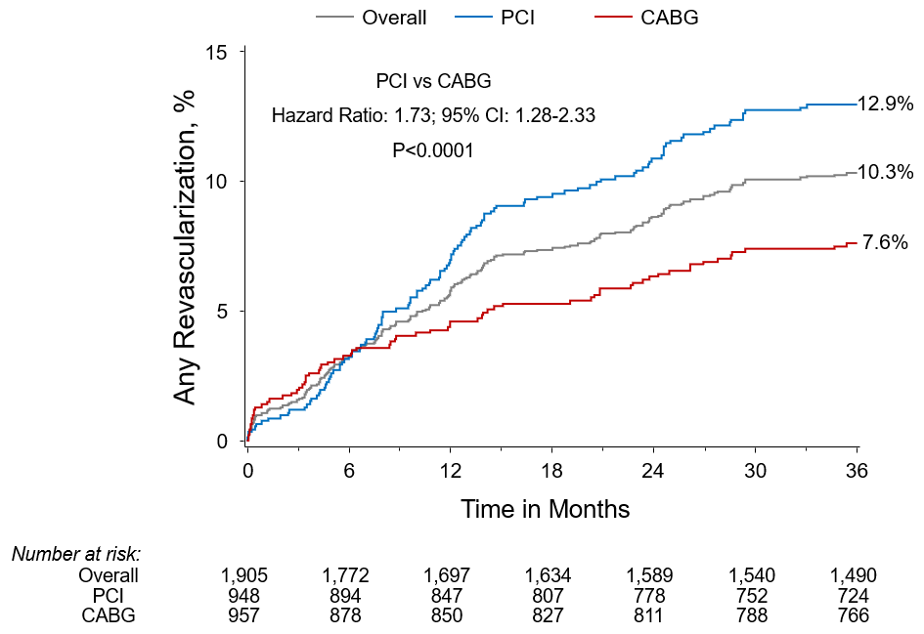

Figure 1B
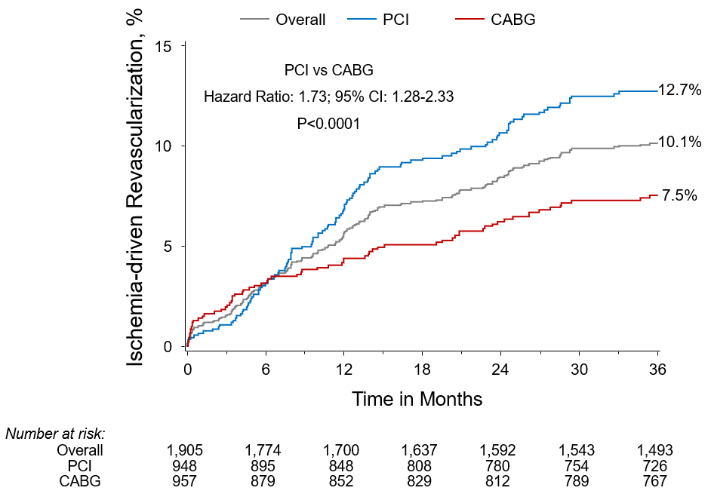

Figure 2A.
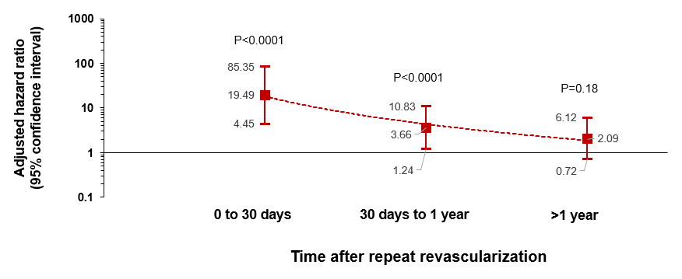

Figure 2B.

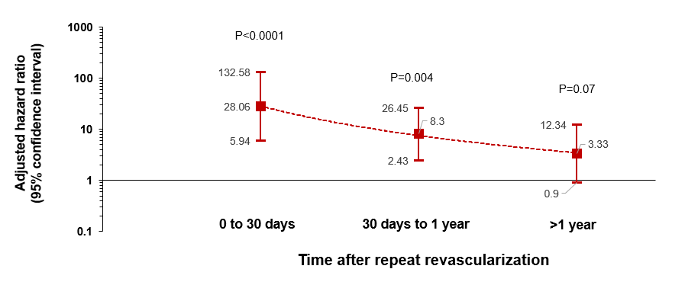

Figure 3A.
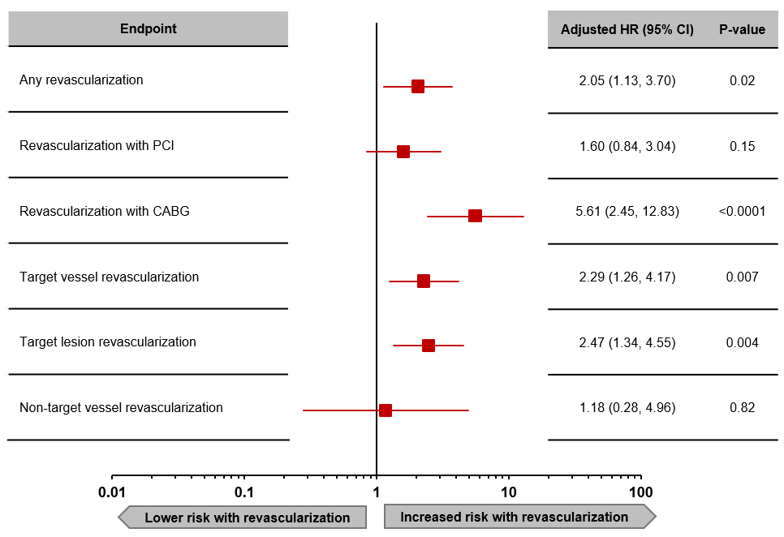

Figure 3B.
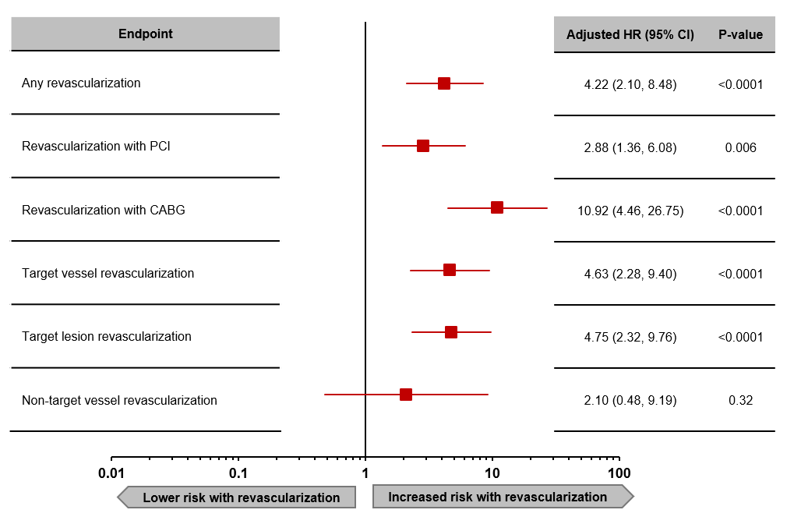

Figure 4A.
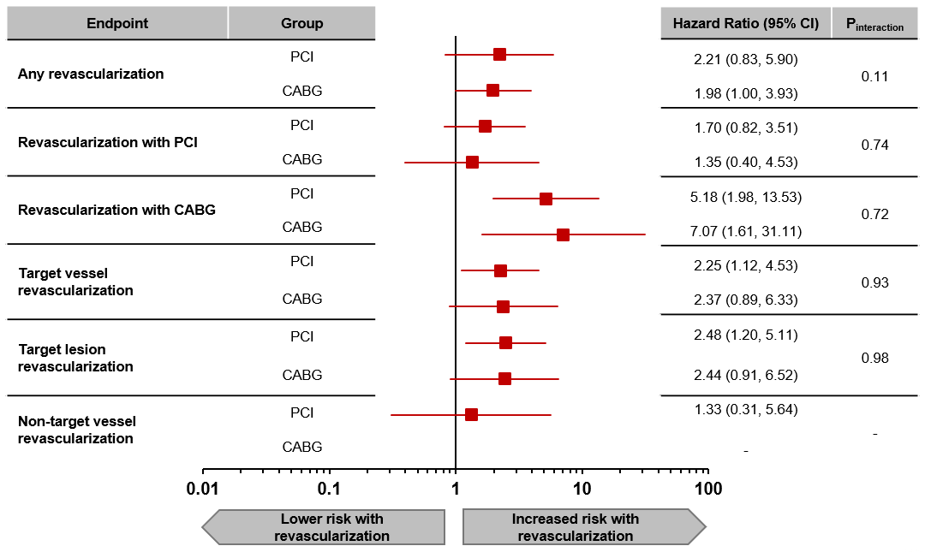

Figure 4B.
