TITLE
Initiation of adjuvant chemotherapy and trastuzumab for human epidermal growth receptor 2-positive early invasive breast cancer in a population-based cohort study of older women in England.

AUTHORS & AFFILIATIONS
Melissa Ruth Gannon (M.R.G.) ^{a b}, David Dodwell (D.D)^{c}, Yasmin Jauhari (Y.J.)^{b d}, Kieran Horgan (K.H.)^{e}, Karen Clements (K.C.)^{f}, Jibby Medina (J.M.)^{b}, and David Alan Cromwell (D.A.C.)^{a b}

ª Department of Health Services Research & Policy, London School of Hygiene & Tropical Medicine, London, UK
^{b} Clinical Effectiveness Unit, The Royal College of Surgeons of England, London, UK
^{c} Nuffield Department of Population Health, University of Oxford, Oxford, UK
^{d} St Georges Healthcare NHS Trust, London, UK
^{e} Department of Breast Surgery, St James’s University Hospital, Leeds, UK
^{f} National Cancer Registration and Analysis Service, Public Health England, 1st Floor, 5 St Philip’s Place, Birmingham, UK

Corresponding author:
Melissa Gannon
Email: melissa.gannon@lshtm.ac.uk
Postal address: London School of Hygiene & Tropical Medicine, 15-17 Tavistock Place, London, WC1H 9SH United Kingdom
Telephone: 020 7869 6603

Manuscript category: original article

ABSTRACT
Background
Clinical guidance on recommended treatment for older patients with breast cancer is often ambiguous, particularly in the context of comorbidities and poor functional status. Older patients, aged 70 years and over, account for a substantial proportion of women with breast cancer yet are underrepresented in randomised controlled trials. This paper investigates the initiation of adjuvant chemotherapy and trastuzumab in older patients in routine care.
Materials and Methods
Women, aged 50 years and over, newly diagnosed with human epidermal growth receptor 2 (HER2)-positive early invasive breast cancer from January 2014 to December 2017 were identified from the England Cancer Registry. Chemotherapy and trastuzumab use was obtained from the Systemic Anti-Cancer Therapy (SACT) dataset. Patient and tumour characteristics influential in treatment decision-making were included in multilevel mixed-effects logistic regression models.
Results
10% of women had HER2-positive tumours. Initiation of adjuvant chemotherapy and trastuzumab decreased with age from ≥70% among women aged 50-64 years to <15% among women aged 80+ years. Initiation varied additionally by tumour characteristics and number of comorbidities. Age remained a factor in treatment decisions despite favourable other factors, with lower use among women aged 70+ years. There was also marked variation across geographical regions.
Conclusions
In women with operable HER2-positive early invasive breast cancer, adjuvant chemotherapy plus trastuzumab was started less frequently as age increased, regardless of tumour characteristics or comorbidity burden. There was substantial variation in the proportion of women who started these treatments across the country.
Key words: HER2-positive, early breast cancer, adjuvant trastuzumab, older women, regional variation

- Introduction
Adjuvant (post-surgical) chemotherapy is a well-established treatment for early breast cancer, with evidence of its efficacy derived from multiple randomised controlled trials (RCTs) and subsequent meta-analyses.¹ In the UK, the National Institute for Health and Care Excellence (NICE) recommends that adjuvant treatment decisions should be based on a balance between the risks and benefits of chemotherapy, particularly in people with comorbidities.² For patients with human epidermal growth receptor 2 (HER2)-positive breast cancer, the HERceptin Adjuvant (HERA) trial demonstrated a strong efficacy benefit of trastuzumab, with a subsequent Cochrane review of eight RCTs reporting a hazard ratio (HR) of 0.66 for improvement in overall survival.^{3, 4} As such, the European Society of Medical Oncology (ESMO) guidelines recommend treatment with chemotherapy and trastuzumab, regardless of estrogen receptor (ER) status.⁵ This is echoed in the NICE guidelines and the American Society of Clinical Oncology (ASCO) guidelines as well as the International Society of Geriatric Oncology (SIOG) and European Society of Breast Cancer Specialists (EUSOMA) recommendations for the management of elderly patients with breast cancer.^{6-8, 2}

The randomised trials on which guidance is based largely under-represent patients aged 70 and over.^{9, 10} Specifically, the maximum age of patients enrolled into the eight RCTs providing evidence of the efficacy of trastuzumab was 80 years at the point of randomisation. This means that clinical guidelines for older patients are often less definitive than for their younger counterparts. A recent report from Cancer Research UK highlights a need for better evidence of treatment effectiveness in older patients.¹¹ Outside of the trial setting, age is a well-documented risk factor for receipt of non-standard treatment and there have been differences reported in the rates of access to treatments among older patients, with subsequent poorer outcomes.¹²⁻¹⁹

More than 50,000 women in England are diagnosed with breast cancer each year, with one third of cases occurring in women aged 70 and over.²⁰ With an ageing population, this number is projected to rise, increasing the need for evidence to support treatment use in older breast cancer populations.²¹ In a population where trials have been initiated and often failed to recruit^{22, 23}, an alternative approach is to use the wealth of routinely collected health data to evaluate the use of adjuvant therapies for breast cancer. Indeed a recent study in the United States used the Surveillance, Epidemiology and End Results (SEER)-Medicare linked dataset to investigate disparities in treatment provision, and reported that approximately a half of patients aged 65 years and older did not receive trastuzumab for Stage I-III HER2-positive breast cancer.²⁴ To our knowledge, there is no such study which has reported the prevalence of HER2-positive early breast cancer in older women and has identified predictors of adjuvant chemotherapy and trastuzumab use among such eligible women in a large population-based English cohort.

The aim of this study was to investigate the initiation of adjuvant chemotherapy and trastuzumab by age, in older women with HER2-positive early invasive breast cancer newly diagnosed and treated in England, to assess whether there is variation in the decision to use post-operative chemotherapy and trastuzumab across England. We did not consider the duration of adjuvant treatment, nor its impact on survival.

- Materials and Methods
2.1 Data
This population-based cohort study was undertaken as part of the National Audit of Breast Cancer in Older Patients (NABCOP). Data for this study are based on patient-level information collected by the National Health Service (NHS), as part of the care and support of patients with cancer. The data are collated, maintained and quality assured by the National Cancer Registration and Analysis Service (NCRAS), which is part of Public Health England (PHE). Cancer Registry data was provided, linked to the Cancer Outcomes and Services Dataset (COSD) for details of patient and tumour characteristics at diagnosis; the Hospital Episode Statistics (HES) database which captured all NHS hospital admissions, for details of surgical procedure; and the Systemic Anti-Cancer Therapy (SACT) data for full information on chemotherapy and trastuzumab. The study is exempt from UK National Research Ethics Committee approval as it involved secondary analysis of an existing dataset of pseudonymised data. The NABCOP has approval for processing health care information under Section 251 (reference number: 16/CAG/0079) for all NHS patients aged 50 years and over diagnosed with breast cancer in England and Wales.

2.2 Study population
Linked, pseudonymised patient records were provided for all women aged 50 years and over, with a new diagnosis of breast cancer between 1 January 2014 and 31 December 2017, diagnosed and treated within a NHS trust in England. For this analysis, we identified all women with HER2-positive early invasive breast cancer (ICD-10 code C50; stage 1-3A UICC TNM staging classification, 7th edition), who received primary surgery with no prior (i.e. neo-adjuvant) chemotherapy or trastuzumab. Women receiving neoadjuvant chemotherapy were not included, to avoid the possible inclusion of patients with locally advanced disease and to allow a better appreciation of the initiation of chemotherapy and trastuzumab in the context of pathological variables unaffected by any previous systemic therapy. Women were classified as having HER2-positive breast cancer where the HER2 status was reported as either positive or borderline but with a positive HER2-FISH (fluorescence in situ hybridization) or equivalent test result. Primary surgery was defined as either breast conserving surgery (BCS) or mastectomy that occurred within six months of diagnosis, and was identified from Office of Population Censuses and Surveys (OPCS) procedure codes entered within the HES patient records (see Appendix Table A1). Patients were allocated to the NHS trust where they were diagnosed. If this information was unavailable, the NHS trust of (1) surgery or (2) MDT was used.

2.3 Adjuvant chemotherapy and trastuzumab
The initiation of adjuvant chemotherapy and trastuzumab was identified primarily from the SACT dataset. Treatment with chemotherapy and trastuzumab was defined as adjuvant where the first cycle was started within six months following primary surgery. Records of chemotherapy administration within HES and the England Cancer Registry/COSD treatment files were examined where adjuvant chemotherapy was not reported in SACT.

2.4 Explanatory variables
The following patient and tumour characteristics were considered likely to inform treatment decisions: age at diagnosis (years), tumour stage (T1, T2, T3), nodal stage (N0, N1, N2), ER status (positive or negative), tumour grade (G1, G2, G3), social deprivation (1-5), number of comorbidities (0, 1, 2+) and performance status (0, 1, 2-4).

Social deprivation was measured using the Index of Multiple Deprivation (IMD) 2015 rank²⁵ which was derived from the patient’s postcode at diagnosis. The IMD rank was grouped into quintiles from most (group 1) to least (group 5) income deprived.

Comorbidity burden was defined using the Royal College of Surgeon’s Charlson Comorbidity Index.²⁶ This counts the presence of specific chronic medical conditions (excluding malignancy), identified using ICD-10 diagnosis codes within patient HES records for a period of two years prior to diagnosis.²⁷

2.5 Statistical analysis
The proportion of women who started adjuvant chemotherapy and trastuzumab was calculated for the overall cohort and within patient subgroups. The statistical significance of differences between group proportions was assessed using a t-test or chi-square test, as appropriate.

A multilevel mixed-effects logistic regression model was developed to describe the relationship between receipt of adjuvant chemotherapy / trastuzumab and the patient factors. The model included age at diagnosis, tumour stage, nodal stage, ER status, tumour grade, social deprivation, and number of comorbidities. A spline was used to describe the relationship between treatment and age, with a knot defined at age = 70 years. For women aged 50-69 years, the spline was simply a linear term; for women aged 70+ years, the spline also included a quadratic term. The model was found to have good prognostic performance, both in terms of its discrimination (concordance (C) statistic / ROC value of 0.846) and calibration (see appendix for plot; Figure A2). The proportions of women with different characteristics starting adjuvant chemotherapy / trastuzumab were predicted from the model as marginal effects (achieved using the margins command in Stata).

A multilevel model was used to account for the clustering of patients within NHS trusts and geographical regions (in which NHS trusts were aggregated into Cancer Alliances). Due to the relatively low levels of activity at NHS trust level, the multilevel model was limited to geographical region, with each Alliance fitted as a random intercept.²⁸ These represent differences between Alliances that are not explained by the patient factors in the model.

As these variables contained few missing values, we conducted a complete case analysis as the primary analysis. We conducted a sensitivity analysis in which categories of “unknown” were created where data items had missing, unintelligible or conflicting information.

- Results
Of 103,568 women, aged 50 years and over, diagnosed with early invasive breast cancer in England between January 2014 and December 2017, there were 10,109 (10%) with HER2-positive tumours. Prevalence of HER2-positive cancer was found to be slightly higher in younger women (those aged 50-69 years at diagnosis) at 11% compared with 8% among older women aged 70+ years. Of these, 7,471 women received primary surgery within six months of diagnosis (97% received surgery within three months after diagnosis), with no prior chemotherapy or trastuzumab. A final total of 6 780 women (91%) had data on the patient and tumour characteristics included in the regression models, and these complete cases formed the primary analysis. Full details of patient selection are shown in Figure A1.

Table 1 provides detail of patient and tumour characteristics for the cohort. Over two-thirds of patients had ER-positive cancers and one-third had malignant lymph nodes. Older women tended to have larger tumours and nodal involvement. Multiple comorbidities were also more prevalent. Overall, 60% (n = 4,051) of women were identified as having started adjuvant chemotherapy and trastuzumab (Table 2). As expected, there was greater initiation among women with higher grade tumours, and with higher T and N stage disease. Rates of treatment initiation fell as age increased, and were also lower among women with more comorbid conditions.

The pattern of initiation among women with different combinations of factors is described in Figure 1. It shows that tumour characteristics (T stage and ER status) seem to play a secondary role compared with the influence of patient age, even taking account of the presence of comorbidity. In particular, a lower proportion of older women started chemotherapy and trastuzumab, even where no comorbidity was recorded.

Figure 2 shows how the initiation of adjuvant chemotherapy and trastuzumab varied by age across the 22 geographical regions, after adjusting for the other patient factors. Among younger women (aged 50-69 years), there was considerable variation between the Alliances in the pattern of treatment. These differences continued among women aged 70-79 years before diminishing as the age at diagnosis increased further. Only among women aged 85+ years did the rates become more similar, being at a low level in all regions.

Among those women for whom chemotherapy and trastuzumab was initiated, use of anthracyclines was observed to vary by age, with use decreasing as age increased. Specifically, rates varied from 71% among women aged 50-59yrs; 64% among women aged 60-69yrs; 45% among women aged 70-79yrs; to 13% among women aged 80+yrs.

The results of the sensitivity analysis were similar to those in the primary analysis. Including those women with “unknown” information for the patient and tumour characteristics in the model did not change the conclusion that age has a strong, negative association with the initiation of adjuvant chemotherapy and trastuzumab, independent of other patient factors.

- Discussion
This study examined the initiation of adjuvant chemotherapy and trastuzumab among women with breast cancer, a therapy which clinical trials have proven to be effective, both in terms of delaying time to recurrence and lengthening overall survival. This study shows that the initiation of these therapies is high among younger women with HER2-positive early invasive breast cancer, a patient population that largely corresponds to the patients enrolled in the clinical trials. The analysis also shows lower rates of adjuvant chemotherapy and trastuzumab among the older patients. This could reflect the impact of reduced levels of patient fitness but the patterns of treatment were not wholly consistent with this interpretation. First, the initiation of adjuvant chemotherapy and trastuzumab among older women was observed to be low for those women with no comorbidity burden, and in spite of the fact that all women in the cohort were considered fit to have received surgery. Second, the initiation of such adjuvant treatment was observed to vary across geographical regions in England. This persisted after adjustment for measured patient and tumour characteristics suggesting further regional factors responsible for variation; these might include factors relating to work force, funding for adjuvant treatment and cultural differences in shared decision-making.

The findings in this study are in line with similar research in this setting, which has shown marked variation in the treatment of older women compared with younger women, both in terms of primary and adjuvant treatment.^{29, 15, 30, 24, 31} Several studies have been conducted in the United States using the SEER-Medicare dataset to look at disparity in the use of targeted therapy for breast cancer along with other treatments such as surgery and radiotherapy. In 2013, an analysis published by Reeder-Hayes et al found that among women with HER2-positive early breast cancer, who were aged 85+, years 15% received adjuvant trastuzumab, compared with 60% of women aged 65-74 years.²⁴ An earlier study in 2010 looking at variation in initial treatments received, by Schonberg et al, found that among women diagnosed with early (stage I-II) breast cancer, the effect of age on receipt of treatment was stronger than the effect of a patient having multiple comorbidities.¹⁵ This mirrors the findings from an integrated health care system, reported by Enger et al in 2010, highlighting women aged 80+ years were nearly six times more likely to receive non-standard treatment for Stage I-II breast cancer, when compared to women aged 65-69 years.²⁹ Considering studies conducted in England, an analysis of all women presenting with primary invasive breast cancer in 2007, found that after the age of 70 years women were increasingly less likely to receive surgery.³⁰ A more recent study, concentrating on two English cancer registry areas, found that among women aged 70-79 years with stage I-III (or unknown) breast cancer treated with surgery for each additional year of age, over the age of 70, the odds of receiving chemotherapy reduced by 24%.³¹

The study has a number of strengths. It used a large, population-based sample, including women diagnosed over a period of four years. Additionally, the data related to women diagnosed within the last five years and so reflects current treatment patterns. Finally, the dataset contained sufficient patient and tumour characteristics associated with treatment decisions to produce a regression model with good discrimination and calibration.

There are various limitations of this study. Of primary concern is the completeness and accurate reporting of adjuvant treatments within the SACT database. Among women aged 50-69 years with HER2-positive early invasive breast cancer who received surgery, 76% were recorded to have received any drug treatment. There is potential for under-reporting. The SACT database does not include treatments delivered in private hospitals, although this corresponds to a small proportion of care within England. Case-ascertainment may also be incomplete from some NHS trusts. This might have lowered the recorded absolute rates of use but there is no reason to believe it would produce either the strong association with age or the extent of the regional variation. The proportion of women considered to have received adjuvant chemotherapy and trastuzumab included 803/4,051 (20%) women for whom only adjuvant chemotherapy was reported in SACT, along with a further 98/4,051 (2%) women for whom only adjuvant trastuzumab was reported in SACT. Including these 803 women in the surgery-only group as a sensitivity analysis made no difference to the findings. Of those 98 women with only trastuzumab details reported in SACT, investigation from other sources including HES and COSD/England Cancer Registry suggested that 82/98 (84%) of such women received adjuvant chemotherapy within six months of surgery. Additionally, it is noted that SACT provides data on prescribed therapies meaning there may be patients considered in this analysis as having started adjuvant therapy where they did not receive it; however as this study aimed to look at variation around treatment decisions the data provided is informative.

Another concern is the potential for errors in patient and tumour characteristics within the England Cancer Registry and COSD datasets. The cancer registration service has various validation steps when compiling the national registration data and the overall effect of coding errors should be small. It is also possible that differing indications for the use of neoadjuvant therapy between trusts over time may have affected the risk profiles of patients being considered for post-operative systemic therapies.

Previous research findings have also noted the impact of unmeasured factors in receipt of treatment and that, in order to fully measure variation in treatment utilisation, the potential confounding effect of factors such as patient choice should be adjusted for.³² The study described here was unable to include all patient factors that influence treatment decisions, such as performance status, expected tolerability of treatment, patient frailty, and preference.³³⁻³⁵ Omission of these factors from the regression model would reduce its level of discrimination. However, putative differences in the prevalence of these characteristics among NHS trusts are unlikely to account for the large variation observed between regions.

- Conclusions
The findings of this study show that fewer older women with operable HER2-positive early breast cancer start the most targeted oncological systemic treatment. While the initiation of adjuvant chemotherapy was observed to vary by tumour characteristics, these factors did not seem to be the dominant reason as to why a patient did not start chemotherapy and trastuzumab. Instead, the rates were strongly associated with age at diagnosis independent of these clinical factors and the presence of comorbidities. This fact, together with the variation in the initiation of adjuvant chemotherapy across regions, suggests there is a need for breast cancer teams to review chemotherapy provision and the criteria for selecting patients. This may lead to a reduction in the unexplained variation in the initiation of adjuvant treatment in older women.

TABLES
Table 1: Patient and tumour characteristics in women with HER2-positive, invasive early breast cancer, diagnosed in NHS trusts in England between January 2014 and December 2017 and receiving primary surgery, overall and by age at diagnosis.
Characteristic | All patients | 50-69 years | 70+ years | P-value
 | N (%) | N (%) | N (%) | (chi-squared test)
 | N = 6780 | N = 4630 | N = 2150 | -
Stage at diagnosis
Stage 1 | 3015 (44%) | 2318 (50%) | 697 (32%) | p<0.0001
Stage 2 | 3246 (48%) | 2029 (44%) | 1217 (57%)
Stage 3A | 519 (8%) | 283 (6%) | 236 (11%)
T stage
T1 | 3630 (54%) | 2776 (60%) | 697 (32%) | p<0.0001
T2 | 2903 (43%) | 1722 (37%) | 1217 (57%)
T3 | 247 (4%) | 132 (3%) | 236 (11%)
N stage
N0 | 4613 (68%) | 3263 (70%) | 1350 (63%) | p<0.0001
N1 | 1736 (26%) | 1135 (25%) | 601 (28%)
N2 | 431 (6%) | 232 (5%) | 199 (9%)
ER status
Positive | 4875 (72%) | 3433 (74%) | 1442 (67%) | p<0.0001
Negative | 1905 (28%) | 1197 (26%) | 708 (33%)
Tumour grade
G1 | 218 (3%) | 162 (3%) | 56 (3%) | p<0.0001
G2 | 2703 (40%) | 1936 (42%) | 767 (36%)
G3 | 3859 (57%) | 2532 (55%) | 1327 (62%)
Charlson Comorbidity Index
0 | 5936 (88%) | 4204 (91%) | 1732 (81%) | p<0.0001
1 | 613 (9%) | 327 (7%) | 286 (13%)
2+ | 231 (3%) | 99 (2%) | 132 (6%)
IMD quintiles
1 - most deprived | 1025 (15%) | 721 (16%) | 304 (14%) | p=0.218
2 | 1227 (18%) | 852 (18%) | 375 (17%)
3 | 1376 (20%) | 915 (20%) | 461 (21%)
4 | 1594 (24%) | 1095 (24%) | 499 (23%)
5 - least deprived | 1558 (23%) | 1047 (23%) | 511 (24%)

Table 2: Proportion of women receiving adjuvant chemotherapy and trastuzumab, by baseline characteristic; odds ratios (OR) from multilevel mixed-effects (MLME) logistic regression models.
Characteristic | Number of patients | % receiving chemotherapy and trastuzumab | Unadjusted OR* (95% CI) | Adjusted OR* (95% CI) | Grouped  p-value
 | 6780 | 60% | - | -
Age Groups – 5-year bands
50–54 yrs | 1221 | 76% | 1.00 | -
55–59 yrs | 1110 | 74% | 0.92 (0.75-1.13) | -
60–64 yrs | 1095 | 70% | 0.70 (0.57-0.86) | -
65–69 yrs | 1204 | 63% | 0.50 (0.41-0.60) | -
70–74 yrs | 820 | 57% | 0.37 (0.30-0.46) | -
75–79 yrs | 660 | 36% | 0.14 (0.11-0.18) | -
80–84 yrs | 428 | 14% | 0.03 (0.02-0.05) | -
85+ yrs | 242 | 1% | 0.00 (0.00-0.01) | -
Age (continuous)
Age spline: 50–69 yrs | - | - | - | 0.95 (0.94-0.96) | <0.0001
Age spline: 70+ yrs | - | - | - | 0.89 (0.84-0.95) | <0.0001
Squared age spline 70+ yrs | - | - | - | 0.99 (0.98-0.99) | <0.0001
T stage
T1 | 3630 | 59% | 1.00 | 1.00 | <0.0001
T2 | 2903 | 60% | 1.11 (1.00-1.24) | 1.43 (1.25-1.63)
T3 | 247 | 64% | 1.23 (0.93-1.64) | 1.89 (1.30-2.74)
N stage
N0 | 4613 | 57% | 1.00 | 1.00 | <0.0001
N1 | 1736 | 65% | 1.52 (1.34-1.72) | 1.64 (1.41-1.90)
N2 | 431 | 68% | 1.63 (1.30-2.04) | 2.46 (1.84-3.30)
ER status
Positive | 4875 | 59% | 1.00 | 1.00 | <0.0001
Negative | 1905 | 63% | 1.27 (1.13-1.42) | 1.41 (1.22-1.63)
Tumour grade
G1 | 218 | 35% | 0.23 (0.17-0.31) | 0.17 (0.12-0.23) | <0.0001
G2 | 2703 | 53% | 0.57 (0.51-0.64) | 0.49 (0.43-0.55)
G3 | 3859 | 66% | 1.00 | 1.00
Charlson Comorbidity Index
0 | 5936 | 62% | 1.00 | 1.00 | <0.0001
1 | 613 | 46% | 0.49 (0.41-0.59) | 0.68 (0.55-0.85)
2+ | 231 | 32% | 0.26 (0.19-0.35) | 0.34 (0.24-0.49)
IMD quintiles
1 - most deprived | 1025 | 59% | 1.00 | 1.00 | 0.0201
2 | 1227 | 59% | 1.04 (0.86-1.25) | 1.10 (0.89-1.36)
3 | 1376 | 59% | 1.14 (0.95-1.37) | 1.34 (1.08-1.66)
4 | 1594 | 61% | 1.23 (1.03-1.47) | 1.35 (1.09-1.66)
5 - least deprived | 1558 | 60% | 1.16 (0.97-1.39) | 1.29 (1.04-1.60)
* MLME model with NHS trust as the cluster level.

List of Figures
Figure 1: Predicted use of adjuvant chemotherapy and trastuzumab, from a multilevel mixed-effects logistic regression model, across four patient and tumour characteristics.
 |  | ER-positive |  |  | ER-negative
Age at diagnosis |  | Charlson comorbidity score |  |  | Charlson comorbidity score
 | T stage | 0 | 1 | 2+ | 0 | 1 | 2+
55 yrs | T1 | 73% | 67% | 53% | 79% | 73% | 60%
 | T2 | 79% | 73% | 60% | 83% | 78% | 67%
 | T3 | 83% | 77% | 66% | 87% | 82% | 72%
65 yrs | T1 | 64% | 57% | 43% | 71% | 64% | 50%
 | T2 | 71% | 64% | 50% | 76% | 70% | 57%
 | T3 | 76% | 69% | 56% | 81% | 75% | 63%
75 yrs | T1 | 46% | 39% | 26% | 53% | 45% | 32%
 | T2 | 54% | 46% | 32% | 61% | 53% | 39%
 | T3 | 59% | 52% | 38% | 66% | 59% | 44%
85 yrs | T1 | 5% | 4% | 2% | 7% | 5% | 3%
 | T2 | 7% | 5% | 3% | 10% | 7% | 4%
 | T3 | 9% | 7% | 4% | 12% | 9% | 5%
Note: Higher percentages are shown in dark blue with a gradient down to light blue for lowest percentages.
N stage, grade and IMD included at overall means.
Note: Predictions based on women diagnosed between 2014 and 2017 and derived from a multilevel mixed-effects logistic regression model shown in Table 2.

Figure 2: Predicted use of adjuvant chemotherapy and trastuzumab, from a multilevel mixed-effects logistic regression model, by age at diagnosis within English geographical regions.
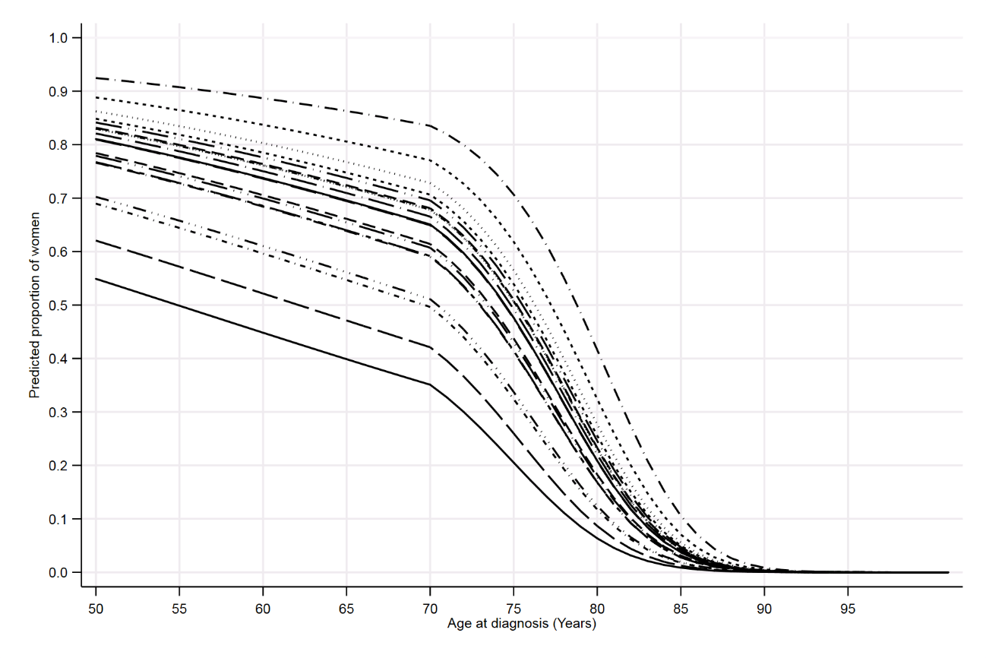
Note: Each line in the above figure is a geographical region within England, defined based on Cancer Alliance. Predictions based on women diagnosed between 2014 and 2017 and derived from a multilevel mixed-effects logistic regression model shown in Table 2.

Additional Information
Ethics approval and consent to participate
The study is exempt from UK National Research Ethics Committee approval as it involved secondary analysis of an existing dataset of pseudonymised data. The NABCOP has approval for processing health care information under Section 251 (reference number: 16/CAG/0079) for all NHS patients aged 50 years and over diagnosed with breast cancer in England and Wales.

Consent for publication
Not applicable.

Availability of data and material
Data for this study are based on patient-level information collected by the NHS, as part of the care and support of cancer patients. The data are collated, maintained and quality assured by the National Cancer Registration and Analysis Service (NCRAS), which is part of Public Health England (PHE). No additional data are available. Data on English cancer registrations can be accessed via the Office for Data Release at Public Health England. https://www.gov.uk/government/publications/accessing-public-health-england-data/about-the-phe-odr-and-accessing-data.

Conflicts of interest
None.

Funding
This study was undertaken as part of the work by the National Audit of Breast Cancer in Older Patients (NABCOP). The Audit is commissioned by the Healthcare Quality Improvement Partnership (HQIP) as part of the National Clinical Audit and Patient Outcomes Programme, and funded by NHS England and the Welsh Government (www.hqip.org.uk/national-programmes). Neither the commissioner nor the funders had any involvement in the study design; in the collection, analysis, and interpretation of data; in the writing of the manuscript; or in the decision to submit the article for publication. The authors had full independence from the HQIP. The aim of the NABCOP is to evaluate the care of older women with breast cancer in England and Wales, and support NHS providers to improve the quality of hospital care for these women. More information can be found at www.nabcop.org.uk.

Authors’ contributions
M.R.G., D.D., and D.A.C were responsible for study design. M.R.G. conducted the statistical analyses and drafted the manuscript. All authors were involved in data interpretation, critical appraisal of the draft manuscript and gave final approval on the version to be published.

REFERENCES
1. EBCTCG. Effects of chemotherapy and hormonal therapy for early breast cancer on recurrence and 15-year survival: an overview of the randomised trials. Lancet. 2005;365(9472):1687-717. Epub 2005/05/17.
2. NICE. Early and locally advanced breast cancer: diagnosis and management.2018. Available from: www.nice.org.uk/guidance/ng101.
3. Piccart-Gebhart MJ, Procter M, Leyland-Jones B, Goldhirsch A, Untch M, Smith I, et al. Trastuzumab after adjuvant chemotherapy in HER2-positive breast cancer. The New England journal of medicine. 2005;353(16):1659-72. Epub 2005/10/21.
4. Moja L, Tagliabue L, Balduzzi S, Parmelli E, Pistotti V, Guarneri V, et al. Trastuzumab containing regimens for early breast cancer. The Cochrane database of systematic reviews. 2012(4):CD006243. Epub 2012/04/20.
5. Senkus E, Kyriakides S, Ohno S, Penault-Llorca F, Poortmans P, Rutgers E, et al. Primary breast cancer: ESMO Clinical Practice Guidelines for diagnosis, treatment and follow-up. Annals of oncology : official journal of the European Society for Medical Oncology. 2015;26 Suppl 5:v8-30. Epub 2015/09/01.
6. Biganzoli L, Wildiers H, Oakman C, Marotti L, Loibl S, Kunkler I, et al. Management of elderly patients with breast cancer: updated recommendations of the International Society of Geriatric Oncology (SIOG) and European Society of Breast Cancer Specialists (EUSOMA). The Lancet Oncology. 2012;13(4):e148-60. Epub 2012/04/04.
7. Denduluri N, Somerfield MR, Eisen A, Holloway JN, Hurria A, King TA, et al. Selection of Optimal Adjuvant Chemotherapy Regimens for Human Epidermal Growth Factor Receptor 2 (HER2) –Negative and Adjuvant Targeted Therapy for HER2-Positive Breast Cancers: An American Society of Clinical Oncology Guideline Adaptation of the Cancer Care Ontario Clinical Practice Guideline. Journal of Clinical Oncology. 2016;34(20):2416-27.
8. Giordano SH, Temin S, Chandarlapaty S, Crews JR, Esteva FJ, Kirshner JJ, et al. Systemic Therapy for Patients With Advanced Human Epidermal Growth Factor Receptor 2-Positive Breast Cancer: ASCO Clinical Practice Guideline Update. Journal of clinical oncology : official journal of the American Society of Clinical Oncology. 2018;36(26):2736-40. Epub 2018/06/26.
9. Hutchins LF, Unger JM, Crowley JJ, Coltman CA, Jr., Albain KS. Underrepresentation of patients 65 years of age or older in cancer-treatment trials. The New England journal of medicine. 1999;341(27):2061-7. Epub 1999/12/30.
10. Ludmir EB, Mainwaring W, Lin TA, Miller AB, Jethanandani A, Espinoza AF, et al. Factors Associated With Age Disparities Among Cancer Clinical Trial Participants. JAMA oncology. 2019. Epub 2019/06/04.
11. CRUK. Advancing Years: Treating and Caring for an Ageing Population.2018. Available from: www.cancerresearchuk.org/about-us/we-develop-policy/our-policy-on-access-to-cancer-treatments/treating-and-caring-for-an-ageing-population
12. Bouchardy C, Rapiti E, Fioretta G, Laissue P, Neyroud-Caspar I, Schafer P, et al. Undertreatment strongly decreases prognosis of breast cancer in elderly women. Journal of clinical oncology : official journal of the American Society of Clinical Oncology. 2003;21(19):3580-7. Epub 2003/08/13.
13. Lavelle K, Todd C, Moran A, Howell A, Bundred N, Campbell M. Non-standard management of breast cancer increases with age in the UK: a population based cohort of women > or =65 years. British journal of cancer. 2007;96(8):1197-203. Epub 2007/03/28.
14. Ring A. The influences of age and co-morbidities on treatment decisions for patients with HER2-positive early breast cancer. Critical reviews in oncology/hematology. 2010;76(2):127-32. Epub 2010/01/26.
15. Schonberg MA, Marcantonio ER, Li D, Silliman RA, Ngo L, McCarthy EP. Breast cancer among the oldest old: tumor characteristics, treatment choices, and survival. Journal of clinical oncology : official journal of the American Society of Clinical Oncology. 2010;28(12):2038-45. Epub 2010/03/24.
16. Foot C, Harrison T. How to improve cancer survival: Explaining England's relatively poor rates.2011. Available from: www.kingsfund.org.uk/sites/default/files/How-to-improve-cancer-survival-Explaining-England-poor-rates-Kings-Fund-June-2011.pdf.
17. Lavelle K, Sowerbutts AM, Bundred N, Pilling M, Degner L, Stockton C, et al. Is lack of surgery for older breast cancer patients in the UK explained by patient choice or poor health? A prospective cohort study. British journal of cancer. 2014;110(3):573-83. Epub 2013/12/03.
18. Public Health England and Association of Breast Surgery: An audit of screen detected breast cancers for the year of screening April 2013 to March 2014. 2015. Available from: https://associationofbreastsurgery.org.uk/media/1108/nhs-bsp-abs-audit-2013-14.pdf.
19. Mislang AR, Biganzoli L. Adjuvant Systemic Therapy in Older Breast Cancer Women: Can We Optimize the Level of Care? Cancers. 2015;7(3):1191-214. Epub 2015/07/08.
20. ONS. Cancer registration statistics, England. 2017.
21. The Lancet O. Not old, just older: considering age in cancer care. The Lancet Oncology. 2019;20(7):887. Epub 2019/07/04.
22. Leonard R, Ballinger R, Cameron D, Ellis P, Fallowfield L, Gosney M, et al. Adjuvant chemotherapy in older women (ACTION) study - what did we learn from the pilot phase? British journal of cancer. 2011;105(9):1260-6. Epub 2011/10/13.
23. Crivellari D, Gray KP, Dellapasqua S, Puglisi F, Ribi K, Price KN, et al. Adjuvant pegylated liposomal doxorubicin for older women with endocrine nonresponsive breast cancer who are NOT suitable for a "standard chemotherapy regimen": the CASA randomized trial. Breast. 2013;22(2):130-7. Epub 2013/03/05.
24. Reeder-Hayes K, Peacock Hinton S, Meng K, Carey LA, Dusetzina SB. Disparities in Use of Human Epidermal Growth Hormone Receptor 2-Targeted Therapy for Early-Stage Breast Cancer. Journal of clinical oncology : official journal of the American Society of Clinical Oncology. 2016;34(17):2003-9. Epub 2016/04/14.
25. The English Indices of Deprivation 2015 Statistical Release.2015. Available from: www.gov.uk/government/statistics/english-indices-of-deprivation-2015.
26. Armitage JN, van der Meulen JH. Identifying co-morbidity in surgical patients using administrative data with the Royal College of Surgeons Charlson Score. The British journal of surgery. 2010;97(5):772-81. Epub 2010/03/23.
27. Preen DB, Holman CD, Spilsbury K, Semmens JB, Brameld KJ. Length of comorbidity lookback period affected regression model performance of administrative health data. Journal of clinical epidemiology. 2006;59(9):940-6. Epub 2006/08/10.
28. Macmillan. Cancer Alliances: a crucial first step.2015. Available from: www.macmillan.org.uk/documents/campaigns/canceralliancesreport.pdf
29. Enger SM, Thwin SS, Buist DS, Field T, Frost F, Geiger AM, et al. Breast cancer treatment of older women in integrated health care settings. Journal of clinical oncology : official journal of the American Society of Clinical Oncology. 2006;24(27):4377-83. Epub 2006/09/20.
30. Bates T, Evans T, Lagord C, Monypenny I, Kearins O, Lawrence G. A population based study of variations in operation rates for breast cancer, of comorbidity and prognosis at diagnosis: failure to operate for early breast cancer in older women. European journal of surgical oncology : the journal of the European Society of Surgical Oncology and the British Association of Surgical Oncology. 2014;40(10):1230-6. Epub 2014/08/02.
31. Ward SE, Holmes GR, Ring A, Richards PD, Morgan JL, Broggio JW, et al. Adjuvant Chemotherapy for Breast Cancer in Older Women: An Analysis of Retrospective English Cancer Registration Data. Clin Oncol (R Coll Radiol). 2019;31(7):444-52. Epub 2019/05/28.
32. Lavelle K, Downing A, Thomas J, Lawrence G, Forman D, Oliver SE. Are lower rates of surgery amongst older women with breast cancer in the UK explained by co-morbidity? British journal of cancer. 2012;107(7):1175-80. Epub 2012/08/11.
33. Mandelblatt JS, Sheppard VB, Hurria A, Kimmick G, Isaacs C, Taylor KL, et al. Breast cancer adjuvant chemotherapy decisions in older women: the role of patient preference and interactions with physicians. Journal of clinical oncology : official journal of the American Society of Clinical Oncology. 2010;28(19):3146-53. Epub 2010/06/03.
34. Handforth C, Clegg A, Young C, Simpkins S, Seymour MT, Selby PJ, et al. The prevalence and outcomes of frailty in older cancer patients: a systematic review. Annals of oncology : official journal of the European Society for Medical Oncology. 2015;26(6):1091-101. Epub 2014/11/19.
35. Brain E, Caillet P, de Glas N, Biganzoli L, Cheng K, Lago LD, et al. HER2-targeted treatment for older patients with breast cancer: An expert position paper from the International Society of Geriatric Oncology. Journal of geriatric oncology. 2019. Epub 2019/06/27.

APPENDIX

Table A1: Description of OPCS codes used to define surgical procedure.
OPCS Code | Description
Mx Excision codes
B27.1 | Total Mx and excision of both pectoral muscles and part of chest wall.
B27.2 | Total Mx and excision of both pectoral muscles NEC.
B27.3 | Total Mx and excision of pec minor.
B27.4 | Total Mx NEC (incl simple mastectomy.)
B27.5 | Subcutaneous Mastectomy.
B27.6 | Skin sparing mastectomy
B27.8 | Other specified total excision of breast
B27.9 | Unspecified total excision of breast
BCS Excision codes
B28.1 | Quadrantectomy of breast
B28.2 | Partial excision of breast NEC
B28.3 | Excision of lesion of breast NEC
B28.5 | Wire guided partial excision of breast
B28.7 | Wire guided excision of lesion of breast
B28.8 | Other specified other excision of breast
B28.9 | Unspecified other excision of breast

Figure A1: Details of patient selection from women aged 50 and over, diagnosed with early invasive breast cancer in a NHS trust in England, between January 2014 and December 2017.
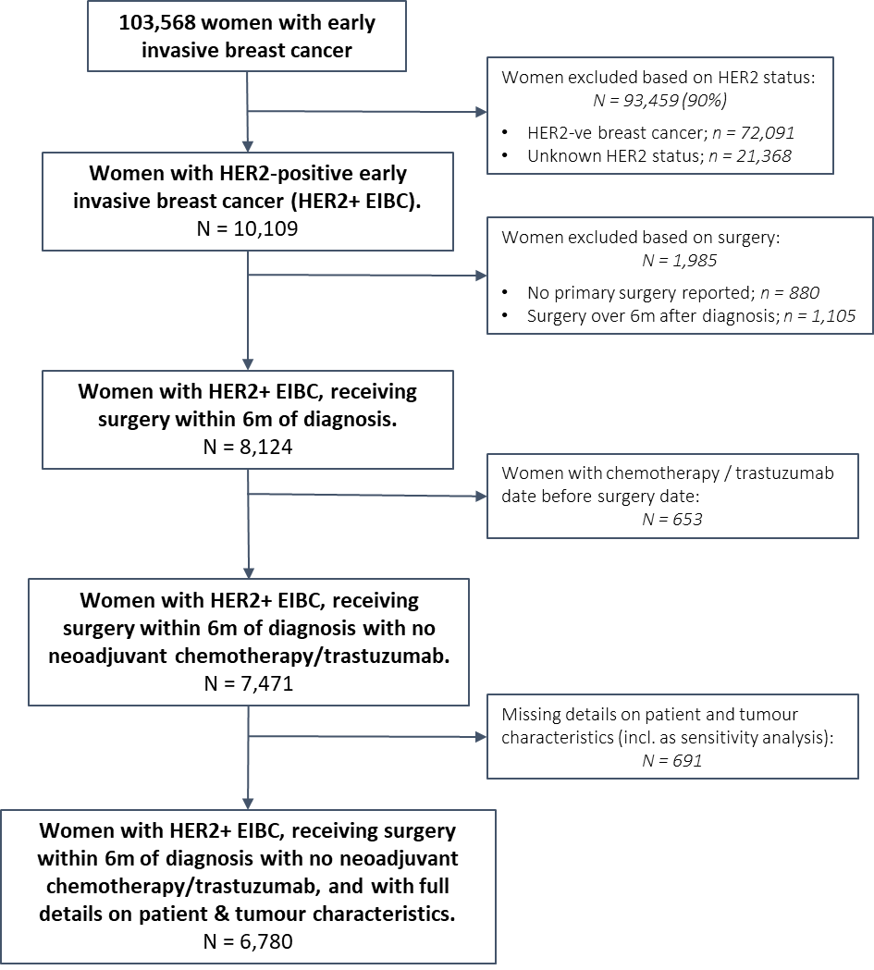

Figure A2: Calibration of prognostic multilevel mixed-effects logistic regression model by levels of predicted risk
