**Table 1.** Characteristics of included studies.

| **Author and year** | **Analytic method** | **Epistemological orientation** | **Data used** | **Study *n*** | **Format** | **Geography** | **Study timeline** | **Places discussed** | **Specific drug?** | **Specific population?** |
| --- | --- | --- | --- | --- | --- | --- | --- | --- | --- | --- |
| Bauermeister, 2007 | Thematic analysis | None stated | Semi-structured face-to-face interviews | 16 | Journal article | San Francisco, CA | 2003-2004 | Dance clubs, sex clubs, gay bars | None stated | Latino gay men |
| Brown et al., 2000 | Unclear | None stated | Face-to-face and online focus groups and interviews | 16 | Monograph | Toronto | Spring 2000 | Dance clubs | None stated | Party attenders |
| Caceres & Cortinas, 1996 | Grounded theory, ethnography | Social constructionist | Observation, interviews, historical research | None | Journal article | San Francisco, CA | Sep-Dec 1992 | Latino gay bar | Alcohol | Latinos |
| Elwood & Williams, 1998 | Grounded theory | Theory of reasoned action | Structured face-to-face interviews | 41 | Journal article | Houston, TX | Dec 1995-Feb 1996 | Bathhouses | None stated | Bathhouse users |
| Green, 2003 | Grounded theory | None stated | Semi-structured face-to-face interviews | 59 | Journal article | New York City | Sep 2000-Nov 2001 | Dance clubs, sex clubs, gay bars | Club drugs | None stated |
| Green & Halkitis, 2006 | Grounded theory | None stated | Semi-structured face-to-face interviews | 49 | Journal article | New York City | Jan-Feb 2001 | Circuit parties, bathhouses, dance clubs, gay bars | Crystal meth | Report recent meth use and sex |
| Greenspan et al., 2011; Husbands et al., 2004 | Thematic analysis | None stated | Semi-structured face-to-face interviews | 74 | Monograph, journal article | Toronto | Jun-Nov 2003 | Dance clubs | Club drugs | Racially diverse clubgoers reporting club drug use |
| Ireland et al., 1999 | Grounded theory | None stated per se, but interpretive epistemology (Finch 1988) cited | Semi-structured face-to-face interviews | 20 | Monograph | Sydney | 1997-1998 | Gay clubs, dance parties | None stated | MSM living with symptomatic HIV, asymptomatic HIV, or without HIV; injecting and non-injecting drug use |
| Klitzman, 2006 | Grounded theory | None stated | Semi-structured face-to-face interviews | 12 | Journal article | New York City | 1999-2001 | Gay clubs, circuit parties | MDMA | MDMA users |
| Lewis & Ross, 1995 | Grounded theory | Social constructionist | Semi-structured face-to-face interviews | 16 | Journal article | Sydney | 1991-1993 | Dance parties | Club drugs, alcohol | Partygoers reporting club drug use |
| Natale, 2008 | Ethnography | None stated | Structured face-to-face interviews, focus groups | 94 | Journal article | Denver, CO | Apr-Jul 2004 | Bathhouses, gay bars | None stated | Highest risk: Black, Latino, MSM living with HIV |
| O’Byrne & Holmes, 2011a, 2011b; O’Byrne, 2009, 2011 | Thematic analysis, ethnography | Deleuze & Guattari, Foucault | Semi-structured face-to-face interviews, observation | 17 | Dissertation, journal articles | Ottawa, Montréal, Toronto | 2007 | Circuit parties | None stated | Circuit party attendees |
| Slavin, 2004 | Ethnography | Bourdieu, De Certeau | Observation, interviews | 1 | Journal article | Sydney | Sep 2000-Sep 2002 | Dance clubs | None stated | "Grunge" subculture |
| Southgate & Hopwood, 1999b | Unclear | None stated | Focus group, interviews, textual analysis | 67 | Monograph | Sydney | mid-1997-late 1998 | Dance clubs | None stated | Drug users |
| Southgate & Hopwood, 1999a | Discourse analysis | None stated | Letters to the editor | None | Journal article | Sydney | late 1992-early 1993 | Mardi Gras circuit party | None stated | None stated |
| Weems, 2007, 2008 | Ethnography | Somatic studies, Butler | Observation, interviews, historical research | None | Dissertation | North America | 1998-2007 | Circuit parties | None stated | None stated |
| Westhaver, 2003, 2005, 2006 | Ethnography | Butler, Bourdieu, Honneth | Observation, interviews, participation | 35 parties; 17 interviews | Dissertation, journal articles | North America | 1998-2002 | Circuit parties | None stated | None stated |
| Wilson, 2004 | Grounded theory | Cognitive distancing (McKirnan et al.) | Semi-structured face-to-face interviews | 38 | Dissertation | New York, Los Angeles, San Francisco, Denver, Salt Lake City | Unclear | Dance clubs, sex clubs, gay bars | Crystal meth | Latino MSM |

**Table 2.** Critical appraisal of included projects.

| **Author and year** | **Steps taken to increase rigour in sampling?\*** | **Steps taken to increase rigour in data collected?\*** | **Steps taken to increase rigour in analysis?\*** | **Findings grounded, supported by data?°** | **Breadth. depth in findings?⌃** | **Study privileges MSM perspectives, experiences?•** | **Researcher's perspective**  **shaped data collection and analysis?•** | **Ethical issues taken into consideration?•** | **Weight of study findings’ reliability, trustworthiness?§** | **Weight of study findings' usefulness?§** |
| --- | --- | --- | --- | --- | --- | --- | --- | --- | --- | --- |
| Bauermeister, 2007 | ++ | + | ++ | ++ | ++ | ++ | - | +++ | + | ++ |
| Brown et al., 2000 | + | - | + | - | +/- | ++ | - | - | - | - |
| Caceres & Cortinas, 1996 | +++ | +++ | ++ | + | -/+ | ++ | + | - | ++ | + |
| Elwood & Williams, 1998 | + | + | +++ | + | +/- | ++ | - | + | + | - |
| Green, 2003 | +++ | - | - | ++ | ++ | ++ | - | - | + | ++ |
| Green & Halkitis, 2006 | ++ | +++ | +++ | ++ | ++ | ++ | - | + | ++ | + |
| Greenspan et al., 2011; Husbands et al., 2004 | ++ | + | + | ++ | ++ | ++ | - | + | + | ++ |
| Ireland et al., 1999 | +++ | +++ | +++ | ++ | ++ | +++ | ++ | +++ | ++ | ++ |
| Klitzman, 2006 | + | ++ | +++ | ++ | ++ | ++ | - | - | + | + |
| Lewis & Ross, 1995 | ++ | +++ | + | ++ | +/- | ++ | - | +++ | + | ++ |
| Natale, 2008 | +++ | +++ | +++ | ++ | +/- | +++ | - | +++ | ++ | + |
| O’Byrne & Holmes, 2011a, 2011b; O’Byrne, 2009, 2011 | +++ | +++ | +++ | ++ | ++ | +++ | +++ | +++ | ++ | ++ |
| Slavin, 2004 | +++ | +++ | +++ | ++ | ++ | +++ | +++ | +++ | ++ | ++ |
| Southgate & Hopwood, 1999b | + | - | - | + | +/- | + | - | + | - | - |
| Southgate & Hopwood, 1999a | - | - | - | - | +/- | + | - | - | - | - |
| Weems, 2007, 2008 | - | - | - | + | +/- | + | +++ | + | - | - |
| Westhaver, 2003, 2005, 2006 | ++ | ++ | + | ++ | ++ | +++ | +++ | +++ | + | + |
| Wilson, 2004 | +++ | +++ | ++ | + | +/- | +++ | - | +++ | + | + |

|  |  |  |  |  |  |
| --- | --- | --- | --- | --- | --- |
| * | Yes, a thorough attempt was made +++ Yes, several steps were taken ++ Yes, a few steps were taken + No, not at all/Not stated/Can’t tell – | ° | Findings are well grounded/supported ++  Findings are fairly well grounded/supported +  Limited grounding/support of findings - | **⌃** | Limited breadth or depth -  Good/fair breadth but very little depth +/-  Good/fair depth but very little breadth -/+  Good/fair breadth AND depth ++ |
|  |  | **•** | Not at all (-), A little (+), Somewhat (++), A lot (+++) | **§** | Low (-), Medium (+), High (++) |

**Development of qualitative analyses**

Everyday world of jobs, age

Everyday world vs gay space fantasy world

Fantasy identities e.g. leather

Fantasy places – bar, club, circuit party, bathhouse

Gay fantasy world mediated through drug use

This is a subjective, mediated world

Public performance central to this fantasy world

Market - commodification of bodies and performance

Drug use as individual resource

Maximise efficiency of time invested

Strategic investment – preplanning, mixing drugs strategically, storing drugs to offer partners

Bolster an individual’s commodities - confidence, performance, physical and emotional anaesthetic

Manage ambivalence

Drug use as collective resource

Create psychological communion

Unite socially and geographically disparate individuals

Transcend/deny commodification of sex

Everyday self versus ‘pushing limits’ in gay spaces/facilitated by drugs

Fantasy world defined by boundary testing

Pushing limits in terms of:

Duration and type of practice

Number of partners

Physical endurance/pain

Transcending everyday psychology

Consumerisms of sexual events

Individual strategic calculations

Prospective transformation of self

Retrospective distancing once back in sober everyday world

Rationalisation of untypical/unwanted decisions to preserve everyday self-concept

Drug use maximises efficiency of fun/minimizes risk of no fun

Some drugs to transcend limitations of other drugs e.g. marijuana for come down

Alcohol as individual resource for enabling ritual, sociality

Alcohol as resource enabling negotiation of sexual intimacy for gay and non-gay identified

Alcohol to prospectively enable move from everyday to fantasy self

Alcohol to retrospectively enable dismissal of transgressions

Collective drunkenness as resource for building community of choice with transient and less transient elements

Performance exemplified by drag queens –pushing limits of gender

Aim of building community from disparate elements

Bar as realm of fantasy

Performance central to this construction

People do drugs on their own

Drug use of the person leading to sex

Intense enjoyment from individual drug use and sex

Ineffability of the experience—cannot be coherently expressed

People do drugs with other people

People do drugs as a group in preparation and enjoyment

People do drugs and sometimes have sex afterwards

Drug use is a phenomenon on the part of a 'people' together

The people in a space link drug use and sex

Reciprocal effects of places and drug use

Effects between person and context and drug use are reciprocally determined

Places that are social are also good for drug use and sometimes sex

Performance happens at the personal level with fitting in

Performance happens with a group

Performance in the space

All the world is a stage—especially in the gay social milieu

Drug use helps fit in

Drug use is a display mechanism

Drug use is instrumental

Staging drug use

Drug use behaviours are shaped by the space

Drug use behaviours shape the person

Groups shape drug use norms

Getting sloppy and overindulging

Diminished capacity

Intentional diminished capacity

Pre-planning drug use

Drug use as a way to maximum enjoyment

Drug use to overcome barriers

Spaces are on the border

People are on the edge

Combining drug use for a certain goal

Drug use is tribal

People are tribal together throughout drug use

Drug use is an equaliser

Norms of drug use--expectations of intoxication

Spaces that are liminal for marginalised populations

**Figure S.1.** Initial codes used to generate the provisional coding scheme.



**Figure S.2.** Initial explanatory matrix.



**Figure S.3.** Explanatory matrix II.



**Figure S.4.** Explanatory matrix III.

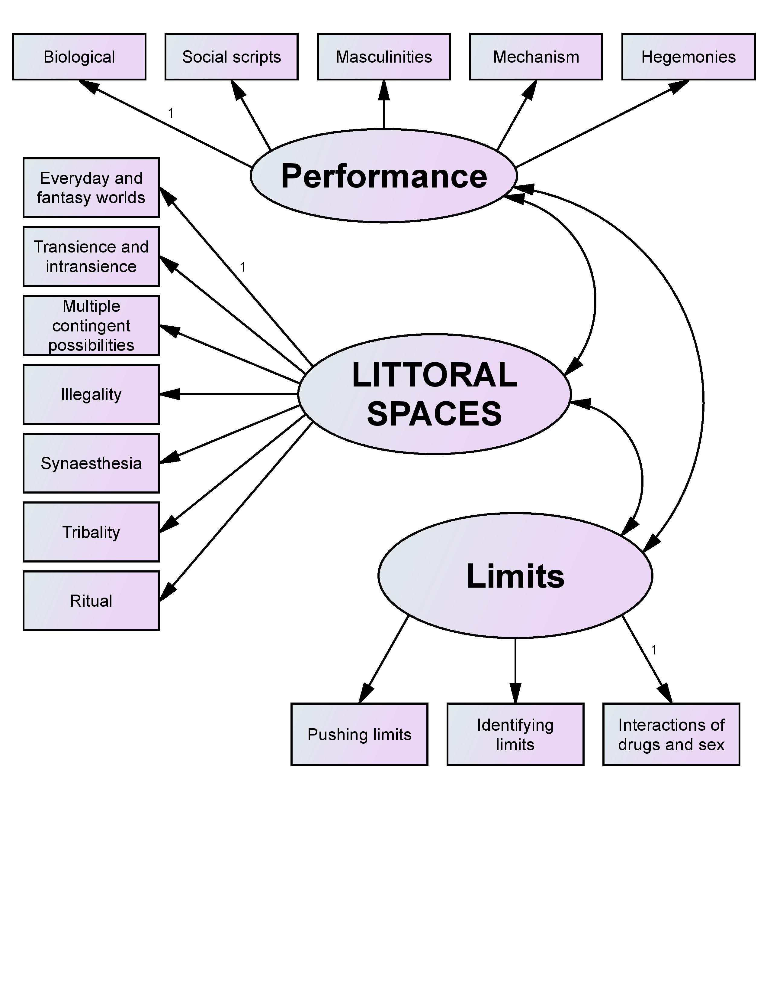

**Figure S.5.** Final explanatory matrix.