Title: Role of pyrazinamide in the emergence of extensively drug-resistant tuberculosis: a multi-strain mathematical model
Running title: Role of pyrazinamide in XDR TB

Authors: Mariam O. Fofana¹, Sourya Shrestha¹, Gwenan M. Knight^{2*}, Ted Cohen³, Richard G. White², Frank Cobelens^{4,5}, David W. Dowdy^{1,6} #

Affiliations:
(1) Department of Epidemiology, Johns Hopkins Bloomberg School of Public Health, Baltimore, MD, USA; (2) TB Modelling Group, TB Centre, Centre for the Mathematical Modelling of Infectious Diseases, London School of Hygiene and Tropical Medicine, London, UK; (3) Department of Epidemiology of Microbial Diseases, School of Public Health, Yale University, New Haven, CT, USA; (4) Amsterdam Institute for Global Health and Development, Academic Medical Center, Amsterdam, Netherlands; (5) KNCV Tuberculosis Foundation, The Hague, Netherlands; (6) Center for Tuberculosis Research, Johns Hopkins University School of Medicine, Baltimore, MD, USA
* Current address: Imperial College, London, UK.

# Corresponding author: David W. Dowdy, MD PhD
615 N. Wolfe St., E6531; Baltimore, MD 21205; USA
Phone: +01 410.614.5022
Fax: +01 410.614.0902
E-mail: ddowdy@jhsph.edu
Abstract
Several infectious diseases of global importance — e.g. HIV, tuberculosis (TB) — require prolonged treatment with combination antimicrobial regimens, typically involving high-potency “core” agents coupled with additional “companion” drugs that protect against de novo emergence of mutations conferring resistance to the core agents. Often, the most effective (or least toxic) companion agents are re-used in sequential (first-line, second-line, etc…) regimens. We used a multi-strain model of M. tuberculosis transmission in Southeast Asia to investigate how this practice might facilitate the emergence of extensive drug resistance, i.e., resistance to multiple core agents. We calibrated this model to regional TB and drug resistance data using an Approximate Bayesian Computational approach. We reported the proportion of data-consistent simulations in which the prevalence of pre-extensively drug resistant (pre-XDR) TB — defined as resistance to both first-line and second-line core agents (rifampin and fluoroquinolones) — exceeded pre-defined acceptability thresholds (1-2 cases per 100,000 population by 2035). Using pyrazinamide (the most effective companion agent) in both first-line and second-line regimens increased the proportion of simulations exceeding the pre-XDR acceptability threshold seven-fold, compared to a scenario in which patients with pyrazinamide-resistant TB received an alternative drug. Model parameters related to emergence and transmission of pyrazinamide-resistant TB and resistance amplification were among those most strongly correlated with projected pre-XDR prevalence, indicating that pyrazinamide resistance acquired during first-line treatment subsequently promotes amplification to pre-XDR TB under pyrazinamide-containing second-line treatment. These findings suggest that appropriate use of companion drugs may be critical to preventing the emergence of strains resistant to multiple core agents.

INTRODUCTION
Antimicrobial resistance has recently been labeled “a problem so serious that it threatens the achievements of modern medicine”(1). Concerns regarding the emergence of drug resistance in the early antimicrobial era, along with the prospect of improving clinical outcomes, led to a shift from monotherapy to combination treatment for many pathogens of global importance, including HIV, tuberculosis (TB), and malaria, but the success of combination antimicrobial therapy is increasingly threatened by the rise of multidrug resistance (2-5). Combination regimens often rely on the use of highly effective “core” drugs that have low toxicity, high microbicidal activity, and/or a high barrier to resistance, supplemented by companion drugs that are typically less active on their own but act to enhance the overall effectiveness of the regimen while also potentially preventing the emergence of resistance to core drugs. For example, in HIV combination therapy, nucleoside inhibitors often serve as companion agents to prevent resistance to the core drug classes of protease inhibitors, non-nucleoside reverse transcriptase inhibitors, and integrase inhibitors (6). These companion drugs are frequently re-used in sequential treatment regimens when alternative companion agents are less effective or more toxic. For instance, due in part to its unique sterilizing activity against M. tuberculosis (M. tb) bacilli, pyrazinamide (PZA) is used to augment the effectiveness of several core agents, including rifampin (RIF) in standard first-line TB treatment, and fluoroquinolones (FQs) in most second-line regimens (7).

In evaluating the emergence of extensive drug resistance, research and surveillance efforts have historically focused on the role of core agents. However, the “recycling” of companion in sequential treatment regimens may play a critical and under-recognized role in the emergence of resistance to the core agents. This is the case for PZA, which is a recommended agent in standardized first- and second-line TB treatment regimens (8). If concomitant use of PZA prevents the emergence of resistance to RIF and FQs (an unproven hypothesis, but one that is consistent with principles of combination drug therapy), PZA resistance may therefore be an important facilitator of the emergence of strains that are resistant to both RIF and FQs – which we define conventionally as pre-extensively drug resistant (pre-XDR) TB. To illustrate this concept, we constructed a dynamic model of M. tuberculosis transmission which incorporates resistance to RIF, PZA, and FQs (Figure 1). We use this model to generate a large set of simulations consistent with available epidemiological data up to 2013 (Figure 2). We then evaluate projected levels of pre-XDR TB in 2035 assuming that concomitant use of PZA protects against de novo resistance to both RIF and FQs. We compare a baseline scenario in which PZA is “recycled” in first- and second-line regimens to a counterfactual scenario in which PZA is replaced by a hypothetical alternative drug of equal efficacy, to demonstrate how repeated use of companion drugs can facilitate the emergence of extensively resistant strains.
MATERIALS AND METHODS
Approach
Our aim was to understand the population-level dynamics of the emergence of multiple antimicrobial resistance in an infectious pathogen treated with combination therapy but for which empirical data on the effects of different resistance patterns are sparse. To achieve this aim, we used mechanistic simulation of TB transmission and drug resistance to project a range of plausible epidemiologic trajectories, randomly sampling parameter values to reflect inherent uncertainty in key variables related to TB drug resistance (Figure 1). First, we identified an outcome that could serve as a useful metric for decision-making; in our primary analysis, we use the proportion of data-consistent trajectories in which the prevalence of pre-XDR TB exceeds an acceptability threshold of 1 case per 100,000 population at 20 years. We then selected epidemiological data to which we could calibrate the model. These calibration targets, shown in Appendix, Table S4, included the prevalence and incidence of TB disease from 1990 to 2013 in Southeast Asia (9, 10) – selected as a target setting because of its high rates of TB and highly drug-resistant TB – as well as the prevalence of resistance against specific drugs for which empirical data were available. Further details of model initialization and calibration are provided in the Appendix (11-15). For each epidemiologic calibration target, we set a tolerance range based on the degree of uncertainty around available data estimates (Appendix, Table S4). We then constructed a representative set of scenarios that might be consistent with existing data by randomly sampling parameter sets using an approximate Bayesian process, retaining those sets that resulted in simulated outcomes within our tolerance ranges. We used these data-consistent parameter sets to project epidemiologic trajectories over the ensuing 20 years. These selected parameter sets are therefore not meant to represent the entirety of all possible scenarios, nor to indicate which scenarios are more likely than others; rather, they are meant as a representative sample that can be useful to inform decision-making. This approach is illustrated step by step in Figure 2.

Mechanistic model structure
The core structure of our model is similar to previous compartmental models of adult pulmonary tuberculosis, assuming static population size, random mixing, and sequential progression through the stages of TB infection (16-18). As shown in Figure 1, people are born in the uninfected state and can progress to latent TB infection (an asymptomatic, non-infectious state) and active pulmonary TB disease (symptomatic and infectious). Each compartment of TB infection or disease is sub-divided to explicitly track eight (i.e., 2³) possible combinations of resistance to the three drugs considered. For any individual being treated for active TB, we assume that the treatment course will be “effective”, “insufficient”, or “ineffective” (defined below), with the probability of each outcome conditional on both the pathogen’s resistance profile and the drug regimen being used (Table 2).

We assume that “effective” treatment is curative treatment that rapidly renders individuals non-infectious, reflecting the steep decrease in bacillary burden upon treatment initiation (19, 20). We include the possibility that some incomplete treatment courses may nonetheless be “effective,” reflecting the range of possible interactions between antimicrobial agents and host immune responses. Those patients who do not complete a full course of treatment and are not cured (i.e., “insufficient” treatment) are assumed to remain ill and infectious. Treatment that results in early relapse is also represented in the model as insufficient.

In contrast to “insufficient” treatment (representing a treatment course that has curative potential but is simply not taken for a sufficient duration of time), “ineffective” treatment in this model represents a course that does not provide additional curative potential beyond the host’s natural immune response. People on ineffective regimens remain infectious in this model, albeit at a reduced level, reflecting regimens that reduce bacillary burden sufficiently to result in negative sputum smears but do not achieve sterilization and cure. Explicitly modeling ineffective treatment allows us to account for failing treatment regimens, which we assume to last for six months on average, reflecting a timepoint at which treatment effectiveness is commonly assessed (8). Individuals on ineffective regimens are assumed to remain symptomatic and/or test positive on follow-up evaluation (e.g., TB smear or culture), triggering the initiation of a repeat course of treatment. Repeat treatment may in turn be effective (leading to immediate transition to the latent compartment), insufficient (transition to active TB compartment) or ineffective (maintenance in the ineffective treatment state), depending on the regimen chosen and the resistance profile of the pathogen.

The model distinguishes patients undergoing their first course of TB treatment from those who have previously been treated, incorporating the greater prevalence of drug resistance among treatment-experienced patients. In the baseline scenario, we assume that 5% and 26% of treatment-naïve and treatment-experienced patients with RIF-resistant TB have access to a standardized second-line treatment regimen, reflecting a combination of access to drug susceptibility diagnostics and presumptive treatment as estimated in this region (9).

Incorporation of data
Selected model inputs are shown in Tables 1 and 2 (see Appendix, Table S3 for more details). Parameters relating to diagnosis and treatment outcomes are based on WHO data and published literature. These data were incorporated in the model using logical assumptions; for instance, with the same regimen, the probability of cure for a patient with TB resistant to two drugs in the regimen cannot be greater than the probability of cure for a patient with TB resistant to just one drug (9, 21-25). We incorporate uncertainty around these baseline outcome probabilities by varying the probability of treatment failure from zero to twice the baseline value, for each of the eight strains.

Some key parameters that lack reliable empirical estimates include: (1) the reduction in transmissibility (transmission fitness) associated with each pattern of drug resistance, (2) the probability of acquiring new antimicrobial resistance during treatment, and (3) the effect of each resistance pattern on treatment outcomes, for each combination of pre-existing drug resistance profile and treatment regimen. For these parameters, we selected values for each simulation from broad and uniform prior distributions, reflecting the inherent uncertainty in the value of these parameters and allowing sufficient coverage of extreme values. Distributions for the probability of acquiring resistance on each regimen were informed by a published meta-analysis (26), allowing for the acquisition of resistance to more than one drug under the assumption of sequential acquisition, with pre-existing drug resistance favoring the emergence of further resistance by reducing the number of active drugs.

Baseline and comparison scenarios
Using these distributions, we randomly sampled 100,000 distinct parameter sets to project trajectories and calibrate the mechanistic model as described above. We initiated simulations from a steady-state condition in the pre-chemotherapy era, sequentially introducing resistance to RIF, PZA, and FQ. All parameters were varied as described above in the baseline scenario. We also attempted to calibrate the model under the assumption that PZA confers no protection against de novo resistance to RIF or FQs—and thus that PZA resistance imposes no additional risk of such mutations—by setting the probability of acquiring resistance to RIF or FQs among individuals with PZA-resistant TB equal to that of patients with PZA-susceptible TB. We conducted all subsequent analyses assuming a protective effect of PZA, and compared the baseline scenario to an alternative scenario in which all patients with PZA-resistant TB receive a hypothetical drug of equal efficacy (with regard to its impact on the probability of cure and relapse).

Sensitivity and uncertainty analyses
For each parameter set considered to be consistent with current epidemiologic data, we compared the proportion of trajectories with levels of pre-XDR TB that exceeded the 20-year prevalence acceptability threshold between the baseline scenario and the alternative scenario in which PZA, is replaced by another drug. We then used multivariable logistic regression of standardized input parameter values on the expected probability of exceeding the threshold, to identify parameters (“drivers”) that are most strongly correlated with this outcome, varying the acceptability threshold and also considering partial rank correlation between inputs and pre-XDR prevalence in sensitivity analyses. We conducted additional analyses in which we blocked specific pathways of resistance amplification by setting the corresponding probabilities to zero, reflecting a hypothetical situation in which RIF and/or FQs are replaced by another drug of equal efficacy for patients with PZA-resistant TB. For all scenarios, we express uncertainty by providing the proportion of data-consistent simulations that reached certain acceptability thresholds (rather than point estimates of pre-XDR TB resistance prevalence), and also the median and interquartile ranges of key intermediate outputs (e.g., the proportion of pre-XDR strains with concomitant PZA resistance) across all data-consistent simulations.

In order to assess the potential impact of stochastic events in the emergence (and potential die-out) of drug resistance, we constructed a stochastic adaptation of the model using the Gillespie stochastic simulation algorithm adaptive tau method (27) and replicated the analysis using this stochastic framework.

Software
The simulation model and all analyses were implemented using the software R (28). All the code necessary to replicate the analyses, tables and figures presented here is available in an online repository: https://github.com/m-fofana/TB-PZA-model.git.

RESULTS
We first attempted to calibrate the model under our baseline assumption that PZA provides protection against de novo resistance to concomitantly administered RIF and FQs, as well as under the alternative assumption that PZA offers no such protection. Attempts to calibrate the model without a protective effect yielded 20-fold fewer simulations consistent with existing epidemiologic data (47 vs. 1,015 out of 100,000 sampled parameter sets), suggesting that this assumption is probably less consistent with the available data than the assumption that PZA protects against resistance to co-administered drugs. We therefore conducted all subsequent analyses assuming that PZA protects against resistance amplification.

Across the 1,015 simulations consistent with epidemiological data (assuming a protective effect of PZA on acquired resistance), the median projected prevalence of pre-XDR TB in 2015 was 0.64 per 100,000 (interquartile range [IQR] 0.51-0.79). The proportion of RIF-resistant strains in 2035 that harbored additional resistance to PZA was greater in the baseline scenario (median 51.7% [IQR 43.7-59.5%]) compared to the alternative scenario in which PZA was replaced (median 44.7%, IQR 36.4-51.3%), although overall TB incidence was similar in both scenarios (median 205.0 per 100,000 [IQR 1886-222.5] baseline vs. 203.7 [IQR 187.6-221.1] PZA replacement). There was an even more pronounced difference in the proportion of pre-XDR strains with additional PZA resistance (80.2% [IQR 72.9-85.6%] vs. 65.8% [IQR 57.9-72.2%]) (Figure 3A-B). Overall, the proportion of simulations in which pre-XDR prevalence exceeded pre-defined acceptability thresholds of 1, 1.5, and 2 per 100,000 population in 2035 was 64.7%, 29.7% and 13.9% respectively in the baseline scenario, versus 23.1%, 8.1%, and 4.5% in the PZA replacement scenario. This corresponds to relative reductions of 64-73% in the proportion of simulations where the prevalence of pre-XDR TB exceeded each acceptability threshold. Similar results are obtained using a stochastic modeling framework: the proportion of simulations in which pre-XDR prevalence exceeds the acceptability thresholds by 2035 decreases from 52.1%, 35.7% and 24.9% in the baseline scenario, to 25.1%, 13.7% and 8.2% in the PZA replacement scenario (Appendix, Figure S9).

We used multivariable sensitivity analysis to investigate those parameters that were most closely associated with the emergence of pre-XDR TB to a prevalence of 1 case per 100,000 population by 2035 (Figure 4). Five of the ten most influential parameters involved PZA; these included the probability of cure for RIF/PZA-resistant TB, the transmission fitness of strains resistant to both least RIF and PZA, and the probabilities of acquiring PZA resistance and subsequently developing additional resistance (Figure 4). Under the PZA replacement scenario, the odds ratios associated with the probabilities of acquiring PZA resistance and subsequent resistance amplification were most attenuated towards a null effect (i.e., OR=1). Sensitivity analyses varying the threshold to 1.5 and 2 pre-XDR cases per 100,000 population yielded similar findings, as did alternative analyses using partial rank correlation coefficients (Appendix, Figure S6).

Finally, we evaluated model scenarios in which specific steps in the progression to pre-XDR TB were inhibited, reflecting the potential effect of tailored therapy for patients diagnosed with PZA-resistant TB (Figure 5). In these analyses, we found that the acquisition of FQ resistance among strains already dually resistant to RIF and PZA was a key step in the development of pre-XDR TB. Blocking this single step in resistance amplification (i.e., allowing pre-XDR TB to emerge only from strains other than RIF/PZA-resistant strains) reduced the proportion of simulations exceeding each pre-XDR acceptability threshold by four- to seven-fold, suggesting that dual RIF/PZA resistance is an important precursor of pre-XDR TB at the population level. In contrast, blocking the emergence of pre-XDR TB from RIF-monoresistant or FQ-monoresistant strains – or from FQ/PZA resistant strains – had a minimal effect on the projected pre-XDR prevalence in 2035.
DISCUSSION
This novel population-level modeling framework incorporating resistance to three distinct antimicrobial drugs suggests that, when companion drugs select against de novo resistance mutations in combination regimens, re-using these drugs in both first- and second-line treatment may critically facilitate the emergence of strains that are resistant to multiple core agents. Specifically, projecting the hypothetical effect of perfect susceptibility testing for PZA and replacement of PZA with another drug for patients with PZA-resistant TB dramatically reduced the proportion of data-consistent model simulations in which the projected prevalence of pre-XDR TB exceeded pre-defined acceptability thresholds within 20 years. Simulations in which we assumed that PZA does not apply selection pressure against concomitantly administered core agents were far less likely to match available epidemiologic data. These findings highlight the urgent importance of understanding the potential mechanisms by which PZA (and other companion drugs) enhances combination antimicrobial regimens, and of expanding drug susceptibility testing and surveillance for resistance to these agents, rather than focusing such efforts on core drugs alone.

Available evidence from both laboratory and clinical studies supports the sequential acquisition of resistance in TB (29, 30). Our results suggest a similar pattern at the population level, and that re-using companion drugs could promote sequential progression to pre-XDR TB during first- and second-line treatment. Specifically, we found that the prevalence of PZA resistance was greatly increased among RIF-resistant strains, and even more so among pre-XDR strains, when PZA was re-used in both first- and second-line TB treatment. Moreover, strains resistant to both RIF and PZA featured as major precursors of pre-XDR. These results suggest that initial acquisition of RIF or PZA resistance may allow for the emergence of resistance to the other agent during first-line treatment, resulting in a large number of RIF/PZA-resistant strains. These strains are then more likely to develop FQ resistance during second-line therapy that includes both PZA and FQs. These results are highly relevant to the deployment of standardized treatment regimens for MDR TB prescribed without prior diagnostic testing for resistance to drugs other than RIF – a practice that may become increasingly common with the scale-up of rapid molecular testing for RIF resistance alone (31-33). In settings where resistance to PZA is common, indiscriminately starting patients on FQ- and PZA-containing standardized second-line regimens (8)—at the very time when mycobacterial burden, and thus incidence of spontaneous resistance-conferring mutations, is highest—may result in the selection of bacilli resistant to other drugs in the regimen, including FQs, before the results of complete drug susceptibility testing (e.g., from TB culture) are available. If PZA does indeed protect against the development of resistance to FQs during second-line therapy, consistent with our model calibration and previous empirical studies, routine rapid testing for PZA resistance among patients with demonstrated RIF resistance would be an important means of preventing the emergence of pre-XDR TB (34, 35). This finding takes on even greater significance in the current drug development climate, as FQs and PZA are considered key agents in the development of many novel regimens for first-line treatment of TB (36, 37).

Overall, our findings highlight the importance of considering not only the interplay between individual antimicrobial drugs, but also how these drugs are incorporated into sequential treatment regimens, in order to better control the spread of extensive drug resistance in the long term. Although our model is specific to TB, our insights regarding the importance of “recycled” companion drugs in facilitating the emergence of multi-resistant pathogens may be relevant to other infectious diseases in which resistance to the current arsenal of drugs represents a major public health threat. For example, HIV is a pathogen of major global health significance in which sequential resistance to antiretroviral drugs occurs over the course of treatment (38, 39). As in our study, a previous model of HIV that explicitly modeled combinations of resistance to three drug classes provided important insights into drug class-specific effects on resistance trajectories (40). Furthermore, by combining a population-level transmission model with policy-relevant outcome thresholds, our study provides useful guidance to decision-makers in the setting of sparse empirical data on key parameters related to drug resistance. This approach, which leverages available epidemiologic data and mechanistic understanding of disease to shed light on future trajectories of drug resistance, can be adapted to other pathogens to inform risk prediction and disease control policies.

This model has several limitations. In seeking to optimize the balance of detail and parsimony, we made several simplifying assumptions, including restricting the model to adult pulmonary TB in an equilibrium population. As our focus was on exploring long-term epidemiologic trajectories rather than clinical outcomes, we chose to exclude forms of TB (i.e., childhood and strictly extrapulmonary disease) that, despite a significant disease burden, do not contribute significantly to transmission. Similarly, we chose the Southeast Asia region, where HIV is not a major driver of the TB epidemic (9), because Southeast Asia currently has higher levels of TB drug resistance. Future adaptations of this model could evaluate different epidemiologic settings, including those in which TB is driven by HIV and those (e.g., the former Soviet Union) with a long history of drug-resistant TB that may reflect high transmission of drug-resistant TB in congregate living settings (e.g., prisons). We limited our model to three key drugs for simplicity, as the addition of additional drugs creates exponentially increasing complexity. As we used a simple acceptance/rejection algorithm to select plausible parameter sets, our results should not be interpreted as probabilistic projections of future TB epidemiology. Rather, our approach allowed us to explore a representative range of data-consistent scenarios—akin to an epidemiological study selecting a representative sample of the population—and benchmark those scenarios against potentially meaningful decision thresholds. This approach enables us to quantify both the key considerations and the level of uncertainty in such decisions, providing a risk management tool that can inform TB control policies without the need to project the precise future of drug-resistant TB. Our conclusions were unchanged when using a stochastic modeling framework that better takes into account rare events in the emergence of drug resistance. Finally, in order to simplify our inferences on the acquisition, transmission fitness and treatment outcomes of drug-resistant strains, we kept most other model parameters at fixed values, and did not explicitly model changes in transmission fitness over time nor potential epistatic effects; our projections may therefore underestimate the true level of uncertainty in future epidemiologic trajectories.

In summary, using a novel, multi-strain modeling approach, we evaluated the impact of a companion drug on future trajectories of TB strains resistant to multiple core agents. This approach suggests that, if the companion agent (such as PZA) is used to augment the role of core drugs in both first-line and second-line regimens, the emergence of strains resistant to multiple core drugs may be dramatically hastened. As such, better data to understand how and to what degree companion drugs enhance the effectiveness of combination regimens (e.g., increased probability of cure, protection against acquired resistance) – and particularly how PZA impacts TB treatment – should be a key research priority. In the absence of such data, our results support the need for drug susceptibility testing for PZA prior to initiating second-line regimens that include PZA without a sufficient number of additional companion agents. These findings may generalize to other microbial pathogens treated with sequential combination regimens, and they highlight an analytic approach that may become increasingly valuable for decision-making in the setting of sparse data on resistance to multiple antimicrobial regimens.

ACKNOWLEDGEMENTS
The authors thank Dr. Larry Moulton for reviewing the study methods and providing helpful suggestions.
References
1. World Health Organization. 2014. Antimicrobial resistance: global report on surveillance 2014. WHO, Geneva. http://www.who.int/drugresistance/documents/surveillancereport/en/. Accessed June 29, 2015.
2. Barber M. 1965. Drug combinations in antibacterial chemotherapy. Proc R Soc Med 58:990-995.
3. Kuritzkes DR. 2011. Drug resistance in HIV-1. Curr Opin Virol 1:582-589. doi:10.1016/j.coviro.2011.10.020.
4. Lawn SD, Zumla AI. 2011. Tuberculosis. Lancet 378:57-72. doi:10.1016/s0140-6736(10)62173-3.
5. Nosten F, Brasseur P. 2002. Combination therapy for malaria: the way forward? Drugs 62:1315-1329. doi:620903 [pii].
6. Thompson MA, Aberg JA, Hoy JF, Telenti A, Benson C, Cahn P, Eron JJ, Gunthard HF, Hammer SM, Reiss P, Richman DD, Rizzardini G, Thomas DL, Jacobsen DM, Volberding PA. 2012. Antiretroviral treatment of adult HIV infection: 2012 recommendations of the International Antiviral Society-USA panel. JAMA 308:387-402. doi:10.1001/jama.2012.7961.
7. Mitchison DA. 2004. Antimicrobial therapy of tuberculosis: justification for currently recommended treatment regimens. Semin Respir Crit Care Med 25:307-315. doi:10.1055/s-2004-829503.
8. World Health Organization. 2010. Guidelines for treatment of tuberculosis. WHO, Geneva. http://www.who.int/tb/publications/2010/9789241547833/en/. Accessed June 29, 2015.
9. World Health Organization. 2014. Global Tuberculosis Control 2014. WHO, Geneva. http://www.who.int/tb/publications/global_report/en/. Accessed June 29, 2015.
10. World Health Organization. 2011. Towards universal access to diagnosis and treatment of multidrug-resistant and extensively drug-resistant tuberculosis by 2015: WHO progress report 2011. WHO, Geneva. http://www.who.int/tb/publications/2011/mdr_report_2011/en/. Accessed June 29, 2015.
11. Umubyeyi AN, Rigouts L, Shamputa IC, Fissette K, Elkrim Y, de Rijk PW, Struelens MJ, Portaels F. 2007. Limited fluoroquinolone resistance among Mycobacterium tuberculosis isolates from Rwanda: results of a national survey. J Antimicrob Chemother 59:1031-1033. doi:10.1093/jac/dkm038.
12. Pierre-Audigier C, Surcouf C, Cadet-Daniel V, Namouchi A, Heng S, Murray A, Guillard B, Gicquel B. 2012. Fluoroquinolone and pyrazinamide resistance in multidrug-resistant tuberculosis. Int J Tuberc Lung Dis 16:221-223, i-ii. doi:10.5588/ijtld.11.0266.
13. Hannan MM, Desmond EP, Morlock GP, Mazurek GH, Crawford JT. 2001. Pyrazinamide-monoresistant Mycobacterium tuberculosis in the United States. J Clin Microbiol 39:647-650. doi:10.1128/jcm.39.2.647-650.2001.
14. Ginsburg AS, Hooper N, Parrish N, Dooley KE, Dorman SE, Booth J, Diener-West M, Merz WG, Bishai WR, Sterling TR. 2003. Fluoroquinolone resistance in patients with newly diagnosed tuberculosis. Clin Infect Dis 37:1448-1452. doi:10.1086/379328.
15. Djuretic T, Herbert J, Drobniewski F, Yates M, Smith EG, Magee JG, Williams R, Flanagan P, Watt B, Rayner A, Crowe M, Chadwick MV, Middleton AM, Watson JM. 2002. Antibiotic resistant tuberculosis in the United Kingdom: 1993-1999. Thorax 57:477-482.
16. Trauer JM, Denholm JT, McBryde ES. 2014. Construction of a mathematical model for tuberculosis transmission in highly endemic regions of the Asia-Pacific. J Theor Biol 358:74-84. doi:10.1016/j.jtbi.2014.05.023.
17. Shrestha S, Knight GM, Fofana M, Cohen T, White RG, Cobelens F, Dowdy DW. 2014. Drivers and trajectories of resistance to new first-line drug regimens for tuberculosis. Open Forum Infect Dis 1. doi:10.1093/ofid/ofu073.
18. Mills HL, Cohen T, Colijn C. 2013. Community-wide isoniazid preventive therapy drives drug-resistant tuberculosis: a model-based analysis. Sci Transl Med 5:180ra149. doi:10.1126/scitranslmed.3005260.
19. Joloba ML, Whalen CC, Cave DM, Eisenach KD, Johnson JL, Okwera A, Morrissey A, Bajaksouzian S, Feagin J, Mugerwa R, Ellner J, Jacobs MR. 2000. Determination of drug susceptibility and DNA fingerprint patterns of clinical isolates of Mycobacterium tuberculosis from Kampala, Uganda. East Afr Med J 77:111-115.
20. Dharmadhikari AS, Mphahlele M, Venter K, Stoltz A, Mathebula R, Masotla T, van der Walt M, Pagano M, Jensen P, Nardell E. 2014. Rapid impact of effective treatment on transmission of multidrug-resistant tuberculosis. Int J Tuberc Lung Dis 18:1019-1025. doi:10.5588/ijtld.13.0834.
21. Yee DP, Menzies D, Brassard P. 2012. Clinical outcomes of pyrazinamide-monoresistant Mycobacterium tuberculosis in Quebec. Int J Tuberc Lung Dis 16:604-609. doi:10.5588/ijtld.11.0376.
22. Orenstein EW, Basu S, Shah NS, Andrews JR, Friedland GH, Moll AP, Gandhi NR, Galvani AP. 2009. Treatment outcomes among patients with multidrug-resistant tuberculosis: systematic review and meta-analysis. Lancet Infect Dis 9:153-161. doi:10.1016/S1473-3099(09)70041-6
23. Ahuja SD, Ashkin D, Avendano M, Banerjee R, Bauer M, Bayona JN, Becerra MC, Benedetti A, Burgos M, Centis R, Chan ED, Chiang CY, Cox H, D'Ambrosio L, DeRiemer K, Dung NH, Enarson D, Falzon D, Flanagan K, Flood J, Garcia-Garcia ML, Gandhi N, Granich RM, Hollm-Delgado MG, Holtz TH, Iseman MD, Jarlsberg LG, Keshavjee S, Kim HR, Koh WJ, Lancaster J, Lange C, de Lange WC, Leimane V, Leung CC, Li J, Menzies D, Migliori GB, Mishustin SP, Mitnick CD, Narita M, O'Riordan P, Pai M, Palmero D, Park SK, Pasvol G, Pena J, Perez-Guzman C, Quelapio MI, Ponce-de-Leon A, et al. 2012. Multidrug resistant pulmonary tuberculosis treatment regimens and patient outcomes: an individual patient data meta-analysis of 9,153 patients. PLoS Med 9:e1001300. doi:10.1371/journal.pmed.1001300.
24. Falzon D, Gandhi N, Migliori GB, Sotgiu G, Cox HS, Holtz TH, Hollm-Delgado MG, Keshavjee S, DeRiemer K, Centis R, D'Ambrosio L, Lange CG, Bauer M, Menzies D, Collaborative Group for Meta-Analysis of Individual Patient Data in M-T. 2013. Resistance to fluoroquinolones and second-line injectable drugs: impact on multidrug-resistant TB outcomes. Eur Respir J 42:156-168. doi:10.1183/09031936.00134712.
25. Espinal MA, Kim SJ, Suarez PG, Kam KM, Khomenko AG, Migliori GB, Baez J, Kochi A, Dye C, Raviglione MC. 2000. Standard short-course chemotherapy for drug-resistant tuberculosis: treatment outcomes in 6 countries. Jama 283:2537-2545.
26. Lew W, Pai M, Oxlade O, Martin D, Menzies D. 2008. Initial drug resistance and tuberculosis treatment outcomes: systematic review and meta-analysis. Ann Intern Med 149:123-134.
27. Cao Y, Gillespie DT, Petzold LR. 2007. Adaptive explicit-implicit tau-leaping method with automatic tau selection. J Chem Phys 126:224101. doi:10.1063/1.2745299.
28. Team RC. 2015. R: A language and environment for statistical computing, R Foundation for Statistical Computing, Vienna. https://www.R-project.org/.
29. Lipsitch M, Sousa AO. 2002. Historical intensity of natural selection for resistance to tuberculosis. Genetics 161:1599-1607.
30. Matthys F, Rigouts L, Sizaire V, Vezhnina N, Lecoq M, Golubeva V, Portaels F, Van der Stuyft P, Kimerling M. 2009. Outcomes after chemotherapy with WHO category II regimen in a population with high prevalence of drug resistant tuberculosis. PLoS One 4:e7954. doi:10.1371/journal.pone.0007954.
31. van Kampen SC, Susanto NH, Simon S, Astiti SD, Chandra R, Burhan E, Farid MN, Chittenden K, Mustikawati DE, Alisjahbana B. 2015. Effects of Introducing Xpert MTB/RIF on Diagnosis and Treatment of Drug-Resistant Tuberculosis Patients in Indonesia: A Pre-Post Intervention Study. PLoS One 10:e0123536. doi:10.1371/journal.pone.0123536.
32. Moyenga I, Roggi A, Sulis G, Diande S, Tamboura D, Tagliani E, Castelli F, Matteelli A. 2015. The impact of Xpert(R) MTB/RIF depends on service coordination: experience in Burkina Faso. Int J Tuberc Lung Dis 19:285-287. doi:10.5588/ijtld.14.0629.
33. Hossain ST, Isaakidis P, Sagili KD, Islam S, Islam MA, Shewade HD, Kamal SM, Husain A. 2015. The Multi-Drug Resistant Tuberculosis Diagnosis and Treatment Cascade in Bangladesh. PLoS One 10:e0129155. doi:10.1371/journal.pone.0129155.
34. Menzies D, Benedetti A, Paydar A, Royce S, Madhukar P, Burman W, Vernon A, Lienhardt C. 2009. Standardized treatment of active tuberculosis in patients with previous treatment and/or with mono-resistance to isoniazid: a systematic review and meta-analysis. PLoS Med 6:e1000150.
35. Franke MF, Becerra MC, Tierney DB, Rich ML, Bonilla C, Bayona J, McLaughlin MM, Mitnick CD. 2015. Counting pyrazinamide in regimens for multidrug-resistant tuberculosis. Ann Am Thorac Soc 12:674-679. doi:10.1513/AnnalsATS.201411-538OC.
36. Schito M, Migliori GB, Fletcher HA, McNerney R, Centis R, D'Ambrosio L, Bates M, Kibiki G, Kapata N, Corrah T, Bomanji J, Vilaplana C, Johnson D, Mwaba P, Maeurer M, Zumla A. 2015. Perspectives on Advances in Tuberculosis Diagnostics, Drugs, and Vaccines. Clin Infect Dis 61Suppl 3:S102-118. doi:10.1093/cid/civ609.
37. Kwon YS, Jeong BH, Koh WJ. 2014. Tuberculosis: clinical trials and new drug regimens. Curr Opin Pulm Med 20:280-286. doi:10.1097/mcp.0000000000000045.
38. Nijhuis M, van Maarseveen NM, Boucher CA. 2007. HIV protease resistance and viral fitness. Curr Opin HIV AIDS 2:108-115. doi:10.1097/COH.0b013e32801682f6.
39. Hamers RL, Schuurman R, Sigaloff KC, Wallis CL, Kityo C, Siwale M, Mandaliya K, Ive P, Botes ME, Wellington M, Osibogun A, Wit FW, van Vugt M, Stevens WS, de Wit TF, PharmAccess African Studies to Evaluate Resistance I. 2012. Effect of pretreatment HIV-1 drug resistance on immunological, virological, and drug-resistance outcomes of first-line antiretroviral treatment in sub-Saharan Africa: a multicentre cohort study. Lancet Infect Dis 12:307-317. doi:10.1016/S1473-3099(11)70255-9.
40. Smith RJ, Okano JT, Kahn JS, Bodine EN, Blower S. 2010. Evolutionary dynamics of complex networks of HIV drug-resistant strains: the case of San Francisco. Science 327:697-701. doi:10.1126/science.1180556.
41. Vynnycky E, Fine PE. 1997. The natural history of tuberculosis: the implications of age-dependent risks of disease and the role of reinfection. Epidemiol Infect 119:183-201.
42. Sutherland I, Svandova E, Radhakrishna S. 1982. The development of clinical tuberculosis following infection with tubercle bacilli. 1. A theoretical model for the development of clinical tuberculosis following infection, linking from data on the risk of tuberculous infection and the incidence of clinical tuberculosis in the Netherlands. Tubercle 63:255-268.
43. Blower SM, McLean AR, Porco TC, Small PM, Hopewell PC, Sanchez MA, Moss AR. 1995. The intrinsic transmission dynamics of tuberculosis epidemics. Nat Med 1:815-821.
44. Division UNP. 2013. World Population Prospects: The 2012 Revision. United Nations, New York. http://data.un.org/Data.aspx?q=life+expectancy&d=PopDiv&f=variableID%3a68. Accessed June 29, 2015.
45. Tiemersma EW, van der Werf MJ, Borgdorff MW, Williams BG, Nagelkerke NJ. 2011. Natural history of tuberculosis: duration and fatality of untreated pulmonary tuberculosis in HIV negative patients: a systematic review. PLoS One 6:e17601. doi:10.1371/journal.pone.0017601.
46. Harries AD, Dye C. 2006. Tuberculosis. Ann Trop Med Parasitol 100:415-431. doi:10.1179/136485906X91477.
47. Behr MA, Warren SA, Salamon H, Hopewell PC, Ponce de Leon A, Daley CL, Small PM. 1999. Transmission of Mycobacterium tuberculosis from patients smear-negative for acid-fast bacilli. Lancet 353:444-449.
48. Leung CC, Yew WW, Chan CK, Chang KC, Law WS, Lee SN, Tai LB, Leung EC, Au RK, Huang SS, Tam CM. 2015. Smoking adversely affects treatment response, outcome and relapse in tuberculosis. Eur Respir J 45:738-745. doi:10.1183/09031936.00114214.
49. Gillespie SH, Crook AM, McHugh TD, Mendel CM, Meredith SK, Murray SR, Pappas F, Phillips PP, Nunn AJ, Consortium RE. 2014. Four-month moxifloxacin-based regimens for drug-sensitive tuberculosis. N Engl J Med 371:1577-1587. doi:10.1056/NEJMoa1407426.
50. Menzies D, Benedetti A, Paydar A, Martin I, Royce S, Pai M, Vernon A, Lienhardt C, Burman W. 2009. Effect of duration and intermittency of rifampin on tuberculosis treatment outcomes: a systematic review and meta-analysis. PLoS Med 6:e1000146. doi:10.1371/journal.pmed.1000146.

FIGURES
A
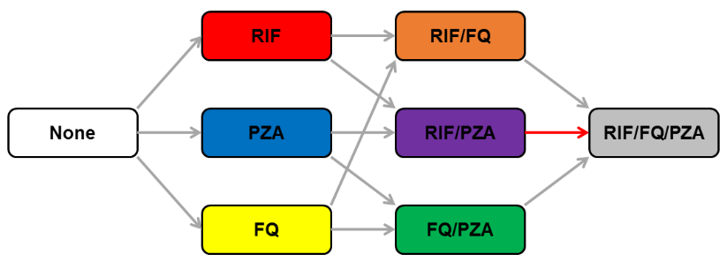
B
Figure 1: Model structure diagram
A) The model features separate compartments for individuals who are uninfected with TB, latently infected, or experiencing active disease. Individuals with TB are further distinguished based on prior treatment experience. A separate compartment exists for patients who are receiving ineffective treatment; these individuals remain ill with TB and are then initiated on a repeat course of treatment. All five TB compartments (with the exception of “Uninfected”) are replicated for each of eight drug resistance states, for a total of 41 unique compartments. Births and deaths are not shown here for simplicity.
B) Progression between drug resistance states is assumed to result only in increasing resistance. In addition to the transitions shown here, resistance can be acquired to multiple drugs within a single course of treatment. The primary mode of acquiring pre-XDR TB (defined as concomitant resistance to at least rifampin [RIF] and fluoroquinolones [FQ]), is highlighted in red and includes acquisition of resistance to pyrazinamide (PZA), a companion drug that is routinely used in both first- and second-line treatment.

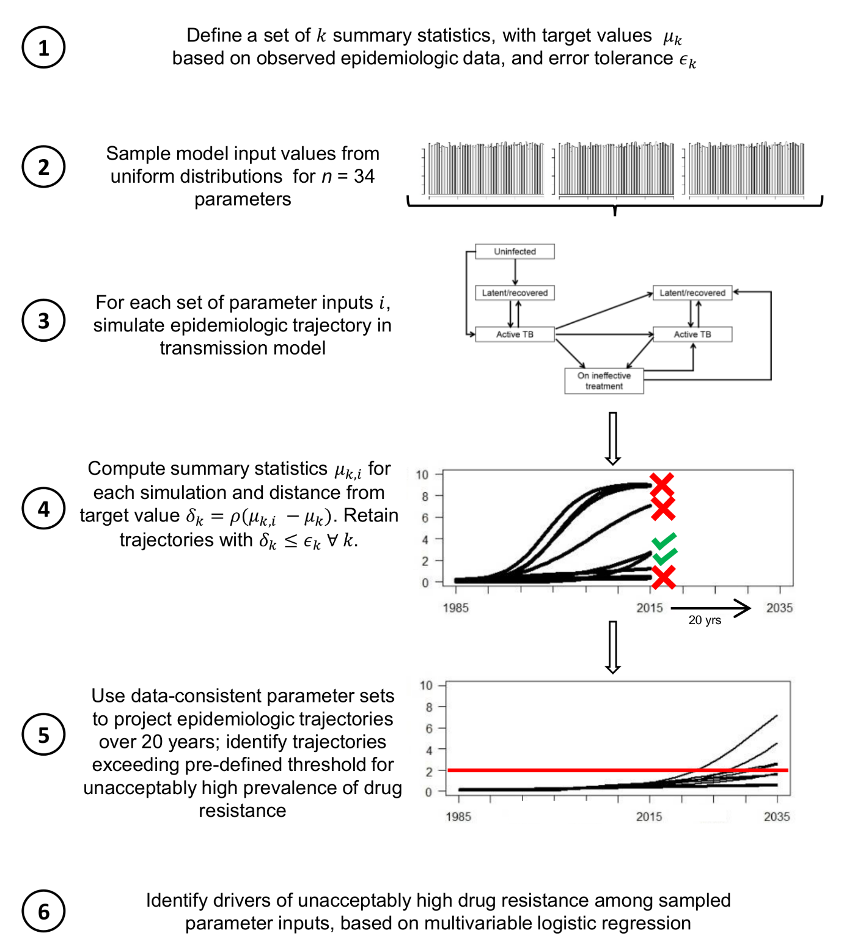
Figure 2: Experimental approach
Shown here is the step-by-step approach of selecting simulations that are consistent with existing epidemiological data and projecting outcomes under those simulations, for purposes of elucidating dynamics between strains with different patterns of resistance to multiple antimicrobial agents.
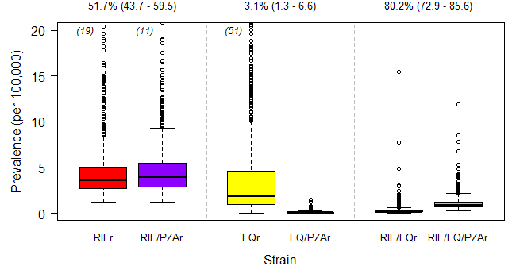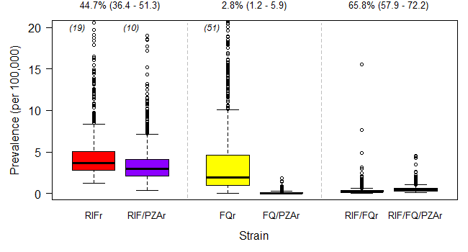
B
A
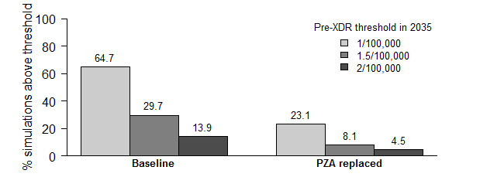
C
Figure 3: Re-use of PZA increases the projected prevalence of pre-XDR TB
Projected prevalence of RIF-resistant (RIFr), FQ-resistant (FQr), and pre-XDR (RIF/FQr or RIF/FQ/PZAr) TB, with and without additional resistance to PZA, in 2035 under the baseline (A) and PZA replacement (B) scenarios. Boxplots show the median, 25th, and 75th percentile values across all data-consistent simulations. Outlier simulations with a projected pre-XDR TB prevalence greater than 20 per 100,000 are not shown; the number of such outliers, if applicable, is indicated in parentheses at the top of each boxplot. (C) Proportion of data-consistent simulations in which projected pre-XDR TB prevalence in 2035 exceeds three pre-defined acceptability thresholds. Replacing PZA with an alternative drug of equal efficacy among patients with PZA-resistant TB greatly reduces the proportion of trajectories exceeding the pre-XDR TB acceptability threshold in 2035.
RIF: rifampin; FQ: fluoroquinolone; PZA: pyrazinamide

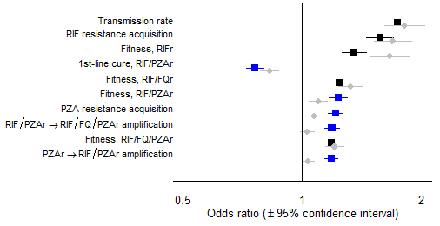
Figure 4: Parameters associated with high future prevalence of pre-XDR TB
Leading drivers of future pre-XDR TB prevalence as assessed by logistic regression on the odds of the primary outcome, namely exceeding a pre-defined acceptability threshold of 1 case per 100,000 population in 2035, comparing baseline conditions (blue and black squares) to the alternative scenario in which PZA is replaced (gray diamonds). Odds ratios reflect the change in the primary outcome associated with an increase of one-tenth of a standard deviation in the independent variable. Parameters related to strains resistant to PZA only (PZAr) or resistant to both RIF and PZA (RIF/PZAr) are highlighted in blue. As an example of scale, one-tenth of a standard deviation corresponds to absolute changes of 0.5% in the probability of acquiring RIF resistance in a single course of treatment, 6% in the transmission fitness of RIF/PZAr strains, or 5% in the probability of cure for RIF/PZAr strains on the first-line regimen.
RIF: rifampin; FQ: fluoroquinolone; PZA: pyrazinamide

A
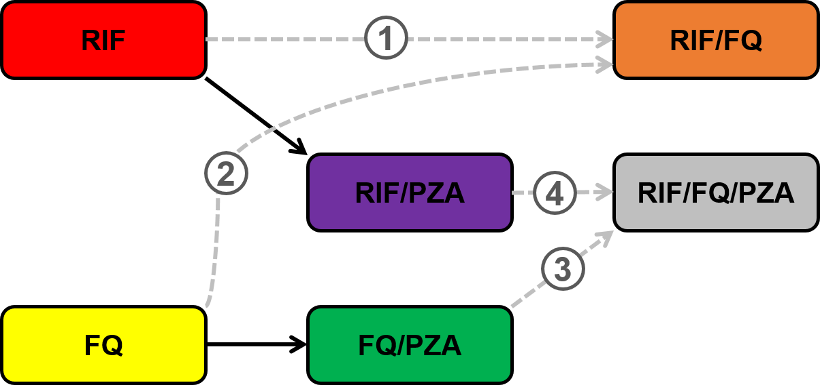
B
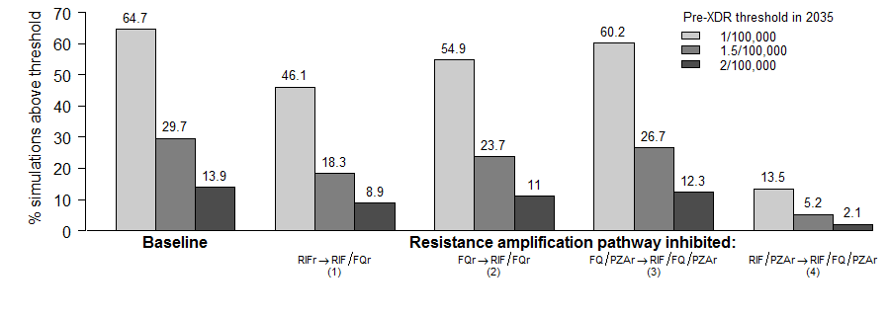
Figure 5: Sequential acquisition of resistance and emergence of pre-XDR TB
A) Pathways from RIF and FQ resistance, with and without additional PZA resistance. We demonstrate that, when PZA prevents the development of resistance to RIF and FQs, the primary pathway to developing pre-XDR TB goes through an intermediate step that includes resistance to both RIF and PZA (RIF/PZAr, arrow 4), rather than directly from RIF or FQ resistance (arrows 1 and 2).
B) Proportion of data-consistent simulations in which projected pre-XDR TB prevalence in 2035 exceeds various acceptability thresholds, after blocking specific pathways of resistance acquisition. Blocking the progression from combined RIF/PZA resistance to RIF/FQ/PZA resistance (corresponding to arrow 4 in panel A) greatly reduces the proportion of trajectories exceeding the acceptability threshold in 2035, as shown in the rightmost bars. In contrast, blocking resistance amplification directly from strains that are RIF- or FQ-monoresistant results in minimal change from the baseline scenario.
RIF: rifampin; FQ: fluoroquinolone; PZA: pyrazinamide

TABLES
Table 1: Selected input parameters (additional details in Appendix, Table S3)

Variable description | Baseline Value | References
Protection from reinfection in latent infection state | 0.5 | (41, 42)
Proportion progressing rapidly to active TB | 0.15 | (43)
Baseline life expectancy, years | 70 | (44)
TB-specific mortality rate, per year | 0.17 | (45)
Probability of endogenous reactivation, lifetime | 5% | (46)
Rate of diagnosis/treatment initiation, per year | 0.69 | (9)
Relative infectiousness of patients on ineffective treatment | 0.2 | (47)
Rate of spontaneous recovery from active TB, per year | 0.17 | (45)
Proportion discontinuing treatment prior to completion, first-line treatment | 6% | (9)
Proportion discontinuing treatment prior to completion, second-line treatment | 23% | (23)
Proportion experiencing early relapse, drug-sensitive TB | 4% | (48, 49)
Proportion experiencing early relapse, RIF-resistant TB | 16% | (50)
Proportion experiencing early relapse, FQ-resistant TB | 12% | (50)
Proportion experiencing early relapse, PZA-resistant TB | 8% | (34)

Table 2: Outcomes upon treatment completion, by resistance profile and treatment regimen (additional details in Appendix, Table S1)

Final drug resistance profile | Probability of cure |  | Probability of early relapse after cure
 | 1st-line | 2nd-line | 1st-line | 2nd-line
Drug-susceptible | 89-99% | -- | 4% | --
RIFr | 40-64% | 89-94% | 16% | 4%
FQr | 89-99% | -- | 4% | --
PZAr | 83-90% | -- | 8% | --
RIF/FQr | 40-64% | 57-74% | 16% | 12%
RIF/PZAr | 32-59% | 76-86% | 16% | 8%
FQ/PZAr | 83-90% | -- | 8% | --
RIF/FQ/PZAr | 32-59% | 47-68% | 16% | 12%

--: not applicable as second-line regimen assumed only to be given to patients with resistance to at least rifampin (RIF).
PZA: pyrazinamide; FQ: fluoroquinolones.

