Association of asymptomatic spinal cord lesions and atrophy with disability
5 years after a clinically isolated syndrome
WJ Brownlee¹, DR Altmann^{1,2}, P Alves Da Mota¹, JK Swanton¹, KA Miszkiel³,
CAM Gandini Wheeler-Kingshott^{1,4}, O Ciccarelli^{1,5}, DH Miller^{1,5}

¹ Queen Square Multiple Sclerosis Centre, Department of Neuroinflammation, UCL Institute of Neurology, London, United Kingdom
² Medical Statistics Department, London School of Hygiene and Tropical Medicine, London, United Kingdom
³ Lysholm Department of Neuroradiology, National Hospital for Neurology and Neurosurgery, London, United Kingdom
⁴ Brain Connectivity Center, C. Mondino National Neurological Institute, Pavia, Italy
⁵ NIHR University College London Hospitals Biomedical Research Centre, London, United Kingdom

Corresponding author: Dr W Brownlee, Box 112, National Hospital for Neurology and Neurosurgery, Telephone +44 20 3108 7409, Fax +44 20 3448 3125, Email w.brownlee@ucl.ac.uk, Twitter @drwbro

Key words: clinically isolated syndrome, multiple sclerosis, MRI, spinal cord
ABSTRACT
Background: Spinal cord pathology is an important substrate for long-term disability in multiple sclerosis (MS).

Objective: To investigate longitudinal changes in spinal cord lesions and atrophy in patients with a non-spinal clinically isolated syndrome (CIS), and how they relate to the development of disability.

Methods: 131 patients with a non-spinal CIS had brain and spinal cord imaging at the time of CIS and approximately 5 years later (median 5.2 years, range 3.0 – 7.9 years). Brain MRI measures consisted of T2-hyperintense and T1-hypointense lesion loads plus brain atrophy. Spinal cord MRI measures consisted of lesion number and the upper cervical cord cross-sectional area (UCCA). Disability was measured using the Expanded Disability Status Scale (EDSS). Multiple linear regression was used to identify independent predictors of disability after 5 years.

Results: During follow-up 93 (71%) patients were diagnosed with MS. Baseline spinal cord lesion number, change in cord lesion number and change in UCCA were independently associated with EDSS (R²=0.53) at follow-up. Including brain T2 lesion load and brain atrophy only modestly increased the predictive power of the model (R²=0.64).

Conclusions: Asymptomatic spinal cord lesions and spinal cord atrophy contribute to the development of MS-related disability over the first 5 years after a non-spinal CIS.

INTRODUCTION
Disability in people with multiple sclerosis (MS) is frequently referable to the spinal cord. Pathological studies in MS show focal lesions involving grey and white matter, neuroaxonal loss and atrophy.¹ Magnetic resonance imaging (MRI) often detects spinal cord abnormalities in established MS.^{1, 2} Focal T2-hyperintense lesions are seen in 75% or more of patients, most commonly in the cervical cord.²⁻⁴ Spinal cord atrophy can also be detected in vivo by measuring the upper cervical cord cross-sectional area (UCCA)⁵ and has robust correlations with disability.³⁻¹³

A clinically isolated syndrome (CIS) represents the first clinical manifestation of relapse-onset MS.¹⁴ Up to half of CIS patients have asymptomatic spinal cord lesions and these can be helpful in establishing a diagnosis of MS.¹⁵⁻¹⁷ Spinal cord lesions may also be of some prognostic value; in clinically isolated optic neuritis asymptomatic cord lesions are associated with an increased risk of disability after 5 years.¹⁸ Spinal cord atrophy has been reported in CIS patients with T2-hyperintense brain lesions^{19, 20}, a group known to be at high-risk for developing MS. Only one previous study has investigated spinal cord atrophy longitudinally in patients with CIS and no detectable change in UCCA was found over a follow-up period of one year.¹⁹ This contrasts with findings in patients with established MS where progressive spinal cord atrophy is evident over follow-up periods of 12–36 months¹⁰⁻¹² and may be associated with progression of disability.^{10, 12}

We wanted to investigate longitudinal changes in spinal cord lesions and UCCA over the first 5 years after a CIS to elucidate whether spinal cord involvement is one of the mechanisms underlying disability in early relapse-onset MS.

METHODS
Patients
Between 1995 and 2004 patients seen at Moorfields Eye Hospital and the National Hospital for Neurology and Neurosurgery with first demyelinating events were invited to take part in a prospective CIS cohort study. Patients aged 16-50 years with a typical CIS suggestive of MS and no previous neurological symptoms were included in the study. The patients were seen at baseline (within 12 weeks of CIS) and were followed up after approximately 5 years. Disability was measured using the Expanded Disability Status Scale (EDSS).²¹ All follow-up, EDSS assessments were done >4 weeks after a relapse or receiving corticosteroids. The currently used McDonald 2010 criteria¹⁷ were retrospectively applied to classify the diagnosis (i.e., MS or CIS) at follow up. Patients who presented with a spinal cord CIS were excluded because we wanted to investigate the significance of clinically silent spinal cord MRI abnormalities at presentation.

The study was approved by relevant institutional ethics committees. Informed consent was obtained at the time of study entry and at follow-up.

MRI acquisition
MRI brain and spinal cord was done at baseline and follow-up on the same 1.5T Signa scanner (General Electric, Wisconsin, USA). There was a scanner upgrade during the study period that was considered in statistical analyses (see below).

The acquisition protocol has been described in detail elsewhere.^{18, 19} MRI of the brain included 46 x 3mm contiguous axial proton density (PD)/T2-weighted images obtained using a dual-echo fast spin sequence (TR 3200ms, TE 15 / 90ms, matrix 256x256, FOV 24cm) and post-contrast T1-weighted fast spin echo axial images (TR 600ms, TE 14ms, matrix 256x256, FOV 24cm). MRI of the spinal cord comprised 9x3mm contiguous sagittal PD/T2-weighted images (TR 2500ms, TE 56/92ms) of the whole cord and a volume acquired inversion prepared fast spoiled gradient echo (FSPGR) scan of the cervical cord (TR 15.6ms, TE 4.2ms, matrix 256x256, FOV 25cm) with 60×1mm sagittal slices.

Image analysis
Lesion measures
The number of T2-hyperintense brain and spinal cord lesions plus T1-hypointense brain lesions was recorded at baseline and follow-up. The lesions were identified by a single experienced neuroradiologist, who was blinded the patient’s clinical status. T2-hyperintense and T1-hypointense brain lesions were outlined using a semi-automated edge finding tool (JIM6, Xinapse systems, Aldwincle, UK). T2 lesion volume (T2LV) and T1 lesion volume (T1LV) was calculated by multiplying lesion area by slice thickness. The change in T2LV, T1LV and spinal cord lesion number between baseline and follow-up was calculated (Figure 1).

Brain atrophy
Normalised brain volume (NBV) at baseline was calculated using SIENAX and the percentage brain volume change (PBVC) between baseline and follow-up using SIENA from T1-weighted fast spin echo scans after filling T1-hypointense lesions.^{22, 23} SIENAX and SIENA analyses were done using FMRIB Software Library (FSL) version 5.0.2.

Spinal cord atrophy
UCCA was measured from FSPGR scans of the cervical cord at baseline and follow-up. In line with previously described studies, sagittally-acquired images were reformatted in the axial plane to obtain five contiguous 3mm slices at the level of the C2/C3 disc⁵ and an active surface model was used to measure the mean UCCA over the five slices^{6, 24, 25} All UCCA measurements were done by a single observer. Change in UCCA between baseline and follow-up was recorded (Figure 1).

Statistical analysis
Patients were grouped based on clinical status at follow-up as CIS, MS with EDSS <3 and MS with EDSS ≥3. Univariable comparisons of MRI measures between binary groups (disabled or not, MS or CIS) were examined using the Wilcoxon rank sum test for lesion and brain atrophy measures, due to their skewed distribution. Linear regression was used for comparisons of UCCA, with age and sex as covariates.

Multiple linear regression models were used to identify independent MRI predictors of EDSS at follow-up and the change in EDSS between baseline and follow-up. Firstly, separate models were constructed for brain and spinal cord MRI measures in order to compare the proportion of variance explained using the R-square (R²) statistic and to restrict the number of covariates. Only variables with p<0.08 were retained in models. Potential confounding by age and sex was examined by entering these into the final models; non-linear effects of continuous MRI predictors and their changes were examined by fitting quadratic terms, and of count predictors by entering these in categorical form. Secondly, the predictor variables from the separate brain and spinal cord models were combined, and manual backwards stepwise elimination used to find the best combined model. Omitted MRI variables were then entered singly and retained if p<0.08. Disease duration (i.e. time from CIS onset to follow-up) was included as a covariate in all models. The potential effect of a scanner upgrade during the follow-up period was assessed by adjusting for those subjects whose baseline and follow-up straddled the upgrade.

Linear regression allows convenient and valid identification of independent predictors of EDSS and assessment of the proportion of variance explained. Two possible disadvantages are: (1) potential violation of the regression residual assumptions; it is important to note that the required assumption is not the normal distribution of EDSS, but of the residuals after regression; however, even though there was no evidence of residual non-normality or heteroscedasticity, inference from final models was confirmed using a non-parametric bias-corrected and accelerated bootstrap²⁶ with 1000 replicates; (2) although regression p-values, confidence intervals and R² are valid after the residual checks above, the regression coefficients for EDSS must be interpreted with caution and used comparatively rather than absolutely, since the EDSS scale is non-linear.

Statistical analysis used Stata 13.1 (Stata Corporation, Texas, USA). Significance is reported at the level of p<0.05.

RESULTS
131 non-spinal CIS patients (mean age 32.6 years, 83 [63%] female) were seen at baseline (mean 47 days after CIS, range 6–88 days) and for follow-up after a mean of 5.3 years (median 5.2 years, interquartile range 1.6 years, range 3.0–7.9 years). 78 (60%) patients were seen for follow-up within 5±1 year of CIS. The cohort included 114 (87%) patients with optic neuritis, 16 (12%) patients with a brainstem/cerebellar syndrome and 1 (1%) patient with a hemispheric syndrome.

During follow-up 93 (71%) patients were diagnosed with MS using the McDonald 2010 criteria. 15 (16%) patients had an EDSS score of ≥3 at follow-up (median EDSS 3.5, range 3–6.5), and were classified as disabled. Four of these patients had developed secondary progressive MS. 78 (84%) MS patients had not developed significant disability (median EDSS 1, range 0–2.5). Disability was similar at follow-up in patients with optic neuritis and other CIS presentations (median EDSS 1 in both groups). During follow-up 23 (18%) patients started disease-modifying treatment (DMT, either beta interferon or glatiramer acetate). Only one CIS patient was treated before a second clinical attack. The proportion of males was higher among patients who remained CIS (53% vs 37%) which is in keeping with female sex being a risk factor for conversion to MS in patients with CIS.

Characteristics of the CIS cohort grouped by clinical status at follow-up are shown in Table 1.

Brain MRI abnormalities
Brain MRI findings at baseline and at follow-up are shown in Table 1. MS patients classified as disabled at follow-up (EDSS ≥3) had a greater T2LV at baseline (means 5.12 vs 1.72ml, p<0.001) and follow-up (18.20 vs 4.89ml, p<0.001) compared with the MS patients without significant disability. The findings were similar for brain T1LV at baseline (0.65 vs 0.21ml, p=0.009) and at follow-up (5.06 vs 0.64ml, p=0.031). The annualised PBVC showed significantly more atrophy in the patients with MS compared with those who remained CIS (-0.40 vs -0.26%, p=0.009), and in the MS patients who were disabled at follow-up compared with those without disability (-0.67 vs -0.35%, p=0.047).

Spinal cord MRI abnormalities
Spinal cord MRI measures at baseline and follow-up are shown in Table 1.

Spinal cord lesions
There was no difference in the number of spinal cord lesions at baseline in patients with optic neuritis and a non-optic neuritis CIS. None of the patients who remained CIS had spinal cord lesions either at baseline or follow-up. Among patients who were diagnosed with MS, the number of spinal cord lesions at baseline (median [range] 2 [0 – 7] vs 0 [0 – 5], p=0.001) and at follow-up (median [range] 5 [1 – 14] vs 1 [0 – 9], p<0.001) was higher in patients with disability compared with those without significant disability.

Spinal cord atrophy
The mean UCCA at baseline and follow-up grouped by clinical status at follow-up is shown in Figure 2.

There was no difference in the mean UCCA at baseline in patients with optic neuritis and a non-optic neuritis CIS. After adjusting for age and sex there was no significant difference in the UCCA at baseline in patients who developed MS compared with those who remained CIS, (unadjusted means 74.66 vs 78.25mm², adjusted difference in means -2.21, p=0.11), or in MS patients with and without disability at follow-up (unadjusted means 76.65 vs 74.27mm², adjusted difference 2.22, p=0.27). The mean annualised change in UCCA showed significantly more atrophy in patients with MS compared with those who remained CIS (unadjusted means -0.42 vs -0.09mm²/year, adjusted difference -0.37, p<0.001), and in MS patients with disability compared with those without significant disability (unadjusted means -0.91 vs -0.32 mm²/year, adjusted difference -0.59, p<0.001).

Independent associations between MRI measures and disability
Multivariable regression models were constructed that included brain MRI measures only, spinal cord MRI measures only and the combination of both (Tables 2 and 3) in order to determine independent associations between MRI measures and disability. Age, sex and scanner upgrade all had a negligible effect on regression coefficients and were not retained in the models. Change in T2LV showed evidence of a non-linear association with EDSS, and the squared term was therefore retained in models.

Multivariable linear regression: EDSS at follow-up
In the brain MRI model the change in T2LV, squared change in T2LV and PBVC were independently associated with EDSS (R²=0.39). The small negative coefficient for squared change in T2LV suggests a levelling off, as volume increases of the association between T2LV growth and higher EDSS. In the spinal cord model baseline cord lesion number, change in cord lesion number and change in UCCA were independently associated with EDSS (R²=0.53).

When the brain and spinal cord MRI measures were combined all the measures from the separate models above remained significant, and baseline UCCA became borderline significant. Combining brain and spinal cord MRI measures only modestly increased the predictive power of the model (adjusted R²=0.61) compared to spinal cord measures alone (adjusted R²=0.51). Bootstrapping confirmed the regression results, except for baseline UCCA in the combined model which became borderline significant (Table 2). Excluding patients with a non-optic neuritis presentation (n=17) made no material difference to any of the models.

Spinal cord lesion number was the only baseline MRI measure associated with disability at follow-up. Univariably, baseline spinal cord lesion number explained a significant proportion of the variability in EDSS at follow-up (adjusted R²=0.24).

Because of differences in the length of follow-up from presentation with CIS (range 3.0 – 7.9) we adjusted for disease duration (i.e., from onset of CIS to last follow up) in all models reported. Omission of disease duration from the models did not materially affect the results. We did not adjust for DMT use in the models. Patients who started DMT had greater disability at follow-up (mean EDSS 2.28 vs 1.21, p<0.001), likely reflecting reverse causality with more severely affected patients receiving treatment. This is consistent with the greater change in T2LV (p<0.001), PBVC (p=0.003), cord lesion number (p<0.001), and UCCA (p=0.034) in patients who received DMT. Since these differences also likely reflect reverse causality, adjustment for DMT is not appropriate²⁷ being plausibly in the causal pathway between the MRI measures and EDSS, with a DMT covariate tending to “steal” the effect of MRI variables. Nevertheless when DMT was entered into the model it was no longer associated with EDSS (p=0.174) and all of the MRI variables remained significant, except baseline UCCA.

Multivariable linear regression: Change in EDSS baseline to follow-up
We repeated analyses using change in EDSS from baseline to follow-up as the dependent variable (Table 3), largely confirming findings above. In the brain only model change in T2LV and the squared change in T2LV were associated with the change EDSS (adjusted R²=0.26) while in the spinal cord only model baseline spinal cord lesion number, change in spinal cord lesion number and with borderline significance the change in UCCA were associated with the change in EDSS (adjusted R²=0.32). In the combined model all of the MRI measures remained significant except the change in UCCA, and PBVC became borderline significant (confirmed with bootstrapping). The adjusted R² for the combined model for change in EDSS was 0.37.

DISCUSSION
In this prospectively recruited CIS cohort followed longitudinally from disease onset, spinal cord MRI abnormalities explained more of the variability in disability after approximately 5 years than brain MRI measures. These findings suggest that spinal cord abnormalities, detected using MRI, may be important in the evolution of disability in the early years following a non-spinal CIS.

Previous studies in patients with established MS have generally found a poor correlation between spinal cord lesion load and disability.²⁻⁴ Many studies have been cross-sectional in nature and included MS patients with different disease durations and clinical courses, whereas our cohort was followed longitudinally from disease onset. We have previously reported in a subgroup of these patients with optic neuritis that asymptomatic spinal cord lesions at the time of CIS are associated with disability after 5 years.¹⁸ In this study we confirm the importance of cord lesions at baseline in a larger cohort and also found that change in cord lesion load was independently associated with disability.

Because of their location in or close to pathways involved in locomotor and sphincter function, spinal cord lesions may cause physical dysfunction more often than brain lesions (although the latter may also do so when they are in clinically eloquent locations, e.g. the brainstem). New spinal cord lesions seen on MRI are more likely to be symptomatic than new brain lesions²⁸ and cord relapses are more likely to leave residual neurological impairment.²⁹ The spinal cord lesions seen at baseline in our study were clinically silent. How they contribute to future disability is uncertain, although one potential explanation is that axonal loss in focal lesions reduces the functional reserve to prevent permanent deficits when new pathological changes develop in the future. Whether the importance of focal spinal cord lesion accumulation lessens over time, particularly after the onset of secondary progression, is uncertain. Previous studies in patients with progressive MS have found no relationship between cord lesions and disability.^{3, 4} However, a recent study at 3T that quantified cervical cord lesion load on axial images with high in-plane resolution found cord lesion load was independently associated with disability in relapsing and progressive forms of MS, and a higher lesion load was seen in patients with progressive MS.³⁰

In addition to focal lesions, we found that the change in UCCA was independently associated with disability at follow-up. Spinal cord atrophy in MS reflects neuroaxonal loss from the effects of axonal transection and Wallerian degeneration (arising from focal lesions) but also diffuse changes in the normal appearing grey and white matter.¹ Spinal cord atrophy, as measured by the UCCA, has been correlated with disability in established MS.^{3-9, 13} Spinal cord atrophy begins early in the course of MS with evidence of spinal cord atrophy in CIS patients with MRI brain abnormalities^{19, 20} (a group at high-risk for MS), compared with healthy controls. Smaller baseline UCCA in this study was associated with EDSS at follow-up, although with borderline significance.

Few studies have evaluated longitudinal changes in spinal cord atrophy in patients with CIS. In a pilot study from this cohort no change in UCCA was seen over a follow-up period of one year.¹⁹ In a small study of patients with early relapsing-remitting MS (disease duration <3 years), the rate of spinal cord atrophy was significantly greater than in healthy controls.¹¹ However, there was no correlation between cord atrophy and change in disability over 3 years. This contrasts with our own findings that significantly greater spinal cord atrophy occurred in MS patients and that the change in UCCA was associated with EDSS at follow-up. Our positive findings might be explained by the longer duration of follow-up, larger sample size or the use of a more robust method for detecting spinal cord atrophy.^{5, 25}

Spinal cord imaging is technically challenging and adds additional time to the brain MRI.³¹ In clinical practice spinal cord MRI is not always used in the diagnosis and monitoring of patients with MS. Recent European and North American guidelines recommend that spinal cord imaging be considered in CIS patients presenting with a spinal cord syndrome and in those patients where brain imaging is not diagnostic of MS.^{32, 33} Whether routine spinal cord imaging should be done in patients with a non-spinal CIS is controversial.³⁴ Our findings suggest that spinal cord imaging may not only be helpful diagnostically¹⁶, but may also provide significant prognostic information. Spinal cord atrophy is currently not able to be monitored in the clinical setting, although fully automated methods for measuring the UCCA are in development and appear to have a good correlation with semi-automated measures.³⁵

Some limitations should be noted. Firstly, only a minority of patients developed significant disability over the 5 year follow-up period. Whether early spinal cord MRI abnormalities retain their prognostic significance in the longer term is uncertain. Future work in this and other CIS cohorts should address how early changes brain and spinal cord MRI measures relate to the development of long-term disability. Secondly, the study did not include a matched healthy control group for comparison. However, in a previously reported study, the annualised decrease in UCCA was significantly greater in early relapsing-remitting MS patients than in healthy controls, and in that study no significant change in UCCA was observed in the healthy control group over a follow-up period of up to 3 years.¹¹ Thirdly, patients with optic neuritis are over-represented in this cohort with only a relatively small number of patients with other non-spinal CIS types. In some studies optic neuritis appears to be associated with a better prognosis than other CIS types.³⁶ However, almost 80% of the cohort had an abnormal baseline MRI scan indicating a group at high-risk for the development of MS. Fourth, we didn’t consider the location of brain and spinal cord lesions. Infratentorial lesions in patients with CIS have been associated with an increased risk of future disability in previous studies that have not included spinal cord imaging.³⁷ Also, the level of spinal cord lesions (e.g. cervical, thoracic or lumbar) may influence clinical symptoms and disability and this was not recorded in this study. Fifth, although much of the disability observed over the follow-up period is likely to be related to the effects of relapses, information on the number of relapses during the follow-up period was not available to include as a covariate in statistical models. Finally, we measured disability using the EDSS score, a scale that is weighted towards locomotor and ambulatory dysfunction and therefore potentially more sensitive to spinal cord dysfunction, and less sensitive to other aspects of MS-related disability. The EDSS is, nevertheless, still the most widely used and accepted scale for monitoring the evolution of MS in clinical trials and natural history studies.

In conclusion, we found that spinal cord MRI measures were more strongly associated with physical disability than brain MRI measures in the first 5 years after a non-spinal CIS. These findings suggest that spinal cord lesions and atrophy may be important in the evolution of disability in early relapse-onset MS.

Table 1. Baseline demographic characteristics and MRI findings at baseline and follow grouped by clinical status after 5 years.

 |  | CIS at 5 years  (n=38) |  |  |  | MS after 5 years |  |  |  |  | p†
 | All patients  (n=131) |  |  |  |  | EDSS < 3  (n=78) |  | EDSS ≥ 3  (n=15)
Demographic and clinical characteristics
Age, years | 32.6 (7.5) | 32.5 (6.9) |  |  |  | 32.8 (7.9) |  | 31.5 (7.4) |  |  | 0.597
Female, n (%) | 83 (63) | 18 (47) |  |  |  | 55 (71) |  | 10 (67) |  |  | 0.766
Optic neuritis, n (%) | 114 (87) | 34 (89) |  |  |  | 69 (88) |  | 11 (73) |  |  | 0.122
Baseline EDSS, median (IQR) | 1 (1) | 1 (1) |  |  |  | 1 (1) |  | 1 (1.75) |  |  | 0.069
Baseline MRI measures
Brain T2LV, ml | 1.63 (3.0) | 0.06 (0.1) |  |  |  | 1.72 (2.9) |  | 5.12 (4.1) |  |  | <0.001
Brain T1LV, ml | 0.20 (0.6) | 0 (0) |  |  |  | 0.21 (0.6) |  | 0.65 (1.1) |  |  | 0.009
NBV, cm³ | 1576 (72) | 1580 (66) |  |  |  | 1582 (68) |  | 1549 (82) |  |  | 0.210
SC lesion number, n | 0.54 (1.2) | 0 (0) |  |  |  | 0.50 (0.9) |  | 2.07 (1.9) |  |  | <0.001
UCCA, mm² | 75.70 (7.8) | 78.25 (7.2) |  |  |  | 74.27 (7.7) |  | 76.65 (7.8) |  |  | 0.270
Annualised change in MRI measures
Δ Brain T2LV, ml | 0.56 (1.3) | 0 (0) |  |  |  | 0.51 (0.8) |  | 2.28 (2.8) |  |  | <0.001
Δ Brain T1LV, ml | 0.12 (0.5) | 0 (0) |  |  |  | 0.07 (0.1) |  | 0.67 (1.4) |  |  | 0.031
PBVC, % | -0.37 (0.3) | -0.26 (0.2) |  |  |  | -0.35 (0.3) |  | -0.67 (0.5) |  |  | 0.047
Δ SC lesion number, n | 0 (0.3) | 0 (0) |  |  |  | 0 (0.4) |  | 0.83 (1.1) |  |  | <0.001
Δ UCCA, mm² | -0.32 (0.5) | -0.09 (0.3) |  |  |  | -0.32 (0.4) |  | -0.91 (0.8) |  |  | <0.001

All data presented as mean (SD) unless otherwise stated.
Abbreviations: Δ = change; DMT = disease-modifying therapy; EDSS = Expanded Disability Status Scale; NBV = normalised brain volume; PBVC = percentage brain volume change; SC = spinal cord; T2LV = T2 lesion volume; T1LV = T1 lesion volume; UCCA = upper cervical cord cross-sectional area.
† p values for comparisons between MS patients with EDSS <3 and ≥3 at follow-up.

Table 2. Multiple linear regression models investigating independent associations of MRI measures with EDSS after 5 years in patients with a non-spinal CIS
MRI measure | Coefficient |  | 95% CI | p |  | R² (Adjusted R²)
Brain MRI measures |  |  |  |  |  |  | 0.39 (0.37)
Change in T2LV |  | 0.19 | 0.12 , 0.26 |  | <0.001
Squared Change in T2LV |  | -0.0032 | -0.0047 , -0.0017 |  | <0.001
PBVC |  | -0.14 | -0.25, -0.02 |  | 0.020
Spinal cord MRI measures |  |  |  |  |  |  | 0.53 (0.51)
Baseline SC lesion number |  | 0.40 | 0.26 , 0.54 |  | <0.001
Change in SC lesion number |  | 0.19 | 0.11 , 0.28 |  | <0.001
Change in UCCA |  | -0.15 | -0.21 , -0.09 |  | <0.001
Brain and spinal cord MRI measures combined |  |  |  |  |  |  | 0.64 (0.61)
Change in T2LV |  | 0.10 | 0.04 , 0.16 |  | 0.002
Squared Change in T2LV |  | -0.0017 | -0.0029, -0.00039 |  | 0.011
PBVC |  | -0.11 | -0.21 , -0.02 |  | 0.018
Baseline SC lesion number |  | 0.37 | 0.24 , 0.50 |  | <0.001
Change in SC lesion number |  | 0.12 | 0.04 , 0.21 |  | 0.004
Baseline UCCA |  | -0.01 | -0.033 , 0.0040  (-0.028, 0.00036*) |  | 0.122  (0.053*)
Change in UCCA |  | -0.11 | -0.18 -0.05 |  | <0.001

Disease duration was included as a covariate in all models.
Abbreviations: CI = confidence interval; NBV = normalised brain volume; PBVC = percentage brain volume change; SC = spinal cord; T2LV = T2 lesion volume; UCCA = upper cervical cord cross-sectional area.
*Bootstrap confidence interval and p-value.
Table 3. Multiple linear regression models investigating independent associations of MRI measures with change in EDSS from baseline to follow-up in patients with a non-spinal CIS
MRI measure | Coefficient |  | 95% CI | p |  | R² (Adjusted R²)
Brain MRI measures |  |  |  |  |  |  | 0.29 (0.26)
Change in T2LV |  | 0.23 | 0.14, 0.32 |  | <0.001
Squared Change in T2LV |  | -0.003 | -0.006, -0.002 |  | 0.037
Spinal cord MRI measures |  |  |  |  |  |  | 0.34 (0.32)
Baseline SC lesion number |  | 0.30 | 0.15 , 0.53 |  | <0.001
Change in SC lesion number |  | 0.24 | 0.12 , 0.34 |  | 0.002
Change in UCCA |  | -0.08 | -0.16, 0.005  (-0.19 , -0.0004*) |  | 0.066  (0.055*)
Brain and spinal cord MRI measures combined |  |  |  |  |  |  | 0.42 (0.37)
Change in T2LV |  | 0.15 | 0.06 , 0.24 |  | 0.002
Squared Change in T2LV |  | -0.002 | -0.004, -0.0007 |  | 0.007
PBVC |  | -0.12 | -0.26 , 0.01  (-0.33, -0.005*) |  | 0.070  (0.045*)
Baseline SC lesion number |  | 0.26 | 0.07 , 0.45 |  | 0.007
Change in SC lesion number |  | 0.15 | 0.03 , 0.27 |  | 0.016

Disease duration was included as a covariate in all models.
Abbreviations: CI = confidence interval; NBV = normalised brain volume; PBVC = percentage brain volume change; SC = spinal cord; T2LV = T2 lesion volume; UCCA = upper cervical cord cross-sectional area.
*Bootstrap confidence interval and p-value.

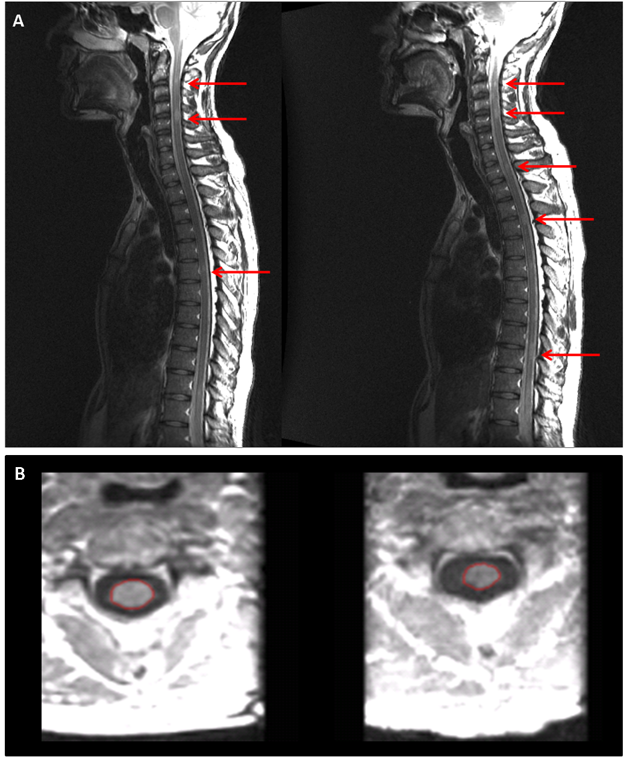
Figure 1. T2-weighted sagittal images of the whole spine (A) and reformatted axial images from volumetric T1-weighted scans of the cervical spinal cord at the level of C2 /C3 (B), obtained at baseline (left) and follow-up (right). Figure 1A shows three spinal cord lesions at baseline and five lesions at follow-up (arrows). Figure 1B shows the upper cervical cord cross-sectional area (outlined in red). The mean UCCA was 72.08 mm² at baseline and 61.28 mm² after 5 years.

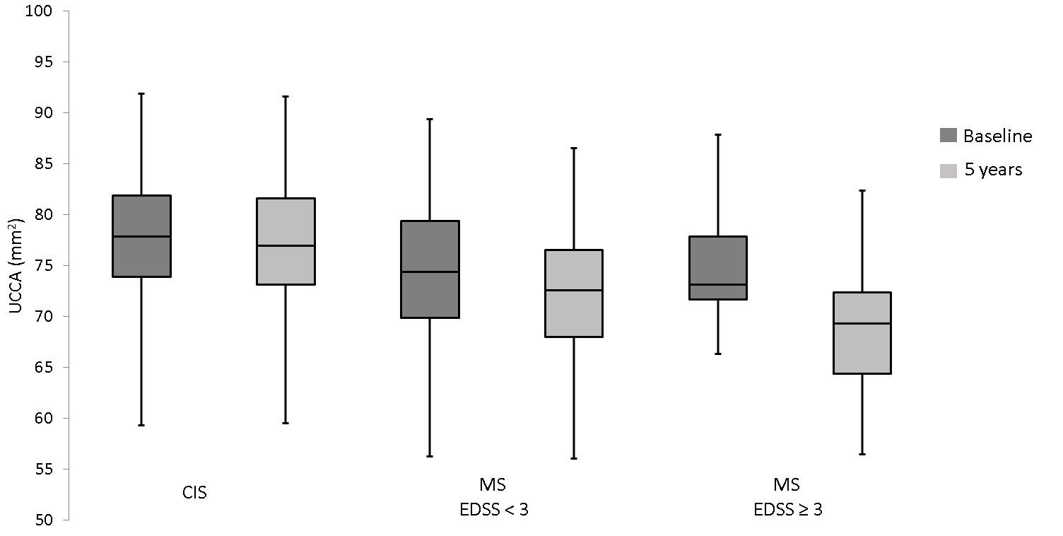

Figure 2. Change in upper cervical cord area from baseline to 5 years grouped by disability status at follow-up.

References
1. Kearney H, Miller DH and Ciccarelli O. Spinal cord MRI in multiple sclerosis-diagnostic, prognostic and clinical value. Nat Rev Neurol. 2015; 11: 327-38.

2. Kidd D, Thorpe JW, Thompson AJ, et al. Spinal cord MRI using multi-array coils and fast spin echo. II. Findings in multiple sclerosis. Neurology. 1993; 43: 2632-7.

3. Lukas C, Sombekke MH, Bellenberg B, et al. Relevance of spinal cord abnormalities to clinical disability in multiple sclerosis: MR imaging findings in a large cohort of patients. Radiology. 2013; 269: 542-52.

4. Nijeholt GJ, van Walderveen MA, Castelijns JA, et al. Brain and spinal cord abnormalities in multiple sclerosis. Correlation between MRI parameters, clinical subtypes and symptoms. Brain. 1998; 121: 687-97.

5. Losseff NA, Webb SL, O'Riordan JI, et al. Spinal cord atrophy and disability in multiple sclerosis. A new reproducible and sensitive MRI method with potential to monitor disease progression. Brain. 1996; 119: 701-8.

6. Rocca MA, Horsfield MA, Sala S, et al. A multicenter assessment of cervical cord atrophy among MS clinical phenotypes. Neurology. 2011; 76: 2096-102.

7. Stevenson VL, Leary SM, Losseff NA, et al. Spinal cord atrophy and disability in MS: a longitudinal study. Neurology. 1998; 51: 234-8.

8. Furby J, Hayton T, Anderson V, et al. Magnetic resonance imaging measures of brain and spinal cord atrophy correlate with clinical impairment in secondary progressive multiple sclerosis. Mult Scler. 2008; 14: 1068-75.

9. Bonati U, Fisniku LK, Altmann DR, et al. Cervical cord and brain grey matter atrophy independently associate with long-term MS disability. J Neurol Neurosurg Psychiatry. 2011; 82: 471-2.

10. Lukas C, Knol DL, Sombekke MH, et al. Cervical spinal cord volume loss is related to clinical disability progression in multiple sclerosis. J Neurol Neurosurg Psychiatry. 2015; 86: 410-8.

11. Rashid W, Davies GR, Chard DT, et al. Increasing cord atrophy in early relapsing-remitting multiple sclerosis: a 3 year study. J Neurol Neurosurg Psychiatry. 2006; 77: 51-5.

12. Lin X, Tench CR, Turner B, Blumhardt LD and Constantinescu CS. Spinal cord atrophy and disability in multiple sclerosis over four years: application of a reproducible automated technique in monitoring disease progression in a cohort of the interferon beta-1a (Rebif) treatment trial. J Neurol Neurosurg Psychiatry. 2003; 74: 1090-4.

13. Kearney H, Rocca MA, Valsasina P, et al. Magnetic resonance imaging correlates of physical disability in relapse onset multiple sclerosis of long disease duration. Mult Scler. 2014; 20: 72-80.

14. Brownlee WJ and Miller DH. Clinically isolated syndromes and the relationship to multiple sclerosis. J Clin NeuroscI 2014; 21: 2065-71.

15. O'Riordan JI, Losseff NA, Phatouros C, et al. Asymptomatic spinal cord lesions in clinically isolated optic nerve, brain stem, and spinal cord syndromes suggestive of demyelination. J Neurol Neurosurg Psychiatry. 1998; 64: 353-7.

16. Sombekke MH, Wattjes MP, Balk LJ, et al. Spinal cord lesions in patients with clinically isolated syndrome: a powerful tool in diagnosis and prognosis. Neurology. 2013; 80: 69-75.

17. Polman CH, Reingold SC, Banwell B, et al. Diagnostic criteria for multiple sclerosis: 2010 Revisions to the McDonald criteria. Ann Neurol. 2011; 69: 292-302.

18. Swanton JK, Fernando KT, Dalton CM, et al. Early MRI in optic neuritis: The risk for disability. Neurology. 2009; 72: 542-50.

19. Brex PA, Leary SM, O'Riordan JI, et al. Measurement of spinal cord area in clinically isolated syndromes suggestive of multiple sclerosis. J Neurol Neurosurg Psychiatry. 2001; 70: 544-7.

20. Biberacher V, Boucard CC, Schmidt P, et al. Atrophy and structural variability of the upper cervical cord in early multiple sclerosis. Mult Scler. 2015; 21: 875-84.

21. Kurtzke JF. Rating neurologic impairment in multiple sclerosis: An expanded disability status scale (EDSS). Neurology. 1983; 33: 1444.

22. Prados F, Cardoso MJ, MacManus D, Wheeler-Kingshott CA and Ourselin S. A modality-agnostic patch-based technique for lesion filling in multiple sclerosis. Med Image Comput Comput Assist Interv. 2014; 17: 781-8.

23. Smith SM, Zhang Y, Jenkinson M, et al. Accurate, robust, and automated longitudinal and cross-sectional brain change analysis. NeuroImage. 2002; 17: 479-89.

24. Horsfield MA, Sala S, Neema M, et al. Rapid semi-automatic segmentation of the spinal cord from magnetic resonance images: application in multiple sclerosis. NeuroImage. 2010; 50: 446-55.

25. Kearney H, Yiannakas MC, Abdel-Aziz K, et al. Improved MRI quantification of spinal cord atrophy in multiple sclerosis. J Magn Reson Imaging. 2014; 39: 617-23.

26. Carpenter J and Bithell J. Bootstrap confidence intervals: when, which, what? A practical guide for medical statisticians. Stat Med. 2000; 19: 1141-64.

27. Weinberg CR. Toward a Clearer Definition of Confounding. Am J Epidemiol. 1993; 137: 1-8.

28. Thorpe JW, Kidd D, Moseley IF, et al. Serial gadolinium-enhanced MRI of the brain and spinal cord in early relapsing-remitting multiple sclerosis. Neurology. 1996; 46: 373-8.

29. Leone M, Bonissoni S, Collimedaglia L, et al. Factors predicting incomplete recovery from relapses in multiple sclerosis: a prospective study. Mult Scler. 2008; 14: 485-93.

30. Kearney H, Altmann DR, Samson RS, et al. Cervical cord lesion load is associated with disability independently from atrophy in MS. Neurology. 2015; 84: 367-73.

31. Wheeler-Kingshott CA, Stroman PW, Schwab JM, et al. The current state-of-the-art of spinal cord imaging: applications. NeuroImage. 2014; 84: 1082-93.
32. Rovira A, Wattjes MP, Tintore M, et al. Evidence-based guidelines: MAGNIMS consensus guidelines on the use of MRI in multiple sclerosis-clinical implementation in the diagnostic process. Nat Rev Neurol. 2015; 11: 471-82.

33. Traboulsee A, Simon JH, Stone L, et al. Revised Recommendations of the Consortium of MS Centers Task Force for a Standardized MRI Protocol and Clinical Guidelines for the Diagnosis and Follow-Up of Multiple Sclerosis. AJNR Am J Neuroradiol. 2015.

34. Hutchinson M. Spinal cord MRI should always be performed in clinically isolated syndrome patients: Commentary. Mult Scler. 2014; 20: 1690-1.

35. Yiannakas MC, Mustafa AM, De Leener B, et al. Fully automated segmentation of the cervical cord from T1-Weighted MRI using PropSeg: Application to multiple sclerosis. NeuroImage Clin 2015; 10:71-7
36. Tintore M, Rovira A, Rio J, et al. Is optic neuritis more benign than other first attacks in multiple sclerosis? Ann Neurol. 2005; 57: 210-5.
37. Tintore M, Rovira A, Arrambide G, et al. Brainstem lesions in clinically isolated syndromes. Neurology. 2010; 75: 1933-8.

