The Impact of ART on the Fertility of HIV-Positive Women in Sub-Saharan Africa: A Systematic Review

Sara Yeatman¹*, Jeffrey W. Eaton², Zosia Beckles³, Lorna Benton⁴, Simon Gregson⁵ and Basia Zaba⁶

¹*Department of Health and Behavioral Sciences, University of Colorado Denver, Campus Box 188, PO Box 173364 Denver, Colorado, USA, sara.yeatman@ucdenver.edu
²Department of Infectious Disease Epidemiology, Imperial College London, London, United Kingdom
³Library Services, University of Bristol, Bristol, United Kingdom
⁴Institute for Global Health, University College London, London, United Kingdom
⁵Biomedical Research and Training Institute, Harare, Zimbabwe.
⁶Department of Population Health, London School of Hygiene and Tropical Medicine, London, United Kingdom

Word count: 4098

Abstract
Objective: Understanding the fertility of HIV-positive women is critical to estimating HIV epidemic trends from surveillance data and planning resource needs and coverage of prevention-of-mother-to-child transmission services in sub-Saharan Africa. In light of the considerable scale-up in antiretroviral therapy (ART) coverage over the last decade, we conducted a systematic review of the impact of ART on the fertility outcomes of HIV-positive women.
Methods: We searched Medline, Embase, Popline, PubMed and African Index Medicus. Studies were included if they were conducted in sub-Saharan Africa and provided estimates of fertility outcomes (live births or pregnancies) among women on ART relative to a comparison group.
Results: Of 2070 unique references, 18 published papers met all eligibility criteria. Comparisons fell into four categories: fertility of HIV-positive women relative to HIV-negative women; fertility of HIV-positive women on ART compared to those not yet on ART; fertility differences by duration on ART; and temporal trends in fertility among HIV-positive women. Evidence indicates that fertility increases after approximately the first year on ART, and that while the fertility deficit of HIV-positive women is shrinking, their fertility remains below that of HIV-negative women. These findings, however, were based on limited data mostly during the period 2005-2010 when ART scaled-up.
Conclusions: Existing data are insufficient to characterize how ART has affected the fertility of HIV-positive women in sub-Saharan Africa. Improving evidence about fertility among women on ART is an urgent priority for planning HIV resource needs and understanding HIV epidemic trends. Alternative data sources such as antenatal clinic data, general population cohorts and population-based surveys can be harnessed to understand the relationship moving forward.

keywords HIV, sub-Saharan Africa, antiretroviral therapy, fertility, pregnancy, births, systematic review

The Impact of ART on the Fertility of HIV-Positive Women in Sub-Saharan Africa: A Systematic Review

Introduction
The fertility of HIV-positive women is a principal determinant of the need for prevention of mother-to-child transmission (PMTCT) and paediatric HIV services. Furthermore, understanding the relationship between HIV and fertility, and variation in this relationship by age, is essential for using HIV prevalence among pregnant women to estimate and track trends in the HIV prevalence of the general population over time (1-3). Although much is known about the relationship between HIV and fertility in sub-Saharan Africa in the absence of anti-retroviral therapy (ART) (3-5), it remains unclear just how the spread of treatment throughout the region has affected this important relationship.

Researchers have long recognized the fertility suppressing effect of HIV on fecundity, the physiologic ability to have children (3, 6, 7). Because the biological effects of HIV on fecundity increase with advancing infection (8), they are most pronounced in older HIV-positive women who are likely to have been infected years earlier. There are also behavioural effects of HIV on fertility that can be either volitional (i.e., done with an explicit fertility motivation) or non-volitional. The former include changes in contraceptive use intended to prevent or encourage a pregnancy while the latter include changes in divorce, widowhood and remarriage patterns due to HIV that indirectly affect fertility.

Before the widespread availability of ART, the fertility of HIV-positive women throughout sub-Saharan Africa was reduced, compared to similar HIV-negative women, because of a combination of biological and behavioural mechanisms. Population-based HIV surveillance studies showed there was variation in the so-called ‘fertility discount’ by age, however. At younger ages (<20), fertility was higher in HIV-positive women due to selection effects (i.e., selection into sexual activity among HIV-positive women). Above age 20, fertility among HIV-positive women was reduced by 25-40% compared to HIV-negative women (3, 5). More recently, using Demographic and Health Survey (DHS) data from before the widespread availability of ART (2003-2006), Chen and Walker (4) showed that the age-specific fertility ratio decreased with age until the fertility of HIV-positive women was approximately half that of HIV-negative women in the 40-44 age group.

With the growing availability of ART throughout much of sub-Saharan Africa, the relationship between HIV and fertility will change (9). Precisely how quickly and to what extent change will occur remains unclear because of the recent nature of expanded ART coverage. Given high levels of underlying fertility in much of the region, small changes in any factor can carry large implications for estimates of PMTCT need and service coverage. Since estimates of paediatric HIV infections are derived using models based on the number of HIV-positive pregnant women and coverage of PMTCT, this can dramatically affect estimates of children living with HIV. Additionally, changes in the fertility discount by age could affect interpretations of prevalence trends in antenatal care (ANC) and PMTCT clinic surveillance.

In order to better understand the effect of ART on the fertility of HIV-positive women in sub-Saharan Africa, we conducted a systematic review of the current literature. We use the term fertility in its demographic sense to refer to fertility outcomes: live births and pregnancies. We present the results and offer an assessment of the limitations of current data and approaches to address this question. We then discuss available data sources and offer suggestions for future research to shed light on the relationship between HIV and fertility as it evolves with the treatment context.

Methods
Search strategy
This systematic review conforms to the PRISMA guidelines (Appendix 1) (10). On 14 October 2015, Medline, Embase, Popline, and African Index Medicus were searched using combinations of search terms without language or date restrictions. A top-up search for non-Medline records was additionally run in PubMed. The review was updated on 26 May 2016. The following concepts were included in the search: antiretroviral therapy (including ART, HAART, cART) AND fertility outcomes (including pregnancy, birth, reproductive health or fertility). Searching for all concepts in subject headings, title and abstract simultaneously proved to have very poor specificity. A faceted approach was therefore used, in which the return of each concept in free-text and subject headings was tested iteratively and the most precise combinations selected for inclusion in the final search. In the final search, concepts were combined as follows:
- Antiretroviral therapy [subject headings and free-text in title and abstract]
- Fertility outcomes [subject headings only]
- 1 AND 2
- Antiretroviral therapy [subject headings and free-text in title only]
- Fertility outcomes [title and abstract free-text]
- 4 AND 5
- 3 OR 6
The combination of fertility terms appearing anywhere and ART terms appearing in the abstract only was found to have very poor specificity and was therefore removed from the final strategy. As the review focus was antiretroviral therapy, terms for HIV infection or seropositivity were not included independently. Where possible, animal studies and studies on assisted reproductive techniques were excluded. The full search strategy is shown in Appendix 2; there is no formal review protocol. Faceted searching was not possible in Popline and African Index Medicus, so a simplified version of the strategy was used. The references lists of all retained studies were additionally searched by hand.

Eligibility criteria
Studies were eligible for inclusion if they were conducted in sub-Saharan Africa, contained estimates of fertility outcomes (i.e., birth or pregnancy) for HIV-positive women on ART (or during a post-ART time period) over a defined period of time, and permitted a comparison of the fertility of HIV-positive women to another population.

Study selection
Titles and abstracts were screened by one author and full texts were sought for potentially relevant publications. In total, 2677 initial references were screened for eligibility and excluded for being duplicates (n=607) or through title (n=1647), abstract (n=375) or full-text review (n=31). An additional study that met criteria for inclusion was identified by checking the references of other reviewed studies (see Fig. 1).

Data extraction and analysis
Data were extracted on: study setting; time period covered; sample description; design; comparisons made; outcome; and key findings. Because fertility is shaped not only by biology, but also by behavior and the social and cultural norms of a specific context, the review focused on the relative differences in fertility adjusted for age rather than on absolute levels of pregnancy rates that may not be generalizable beyond a particular study setting. Substantial heterogeneity in comparators, sample inclusion criteria, and control variables prevented the meaningful pooling of statistics.

Quality assessment
In line with the PRISMA guidelines, the risk of bias was assessed, focusing on the comparability of comparison populations, selectivity and size of sample, method of measuring pregnancy or birth, and appropriate handling of age. Given the strong and non-linear relationship between age and fertility, and that women on ART are older on average, it is essential to stratify or use age-standardized comparison populations to reduce biases introduced by differences in age composition.

---Figure 1 about here---

Results
After exclusions, the literature search identified 18 articles that met all study criteria (Table 1). Included articles offered at least one of four comparisons: (1) fertility of HIV-positive women on ART relative to fertility of HIV-negative women; (2) fertility of HIV-positive women on ART to HIV-positive women not yet on ART; (3) fertility of HIV-positive women by time on ART or time-varying CD4 count after initiation; or (4) fertility of HIV-positive women before and after ART was widely available. Most studies were from a single setting, although five used data from multiple countries in the region (11-15). Data came from Uganda (9 studies), South Africa (4), Kenya (4), Malawi (2), Rwanda (2), Cote d’Ivoire (2), Zimbabwe (2), Zambia (1), Tanzania (1), Gambia (1), Mali (1), Guinea-Bissau (1), Nigeria (1), Burkina Faso (1), Benin (1) and Senegal (1). The included countries range widely in HIV prevalence (from 0.5% in Senegal to 18.9% in South Africa) (16) and total fertility rate (from 2.4 in South Africa to 6.4 in Mali) (17).

---Table 1 about here---

The majority of studies were conducted in HIV clinics (n=12) or as part of HIV outreach programs or studies (n=3). Only three studies used population-based samples: a study that was conducted among 12 communities in eastern Zimbabwe (1); one that drew from demographic and HIV surveillance sites in Uganda, Tanzania and South Africa (13); and another that used two rounds of the nationally-representative Malawi Demographic and Health Survey (DHS) (18). These studies were the only to contain data from a more representative sample of HIV-positive women, some of whom may not be enrolled in clinical care nor necessarily aware of their HIV positive status. Clinic-based studies, however, were better able to accurately assess ART status at the time of conception.

Fifteen studies used pregnancy incidence or prevalence as the main outcome. The three exceptions were a cross-sectional study from semi-urban Uganda that examined the likelihood of live birth and of pregnancy over the previous three years (19), and two of the population-based studies that used age-specific fertility rates and thus focused on live births rather than pregnancies (13, 18). Eight of the 16 studies measuring pregnancy used testing or clinical examination to determine pregnancy while the others relied on self-reported pregnancy, which will be biased toward established pregnancies and pregnancies that end in live birth. On the other hand, for estimates of the need for PMTCT and paediatric HIV, live births and more advanced pregnancies are the most relevant outcomes.

Studies covered a range of years from 1998-2013 with most person-years of data concentrated in the 2005-2010 period, a time in which ART access expanded rapidly in most settings. All studies included women from across the reproductive ages, although some (1, 11, 13, 18, 20, 21) handled age more thoroughly in analyses than others (see Table 1).

HIV-positive women’s fertility relative to HIV-negative women
Only three studies (1, 13, 18) had a purposefully-selected HIV-negative comparison group, although two more made indirect comparisons to national level data (21, 22). Gregson and colleagues (1) found that in a period of increasingly good access to ART in Zimbabwe (2009-2011), the age-adjusted prevalence of pregnancy among HIV-positive women (not all of whom were aware of their status) was 75% that of HIV-negative women. With the exception of the youngest age group (15-24) in which fertility did not differ by HIV status, HIV-positive women had substantially lower pregnancy prevalence regardless of ART use.

Recently, Marston et al. (13) analysed data from four demographic and HIV surveillance sites in Uganda, Tanzania and South Africa. Using data from 59,440 women, the researchers found that the gap between the age-specific fertility rates of HIV-positive and HIV-negative women narrowed in the post-ART period relative to the years before ART was available. The narrowing was principally due to reductions in the fertility of HIV-negative women rather than to increases among HIV-positive women whose fertility stayed steady or only slightly increased over the study period (depending on study site). Despite this narrowing, the age-adjusted fertility rate ratio of HIV-positive: HIV-negative women still ranged between 0.57 (95% CI 0.64-0.83) to 0.83 (95% CI 0.78-0.87) across sites and followed the same age-pattern as in the pre-ART period.

The findings from nationally-representative cross-sectional data from Malawi support the aforementioned studies (18). Despite a relative increase in the fertility of HIV-positive women compared to HIV-negative women between 2004 and 2010, the fertility of HIV-positive women remained at least 25% lower than that of HIV negative women in the latter time period (18).

Two of these population-based studies (13, 18) lack data on individual ART use, and therefore cannot speak to the relative fertility contribution of women on ART and not on ART, which is important for estimating the need for PMTCT and paediatric HIV services.

Fertility of HIV-positive women on ART compared to those not yet on ART
There was disagreement among studies on the pregnancy incidence of women on ART relative to HIV-positive women engaged in care but not yet on ART. Using data from a postpartum sample of women attending 11 urban HIV clinics in six sub-Saharan Africa countries, Myer et al. (11) compared the pregnancy incidence of women on ART to HIV-positive women in pre-ART care after adjusting for a number of variables including age and CD4 count at enrollment. The researchers found that pregnancy incidence was 1.74 (95% CI 1.19–2.54) times greater among HIV-positive women who recently initiated ART relative to women who had yet to initiate. The same trend was noted across study countries although it was stronger in some than in others. Similarly, a community-based HIV care program in rural Uganda found that pregnancy incidence was twice as high among HIV-positive women on ART (23).

In contrast, a recent study from 26 HIV clinics in Uganda and Kenya found no difference in pregnancy incidence comparing women on ART to those not yet on ART. Importantly, these researchers adjusted for time-varying clinical stage and CD4 count and robustly accounted for loss-to-follow up and death (14). Another study (24) similarly found no difference in the pregnancy incidence of women in an HIV-clinic in Kenya using a nevirapine-based ART regimen relative to women not yet on ART after adjusting for sociodemographic characteristics and time-varying CD4 count. This was similar to the findings of a Kenyan study of HIV-positive women in sero-discordant relationships (25).

Two other studies found no difference in pregnancy incidence by ART (26, 27)and another found higher pregnancy incidence among women not yet on ART relative to those on ART (15), but these studies did not adjust for sociodemographic or health differences among the comparison groups.

Fertility differences by duration on ART
A common approach taken by clinic-based studies was to examine changes in pregnancy incidence by time on ART. Some studies prospectively examined women from their initiation on ART, while others included women who may have started on ART before study enrollment but from whom they had data on time of ART initiation. Most studies found significant variation in pregnancy incidence by time on ART. Tweya and colleagues (21), for example, found that pregnancy incidence was particularly low among women in an urban Malawian ART clinic during their first six months on ART. After those six months, fertility substantially increased among all age groups. One study from rural Uganda found that pregnancy incidence peaked 12 to 18 months after initiation (22), while another study from rural Uganda found peaks at 6 to 12 months and then again at 4 years presumably due to a birth interval effect (28). In West Africa, data from ART clinics in six countries showed pregnancy incidence was highest in year four (12). In contrast, a study from Johannesburg, South Africa found no difference in pregnancy incidence by time on ART (29).

One study used time-varying CD4 count and adherence as a proxy for quality of ART use (20). This study from Johannesburg, South Africa found that pregnancy incidence increased among women on ART when their CD4 count was above 100 cells/mm³ and with better adherence (20). Their finding is consistent with two others that found pregnancy incidence to be significantly higher among women who initiated at WHO Stage 1/2 instead of WHO Stage 3/4 (12, 21).

Temporal trends in fertility among HIV-positive women
A final approach taken has been to examine trends in the fertility of HIV-positive women over time. The clinical cohort study from Kenya and Uganda found that pregnancy incidence was higher among HIV-positive women enrolled in clinical care in 2005-2006 relative to those enrolled in 2001-2004 (Elul et al 2016). For women enrolled between 2007-2009, however, pregnancy incidence was no longer different from the earliest years after adjusting for compositional changes including ART use, CD4 count and age (as a linear variable).

The study using clinical cohort data from six West African countries found that overall pregnancy incidence of women on ART increased over the time period (1998-2011). After adjusting for age, CD4 count, WHO clinical stage and hemoglobin at initiation, women who initiated ART between 2009-2011 had 58% (95% CI 35-86) higher pregnancy incidence relative to those who initiated prior to 2005 (12).

Finally, the population-based study from four demographic and health surveillance sites found that the fertility of HIV-positive women, including those not engaged in care, stayed the same at two of the study sites and modestly increased at two other two sites over the pre-ART to post-ART periods (13). When interpreted against a background of secular declines in fertility, however, this stability represents increases in the fertility of HIV-positive women relative to HIV-negative women (13).

Discussion
This systematic review examined the evidence for how the provision of ART has affected the fertility patterns of HIV-positive women and the broader relationship between HIV and fertility in sub-Saharan Africa. Currently available evidence suggests that: 1) fertility increases among women after they have been on ART for a period of time (approximately one year); 2) fertility of women on ART is similar to comparable clinic populations of women not yet on ART when adjusted for health (e.g. CD4 count), but 3) remains somewhat lower than HIV-negative women.

However, the current evidence is insufficient to be confident in these conclusions. Fertility of HIV-positive women relative to HIV-negative women, appropriately accounting for age and ART use, is the gold standard comparison and what is required for robust answers to these questions. Unfortunately, only one study identified in the review included a purposefully-selected HIV-negative comparison population and data on ART use, and in this study ART utilization was self-reported and information about timing of ART initiation was not available (1).

Nonetheless, we can make general observations about the effects of ART on the fertility of HIV-positive women based on existing evidence. Taken together, the reviewed studies suggest that women who access ART in the advanced stages of disease increase their fertility after a period of time likely due to improvements in their health and associated changes in sexual behavior and fertility desires. As more women access ART, the fertility of HIV-positive women who are not yet on ART also increases due to the selective removal (onto ART) of those formerly at more advanced stages of infection. These two trends contribute to similar age-specific fertility rates among HIV-positive women on- and not yet on ART, although their fertility still remains below that of HIV-negative women. Furthermore, the relative stability of age-specific fertility among HIV-positive women over time may reflect the counterbalancing effects of increased fertility of HIV-positive women due to ART and secular declines in fertility (13).

Returning to the principal motivation for this study – an urgent need to inform estimates for HIV service provision and the monitoring of HIV prevalence, we make the following tentative conclusions. First, HIV-positive pregnant women will comprise a growing proportion of the ANC population in the near future due to reductions in the fertility differential between HIV-positive and HIV-negative women, and the longer survival of HIV infected women. The implication is that apparent increases in HIV prevalence among pregnant women may reflect changes in the fertility differential, as well as reflecting the underlying population-wide HIV trends. Failing to account for narrowing of the fertility rate ratio between HIV-positive and HIV-negative women could result in over-estimates of population HIV increases derived from prevalence among pregnant women. Second, although reductions in the fertility differential will increase the need for PMTCT services, more of these women will conceive while on ART, reducing the risks of onward transmission to their children.

Notably, the data in the reviewed published papers are concentrated over a period in which ART was rapidly expanding (2005-2010) but not as well established as today. Changes in the characteristics of women initiating ART and the widening of CD4 guidelines suggest that we should be cautious about extrapolating data from 2005-2010 to the current or a future situation. Additionally, the recent and rapid adoption of the Option B+ policy, which recommends lifelong ART to all HIV-positive pregnant women, as well as the WHO’s now recommended policy of universal eligibility for ART (30), will mean that women initiate ART at earlier stages in the course of their disease before an advanced infection affects their fecundity. As this trend continues, the fertility of HIV positive women on ART may begin to look more like that of HIV negative women.

Given these recent and rapid changes in ART policy and availability, there is an urgent need to analyse more recent data from the post-2010 period. Fortunately, researchers seem aware of this need—7 of the 18 studies in this review were published in 2015 or the first few months of 2016, including the only three population-based studies. In the remaining paragraphs, we offer guidance for future research on the impact of ART on the fertility of HIV-positive women.

The studies included in the systematic review came largely from HIV clinics. Given the limitations of HIV clinic data, which lack an HIV-negative comparison and are limited to the subset of HIV positive women engaged in care, other data sources such as ANC clinics, general population cohort studies (e.g. demographic surveillance sites), and retrospective population-based surveys (e.g. DHS and the new Population-based HIV Impact Assessment surveys (PHIA)(31)) are likely to be the most informative in the future. Nonetheless, interpretation of currently available data from each of these sources is challenging because reporting of ART utilization and the timing of ART initiation relative to pregnancy incidence tend to be less precise if self-reported. Precision about this is important considering the high risk of potential confounding whence many women are diagnosed and initiate ART because they are pregnant, particularly under Option B+, and the unique PMTCT needs of women on- and not on ART in the first trimester. In all of these data sources, retrospective reporting may be enhanced by inclusion of a specific survey question about whether the women was on ART prior to the first ANC visit, in addition to the now standard questions about HIV testing and PMTCT provision during the pregnancy.

Among these data sources, ANC clinic data are limited because, while they include data about both HIV-positive and HIV-negative women, the denominator for each group is unknown. An assumption about the population size and prevalence in the catchment population is required in order to calculate relative fertility rates. Moreover, to date, routine ANC clinic reporting has not tended to include reporting of whether women were already on ART and age stratification is often not reported.

Prospective general population cohorts may be considered the gold standard if they also precisely identify the timing of ART relative to pregnancy through prospective linkage to HIV service delivery data. However, these data are only available in a few eastern and southern African countries, and tend to be among rural populations. DHSs, PHIAs and similar nationally-representative surveys with retrospective fertility histories potentially overcome this limitation: they include both urban and rural populations and will cover a large number of SSA countries. These surveys will increasingly include biomarker measurement of antiretroviral use, but inclusion of a specific question about whether ART was initiated prior to pregnancy is essential. Estimates from retrospective fertility histories, however, are susceptible to survivorship bias in which fertility experiences of recently deceased women are excluded, although survivorship bias may be less important in the ART era than earlier when HIV mortality was higher. They are also susceptible to the underreporting of early infant mortality, which will disproportionately affect HIV-positive women not on ART and could artificially inflate estimates of the effect of ART on fertility as declines in early infant mortality could appear as increases in fertility.

The current review focused on actual fertility differentials among women on ART relative to comparison populations as a critical first step in understanding how ART use affects fertility. Future studies, however, should be sensitive to the relative impact of biological versus behavioral differences—volitional and not—in the fertility response to ART across settings as they will provide essential inputs for models such as Spectrum (32, 33) that attempt to estimate the future direction of HIV and the family planning needs—including safe conception counseling—of these women.

Conclusion
Available evidence indicates that fertility increases after the first year on ART, but women on ART still have lower fertility than HIV-negative women of the same age. These conclusions, however, are based on limited data largely from the 2005-2010 period during which ART was scaled-up. Caution should be exercised generalizing to the current era when guidelines have changed, women initiate ART earlier, coverage is higher, and women have been on ART longer. Improving evidence about fertility among women on ART is an urgent priority for planning HIV resource needs and understanding HIV epidemic trends.

Funding
The first author received funding from the UNAIDS Reference Group on Estimates, Modelling and Projections to prepare an initial report that developed into the present systematic review.

APPENDIX 1-PRISMA Checklist
Section/topic | # | Checklist item | Reported on page #
TITLE
Title | 1 | Identify the report as a systematic review, meta-analysis, or both. | 1
ABSTRACT
Structured summary | 2 | Provide a structured summary including, as applicable: background; objectives; data sources; study eligibility criteria, participants, and interventions; study appraisal and synthesis methods; results; limitations; conclusions and implications of key findings; systematic review registration number. | 2
INTRODUCTION
Rationale | 3 | Describe the rationale for the review in the context of what is already known. | 3-4
Objectives | 4 | Provide an explicit statement of questions being addressed with reference to participants, interventions, comparisons, outcomes, and study design (PICOS). | 3-4
METHODS
Protocol and registration | 5 | Indicate if a review protocol exists, if and where it can be accessed (e.g., Web address), and, if available, provide registration information including registration number. | 5
Eligibility criteria | 6 | Specify study characteristics (e.g., PICOS, length of follow-up) and report characteristics (e.g., years considered, language, publication status) used as criteria for eligibility, giving rationale. | 5-6
Information sources | 7 | Describe all information sources (e.g., databases with dates of coverage, contact with study authors to identify additional studies) in the search and date last searched. | 4-5
Search | 8 | Present full electronic search strategy for at least one database, including any limits used, such that it could be repeated. | 19
Study selection | 9 | State the process for selecting studies (i.e., screening, eligibility, included in systematic review, and, if applicable, included in the meta-analysis). | 6
Data collection process | 10 | Describe method of data extraction from reports (e.g., piloted forms, independently, in duplicate) and any processes for obtaining and confirming data from investigators. | 6
Data items | 11 | List and define all variables for which data were sought (e.g., PICOS, funding sources) and any assumptions and simplifications made. | 6
Risk of bias in individual studies | 12 | Describe methods used for assessing risk of bias of individual studies (including specification of whether this was done at the study or outcome level), and how this information is to be used in any data synthesis. | 6
Summary measures | 13 | State the principal summary measures (e.g., risk ratio, difference in means). | 6-8
Synthesis of results | 14 | Describe the methods of handling data and combining results of studies, if done, including measures of consistency (e.g., I²) for each meta-analysis. | n/a

Risk of bias across studies | 15 | Specify any assessment of risk of bias that may affect the cumulative evidence (e.g., publication bias, selective reporting within studies). | 6
Additional analyses | 16 | Describe methods of additional analyses (e.g., sensitivity or subgroup analyses, meta-regression), if done, indicating which were pre-specified. | n/a
RESULTS
Study selection | 17 | Give numbers of studies screened, assessed for eligibility, and included in the review, with reasons for exclusions at each stage, ideally with a flow diagram. | 6, Fig.1
Study characteristics | 18 | For each study, present characteristics for which data were extracted (e.g., study size, PICOS, follow-up period) and provide the citations. | Tab.1
Risk of bias within studies | 19 | Present data on risk of bias of each study and, if available, any outcome level assessment (see item 12). | 7-11 Tab.1
Results of individual studies | 20 | For all outcomes considered (benefits or harms), present, for each study: (a) simple summary data for each intervention group (b) effect estimates and confidence intervals, ideally with a forest plot. | 7-11, Tab. 1
Synthesis of results | 21 | Present results of each meta-analysis done, including confidence intervals and measures of consistency. | n/a
Risk of bias across studies | 22 | Present results of any assessment of risk of bias across studies (see Item 15). | 7-11
Additional analysis | 23 | Give results of additional analyses, if done (e.g., sensitivity or subgroup analyses, meta-regression [see Item 16]). | n/a
DISCUSSION
Summary of evidence | 24 | Summarize the main findings including the strength of evidence for each main outcome; consider their relevance to key groups (e.g., healthcare providers, users, and policy makers). | 12-13
Limitations | 25 | Discuss limitations at study and outcome level (e.g., risk of bias), and at review-level (e.g., incomplete retrieval of identified research, reporting bias). | 12-13
Conclusions | 26 | Provide a general interpretation of the results in the context of other evidence, and implications for future research. | 12-15
FUNDING
Funding | 27 | Describe sources of funding for the systematic review and other support (e.g., supply of data); role of funders for the systematic review. | 17

Source: Moher D, Liberati A, Tetzlaff J, Altman DG, The PRISMA Group (2009). Preferred Reporting Items for Systematic Reviews and Meta-Analyses: The PRISMA Statement. PLoS Med 6(7): e1000097. doi:10.1371/journal.pmed1000097
For more information, visit: www.prisma-statement.org.

APPENDIX 2: Full search strategy for Medline
Database(s): Ovid MEDLINE(R) 1946 to May 26, 2016
# | Searches
1 | exp ANTI-RETROVIRAL AGENTS/
2 | ANTIRETROVIRAL THERAPY, HIGHLY ACTIVE/
3 | (HAART or cART or anti retroviral$ or antiretroviral$).ti,ab.
4 | ART.ti,ab. not (exp REPRODUCTIVE TECHNIQUES, ASSISTED/ or CRYOPRESERVATION/ or (assisted reproduct$ or artificial reproduct$ or cryopreserv$ or "state of the art").ti,ab.)
5 | exp HIV INFECTIONS/dt, th [Drug Therapy, Therapy]
6 | HIV SEROPOSITIVITY/dt [Drug Therapy]
7 | ((HIV$ or antiHIV$ or human immuno deficiency virus$ or antihuman immuno deficiency virus$ or human immunodeficiency virus$ or antihuman immunodeficiency virus$) adj (therap$ or agent? or drug?)).ti,ab.
8 | or/1-7
9 | exp PREGNANCY RATE/
10 | exp PREGNANCY/sn [Statistics & Numerical Data]
11 | exp FERTILITY/
12 | INFERTILITY/
13 | INFERTILITY, FEMALE/
14 | REPRODUCTIVE HEALTH/
15 | or/9-14
16 | and/8,15
17 | exp *ANTI-RETROVIRAL AGENTS/ or *ANTIRETROVIRAL THERAPY, HIGHLY ACTIVE/ or exp *HIV INFECTIONS/dt, th or *HIV SEROPOSITIVITY/dt [Drug Therapy, Therapy]
18 | (HAART or cART or anti retroviral$ or antiretroviral$).ti.
19 | ART.ti. not (exp REPRODUCTIVE TECHNIQUES, ASSISTED/ or CRYOPRESERVATION/ or (assisted reproduct$ or artificial reproduct$ or cryopreserv$ or "state of the art").ti,ab.)
20 | ((HIV$ or antiHIV$ or human immuno deficiency virus$ or antihuman immuno deficiency virus$ or human immunodeficiency virus$ or antihuman immunodeficiency virus$) adj (therap$ or agent? or drug?)).ti.
21 | or/17-20
22 | ((pregnan$ or birth$ or livebirth$ or stillbirth$) adj2 (risk$ or rate? or incidence? or prevalen$)).ti,ab.
23 | (fertil$ or subfertil$ or infertil$ or birthrate? or reproductive health or pregnancies).ti,ab.
24 | or/22-23
25 | and/21,24
26 | or/16,25
27 | LETTER/
28 | EDITORIAL/
29 | NEWS/
30 | exp HISTORICAL ARTICLE/
31 | ANECDOTES AS TOPIC/
32 | COMMENT/
33 | CASE REPORT/
34 | (letter or comment*).ti.
35 | or/27-34
36 | RANDOMIZED CONTROLLED TRIAL/ or random*.ti,ab.
37 | 35 not 36
38 | ANIMALS/ not HUMANS/
39 | exp ANIMALS, LABORATORY/
40 | exp ANIMAL EXPERIMENTATION/
41 | exp MODELS, ANIMAL/
42 | exp RODENTIA/
43 | (rat or rats or mouse or mice).ti.
44 | or/37-43
45 | 26 not 44
46 | 2016????.dc,ed,ep,up,yr.
47 | and/45-46

References
1. Gregson S, Dharmayat K, Pereboom M, Takaruza A, Mugurungi O, Schur N, et al. Do HIV prevalence trends in antenatal clinic surveillance represent trends in the general population in the antiretroviral therapy era? The case of Manicaland, East Zimbabwe. Aids. 2015;29(14):1845-53.
2. Eaton JW, Rehle TM, Jooste S, Nkambule R, Kim AA, Mahy M, et al. Recent HIV prevalence trends among pregnant women and all women in sub-Saharan Africa: implications for HIV estimates. AIDS. 2014;28:S507-S14.
3. Zaba B, Gregson S. Measuring the impact of HIV on fertility in Africa. Aids. 1998;12:S41-S50.
4. Chen W-J, Walker N. Fertility of HIV-infected women: insights from Demographic and Health Surveys. Sexually transmitted infections. 2010;86(Suppl 2):ii22-ii7.
5. Lewis JJC, Ronsmans C, Ezeh A, Gregson S. The population impact of HIV on fertility in sub-Saharan Africa. Aids. 2004;18:S35-S43.
6. Ross A, Van der Paal L, Lubega R, Mayanja BN, Shafer LA, Whitworth J. HIV-1 disease progression and fertility: the incidence of recognized pregnancy and pregnancy outcome in Uganda. Aids. 2004;18(5):799-804.
7. Desgrées du Loû A, Msellati P, Yao A, Noba V, Viho I, Ramon R, et al. Impaired fertility in HIV-1-infected pregnant women: a clinic-based survey in Abidjan, Côte d ‚Ivoire, 1997. Aids. 1999;13(4):517-21.
8. Nguyen RHN, Gange SJ, Wabwire-Mangen F, Sewankambo NK, Serwadda D, Wawer MJ, et al. Reduced fertility among HIV-infected women associated with viral load in Rakai district, Uganda. International Journal of Std & Aids. 2006;17(12):842-6.
9. Kaida A, Andia I, Maier M, Strathdee SA, Bangsberg DR, Spiegel J, et al. The potential impact of antiretroviral therapy on fertility in sub-Saharan Africa. Curr HIV/AIDS Rep. 2006;3(4):187-94.
10. Liberati A, Altman DG, Tetzlaff J, Mulrow C, Gotzsce PC, Ioannidis JP, et al. The PRISMA statement for Reporting Systematic Reviews and Meta-Analyses of Studies That Evaluate Health Care Interventions: Explanation and Elaboration. PLoS Medicine. 2009;6(7):2-28.
11. Myer L, Carter RJ, Katyal M, Toro P, El-Sadr WM, Abrams EJ. Impact of antiretroviral therapy on incidence of pregnancy among HIV-infected women in Sub-Saharan Africa: a cohort study. PLoS Med. 2010;7(2):e1000229.
12. Burgos-Soto J, Balestre E, Minga A, Ajayi S, Sawadogo A, Zannou MD, et al. Incidence of pregnancy after antiretroviral therapy initiation and associated factors in 8 West African Countries. Journal of Acquired Immune Deficiency Syndromes. 2014;67(2):e45-e54.
13. Marston M, Nakiyingi-Miiro J, Hosegood V, Lutalo T, Mtenga B, Zaba B. Measuring the Impact of Antiretroviral Therapy Roll-Out on Population Level Fertility in Three African Countries. PloS one. 2016;11(3):e0151877.
14. Elul B, Wools-Kaloustian KK, Wu Y, Musick BS, Nuwagaba-Biribonwoha H, Nash D, et al. Untangling the relationship between antiretroviral therapy use and incident pregnancy: A marginal structural model analysis using data from 47,313 HIV-positive women in East Africa. J Acquir Immune Defic Syndr. 2016.
15. Lancaster KE, Kwok C, Rinaldi A, Byamugisha J, Magwali T, Nyamapfeni P, et al. Incident pregnancy and pregnancy outcomes among HIV-infected women in Uganda and Zimbabwe. International Journal of Gynecology and Obstetrics. 2015;131(3):255-9.
16. UNAIDS. HIV prevalence among adults (15-49), http://aidsinfo.unaids.org Last accessed on December 16, 2015
17. United Nations Population Division. World Population Prospects: The 2015 Revision. http://esa.un.org/unpd/wpp/DataQuery/ Last accessed December 16, 2015.
18. Souza E, Moultrie TA. Estimating the effect of HIV/AIDS on fertility among Malawian women using demographic and health survey data. Afr. 2015;14(4):315-21.
19. Maier M, Andia I, Emenyonu N, Guzman D, Kaida A, Pepper L, et al. Antiretroviral therapy is associated with increased fertility desire, but not pregnancy or live birth, among HIV+ women in an early HIV treatment program in rural Uganda. Aids Behav. 2009;13 Suppl 1:28-37.
20. Westreich D, Evans D, Firnhaber C, Majuba P, Maskew M. Prevalent pregnancy, biological sex, and virologic response to antiretroviral therapy. J Acquir Immune Defic Syndr. 2012;60(5):489-94.
21. Tweya H, Feldacker C, Breeze E, Jahn A, Haddad LB, Ben-Smith A, et al. Incidence of pregnancy among women accessing antiretroviral therapy in urban Malawi: a retrospective cohort study. Aids Behav. 2013;17(2):471-8.
22. Homsy J, Bunnell R, Moore D, King R, Malamba S, Nakityo R, et al. Reproductive Intentions and Outcomes among Women on Antiretroviral Therapy in Rural Uganda: A Prospective Cohort Study. PLoS ONE. 2009;4(1):e4149.
23. Makumbi FE, Nakigozi G, Reynolds SJ, Ndyanabo A, Lutalo T, Serwada D, et al. Associations between HIV antiretroviral therapy and the prevalence and incidence of pregnancy in Rakai, Uganda. AIDS research and treatment. 2011;2011.
24. Patel RC, Onono M, Gandhi M, Blat C, Hagey J, Shade SB, et al. Pregnancy rates in HIV-positive women using contraceptives and efavirenz-based or nevirapine-based antiretroviral therapy in Kenya: A retrospective cohort study. The Lancet HIV. 2015;2(11):e474-e82.
25. Guthrie BL, Choi RY, Liu AY, Mackelprang RD, Rositch AF, Bosire R, et al. Barriers to antiretroviral initiation in HIV-1-discordant couples. Journal of acquired immune deficiency syndromes (1999). 2011;58(3):e87.
26. Kabami J, Turyakira E, Biraro S, Bajunirwe F. Increasing incidence of pregnancy among women receiving HIV care and treatment at a large urban facility in western Uganda. Reprod Health. 2014;11:81.
27. Asiimwe-Kateera B, Veldhuijzen N, Balinda JP, Rusine J, Eagle S, Vyankandondera J, et al. Combination Antiretroviral Therapy for HIV in Rwandan Adults: Clinical Outcomes and Impact on Reproductive Health up to 24 Months. AIDS research and treatment. 2015;2015:740212.
28. Kaida A, Matthews LT, Kanters S, Kabakyenga J, Muzoora C, Mocello AR, et al. Incidence and predictors of pregnancy among a cohort of HIV-positive women initiating antiretroviral therapy in Mbarara, Uganda. PLoS ONE. 2013;8(5):e63411.
29. Schwartz SR, Mehta SH, Taha TE, Rees HV, Venter F, Black V. High pregnancy intentions and missed opportunities for patient–provider communication about fertility in a South African cohort of HIV-positive women on antiretroviral therapy. AIDS and Behavior. 2012;16(1):69-78.
30. World Health Organization. Consolidated guidelines on the use of antiretroviral drugs for treating and preventing HIV infection: recommendations for a public health apporach -- 2nd edition. 2016.
31. ICAP. The Population-based HIV Impact Assessment Surveys, Columbia University, http://icap.columbia.edu/global-initatives/the-phia-project/ Accessed May 29, 2016
32. Stover J, Johnson P, Hallett T, Marston M, Becquet R, Timaeus I. The Spectrum projection package: improvements in estimating incidence by age and sex, mother-to-child transmission, HIV progression in children and double orphans. Sex Transm Infect. 2010;86(Suppl 2):ii16-ii21.
33. Stover J, McKinnon R, Winfrey B. Spectrum: A model platform for linking maternal and child survival interventions with AIDS, family planning and demographic projections. International Journal of Epidemiology. 2010;39(SUPPL. 1):i7-i10.

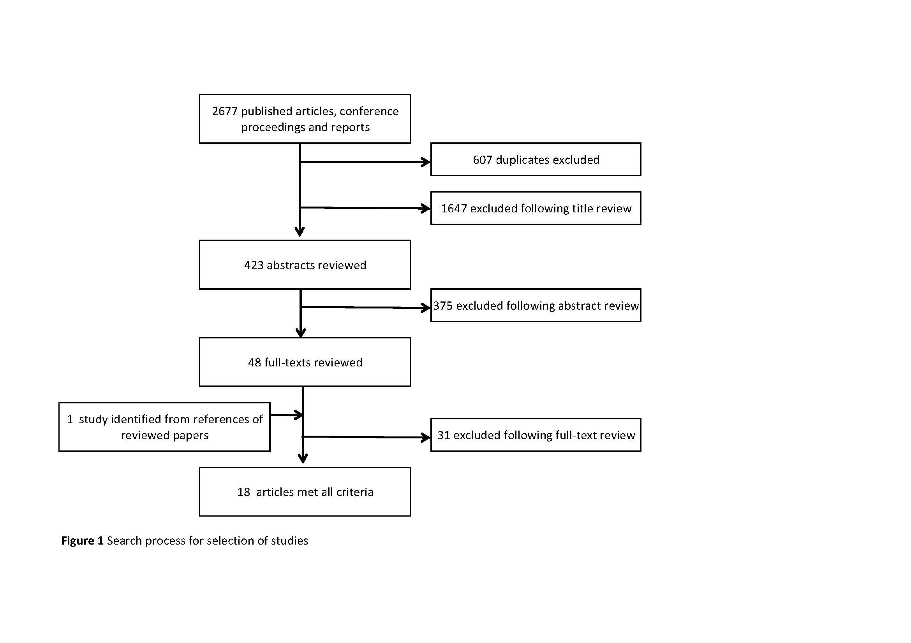

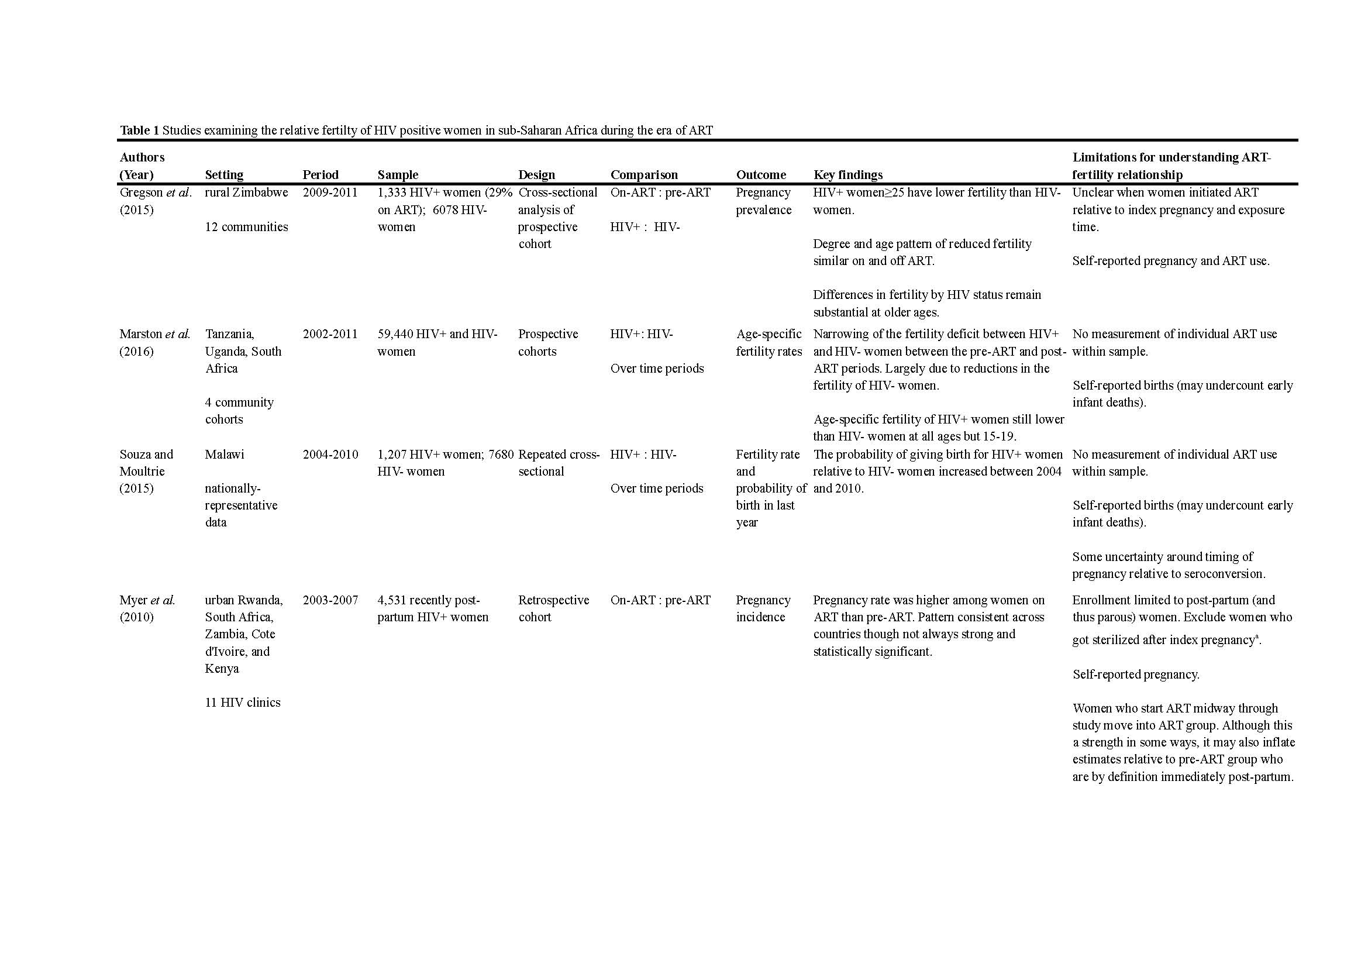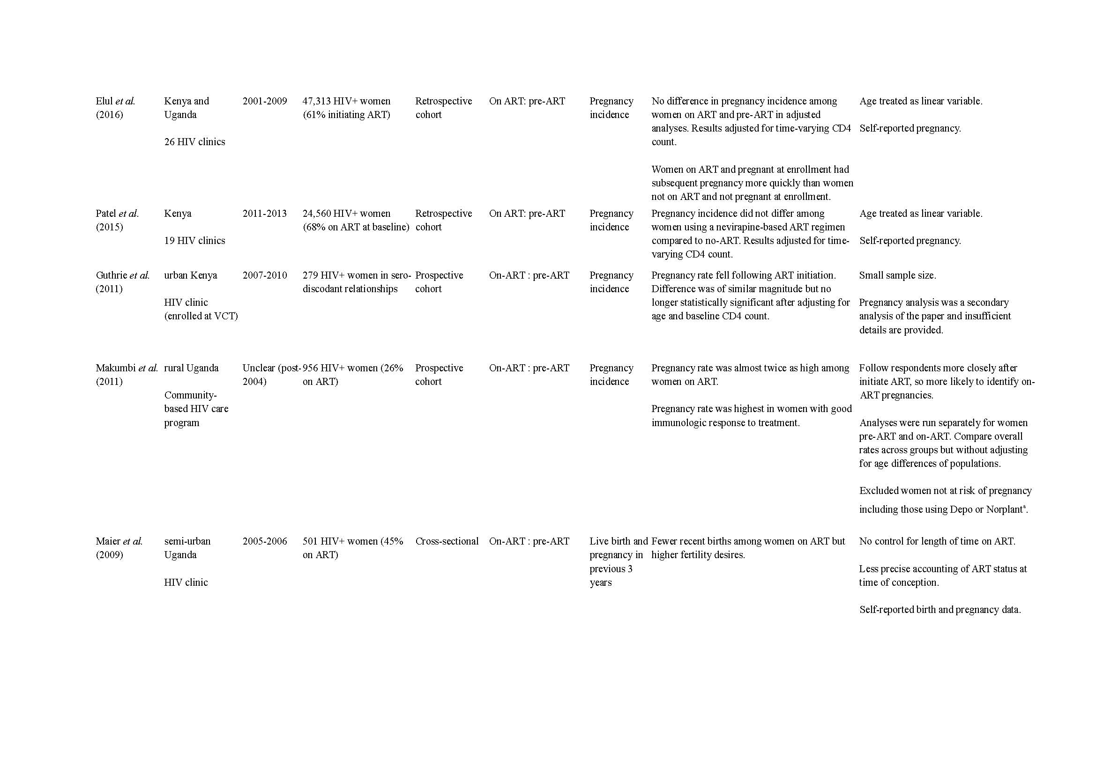
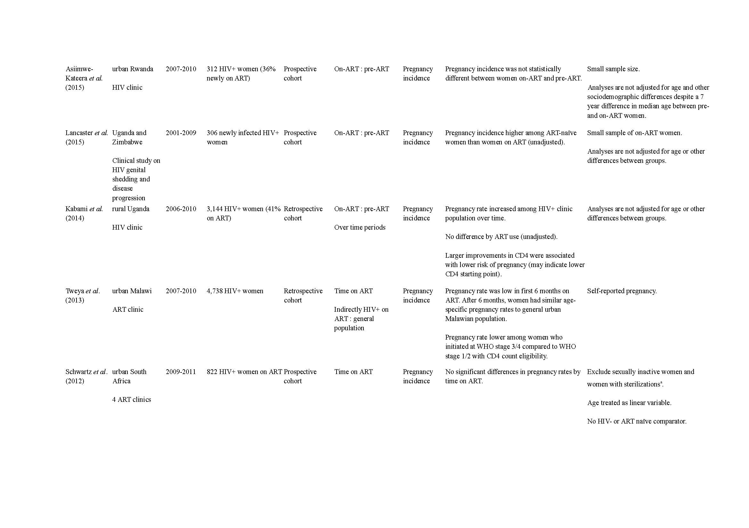
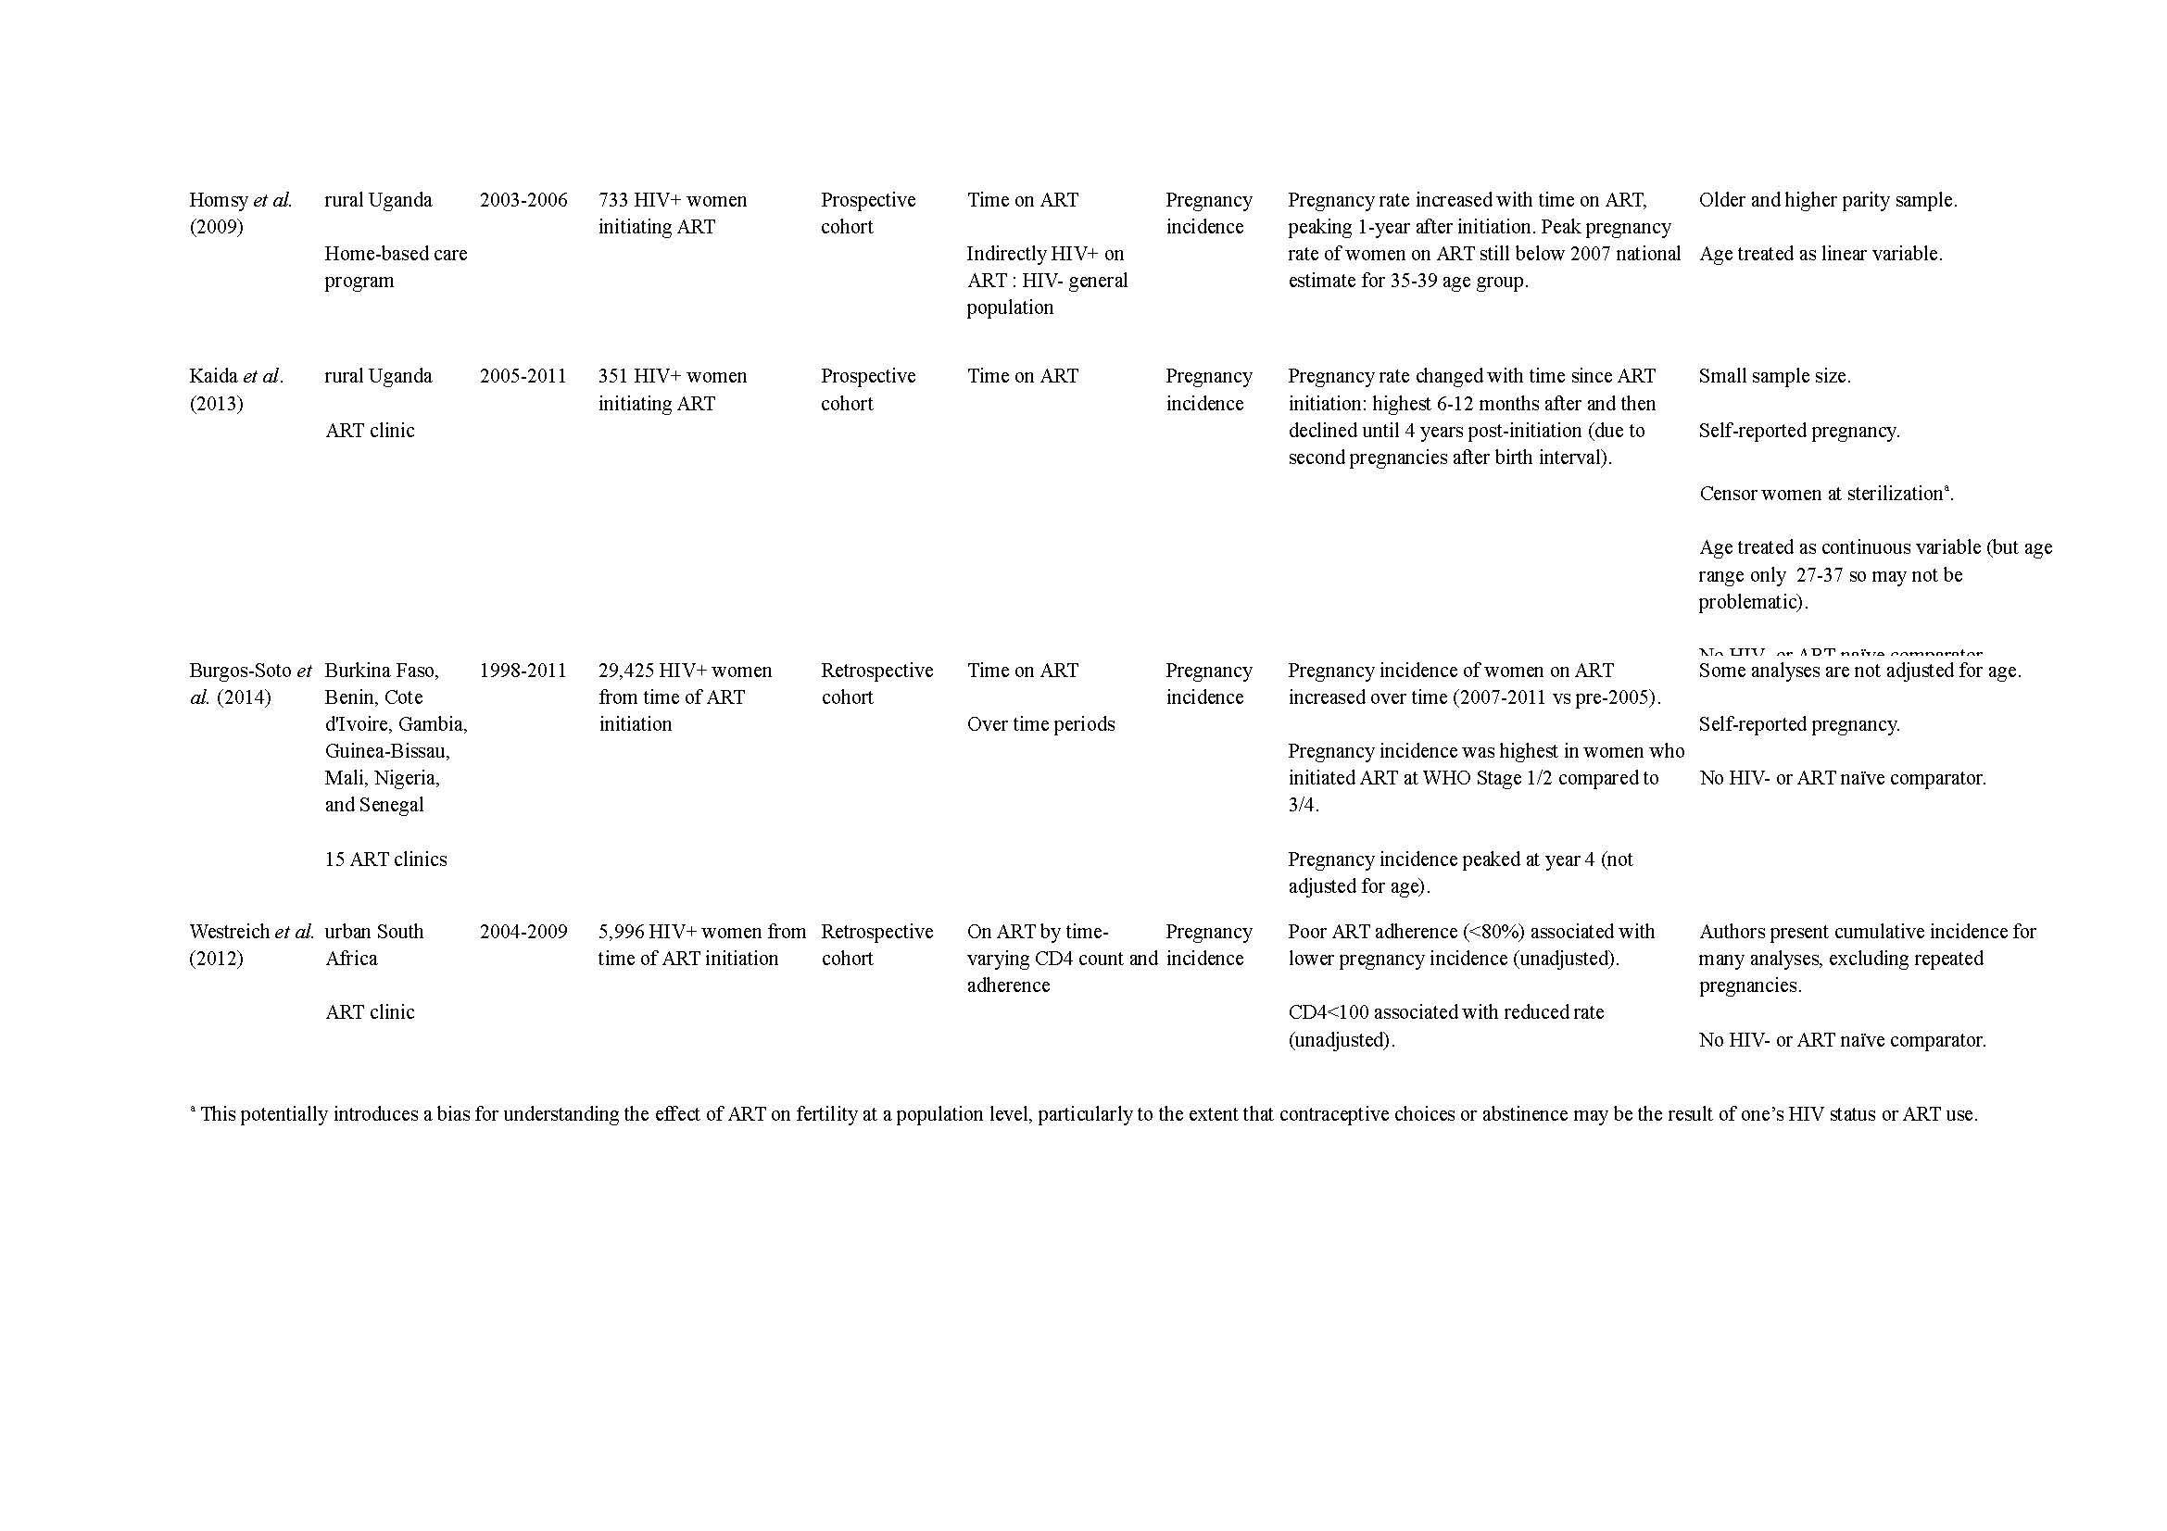

Our summary excludes one study that did not account for compositional differences in their clinic population over time (25)

