Figure 1: SAGE Working Group (WG) “Model of determinants of Vaccine Hesitancy”
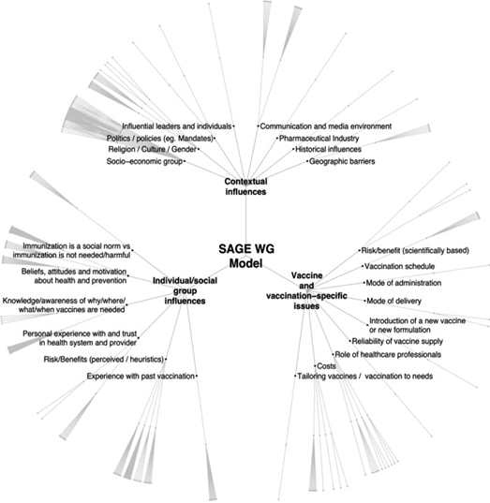

Figure 2: Search process Flow Chart
Additional articles found using Snowballing technique

(n=239)

Added from peer recommendations
(n=14)
Total no. of identified articles from original vaccine hesitancy search⁽¹⁾

n=1164

(n=42)

Added from PubMed search alert
(n=111)

Excluded by title and abstract review
(n=3)
Pregnancy-related articles from original vaccine hesitancy search⁽¹⁾

(n=42)

Not available by full text/unable to translate

(n=3)
Excluded by title and abstract

(n=183)
Screened by title and abstract
(n=42)
Screened by title and abstract

(n=364)

Excluded by full text review
(n=1)
Screened by full text
(n=178)

Excluded by full text

(n=61)

Screened by full text
(n=39)

Total included by full text Flu: (n=84)
Any vaccines provided during pregnancy (n=14)
Tetanus (n=11)
dTaP/ IPV (n=7)
GBS (n=1)
Total (n=117)

Articles included by full text
Flu: (n=29)
Tetanus (n=5)
Any vaccines provided during pregnancy (n=3)
GBS (n=1)
dTaP/ IPV (n=0)

Total (n=38)

Total articles included by full text from VH paper search and Snowballing technique
(n=155)

Figure 3: Vaccines mentioned in the literature by country

Figure 4: Articles by publication date and vaccine

Figure 5: Concerns by vaccine

Note: Numbers do not add up to total number of articles as only articles specifying a particular, currently available vaccine were included in this chart.

Figure 6: Concerns by vaccine according to SAGE Working Group Model of Determinants

